Stacks

* a linear data structure which follows a particular order in which the operations are performed.
* Stacks are  LIFO(Last In First Out) or FILO(First In Last Out)
* Think of the LIFO and FILO properties as you would any other stack in real life
* If you have a stack of plates, the last plate that you put on a stack would be the first plate you remove

The 10 is the first element placed in the stack so it would be the last one removed. This is because we can only access the top element of a stack. To access the other elements we must keep removing (or popping) from the stack until we get to the element we desire

# Operations

1. push(x) → add x to the top of the stack →time complexity: O(1)

2. pop() → remove what is at the top of the stack →time complexity: O(1)

3. peek() →check what is at the top of the stack →time complexity: O(1)

4. isEmpty() → check if stack is empty →time complexity: O(1)

# Applications

* Function Calls/Recursion
* Undo/redo in many editors

# Array Implementation

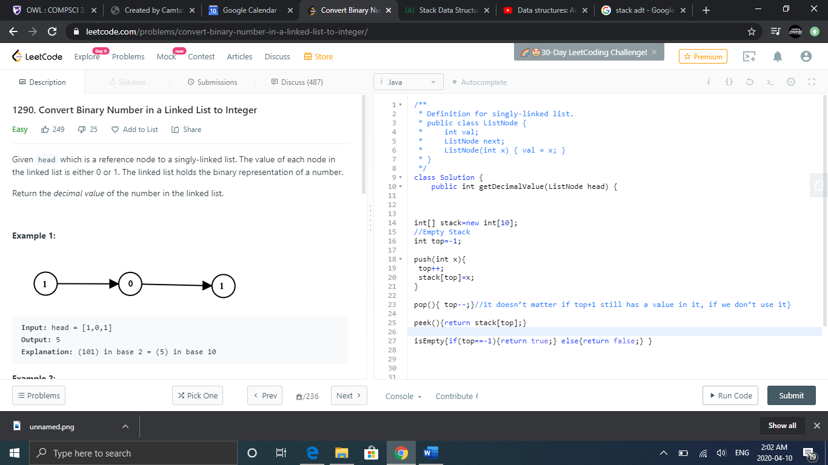

* top references an array index. Since array indexes start at 0, an empty stack would have a top value of -1 because it would not reference any values in the array
* when using array implementation, you must be sure the size of your array is big enough to hold all the values that will be in your stack

# Linked List Implementation

