

Discovery Vitality:
Member Health & Engagement Analysis

Prepared By:
Gugulethu Dladla
📧 Email: gugulethudladla824@gmail.com
📍 Location: South Africa, Johannesburg
📅 Date: 4 July 2025 – 5 August 2025
Project Description:
This project analyses health and behaviour patterns using three datasets; members.xlsx, claims.xlsx, and vitality.xlsx. Leveraging Python, SQL, and Power BI to uncover how lifestyle engagement influences health risks and insurance claim behaviour for the Discovery Vitality program.

Prepared By using:
PYTHON
SQL
POWERBI

Contents
Project Background 2
Project Scope 2
Tools used for this project 3
Progressive states of the project 3
Project Objectives: 3
Data Overview 4
Members.csv 4
Claims.csv 5
Vitality.csv 5
Phase 1: Python Data Cleaning 6
Displayed datasets for each stated variable: 6
Cleaning data frames 7
Datatype cleaning 9
MERGE DATASETS 11
Phase 2: SQL Data Exploration 13
Creating the table for SQL 13
Displaying the table 16
Statistics Overview 16
Data Distribution 18
Gender Distribution 18
Age Distribution 19
Region Distribution 20
Segmentation of member and plan type 21
Chronic Condition 22
Diagnosis Code 23
High Risk Members 23
Claims vs Engagement 24
Monthly Claims Trends 25
Plan Type vs Claim Frequency 26
Wellness engagement 27
Phase 3: Power BI Dashboard 28
Member demographic 28
Plan Type 29
Claims analysis 30
Engagement and Activity 31
Financial and Claims efficiency 32
Interactive Overview 33
Final Project Summary 34

Project Background
Project Overview
Discovery vitality is a program that encourages healthy behaviours among its members. It integrates the lifestyle and health related services, rewarding members for activities such as exercising, eating well, and attending clinic medical check-ups. This data centric model presents an opportunity to better understand member behaviour in relation to health risks, engagement levels, and insurance claims.
Business Goals
To support Discovery’s data driven strategy, this project analyses is from simulated data derived from member, vitality, and claim records. The aim is to uncover insights how wellness activities correlate with health risks and medical claims. Insights drawn from this analysis will inform strategies to optimize rewards structure, reduce Healthcare risks and costs, and personalize member engagement efforts.

Project Scope
This project focuses on analysing simulated datasets from Discovery Vitality, specifically member demographics, wellness engagement, and medical claims. The analysis is conducted in four phases.:
Phase 1: Data Cleaning & Preparation – Merging and standardization of Member, Claims, and Vitality datasets for consistency and analytical readiness.
Phase 2: Exploratory SQL Analysis – Extracting and summarizing key metrics such as engagement levels, regional distribution, and claim behaviour, and risk profile using structured querying.
Phase 3: Dashboard Visualization – Developing a Power BI dashboard to visually represent insights of member, health risks, and claims distribution.
Phase 4: Insight Generation – Drawing conclusions and recommendations based on data patterns and focusing on how wellness activities relate to health outcomes and costs.

Tools used for this project
The progressive state of creating insightful data will be documented. Although it is important to state the tools used to experiment and curate our data for decision-making.

Progressive states of the project

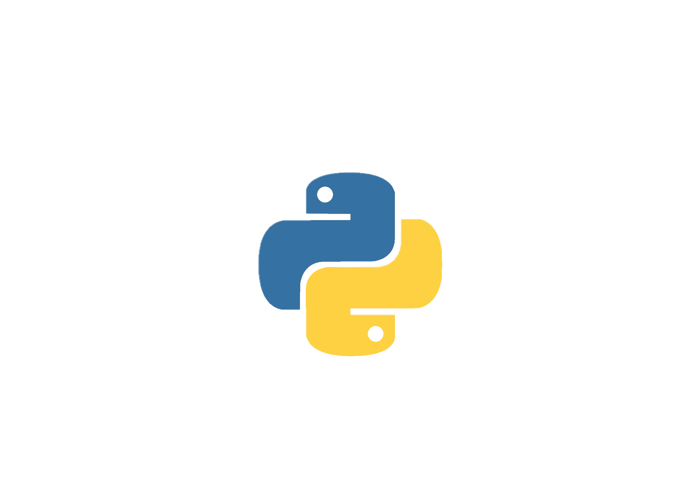
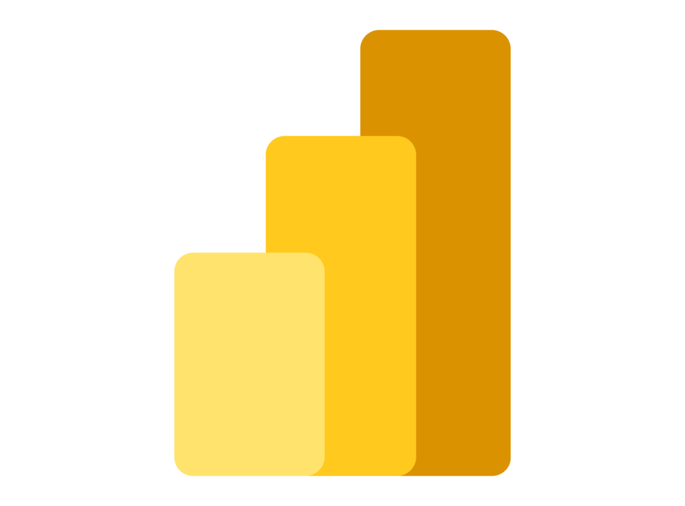
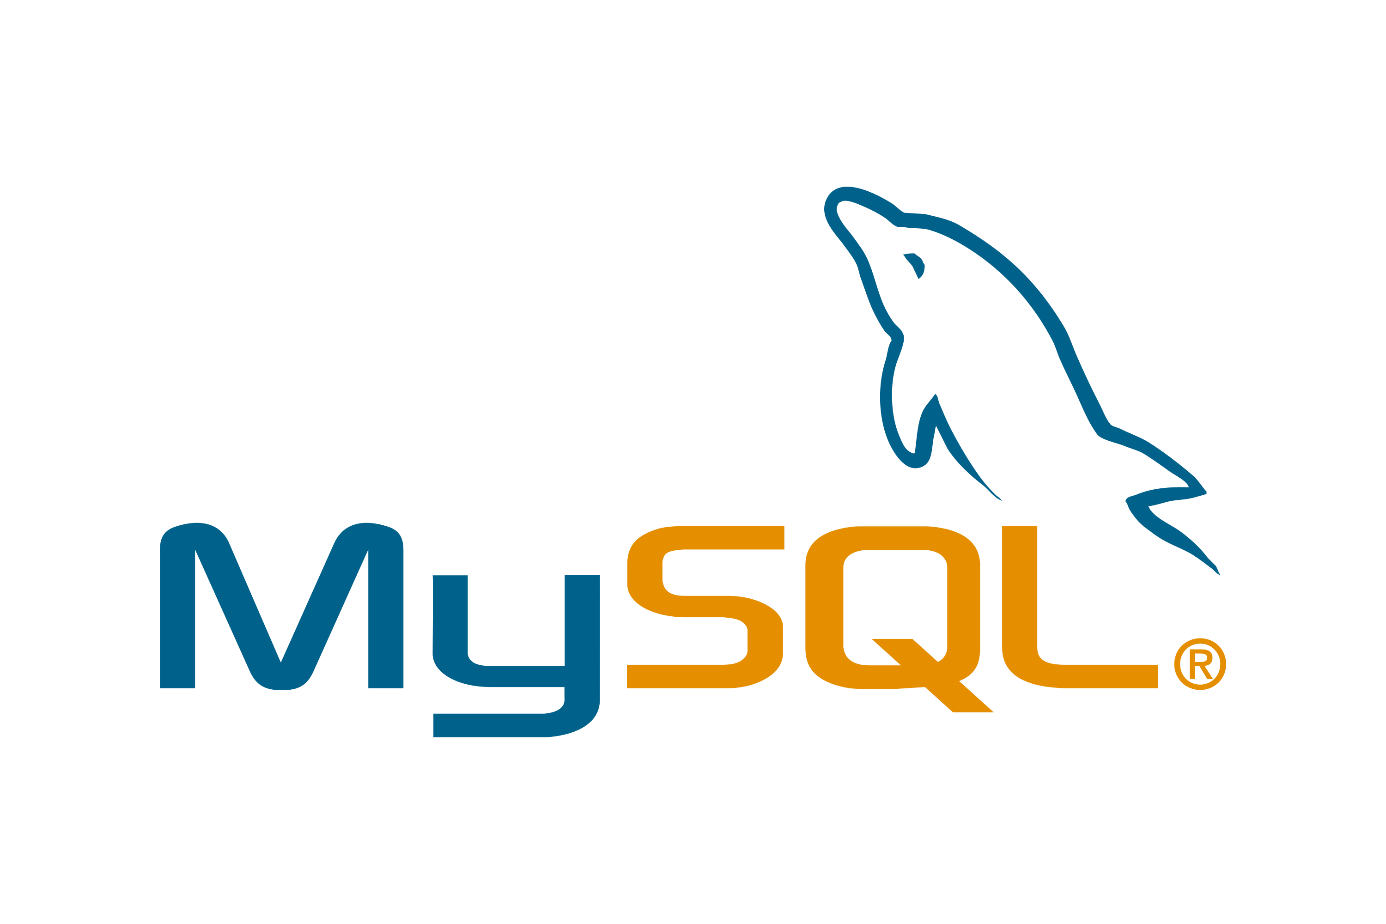

Power BI: Data visualization
MYSQL: Data Analysis
Python: Data cleaning

Project Objectives:
- Merge and clean the three datasets: Members, claim, and wellness data by ensuring consistency and readiness for analysis.
- Evaluate engagement levels through analysing physical activity metrics; included are the data of steps, gym visits and vitality Points earned.
- Access health risk factors: focusing on BMI classification, smoking status and presence of chronic conditions across the member base
- Investigation correlation between lifestyle behaviour and healthcare claims to uncover cost-driven patterns by each member.
- Segmenting members into groups to ensure supported wellness program for targeted wellness strategies and risk management across the board.

Data Overview
Before we can begin the process of data wrangling using the Python tool, we must consider what each dataset represents. What we find are the three datasets that we will be working with, and each of these datasets have null values from missing information gathered from the members. Not only that but we also find inaccurate datatypes – a mistake done by surveys when data was gathered.

Members.csv
In this dataset we are seeing member information with their personal details such as chronical conditions and what kind of plan they have selected. We approximately have 1011 rows and 8 columns, and the idea is to access null values first ensure the name column is split into two columns of ‘FirstName’, and ‘Surname’.
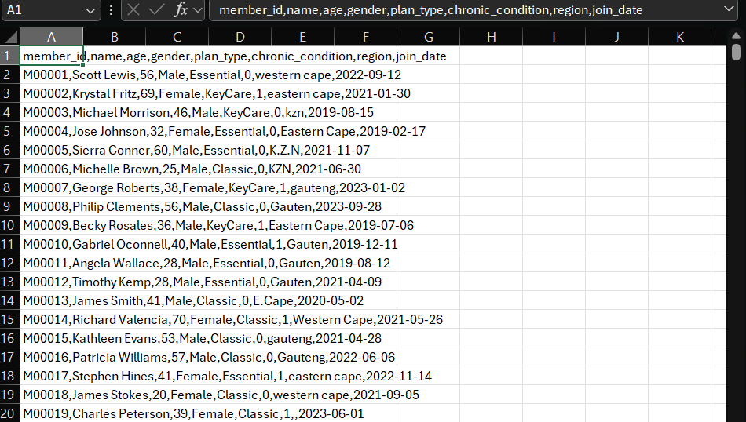

Claims.csv
This dataset is centre around the members claims - relationship between claims dataset and member dataset – Here we are seeing on the members id as the foreign key and indication of which member has claimed what on this dataset. We have 7 columns and 10001 rows in this gathered set.
In the claims dataset we initially see how the datatypes of the amounts claimed is string type – that must be clean and changed to integer type.
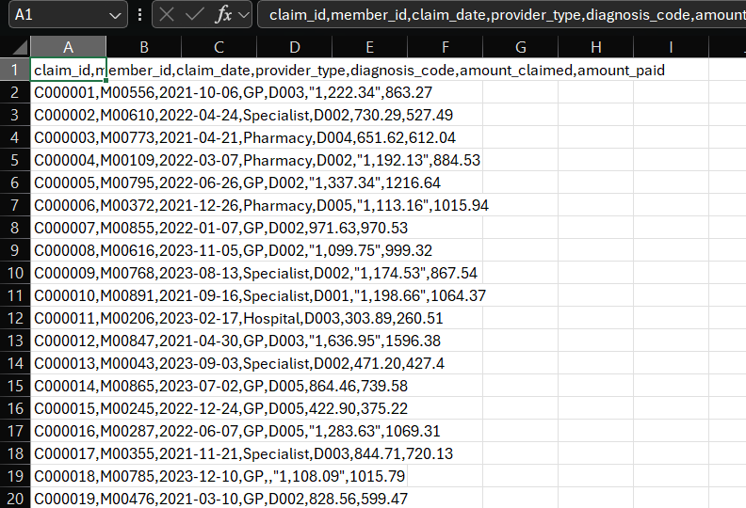

Vitality.csv
In this dataset we see am establish relationships of how members use their vitality points that can be earned by the program’s activities that promote the incentive of the organization’s objectives with this program for the members.
We see that we have 5 columns and 3001 rows in this dataset.
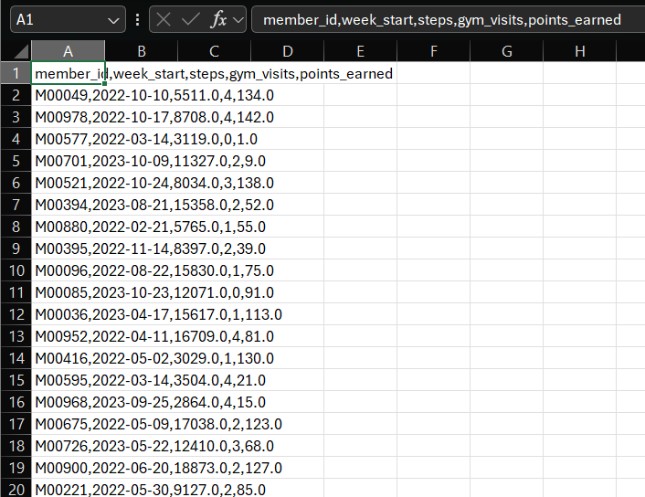

Phase 1: Python Data Cleaning
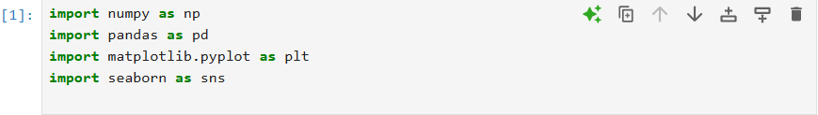
Inserting the required libraries for this project is essential, below are the chosen libraries I will use to clean, structure, create stats and visualize certain data.
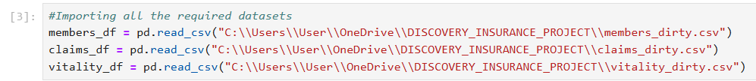
Followed step after importing libraries, I had to read the csv file and give each inserted dataset a variable for the project’s duration.
Displayed datasets for each stated variable:
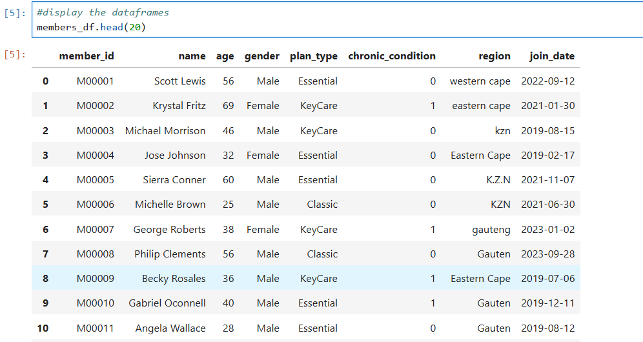
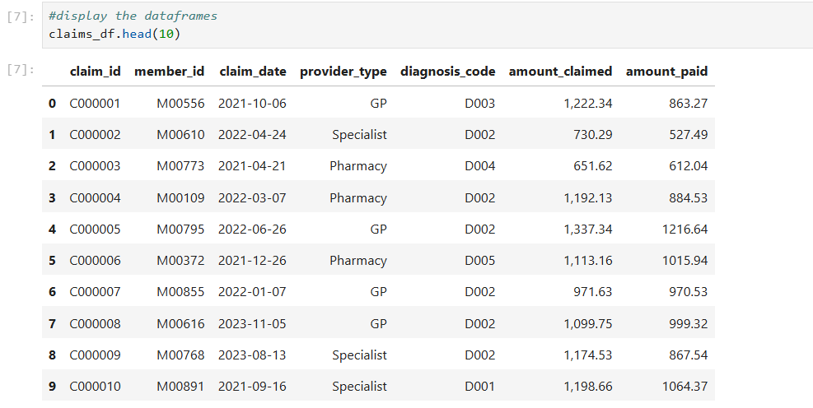
Members data frame
Claims data frame
Vitality data frame
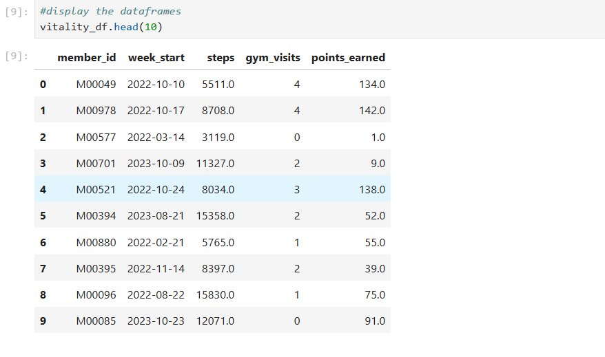

Cleaning data frames
#Checking null values in member_df
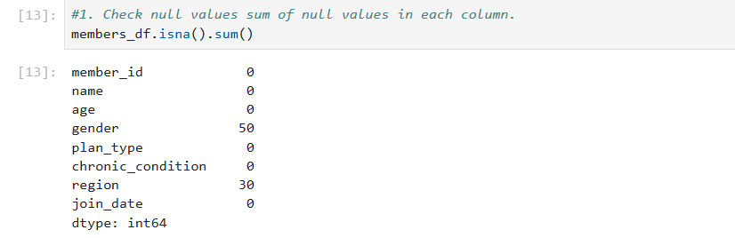
In the members dataset we see that we have gathered data from members that have not filled up the surveys completely in the two categories – ‘gender’ and ‘region’. These are essential for us to understand the gender of our members especially when it comes to vitality products and claims. To solve this problem, we can categorize the unknown data as ‘Uknown’, we cannot drop the rows; that action might compromise our investigation. The decision of labelling the unknow data from both categories as unknown us much more efficient in experimenting with our investigation.
Below is an image of how I cleaned the null values by filling with the word “Unknown” – keeps data integrity and ensures member privacy is kept:
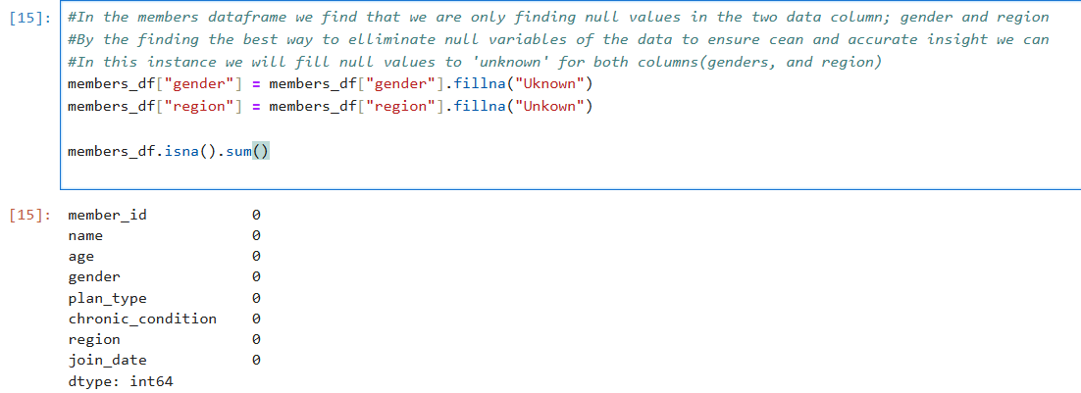
#claim_data set null value check
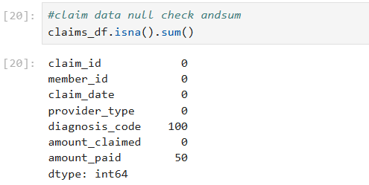
Checking the total sum of null values we are indicated there are several missing data from the claims dataset – especially in two categories; diagnosis code and amounts paid. The interesting issue with the category ‘amount paid’, we have established that the data was collected through string data type format.
This problem will give us an error when it is time to do calculations and round figures of how many members have paid for their claims. The first step is to clean the ‘diagnoses_code’ and fill with ‘unknow’, this again, will ensure we do not create bias data that will display inaccurate presentation of the organization’s members. It will keep the data clear of scrutiny
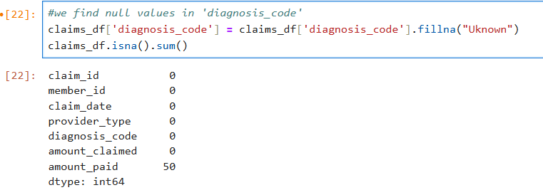
Followed by correcting the datatype in the category of the ‘amounts paid’ by turning to numeric values.
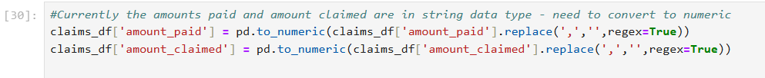
Next, filling the values with mean aggregation will help keep this experiment to an accurate investigation. Numbers will not be too far off from each other, thus stated – it will keep the amounts paid data values within the perimeters of our investigation ensuring no hyperbolic figures are presented.
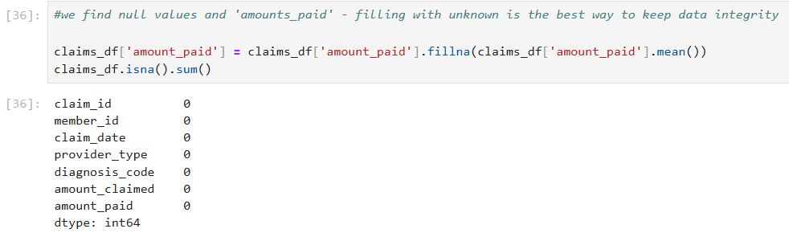
#checking null values in Vitality data table
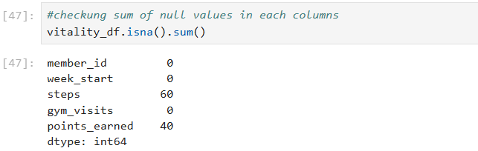
The main errors of this data frame are we find that member’s vitality (actional activities) is missing from being documented. This means that our experiment will find an obstacle in discovering what our data represents in relation to our members. Errors are integer data missing – meaning that filling this data with mean as our measure of central tendency.
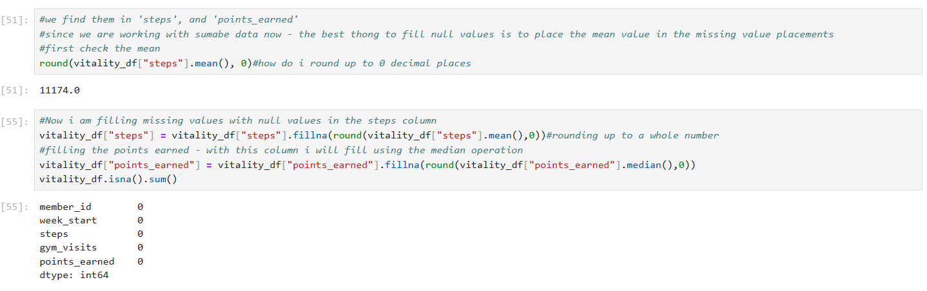
The above code displays the steps taken to show what the mean value of the steps category of members in our investigation. As stated, the value will not be far off from the entire dataset. It is advised to round the value to the nearest whole number as steps cannot be taken as decimals. I then also decided to also round the points earned as whole numbers for this investigation, but the measure of central tendency used is median.

Datatype cleaning
Checking whether the data frame categories are displaying as ‘object’ will hinder us from gathering accurate value data. Not all columns must include ‘object’ data values especially where there are categories in our understanding of our project.
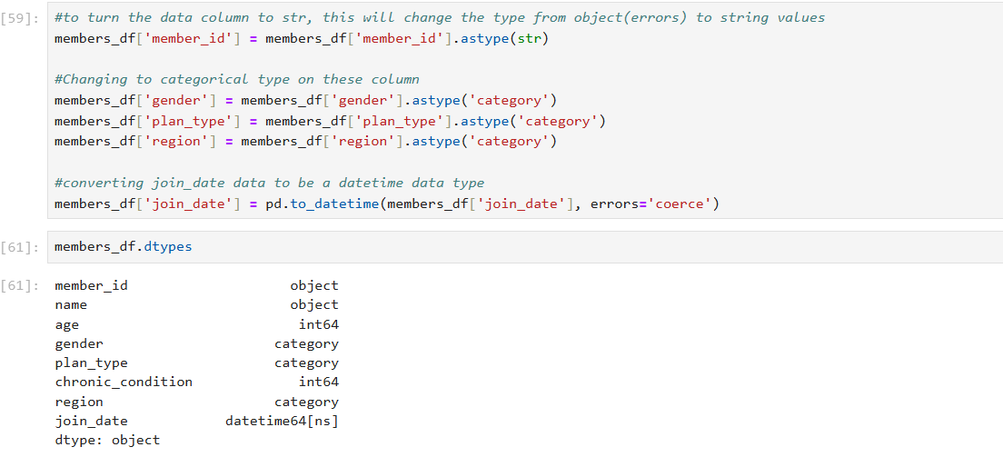
The above code ensures our data values are categorized to their specific function. Integers are for age, and chronic conditions. Objects are string simple values for ‘member ID’ and ‘name’, but category is used for data the reoccurs within the same column for a different member.

‘Name’ has the members full name in one column, highly unrecommended for deeper investigations especially if we want to categorize by name. Separating by the open space between first name and their surname is how we will establish the separation.
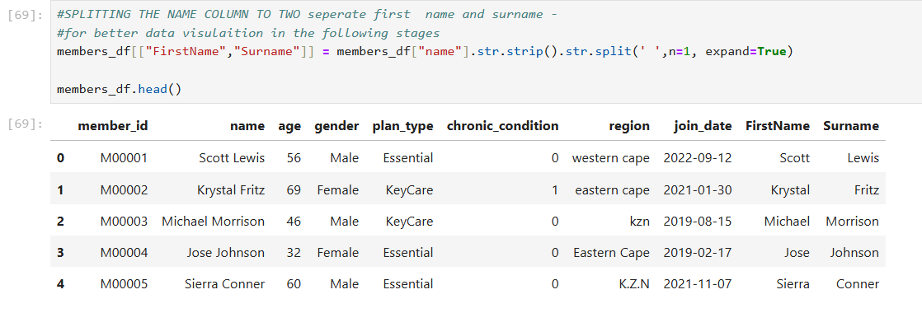
The two new columns are created to separate the name column in two
Although now we see an unnecessary column, ‘name’, I need to drop the column and place the two new columns right next to each other following the ‘member_id’
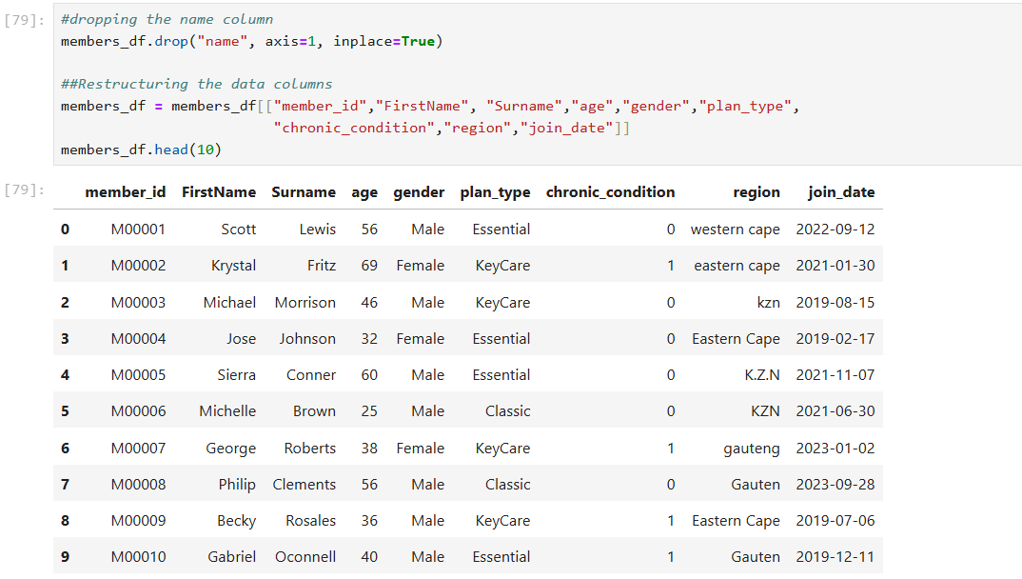
On the above data frame, we see the ‘region’ datasets in inconsistent values, KZN and Eastern Cape has needs to be transformed into consistent data values for our investigation.
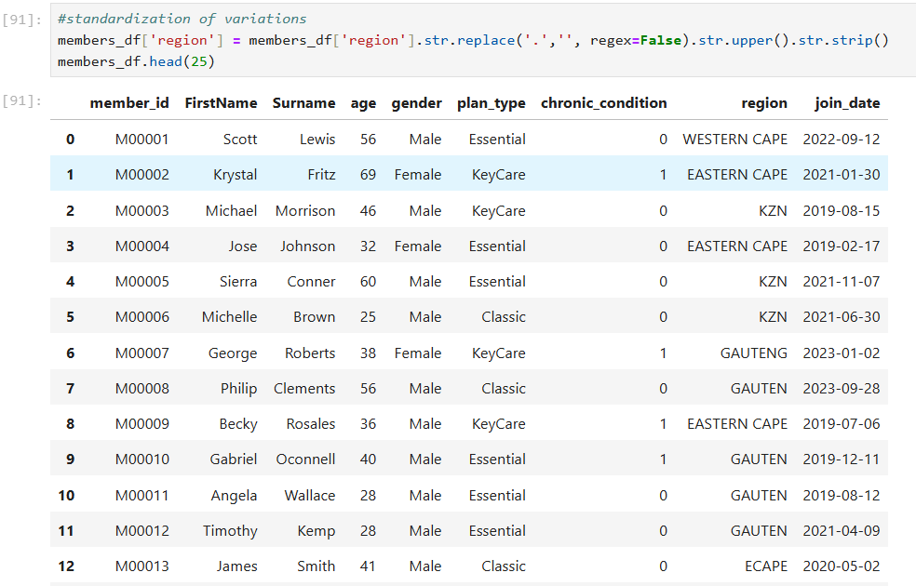 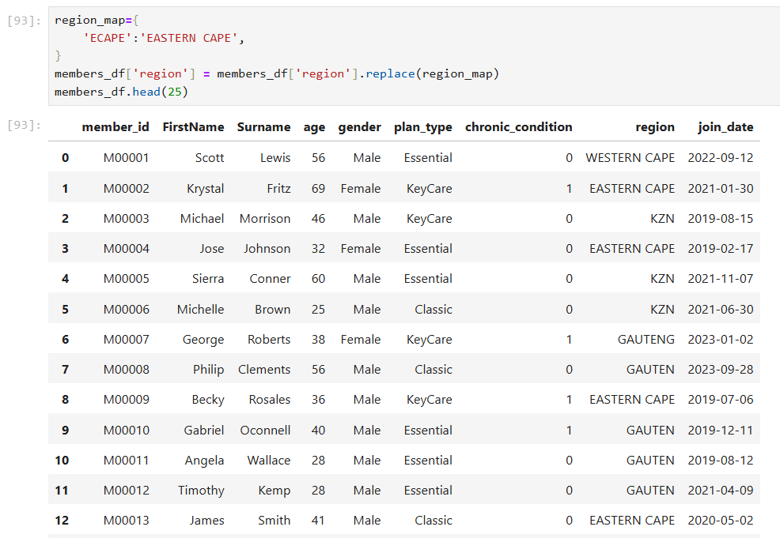

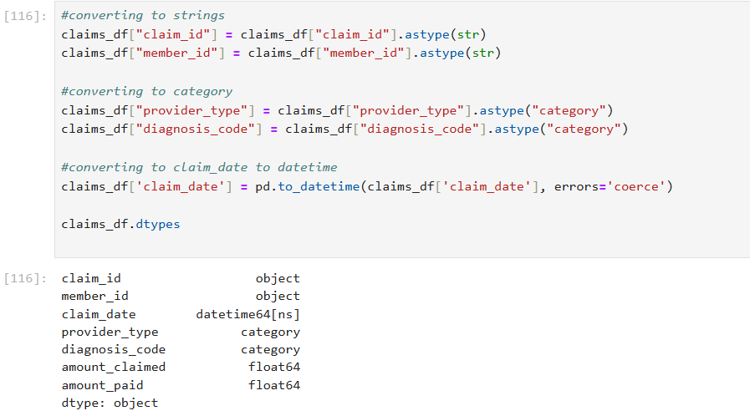
Vitality datatype check
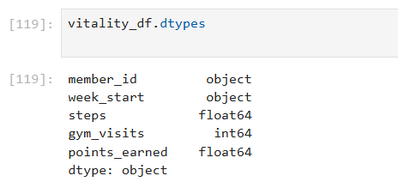
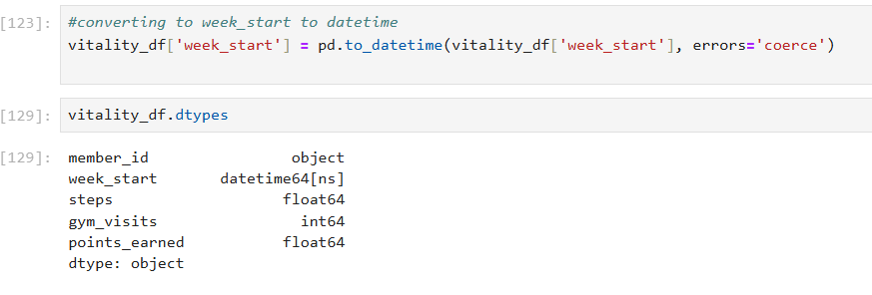

MERGE DATASETS
Merging the datasets into one will now move me to export the cleaned data and import into MySQL for data aggregation in our second phase of analysis. Below is my code displaying the steps taken to merge the first two data frames int one data frame.
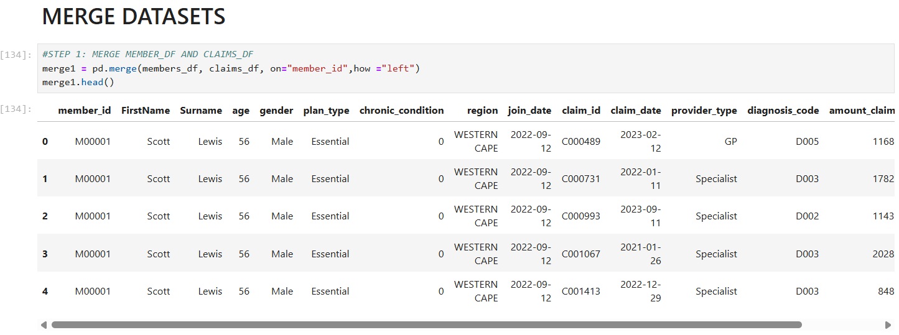
The we move to merging the vitality data frame to the merged data frame, but still give it a new variable.
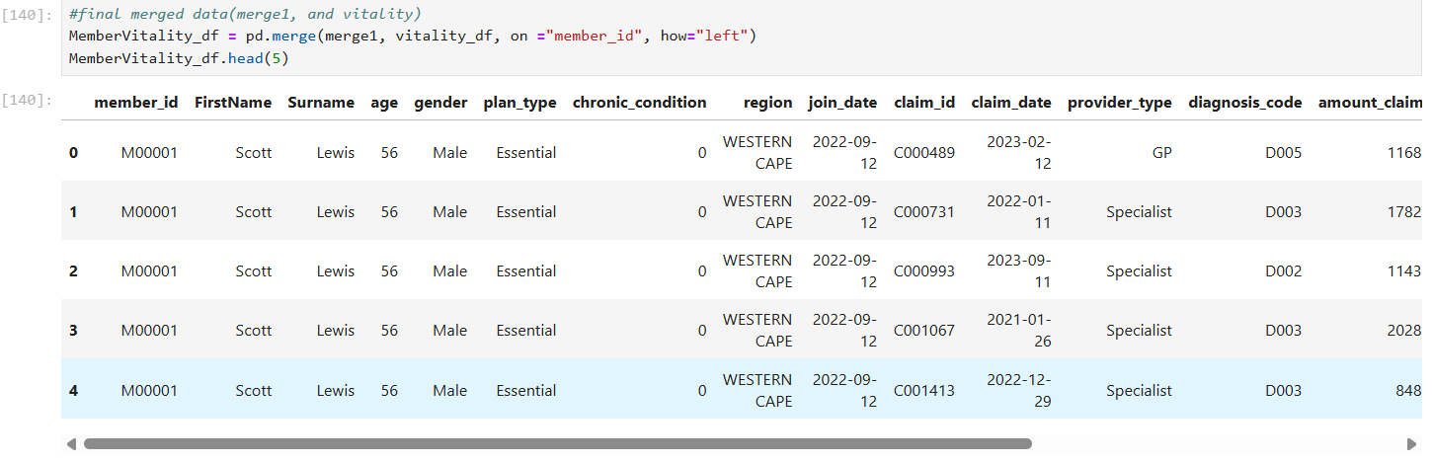
Final stage of using python is to export the data into csv or excel files
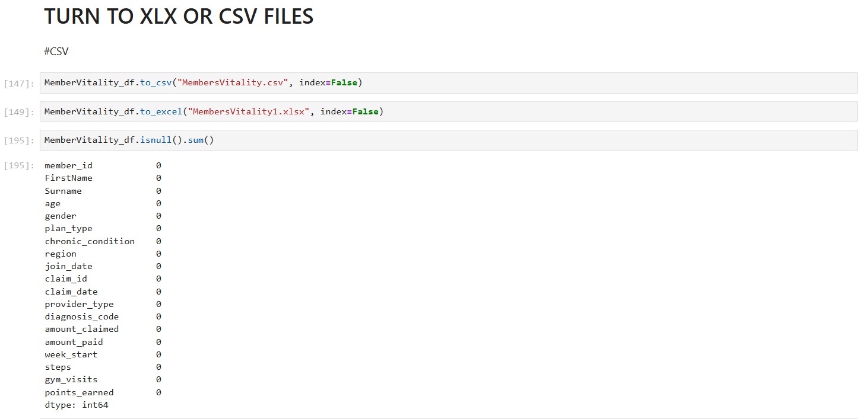

Phase 2: SQL Data Exploration
In this phase of the project, we will pivot to the use of SQL for our data exploration, analysis and to summarize the cleaned integrated dataset that which combines members, claims and wellness. Using SQL, we get various queries that are executed to uncover key patterns across member demographic, claim behaviour, vitality engagement and health condition. The aim is to derive meaningful insights through descriptive statistics and grouping operations enabling the foundation for more advanced analytics and visualizations in subsequent phases. Below will be the structured SQL queries used along their corresponding outputs.

Creating the table for SQL
mysql> CREATE TABLE `MEMBER_VITALITY`(
-> MEMBER_ID VARCHAR(50),
-> FIRSTNAME VARCHAR(50),
-> SURNAME VARCHAR(50),
-> AGE INT,
-> GENDER VARCHAR(10),
-> PLAN_TYPE VARCHAR(20),
-> CHRONIC_CONDITION INT,
-> REGION VARCHAR(50),
-> JOIN_DATE DATE,
-> CLAIM_ID VARCHAR(50),
-> CLAIM_DATE DATE,
-> PROVIDER_TYPE VARCHAR(50),
-> DIAGNOSIS_CODE VARCHAR(10),
-> AMOUNT_CLAIMED DECIMAL(10,2),
-> AMOUNT_PAID DECIMAL(10,2),
-> WEEK_START DATE,
-> STEPS INT,
-> GYM_VISITS INT,
-> POINTS_EARNED INT,
-> PRIMARY KEY(MEMBER_ID)
-> );
Query OK, 0 rows affected (0.05 sec)
mysql> SELECT * FROM MEMBER_VITALITY LIMIT 10;
Empty set (0.03 sec)
mysql> LOAD DATA LOCAL INFILE "C:/Users/User/Downloads/MembersVitality.csv"
-> INTO TABLE `MEMBER_VITALITY`
-> FIELDS TERMINATED BY ','
-> ENCLOSED BY '"'
-> LINES TERMINATED BY '\n'
-> IGNORE 1 ROWS;
Query OK, 1000 rows affected, 29928 warnings (0.61 sec)
Records: 30928 Deleted: 0 Skipped: 29928 Warnings: 29928
mysql> SELECT * FROM MEMBER_VITALITY LIMIT 10;
+-----------+-----------+----------+------+--------+-----------+-------------------+--------------+------------+----------+------------+---------------+----------------+----------------+-------------+------------+-------+------------+---------------+
| MEMBER_ID | FIRSTNAME | SURNAME | AGE | GENDER | PLAN_TYPE | CHRONIC_CONDITION | REGION | JOIN_DATE | CLAIM_ID | CLAIM_DATE | PROVIDER_TYPE | DIAGNOSIS_CODE | AMOUNT_CLAIMED | AMOUNT_PAID | WEEK_START | STEPS | GYM_VISITS | POINTS_EARNED |
+-----------+-----------+----------+------+--------+-----------+-------------------+--------------+------------+----------+------------+---------------+----------------+----------------+-------------+------------+-------+------------+---------------+
| M00001 | Scott | Lewis | 56 | Male | Essential | 0 | WESTERN CAPE | 2022-09-12 | C000489 | 2023-02-12 | GP | D005 | 1168.88 | 1117.00 | 2023-07-31 | 10748 | 3 | 39 |
| M00002 | Krystal | Fritz | 69 | Female | KeyCare | 1 | EASTERN CAPE | 2021-01-30 | C001340 | 2023-02-10 | Specialist | D004 | 1394.56 | 1019.00 | 2022-05-09 | 16611 | 3 | 116 |
| M00003 | Michael | Morrison | 46 | Male | KeyCare | 0 | KZN | 2019-08-15 | C001018 | 2022-03-20 | Specialist | D002 | 1771.05 | 1495.00 | 2022-09-19 | 18463 | 0 | 28 |
| M00004 | Jose | Johnson | 32 | Female | Essential | 0 | EASTERN CAPE | 2019-02-17 | C002079 | 2021-10-02 | Hospital | D004 | 1645.33 | 1486.00 | 2022-07-18 | 2215 | 1 | 9 |
| M00005 | Sierra | Conner | 60 | Male | Essential | 0 | KZN | 2021-11-07 | C001930 | 2021-01-06 | Hospital | D004 | 900.59 | 896.00 | 2022-02-07 | 12028 | 2 | 35 |
| M00006 | Michelle | Brown | 25 | Male | Classic | 0 | KZN | 2021-06-30 | C002977 | 2022-02-22 | GP | D003 | 2137.11 | 1665.00 | 2022-07-04 | 5981 | 0 | 82 |
| M00007 | George | Roberts | 38 | Female | KeyCare | 1 | GAUTENG | 2023-01-02 | C000194 | 2023-08-29 | Hospital | D002 | 1488.29 | 1068.00 | 2022-03-07 | 9736 | 0 | 131 |
| M00008 | Philip | Clements | 56 | Male | Classic | 0 | GAUTEN | 2023-09-28 | C000076 | 2023-03-31 | GP | D001 | 1261.29 | 1044.00 | 2022-03-21 | 6264 | 4 | 58 |
| M00009 | Becky | Rosales | 36 | Male | KeyCare | 1 | EASTERN CAPE | 2019-07-06 | C000474 | 2022-11-29 | Hospital | D003 | 924.66 | 778.00 | 2022-01-10 | 11107 | 2 | 74 |
| M00010 | Gabriel | Oconnell | 40 | Male | Essential | 1 | GAUTEN | 2019-12-11 | C000776 | 2021-01-14 | Specialist | D002 | 1223.79 | 1067.00 | 2022-10-03 | 4907 | 2 | 55 |
+-----------+-----------+----------+------+--------+-----------+-------------------+--------------+------------+----------+------------+---------------+----------------+----------------+-------------+------------+-------+------------+---------------+
10 rows in set (0.00 sec)
mysql>

Displaying the table
Brief
After cleaning the data by using Python, I had imported a csv file into mySQL workbench. This phase will help us analyse the dataset accordingly.
use discoverymember_data;
/*Displaying all fields and 10 records from the member_vitality table*/
select * from member_vitality;
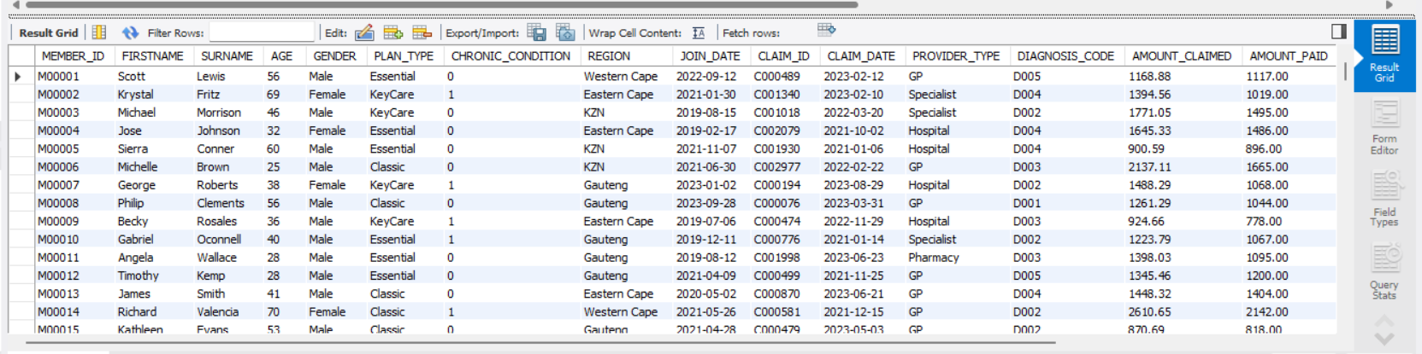

Statistics Overview
- Count total values of members in the database
brief
To begin our investigation we first need to establish how many unique members are in our dataset. This will answer foundational question; “How many members are participating in the Discovery vitality program?”
/*creating basic statistics for our experimentation*/
/*Displaying total value of distict members in the data table*/
SELECT COUNT(DISTINCT MEMBER_ID) AS totalMmbers from
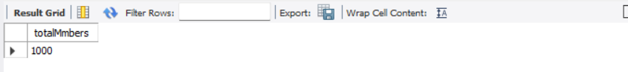
Insight
The above Query displays the total number of members in our investigation. By knowing how many individuals are part of Discovery vitality programs in Claims and Vitality group, we can build meaningful metrics such as averages, minimum, maximum; essential for analysing health trends and claims behaviours.

- Number of claims aggregated
Brief
After establishing the total members in our program, it is now imperative to establish a number of claims submitted by members, this will help us understand the claim behaviour in the steps going forward

/*Total claims recorded in the data table*/
SELECT COUNT(DISTINCT CLAIM_ID) AS TotalClaims from member_vitality;

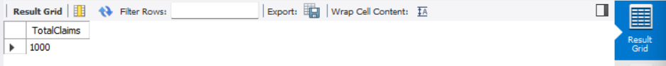
Insight
The results state that all members from the previous year has submitted a claim during the observed period. This help supports the assumption that the dataset hold active policy holders thus making our analysis rooted in relevant claim behaviour.

- Member engagement
Brief
Member engagement is vital in enabling users and discovery to ensure honesty in claims being paid out through initiative engagement.

/*Total vitality records(assumming steps or gym visits represents engagement)*/
SELECT COUNT(*) AS TotalVitality_Entries
FROM member_vitality
WHERE STEPS IS NOT NULL OR GYM_VISITS IS NOT NULL;

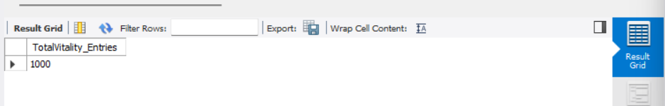
Insight
We have accounted for missing engagement data by replacing null values with ‘0’, therefore a value 0 now indicates no recorded activity. This ensures a more accurate reflection of engagement trends in trends in the data and lays the foundation for deeper analysis, such as segmenting active and inactive members

Data Distribution

Gender Distribution
Brief
To understand how different genders are engaging with the Discovery program, we analyse the distribution among members by gender This helps us assess both participation in wellness activities and claims behaviours.
SQL code
Their da
/*Gender distribution*/
SELECT GENDER, COUNT(*) AS Count_Gender
FROM member_vitality
GROUP BY GENDER;
Insight
From the results it’s clear that a larger proportion of members are male, followed by female participants. A third group include members who chose not to disclose their gender, recorded as ‘Unknown’. Including these values helps maintain data integrity and ensure findings are not skewed by missing or confidential demographic information.

Age Distribution
Brief
To analyse the distribution of ages in the member population, members were grouped int four brackets: 18 - 29, 30 – 44, 45 – 59 and 60+. This segmentation helps understand engagement and risk across life stages.
SQL CODE
/*Select case for age distribution for our experiment*/
SELECT
CASE
WHEN AGE BETWEEN 18 AND 29 THEN '18-29'
WHEN AGE BETWEEN 30 AND 44 THEN '30-44'
WHEN AGE BETWEEN 45 AND 59 THEN '45-59'
WHEN AGE >= 60 THEN '60+'
ELSE 'Unknown'
END AS Age_Group,
COUNT(*) AS MemberCount
FROM member_vitality
GROUP BY Age_Group;

Insight
The largest age group is 45 – 59, followed by 60+ This suggests that majority of the members fall within the working age, and old age population. This does influence both vitality engagement and claim behaviours. The population that is 60+ may require more risk related attention, while younger groups show lower representation.

Region Distribution
To understand where our member base is concentrated geographically, we analyse all members grouped by their region. This helps identify which province has the highest participation and may reveal patterns in claims behaviours and wellness engagement.
A) First I have established count of member grouped by province
SQL CODE
/*A) counting members grouped by region */
SELECT REGION, COUNT(*) AS MemberByRegion
FROM member_vitality
group by REGION;

B) Counting members claims by region
After establishing the regional distribution of members, we investigate the total number f claims recorded by each region. This will reveal which area have higher healthcare demand or cost.
SQL CODE
/*Total amount claims grouped by region*/
SELECT REGION, count(CLAIM_ID) as TOTALCLAIMS, SUM(AMOUNT_CLAIMED) AS TOTAL_AMOUNT
FROM member_vitality
GROUP BY REGION;
Insight
From the regional member distribution query, the western cape has the highest number of members, followed by Eastern cape, when comparing claim counts and wellness activity, the western cape also leads in claims frequency steps, steps taken and gym visits.
This then suggest members of the western cape are both more active in the wellness program and more frequent users of healthcare services than the other regions. Although in this investigation we find a duality;
PRO – High participation may indicate better engagement with the program emphasizing wellness initiatives are being adopted by members.
CON – The higher claim rate could reflect underlying regional health challenges and member risk profiles that are not mitigated by current wellness efforts.
Thus members of this region may be profiled as high-risk members and Discovery may need to deepen its risks assessment model to refine regional engagement strategies.
C) Wellness engagement vs Claim Behaviour by Region
SQL CODE
/*Let’s check claim data vs their wellness activities*/
SELECT REGION, COUNT(CLAIM_ID) AS TOTALCLAIMS, SUM(STEPS) AS TOTALSTEPS, SUM(GYM_VISITS) AS TOTAL_GYM_VISITS
FROM member_vitality
GROUP BY REGION;
This data shows Western Cape still maintains the highest figures for both claims submitted and wellness engagement metrics (steps and gym visits). Eastern cape follows, clearly stating not direct conflict between wellness participation and claim frequency. Although this could mean while members are engaged in the wellness activities, the reasons of higher claim rate could indicate to factors such as chronic condition, lifestyle history and healthcare access.

Segmentation of member and plan type
Brief
To understand how discovery members are distributed across the available plan types, this query segments the datasets by gender and plan type. This analysis aims to uncover which plan is preferred by both groups. Helping identify trends and product uptake across different demographic groups.
SQL CODE
/*segmenting member by gender and plan type*/
/*GROUP BY PLAN TYPE, AND GENDER*/
SELECT GENDER, PLAN_TYPE, COUNT(*) AS MEMBERCOUNT
FROM member_vitality
group by GENDER, PLAN_TYPE;
Insight
The results reveal that the ‘Classic’ plans the most subscribed option among the male members with a total of 207 members enrolled for the plan. This is followed again by the male members who are subscribed to the ‘Essential plan by the total members of 196.
This dual concentration suggests male members dominate the enrolment for both classic and essential plans. On the other hand, the least enrolled plan type we have in our investigation seems to be the ‘KeyCare’ plan for both male and female member base
This business insight will help you stakeholders and marketing team strategists to create products and services that will gravitate towards each gender per plan offered.

Chronic Condition
Brief
Chronic illness status is a critical determinant of a member’s claim behaviour and overall health risk. This query segments members based on whether they have been diagnosed with a chronic condition.
SQL CODE
/*count and Group by chronic condition*/
SELECT CHRONIC_CONDITION, COUNT(*) AS TotalChronicCount
FROM member_vitality
GROUP BY CHRONIC_CONDITION
ORDER BY TotalChronicCount DESC;
Insight
This analysis helps establish how many members are living with chronic conditions. In this dataset, the values are binary:
- 1 indicates the member has a chronic condition
- 0 indicates no chronic condition
Understanding the size of the chronically ill population assists Discovery in profiling health risks, anticipating claim behaviour, and building more tailored healthcare support strategies.

Diagnosis Code
Brief
To further understand member health profiles, we analysed diagnosis codes to uncover the most common conditions being reported. This segmentation identifies prevalent health issues and supports the development of targeted risk mitigation programs.
SQL CODE
/*analysis of total diagnoses code by chronic condition*/
SELECT DIAGNOSIS_CODE, COUNT(DIAGNOSIS_CODE) AS TOTAL_DIAGNOSIS_CODE
FROM member_vitality
GROUP BY DIAGNOSIS_CODE;
Insight
From our investigation we find D002 diagnosis for our members has the highest number of members diagnosed with that code. Not only that but we have a pattern that just to D005 that is also quite high at the mark of 204. The least diagnosed D002, the mark of 186. On the other hand, we have an unknown value of diagnosis of 11 members that have been ascribed to.

High Risk Members
Brief
To identify members who may pose a higher financial and medical risk, this query extracts all members with both a chronic condition and total claims exceeding R500. These members represent a critical group for focused risk management.
SQL CODE
/*HIGH RISK MEMBERS*/
SELECT
MEMBER_ID, FIRSTNAME, SURNAME, SUM(AMOUNT_CLAIMED) AS TOTALClaimed, CHRONIC_CONDITION
FROM member_vitality
group by MEMBER_ID, FIRSTNAME,SURNAME, CHRONIC_CONDITION
HAVING TOTALClaimed > 500 and CHRONIC_CONDITION = 1
ORDER BY TOTALClaimed DESC;

Insight
This segment identifies members with both high claim totals and existing chronic conditions, flagging them as high-risk. These individuals are essential to monitor closely, as they contribute significantly to healthcare costs and could benefit most from targeted wellness interventions or disease management programs.
Such profiling can guide Discovery’s efforts to:
- Reduce long-term claim expenses
- Improve member health outcomes
- Personalize care and communication strategies

Claims vs Engagement
Brief
This analysis aims to provide correlation between healthcare claims and member wellness engagement provided by our vitality program. The aggregation claim amounts, steps and gym visits per member, we must investigate physically active member claims and members with less engagement.
SQL CODE
/*Caims vs Engageent Correlation*/
SELECT member_id,
SUM(AMOUNT_CLAIMED) AS Total_Claims,
SUM(STEPS) AS Total_Steps,
SUM(GYM_VISITS) AS Total_Gym_Visits
FROM member_vitality
GROUP BY member_ID;
Insight
There is a trend that appears where members with higher step counts and more gym visits tend to have lower claim total. This implies that consistent wellness engagement correlates with reduced healthcare costs.

Monthly Claims Trends
Briefs
This query analyses the monthly distribution of claims throughout the year to understand the seasonality in forecasting costs and optimizing budgets and planning health campaigns during peak claim periods.
SQL CODE
/*Monthly Claims Trend*/
Select
MONTH(CLAIM_DATE) AS ClaimMonth,
SUM(AMOUNT_CLAIMED) AS MonthlyClaimedTotal
FROM member_vitality
GROUP BY ClaimMonth
ORDER BY ClaimMonth;
Insight
Claims peak in certain months such as winter flu season or post-holiday periods. Identifying these spikes can assist in preparing preventive care initiative and resource planning.

Plan Type vs Claim Frequency
Brief
This analysis compares the frequency of claims across different medical plan types. The goal to identify which plan types have higher claims activity whether some plans attract more engagement or higher risks.
SQL CODE
/* PLAN TYPE VS CLAIM FREQUENCY*/
SELECT PLAN_TYPE,
COUNT(DISTINCT MEMBER_ID) AS MemberCount,
COUNT(CLAIM_ID) AS TotalClaims,
Round(count(CLAIM_ID) * 1.0 / COUNT(DISTINCT MEMBER_ID),2) AS AVG_ClaimPer_Member
FROM member_vitality
GROUP BY PLAN_TYPE;
Insight
Certain plans may have significantly higher claim rates per member, suggesting they attract individuals with greater healthcare needs or better coverage benefits. These insights could inform future pricing or product design.

Wellness engagement
Brief
This metric scores member engagement in wellness activities using steps and gym visits. The goal is to quantify how actively members participate in wellness programs and identify high-engagement individuals for targeted objectives.

/*Wellness engagement score*/
SELECT
MEMBER_ID,
(SUM(STEPS)/1000 + SUM(GYM_VISITS)*10) AS EngagementScore
FROM member_vitality
GROUP BY MEMBER_ID;
Insights
Members with high engagement scores represent a valuable segment for targeted wellness campaigns. These members might also incur fewer claims, reinforcing the value of wellness incentives in reducing overall healthcare costs.

Phase 3: Power BI Dashboard

Member demographic
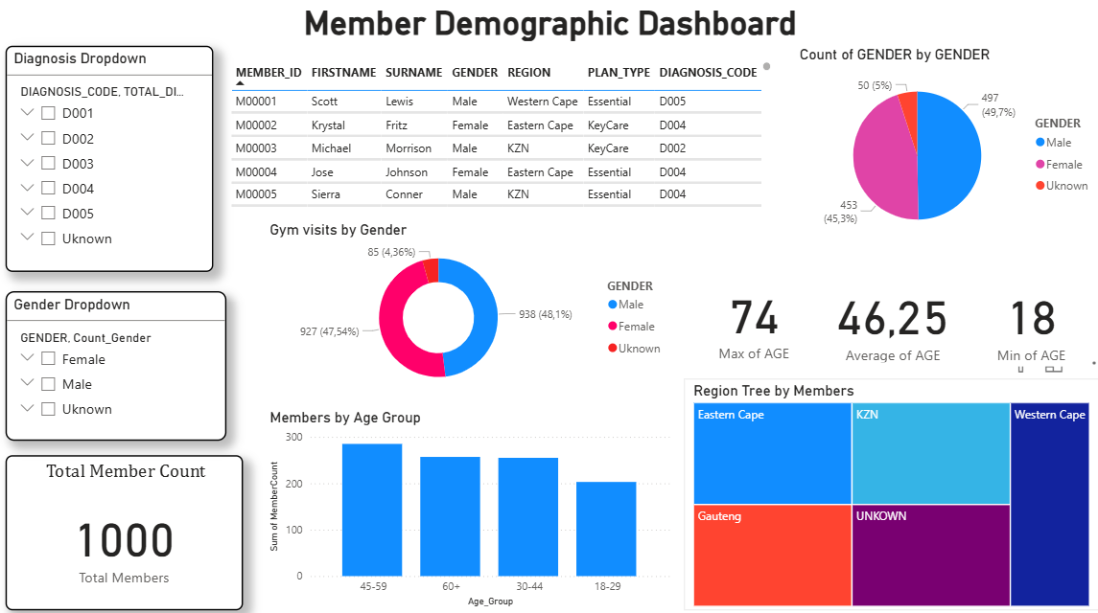
Insight:
The member’s demographic dashboard features datasets that have been analysed to communicate our understanding our members;
1. This communicates our member Gender distribution by their region, age group and diagnosis code.
2. The trend we see from ‘Member by Age Group’ column graph we see the age group of members between 45 – 59 are the largest participators of the vitality program, followed by the age group of 60+; Indicating we have elderly members who are our main target market.
We can create two duality features that will keep our elderly members satisfised and another feature that will draw more young members into our program.
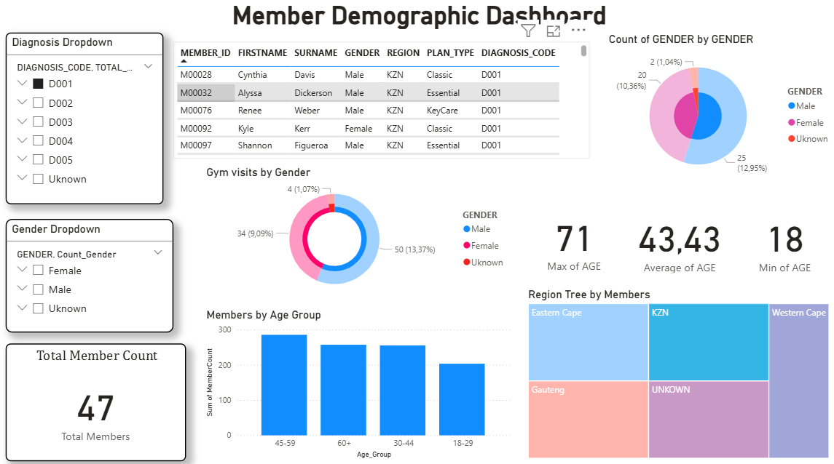
Displaying the interactive image of the dashboard; This indicates there are 47 members that are diagnosed with D001 in KZN

Plan Type
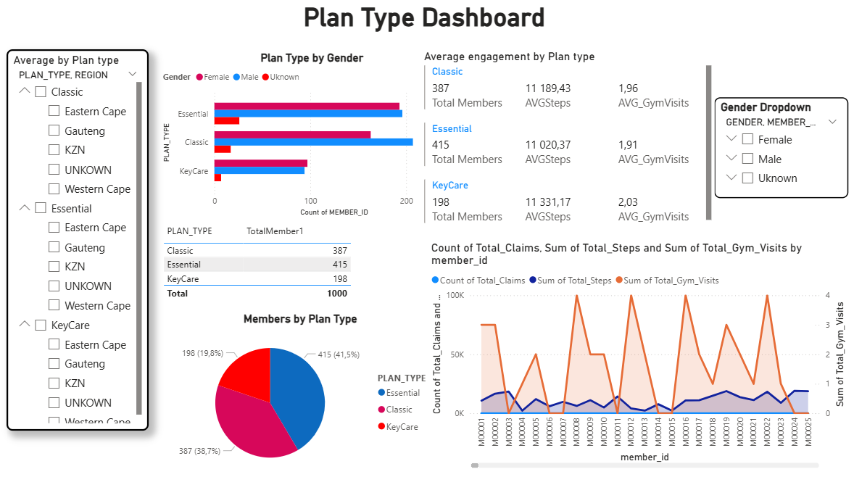
Insight:
In this segment we are displaying an analysis of how our members are interacting with the plans we offer as an organization. These plans are split into three subscriptions:
1. The most subscribed plan is the essential plan for both male and female, making KeyCare the least opted for plan we offer.
2. We also see an engagement metric from our members based on the plan type they have selected.
3. This information displays the members individual sum of gym visits vs sum of steps taken as a metric to calculate plan type engagement.
Essential plan type is indicating a positive record of most selected plan.
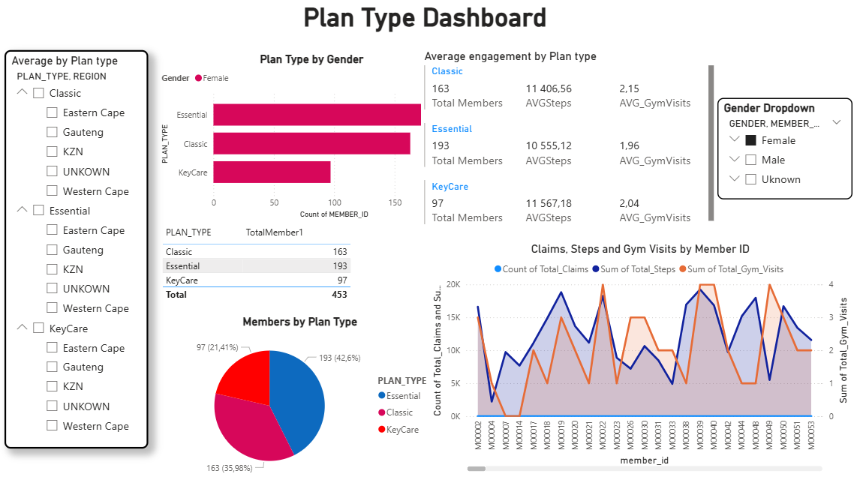
This stage displays the engagement of females within all three plan types

Claims analysis
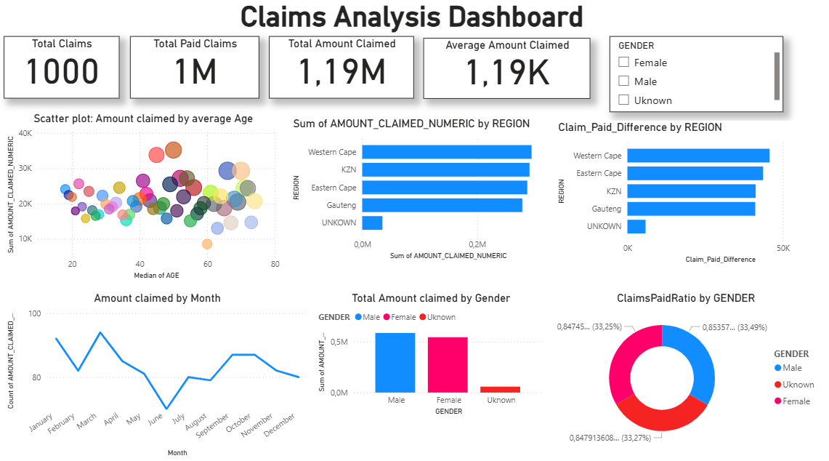
Insight:
In our Third dashboard I suggested that we create a claims analysis to identify our clients claim behaviour.
1. We see that we have 1000 members that claimed, with a total of 1 million claims that have been paid, but R1.19 million amounts claimed by members.
2. Based on our members, Western Cape and KZN seems to be the highest provinces with claims.
Suggestion would be to tailor that regions membership data, to ensure there are no high-risk members that will disrupt the organizations goals and objectives.
3. The highest gender that has claimed is the male, but by a small percentage that could make the data between genders equal.
4. There is also a trend of amounts claimed by months, making march the highest month for clients to claim and between June and July the value is at its lowest.
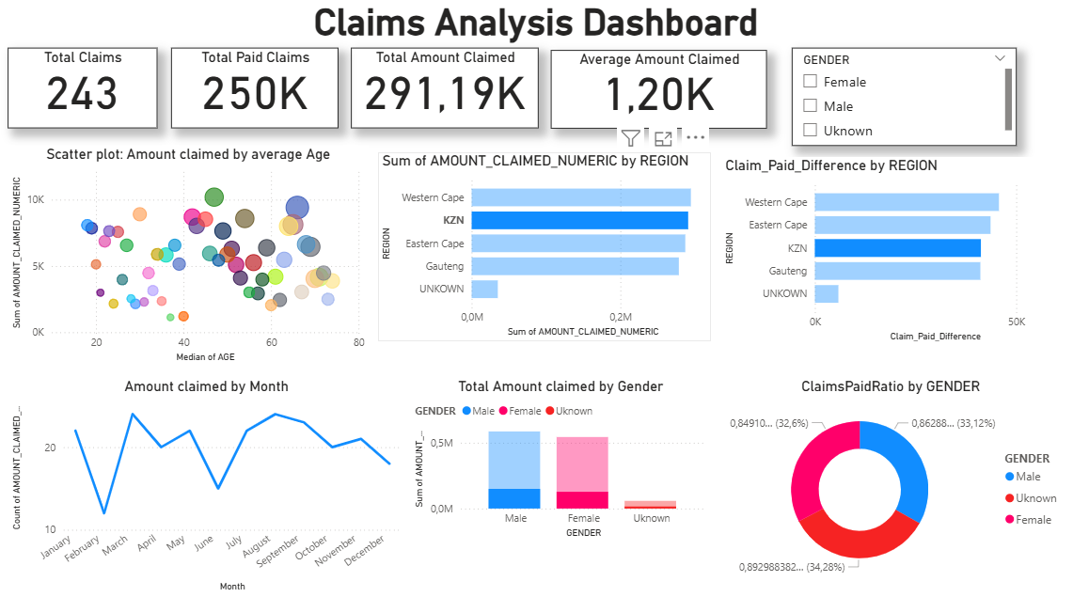
KZN has a total of 243 claims made and R250 thousand paid, with an average of R1,200

Engagement and Activity
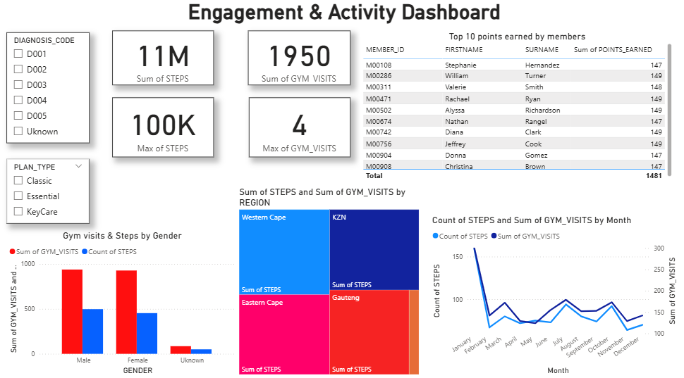
Insight:
The engagement vs activity dashboard shows indication of member engagement towards our vitality program we offer from the plan types within the program to the regions that are showing trends of high and low participation.
1. We see that a total of steps taken by the member is 11 million, with a total sum of 1950 gym visits from members.
2. The trend of engagement between steps and gym visits by months we see an indication of January having the highest total of engagement for members.
3. I also identified the top ten members with the most earned points which is a metric of members having a high level of engagement.
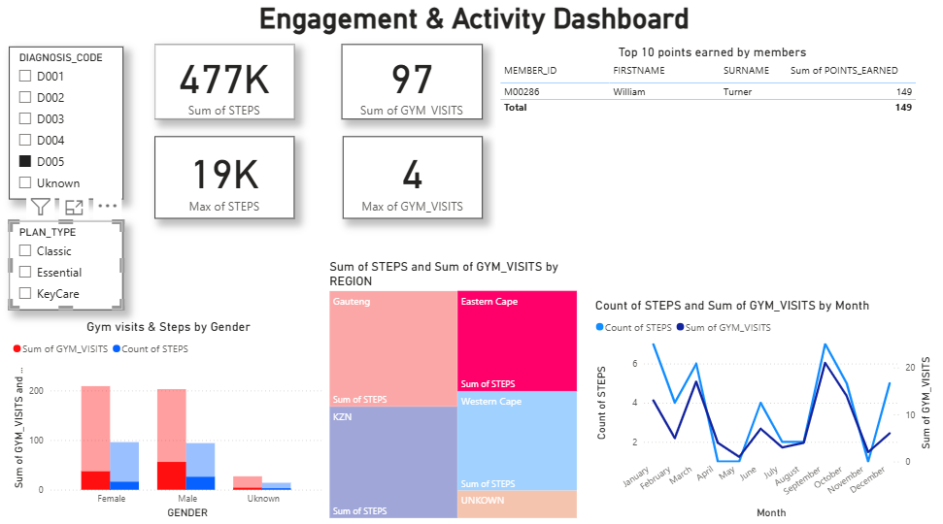
This image of the dashboard displays the members with the diagnosis code D005 from Eastern Cape. Highlighting standard measures of 477k steps taken a year, 97 gym visits, and the trend of throughout the year in months

Financial and Claims efficiency
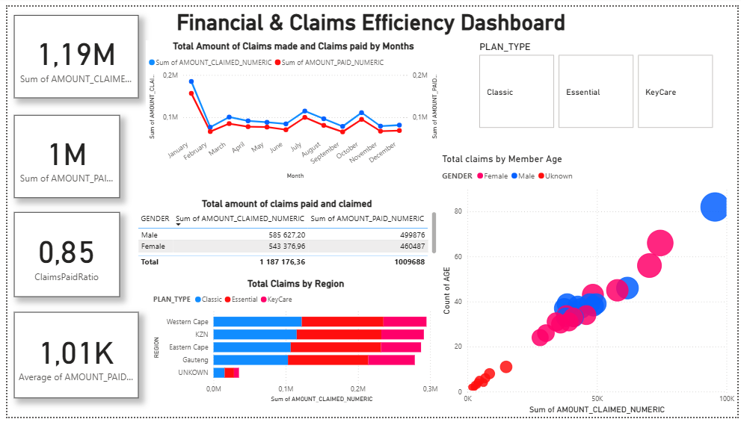
This dashboard we identify the analysed datasets of financial and claims efficiency to indicate the business practice goals and objectives.
1. We have identified that we have a total of 1.19 million claims made by member that the organization must pay out, but we get to see that the total pay is no more that 1 million.
2. We get to slice the data based on three options; Classic plan type, Essential plan type and KeyCare plan type.
3. With a table that indicates our total member amounts claimed vs total paid claims.
4. We also see a scatter plot that slices data by gender, with the indication of male members having the highest claims from the age of 70+. The anomalies which are labelled unknown are the lowest sets of data in the scatter plot.
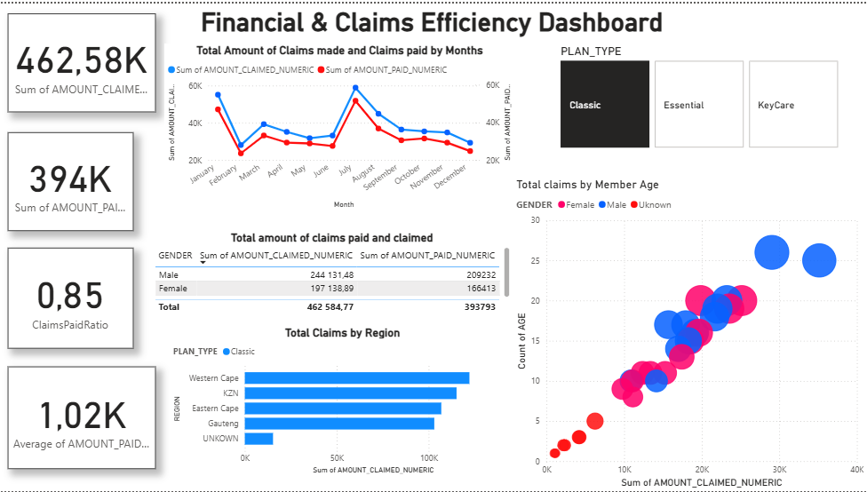
With our plan, Classic considered, we can see the trend having western cape claiming the most regards to their vitality plan. This identifies the pattern of January and July as the highest months with amounts claimed by members.

Interactive Overview
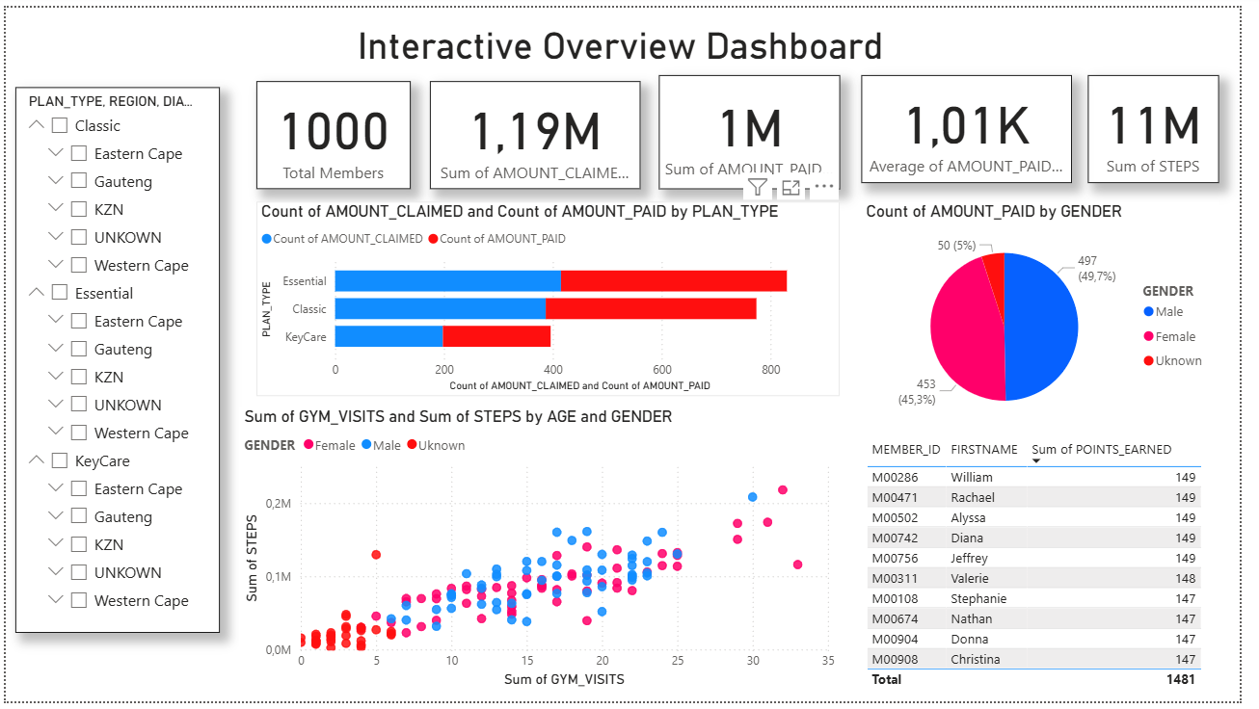
An overview of our analysis and investigation it is advisable to curate a dashboard that summarises of findings.
1. I decided to display the aggregation of our total members, amounts claimed, paid amounts, average paid and total engagement; as our vitality program is crucial to our members having consistent engagement.
2. I also indicated the plan type engagement between genders, having a significant value of more male members in each plan compared to female members.
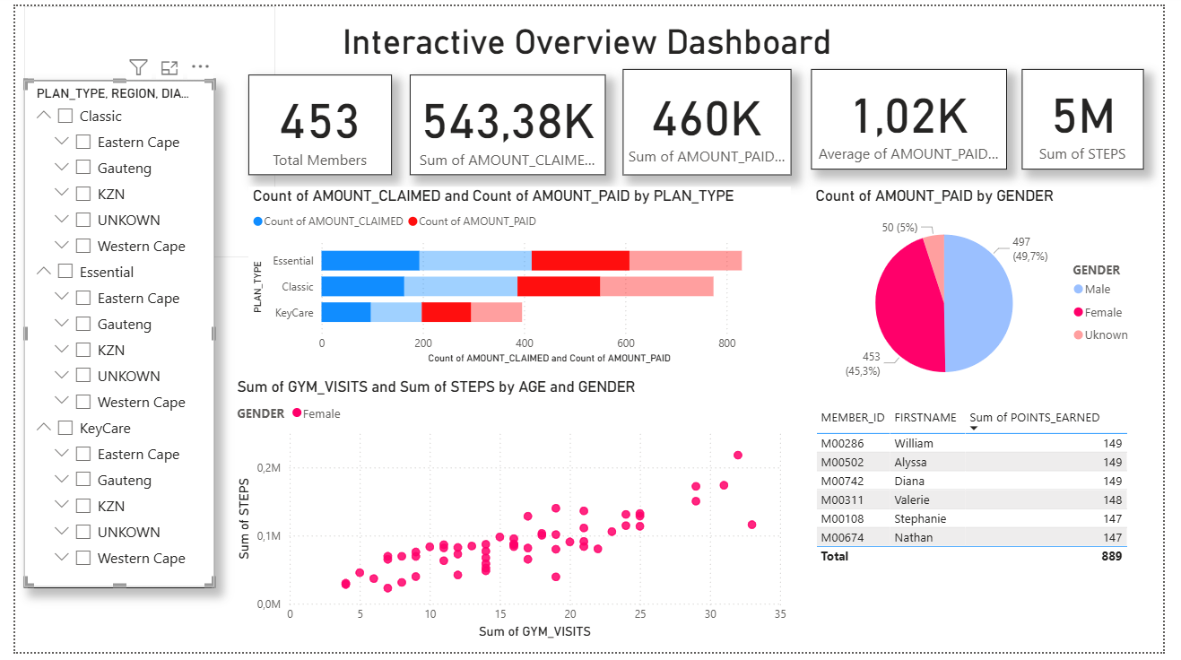
In this stage I considered displaying how our female members are engaging with our program, with a total of 453 members and a total of R543 thousand claims made by them

Final Project Summary
This project involves comprehensive end-to-end data analysis of Discovery Health’s member, claims and vitality dataset. The objective was to derive actionable insights that could support decision making in areas such as member engagement, claims efficiency and overall wellness activity of the members for the organization’s program.
The analysis was divided into three multiple structured phases that include:
- Data Cleaning and preparation: Ensured data integrity across all datasets (member, claims and vitality). Performed formatting, null value handling, and standardizing of data types using the tool Python and its libraries such as Pandas, and NumPy.
- SQL Querying: Extracted, joined, and performed aggregated formulas for data points across datasets using MySQL to support exploratory and targeted analysis
- Power BI Dashboard Development: Built four interactive and visual dashboards for stakeholder-facing reporting:
Member Demographics Dashboard; Explored member distribution by gender, age, region, and plan type.
Claims Analysis Dashboard; Analysed the volume, value, and frequency of claims, along with payment patterns.
Financial & Claims Efficiency Dashboard; Investigated payout vs claim values and calculated efficiency metrics.
Engagement & Activity Dashboard; gym visits, steps, and wellness behaviour to understand member activity.
Interactive Overview Dashboard (Executive Summary); Combined KPIs and visuals from all dashboards for a holistic, filterable view.

Tools such as Excel, Power BI, SQL, and Python were used to create data driven narrative. The final dashboards are interactive, user friendly and designed to support the organization’s strategic planning stakeholders in identifying key trends and making informed decisions.
This project is not only demonstrating strong technical ability to create data driven queries but also showcases business understanding with reflecting on deep interests in data storytelling and health analytics for organization’s objectives and goals for clients and members. It serves as my growing portfolio as I pursue opportunities in data science and analytics space.

