Web and Social Media

Analytics

WHAT IS TWITTER SENTIMENT ANALYSIS?

Twitter is an online news and social networking service that enables users to send and read short 140-character messages called "tweets". Registered users can read and post tweets, but those who are unregistered can only read them. Hence Twitter is a public platform with a mine of public opinion of people all over the world and of all age categories.

As of October 2016, Twitter has more than 315 million monthly active users.

Twitter Sentiment Analysis is the process of determining the emotional tone behind a series of words, used to gain an understanding of the attitudes, opinions and emotions expressed within an online mention.
WHY TWITTER SENTIMENT ANALYSIS?

The applications for sentiment analysis are endless. It is extremely useful in social media monitoring as it allows us to gain an overview of the wider public opinion behind certain topics However, it is also practical for use in business analytics and situations in which text needs to be analyzed. Sentiment analysis is in demand because of its efficiency. Thousands of text documents can be processed for sentiment in seconds, compared to the hours it would take a team of people to manually complete. Because it is so efficient (and accurate – Semantria has 80% accuracy for English content) many businesses are adopting text and sentiment analysis and incorporating it into their processes.

APPLICATIONS:

The applications of sentiment analysis are broad and powerful. Shifts in sentiment on social media have been shown to correlate with shifts in the stock market. For example, the Obama administration used sentiment analysis to gauge public opinion to policy announcements and campaign messages ahead of 2012 presidential election.

The ability to quickly understand consumer attitudes and react accordingly is something that Expedia Canada took advantage of when they noticed that there was a steady increase in negative feedback to the music used in one of their television adverts.
OVERVIEW

Tweets are imported using R and the data is cleaned by removing emoticons and URLs. Lexical Analysis as well as Naive Bayes Classifier is used to predict the sentiment of tweets and subsequently express the opinion graphically through ggplots, histogram, pie chart, wordcloud and tables.

SYSTEM REQUIREMENTS

- Installation of R

- Twitter Authentication to access API

- Google Achiever Chrome Application
FEATURES

- EXTRACTION OF TWEETS –

  - Create Twitter Account

  - Create Twitter API

  - Use Google Sheets Chrome Application – Google Achiever

  - Search Rule - Rule @SouthwestAir OR @Delta OR @AmericanAir OR @USAirways OR @VirginAmerica OR @united lang:en

- CLEANING TWEETS

  - The tweets are cleaned in R by removing:

  - Extra punctuation

  - Stop words (Most commonly used words in a language like the, is, at, which, and on.)

  - Redundant Blank.

- Word Cloud tab: wordcloud

A word cloud is a visual representation of text data, typically used to depict keyword metadata (tags) on websites, or to visualize free form text. This format is useful for quickly perceiving the most prominent terms and for locating a term alphabetically to determine its relative prominence. We have used tm and wordcloud package to depict the most used words associated with the hashtag in a pictorial representation under the Wordcloud tab.

4. Domain Selected – Major Airlines of USA

With a combined market cap of nearly $130 billion, the seven largest domestic airlines carry a vast majority of air passengers in the U.S. They service hundreds of destinations all over the globe, flying more than 740 million revenue passenger miles (RPMs)—which is what you get when you multiply the number of paying customers by the distance travelled—in 2014 alone.

- Findings Source of data- Twitter

- Below is the plot which shows distribution of the chosen airlines, in this we can clearly see which airline people choose.
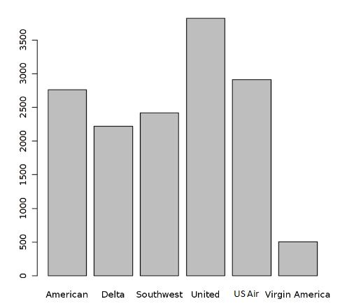

- Below is the plot which shows the three categories of sentiments, with the help of which we can clearly see what people think.

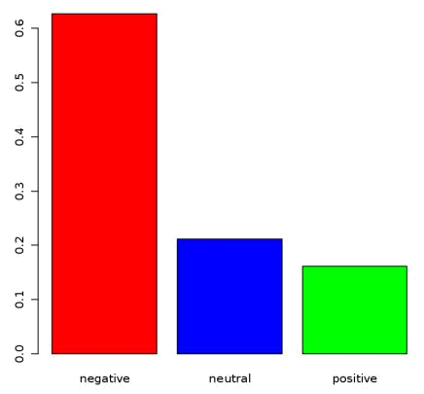

- Below plot shows the sentiments of the people on different airlines on the basis of airline sentiment confidence.

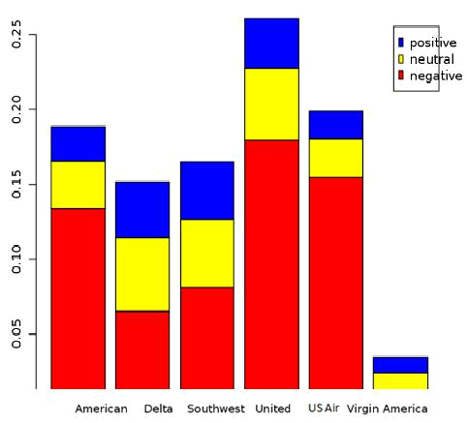

- Following are the list of reasons because of which people have negative sentiments on the basis of airline sentiments confidence.

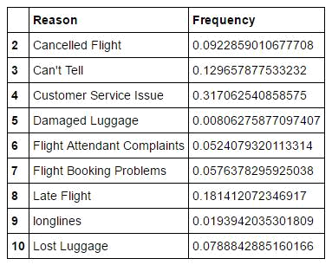

- Again we will see the distribution on confidence level

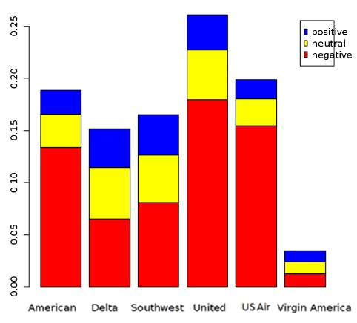

- Counts of sentiments polarity

negative neutral positive
9178 3099 2363

PACKAGES USED

twitteR : Provides an interface to the Twitter web API

stringr : String operations in R.

RCurl : Provides functions to allow one to compose general HTTP requests and provides convenient functions to fetch URIs, get & post forms, etc. and process the results returned by the Web server.

ggplot2 : An implementation of the grammar of graphics in R. It combines the advantages of both base and lattice graphics: conditioning and shared axes are handled automatically, and you can still build up a plot step by step from multiple data sources.

tm : A framework for text mining applications within R.

