**Angular JS 2**

-> cd..

-> ng new myproject

-> ng serve

|  |  |
| --- | --- |
| App.component.ts | App.component.html |
| Example1:  import { Component } from '@angular/core';  @Component({  selector: 'app-root',  templateUrl: './app.component.html',  styleUrls: ['./app.component.css']  })  export class AppComponent {  title = 'வணக்கம்!!!! ';  } | <h1>  இனிய காலை {{title}}!  </h1> |

|  |  |
| --- | --- |
| App.component.ts | App.component.html |
| Example2:  import { Component } from '@angular/core';  @Component({  selector: 'app-root',  templateUrl: './app.component.html',  styleUrls: ['./app.component.css']  })  export class AppComponent {  title = {name:"Guhan",mobile:9791815599 };  } | <h1>  {{title.name}} && {{title.mobile}}  </h1> |

**Create component:**

-> ng generate component c1

|  |  |
| --- | --- |
| app.component.html | C1.component.html |
| Ex1:  <div style="text-align:center">  <h1>  Welcome to {{title}}!  <app-c1> </app-c1>  </h1>  ---------------------------------------  Ex2:  <style>  .div1{border:1px solid blue; padding: 10px; height: auto;position: absolute;}  </style>  <div class="div1">    <app-c1> </app-c1>    </div>  Output: | <p>  c1 works!  </p>  ------------------------------------------------------------------  <style>  div{border:1px solid red; width:200px; height:200px;float:left;}  </style>  <div> </div>  <div> </div>  <div> </div>  <div> </div> |

**One way data binding:**

|  |  |
| --- | --- |
| C1.component.ts | C1.component.html |
| import { Component, OnInit } from '@angular/core';  @Component({  selector: 'app-c1',  templateUrl: './c1.component.html',  styleUrls: ['./c1.component.css']  })  export class C1Component implements OnInit {    // One way data binding  x={name:"Guhan",mob:9090}  constructor() { }  ngOnInit() {  }  }  ---------------------------------  Ex2:  export class C1Component implements OnInit {    // One way data binding  x={name:"Guhan",mob:9090}  constructor() { }  ngOnInit() {  }  }  Ex3:  export class C1Component implements OnInit {    // One way data binding  x={name:"Guhan",mob:9090}  y="http://images5.fanpop.com/  image/photos/31200000/Dove-doves-31209120-1024-768.jpg";  constructor() { }  ngOnInit() {  }  } | <style>  div{border:1px solid red; width:200px; height:200px;float:left;}  </style>  <div>{{x.name}} </div>  <div>{{x.mob}} </div>  <div> </div>  <div> </div>  Output:    ---------------------------------------------------------------------------------------------  <style>  div{border:1px solid red; width:200px; height:200px;float:left;}  input{margin-left: 10px; }  </style>  <div> <br> <br><input value='{{x.name}}'/> </div>  <div> <br> <br> <input value='{{x.mob}}'/> </div>  <div> </div>  <div> </div>  **Output:**    <style>  div{border:1px solid red; width:200px; height:200px;float:left;}  input{margin-left: 10px; }  img{width:200px;height: 200px;}  </style>  <div> <br> <br><input value='{{x.name}}'/> </div>  <div> <br> <br> <input value='{{x.mob}}'/> </div>  <div>  <img [src]='y'>  </div>  <div> </div>  Output: |

**Event Binding:**

**Ex1:**

|  |  |
| --- | --- |
| C1.component.ts | C1.component.html |
| export class C1Component implements OnInit {  x={name:"Guhan",mob:9090}  y="http://images5.fanpop.com  /image  /photos/31200000  /Dove-doves-31209120-1024-768.jpg";  c;  onClick(){  this.c= "Yu hav Clikd me!!";  }  constructor() { }  ngOnInit() {  } } | <style>  div{border:1px solid red; width:200px; height:200px;float:left;}  input{margin-left: 10px; }  img{width:200px;height: 200px;}  </style>  <div> <br> <br><input value='{{x.name}}'/> </div>  <div> <br> <br> <input value='{{x.mob}}'/> </div>  <div>  <img [src]='y'>  </div>  <div>  <button (click)="onClick()">click</button>  <p>{{c}}</p>  </div> |

Output:

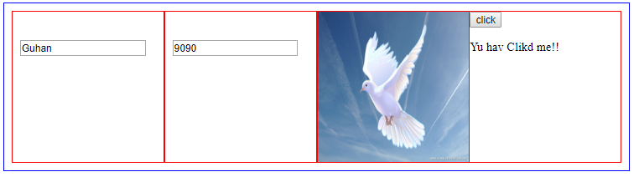

**Ex2:**

|  |  |
| --- | --- |
| C1.component.ts | C1.component.html |
| export class C1Component implements OnInit {    // One way data binding  x={name:"Guhan",mob:9090}  y="http://images5.fanpop.com/image/photos/31200000/Dove-doves-31209120-1024-768.jpg";  c;  d;  onClick(){  this.c= "Yu hav Clikd me!!";  }  onClick1(value:string)  {  this.d=value;  }  constructor() { }  ngOnInit() {  }} | <style>  div{border:1px solid red; width:200px; height:200px;float:left;}  input{margin-left: 10px; }  img{width:200px;height: 200px;}  </style>  <div> <br> <br><input value='{{x.name}}'/> </div>  <div> <br> <br> <input value='{{x.mob}}'/> </div>  <div> <img [src]='y'> </div>  <div>  <button (mouseover)="onClick()">click</button>  <br>  <p>{{c}}</p>  <input type="text" #i1/>  <button (click)="onClick1(i1.value)">click</button>  <br>  <p>{{d}}</p>  </div> |

**Output:**

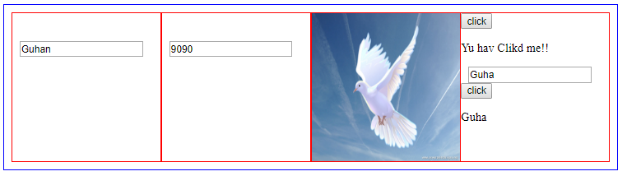

**Two way data binding:**

First consider 1 way for <input>

-> Create new component name c2 and include it app.component.html as <app-c2> </app-c2>.

|  |  |
| --- | --- |
| C2.component.ts | C2.component.html |
| export class C2Component implements OnInit {  title="Guhan";  constructor() { }  ngOnInit() {  }  } | <div>  First Name: <input [value]="title"/>{{title}}  </div> |

**2 way:**

|  |  |
| --- | --- |
| C2.component.ts | C2.component.html |
| export class C2Component implements OnInit {  title="Guhan";  constructor() { }  ngOnInit() {  }  }  OR | <div>  First Name: <input [value]="title"  (input)='title=$event.target.value'  />{{title}}  </div> |

**[value]-> property binding**

**$event-> event binding**

**[(ngModel)]=both property and event binding**

**So you should import the BroserModule and Forms Module in app.module.ts**

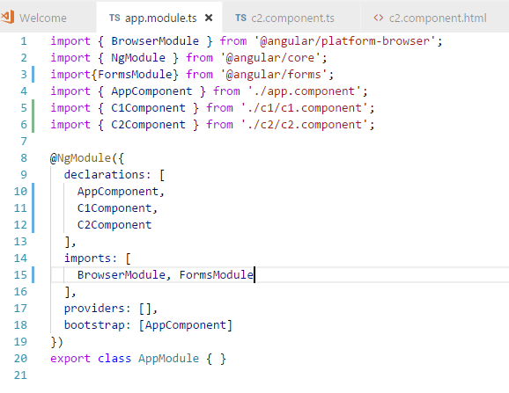

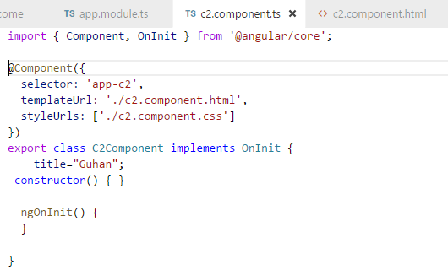

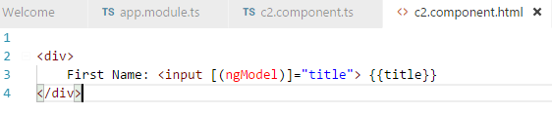

**Output:**

