Western Sydney University
School of Computing, Engineering and Mathematics
Advanced Engineering Topic 1 Major
Implementation of A* algorithm in C++ using ARIA library
Michael Seecy 18035878@student.Westernsydney.edu.au
27th of May 2016
Supervisor:
Prof. Gu Fang

Abstract
As robust as modern mobile robots may seem, at the core of their functionality there are two main ideologies. Firstly, mobile robots require a base path planning algorithm, used to determine the path which the robot will traverse, according to its environment, capabilities and other factors. Secondly, this algorithm must be implemented, i.e. actually used to manoeuvre the robot through its environment, making necessary an interface, or some form of communication between the software inside the robot containing the path planning algorithm, with the software which dictates the motion of the robot.
This report will give a brief overview of the A* algorithm, followed by a detailed methodology on how the algorithm could be implemented in C++, and then used to dictate the movements of a pioneer robot. This report will also delve quickly into a few areas of interest concerning the A* algorithm, mainly concerning the heuristics or estimation involved in the algorithm.

Table of Contents
Chapter 1: Introduction 4
1.1 Overview of A* algorithm 4
1.2 Objective 6
Chapter 2:Method of implementing A* in C++ 7
2.1 Algorithm Application 7
2.2 Finalization and Visual Representation 11
Chapter 3: Implementation with ARIA library 15
3.1 A* algorithm ARIA interaction 15
Chapter 5:Further Development of the A* algorithm 18
4.1 Improvement of the A* C++ solution 18
4.2 Utilizing an 8-directional path 19
4.3 Applying Chebyshev Heuristic 20
4.4 Applying Chebyshev and 8 directional motion to a larger map 21
Chapter 5: Conclusion 22
5.1 Evaluation of work 22
5.2 Overview 23
Acknowledgements 24
References 25
Appendices 27

Chapter 1
Introduction
  - Overview of A* algorithm
The A* algorithm is a path planning algorithm, which was invented in 1968 by a group of men studying at Stanford University, named Peter Hart, Nils Nilsson and Bertram Raphael (Hart et al., 1968). Ultimately, the A* algorithm is a search algorithm, used to find the shortest distance between 2 points in a grid. This kind of algorithm has proven extremely useful in fields such as video game development, GPS, and furthermore in mobile robot path planning (Zeng & Church, 2009).
The A* algorithm must be provided with a grid, divided up into nodes. Each node must be equipped with previously provided information, dictating whether it is a start node, finish node, traversable or untraversable. Note that untraversable nodes are simply ones which cannot be crossed, since they might present a cause of collision, or because it is simply undesirable that they should be crossed. The algorithm initializes by analysing the surrounding nodes that are closest to the start node, i.e. by giving the selected nodes 3 scores which describe each node to an extent (Koenig et al., 2004). These scores are called the G, H and F scores. The G score denotes the amount of nodes which have been crossed from the start node, to the node that is being analysed at a point in time. The H score is a Heuristic, which is an estimation of the distance between the current node and the end node. Some types of Heuristic include Euclidian, Manhattan and Chebyshev (Ballard & Vacherand, 1993). The most simple of these 3 is the Manhattan heuristic, which simply counts the nodes in the x and y directions from the current node to the end node, and adds these values together. Finally, the F score of a node is the addition of the G and H score of that node, and can be represented visually as:

After the nodes surrounding the start point are all analysed, the algorithm chooses one with the lowest F score and repeats this process at the new node. If the algorithm reaches a point where a previously analysed node had a lower F score than the one being analysed currently, that previously analysed node is returned to, and the process of analysing surrounding nodes is continued. This is repeated several times, and in this process all nodes are divided into two sets, these being the open and closed set. Nodes in the closed set have already been checked, and nodes in the open set are nodes that may be part of the final path from the start to end node. At each reiteration of this process of analysing nodes surrounding a central node, the central node is treated as the “parent” node of those surrounding nodes (Hart et al., 1968). Eventually, the algorithm will scan the surrounding nodes of a central node, and one of the nodes being analysed will be the finish node of the grid. At this point, the algorithm stops, and the “shortest path” is traced backwards from the end node to the start node, via the “parent nodes”.
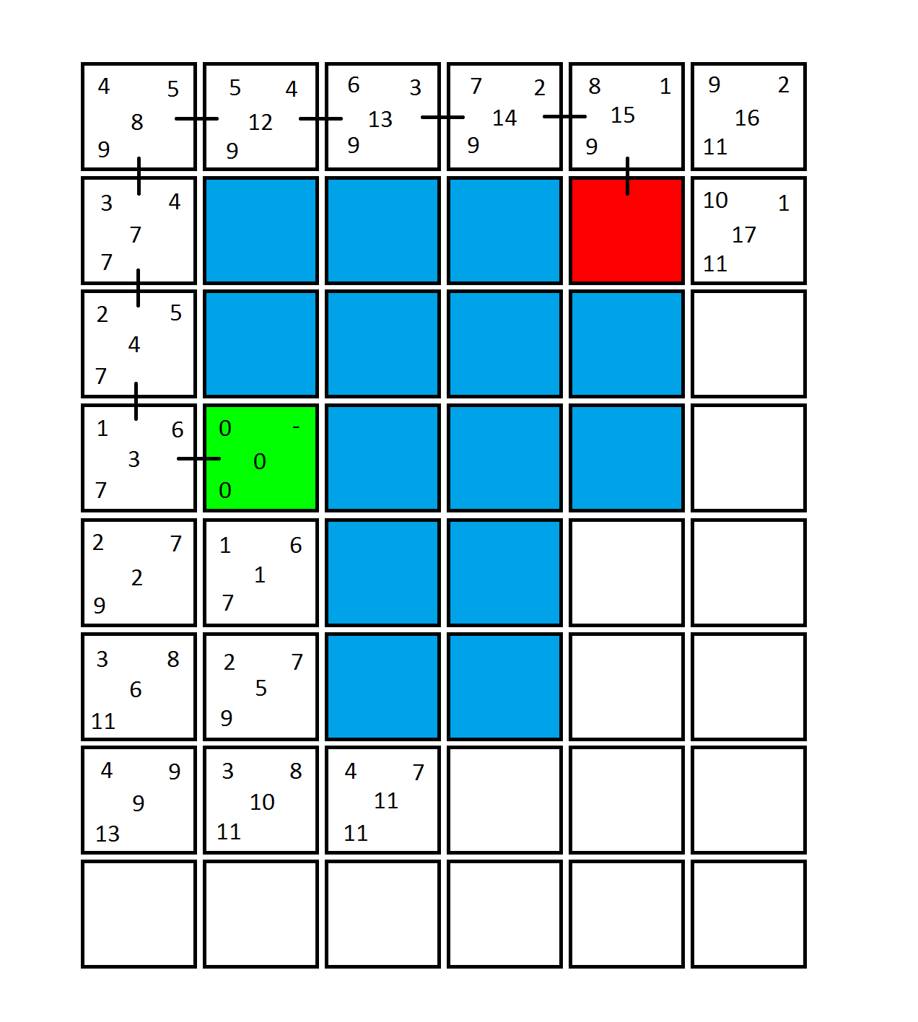
Figure 1.1 presents a tile map which will be used as a primary example for the rest of this report. This map shows how each node is analysed, and how it’s G score (top left of tile), H score (top right of tile) and F score (bottom left of tile) are determined. The green, red and blue tiles represent the start node, end node and untraversable nodes respectively (Figure 1.1). The numbers in the centre of each node represent the order in which the nodes were analysed, and the black lines between nodes denote the path from the end point to the start point via the “parent nodes”. Therefore, for the example in figure 1.1, working back from the end point, the algorithm will create a path from start to finish through the nodes: 3, 4, 7, 8, 12, 13, 14 and 15.
Figure 1.1: Example tile map showing how A* analyses nodes, and creates a subsequent path.
  - Objective
The objective of this report will be to divide the implementation of the A* algorithm in mobile robots, into two steps. Firstly, it will be shown how the A* algorithm can be incorporated into a C++ console application, and run on its own, in order to find the shortest path in a grid, using functions found solely in the Visual studio library. This initial implementation will be based on a 4 directional system, i.e. the algorithm will be designed only to allow movements in up, down, left and right directions. Secondly, this C++ program will be used to output a set of directions, which will then be read using the ARIA library in C++, and used to dictate the motion of a pioneer robot around a room. The room will be based on the map represented by figure 1.1. This initial implementation of the A* algorithm in ARIA, will then be compounded upon by analysis of a larger room, and then with the application of an 8 direction algorithm, allowing diagonal movements.

Chapter 2
Method of Implementing A* in C++
2.1 Algorithm Application
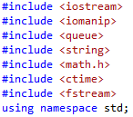
The C++ code used in this section is a modified version of the code developed by user FB36 on the website ActiveState.com (“A-star shortest path algorithm”, 2010). This section will describe how the user implemented the code, as well as how it was modified for the purpose of this study. The C++ code for implementing the A* algorithm is relatively large considering the simple task of the algorithm, making it however capable of being analysed in 4 different sections, which will each be discussed here. Firstly, it is important to note the include files which will be used in this solution, as seen in figure 2.1:

Figure 2.1: Shows the include files used in this C++ solution.
These libraries will be used mainly to implement the algorithm, however it is important to notice the presence of the code: which is also a modification to the original code. This is used because the initial implementation of A* in C++ will provide the user with two main pieces of data, these being a visual representation of the shortest path between the start and end nodes, as well as an array of directions. These directions need to be exported so as to be used in a separate solution, i.e. to dictate the direction of motion for the actual robot when using ARIA, necessitating use of the library.
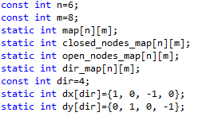
Here is contained the first major modification to the code. Originally user FB36’s code contained an algorithm for a 60x60 node map, and for an 8 directional movement, i.e. the algorithm could move horizontally, vertically and diagonally (“A-star shortest path algorithm”, 2010). Hence the map dimensions, ‘n’ and ‘m’ were modified as well as the function used to initiate directional states. The function is used to create the overall map for the grid being analysed, as well as to create the open and closed sets, which nodes will be placed in after analysis (Figure 2.2). Also, the function is used to initiate the directions of movement as two singular arrays of movements in the x and y directions (Figure 2.2):

Figure 2.2: Shows how the different maps in the code are initialised, as well as the direction arrays.
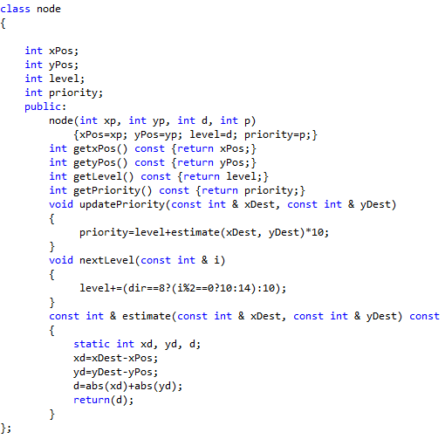
Now, to implement the scoring system into the C++ code. The F score, as shown in chapter 1, determines the priority of a node, i.e. a node with a lower F score has more priority than one with a greater F score. In this code, the G score will be denoted as the H score will be denoted as, and the F score will be denoted as (Figure 2.3):
Figure 2.3: Shows how the nodes are located, and scored.
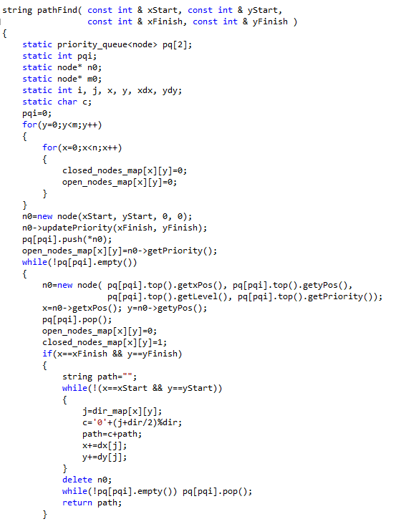
The code in figure 2.3 shows how the nodes in the algorithm, are set in their own class. This is where analysis of each node is undertaken. As explained in chapter 1, it is important to note the code (Figure 2.3), which advises that the ‘Manhattan’ distance or heuristic, is being used to estimate the distance from the current node to the end point. This is another modification that was made to the code, i.e. originally user FB36 used code for the Euclidian distance: , which finds the exact distance from the current to end node by applying Pythagoras theorem. This is one of the most simple, and simultaneously most accurate heuristics which can be used (Gu et al., 2008). In summary, the code shown in figure 2.3 updates the priority of a node being analysed, so that the next section of the code can determine which nodes to analyse, and in what order, based on the priority of their parent node (figure 2.4):
Figure 2.4: Shows the code used to manoeuvre the algorithm in regards to choosing nodes to analyse.
The code in figure 2.4 is part of the code that was left unaltered since it is vital to the implementation of the algorithm (“A-star shortest path algorithm”, 2010), and initiates a string, i.e. , which will be one of the main outputs of this algorithm, and will effectively represent a set of nodes, which all fall along the final path determined by the algorithm, moving in only 4 directions as expressed by (figure 2.2). The ‘for’ loop after the initialisation of integers etc. (figure 2.4), is used to clear the open and closed sets, so that the algorithm can begin searching for a path. From (Figure 2.4) onwards, the code is analysing each node in the grid, firstly by pushing the current node into the ‘open set’, and returning the x position, y position, ‘level’ and ‘priority’, via the algorithm in figure 2.3.
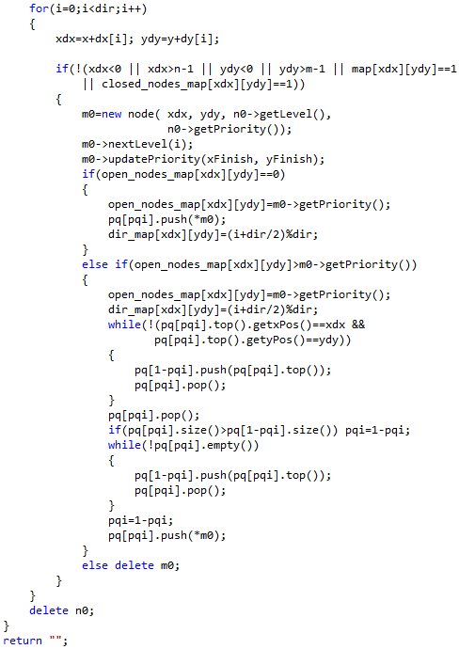
This part of the overall algorithm after having analysed each node, in an order according to their priority as determined in the code in figure 2.3, then pushes the analysed nodes into the ‘closed set’, meaning that they should not be analysed again. This is achieved via:. Also, it is important to note that when the finish node is being analysed, that the algorithm is designed to stop searching and progress to the next section of code, through the ‘if’ statement and the proceeding instructions (Figure 2.4). This ‘if’ statement simply realises that the estimate distance to the finish node is equal to zero, and hence deduces that it is actually the finish node that is being analysed.
Figure 2.5: Code showing how the algorithm returns a set of directions as a string.
The code shown in figure 2.5 is essentially meant to generate moves in up, down, left and right directions, according to a path which is designed to travel backwards through the ‘parent’ nodes of the system, or effectively, forward through the ‘child’ nodes of the system. The code (figure 2.5) is used to generate a ‘child’ node, i.e. when a new node is analysed it is considered the child of the node which caused the prompting for the new node to be scanned. This method of creating child nodes is much more efficient than creating parent nodes and working backwards.
The first line in figure 2.5, i.e. is a ‘for’ loop that basically causes the algorithm, at any node being analysed to scan surrounding nodes up to the amount of directions which the algorithm has been defined to be able to move, which is in this case 4 different directions (Figure 2.3). Also, after any node has been analysed, the ‘parent’ node direction is noted, as seen in the ‘if’ statement:, and its proceeding algorithm.
After the code in figure 2.5 is executed, the algorithm will have determined the relationships between all of the nodes, and the following line from figure 2.4 will be called upon again, determining a string of node positions, that are along the final path, from the start point to the finish point:

The directions returned will be in the form of values ranging from 0 to 3, where 0 right, 1 is down, 2 is left and 3 is up. These values will be very important when it comes time to implement this algorithm using ARIA library.
2.2 Finalisation and Visual Representation
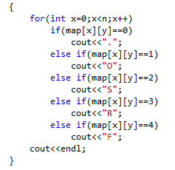
Before implementation of this code using ARIA library, it is possible to map the situation by executing a console application, with just a few more sets of commands used to visually implement the algorithm. At the very end of the above demonstrated code should be placed the following code:
Figure 2.6: Representation of how the visual output should be formed.
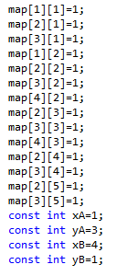
The code seen in figure 2.6 states that nodes with value ‘1’ should output an ‘O’ for ‘obstacle’, nodes with value ‘2’ should output an ‘S’ for ‘start’, those with value ‘3’ should output an ‘R’ for ‘Route’, and lastly, nodes with value ‘4’ should output an ‘F’ for ‘Finish’. These outputs are all reasonable, however it is first necessary to define how certain nodes gain these values. In the original code, the values were assigned using a function, however in the modified code, each node which is untraversable should be given a value of ‘1’ manually as shown below (figure 2.7). Also, the ‘x’ and ‘y’ values of the start and finish points, ‘A’ and ‘B’ must be entered instead of being randomized as they were in the original code.
Figure 2.7: Displays the user input into the algorithm.
It can be seen in the figure above how the user must input both ‘obstacle’ points and the ‘start’ and ‘finish’ point of the system. The obstacle points are denoted by the codes: (Figure 2.7). I.e. to say that each node made to equal ‘1’ will be counted as an obstacle. It is also important to refer back to the ‘if’ statement, (Figure 2.5), and the proceeding code, which effectively determines that any nodes with value ‘1’ are automatically pushed into the closed set, and are not allocated a ‘child’ or ‘parent’ node. This effectively means that the obstacle node cannot be counted as options for the final path of the algorithm.
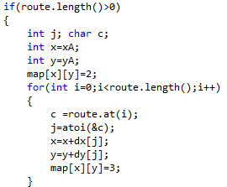
There is one last code of interest in finalising the visualisation of this algorithm:
Figure 2.8: Shows how start, finish and route nodes are flagged.
Lastly, the code in figure 2.8 begins with the line: . This is important since if the distance from the start node to the end node is in fact ‘0’, then any amount of errors could arise, since essentially the start and end nodes have been set at the same point. Also, the ‘for’ loop, (figure 2.8) and the code following determines that each node that is part of the final route is given a value of 3, which is necessary to display the route at the output.
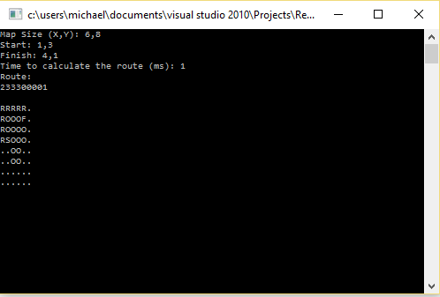
The above designed Visual studio solution is ready to be compiled. Note that there are other smaller pieces of code involved in the implementation of the algorithm which have not been discussed above, which are necessary so as to comply with the syntax of a C++ solution, however they are not necessary to the explanation of how the algorithm achieves its objectives.
Figure 2.9: Shows the output of the console application described in this Chapter.
The map used in this example (Figure 2.9) is a replica of the tile map that was assessed in Chapter 1 of this report. Evidently, the path determined using the A* algorithm in Chapter 1, has once again been determined using this software, indicating to an extent the accuracy of the designed C++ solution.
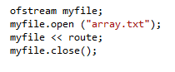
The last modification to the original code is an important function inside this solution which is not displayed in the output of the application (Figure 2.9), and it is the use of the command, in order to export the movement directions into a text file:
Figure 2.10: The commands used to export a direction data string into a text file.
The command is used to access a file inside visual studio folder for a project being compiled. Note that if the file “array.txt” doesn’t already exist, then the above commands (Figure 2.10) will initiatively create the file. Briefly, the string ‘route’ has not been previously explained. The string “pathFind” (Figure 2.4) holds an array of nodes, which are along the path that the A* algorithm deems to be the shortest. This output of nodes, or effectively x and y coordinates is quite useless in light of the next part of the implementation of this A* algorithm, i.e. the ARIA application. Therefore the following command is used to store in the array ‘route’, only the directions which are taken to reach the finish point from the start point:

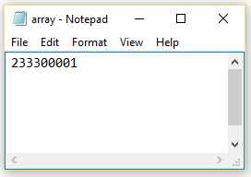
This code successfully converts the node positions of the route, into a string of digits which are then stored in the text document, “array.txt” (Figure 2.10). The document can then be opened by the user (figure 2.11) in windows view, however it can also be imported into another solution for further use:
Figure 2.11: A display of the text file which is created by the C++ solution.

Chapter 3
Implementation with ARIA library
  - A* algorithm ARIA interaction
The Pioneer robot is a robust unit, which can undertake several different functions, and has many on-board peripherals, including a sonar, heat and laser sensors (Slany et al., 2011). The main function of the pioneer robot of interest in this chapter of the report, is the function. Is possibly the simplest level of interaction with a pioneer robot using the ARIA library, and is effectively a direct link between C++ and the robot, i.e. to say using is a direct method of dictating commands, and motions to the robot (Afzulpurkar et al., 2008).
For this section of the report, ‘MobileSim’ software will be used to simulate the results which are attained, ‘MobileSim’ being a software package that can execute a C++ code with an ARIA library inclusion in order to visually represent the movement of several different robots in a map (Kirlik et al, 2009). ARIA software is quite comprehensive, and comes equipped with multiple motion examples, as well as ‘include’, ‘library’ and ‘binary’ files which are vital in developing code which will be compatible with ‘MobileSim’ and eventually the actual robot itself. This part of the report will not explain the syntax of creating a ‘TCP’ connection between Visual Studio and ‘MobileSim’, since the code used to link these is generic, and the precise code is used in all motion examples, however the generic linking code will be included at the end of this report (Appendix 1). Note that a ‘TCP connection is a form of ‘host-to-host’ connectivity, meaning neither ‘MobileSim’ or Visual Studio are the singular host, but both have to connect to a mutual network in order to interact (Hiroyuki et al., 2003).
Now, onto the code which will be used to implement the A* algorithm developed in chapter 2, into a Visual Studio solution which will manoeuvre the pioneer robot around a room. Firstly, observe the include files which are necessary to this solution, namely ‘Aria.h’, ‘iostream’, ‘fstream’ and ‘string’ (Figure 3.1).
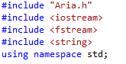
Figure 3.1: Include files used in ARIA implementation
The ‘Aria.h’ include file is a necessary inclusion in any solution meant to interface with ‘MobileSim’, using the ARIA library i.e., however the other inclusions (figure 3.1) will be necessary in implementing A* in this solution. Besides the initial protocol used for connecting Visual Studio with ‘MobileSim’, there are only two main functions of interest in the rest of the solution, namely an command used to open “array.txt” (figure 2.10), and a loop, used to dictate the motion of the robot.
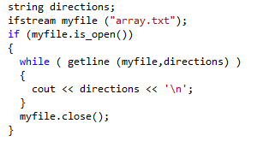
The command is extremely basic, and simply requires that the file to be accessed previously existed, unlike the command which can also create a file. The array of directions in “array.txt” is opened using the function, and is then placed into a string of unknown size, called ‘directions’ (figure 3.2).
Figure 3.2: Represents the method of placing information from “array.txt” into a string.
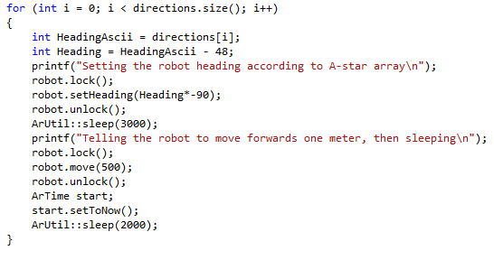
Next, the information placed into the string ‘directions’ must be utilised in a way where the single digit integers placed into the string can determine the heading of the robot as it moves small distances.

Figure 3.3: A ‘for’ loop used to dictate the headings of the robot.
Hence, a ‘for’ loop is used to change the ‘heading’ or direction that the robot faces, in intervals. Firstly, it can be observed that the ‘for’ loop runs from to (figure 3.3). This is since is the size of the string ‘directions’, and therefore it also corresponds with the amount of movements that the robot will make, between different nodes in the grid.
Also, it is important to note that when C++ reads the string ‘directions’, since it was imported as a string, instead of the integer values for the numbers placed in “array.txt” being generated, the ASCII values for ‘0’, ‘1’, ‘2’ and ‘3’ are generated, i.e. ‘48’, ‘49’, ‘50’ and ‘60’ respectively (O’Grady & Rickard, 2008). Therefore it can be seen in the line (figure 3.3) that the actual headings are determined simply by subtracting 48 from the ASCII values. Next, the single digit integer headings are converted to angular headings. Remember that the integer ‘0’ represented a right turn, and the numbers ascended from there in intervals of turns, in the clockwise direction. Thus the code used to convert this digit headings into actual degree headings is , a code which effectively determines the heading angle, and simoultenesouly dictates the heading angle to the robot. After the angle heading angle is set at each stage, the function is used to move the robot forward half a meter.
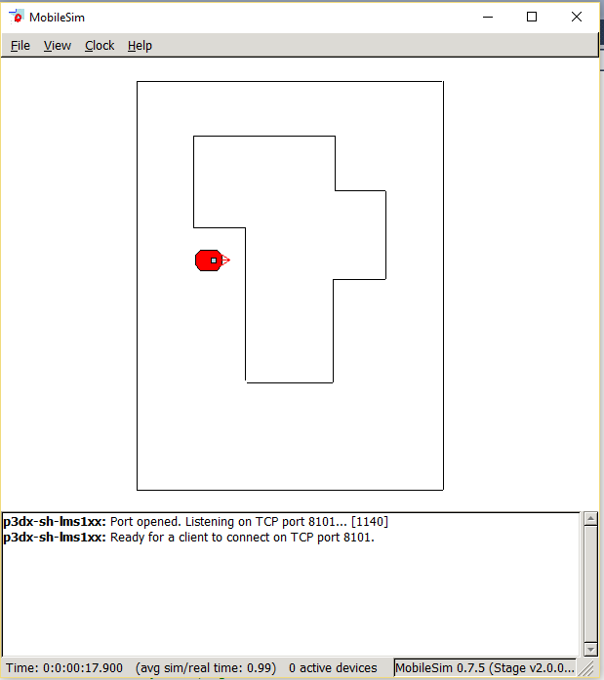
This code can now be compiled and run through a ‘TCP’ connection into mobile sim, and manoeuvre the robot as required (Figure 3.4):
Figure 3.4: Shows the ‘MobileSim’ window and a visual representation of the example in chapter 1.
Note: Files associated with the examples in this report will be attached to the report.

Chapter 4
Further Development of the A* Algorithm
  - Improvement of the A* C++ solution
The A* algorithm implemented in Chapter 2 of this report is quite comprehensive, and can also be manipulated in a few ways in order to achieve greater functionality, or to undertake a more vast calculation. This chapter of the report will discuss 3 different changes that could be made to the algorithm in order to both improve the algorithm, as well as testing it further. These changes are namely, slightly altering the code for an 8-directional path. implementing a different heuristic, and simply testing the algorithm on a much larger map using both of the aforementioned changes.

  - Utilising an 8-directional path
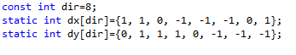
Firstly, the A* algorithm being able to generate an 8-directional path simply means that the robot path being designed will be capable of moving diagonally, as well as horizontally and vertically. This is much more efficient since one diagonal move effectively undertakes both a horizontal move and a vertical move, while having travelled a much smaller distance, as is defined by Pythagoras theorem (Ciobanu & Rusa, 2007). The code developed in Chapter 2 was actually incrementally designed to be able to become an 8-directional algorithm, simply by changing a few values within the code.
Figure 4.1: Changes to be made to code for 8 direction algorithm.
This part of the report will not delve into how all of the other functions in the solution were designed the first time around to be able to account for a change to an 8-directional algorithm, however it can be clearly deduced that the integer ‘direction’ has been increased to 8, and that the arrays ‘dx’ and ‘dy’ have been manipulated so that the 8 different directions in which the robot can move are each associated with a movement in both the x and y directions.
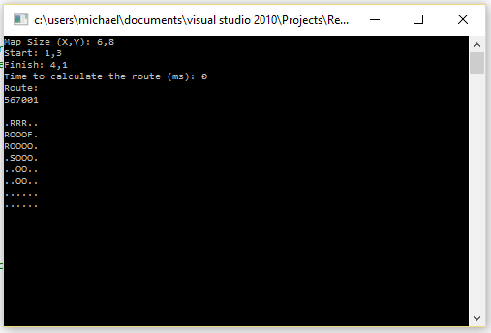
Implementation of the algorithm using this updated code, and the example tile map from chapter 1 yields a route that involves 3 less steps (figure 4.2) than the route determined by the software in chapter 2 (figure 2.9).
Figure 4.2: The output of the 8-directional algorithm.

  - Applying the Chebyshev heuristic
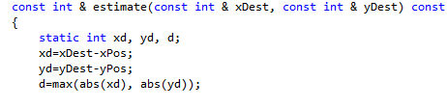
The Chebyshev heuristic, much like the Manhattan heuristic, is very simple. The Chebyshev heuristic also counts the x and y distances from a node being analysed to the end node. However, instead of summing these two values together, the Chebyshev Heuristic simply analyses both and decides that the x or y distance with the greater values, is used as the heuristic value (Wei & Pan, 2012). This can be useful in situations where an extremely large obstacle is placed between the start and end nodes of the system. Implementation of this heuristic is quite simple, just like the implementation of an 8 directional algorithm. The value of ‘d’(figure 2.3) is simply changed to (figure 4.3).
Figure 4.3: Shows how the Chebyshev heuristic can be implemented.
Note that the function is used to determine whether the amount of steps in the x direction are greater or less than the amount in the y direction.
Using this Chebyshev heuristic yields the same result as seen in figure 4.2, it is therefore more likely that the Chebyshev heuristic would change the output of the algorithm on a much larger scale.

  - Applying Chebyshev and 8 directional motion to a larger map
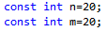
Firstly, the map will be extended to a size of 20 nodes by 20 nodes (figure 4.4). The initial obstacle points will be kept, with a few more random points added to test the accuracy of the algorithm in a larger space.
Figure 4.4: Shows the change in map size.
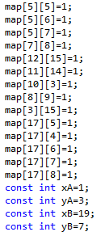
Figure 4.5 shows the randomly decided upon extra obstacle points that will be inputted into the algorithm, as well as the change in finish point. The finish point has been moved to a point where it will be behind a wall of obstacle nodes, in order to further test the capability of the algorithm:
Figure 4.5: Showing the change in user input to test the updated algorithm.
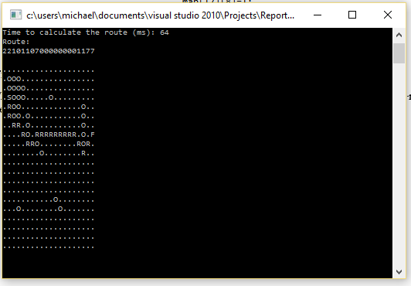
The output of the altered algorithm is as expected, and achieves what is clearly the shortest route between the start and end nodes (figure 4.6). Note again that ‘R’ represents the route.
Figure 4.6: Shows how the updated algorithm manoeuvres the grid.
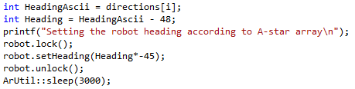
There is however one more part to implementing this updated algorithm, specifically making the ARIA solution designed in chapter 3 capable of actually undertaking the instructions which would now be placed into “array.txt”. The updated algorithm placed digits from ‘0’ to ‘7’ into the text file, and unlike the first algorithm where these angles translated to 90turns in the clockwise direction, an 8 direction algorithm will result in 45turns. The ARIA code can therefore be easily updated as well, by simply replacing ‘90’ with ‘45’ (figure 4.7).
Figure 4.7: Updates to be made to ARIA solution.

  - Further Research
Overall the methodology described in this report has been quite simple, and has achieved a result which however satisfactory, is not fully applicable to the real world. Mobile robots are commonly placed in unknown environments, or changing environments, both of which the A* algorithm is incapable of manoeuvring (Gini et al., 1993).
Therefore a suggestion for future research on this topic would be to attempt designing a D* algorithm in C++, for integration into a pioneer robot. D* is a dynamic A* algorithm, fundamentally meaning that it is a form of the A* algorithm that can account for a moving environment, by updating the F score, and hence the priority of every single node in a grid, each time the robot makes a move (Stentz, 1994). This sort of system requires an ongoing knowledge of the environment in which the robot is moving, i.e. to say the robot is required to possess on-board sonar and sensors, both of which the pioneer robot possesses (Slany et al., 2011). Also, unlike the ARIA implementation used in chapter 3 of this report, the ‘ArRobot’ function which implies a direct motion dictation would not be used. Ultimately the ARIA and D* algorithm would be implemented in the same C++ solution, utilising more complex functions such as and . The method of how D* could be implemented will not be explained here since this report is based on the implementation of the A* algorithm.

Chapter 5
Conclusion
  - Evaluation of Work
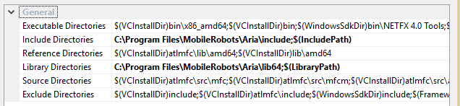
Overall, this research and implementation has yielded pleasing results. The A* algorithm developed in chapter 2 has been shown to produce the same path as determined for the tile map analysed in chapter 1, and on a large scale the algorithm was shown to be accurate in finding the shortest path between 2 points given many varies obstacles. Also, the implementation of the algorithm using the ARIA library was substantially successful, however simple. Some technical difficulties were encountered in compiling the ARIA solution, since the target machine must be set to x64, and all ‘include’, ‘library’ and ‘binary’ directories must be properly referenced (figure 5.1), however this problem was easily overcome.
Figure 5.1: Screenshot of the list of directories.
One permanent problem that was encountered was a scaling issue with ‘Mobile Sim’ and ‘Mapper’. The ‘Mapper’ software is used to create a map to be opened in ‘MobileSim’, so that the programmed pioneer robot can manoeuvre around the given map. The ‘Mapper software’ is very old, and when used with the latest version of ‘MobileSim’, the generated map has an issue where the scale of the horizontal axes is double that of the vertical axes. This means that when the robot moves up or down it is observed to be moving the required distance, but when it moves right or left, the distance travelled is observably half the designed distance. This problem would not be observed if the implemented ARIA code were uploaded into an actual pioneer robot, and hence these software issues do not pose major problems.

  - Conclusion
The above report has presented a quite challenging task, namely of implementing a mathematical search algorithm in C++, visually representing it and then translating the output into a form where the motion of a robot can be dictated. C++ implementation involved continual testing and evaluation, as the project progressed, and was eventually completed to a satisfactory standard, as shown in chapters 2 and 4 of this report. The visual representation of the system was at consequently very simple, since it built upon the code developed in the main part of the C++ solution. Lastly, the method of interfacing the algorithm with the simulator using by creating a C++ solution with the ARIA library was perhaps the most candid part of this project, since it effectively only necessitated code to read a previously initialised text document, and to translate a string of direction integers into a set of headings. Overall, this project has been extremely enlightening, and has achieved all of its objective, with prospects of further research being determined.
Note: Final codes will be included for the project, as well as a map file for the first example only.

Acknowledgements
A special thanks goes to Professor Gu Fang for volunteering his time so as to be a supervisor for this project, progressively helping with each section of the project, especially the troubleshooting. Mentionable people also include Benjamin Stockley and James Xiberras who helped with correcting the syntax of the code in order for it to run properly.

References
Ballard, P. & Vacherand, F. 1993, “The Manhattan method: a fast Cartesian elevation map reconstruction from range data”, International Conference on Robotics and Automation, 1993. Proceedings, pp. 143 – 148.
Bertram, R., Hart, P.E. & Nilsson, N.J. 1968, “A formal Basis for the Heuristic Determination of Minimum Cost Paths”, IEEE Transactions on System Science and Cybernetics, pp. 100 – 107.
Bodhale, D., Afzulpurkar, N. & Thanh, N. T. 2008, "Path planning for a mobile robot in a dynamic environment,", IEEE International Conference on, Bangkok, 2009, pp. 2115-2120.
Ciobanu, G. & Rusu, D. 2007, "Pythagoras: An Interactive Environment for Plane Geometry," 2007 IEEE International Conference on Intelligent Computer Communication and Processing, Cluj-Napoca, pp. 283-286.
Ferguson, D. & Stentz, A. 2005, “The Delayed D* Algorithm for efficient path Replanning”, Proceedings of the 2005 IEEE International Conference on Robotics and Automation, pp. 2045 – 2050.
Gu, W., Li, J., Wang, S. & Yin, M. 2008, “A novel casual graph based heuristic for solving planning problem”, 2008 International Conference on Machine Learning and Cybernetics, pp. 2223 – 2228.
Hiroyuki, H., Ohsaki, H. & Murata, M. 2003, "Steady state and transient behavior analyses of TCP connections considering interactions between TCP connections and network," Applications and the Internet, 2003, pp. 309-316.
Hwang, K., Kim, D., Kuc, T. & Lee, D. 2006, “Mobile Robot Design apply to Design Concept”, SICE-ICASE International Joint Conference, pp. 2989 – 2992.
Koenig, S., Likhachev, M., Furcy, D. 2004, "Lifelong Planning A*", Artificial Intelligence Journal 155.
LaValle, S.M. 1998, "Rapidly-exploring random trees: A new tool for path planning", Technical Report, Computer Science department at Iowa State University.
Leenen, L. & Terlunen, A. 2013, “A focussed dynamic path finding algorithm with constraints”, 2013 International Conference on Adaptive Science and Technology, pp. 1 – 8.
O'Grady, P. D. & Rickard, S. T. 2008, "Automatic ASCII Art conversion of binary images using non-negative constraints," Signals and Systems Conference, 208. (ISSC 2008). IET Irish, Galway, 2008, pp. 186-191.
Ratering, S. and Gini, M. 1993, "Robot navigation in a known environment with unknown moving obstacles," 1993 IEEE International Conference on, Atlanta, GA, 1993, pp. 25-30 vol.3.
Stentz, A. 1994, “Optimal and efficient path planning for partially-known environments”, 1994 IEEE International Conference on Robotics and Automation, pp. 3310 – 3317.
Xiaoyan Wei & Zhibin Pan 2012, "Chebyshev kernel with orthogonal features," Computer Science and Information Processing (CSIP), 2012 International Conference on, Xi'an, Shaanxi, 2012, pp. 941-944.
Yazici, A., Kirlik, G., Parlaktuna, O. & Sipahioglu, A. 2009, "A dynamic path planning approach for multi-robot sensor-based coverage considering energy constraints," 2009 IEEE/RSJ International Conference on Intelligent Robots and Systems, St. Louis, pp. 5930-5935.
Zeng, W., Church, R. L. 2009, "Finding shortest paths on real road networks: the case for A*", International Journal of Geographical Information Science.
Zaman, S., Slany, W. and Steinbauer, G. 2011, "ROS-based mapping, localization and autonomous navigation using a Pioneer 3-DX robot and their relevant issues," Electronics, Communications and Photonics Conference (SIECPC), pp. 1-5.
FB36 2010, “A-star Shortest Path Algorithm”, http://code.activestate.com/recipes/577457-a-star-shortest-path-algorithm

Appendix 1
#include "Aria.h"
#include <iostream>
#include <fstream>
#include <string>
using namespace std;
class ConnHandler
{
public:
// Constructor
ConnHandler(ArRobot *robot);
// Destructor, its just empty
~ConnHandler(void) {}
// to be called if the connection was made
void connected(void);
// to call if the connection failed
void connFail(void);
// to be called if the connection was lost
void disconnected(void);
protected:
// robot pointer
ArRobot *myRobot;
// the functor callbacks
ArFunctorC<ConnHandler> myConnectedCB;
ArFunctorC<ConnHandler> myConnFailCB;
ArFunctorC<ConnHandler> myDisconnectedCB;
};

ConnHandler::ConnHandler(ArRobot *robot) :
myConnectedCB(this, &ConnHandler::connected),
myConnFailCB(this, &ConnHandler::connFail),
myDisconnectedCB(this, &ConnHandler::disconnected)

{
myRobot = robot;
myRobot->addConnectCB(&myConnectedCB, ArListPos::FIRST);
myRobot->addFailedConnectCB(&myConnFailCB, ArListPos::FIRST);
myRobot->addDisconnectNormallyCB(&myDisconnectedCB, ArListPos::FIRST);
myRobot->addDisconnectOnErrorCB(&myDisconnectedCB, ArListPos::FIRST);
}

// just exit if the connection failed
void ConnHandler::connFail(void)
{
printf("directMotionDemo connection handler: Failed to connect.\n");
myRobot->stopRunning();
Aria::exit(1);
return;
}

// turn on motors, and off sonar, and off amigobot sounds, when connected
void ConnHandler::connected(void)
{
printf("directMotionDemo connection handler: Connected\n");
myRobot->comInt(ArCommands::SONAR, 0);
myRobot->comInt(ArCommands::ENABLE, 1);
myRobot->comInt(ArCommands::SOUNDTOG, 0);
}

// lost connection, so just exit
void ConnHandler::disconnected(void)
{
printf("directMotionDemo connection handler: Lost connection, exiting program.\n");
Aria::exit(0);
}

int main(int argc, char **argv)
{
Aria::init();

ArArgumentParser argParser(&argc, argv);
argParser.loadDefaultArguments();

ArRobot robot;
ArRobotConnector con(&argParser, &robot);

// the connection handler from above
ConnHandler ch(&robot);

if(!Aria::parseArgs())
{
Aria::logOptions();
Aria::exit(1);
return 1;
}

if(!con.connectRobot())
{
ArLog::log(ArLog::Normal, "directMotionExample: Could not connect to the robot. Exiting.");

if(argParser.checkHelpAndWarnUnparsed())
{
Aria::logOptions();
}
Aria::exit(1);
return 1;
}

ArLog::log(ArLog::Normal, "directMotionExample: Connected.");

if(!Aria::parseArgs() || !argParser.checkHelpAndWarnUnparsed())
{
Aria::logOptions();
Aria::exit(1);
}

