
Assessment Cover Page

Student Full Name Guilherme Andrei Gonçalves Pulquerio

Student Number 2024637
Module Title Distributed Digital Transactions

Assessment Title CA1
Assessment Due Date 13/11/2026
Date of Submission 13/11/2026
GitHub Link https://github.com/GuiAndrei12/CA1_DDT_Guilherme_Pulquerio
Video Link

Declaration
By submitting this assessment, I confirm that I have read the CCT policy on academic misconduct and understand the implications of submitting work that is not my own or does not appropriately reference material taken from a third party or other source.
I declare it to be my own work and that all material from third parties has been appropriately referenced.
I further confirm that this work has not previously been submitted for assessment by myself or someone else in CCT College Dublin or any other higher education institution.

DP-1: Actors & Roles 3
DP-2: System Use Cases & Lifecycle 3
DP-3: Data Structures & State Mappings 3
DP-4: Security Rules & Financial Accounting 3
Benefits 4
Challenges 4
Cryptographic Method: 4
How It Enhances Security in the Blockchain: 4
Screenshots 5

Design Principles: Hotel Booking Smart Contract

DP-1: Actors & Roles

- Hotel Owner (Admin): The account that deploys the smart contract. Holds administrative privileges to register new rooms, set prices, update availability, and withdraw accumulated booking revenue.
- Guest (Customer): Any blockchain user account that views available rooms and books them by sending the exact required payment in Ether.

DP-2: System Use Cases & Lifecycle

- Core Use Cases:

1. addRoom (Register Room): The Hotel Owner adds a new room to the inventory by providing a name (e.g., "Deluxe Suite 101") and a nightly price.
2. bookRoom (Reserve Room): A Guest selects a room ID, specifies the number of nights, and sends the total Ether payment.
3. withdrawBalance (Collect Revenue): The Hotel Owner transfers accumulated funds from the contract balance to their personal wallet.
4. getRoomDetails (View Information): Anyone can check if a room is available and view its price per night.

- Room State Lifecycle:

Room Created (Available) => Guest Sends Payment => Room Booked (Occupied)

DP-3: Data Structures & State Mappings

- Room Data Structure (struct Room): Stores key information for each room

* id: Unique room identification number.
* name: Name or description of the room.
* pricePerNight: Cost of one night in Ether (Wei).
* isBooked: Boolean flag (true/false) tracking whether the room is occupied.
* currentGuest: Wallet address of the guest who booked the room.

- Inventory Mapping (mapping): A lookup table (mapping(uint256 => Room) public rooms) connecting each room ID to its details.

- Access Control Guard (modifier onlyOwner): Restricts administrative actions (adding rooms, withdrawing revenue) exclusively to the Hotel Owner.

- System Notifications (events): Emits public logs on the blockchain whenever a room is added (RoomAdded), booked (RoomBooked), or revenue is withdrawn (BalanceWithdrawn).

DP-4: Security Rules & Financial Accounting

- Restricted Access Control: Admin functions are guarded by onlyOwner, preventing unauthorized users from tampering with room inventory or stealing funds.
- Exact Payment Verification: The contract calculates totalCost = pricePerNight * nights and requires msg.value == totalCost. If the guest sends too little or too much Ether, the transaction reverts.
- Safe Fund Custody: Customer payments are stored safely inside the smart contract balance until the Hotel Owner explicitly calls the withdrawal function.

Benefits and Challenges of Blockchain for Hotel Booking

Benefits

Elimination of Intermediaries & Lower Fees: Traditional Online Travel Agencies charge commission fees per reservation, whereas a Smart Contract operates peer-to-peer (P2P) between the guest and hotel owner with zero middleman fees.

Immutability & Fraud Prevention: Room inventory, prices, and booking confirmations are locked on the blockchain, preventing double-booking, fake reviews, or unauthorized price changes.

Automated & Instant Settlement: Payments in Ether are locked safely in escrow inside the contract and released automatically upon booking execution, eliminating credit card chargebacks.

Challenges

User Onboarding & Adoption: Non-technical guests must have a Web3 crypto wallet (e.g., MetaMask) and Ether (ETH) to interact with the contract.

Price Volatility: Cryptocurrency price fluctuations can affect the real-world value of booking revenue between the reservation date and withdrawal time.

Gas Fees & Scalability: High network activity on Ethereum can occasionally increase transaction (gas) fees for guests when booking a room.

Suitable Cryptographic Method & Security Enhancement

Cryptographic Method:

Elliptic Curve Cryptography (ECC) & ECDSA
The most suitable cryptographic framework securing this solution is Elliptic Curve Cryptography (ECC) using the secp256k1 curve, paired with the Elliptic Curve Digital Signature Algorithm (ECDSA) and SHA-256 hashing.

How It Enhances Security in the Blockchain:

Digital Signatures & Non-Repudiation: When a guest books a room, their wallet signs the transaction with their Private Key without revealing it. The network uses the guest's Public Key to verify that msg.sender is the legitimate owner of the funds, preventing identity impersonation.

Tamper-Proof Data Integrity: Transaction details and event logs (RoomBooked) are hashed using SHA-256 and chained into immutable blocks. This ensures that neither the owner nor any malicious actor can retroactively alter a guest's booking record.

Screenshots

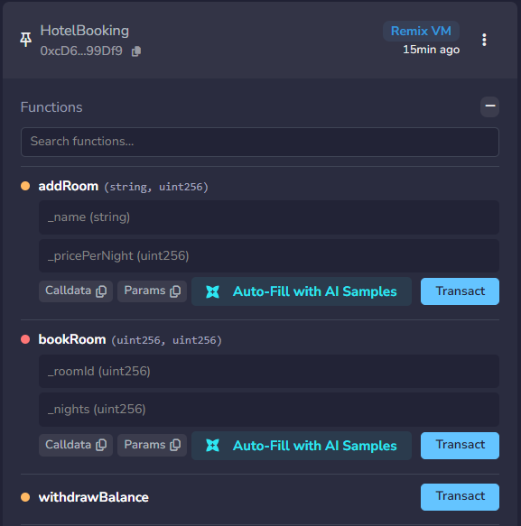

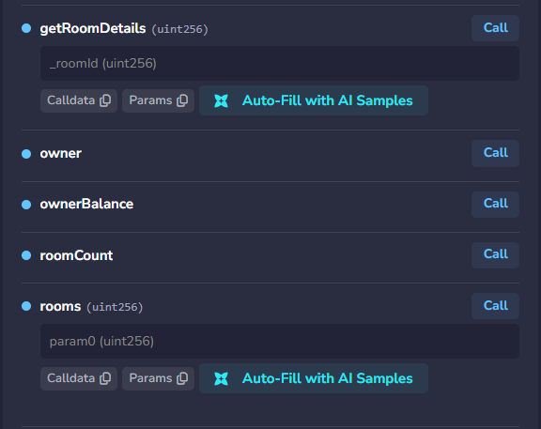

Fig1 and 2. Contract deployed and ready to work

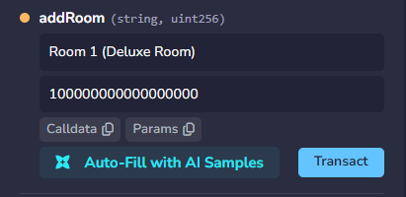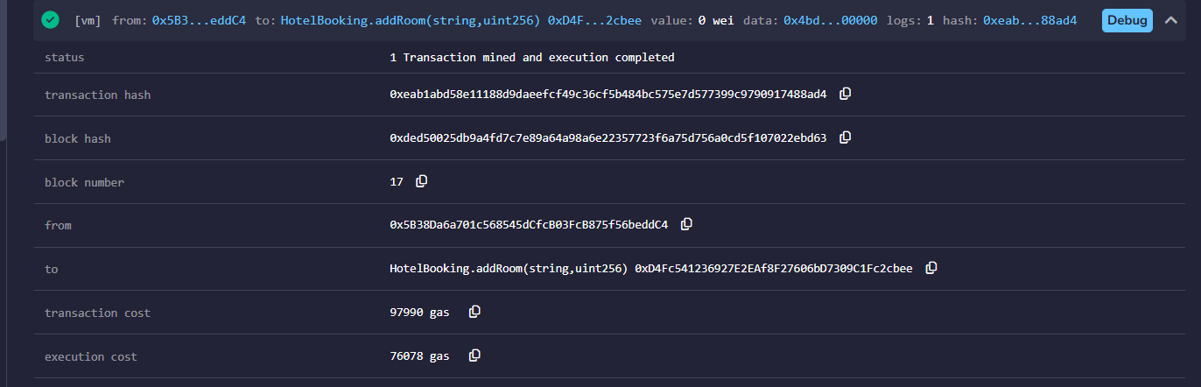

Fig3 and 4. First room “Room 1 (Deluxe Room)” added

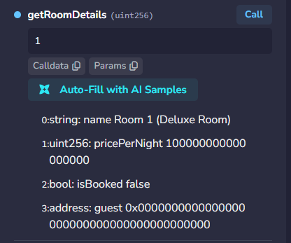
Fig5. First room “Room 1 (Deluxe Room)” details

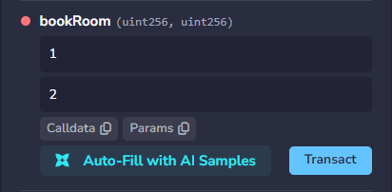

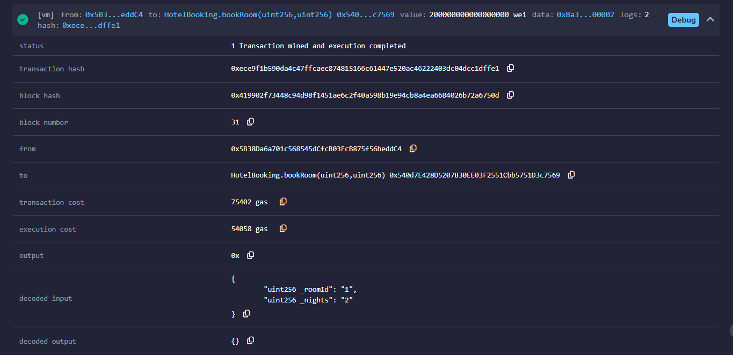

Fig6 and 7. Booking “Room 1 (Deluxe Room)” for 2 nights.

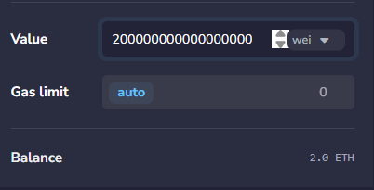

Fig8. Total transferred for 2 nights for “Room 1 (Deluxe Room)”

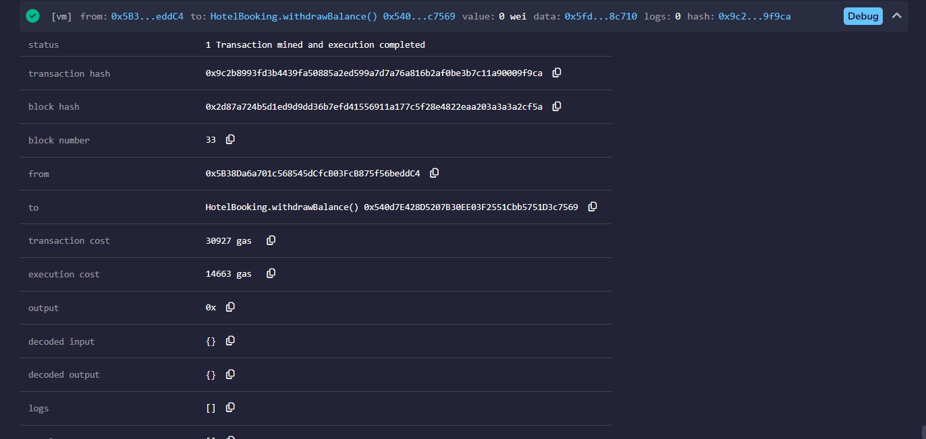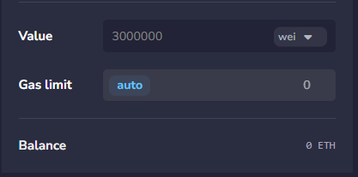

Fig9 and 10. Owner withdrawing the total transferred for 2 nights for “Room 1 (Deluxe Room)”

