Evidence Checklist

01. Adding a Valid Food Item
In NetBeans, show the insertion of a food item, such as Burger, with a valid weight and best-before date. Make sure the success message is visible.

Evidence of: Food registration and data validation.

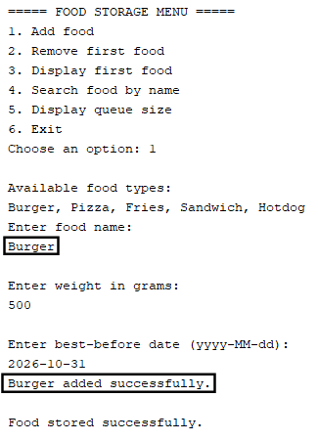

02. Invalid Input Validation
Show the rejection messages for an invalid food type, invalid weight, and invalid date. If they cannot all fit clearly in one screenshot, use two screenshots.

Evidence of: Input validation and error handling.
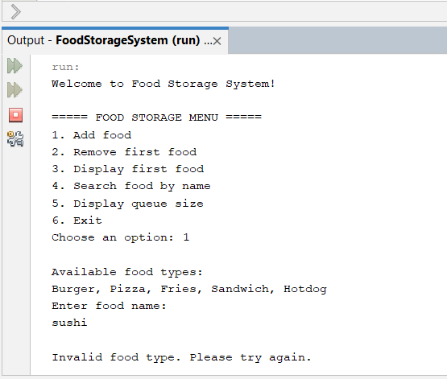

03. Maximum Capacity of 8 Items
Show the queue containing 8 items, followed by an attempt to insert a 9th item, which must be rejected.

Evidence of: The maximum capacity requirement specified in the assignment brief.
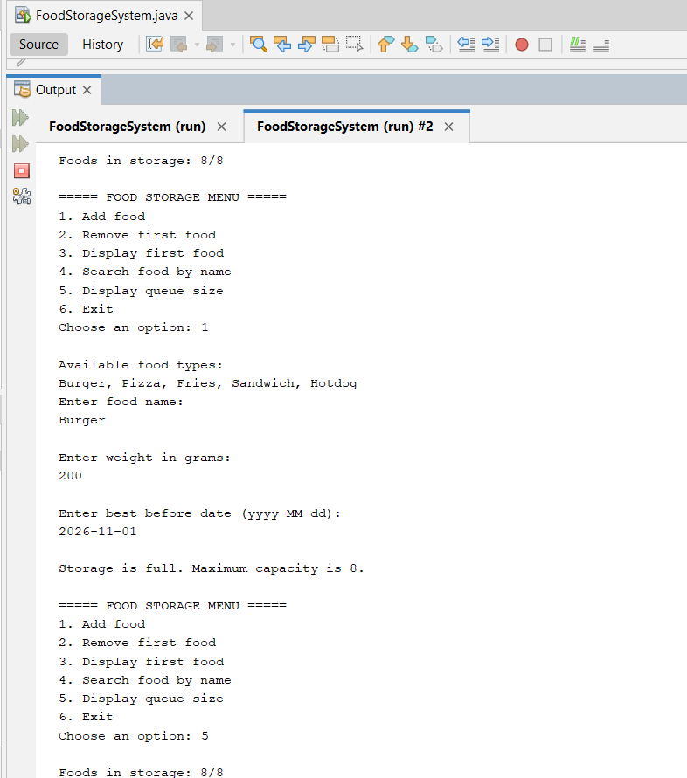

04. FIFO Removal and Displaying the First Item
Add items with different names. Display the first item, check it without removing it, and then remove it. Keep the order of operations visible.

Evidence of: FIFO behaviour, peek/display functionality, and removal.

05. Circular Queue Reusing Array Positions
Fill the queue, remove some items, and add new ones. Show that the new insertions are successful and that the logical order of the queue remains correct.

Evidence of: The correct operation of front, rear, and size in the circular array.

06. Searching for a Food Item
Show one search that successfully finds a food item and another that does not find a match. Ideally, search for a name using different uppercase and lowercase letters.

Evidence of: Searching by name and case-insensitive search functionality.

07. Empty Queue
With the queue empty, attempt to remove and display the first food item. Show the messages and confirm that the program continues running.

Evidence of: Handling empty data and preventing errors when no items are available.

