SENTIMENTAL ANALYSIS FOR AMAZON WATCH REVIEWS
Problem Solving for Industry [Final Year Project]
CCT College Dublin

Group Members:
Waseem Mehboob : 2020393
Guilherme Correa Ramos : 2020395
Tefo Molemohi : 2020484
Saim Ahmed : 2016456
Contents
1. Introduction: 1
2. Project Description: 1
3. Objectives: 1
4. Methodology: 2
4.1 Open-Source vs Proprietary: 2
5. Development Methodology: 3
Software requirements: 3
5.1 Jupyter Notebook: 3
5.2 Language: 3
5.3 Libraries: 3
5.4 NumPy: 3
5.5 Scikit-learn: 4
5.6 TensorFlow: 4
5.7 Keras: 4
5.8 Pandas: 4
5.9 Matplotlib: 5
5.10 Plotly: 5
5.11 Reg-Ex: 5
6. NLTK (Natural Language Toolkit): 5
7. Long short-term memory (LSTM): 6
8. Convolutional Neural Networks: 6
9. Procedure: 7
10. Figures: 8
11. Conclusions: 12
11.1 Strength: 12
11.2 Weaknesses: 12
11.3 Future Potential: 12
In future we have to spread our system and create web based over which everybody can simply contact through simple clicks on web, and effortlessly develop the reviews by their product which will be supportive for their products. 12

Introduction:

Currently world is entirely about giving far detail as well as devotion to the Internet plus what is happening on the World Wide Web (WWW). This courtesy has brought a group of data prepared to be examined by different experts across diverse fields. The data contains facts concerning everything from reviews to a products/services website to arguments as well as views discussing different topics like education, culture, upcoming elections, government policies, religion, as well as current situation of a specific area. Data similar to this could be accessible on a social media platform, forums of diverse companies as well as manufacturer’s websites, blogs, etc.

Sentiment is defined as the thought or view that constrains your mind under a specific situation or which is permanent to certain views due to preceding beliefs or events. The reviews, opinions or simple post on the social media platforms can cover certain sentiment concerning about the objects under consideration. Sentiment investigation or opinion mining is an area which has presently gained considerable attraction from the researchers in together the areas of education as well as industry. This area is a sub-field of text mining and its main influence is in the analysis of the text with perception of the opinions of the writer as well as the general impression being shown.

Project Description:

In current years, due to the public voicing their views on the internet, it has been believed important by business intelligence to observe these opinions or reviews. This is important for planning as well as organizing their future products and what the user must be recommended in their news feed.

Amazon is an international technology company that runs diverse businesses amongst which the most noticeable is its e-commerce website. A huge quantity of data is formed every minute on the website which can express a lot about what is being loved by the users as well as what is being unnoticed. This information, if examined accurately, can help the seller to recognize their weaknesses as well as what the user needs so that they can plan their upcoming products and the present services.

Our project is created on these reviews which can take opinions from numerous peoples as well as on basis of those evaluations a forecast gets that what’s a chance to result of same reviews and it’s help for various companies about their product listening.

Objectives:

The purpose of our project is to achieve sentimental analysis on the Amazon watch reviews. In this task, data from watch reviews of various brands accessible on the e-commerce site will be collected as well as investigated accordingly. This information will help in pointing out the customers’ sentiment behind the reviews which can be categorized into three wide classes: positive, negative as well as neutral. [1]A particular review can have all the three opinions as well. For instance, a customer bought a Bluetooth headset. He was pleased with the audio quality as well as global connectivity but displeased by the timing of the battery and was satisfactory with the aesthetics of the headset. This review demonstrates that there are miscellaneous sentiments about various features of a product. But general, it added to a helpful review because of the number of features being adored by the customer.

Our objective is to investigate the customer expectancy before-sales as well as sentiment after-sales. This will support the seller to see what feature of the product was enjoyed by the customer and what feature of the product can be altered to suit the liking of the customer. Lastly, this will benefit them to hold their customers as well as increase their business’ overall sales.

Methodology:

To start with it is significant to study a development methodology that is useful within the limitations of time as well as scope for this specific project. There are two methods over which a sentiment analysis can be performed. One is the lexical method in which the sentiment of a content is well-defined by investigating the individual arguments as well as phrases present. However, the other is the machine learning method that covers the sentiment analysis job as a text classification problem which can be solved by using an already labelled data set.
We will be using the machine learning method because of its achieved accuracy in numerous domains as related to the lexical method. The lexical method needs a sentiment dictionary at all times to properly identify the view. Though, it is frequently hard to handle sentiment in various contexts where a particular word can mean something in one domain as well as changed in other. On the other hand, machine learning does not need any verbal resources but can be combined for improved results.

Generally speaking, numerous methods come under the umbrella of machine learning method among which we have decided to work with detailed learning approaches in combination with clustering procedures. Deep learning technique runs by organizing the mining algorithm into layers to generate “artificial neural network”. This system will then be capable of learning as well as creating decision all by itself. On the other hand, the clustering technique is an important machine learning technique whose excellence depends on the data distribution. This is where the deep neural networks will be operative by altering mappings from a high-dimensional data space into a lower-dimensional feature space, leads to better clustering outcomes.

Open-Source vs Proprietary:

For this task, we will be consuming open-source codes, tools as well as software, keeping in notice the point that the public reviews have to be studied for sentiment mining. We will be demanding data sets for the analysis and since there is not much data obtainable for Amazon watch reviews hence, one of the two choices are accessible. Either we will have to generate our own data set which will not be precise enough or we have to ask for teamwork from other developers to deliver us with data sets that have previously operated upon.

Furthermore, open-source technique permits for collaboration among developers across the world. This in turn creates the code well and flexible for several domains. Also, any susceptibility, if accessible, can be pointed and fixed by one or the other inventor. On the other hand, proprietary software goes only in the hands of developer that belong to a definite company or organization and hence, restricted brains are looking at the code. This in turn delivers evidence for a possibility that the inventers might miss out on errors and bugs in the code.

Open-source code also deliver numerous customization choices which permits the developer to use the code as needed by his necessities though the proprietary software has certain restricted flexibility choices. Portability is additional feature that is delivered by the open-source community which permits for the service to be hosted on several platforms working under different circumstances. Though, proprietary solution limits the developer in terms of portability as well as adaptability with only permitting platforms that are identified to a specific company or organization.

Development Methodology:

Software requirements:

Software that are used to create this system are:

Jupyter Notebook:

Project Jupyter is a task as well as community whose objective is to "create open-source software, open-standards, as well as services for communicating computing across lots of programming languages". It was turned off from IPython in 2014 by Fernando Pérez. Project Jupyter's name is a reference to the three core programming languages supported by Jupyter, which are Julia, Python as well as R, and also a homage to Galileo's notebooks and the footage the discovery of the moons of Jupiter. Project Jupyter has established and supported the collaborating computing products Jupyter Notebook, JupyterHub, as well as JupyterLab.

Language:

Python Language is used to develop this task due to numerous benefits.

1. It is Easy to Read, Learn as well as Write.
2. It is enhanced Productivity.
3. It openly performs the code line by line.
4. It is automatically allocating the data type during performance.
5. It is free as well as Open-Source.
6. It is huge libraries Support.
7. It is easy as well as portable with all other situation.

Libraries:

Various python libraries for machine learning are used to develop this task which are useful on various module.

NumPy:
It is famous general-purpose array-processing set. A wide collection of great complexity mathematical functions makes NumPy influential to develop large multi-dimensional arrays as well as matrices. NumPy is very beneficial for conducting linear algebra, Fourier transforms, as well as random numbers. Additional libraries like TensorFlow uses NumPy at the backend for operating tensors.

Scikit-learn:
It was made on top of two Python libraries – NumPy as well as SciPy and has become the most widespread Python machine learning library for emerging machine learning algorithms.

It has an extensive variety of supervised as well as unsupervised learning algorithms that works on a reliable interface in Python. The library can also be used for data mining as well as data analysis. The main machine learning tasks that this library can hold are model selection classification, regression, clustering, dimensionality reduction, as well as preprocessing.

TensorFlow:
It is was established for Google’s internal use by the Google Brain team. TensorFlow is a common computational framework for generating machine learning models. It supports a wide range of different toolkits for creating models at varying levels of perception.

Keras:
It is an open-source library used for neural systems as well as machine learning. It can run on highest of TensorFlow, Theano, Microsoft Cognitive Toolkit, R, or PlaidML. It also can run competently on CPU as well as GPU.

It runs with neural-network building blocks like layers, objectives, activation functions, as well as optimizers. It also has a group of features to work on images as well as text images that arises handy when writing Deep Neural Network code. Separately from the standard neural network, it supports convolutional plus regular neural networks.

Pandas:
They are turning up to be the most widespread Python library that is used for data investigation with support for fast, flexible, as well as communicative data constructions planned to work on both “relational” as well as “labeled” data. Pandas nowadays is an unavoidable library for solving practical, real-world data examination in Python. Pandas is extremely stable, providing highly improved performance. The backend code is virtuously written in C or Python.

The two dominant kinds of data structures used by pandas are:

Series (1-dimensional)
Data Frame (2-dimensional)

These two placed together can handle a bulk of data necessities and use cases from most fields like science, statistics, social, finance, and of course, analytics as well as other areas of engineering.

Matplotlib:
We can generate stories with the data envisioned with Matplotlib. Additional library from the SciPy Stack, Matplotlib plots 2D figures. It is the scheming library for Python that delivers an object-oriented API for implanting strategies into applications. It is similar to MATLAB fixed in Python programming language.

Histogram, area plot, pie plot, bar plots as well as scatter plots, Matplotlib can portray an extensive variety of visualizations. With a moment of effort and shade of visualization abilities, with Matplotlib, you can generate just any visualizations. It also allows labels, grids, legends, as well as some additional formatting objects with Matplotlib. Essentially, everything that can be drawn.

Plotly:
It’s an essential graph plotting library for Python. We can stream data, import, and copy, paste that is to be examined as well as visualized. Plotly suggests a sandboxed Python (Somewhat where you can run a Python that is restricted in what it can do) Currently I’ve had a tough time understanding what sandboxing is but i identify a fact that Plotly makes it simple.

It can be used to generate and show figures, update figures, hover over text for details. It also has an extra feature of transfer data to cloud servers. It helps to plan an extensive variety of graphs that you can plot:
Basic Charts:
Line, Treemap, Sankey, Pie, Scatter, Bubble, Dot, Gantt, Sunburst and Filled Area Charts.

Reg-Ex:
A regular expression is a distinct order of characters that assists you match or find further strings or groups of strings, using a particular syntax held in an arrangement. Regular expressions are extensively used in UNIX world.

The Python module delivers complete support for Perl-like regular expressions in Python. The re-module increases the exception re-error if an error happens while collecting or consuming a regular expression.

NLTK (Natural Language Toolkit):

It mostly works with human language more than computer language to apply natural language processing (NLP). It covers text processing libraries with which you can make tagging, stemming, tokenization, parsing, classification, as well as semantic reasoning of data. It may sound uninteresting of what this library can do but every lib in Python was written to address particular efficiency.

The NLTK library is one of the oldest and most frequently used Python libraries for Natural Language Processing. NLTK helps to stop word deletion, and you can discover the list of stop words in the corpus module.

In Python tokenization mainly refers to splitting up a larger body of text into smaller lines, words or even creating words for a non-English language. The several tokenization purposes in-built into the NLTK module itself and can be used in programs as shown below.

The tokenize module offers a lexical scanner for Python source code, applied in Python. The scanner in this module yields comments as tokens as well, making it valuable for implementing “pretty-printers”, containing colorizers for on-screen displays.

Long short-term memory (LSTM):

It’s a false recurrent neural network (RNN) architecture used in the area of deep learning. Unlike standard feedforward neural networks, LSTM has response connections. It can not simply practice single data points (such as images), but furthermore complete orders of data (such as speech or video). For example, LSTM is effective to tasks such as unsegmented, connected handwriting recognition, speech recognition as well as irregularity detection in network traffic or IDSs (intrusion detection systems).

A common LSTM unit is comprised of a cell, an input gate, an output gate as well as a forget gate. The cell recalls values over arbitrary time intervals and the three gates control the stream of information in and out of the cell.

LSTM networks are compatible to classifying, processing as well as creating predictions centered on time series data, since there can be gaps of unknown duration between essential events in a time series. LSTMs were established to deal with the vanishing gradient problem that can be faced when training traditional RNNs. Relative insensitivity to gap length is a benefit of LSTM over RNNs, hidden Markov models plus other series learning ways in many applications.

It offers a platform to the hospital workers to include the patient data so that it can be followed for the informational purpose for the patient as well as make alterations in the patient history by the doctors as per the requirements for the health care of the patients. Last stage is the application of the system.

Convolutional Neural Networks:

They are a portion of what create Deep Learning extent the headlines so frequently in the last years. Now we’ll train a text classifier to tell us whether reviews comprise positive review as well as negative review by TensorFlow’s eager API[9].

Artificial Neural Networks have disturbed numerous industries recently, due to their exceptional capabilities in various areas. Though, various Deep Learning architectures excel on each one:

In Multi-Layer Perceptron’s (MLP), the vanilla Neural Networks, each layer’s neurons link to all the neurons in the next layer. We name this kind of layers fully linked.

A Convolutional Neural Network is different: they have Convolutional Layers.
The convolution process, known an input matrix A (usually the previous layer’s values) as well as a (typically much smaller) weight matrix named as kernel or filter K, will output a new matrix B.

Procedure:

We introduced dataset of amazon watches for the review method what the client’s review about those products. Import data is first step for studying data. After then it delivers the dataset from the import files over various libraries as there are various kind of data so each library has various function. Similarly, for check ordered expression we use Reg-Ex Library, for matrices operation we use NumPy.

In demand to check the ratings, we draw Graphs over data-visualization libraries called Plotly library as well as Matplotlib library which display ratings as well as supportive reviews as per customer’s experience; all values are straightly taken from data groups.

It's all organized in descending order (i.e. top to bottom). The data frame is prepared with the term `permanent` which design out rankings as well as customer’s data. We create a data frame for evaluation purpose which collect review value from customers that how many customers give 5* reviews how many give 4* reviews and so on till 1*. Again, we generate additional data frame called Permanent Data Frame in which we occupied that data frame which Review data, Text data, Title as well as username after that in this data frame we check null value exit or not if any null value exit, we checked that and eliminate from data frame. After eliminating the null value from the permanent data frame, we generate additional data frame named Actual Data frame, which objective is to gather review 5* to 1* in descending order.

Then we examine the stopwords the words like a, an, are, the, he, have etc. They don’t have any influence on models and to draw out the alphabets in readable computing format. For that we used NLTK library sub module corpus. Thus, entirely stopwords are eliminated through this library.

Currently, we have a portion of columns that have various kind of data. We use vectorization to alter data into binary or numeric form so computer can recognize easily i.e. 0, 1, 2, 3 or 0.0023 etc. binary form is in bits i.e. 0 or 1. All machine learning algorithms are founded on mathematics. Thus, we want to change all the columns into numerical format.

We again eliminate data then redesign it by using various dictionaries too and planting Histogram (graphical display of data in graph form) which aids to display data. We eliminate additional things and data predictions are kept in predict variable which displays outputs based upon inputs and support to give and read reviews by reading customer sentiments (opinions). All this procedure for the feed data in neural networks.

Neural networks similarly used at the end on the final data frame as it the method of deep learning, which is a subfield of machine learning, where the structure of the human brain motivates the algorithms. Neural networks take input data, train themselves to identify designs found in the data, and then guess the output for a novel set of identical data. Therefore, a neural network can be thought of as the functional unit of deep learning that means the behavior of the human brain to answer complex data-driven difficulties.

Subsequently Neural networks feeds all data save in to LSTM as they once more shape the data as LSTM as well as Neural networks firmly follow law for data processing. All predications are saved in tides variable and at the last calculate all the reviews about the positive reviews as well as negative reviews so in this manner we acquire a forecasts of customers sentiments.
Data Collection

Data Pre-Processing
Tokenization
Data Analysis
Sentiment Algorithm
Negative Reviews
Results
Filtering
Stopwords
Stemming
Positive Reviews

Figures:

Different figures are shown below at different stages while project is in running conditions.

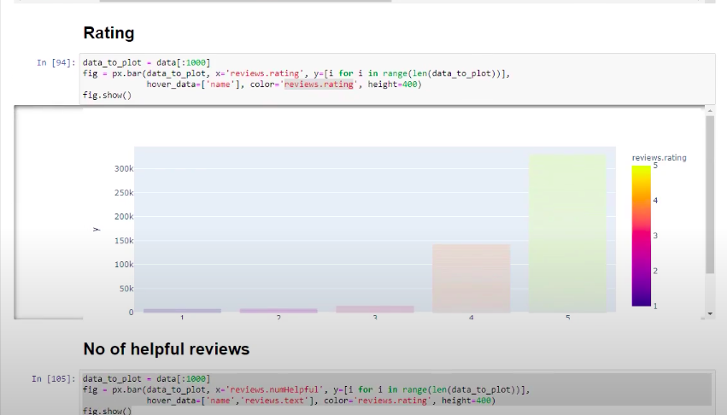

Review Rating are plot in above figure from 1* to 5*.
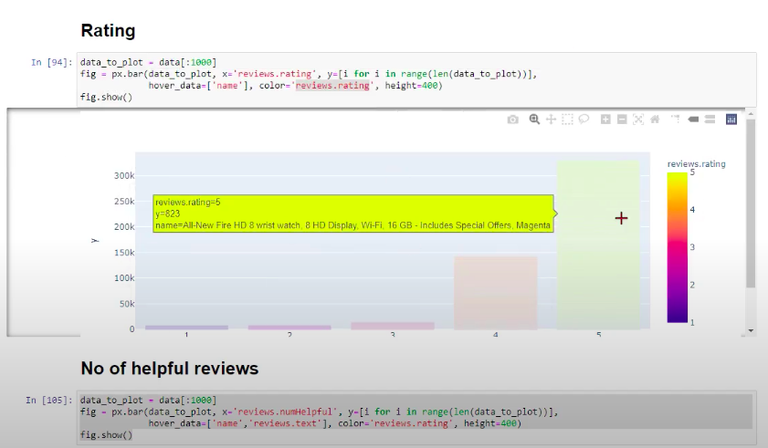

Review Rating are plot in above figure along which description what these rating are.

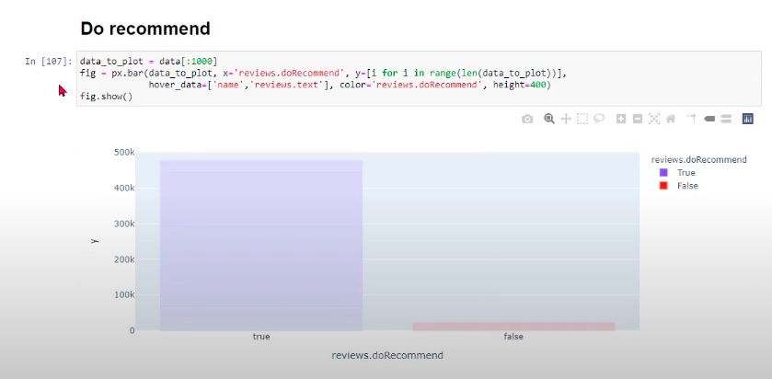

At the end recommended rating are plot which show result in True & False state in above figure.

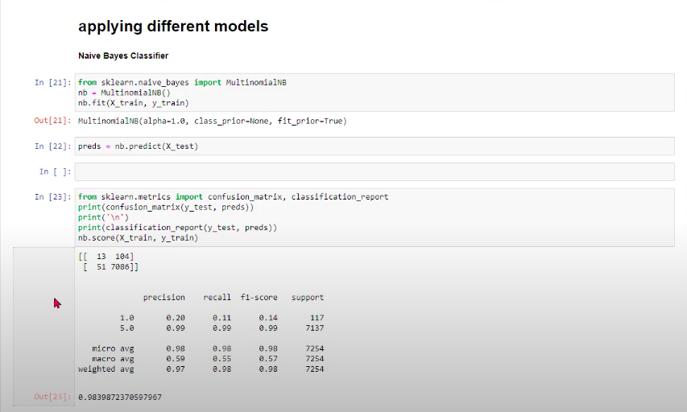

In above figure different models are applied through different libraries. Also can be seen ML models and Neural Network are apply for classification.

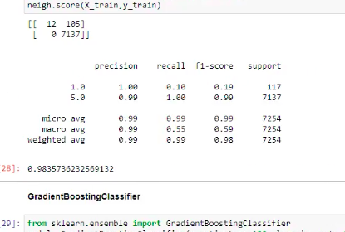

In above figure accuracy of each models are shown.
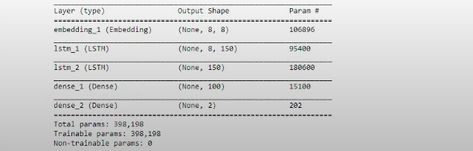

In above figure model summary of neural network build using module keras.

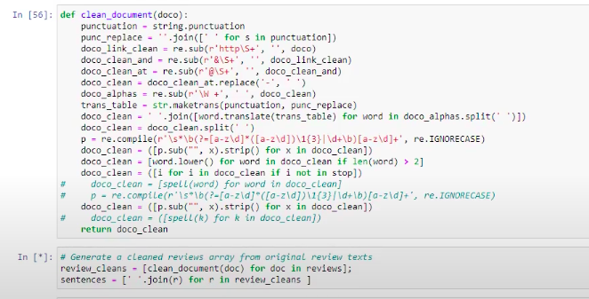

In above figure it seen document are clean from null value and from stopping words through libraries.

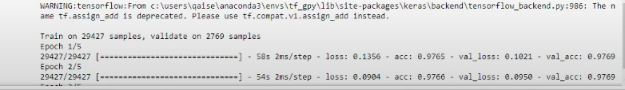

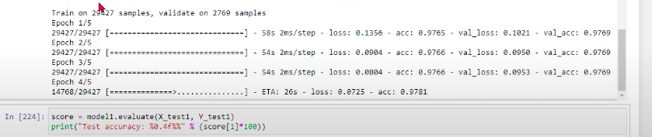

In above figures system are train through neural network model.

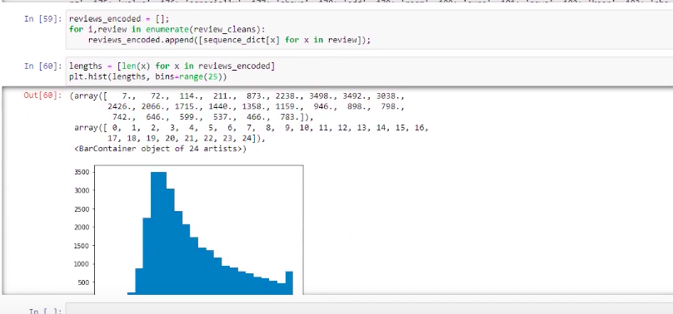

In above figure graph are plot through Plotly library.

Conclusions:

When a string (data set) passes over this model there will be reviews develop which tell the product owner (in our case we take data set of amazon watches) that what properties mostly liked by customers and on which features want enhancement. Likewise, through outcomes there will get an additional clue in future what customers need, what kind of further product will get in market that appeal more easily to customers.

Strength:

By this model product owner or store owner develop an idea if he introduces a product and its outcome, it full filled market tendencies or its fails. Like in our method we simply calculate the reviews from the outcome that what features are mostly liked by customers and what will need to be enhanced. Over this system product owner simply improve their product if desired.

Weaknesses:

It’s not a web-based method which means it is not obtained by anybody so it will be installed on everyone personal computer distinctly.

Future Potential:

In future we have to spread our system and create web based over which everybody can simply contact through simple clicks on web, and effortlessly develop the reviews by their product which will be supportive for their products.

References
- Liu, B., 2012. Sentiment analysis and opinion mining. Synthesis lectures on human language technologies, 5(1), pp.1-167.

- Pang, B. and Lee, L., 2008. Opinion Mining and Sentiment Analysis. Foundations and Trends® in Information Retrieval, 2(1–2), pp.1-135.

- Al-Moslmi, T., Omar, N., Abdullah, S. and Albared, M., 2017. Approaches to Cross-Domain Sentiment Analysis: A Systematic Literature Review. IEEE Access, 5, pp.16173-16192.

- Karim, M., Beyan, O., Zappa, A., Costa, I., Rebholz-Schuhmann, D., Cochez, M. and Decker, S., 2020. Deep learning-based clustering approaches for bioinformatics. Briefings in Bioinformatics, 22(1), pp.393-415.

- Aljalbout, E., Golkov, V., Siddiqui, Y., Strobel, M. and Cremers, D., 2018. Clustering with deep learning: Taxonomy and new methods. arXiv preprint arXiv:1801.07648.

- GreatLearning Blog: Free Resources what Matters to shape your Career!. 2020. Which is better Deep Learning or Machine Learning | Deep Learning vs ML. [online] Available at: https://www.mygreatlearning.com/blog/is-deep-learning-better-than-machine-learning

- Melwani, U., 2019. Open-source vs Proprietary Software - Which One Is More Secure?. [online] Srijan.net. Available at: https://www.srijan.net/blog/open-source-vs-proprietary-software-which-one-is-more-secure
- https://en.wikipedia.org/wiki/Project_Jupyter
- https://en.wikipedia.org/wiki/Long_short-term_memory
- https://www.upgrad.com/blog/top-python-libraries-for-machine-learning/
- https://towardsdatascience.com/top-10-python-libraries-for-data-science-cd82294ec266
- https://www.kdnuggets.com/2019/07/convolutional-neural-networks-python-tutorial-tensorflow-keras.html

Group Members and Roles:

Tefo Molemohi: Presentation and Video
Waseem Mehboob: Python Coding
Guilherme Correa Ramos: Final Report
Saim Ahmed: Python Coding

Appendix

