
Building a Secure Decentralized Application (DApp)Using OpenZeppelin
Lab 7

March 13, 2026
UOWD
Muath Alrammal

Table of Contents
1. Learning Objectives 2
2. Background 3
2.1 What is a DApp? 3
2.2 Architecture in This Lab 3
2.3 The FinancialContract 3
3. Smart Contract Review 4
3.1 Function Summary 5
4. Environment Setup 6
5. OpenZeppelin — Why and How to Use Audited Libraries 9
5.1 What is OpenZeppelin? 9
5.2 Why OpenZeppelin Matters for FinancialContract 9
5.3 Installing OpenZeppelin in Your Hardhat Project 9
5.4 Refactoring FinancialContract to Use OpenZeppelin Ownable 10
5.5 Upgrading to OpenZeppelin AccessControl 13
6. Part — Auto-Generate the DApp with dapp-generator.js 21
7. Run and Test the DApp 23
9. Troubleshooting Guide 33

Building a Secure Decentralized Application (DApp)
Using OpenZeppelin
MetaMask · Ganache · Web3.js · FinancialContract

Prerequisite | Lab 6 completed — Hardhat configured, Ganache running, FinancialContract.sol deployed
Estimated Time | 90 – 120 minutes
Tools Required | Ganache Desktop, MetaMask, VS Code, Node.js, Web Browser (Chrome/Firefox)
Contract | FinancialContract.sol — deposit, withdraw, getBalance, getContractBalance
Deliverables | DApp (index.html + app.js), Lab report with screenshots, Reflection answers

1. Learning Objectives
By the end of this lab you will be able to:
- Connect a browser-based DApp to MetaMask and detect the user’s Ethereum account
- Configure MetaMask to communicate with a local Ganache blockchain network
- Deploy and interact with the FinancialContract smart contract using Web3.js Use
- OpenZeppelin’s AccessControl module to manage smart contract permissions
- Assign and manage roles using grantRole() and revokeRole() functions
- Implement role-based access control to restrict functions such as deposit() and withdraw()
- Call the payable deposit() function and send real ETH from MetaMask
- Call the withdraw() function and observe how role-based restrictions are enforced
- Read contract state with getBalance() and getContractBalance() without gas cost
- Capture and display Deposit and Withdrawal events in real time
- Use the dapp-generator.js tool to automatically generate a DApp frontend from a smart contract

2. Background

2.1 What is a DApp?
A Decentralized Application (DApp) combines a traditional web frontend (HTML/CSS/JavaScript) with a smart contract backend running on the Ethereum blockchain. Unlike conventional web apps, no central server stores or controls the application’s core logic — the smart contract is the backend, deployed immutably on-chain.

2.2 Architecture in This Lab
- Presentation Layer — Static HTML/CSS/JS page served via http-server on localhost:3000
- Web3 Provider Layer — MetaMask (window.ethereum) signs and relays transactions
- Blockchain Layer — Ganache local network hosting the deployed FinancialContract

2.3 The FinancialContract
The contract you will interact with implements a simple on-chain fund manager. Key characteristics: it tracks an owner set at deployment, accepts ETH deposits from any address, restricts withdrawals to the owner only via the onlyOwner modifier, and emits events on every deposit and withdrawal for easy off-chain tracking.

3. Smart Contract Review
Study the full FinancialContract source before building the frontend. Understanding the function signatures, modifiers, and events is essential for writing correct Web3.js calls.

// SPDX-License-Identifier: MIT
pragma solidity ^0.8.20;

import "hardhat/console.sol";

/**
* @title FinancialContract
* @dev Manage deposits and withdrawals with owner control
*/
contract FinancialContract {
address public owner;
uint256 public balance;

event Deposit(address indexed sender, uint256 amount, uint256 newBalance);
event Withdrawal(address indexed recipient, uint256 amount, uint256 newBalance);

modifier onlyOwner() {
require(msg.sender == owner, "Only owner can call this function");
_;
}
modifier hasBalance(uint256 _amount) {
require(balance >= _amount, "Insufficient balance");
_;
}

constructor() {
owner = msg.sender;
balance = 0;
}

function deposit() public payable {
require(msg.value > 0, "Must send some ETH");
balance += msg.value;
emit Deposit(msg.sender, msg.value, balance);
}

function withdraw(uint256 _amount) public onlyOwner hasBalance(_amount) {
balance -= _amount;
payable(owner).transfer(_amount);
emit Withdrawal(owner, _amount, balance);
}

function getBalance() public view returns (uint256) {
return balance;
}

function getContractBalance() public view returns (uint256) {
return address(this).balance;
}
}

3.1 Function Summary
Function | Type | Access | Description
deposit() | payable | Anyone | Send ETH to the contract; emits Deposit event
withdraw(uint256) | nonpayable | Owner only | Withdraw _amount wei to owner; emits Withdrawal event
getBalance() | view | Anyone | Returns the tracked balance state variable
getContractBalance() | view | Anyone | Returns address(this).balance — actual ETH held
owner() | view | Anyone | Returns the owner address set in the constructor
balance() | view | Anyone | Returns the public state variable balance

4. Environment Setup
Step 1 — Verify Ganache and Hardhat

- Open Ganache Desktop. Confirm 10 pre-funded accounts each holding 100 ETH.
- Copy the MNEMONIC
- Open the file hardhat.config.ts. Replace the old value of MNEMONIC with the new one. Note we have done this before, it should be easy for you to do it.
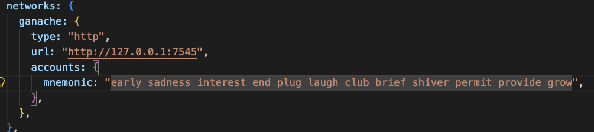

- Using terminal or powershell navigate to your Hardhat project from Lab 5.
- Under /contracts (from finder or windows explorer), access the FinancialContract.sol copy it to have a backup. Save the copy outside the folder contracts.
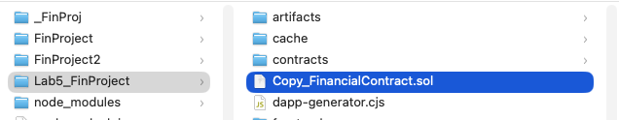
- (Done before) Navigate back to the main folder of the project. Deploy FinancialContract to Ganache:

npx hardhat run scripts/deploy.js --network ganache

- Copy and save the contract address printed in the terminal.

⚠️ Keep Ganache running throughout the entire lab. Restarting Ganache resets the blockchain and changes the contract address.

Step 2 — Install MetaMask (Done before)

- Open Chrome or Firefox and install the MetaMask extension from https://metamask.io
- Create a new wallet and record your Secret Recovery Phrase. A simple password is fine for this testnet lab.

Step 3 — Connect MetaMask to Ganache (Done before)

- Click the MetaMask fox icon → network dropdown → “Add Network” → “Add a network manually”.
- Enter these exact values:

Field | Value
Network Name | Ganache Local
New RPC URL | http://127.0.0.1:7545
Chain ID | 1337
Currency Symbol | ETH
Block Explorer URL | (leave blank)

- Click “Save”. MetaMask should now show “Ganache Local”.

Step 4 — Import a Ganache Account into MetaMask (you have to do it )

- In Ganache, click the 🔑 key icon next to Account 1 to reveal its private key.
- Copy the private key.
- In MetaMask→ “Import Accounts” Wallet→import an acoount →paste key → “Import”.
- Confirm the balance shows ~100 ETH.

ℹ️ Account 1 (index 0) in Ganache is the deployer and therefore the owner of FinancialContract. You must use this account to call withdraw().

Copy the private key
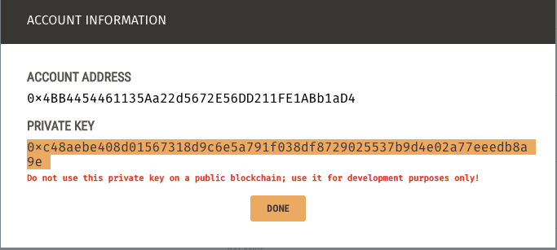
Click on imported accounts drop dowm menu
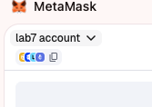

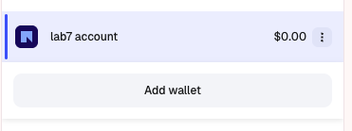
Click on import an account

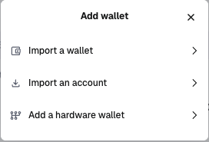

Past the private key and rename the account to be for example lab7 Account.
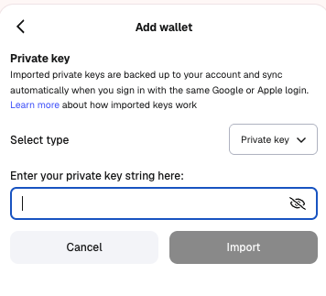

5. OpenZeppelin — Why and How to Use Audited Libraries

5.1 What is OpenZeppelin?
OpenZeppelin is the most widely used open-source library for secure smart contract development on Ethereum. It provides pre-written, community-audited Solidity modules that implement battle-tested patterns: access control, token standards (ERC-20, ERC-721, ERC-1155), security guards, and upgrade mechanisms. Using OpenZeppelin significantly reduces the risk of introducing well-known vulnerabilities into your contracts.

Category | Key Contracts
Access Control | Ownable, Ownable2Step, AccessControl, AccessControlEnumerable
Fungible Tokens | ERC20, ERC20Burnable, ERC20Permit, ERC20Votes
NFTs | ERC721, ERC721Enumerable, ERC721URIStorage, ERC1155
Security | ReentrancyGuard, Pausable, PullPayment
Utilities | Address, Strings, Math, SafeCast, Counters
Upgradability | TransparentUpgradeableProxy, UUPS, Beacon

5.2 Why OpenZeppelin Matters for FinancialContract
The onlyOwner modifier written manually in FinancialContract re-implements logic that already exists in OpenZeppelin’s Ownable contract — a version that has been formally reviewed, fuzz-tested by thousands of developers, and audited by professional security firms. The risks of writing access control from scratch include subtle logic bugs, inconsistent error messages that break off-chain monitoring, and missing features like transferOwnership() that users expect.

📚 Industry Insight: The 2022 Nomad Bridge hack ($190M) and the 2021 Poly Network hack ($611M) both exploited access-control flaws. OpenZeppelin’s Ownable or AccessControl would have prevented both. Reusing audited libraries is professional practice, not laziness.

5.3 Installing OpenZeppelin in Your Hardhat Project
- Install the contracts package:

npm install @openzeppelin/contracts

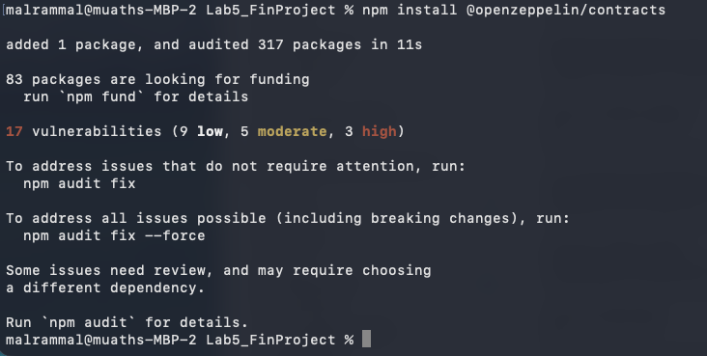
- Verify the access folder exists:

ls node_modules/@openzeppelin/contracts/access/

You should see Ownable.sol, Ownable2Step.sol, and AccessControl.sol among others.

5.4 Refactoring FinancialContract to Use OpenZeppelin Ownable
Replace the manual owner variable and onlyOwner modifier with inheritance from OpenZeppelin Ownable. The refactored contract is shorter and gains transferOwnership() and renounceOwnership() for free:
- Open you smart contracrt and replace its content with the one below.
// SPDX-License-Identifier: MIT
pragma solidity ^0.8.20;

import "@openzeppelin/contracts/access/Ownable.sol";
import "hardhat/console.sol";

contract FinancialContract is Ownable {
uint256 public balance;

event Deposit(address indexed sender, uint256 amount, uint256 newBalance);
event Withdrawal(address indexed recipient, uint256 amount, uint256 newBalance);

modifier hasBalance(uint256 _amount) {
require(balance >= _amount, "Insufficient balance");
_;
}

// OpenZeppelin v5: must pass initialOwner to Ownable constructor
constructor() Ownable(msg.sender) {
balance = 0;
}

function deposit() public payable {
require(msg.value > 0, "Must send some ETH");
balance += msg.value;
emit Deposit(msg.sender, msg.value, balance);
}

// onlyOwner comes from Ownable — no need to define it manually
function withdraw(uint256 _amount) public onlyOwner hasBalance(_amount) {
balance -= _amount;
payable(owner()).transfer(_amount); // owner() is now a function call
emit Withdrawal(owner(), _amount, balance);
}

function getBalance() public view returns (uint256) { return balance; }
function getContractBalance() public view returns (uint256) { return address(this).balance; }
}

- Deploy the changeed/updated smart contract

npx hardhat run scripts/deploy.js --network ganache

What Changed?
Aspect | Original (manual) | With OpenZeppelin
Owner storage | address public owner | Inherited from Ownable
onlyOwner modifier | Written manually | Inherited from Ownable
Read owner address | owner (public variable) | owner() function
Transfer ownership | Not available | transferOwnership(addr)
Renounce ownership | Not available | renounceOwnership()
Security audit | Unaudited | Audited by OpenZeppelin

Changing Ownership — Step-by-Step
The two inherited functions below are the only ownership-management tools you need. Call them from a Hardhat script or directly in the console.

- Open a Hardhat console session connected to Ganache:

npx hardhat console --network ganache

- Attach to the deployed contract and confirm the current owner. Run the below code line by line. Do not forget to get the contract address from ganache.

const { ethers } = await network.connect();

const FC = await ethers.getContractFactory("FinancialContract");
const contract = await FC.attach("<DEPLOYED_Contract_ADDRESS>");

// Should return Ganache Account 1 (the deployer)
await contract.owner();

In my case, it is :
const { ethers } = await network.connect();
const FC = await ethers.getContractFactory("FinancialContract");
const contract = await FC.attach("0x04F0F1984a610C1f863556557A74d6EaE3770565");
// Should return Ganache Account 1 (the deployer)
await contract.owner();

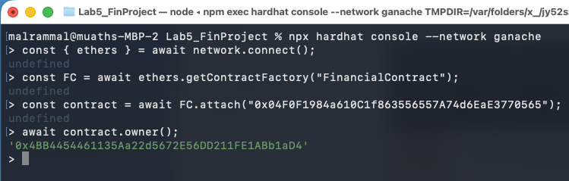

- Transfer ownership to a second Ganache account:

const [owner, newOwner] = await ethers.getSigners();

// transferOwnership() is inherited from OpenZeppelin Ownable.
// It validates newOwner != address(0) and emits OwnershipTransferred.
const tx = await contract.connect(owner).transferOwnership(newOwner.address);
await tx.wait();

// Confirm — should now return newOwner.address
await contract.owner();

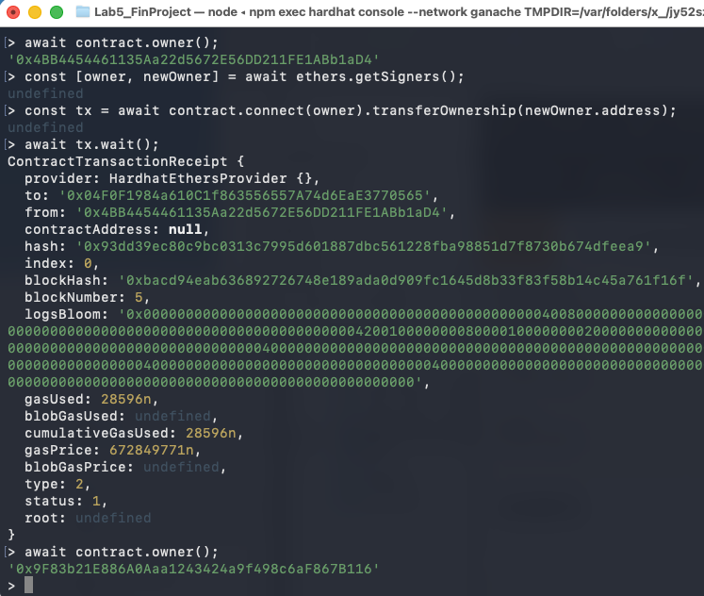
- To permanently remove all ownership (irreversible — use with extreme caution/ do not do it ):

// Sets owner to address(0). No wallet can ever call onlyOwner again.
const tx = await contract.connect(owner).renounceOwnership();
await tx.wait();

// Returns 0x0000000000000000000000000000000000000000
await contract.owner();

⚠️ renounceOwnership() is permanent and irreversible. Only use it to make a contract intentionally permissionless.

ℹ️ For safer transfers, replace Ownable with Ownable2Step.sol. The recipient must explicitly call acceptOwnership() to confirm — preventing accidental transfers to wrong addresses.

5.5 Upgrading to OpenZeppelin AccessControl
Section 5.4 introduced Ownable — a single-owner model. This section upgrades that same contract to AccessControl, replacing the single owner with two independently managed roles: DEPOSITOR_ROLE and WITHDRAWER_ROLE. Highlighted lines are the ones that change; everything else stays identical.

The Upgraded Contract (highlighted lines = changes from 5.4)
- Open you smart contracrt and replace its content with the one below.

// SPDX-License-Identifier: MIT
pragma solidity ^0.8.20;

// ── CHANGE 1: swap the import ─────────────────────────────────────
import "@openzeppelin/contracts/access/AccessControl.sol";
import "hardhat/console.sol";

/**
* @title FinancialContract (5.5 — AccessControl upgrade)
* @notice deposit() requires DEPOSITOR_ROLE.
* withdraw() requires WITHDRAWER_ROLE.
* DEFAULT_ADMIN_ROLE can grant / revoke both.
*/
// ── CHANGE 2: inherit AccessControl instead of Ownable ────────────
contract FinancialContract is AccessControl {

// ── CHANGE 3: declare named role constants ──────────────────────
bytes32 public constant WITHDRAWER_ROLE = keccak256("WITHDRAWER_ROLE");
bytes32 public constant DEPOSITOR_ROLE = keccak256("DEPOSITOR_ROLE");

uint256 public balance;

event Deposit(address indexed sender, uint256 amount, uint256 newBalance);
event Withdrawal(address indexed recipient, uint256 amount, uint256 newBalance);

modifier hasBalance(uint256 _amount) {
require(balance >= _amount, "Insufficient balance");
_;
}

// ── CHANGE 4: constructor grants roles instead of Ownable(msg.sender) ──
constructor() {
_grantRole(DEFAULT_ADMIN_ROLE, msg.sender); // full admin
_grantRole(WITHDRAWER_ROLE, msg.sender); // can withdraw
_grantRole(DEPOSITOR_ROLE, msg.sender); // can deposit
balance = 0;
}

// ── CHANGE 5a: restrict deposit() to DEPOSITOR_ROLE ───────────────
function deposit() public payable onlyRole(DEPOSITOR_ROLE) {
require(msg.value > 0, "Must send some ETH");
balance += msg.value;
emit Deposit(msg.sender, msg.value, balance);
}

// ── CHANGE 5b: restrict withdraw() to WITHDRAWER_ROLE ─────────────
function withdraw(uint256 _amount)
public
onlyRole(WITHDRAWER_ROLE)
hasBalance(_amount)
{
balance -= _amount;
payable(msg.sender).transfer(_amount);
emit Withdrawal(msg.sender, _amount, balance);
}

// Unchanged from 5.4 ─────────────────────────────────────────────
function getBalance() public view returns (uint256) {
return balance;
}

function getContractBalance() public view returns (uint256) {
return address(this).balance;
}
}

Change-by-Change Explanation
Change 1 — swap the import. AccessControl.sol replaces Ownable.sol. No other import is needed; onlyRole() is defined inside AccessControl.
Change 2 — update the inheritance declaration. is AccessControl replaces is Ownable. This removes the owner() state variable and brings in hasRole(), grantRole(), revokeRole(), and the onlyRole() modifier.
Change 3 — declare role constants. Each role is a bytes32 hash of a human-readable string. Storing it as a public constant lets scripts reference the same value without recomputing the hash manually.
Change 4 — rewrite the constructor. Ownable(msg.sender) is replaced by three _grantRole() calls. The deployer receives DEFAULT_ADMIN_ROLE (can manage all other roles), WITHDRAWER_ROLE, and DEPOSITOR_ROLE so they can immediately use the contract.
Change 5 — swap the modifiers. onlyOwner on deposit() and withdraw() is replaced by onlyRole(DEPOSITOR_ROLE) and onlyRole(WITHDRAWER_ROLE) respectively. The revert message and gas cost are equivalent.

Steps to Create, Grant, and Revoke Roles

- Recompile — AccessControl.sol is pulled in automatically via the import:

npx hardhat compile

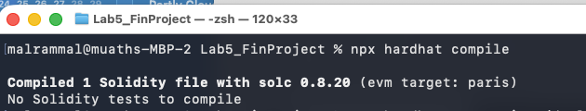
- Redeploy to Ganache and save the new contract address:

npx hardhat run scripts/deploy.cjs --network ganache

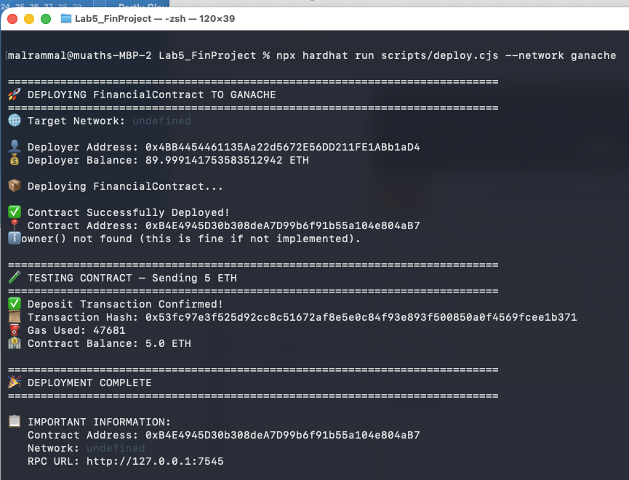

- Create a script file, name it manageRole.cjs. Add it under the folder scripts. Add the following code to it. You can do it either from teminal/fnder or powershell/windows explorer. In this lab, the terminal is used.
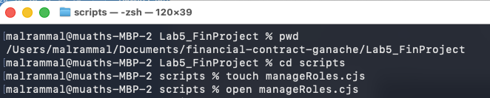
Once the file is opened, just paste the script code below and save the file.
Note: Do not forget to add the address of your smart contract in the script. Go to ganache, and check the last block created and the address of the smart contract.

Note: the file is also provided on moodle, you can download it. However, you need to read it carefully to understand the next step.
/**
* scripts/manageRoles.cjs
*
* Connect to Ganache first, then attach to a deployed FinancialContract
* and manage roles using ethers + Hardhat artifacts.
*/

async function main() {
// Import Hardhat only for reading compiled artifacts
const hardhatModule = await import("hardhat");
const hre = hardhatModule.default ?? hardhatModule;

// Import ethers directly
const ethersModule = await import("ethers");
const {
JsonRpcProvider,
Contract,
} = ethersModule;

// --------------------------------------------------
// 1. Connect to Ganache
// --------------------------------------------------
const rpcUrl = "http://127.0.0.1:7545"; // Change if needed
const provider = new JsonRpcProvider(rpcUrl);

const net = await provider.getNetwork();
console.log("Connected to Ganache");
console.log("Chain ID:", net.chainId.toString());

// --------------------------------------------------
// 2. Get Ganache signers
// --------------------------------------------------
const admin = await provider.getSigner(0);
const depositor = await provider.getSigner(1);
const withdrawer = await provider.getSigner(2);

const adminAddress = await admin.getAddress();
const depositorAddress = await depositor.getAddress();
const withdrawerAddress = await withdrawer.getAddress();

console.log("Admin:", adminAddress);
console.log("Depositor:", depositorAddress);
console.log("Withdrawer:", withdrawerAddress);

// --------------------------------------------------
// 3. Put your deployed contract address here. Get it from Ganache
// --------------------------------------------------
const deployedAddress = "0xdb5445F4123F6726e40112a4f9069e9C0Aa59e58";

// --------------------------------------------------
// 4. Read ABI from Hardhat artifacts
// --------------------------------------------------
const artifact = await hre.artifacts.readArtifact("FinancialContract");

// Create contract instance connected as admin
const contract = new Contract(deployedAddress, artifact.abi, admin);

// --------------------------------------------------
// 5. Read role constants from the contract
// --------------------------------------------------
// This assumes your Solidity contract has:
// bytes32 public constant WITHDRAWER_ROLE = ...
// bytes32 public constant DEPOSITOR_ROLE = ...
const WITHDRAWER_ROLE = await contract.WITHDRAWER_ROLE();
const DEPOSITOR_ROLE = await contract.DEPOSITOR_ROLE();

// --------------------------------------------------
// 6. Grant DEPOSITOR_ROLE to account 2
// --------------------------------------------------
const tx1 = await contract.grantRole(DEPOSITOR_ROLE, depositorAddress);
await tx1.wait();
console.log("Depositor role granted to:", depositorAddress);

// --------------------------------------------------
// 7. Grant WITHDRAWER_ROLE to account 3
// --------------------------------------------------
const tx2 = await contract.grantRole(WITHDRAWER_ROLE, withdrawerAddress);
await tx2.wait();
console.log("Withdrawer role granted to:", withdrawerAddress);

// --------------------------------------------------
// 8. Verify both roles
// --------------------------------------------------
console.log(
"Depositor has role:",
await contract.hasRole(DEPOSITOR_ROLE, depositorAddress)
);

console.log(
"Withdrawer has role:",
await contract.hasRole(WITHDRAWER_ROLE, withdrawerAddress)
);

// --------------------------------------------------
// 9. Revoke DEPOSITOR_ROLE from account 2
// --------------------------------------------------
const tx3 = await contract.revokeRole(DEPOSITOR_ROLE, depositorAddress);
await tx3.wait();

console.log(
"Depositor has role after revoke:",
await contract.hasRole(DEPOSITOR_ROLE, depositorAddress)
);
}

main().catch((error) => {
console.error("Script failed:");
console.error(error);
process.exitCode = 1;
});

- Then, Run the role management script to grant roles to Accounts 2 and 3, verify them, then revoke one:
npx hardhat run scripts/manageRoles.cjs --network ganache
Output:

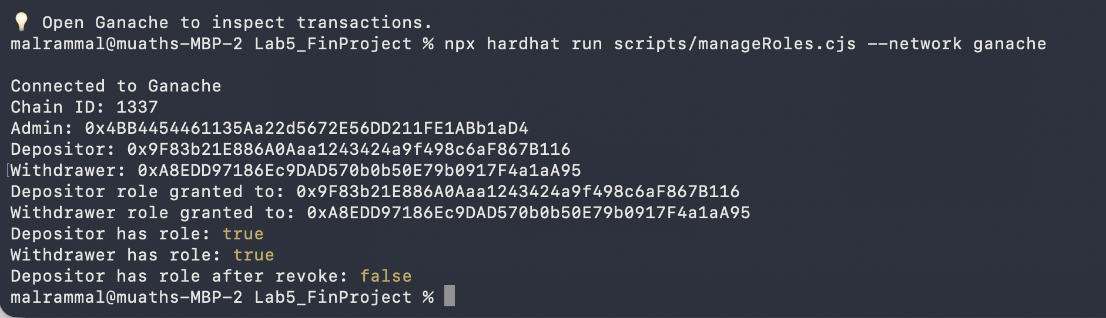
Connected to Ganache
Chain ID: 1337
Admin: 0x<Account 1 address>
Depositor: 0x<Account 2 address>
Withdrawer: 0x<Account 3 address>
Depositor role granted to: 0x<Account 2 address>
Withdrawer role granted to: 0x<Account 3 address>
Depositor has role: true
Withdrawer has role: true
Depositor has role after revoke: false

What Changed vs the 5.4 Ownable Version

Aspect | 5.4 Ownable | 5.5 AccessControl
Import | Ownable.sol | AccessControl.sol
Inheritance | is Ownable | is AccessControl
Constructor | Ownable(msg.sender) | _grantRole(DEFAULT_ADMIN_ROLE, ...)
Role constants | Not needed | WITHDRAWER_ROLE, DEPOSITOR_ROLE
Permission model | Single owner address | Multiple named role hashes
Modifier | onlyOwner | onlyRole(ROLE_CONSTANT)
Grant access | transferOwnership(addr) | grantRole(ROLE, addr)
Revoke access | renounceOwnership() only | revokeRole(ROLE, addr)
Check access | owner() == msg.sender | hasRole(ROLE, msg.sender)
⚠️ Anti-Pattern: Do NOT write a custom changeOwnership() function. OpenZeppelin's inherited transferOwnership() is already audited, emits OwnershipTransferred, and validates newOwner != address(0). A custom name also breaks compatibility with block explorers and DApp tools that recognise the standard ABI.

ℹ️ DEFAULT_ADMIN_ROLE is the master key — its holder can grant and revoke every other role. In production, always assign it to a Gnosis Safe multi-sig. When migrating the admin, always grantRole to the new admin first, then revokeRole from the old one after confirming the new admin can act.

⚠️ AccessControl does not include transferOwnership(). To migrate the admin: (1) grantRole(DEFAULT_ADMIN_ROLE, newAdmin), (2) new admin confirms by calling an admin function, (3) revokeRole(DEFAULT_ADMIN_ROLE, oldAdmin). Never revoke before confirming.

6. Part — Auto-Generate the DApp with dapp-generator.js
Hardhat stores the compiled contract ABI in the artifacts/ folder as a JSON file. The dapp-generator.js tool reads that JSON, inspects every function and event in the ABI, and automatically produces a complete index.html + app.js frontend tailored to your specific contract. You do not need to write the boilerplate code by hand.

Step 1 — Download dapp-generator.js

- Save the provided dapp-generator.js file into the root of your Hardhat project.
- Confirm it is present:

ls dapp-generator.js

Step 2 — Run the Generator

- In the VS Code terminal, run the generator pointing at your compiled artifact. Replace <YOUR_DEPLOYED_ADDRESS> with the address from Step 1.1.

node dapp-generator.cjs \
artifacts/contracts/FinancialContract.sol/FinancialContract.json \
--address <YOUR_DEPLOYED_ADDRESS> \
--out ./frontend \
--network http://127.0.0.1:7545 \
--chain 1337

node dapp-generator.js \
artifacts/contracts/FinancialContract.sol/FinancialContract.json \
--address 0xdb5445F4123F6726e40112a4f9069e9C0Aa59e58 \
--out ./frontend \
--network http://127.0.0.1:7545 \
--chain 1337
However, for windows run:
artifacts/contracts/FinancialContract.sol/FinancialContract.json `
--address 0xdb5445F4123F6726e40112a4f9069e9C0Aa59e58 `
--out ./frontend `
--network http://127.0.0.1:7545 `
--chain 1337

- The tool will print a summary and create two files:

frontend/
index.html ← complete dark-themed UI with one card per function
app.js ← Web3.js code pre-wired to your contract ABI and address

Output:
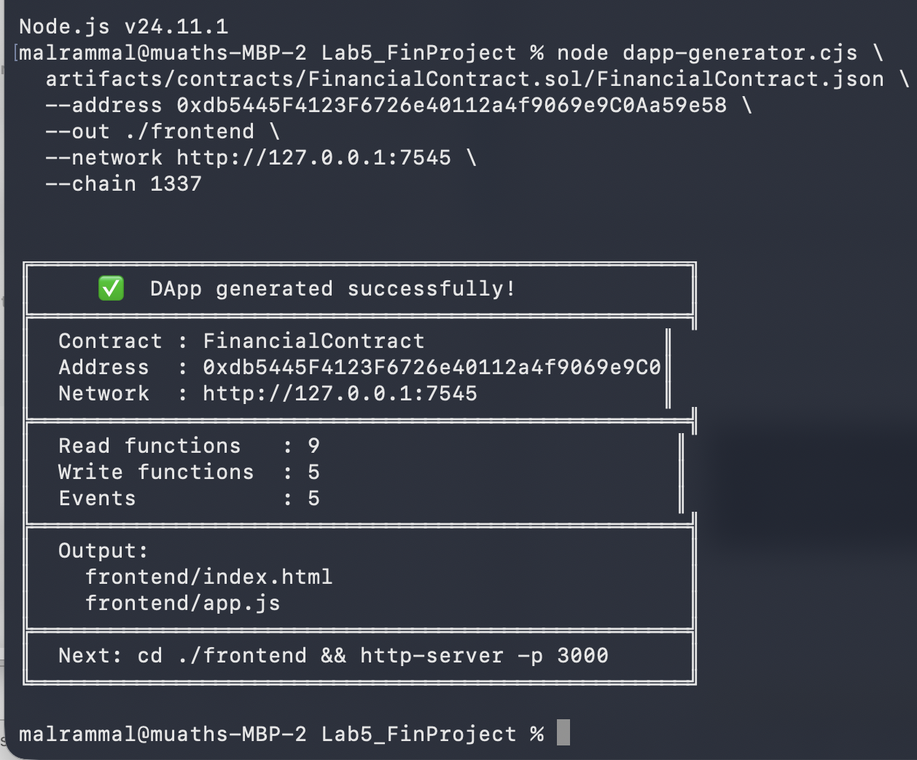

💡 How the generator works: it classifies every ABI entry — view/pure functions become Read cards (no gas), payable functions get an ETH amount input, nonpayable functions get a MetaMask confirmation button, and events are subscribed to automatically.

Step 3 — Inspect the Generated Files

- Open frontend/index.html in VS Code. You will see individual cards for: owner(), balance(), getBalance(), getContractBalance(), deposit(), and withdraw().
- Open frontend/app.js. Locate the CONTRACT_ADDRESS and CONTRACT_ABI constants at the top. Verify your address is embedded correctly.
- Notice the generated functions: call_owner(), call_getBalance(), call_getContractBalance(), send_deposit(), send_withdraw().

7. Run and Test the DApp
Step 1 — Start the Local Web Server

- Install http-server if not already installed:
npm install http-server --save-dev

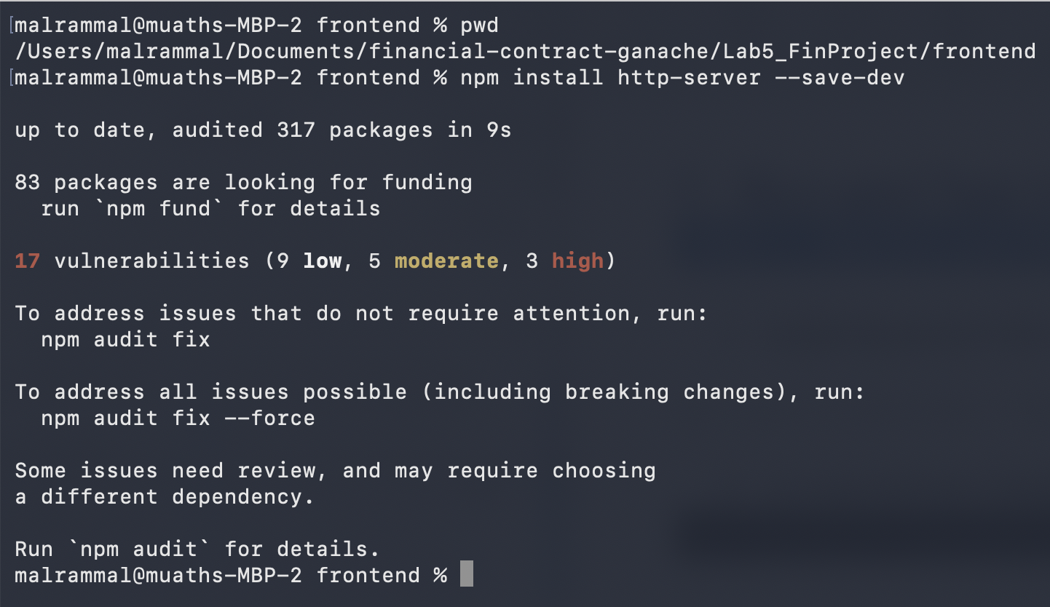
- In a new terminal, Navigate to the frontend folder and start the server:
Npx http-server -p 3000

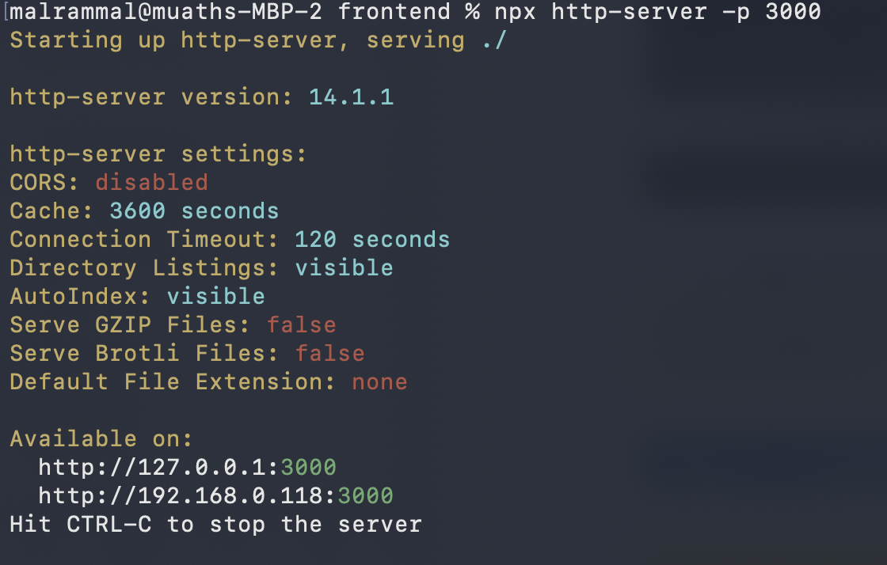
- Open Chrome at http://localhost:3000
ℹ The DApp must be served over HTTP. Opening index.html via file:// prevents MetaMask from injecting window.ethereum.
Check the interface:
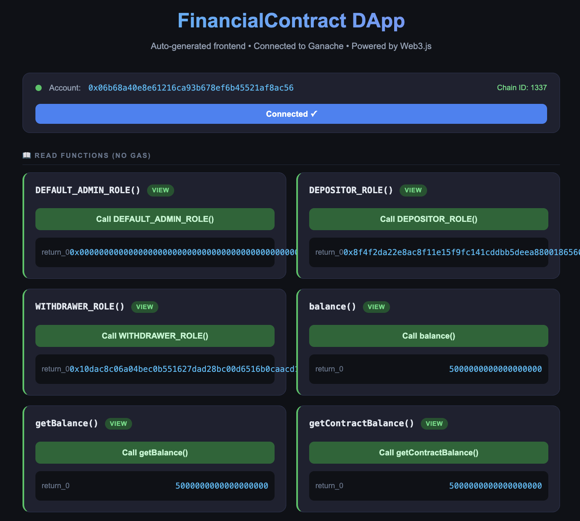
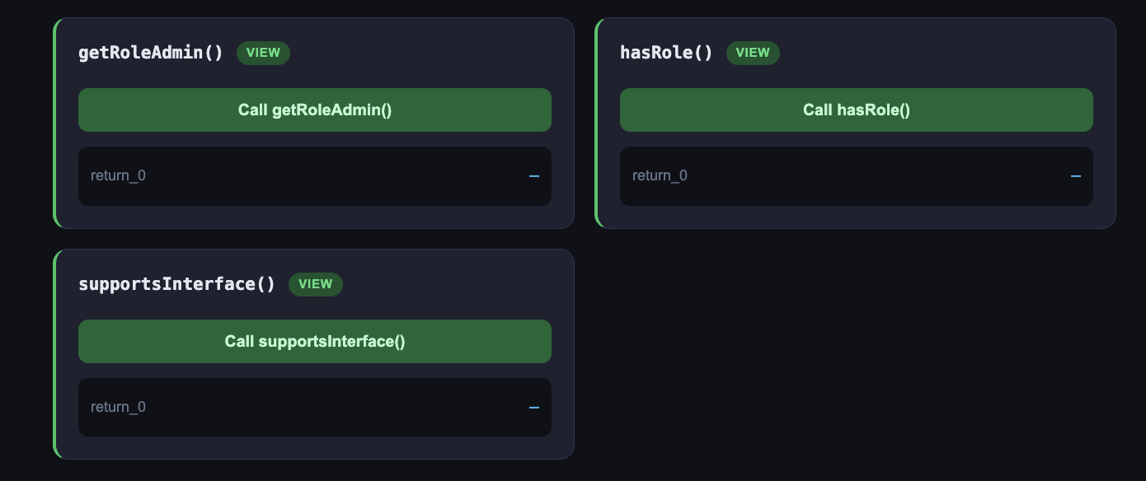
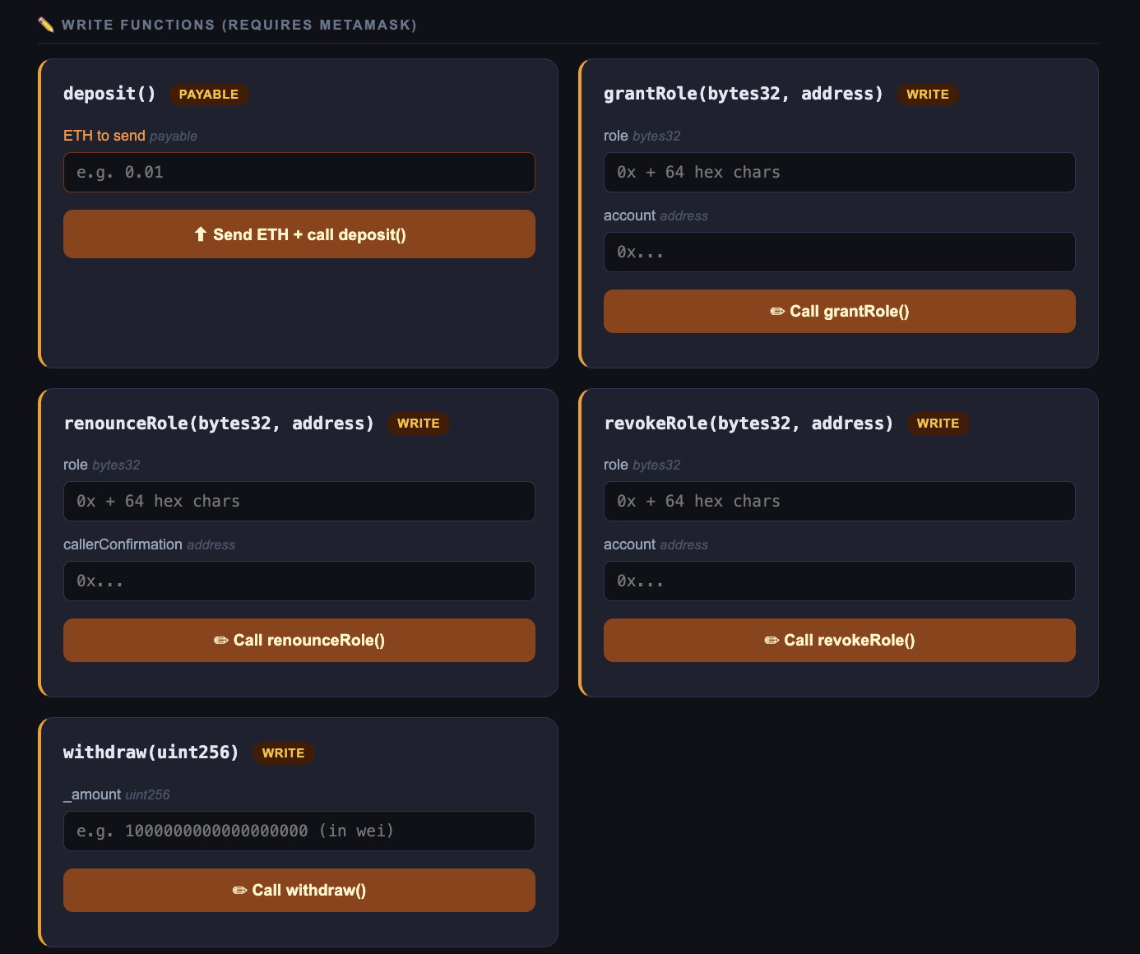

Step 2 — Assign Roles via manageRoles Script (Done)

We did before: only do it if you want to change the script: like the accounts, the revoke, the grant
Before connecting the wallet or testing contract functions, you must assign the DEPOSITOR_ROLE and WITHDRAWER_ROLE to the appropriate Ganache accounts using the provided management script.

Remember: the script performs the following operations in sequence:
- Reads DEPOSITOR_ROLE and WITHDRAWER_ROLE bytes32 constants from the deployed contract
- Calls grantRole(DEPOSITOR_ROLE, Account 2) — Account 2 can now call deposit()
- Calls grantRole(WITHDRAWER_ROLE, Account 3) — Account 3 can now call withdraw()
- Verifies both roles with hasRole()
- Demonstrates revokeRole() by removing the DEPOSITOR_ROLE from Account 2

ℹ Account 1 (index 0) is the DEFAULT_ADMIN_ROLE holder — it was set as admin during contract deployment. Only the admin can call grantRole() and revokeRole().

Step 3 — Connect Wallet

- Click "Connect MetaMask". A MetaMask popup will appear.
- Import the first four accounts to metamask and named them as per the image below. Remember, you need to get the private key from ganache.

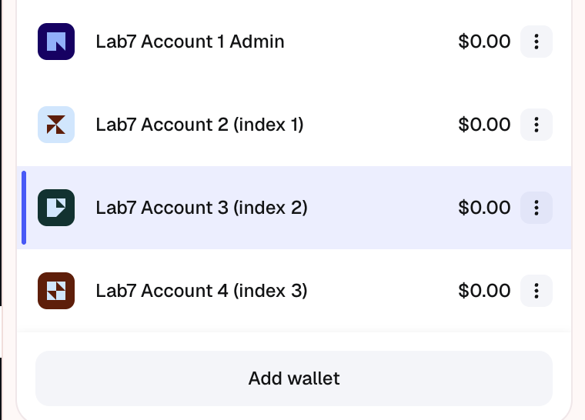

Step 4 — Test deposit() — Unauthorised Account (Access Control Check)

deposit() requires the caller to hold DEPOSITOR_ROLE. Lab7 Account 2 was granted this role, but revoked after that as per the script. So technically, this account now, cannot deposit money.

- Switch MetaMask to Account 2 (the depositor). Then connect. After that refresh html page http://localhost:3000/
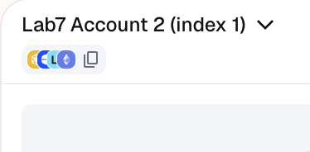

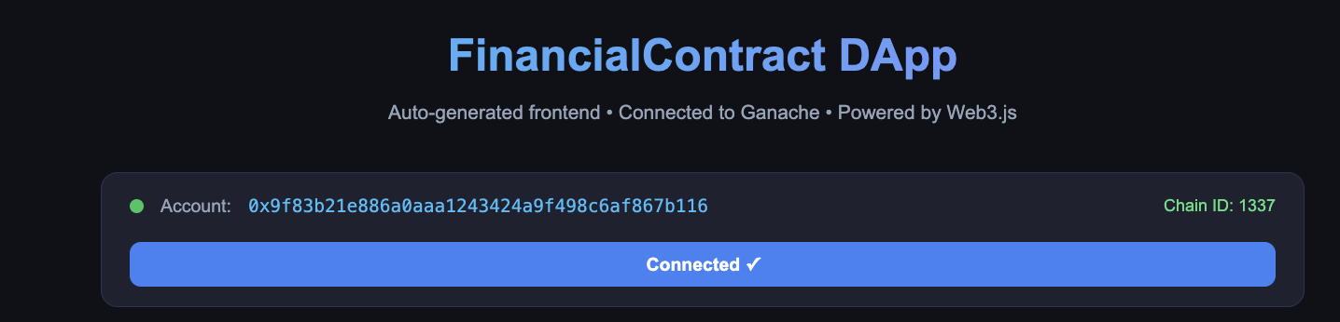
- Find the deposit() card (labelled "payable").
- Enter an ETH amount (e.g. 2) in the "ETH to send" field.
- Click "Send ETH + call deposit()". MetaMask will open a confirmation popup showing the ETH amount and estimated gas.
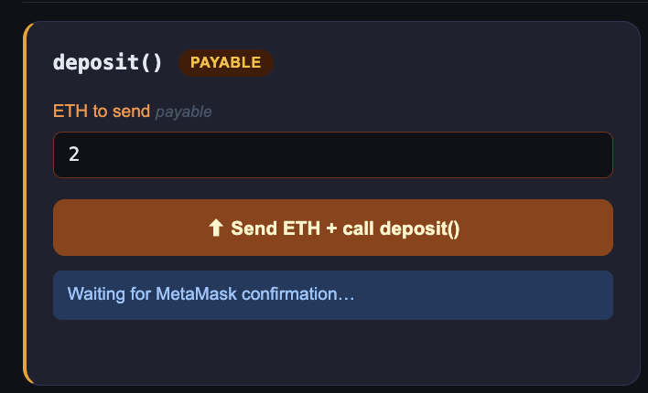 | 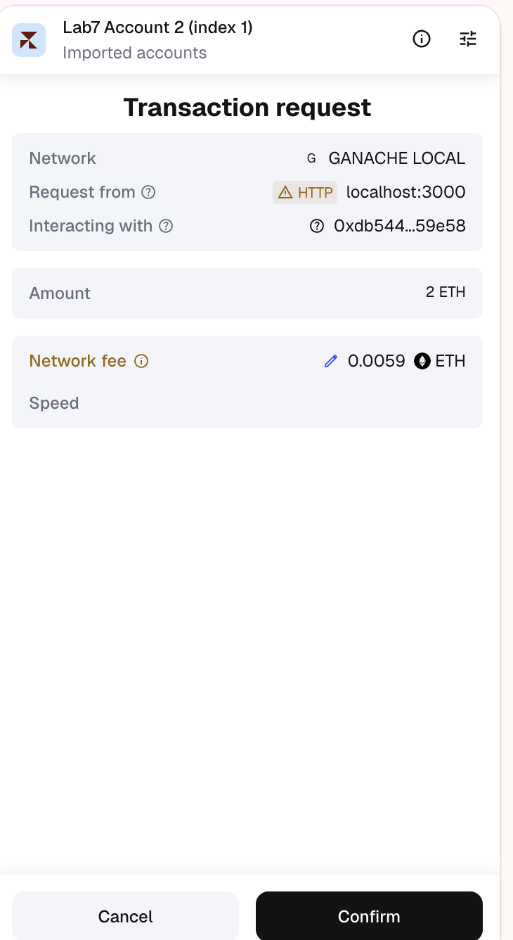
Output
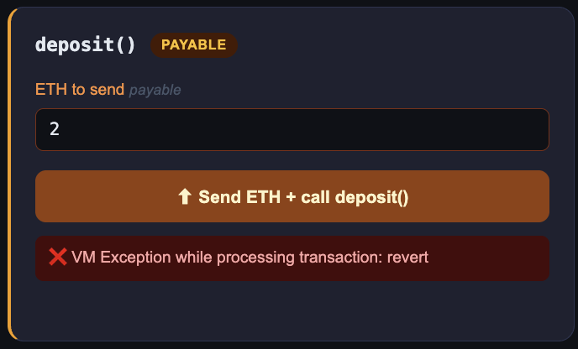
Can you explain it?
Explanation: in the deployment script “manageRoles.cjs” we granted account 2 the deposit role, then, we revoked it. The question is how to re-grant it to account 2?

How to Fix it?
- In MetaMask, connect as Admin (Lab7 Admin), the resreach the application interface (html of the http://localhost:3000/). Makesure the address of index 0 (ganache) appear next the account field ad per the screenshot below.
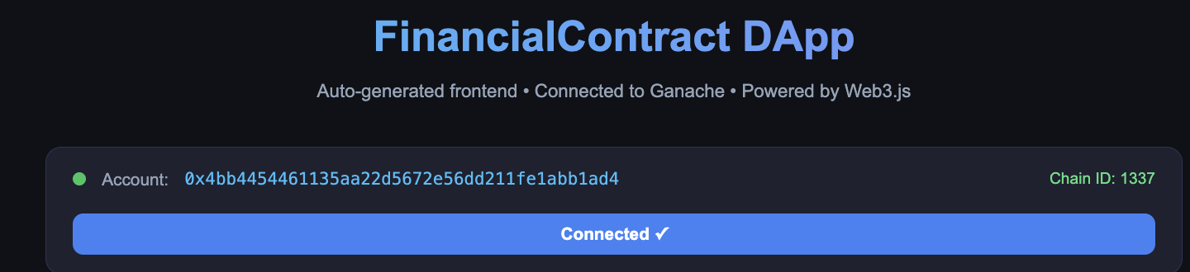
- Invoke the method Depositor_role() and copy the role value of byte23: it starts by 0x..
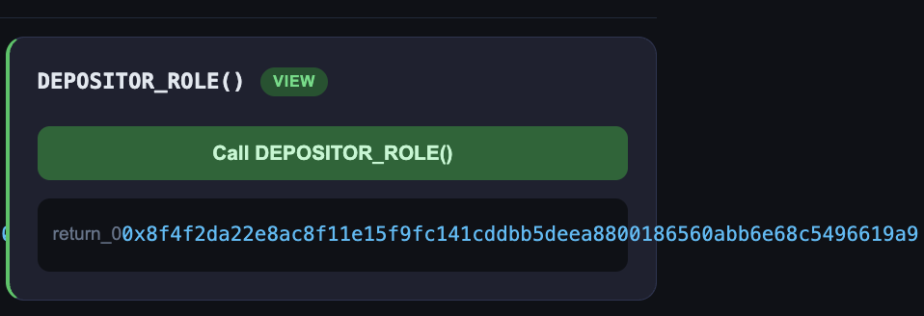

- Invoke the method grantRole() that needs two arguments:
first: the output value of DEPOSITOR_ROLE() that is byte23
second: the addess that we would like to grant it the role. In our example, account 2 that has index 1 (you can copy it from ganache).
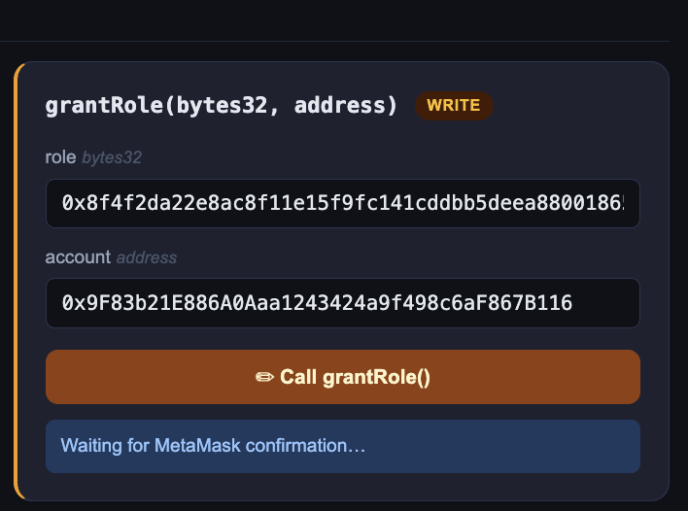
- Click "Confirm" in MetaMask: Note the the application is waiting the confirmation from metamask. So confirm this request/transaction. And you will get the cnfirmation form the applciation as per the sceenshot below.

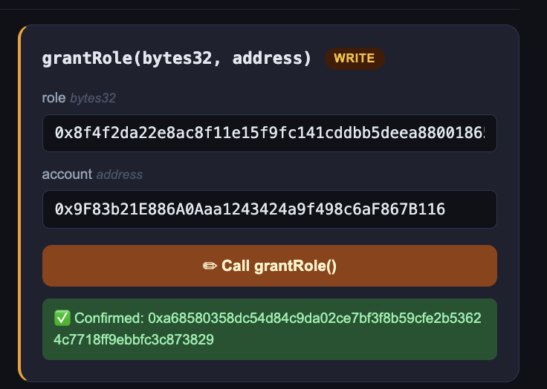

.
Observe: the status bar shows the transaction hash, the balance cards update, and a Deposit event appears in the event log panel.

- In Ganache Desktop, check the Transactions tab — you should see the new transaction.

In the next step, we will exmain if Lab7 Account 2 can deposit money.

Step 5 — Test deposit() — Authorised Account

- MetaMask: connect as Lab7 Account 2 to check if this accont is allowed to deposit money to the smart contract. Then refresch the application.
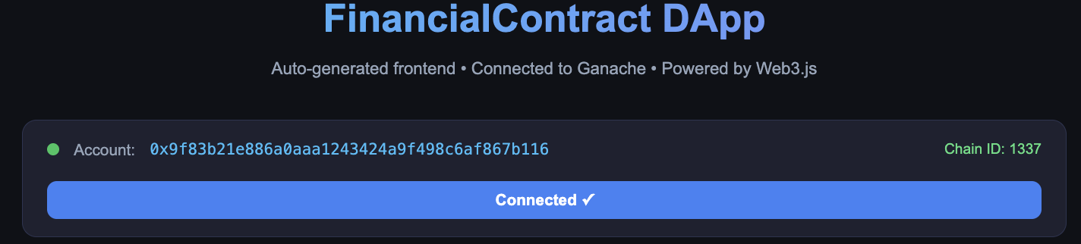

- Invoke the method deposit, send 2 Eth
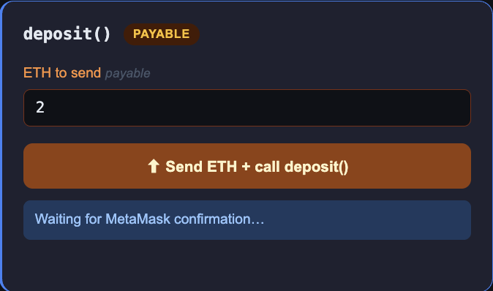

- MetaMask : confirm the transaction request.

- Check the result. See the confirmation hash. You can also check the balance of the second account on ganache (index 1).
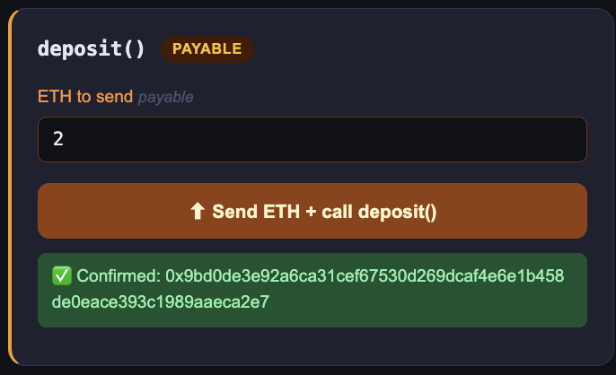

Note: All steps below must be done by the student

Step 6 — Student Work: Test deposit() —Account 3

Now verify that an account without DEPOSITOR_ROLE cannot call deposit(). Use Account 3. It holds WITHDRAWER_ROLE only.
- Switch MetaMask to Account 3 (the withdrawer — no DEPOSITOR_ROLE).
- Find the deposit() card and enter any ETH amount (e.g. 0.1).
- Click "Send ETH + call deposit()".
- MetaMask will still show a confirmation popup — click "Confirm".
- Observe the transaction fails. The status bar should display a revert error:
AccessControl: account 0x<Account 3> is missing role 0x<DEPOSITOR_ROLE hash>
- In Ganache Desktop, check the Transactions tab — the transaction appears but is marked as FAILED (red).
- Confirm no Deposit event was emitted in the DApp event log.

ℹ This confirms the DEPOSITOR_ROLE guard on deposit() is working. Account 1 (admin) will also fail this test — admin role does not automatically include depositor permissions.

Step 7 — Student Work :Test withdraw() — Authorised Account

withdraw() requires the caller to hold WITHDRAWER_ROLE. Account 3 was granted this role in Step 2.

- Switch MetaMask to Account 3 (the withdrawer).
- Find the withdraw() card.
- Enter an amount in wei (e.g. 500000000000000000 for 0.5 ETH).
- Click "Call withdraw()". MetaMask will prompt for confirmation.
- Confirm the transaction. The balances should decrease and a Withdrawal event should appear in the event log.

Step 8 — Student Work : Test withdraw() — Unauthorised Account (Access Control Check)

Now verify that an account without WITHDRAWER_ROLE cannot call withdraw(). Use Account 2 — it holds DEPOSITOR_ROLE only.

- Switch MetaMask to Account 2 (the depositor — no WITHDRAWER_ROLE).
- Find the withdraw() card and enter any wei amount (e.g. 100000000000000000 for 0.1 ETH).
- Click "Call withdraw()".
- MetaMask will show a confirmation popup — click "Confirm".
- Observe the transaction fails. The status bar should display a revert error:
AccessControl: account 0x<Account 2> is missing role 0x<WITHDRAWER_ROLE hash>
- In Ganache Desktop, confirm the transaction is marked FAILED.
- Confirm no Withdrawal event was emitted in the DApp event log.

ℹ This confirms the WITHDRAWER_ROLE guard on withdraw() is working. Account 1 (admin) will also fail this test for the same reason.

Step 9 — Student Work: Test revokeRole() and Re-Grant

The script already demonstrated revokeRole() in the console output. You can confirm this in the DApp:

- Switch back to Account 1 (admin) in MetaMask.
- In the DApp, call hasRole(DEPOSITOR_ROLE, Lab7 Account 2 address) — it should return true.
- Do the revoke, then it your work
- rue and that Account 2 can deposit again.

Step 10 — Student Work : Verify Role Events in Ganache

- Open Ganache Desktop and navigate to the Transactions tab.
- Locate the grantRole and revokeRole transactions generated by the script.
- Click each transaction to inspect the input data — you should see the role bytes32 hash and the target address.
- In the DApp event log panel, confirm RoleGranted and RoleRevoked events are listed with the correct role, account, and sender fields.

ℹ RoleGranted and RoleRevoked are standard OpenZeppelin AccessControl events. They are emitted on-chain and can be filtered by role hash for audit purposes.

9. Troubleshooting Guide
Problem | Solution
withdraw() reverts: 'Only owner' | Switch MetaMask to the account that deployed the contract (Ganache Account 1).
deposit() fails: 'Must send some ETH' | The ETH to send field must be greater than 0. Enter e.g. 0.01.
getBalance ≠ getContractBalance | Both should be equal under normal use. A discrepancy means ETH arrived outside of deposit() (e.g. coinbase or forced transfer).
MetaMask shows wrong network | Network dropdown → select “Ganache Local”. Ensure Ganache is running on port 7545.
window.ethereum is undefined | Open via http://localhost:3000, not file://. Run http-server -p 3000.
Nonce too high / nonce error | MetaMask → Account → Settings → Advanced → Reset Account to clear the local nonce cache.
Generator error: cannot read ABI | Ensure you ran npx hardhat compile first and the path to FinancialContract.json is correct.

