Inhalt
1 Raspberry Pi Installieren 2
1.1 Image erstellen 2
1.2 Eclipse aus Raspberry installieren 3

- Raspberry Pi Installieren

  - Image erstellen

- Unter MS Windows auf X86
- Download 2019-09-26-raspbian-buster-full.zip from https://www.raspberrypi.org/downloads/raspbian/
- Alte Versionen: http://downloads.raspberrypi.org/raspbian_full/images/
- Oder http://downloads.raspberrypi.org/raspbian/images/
- 7zip unzip image
- Etcher: flash image to microSD

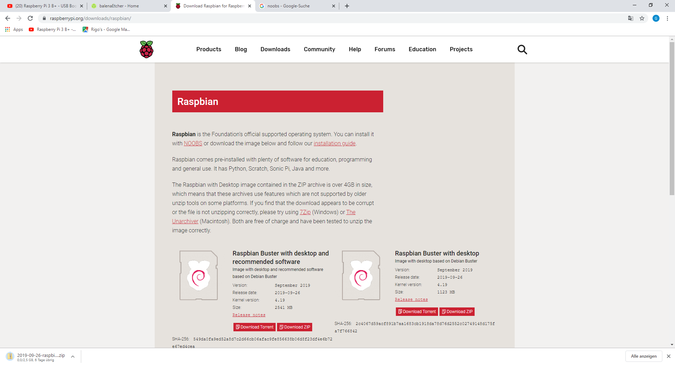
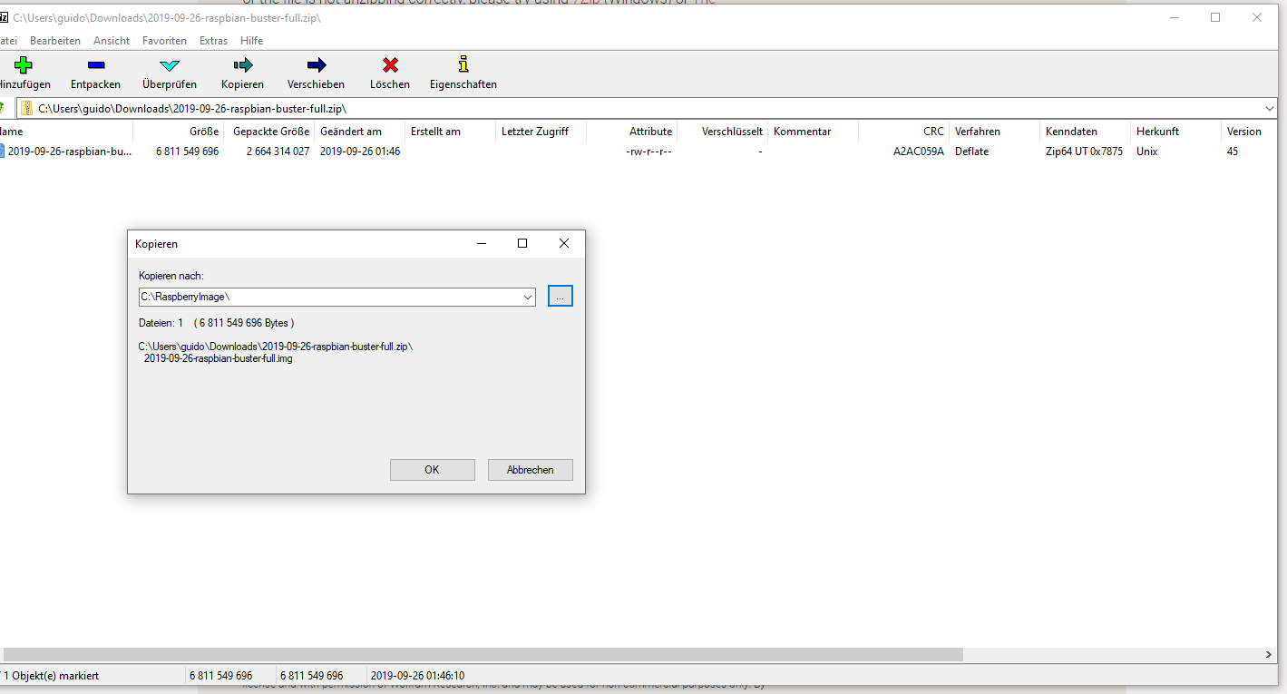
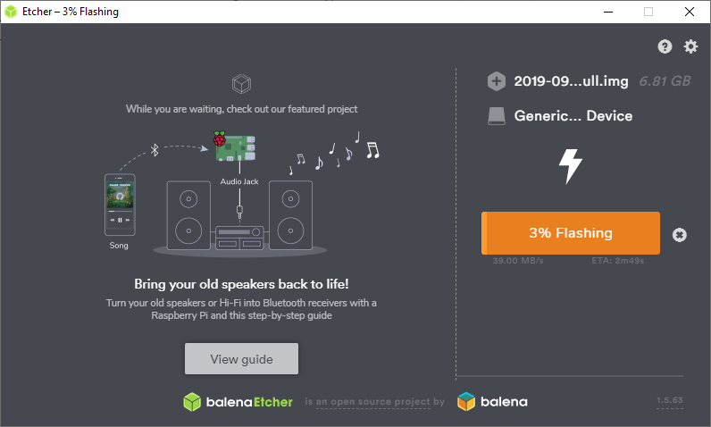

  - Eclipse aus Raspberry installieren

- sudo apt-get update
- sudo apt-get remove openjdk*
- sudo apt-get install openjdk-8-jdk
- sudo apt-get install eclipse

