CS485   
GAME PROGRAMMING

MidTerm Project

Individual Project

Made by Guilhem REMBURRE

GitURL: <https://github.com/GuiguiLaGuimauve/Mid-Term_CSUSM_CS485>

Introduction

This individual project is the MidTerm Project for class Game Programming at CSUSM. It is a game containing at least two scenes, one menu and one level.  
My game is call Zombie Runner and you must survive as long as possible in a dark forest infested by zombies.

# Main Menu

The main menu is composed with two buttons:

* Play: Play Zombie Runner
* Exit: Quit the project

Une image contenant capture d’écran

Description générée avec un niveau de confiance élevé

Go to the Roll-a-Ball game

Exit the project

Go the the plateform game

# Zombie Runner

Objective:

Survive as long as possible in a dark forest infested by Zombies  
How to play:

Use the directional keys to move into the forest and use the mouse to look around. Use the spacebar to jump.

To quit the game or retry just press escape to release the mouse, and click to the menu button to go back to the main menu or retry to restart the game.

## Reference:

* Trees and vegetation:<https://assetstore.unity.com/packages/3d/environments/paper-environment-pack-vol-1-94532>
* Skybox: <https://assetstore.unity.com/packages/2d/textures-materials/sky/10-skyboxes-pack-day-night-32236>

## Contribution:

* Terrain and level
* Zombies
* First person view
* 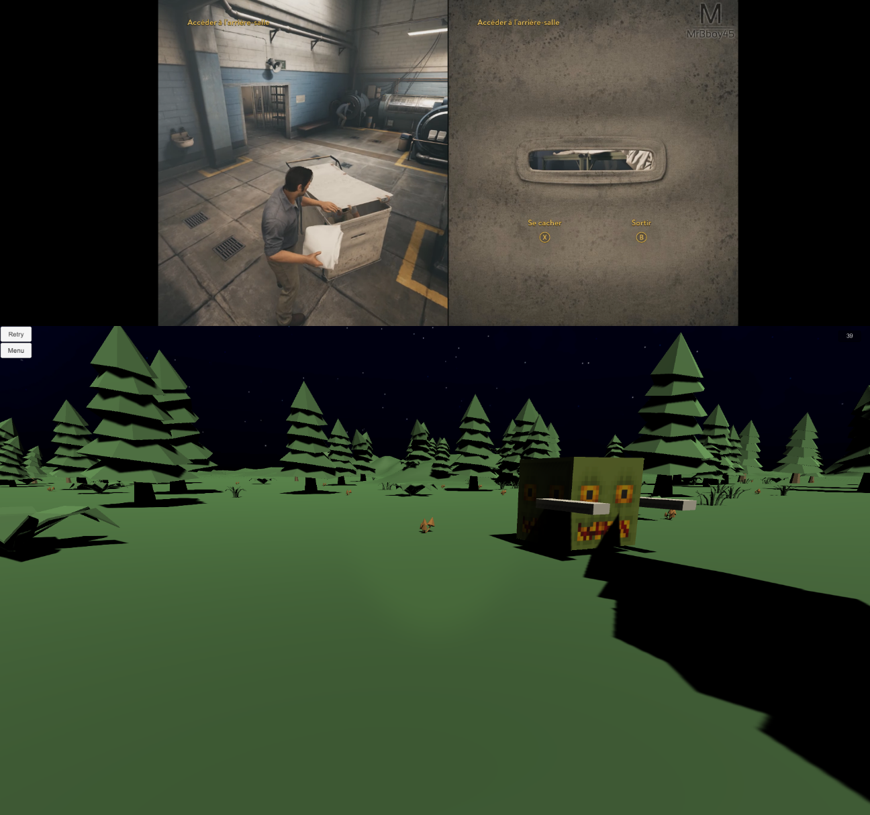

Seconds Counter

Zombies

Menu

# What I learned

Your score

* How to use Unity 3D
* Create a controllable object
* Camera usage (3rd and 1st person view)
* Collision
* Texture and Material
* User Interface
* Simple AI
* Navigation Mesh Controller

# Future of the project

Survivor game:

* Other level
* Add collectibles
* Night cycle
* Different Zombie type
* Weapons