create

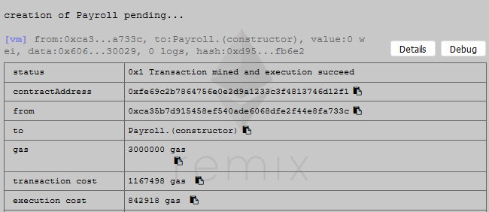

addFund 100ether

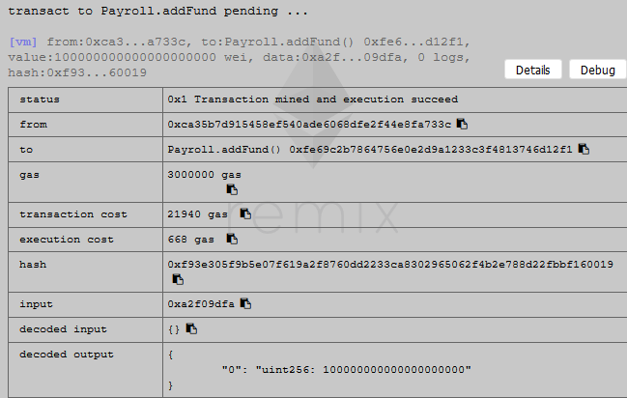

addEmployee(0x14723a09acff6d2a60dcdf7aa4aff308fddc160c,1)

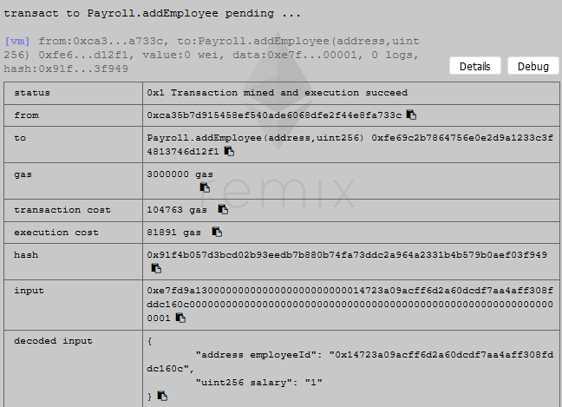

addEmployee(0x4b0897b0513fdc7c541b6d9d7e929c4e5364d2db,2)

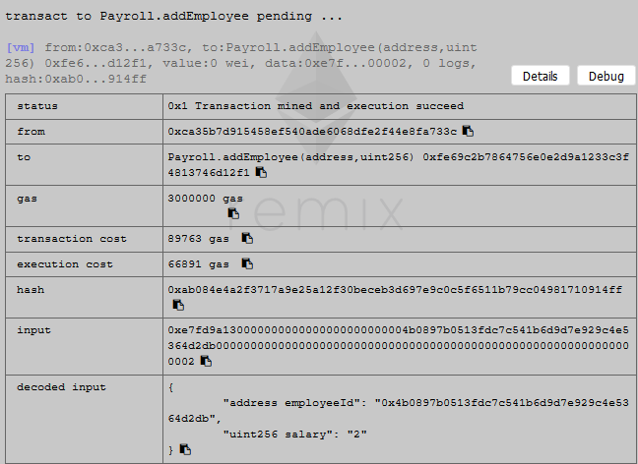

checkEmployee(0x4b0897b0513fdc7c541b6d9d7e929c4e5364d2db)

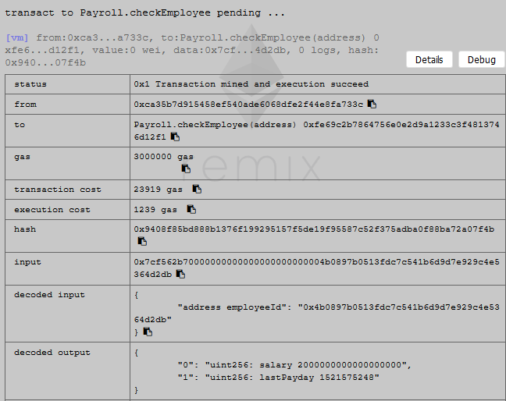

calculateRunaway

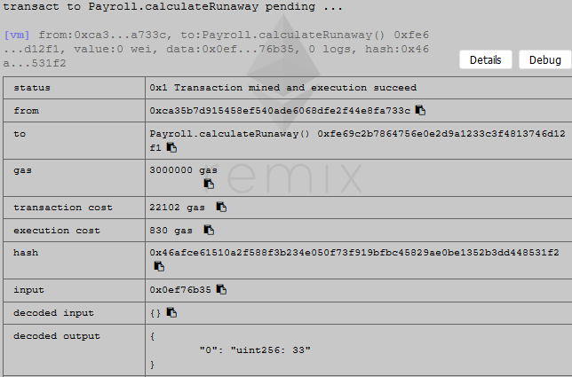

hasEnoughFund

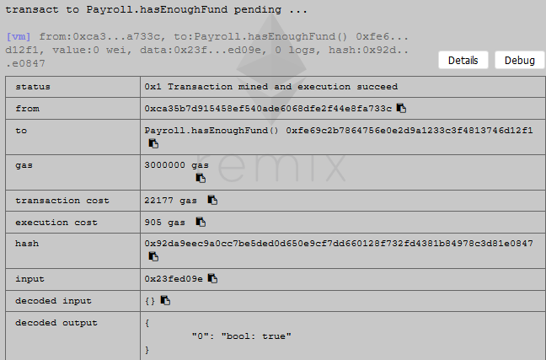

updateEmployee(0x4b0897b0513fdc7c541b6d9d7e929c4e5364d2db,1)

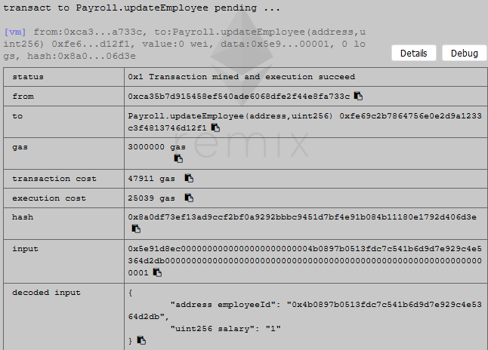

changePaymentAddress("0x4b0897b0513fdc7c541b6d9d7e929c4e5364d2db ","0xdd870fa1b7c4700f2bd7f44238821c26f7392148")

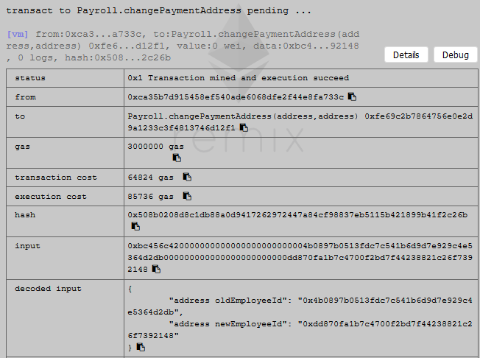

switch to address "0xdd870fa1b7c4700f2bd7f44238821c26f7392148"

getPaid

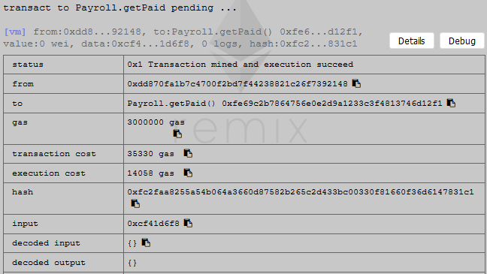

switch to address "0xca35b7d915458ef540ade6068dfe2f44e8fa733c "

remove(0xdd870fa1b7c4700f2bd7f44238821c26f7392148)

