We developed our software using the Factory Method. Room is our Abstract base class declared by the framework where we got two attributes (Price and room number) that will be used in all of the classes that implement the abstract class. The classes that represents the types of room (Standart Single, Standart Double, Penthouse, Deluxe King and Deluxe Queen) are the Concrete Products, all of them implements the abstract class Room.

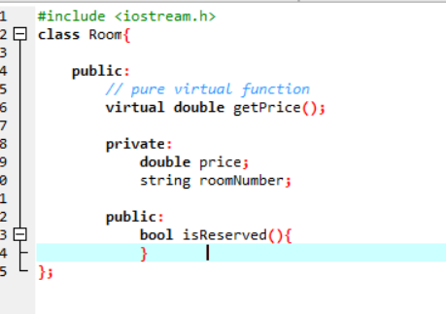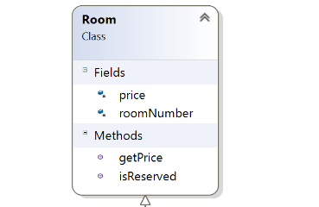

The class Reservation is where all the process related to the reservation are made. It is responsible for making reservations, cancel reservations, change rooms or days in an existent reservation. Check-in is responsible for all the information and process related to the arrival of the customer. The checkout class is responsible for calculate the price that the customer should pay, including extra expenses (maintained by the class ExtraExpenses).

The class Application is the declaration of the framework (a.k.a Creator), where is declared the factory method that returns a different object depending on the type of the room that the client wants.

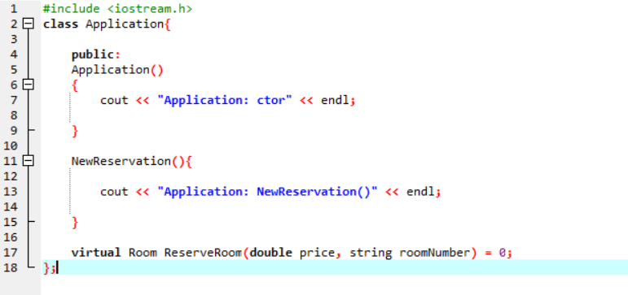

MyApplication is the ConcreteCreator of the project. This class override the method from the Application class (in this case ReserveRoom method) and return an instance of the type of room that the client reserved.

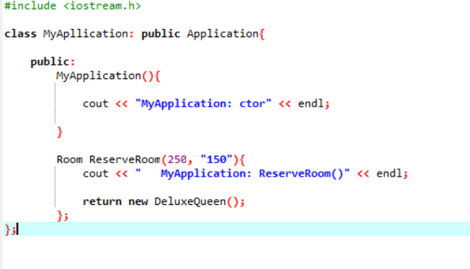

The other classes that are left, are just used to model the rest of the scenario and to maintain the data for the Customers and process that are used in the hotel.