CCT College Dublin
BSc (Hons) in Computing in IT — Problem Solving for Industry
Predicting Electric Vehicle Adoption in Ireland:
A Data Analytics and Machine Learning Study
Student Name: [Your Name]
Student Number: [Your Number]
Lecturers: Muhammad Iqbal, Ken Healy
Submission Date: 29th May 2026
Word Count: [Insert final word count — target 4,500–5,500]

1. Introduction
Electric vehicles are becoming an important part of Ireland's transition towards cleaner transport. As the transport sector continues to depend heavily on petrol and diesel vehicles, increasing EV adoption can help reduce emissions and support national climate goals. Ireland has set ambitious targets for electric vehicle growth by 2030, making it important to understand the factors that drive consumer adoption.
This project uses data analytics and machine learning to examine how electric vehicle adoption in Ireland has changed over time and whether selected factors — fuel prices, government grants, and time — can help predict future sales. The analysis is structured using the CRISP-DM framework and results in a working scenario simulation prototype.

1.1 Project Objectives
• Analyse historical EV adoption trends in Ireland, with the final modelling dataset covering 2015–2024
• Investigate the relationship between EV adoption and fuel prices, government grant values, and time-based trends
• Build and evaluate multiple machine learning models to predict EV sales
• Develop a scenario simulation prototype to explore how different conditions may affect predicted EV adoption
• Critically evaluate model performance, limitations, and reliability of findings

1.2 Research Question
To what extent can fuel prices, government grant incentives, and time-based trends be used to predict Battery Electric Vehicle adoption in Ireland?

1.3 Report Structure
Section 2 outlines roles and responsibilities. Sections 3–8 follow the six phases of the CRISP-DM framework. Section 9 presents conclusions. Appendices contain supporting materials including the group reflection, AI usage declaration, and GitHub contribution summary.

2. Roles and Responsibilities
This project was completed as an individual submission. The following outlines the roles and responsibilities undertaken throughout the project lifecycle. GitHub commit history provides evidence of ongoing individual contribution across all phases.

2.1 Individual Role Breakdown
This project was completed as an individual submission. As the sole contributor, all phases of the CRISP-DM framework were undertaken independently, including data sourcing, exploratory analysis, machine learning modelling, prototype development, and report writing.

2.2 GitHub Contribution
All project work was version-controlled using GitHub Classroom. Regular commits were made throughout the project lifecycle as evidence of ongoing progress.

3. Phase 1 — Business Understanding
The Business Understanding phase defines the project from a domain perspective and translates it into a data analytics problem. In this project, the business problem is to understand and predict electric vehicle adoption in Ireland using historical EV sales data, fuel prices, grant values, and time-based trends.
Electric vehicle adoption is an important part of Ireland's wider transition towards cleaner transport. Ireland has set ambitious climate and transport targets, including increasing the share of electric vehicles in the national car fleet by 2030. EV adoption is not driven by one factor alone — it may be affected by fuel prices, purchase grants, vehicle availability, technology improvements, charging infrastructure, and consumer confidence.
The problem addressed in this project is the difficulty of understanding and predicting EV adoption in Ireland. Although sales have generally increased over time, the rate of adoption has not been completely consistent. This creates uncertainty for policymakers, transport planners, and businesses trying to plan for future EV demand.

3.1 Project Objectives
• Identify key variables that may help explain EV sales in Ireland
• Build and compare predictive models for estimating EV adoption
• Develop a scenario simulation prototype to test different fuel price and grant conditions

3.2 Success Criteria
A successful outcome would be a model achieving an R² score close to or above 0.70, a working prototype that accepts user-defined inputs, and a clearly justified final model selection. Interpretability was also treated as a success criterion, since the prototype is intended as a decision-support tool for non-technical stakeholders.

3.3 Ethical and Legal Considerations
This project uses publicly available and non-personal datasets, so the risk to individual privacy is low. The main ethical consideration is avoiding misleading conclusions. Machine learning models can identify patterns in historical data but cannot guarantee future outcomes or prove direct causation. For this reason, the project clearly explains its limitations and presents predictions as estimates rather than certainties. All data sources are properly referenced, and legal considerations around responsible dataset use are observed throughout.

3.4 Costs and Benefits
The main costs are related to time, data collection, and the risk that small dataset size may limit prediction reliability. The main benefit is demonstrating how data analytics and machine learning can be applied to a real-world sustainability challenge, providing a simple but useful way to explore how selected factors may influence EV adoption in Ireland.

4. Phase 2 — Data Understanding
The Data Understanding phase involved collecting, exploring, and assessing the quality of the datasets used in this project. Four datasets were investigated, of which three were used in the final modelling dataset.

4.1 Datasets Used

4.1.1 IEA Global EV Data Explorer
The main electric vehicle dataset was obtained from the International Energy Agency Global EV Data Explorer. The dataset was filtered to focus on Ireland, passenger cars, the EV sales parameter, and Battery Electric Vehicles. The key variable extracted was ev_sales — the number of BEV cars sold per year. The notebook also compared BEV and PHEV adoption trends to understand whether fully electric cars and plug-in hybrids followed similar patterns.

4.1.2 CSO Consumer Price Index — CPM12
The fuel price dataset was obtained from the Central Statistics Office Ireland Consumer Price Index data. The dataset included monthly national average prices for consumer items, including petrol and diesel prices. The Month column was converted into datetime format and grouped by year to calculate an average annual fuel price, creating the fuel_price variable. Aggregating monthly fuel prices into yearly averages was necessary because the EV sales data was annual.

4.1.3 CSO TEM12 — Vehicle Licensing
The TEM12 dataset relates to new vehicles licensed for the first time in Ireland and was excluded from the final annual models because the IEA dataset already provided the core EV sales target variable. However, TEM12 was used in a separate monthly dataset exploration, providing 134 monthly EV registration observations between 2015 and 2026.

4.1.4 CSO ETA02 — Environmental Taxes
The ETA02 dataset was investigated as a potential source of Vehicle Registration Tax data. However, it was excluded from the final models because it did not align clearly with the annual modelling structure and would have required additional assumptions. It was therefore treated as contextual policy data only.

4.1.5 SEAI Grant Dataset — Manually Created
The EV grant dataset was manually created using SEAI and government information on electric vehicle grant support. It covered annual grant values from 2011 to 2024 and created the variable grant_value. An important limitation is that this dataset was manually compiled rather than downloaded directly, meaning it relies on the accuracy of the researcher's data entry and interpretation.

4.2 Exploratory Data Analysis

4.2.1 EV Sales Trend
EV sales showed a clear increase in BEV adoption, especially after 2020. BEVs experienced stronger growth than PHEVs, suggesting a shift towards fully electric vehicles. A dip in BEV sales was observed in 2024, which may reflect the SEAI grant reduction from €5,000 to €3,500 or wider market conditions.
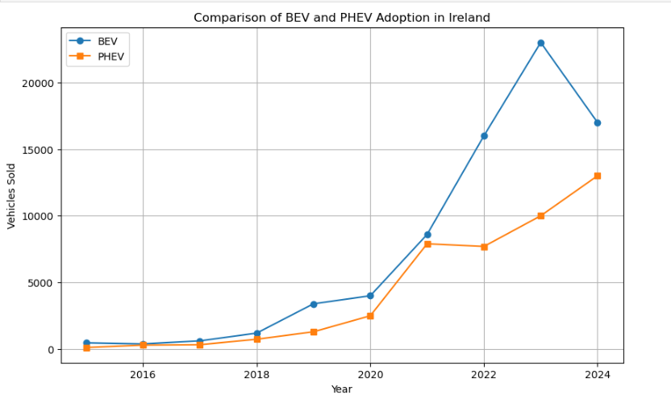

4.2.2 Fuel Price Analysis
Petrol and diesel prices declined around 2015–2016 and later increased, with a clear spike around 2021–2022. This spike coincided with a period of stronger EV adoption. The scatter plot suggested a positive relationship between fuel prices and EV sales, though this should not be interpreted as direct causation.
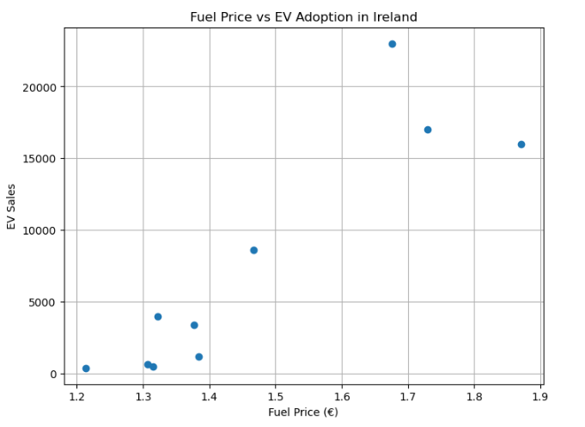

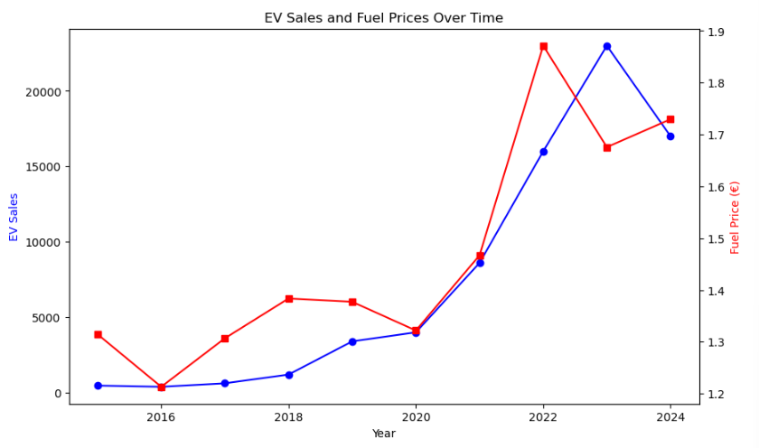

4.2.3 Correlation Analysis
The correlation matrix showed strong relationships between the modelling variables. ev_sales had a strong positive correlation with year (approximately 0.90) and with fuel_price (approximately 0.90). grant_value had a negative correlation with ev_sales of approximately -0.80, reflecting the timing of grant reductions during a period of growing adoption rather than evidence that grants reduced EV sales.
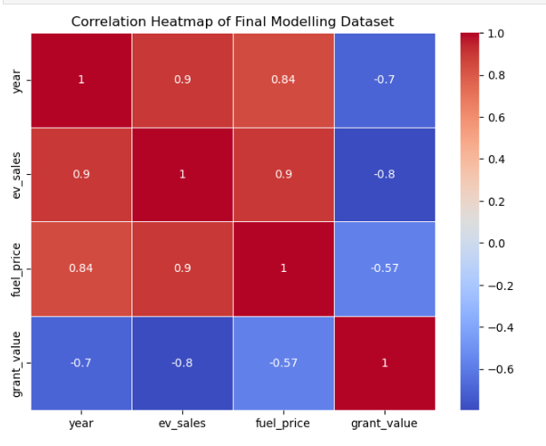

4.3 Data Quality
• IEA EV dataset — no missing values after filtering, suitable for analysis
• CSO fuel price dataset — 1,317 missing values in full dataset, handled by filtering to relevant rows and aggregating by year
• Grant dataset — no missing values, but manually constructed and limited to 14 annual data points
• Final modelling dataset — 10 rows covering 2015 to 2024, zero missing values

5. Phase 3 — Data Preparation
The Data Preparation phase focused on converting the selected raw datasets into one final modelling dataset. Since datasets came from different sources and formats, they had to be filtered, cleaned, transformed, and merged before machine learning models could be trained.

5.1 Filtering and Cleaning
The IEA EV dataset was filtered to Ireland, cars, Battery Electric Vehicles, and the EV sales parameter, then sorted chronologically. Duplicate merge cells in the notebook were removed and documented. The fuel price dataset was filtered to petrol and diesel rows only, and monthly values were aggregated into yearly averages.

5.2 Feature Engineering
Three features were selected for the final models. The year feature captured the general time-based trend in EV adoption. The fuel_price variable represented the average annual petrol and diesel price. The grant_value variable represented the annual SEAI EV purchase grant and was manually mapped to each year. Feature selection was justified by the correlation analysis, which showed strong relationships between these variables and ev_sales.

5.3 Final Modelling Dataset
The final dataset covered 2015 to 2024, giving 10 annual observations with no missing values. The dependent variable was ev_sales; the independent variables were year, fuel_price, and grant_value. The small number of rows was an important limitation, reducing the amount of data available for training and testing.

5.4 Train/Test Split and Validation Strategy
The dataset was divided into training and testing sets using an 80/20 split, producing approximately 8 training and 2 test observations. Because 2 test points are statistically weak on their own, k-fold cross-validation was also applied as a supplementary validation method. This tested the model across multiple train/test combinations, making better use of the limited data.

6. Phase 4 — Modelling
The Modelling phase implemented four machine learning models to predict annual Battery Electric Vehicle sales in Ireland. The approach was progressive, starting with simple Linear Regression and adding features incrementally, before implementing Random Forest as a comparison model.

6.1 Model Selection Rationale
Linear Regression was selected as the primary model because it is interpretable and appropriate for small datasets. Each coefficient can be explained directly, which is important for a decision-support tool. Random Forest was selected as a comparison because it captures non-linear relationships and interactions between variables, making it useful to assess whether a more advanced model could improve performance.

6.2 Independent and Dependent Variables
The dependent variable in all models was ev_sales, representing annual BEV car sales in Ireland. Independent variables were added progressively: fuel_price in Model 1, year in Model 2, and grant_value in Model 3 and 4. These features were selected based on the correlation analysis conducted in Phase 2.

6.3 Model Descriptions and Results

6.3.1 Model 1 — Linear Regression (fuel_price only)
Model 1 used only fuel_price as the independent variable. The model achieved an R² score of approximately 0.357 and an MSE of 58,059,141. The coefficient for fuel_price was approximately 29,691, suggesting that a €1 increase in average fuel price was associated with around 29,691 additional EV sales. This is a moderate result, showing that fuel price alone partially explains EV adoption but is insufficient on its own.

6.3.2 Model 2 — Multiple Linear Regression (fuel_price + year)
Adding year as a second variable improved the R² to approximately 0.535 and reduced MSE to 41,965,204. The year coefficient of approximately 1,024 suggests that, holding fuel price constant, EV sales increased by around 1,024 vehicles per year — reflecting the broader long-term growth driven by market development and technology improvement.

6.3.3 Model 3 — Multiple Linear Regression (fuel_price + year + grant_value)
Model 3 achieved an R² of approximately 0.665 and an MSE of 30,209,100. Coefficients were approximately 18,694 for fuel_price, 767 for year, and -1.62 for grant_value. The negative grant coefficient reflects the grant paradox — SEAI grants decreased from €5,000 to €3,500 during a period of accelerating EV adoption, creating an inverse statistical relationship. This does not mean grants reduce EV adoption; it reflects historical timing.
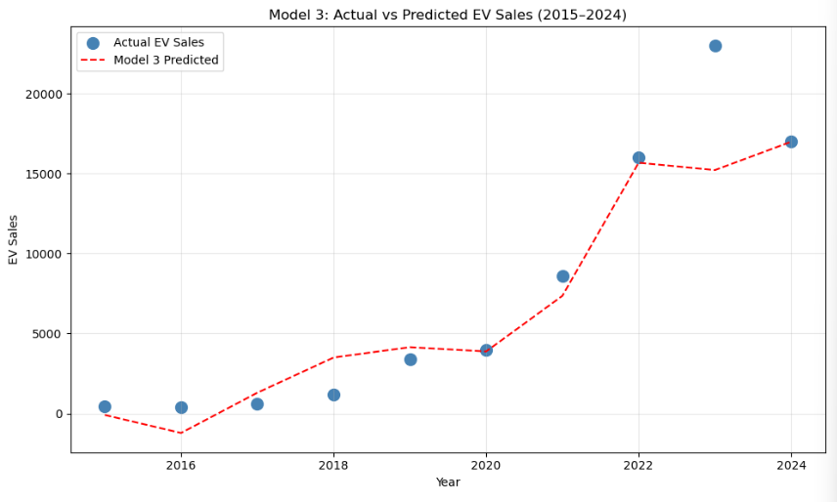

6.3.4 Model 4 — Random Forest Regressor
The Random Forest model achieved the highest R² of approximately 0.702 and an MSE of 26,872,621. Feature importance analysis showed that fuel_price (0.486) and year (0.476) contributed approximately 96% of predictive importance, with grant_value contributing only 3.8%. This confirms that EV adoption is primarily driven by fuel costs and time-based structural forces rather than grant policy.
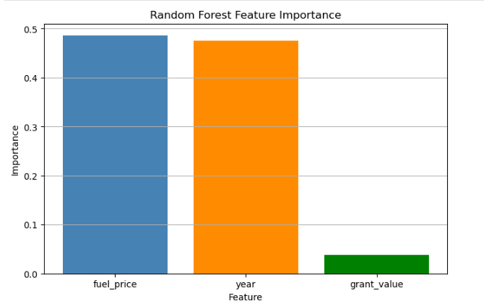

Feature | Importance Score | % of Total
fuel_price | 0.486 | ~49%
year | 0.476 | ~48%
grant_value | 0.038 | ~4%

6.4 Hyperparameter Tuning
GridSearchCV was applied to the Random Forest model, testing n_estimators values of 50, 100, and 200, and max_depth values of 2, 3, 4, and None. MAE was used as the scoring metric because R² is unstable on very small validation folds. The best parameters were max_depth = 4 and n_estimators = 200, with a best cross-validation MAE of approximately 2,875. This confirmed the model was tested beyond default settings, though improvement was modest given the small dataset.

6.5 Cross-Validation
Five-fold cross-validation was applied to both models. The Linear Regression model produced a mean cross-validation R² of approximately -17.41, while the Random Forest produced -35.15. These negative values confirm that R² is unstable when splitting 10 rows into 5 folds of 2 observations each.
MAE provided more stable results: Linear Regression achieved a mean cross-validation MAE of approximately 2,794, while Random Forest achieved approximately 2,311. Based on MAE, Random Forest performed better on average. However, both results must be interpreted cautiously given the dataset size.

6.6 Extended Monthly Analysis
An extended analysis was conducted using monthly EV registration data from the CSO TEM12 dataset, providing 134 monthly observations compared with the 10 annual rows in the primary dataset. While test R² scores improved substantially under the monthly approach, cross-validation revealed severe overfitting driven by the exponential time trend in EV adoption. Models trained on later months failed to generalise to earlier periods, confirming that the models were capturing the time trend rather than genuine relationships between the independent variables and EV sales. The annual model was retained as the primary analysis because it provides more honest and generalisable results when its limitations are explicitly acknowledged. The monthly exploration is retained in the GitHub repository as evidence of iterative analysis.

7. Phase 5 — Evaluation

7.1 Model Comparison
The table below summarises the performance of all four models across R² and MSE metrics.
Model | Features Used | R² Score | MSE
Model 1 — Linear Regression | fuel_price | 0.357 | 58,059,141
Model 2 — Multiple LR | fuel_price, year | 0.535 | 41,965,204
Model 3 — Multiple LR + Grant | fuel_price, year, grant_value | 0.665 | 30,209,100
Model 4 — Random Forest | fuel_price, year, grant_value | 0.702 | 26,872,621

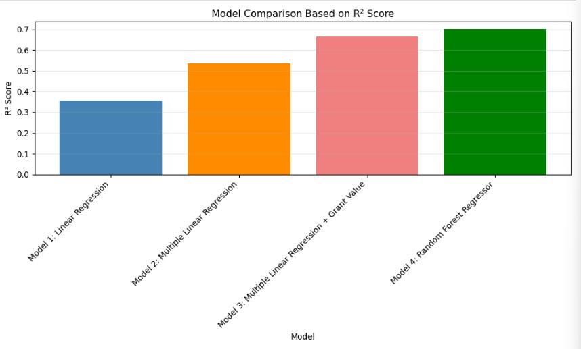

7.2 Final Model Selection
Model 3 — Multiple Linear Regression — was selected as the final model for the scenario simulation prototype. Although Random Forest achieved the highest test performance, the difference was relatively small (R² 0.665 vs 0.702). Random Forest does not provide interpretable coefficients, making it harder to explain predictions to non-technical stakeholders such as policymakers or SEAI analysts. Model 3 was selected because it offered a good balance between predictive performance and explainability.

7.3 Scenario Simulation Results
The scenario simulation used Model 3 to estimate EV sales under six different conditions. Results are shown in the table below.
Scenario | Fuel Price | Year | Grant Value | Predicted EV Sales
Baseline 2025 | €1.80 | 2025 | €3,500 | 19,085
Higher Fuel Price | €2.00 | 2025 | €3,500 | 22,824
Lower Fuel Price | €1.60 | 2025 | €3,500 | 15,346
Grant Increased | €1.80 | 2025 | €5,000 | 16,654
Grant Reduced | €1.80 | 2025 | €2,500 | 20,706
Future Growth 2026 | €1.85 | 2026 | €3,500 | 20,787

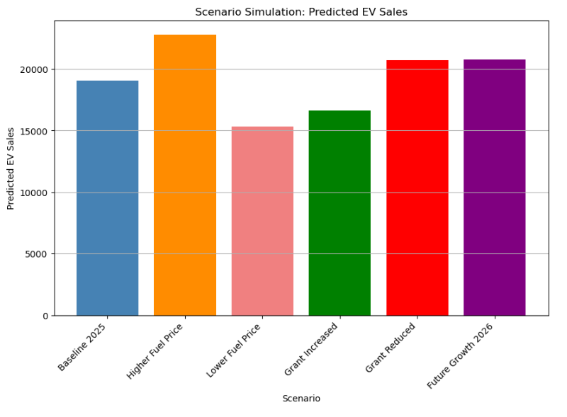

The baseline 2025 prediction of 19,085 EV sales provides a reference point. Higher fuel prices (€2.00) increased the prediction to 22,824 — a difference of approximately 3,739 sales — demonstrating that fuel price had the strongest effect on predictions within the model. The grant scenarios produced counterintuitive results, reflecting the grant paradox discussed in Section 6.3.3. The future year scenario predicted gradual growth from 19,085 in 2025 to 22,154 by 2029, assuming constant fuel prices and grant values.

7.4 Limitations
• Small dataset — the final modelling dataset contained only 10 annual observations, limiting statistical reliability and generalisability
• Correlation not causation — the model captures statistical associations, not direct causal relationships; EV adoption is affected by many factors not included in the model
• Manually constructed grant dataset — relies on accuracy of researcher data entry and interpretation
• Train/test split weakness — an 80/20 split on 10 rows produces only 2 test points; cross-validation partially mitigates this but cannot fully solve limited data
• Time trend dominance — feature importance showed year (0.476) and fuel_price (0.486) together account for 96% of predictive importance, meaning the model is primarily capturing the time trend rather than isolating the marginal impact of individual policy variables
• Monthly analysis overfitting — the extended monthly analysis showed severe cross-validation overfitting (CV R² as low as -112), confirming that increasing data frequency does not resolve the underlying challenge of time trend dominance

7.5 Evaluation Against Objectives
• Analyse historical EV trends — achieved through EDA showing BEV growth post-2020, BEV vs PHEV comparison, and fuel price relationship
• Investigate key influencing factors — achieved through correlation analysis (year ~0.90, fuel_price ~0.90, grant_value ~-0.80) and feature importance
• Build and evaluate multiple models — achieved with four models, cross-validation, hyperparameter tuning, and comparative analysis
• Develop scenario simulation prototype — achieved with six named scenarios and three range visualisations
• Critically evaluate performance and limitations — achieved, including honest discussion of negative CV scores, grant paradox, and monthly analysis findings

8. Phase 6 — Deployment

8.1 Prototype Description
The prototype developed in this project is a scenario simulation tool built in the Jupyter Notebook using the trained Model 3. The prototype accepts three input variables — fuel_price, year, and grant_value — and produces a predicted annual BEV sales value. Its purpose is to explore what-if scenarios rather than produce guaranteed forecasts.

8.2 Potential Users and Use Cases
• SEAI — to explore how changes in grant values may be associated with future adoption rates and assess whether current incentive levels are effective
• Department of Transport — to test different fuel price and year scenarios in support of Ireland's 2030 EV target planning
• Automotive industry analysts — to estimate possible market demand under different economic conditions
• Academic researchers — as a baseline model for more detailed EV adoption studies

8.3 Deployment Considerations
Deploying this tool beyond the Jupyter Notebook prototype would require a user-friendly interface such as a Streamlit or Dash web dashboard. The dataset would also need to be updated annually, with a process for retraining the model and checking data quality. Model outputs would require clear warnings explaining that predictions are estimates based on historical patterns, not guaranteed future outcomes.

8.4 Future Development
• Expand the dataset with post-2024 annual data as it becomes available
• Add additional features such as charging infrastructure density, electricity prices, and EV purchase price trends
• Explore time series models such as ARIMA or Prophet, which are better suited to temporally dependent data
• Develop a web-based interactive dashboard using Streamlit or Dash

9. Conclusion
This project applied the CRISP-DM framework to analyse and predict electric vehicle adoption trends in Ireland using publicly available data on EV sales, fuel prices, and government grant values. The project followed a structured process from business understanding through data exploration, preparation, modelling, evaluation, and prototype deployment.
Ireland’s target of significantly increasing EVs on the road by 2030 means that understanding the factors driving adoption is not only academically interesting but practically important for transport planning and climate policy. The scenario simulation prototype developed in this project allows policymakers to test how changes in fuel prices and grant values may affect adoption compared with the model’s baseline growth projection.
The key findings showed that EV adoption in Ireland has increased significantly over time, especially after 2020. Year and fuel_price were the strongest predictors of EV sales, together accounting for approximately 96% of the Random Forest model's predictive importance. Grant value showed a negative coefficient, reflecting historical timing rather than evidence that grants reduce adoption. This suggests that EV adoption in Ireland is primarily driven by structural long-term forces, and that the role of specific policy interventions is difficult to isolate using the available data.
Four models were developed and compared. Random Forest produced the strongest predictive performance (R² 0.702), while Multiple Linear Regression was selected for the scenario simulation because it offered a better balance between performance and interpretability. The main limitation was the small dataset size of 10 annual observations. The model captured correlation rather than causation, and important factors such as charging infrastructure, vehicle prices, electricity costs, and consumer attitudes were not included.
Overall, this project demonstrated that data analytics and machine learning can provide useful insights into sustainable transport trends. With larger datasets and additional features, similar models could support more informed decision-making for Ireland's future electric vehicle and climate policy.

References
Central Statistics Office Ireland (2026). Consumer Price Index — CPM12: National Average Consumer Prices by Consumer Item and Month. Available at: https://www.cso.ie [Accessed: May 2026].

Central Statistics Office Ireland (2026). Environmental Taxes — ETA02: Environmental Taxes by Type. Available at: https://www.cso.ie [Accessed: May 2026].

Central Statistics Office Ireland (2026). TEM12: New Vehicles Licensed for the First Time by Type of Vehicle Registration, Type of Fuel, Month and Statistic. Available at: https://www.cso.ie [Accessed: May 2026].

International Energy Agency (2025). Global EV Data Explorer. Available at: https://www.iea.org/data-and-statistics/data-tools/global-ev-data-explorer [Accessed: March 2026].

Pedregosa, F. et al. (2011). Scikit-learn: Machine Learning in Python. Journal of Machine Learning Research, 12, pp.2825–2830. Available at: https://jmlr.org/papers/v12/pedregosa11a.html [Accessed: May 2026].

Sustainable Energy Authority of Ireland (2025). Electric Vehicle Grant Scheme. Available at: https://www.seai.ie/grants/electric-vehicle-grants [Accessed: May 2026].

Appendices

Appendix A — Individual Reflection
Note: This section is required by the brief (~250 words per student). It does not count towards the 5,000-word limit. Reflect on: project progression, challenges, what you learned technically and professionally, what you would do differently, and evidence of your individual contribution referencing specific GitHub commits.
[Write your individual reflection here — approximately 250 words]

Appendix B — AI Usage Declaration
Note: Required by the CCT GenAI policy. List all AI tools used, how they were used, and paste full prompt logs and outputs below.

AI Tools Used
[List tools — e.g. Claude (Anthropic), GitHub Copilot, Grammarly]

How AI Was Used
• Brainstorming and refining project ideas and research questions
• Code suggestions and debugging assistance in the Jupyter Notebook
• Grammar and style checking of written sections
• [Add or remove items to accurately reflect your actual usage]

AI Prompt Logs and Outputs
[Paste all AI prompts submitted and outputs received here, labelled by tool, date, and purpose]

Appendix C — Additional Visualisations

