Three JS - First Report

Guilherme Casal (102587) , Pedro Durval ()

Information Visualization, 2023 (Msc in Data Science, University of Aveiro)

Abstract

This report presents a comprehensive analysis of a script developed using the library Three.js library for creating interactive 3D graphics on the web. Three.js, a powerful JavaScript library was employed to craft a visually engaging experience, exploring the capabilities of three-dimensonal rendering in the online environment.The script covers fundamental aspects, from setting up the environment to implementing complex geometries and advanced visual effects, details about the code structure, design choices, and optimizations.

# Renderer and Scene

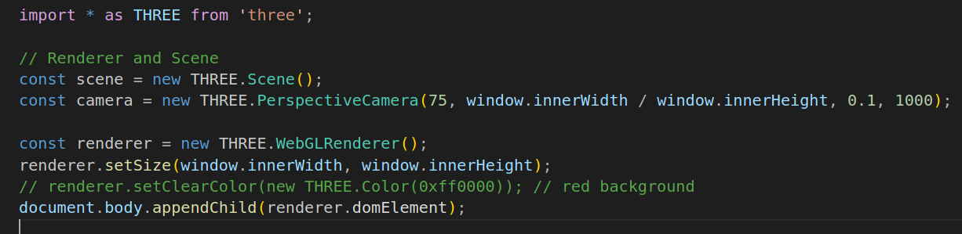These two components, Renderer and Scene, work together to create a cohesive and interactive visual experience. The Renderer processes the Scene and displays it in the viewing environment, allowing users to explore and interact with three-dimensional objects created within the context of Three.js. This basic structure provides a solid foundation for the development of 3D applications and games on the web using Three.js.

# First Challenge

The first proposed challenge was to render a series of triangles with unique characteristics.

Setting the triangles was an easy task, however attributing distinct characteristics to each took an added amount of time. With this task we managed to understand the various types of objects that we can use in Three.js and how to modify them according to our goals.

Nonetheless, with the high availability of online documentation and help from the teacher, this task was achieved fairly quickly and set the knowledge fundamentals the empowered the independent resolution of the following challenge.

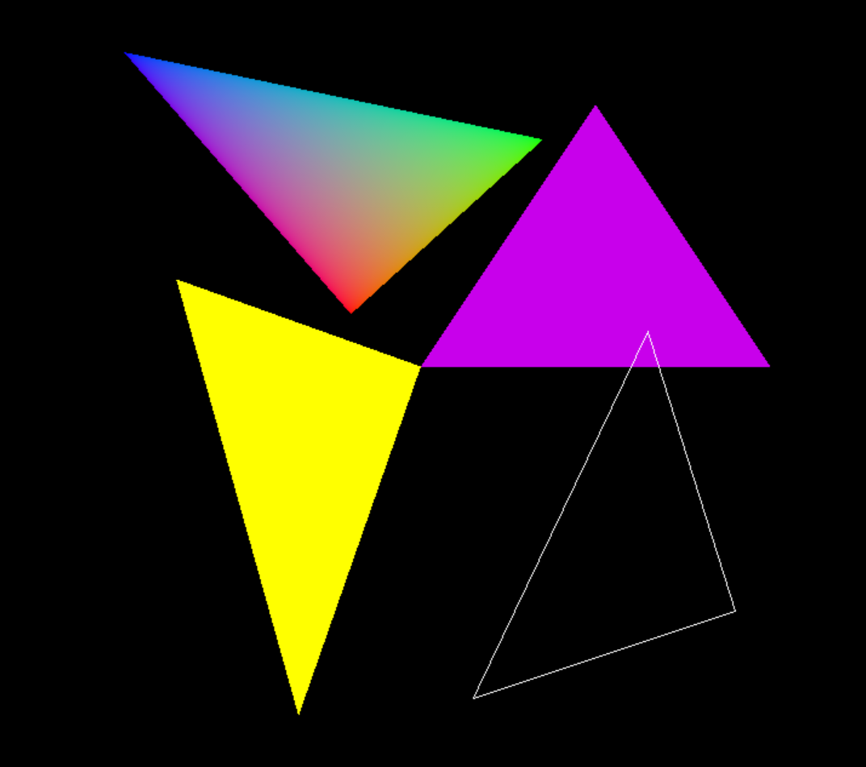

# Second Challenge

With the basic rules of the language already understood, such as how to define the positions of points, this exercise was quite straight forward.

It engaged us to research about what other structures could be generated, positioned and also attributing dynamic characteristics, such as movement.

With this said, no major challenge originated from this task, but it still managed to stimulate our improvement.

