Three JS - First Report

Guilherme Casal (102587) , Pedro Durval ()

Information Visualization, 2023 (Msc in Data Science, University of Aveiro)

Abstract

This report presents a comprehensive analysis of a script developed using the library Three.js library for creating interactive 3D graphics on the web. Three.js, a powerful JavaScript library was employed to craft a visually engaging experience, exploring the capabilities of three-dimensonal rendering in the online environment.The script covers fundamental aspects, from setting up the environment to implementing complex geometries and advanced visual effects, details about the code structure, design choices, and optimizations.

# Renderer and Scene

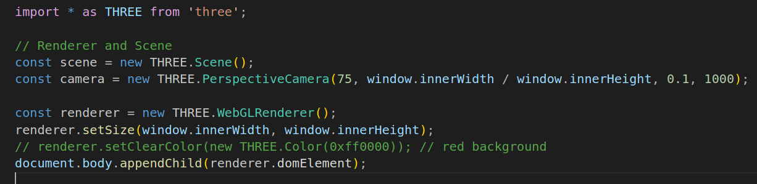These two components, Renderer and Scene, work together to create a cohesive and interactive visual experience. The Renderer processes the Scene and displays it in the viewing environment, allowing users to explore and interact with three-dimensional objects created within the context of Three.js. This basic structure provides a solid foundation for the development of 3D applications and games on the web using Three.js.

# First Result and Problem

This was our first outcome up to the "Color Addiction" chapter, and until this point, we encountered no issues; everything was quite intuitive. However, in this chapter, things started to get complicated as we faced some challenges. All the triangles were "multicolored," and there was some difficulty in creating two models: one multicolored, another two in yellow and purple, and one in wireframe.

# Dataset

Lorem ipsum dolor sit amet, consectetuer adipiscing elit, sed diam nonummy nibh euismod tincidunt ut laoreet dolore magna aliquam erat volutpat (http://…..). Ut wisi enim ad minim veniam, quis nostrud exercit­ation ullamcorper suscipit lobortis nisl ut aliquip ex ea commodo consequat[1][2]. Duis autem vel eum iriure dolor in hendrerit in vulpu-tate velit esse molestie consequat, vel illum dolore eu feugiat nulla facilisis at vero eros et accumsan et iusto odio dignissim qui blan-dit praesent luptatum zzril delenit augue duis dolore te feugait nulla facilisi.

# Visualization Solution

Lorem ipsum dolor sit amet, consectetuer adipiscing elit, sed diam nonummy nibh euismod tincidunt ut laoreet dolore magna aliquam erat volutpat [1][2][3]. Ut wisi enim ad minim veniam, quis nostrud exercit­ation ullamcorper suscipit lobortis nisl ut aliquip ex ea commodo consequat. Duis autem vel eum iriure dolor in hendrerit in vulpu-tate velit esse molestie consequat, vel illum dolore eu feugiat nulla facilisis at vero eros et accumsan et iusto odio dignissim qui blan-dit praesent luptatum zzril delenit augue duis dolore te feugait nulla facilisi.

## Low fidelity prototype and user feedback

Lorem ipsum dolor sit amet, consectetuer adipiscing elit, sed diam nonummy nibh euismod tincidunt ut laoreet dolore magna aliquam erat volutpat (Figure 1). Ut wisi enim ad minim veniam, quis nostrud exercit­ation ullamcorper suscipit lobortis nisl ut aliquip ex ea commodo consequat (Figure 2). Duis autem vel eum iriure dolor in hendrerit in vulpu-tate velit esse molestie consequat, vel illum dolore eu feugiat nulla facilisis at vero eros et accumsan et iusto odio dignissim qui blan-dit praesent luptatum zzril delenit augue duis dolore te feugait nulla facilisi [2].

## 

1. Aspect of the low fidelity prototype

## Functional prototype

Lorem ipsum dolor sit amet, consectetuer adipiscing elit, sed diam nonummy nibh euismod tincidunt ut laoreet dolore magna aliquam erat volutpat. Ut wisi enim ad minim veniam, quis nostrud exercit­ation ullamcorper suscipit lobortis nisl ut aliquip ex ea commodo consequat. Duis autem vel eum iriure dolor in hendrerit in vulpu-tate velit esse molestie consequat, vel illum dolore eu feugiat nulla facilisis at vero eros et accumsan et iusto odio dignissim qui blan-dit praesent luptatum zzril delenit augue duis dolore te feugait nulla facilisi.

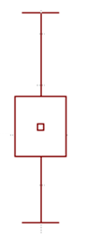

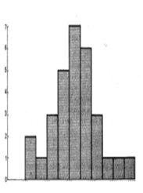

1. Visualizations to answer question Q1.

## 

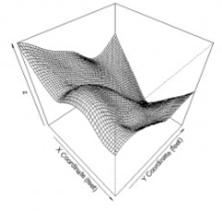

1. Visualizations to answer the question Q2.

Lorem ipsum dolor sit amet, consectetuer adipiscing elit, sed diam nonummy nibh euismod tincidunt ut laoreet dolore magna aliquam erat volutpat. Ut wisi enim ad minim veniam, quis nostrud exercit­ation ullamcorper suscipit lobortis nisl ut aliquip ex ea commodo consequat. Duis autem vel eum iriure dolor in hendrerit in vulpu-tate velit esse molestie consequat, vel illum dolore eu feugiat nulla facilisis at vero eros et accumsan et iusto odio dignissim qui blan-dit praesent luptatum zzril delenit augue duis dolore te feugait nulla facilisi.

## Implementation challenges

Lorem ipsum dolor sit amet, consectetuer adipiscing elit, sed diam nonummy nibh euismod tincidunt ut laoreet dolore magna aliquam erat volutpat (<https://d3js.org/>). Ut wisi enim ad minim veniam, quis nostrud exercit­ation ullamcorper suscipit lobortis nisl ut aliquip ex ea commodo consequat. Duis autem vel eum iriure dolor in hendrerit in vulpu-tate velit esse molestie consequat, vel illum dolore eu feugiat nulla facilisis at vero eros et accumsan et iusto odio dignissim qui blan-dit praesent luptatum zzril delenit augue duis dolore te feugait nulla facilisi.

## Evaluation and changes in the prototype

Lorem ipsum dolor sit amet, consectetuer adipiscing elit, sed diam nonummy nibh euismod tincidunt ut laoreet dolore magna aliquam erat volutpat. Ut wisi enim ad minim veniam, quis nostrud exercit­ation ullamcorper suscipit lobortis nisl ut aliquip ex ea commodo consequat. Duis autem vel eum iriure dolor in hendrerit in vulpu-tate velit esse molestie consequat, vel illum dolore eu feugiat nulla facilisis at vero eros et accumsan et iusto odio dignissim qui blan-dit praesent luptatum zzril delenit augue duis dolore te feugait nulla facilisi.

# Conclusion and Future Work

Lorem ipsum dolor sit amet, consectetuer adipiscing elit, sed diam nonummy nibh euismod tincidunt ut laoreet dolore magna aliquam erat volutpat. Ut wisi enim ad minim veniam, quis nostrud exercit­ation ullamcorper suscipit lobortis nisl ut aliquip ex ea commodo consequat. Duis autem vel eum iriure dolor in hendrerit in vulpu-tate velit esse molestie consequat, vel illum dolore eu feugiat nulla facilisis at vero eros et accumsan et iusto odio dignissim qui blan-dit praesent luptatum zzril delenit augue duis dolore te feugait nulla facilisi.

Lorem ipsum dolor sit amet, consectetuer adipiscing elit, sed diam nonummy nibh euismod tincidunt ut laoreet dolore magna aliquam erat volutpat. Ut wisi enim ad minim veniam, quis nostrud exercit­ation ullamcorper suscipit lobortis nisl ut aliquip ex ea commodo consequat. Duis autem vel eum iriure dolor in hendrerit in vulpu-tate velit esse molestie consequat, vel illum dolore eu feugiat nulla facilisis at vero eros et accumsan et iusto odio dignissim qui blan-dit praesent luptatum zzril delenit augue duis dolore te feugait nulla facilisi.

References

1. T. Minzner, *Visualization Analysis and Design*, A K Peters/CRC Press, 2014
2. A. Kirk, *Data Visualization : a successful design process*, Packt Publishing, 2012
3. J. Heer, M. Bostock, V. Ogievetsky, A tour through the visualiza-tion zoo. *Communications of the ACM*, vol. 8, n.1, pp. 59-67, 2010