**Compiling UE4 (slow method)**

Download the engine source from github:

<https://github.com/EpicGames/UnrealEngine>

Navigate to the folder where you have downloaded the source

Run Setup.bat

Then run GenerateProjectFiles.bat

Open UE4.sln (requires Visual Studio 2015 – VS 14.0)

Configuration: Development Editor – Win64

C:\Users\Guilherme\Downloads\Screenshot_7.png

Right click UE4 in solution explorer and click Build

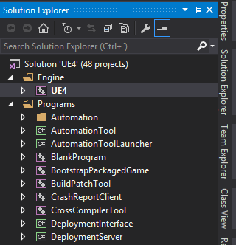

**Compiling UE4 (fast method)**

Get The UE4 engine source (link above)

Download the batch files in this repository (build\_ue4.bat & rebuild\_ue4.bat (only if needed in the future)):

<https://github.com/xX-TheDoctor-Xx/RVHandyStuff>

Run build\_ue4.bat

**Installing Linux compile toolchain**

Download the compiler toolchain from the RVHandyStuff repository:

<https://wiki.unrealengine.com/Compiling_For_Linux>

The instructions are also there but i make your life easier here with less text and more images

Place the toolchain somewhere in a folder doesnt matter where

Go to Start Menu – This PC – Properties – Advanced System Settings – Enviroment Variables

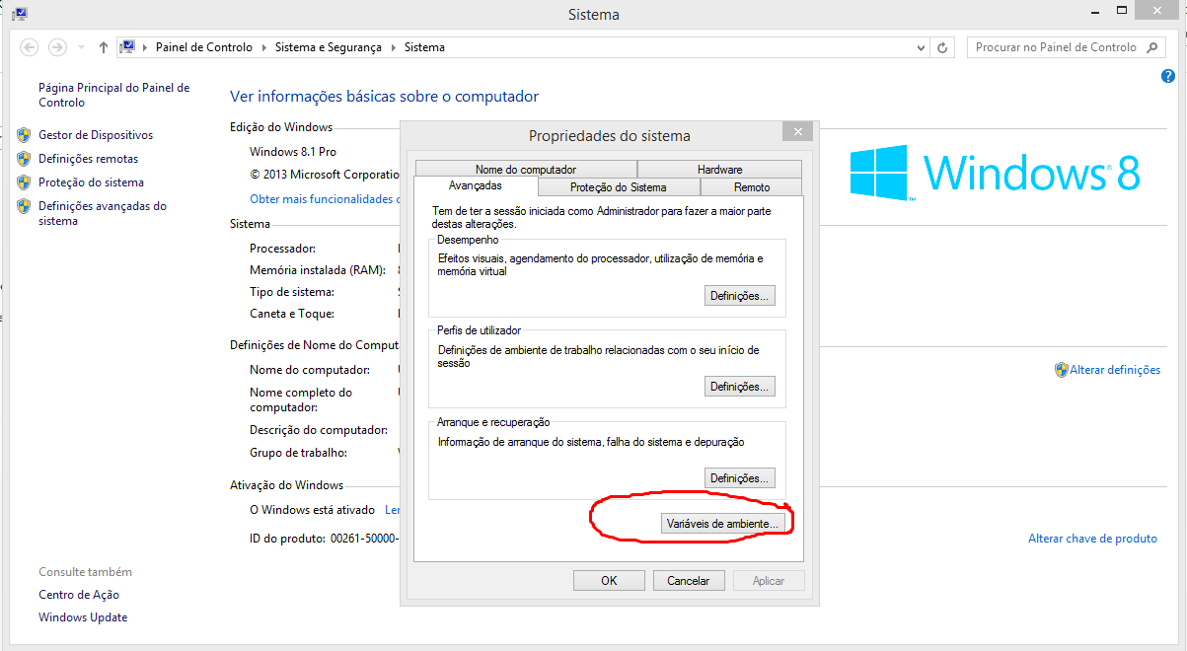

Create a new System Variable called LINUX\_ROOT and the value will be the path to the toolchain for example: C:\v4\_clang-3.7.0\_ld-2.24\_glibc-2.12.2\toolchain, the path should point to the toolchain folder

The content of the folder should be this:

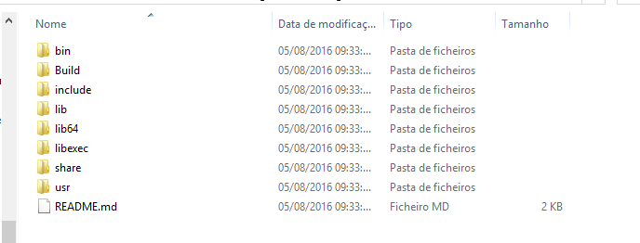

You have to rebuild the engine now, use one of the two methods above (for the fast method you should use rebuild\_ue4.bat)

If you open the visual studio game solution and check the configuration manager, where it says Win32, Win64, Mac, you now should (hopefully) see Linux, if it doesnt show up repeate the process above.

**Compiling the game**

Go to RGLine\_Template project folder

Right click on RGLine\_Template.uproject and click Switch Unreal Engine Version, a window like this should pop up

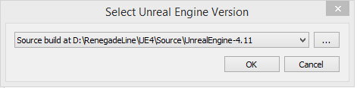

Select your source built UE4 version

Right click again on RGLine\_Template.uproject and click Generate Visual Studio Project Files

Open RGLine\_Template.sln

Inside visual studio you will select the appropiate build configuration and platform of your choice



**Note: Go on the solution explorer and select RGLine\_Template project inside the games folder and right click and click Build, If you build the solution, it will build the whole UE4 engine again and we dont want that**

**