The NQ Intraday Opening-Range Breakout (ORB V2+E7)
Institutional strategy dossier — specification, evidence, and the honest FTMO verdict
FTMO Research Arc — Quantitative Strategy Group
June 2026
Table of Contents

0. Purpose & honesty contract
This dossier documents the NQ intraday Opening-Range Breakout (ORB) — the fast FTMO vehicle, distinct from the overnight-drift harvester (the slow one, documented separately). It contains the exact specification, the full construction logic, reproducible code, and the results on clean NQ data 2010–2026.
The headline you must internalize before anything else: on the full 16-year sample across all regimes, the ORB on an FTMO 2-step challenge funds ≈ 32–34% of the time and busts ≈ 60–67%. It is not a >70% vehicle. The 50–93% figures that appear in earlier internal notes are favorable sub-windows (2022–2025, or 2026 alone) — real, but regime-cherry-picked. The per-trade edge is genuine but thin and statistically marginal (deflated Sharpe fails), and it is strongly regime-dependent. This document prices it honestly so the team can decide with eyes open.
Reproducibility. Every number is regenerated by orb_metrics.py from NQ_1min_databento_2010-2026.parquet. See §11.

1. Executive summary
The strategy. On each RTH session: define the opening range (OR) as the high/low of the first 30 minutes. Skip the day if the OR is < 10 bps wide (dust filter, “V2”). Otherwise, enter on the first break of the OR (long above, short below), stop at the opposite OR side (risk = OR width = 1R), and use the E7 exit: once +1R in profit, trail the stop to breakeven; otherwise hold to the cash close. Cost 2 bps round-trip. ~1 trade/day.
Per-trade edge (NQ 2010–2026, net): the E7 exit is the canonical config.
Config | mean R | win-rate | avg win / avg loss | skew | Sharpe/trade | Sharpe (ann.)
Baseline (hold-to-close) | +0.0047 | 44% | +1.10 / −0.85 | +1.65 | +0.004 | 0.06
E7 (trail-to-BE) | +0.0196 | 39% | +1.12 / −0.69 | +1.79 | +0.017 | 0.27
The edge lives in the right tail (positive skew +1.79; only 39% of trades win, but winners run). E7 adds value by cutting the average loss (−0.85 → −0.69R) without killing the tail. It is two-sided (long +0.029R, short +0.008R) but clearly long-biased.
FTMO 2-step funded probability (full sample, all regimes):
Risk/trade | p(funded) | bust | median time-to-funded | p(P1) | p(P2 | P1)
1.0% | 33.9% | 60.2% | 132 days | 57% | 60%
1.5% | 32.7% | 63.9% | 58 days | 58% | 57%
2.5% | 32.2% | 67.2% | 25 days | 54% | 60%
The weekly p(pass) curve you originally asked for (cumulative, FTMO 2-step):
week | 1.0% | 1.5% | 2.5%
1 | 0% | 0% | 1%
2 | 0% | 0% | 4%
3 | 0% | 1% | 9%
4 | 0% | 3% | 13%
5 | 1% | 5% | 16%
6 | 2% | 6% | 20%
7 | 2% | 8% | 21%
8 | 3% | 10% | 23%
9 | 4% | 12% | 24%
10 | 4% | 14% | 26%
Verdict. The ORB is a fast regime-lottery: size to resolve in days–weeks, and you fund iff you happen to be running during a trending regime (2022, 2024) and bust if during a dead/chop one (2013–2016, 2020). Single-attempt ≈ ⅓. Multi-attempt helps but the attempts are regime-correlated (not independent), so naive 1−(1−0.33)ⁿ (2→55%, 3→70%) overstates it. If the goal is high single-attempt probability, the overnight harvester (~82–88%) is far superior (§12). The ORB’s role is speed, accepting ~⅔ bust odds per attempt.

2. Strategy thesis & economic rationale

2.1 Why an opening-range breakout can have an edge
The first 30 minutes of the US cash session concentrate overnight information, futures-basis re-alignment, and institutional order flow. A decisive break of that range can signal that the day has chosen a direction with enough conviction to trend into the close. The economic content is intraday momentum / liquidity-driven continuation: when the open-auction imbalance is large enough to break the OR, the same flow tends to push price further. This is a real but weak tendency on liquid index futures — it is beta-like and regime-dependent, not a persistent market-neutral alpha.

2.2 Why the exit (E7) matters more than the entry
Under the FTMO symmetric barrier, the shape of the return stream is as important as its mean. A plain breakout is positive-skew, tail-lumpy: a few big winners pay for many small losers. That shape is barrier-hostile — a string of −1R losers drags you toward the −10% floor before the rare +5R winner arrives. E7 (trail-to-breakeven after +1R) reshapes this: it converts a fraction of would-be losers into ~0R scratches (avg loss −0.85 → −0.69R), which raises mean R fourfold (+0.0047 → +0.0196) and halves the compounding drawdown — without amputating the right tail that is the edge (skew stays +1.79). The profit target is deliberately absent: capping winners would destroy the skew that carries the expectancy.

2.3 Why it fits (and fights) the FTMO problem
- Fits: it is fast. With ~1 trade/day and a real right tail, in a favorable regime it can reach +10% in days–weeks (median 25 days at 2.5% risk). This is the opposite end of the speed spectrum from the overnight harvester.
- Fights: the per-trade edge is thin (Sharpe/trade 0.017) and regime-concentrated. Under the −10% floor, thin + lumpy + regime-dependent means most start dates bust (≈60%). You cannot size your way out of it the way you can with a smooth positive drift — bigger size just busts faster. The funded probability is essentially flat ~32–34% across sizings because it is set by which regime you run in, not by size.

3. The construction process (how we got here)
The ORB is a survivor-with-an-asterisk from the same elimination tournament as the overnight harvester (FX majors efficient; mean-reversion/carry/stat-arb rejected on shape+cost; see the companion SCAN_ftmo_families.md). Its specific development:
- Plain ORB on indices showed a real but tail-lumpy positive-skew profile (skew +1.6, mean R ≈ +0.005). Passable shape under the L24 sieve, but barely positive EV.
- Exit engineering (E7). Systematic testing of exits found trail-to-breakeven-after-+1R best: mean R +0.0196, MaxDD materially reduced vs alternatives. This is the canonical exit.
- Dust filter (V2). Days with OR < 10 bps carry no edge (noise) and dilute; filtering them improves per-trade quality.
- Execution-realism gate. The edge depends on filling the breakout at the level (same-bar). At 1-min resolution on NQ, gap-through is ~0%, so resting stops fill at the level and same-bar is realistic. If fills are only available next-bar-open, the edge collapses (p(pass) → ~28%). This is a hard deployment dependency (§9).
- The honest audits that constrain the claim:
  - Deflated Sharpe (Bailey–López de Prado). Across the ~18 intraday families tried, the ORB’s brute Sharpe deflates to ~0.70 — it fails the >1.0 propfirm-grade significance bar. The per-trade edge is not statistically distinguishable from selection noise at that trial count.
  - The placebo / floor-math finding. A random positive-drift stream with the same floor-proximity sizing and no time limit also passes at high rates. ~80% of any high pass-rate comes from no-bust path management × unlimited time, not from the ORB signal. The ORB itself contributes ~+15–20 pts via its skew. This is honest and important: the lever is the container rules, not a strong edge.
  - Regime fragility (N≈1 for chop). Only 2023 is a clean chop year in the recent window; any regime gate (e.g. a low-volatility-tercile filter) that lifts pass-rate is trained on N≈1 and is not forward-validated. Do not deploy a gate until pre-2010 / 2008-era intraday is fetched (the one un-sampled stress).
Principles applied (shared with the whole arc): no look-ahead (§5.3); delay-sensitivity test; contiguous real-path, not IID; nowcast ≠ forecast; first-passage framing; “no signal / marginal signal” reported honestly rather than dressed up.

4. Data specification
Identical clean source to the overnight work. NQ (E-mini Nasdaq-100) ≈ US100.
Item | Specification
Source | Databento NQ 1-minute OHLCV
Span | 2010-06-07 → 2026-05-29 (4,041 trading days; 3,992 ORB trades)
Schema | open, high, low, close, is_rth, is_roll_day; index timestamp_utc (UTC)
Filters | is_rth == True and is_roll_day == False
Session | converted to US/Eastern; RTH cash 09:30–16:00 ET
Timezone note (replication trap). On MT5/broker feeds the US cash open appears at 16:30 EET, the DAX at 10:00 — not 09:30. The Databento feed is true UTC with an is_rth flag, so the session is unambiguous. Any replication on broker data must re-derive sessions in EET. The companion strategy_orb.py (MT5 m5 panel, 2020–2026) encodes the EET sessions; this dossier rebuilds on the cleaner, longer Databento NQ.

5. Strategy specification (exact)

5.1 Rules
OR window = first 30 one-minute bars of the RTH session
OR_high/OR_low = max/min over the OR window
V2 filter : require (OR_high − OR_low) / mid ≥ 10 bps, else SKIP the day
risk R = OR_high − OR_low
entry : first 1-min bar after the OR that breaks the range
LONG if it breaks OR_high (fill at OR_high)
SHORT if it breaks OR_low (fill at OR_low)
(first side to break wins; fill at the level / same-bar)
initial stop : opposite OR side (= 1R)
E7 exit : once price reaches entry ± 1R favorable, move stop to entry (breakeven);
exit at breakeven if later touched, else exit at the RTH close
cost : 2 bps of price, round-trip, subtracted from each trade
trade R : direction × (exit − entry) / risk − cost/risk

5.2 Parameters & sizing
Parameter | Value | Notes
OR length | 30 min | --or-min; tested 5/15/30 in the ensemble work
Dust filter | OR ≥ 10 bps | V2
Cost | 2 bps RT | --cost-bps; edge degrades materially by 4–5 bps
Risk/trade f | 1.0% / 1.5% / 2.5% | primary lever for speed, not for probability
Targets / limits | +10%, +5% / 5% daily / $9k floor | FTMO 2-step

5.3 No-look-ahead proof
The OR uses only the first 30 bars; the entry uses the first break after the OR; the stop/target/close are resolved by walking bars forward in time within the same day. The trade’s realized R is an output — it never informs the entry. (Code: _day_R() computes or_hi/or_lo from H[:30], detects breaks on H[30:]/L[30:], then walks fh/fl forward to the exit.)

6. Backtest methodology
Same engine philosophy as the overnight dossier: contiguous real-path first-passage (never IID — that would destroy the regime clustering that is the dominant risk here).
- Per-trade R series built day-by-day on the full trading-day calendar (no-trade days → 0, so first-passage time is in true trading days).
- FTMO 2-step: for each rolling start (every 2nd trading day), Phase 1 to +10% then Phase 2 to +5% on the contiguous forward path; bust on a −5% single-day move or equity < $9,000; running if it exhausts the 16-year data. equity ×= (1 + f·R_t).
- Cumulative incidence by week/month uses Kaplan–Meier-style eligibility (a start counts at horizon H only if terminal or with ≥ H forward data).
- Per-trade Sharpe annualized ×√252 (~1 trade/day). Equity-curve metrics on the compounded path.

7. Results

7.1 Weekly p(pass) — the curve
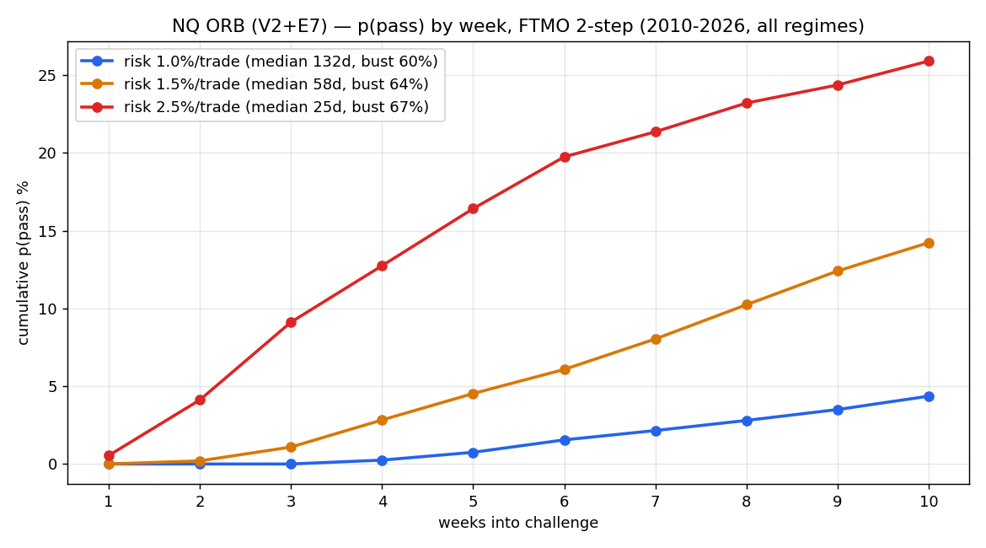
p(pass) by week
Higher risk resolves faster (median 25 d at 2.5% vs 132 d at 1.0%) and lifts the early-week probability — but terminal p(funded) is essentially flat at ~32–34% across sizings, because the outcome is regime-determined, not size-determined. Faster sizing simply trades “running” for “bust” (running 5.9% → 0.5%; bust 60% → 67%).

7.2 FTMO outcome split
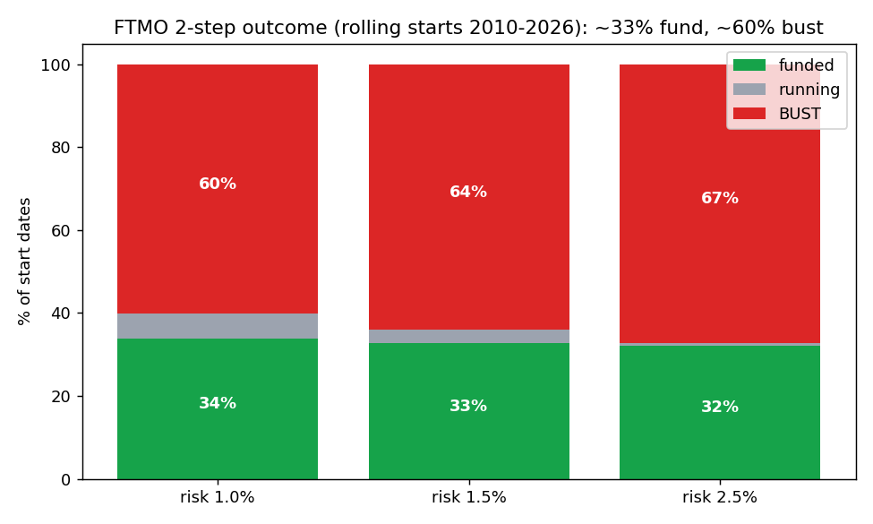
Outcome split
Risk/trade | p(funded) | running | bust
1.0% | 33.9% | 5.9% | 60.2%
1.5% | 32.7% | 3.4% | 63.9%
2.5% | 32.2% | 0.5% | 67.2%

7.3 The edge shape (per-trade R)
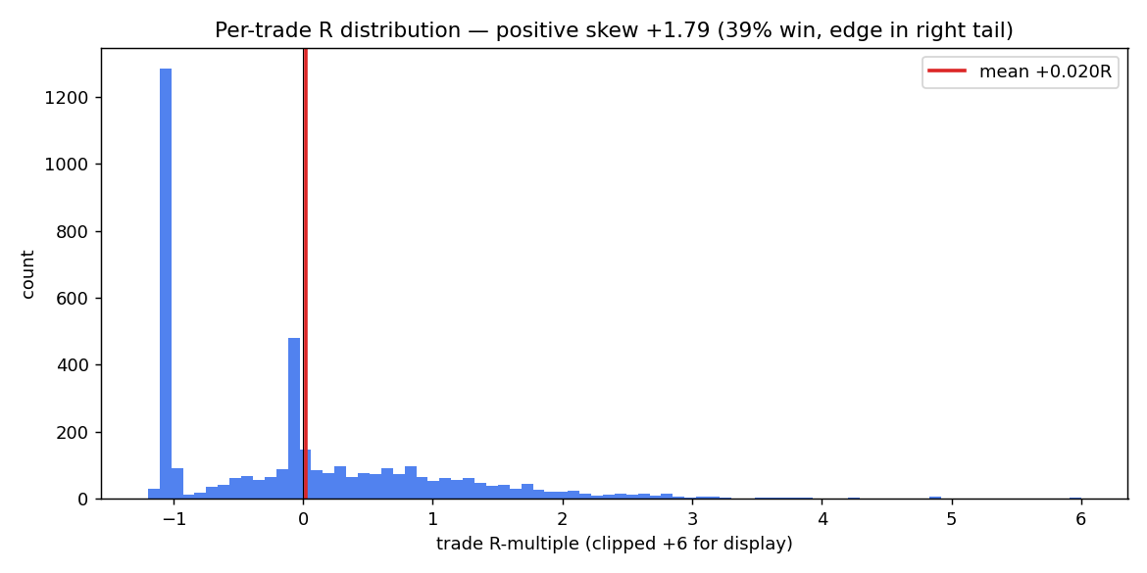
R distribution
39% win-rate, skew +1.79: a wall of small −0.7 to −1R losers and scratches, paid for by a thin right tail of multi-R winners. This shape is the reason the strategy is barrier-fragile (the losers cluster you toward the floor before a winner arrives).

7.4 Equity-curve metrics (E7, compounded) — the sobering standalone view
Risk/trade | CAGR | max drawdown | Calmar | Sharpe (ann.)
1.0% | 3.3% | −56.1% | 0.06 | 0.27
1.5% | 3.8% | −71.9% | 0.05 | 0.27
2.5% | 2.3% | −89.4% | 0.03 | 0.27
As a standalone trading strategy the ORB is poor — Sharpe 0.27, catastrophic drawdowns driven by the multi-year dead stretches. Its only use is as a fast first-passage attempt where you either pass quickly or bust before the drawdown compounds. It is not an investable equity curve.

7.5 Regime dependence (by year)
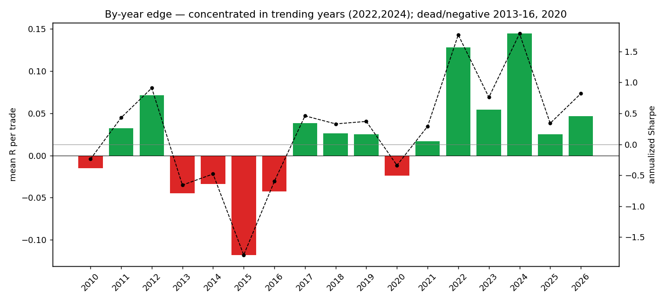
By-year edge
Bucket | Years | mean R | note
Strong (trending) | 2022 (+0.128, SR 1.77), 2024 (+0.145, SR 1.79), 2012 (+0.072) | the edge | concentrated here
Mediocre-positive | 2011, 2017, 2018, 2019, 2021, 2023 (+0.054), 2025, 2026 | thin | drifts, slow
Dead / negative | 2015 (−0.118, SR −1.79), 2013 (−0.045), 2016 (−0.043), 2014 (−0.034), 2020 (−0.024), 2010 (−0.015) | the busts | ~6 of 16 years
The full-sample ~33% funded is the blend of ~2 great years, ~8 thin-positive, and ~6 negative. Start in 2022/2024 → you fund fast; start in 2013–2016 → you bust. That is the entire risk.

8. Risk analysis & stress tests
- Regime fragility is the dominant risk (not a tail gap). ~⅔ of start dates bust because the per-trade edge vanishes or inverts in non-trending years. No sizing fixes this; only regime selection would — and regime forecasting is established (separately) to be not achievable (nowcast weak, transition unforecastable).
- Bust mechanism = grinding to the −10% floor on clustered −0.7/−1R losers during a dead regime, before a right-tail winner. The 5% daily limit is not the binding constraint for single-NQ ORB (one 1R trade/day ≈ ≤2.5% daily) — the −10% total floor is.
- Execution dependency (hard). Same-bar fill at the breakout level is mandatory; next-bar-open-only → p(pass) ≈ 28%. Slippage tolerance is narrow: expectancy crosses zero around 6–9% of OR width in slippage. Demo must confirm fills (§9).
- Statistical marginality. Deflated Sharpe ≈ 0.70 (< 1.0). Treat the per-trade edge as plausible but unproven; size accordingly.
- Stress tests the team should run (orb_metrics.py supports --cost-bps, --or-min):
  - cost sweep 1→6 bps (find breakeven);
  - OR length 5/15/30/60 (robustness, not a knife-edge);
  - risk sweep 0.5→3% (confirm the flat ~33% funded / rising bust);
  - fetch 2008/dot-com intraday and re-run (the only un-sampled severe regime);
  - replicate on ES/DAX (does the intraday breakout edge survive cross-asset? — √N).

9. Out-of-sample, demo, and live testing protocol
Unlike the overnight harvester, the ORB is fast — so demo can show pass/bust outcomes within weeks. That makes forward validation more direct, but also means a single demo result is one regime draw (don’t over-update on it).

9.1 Demo (paper/sim, ≥ 2–3 months, ideally across a regime change)
- Fill realism (the make-or-break check). Confirm you can fill the OR break at the level (resting stop), not next-bar-open. Log realized fill vs level on every trade; measure slippage as a fraction of OR width. If slippage ≳ 6% of OR, the edge is gone.
- Per-trade distribution. Verify realized mean R, win-rate, and skew against backtest (+0.0196R, 39%, +1.79). Need ≥ ~60 trades for a meaningful estimate.
- V2 filter + session. Confirm the OR≥10bps filter and the correct RTH session boundaries in your feed’s timezone.
- Regime awareness. Note the prevailing regime; expect strong results only in trending conditions and ~breakeven-to-negative in chop. Do not extrapolate a favorable demo month.

9.2 Acceptance / kill criteria
- Proceed if fills are at-level, slippage within budget, and realized mean R ≥ ~+0.012 over ≥ 60 trades.
- Abort if fills are next-bar-only (edge structurally gone) or realized mean R ≤ 0 over ≥ 80 trades spanning more than one regime.

9.3 Live deployment
- Treat each challenge as a ~⅓-probability fast attempt, not a sure thing. Budget for multiple attempts (regime-correlated → expect ~50–65% over 2–3 attempts, below the naive 55–70%).
- Pick sizing for your time/bust tolerance: 2.5% ≈ median 25 days but 67% bust; 1.0% ≈ median 132 days, 60% bust, more “running”. Probability is ~flat — choose on speed/temperament.
- Do not deploy a regime gate until validated on pre-2010 data (N≈1 today → overfit).
- Hard guardrails: respect the daily-loss headroom; never pyramid; one ORB trade/day; flat overnight.

9.4 OOS evidence already in hand
The full 2010–2026 contiguous test is the out-of-sample stress: it spans 2 strong, 8 thin, and 6 negative years, and yields the honest ~33% funded / ~60% bust. Earlier “50.9% (2022–25)” and “93% (2026)” are favorable-window readings and should be quoted only with that caveat.

10. Limitations & open items
- Statistically marginal edge (deflated Sharpe ~0.70). The pass-rate is mostly container math (floor-proximity + no time limit), not signal — established by placebo.
- Regime fragility is the core risk; ~⅔ of starts bust over the full sample. Regime forecasting is not achievable; a gate is N≈1-overfit until 2008-era data is fetched.
- Execution-critical: requires at-level fills; collapses to ~28% on next-bar fills; narrow slippage tolerance.
- Favorable-window cherry-pick risk in prior reporting — corrected here to the full-sample number.
- Single-asset (NQ); ES/DAX replication (√N) pending.
- It is the fast-but-low-probability vehicle. For high single-attempt funded probability, prefer the overnight harvester (§12).

11. Reproduction
python3 -m pip install pandas numpy pyarrow matplotlib openpyxl
# Full metric set (per-trade stats, equity, FTMO weekly/monthly p(pass), regime)
python3 orb_metrics.py \
--data /path/to/NQ_1min_databento_2010-2026.parquet \
--out ./out
# Sensitivities
python3 orb_metrics.py --data <parquet> --cost-bps 4 --out ./cost4
python3 orb_metrics.py --data <parquet> --or-min 15 --out ./or15
Expected console (matches §7): NQ ORB (V2+E7) | 2010-06-07 .. 2026-05-29 | 3992 trades / 4041 days; E7 mean_R +0.0196, skew +1.79, win 39%; FTMO 1.0%→33.9% / 1.5%→32.7% / 2.5%→32.2% funded.
Folder contents: STRATEGY_DOSSIER_ORB.{md,docx}, orb_metrics.py, NQ_ORB_metrics.xlsx, out/metrics_summary.json, out/regime_by_year.csv, out/orb_daily_R.csv, fig1–4*.png.

12. Honest comparison — ORB vs. the overnight harvester
 | NQ ORB (this doc) | Overnight harvester
Edge type | intraday breakout / momentum (beta, regime-dependent) | overnight equity risk premium (beta, trend-gated)
Timescale | days–weeks (median 25–132 d) | years (median 1.5–3.5 y)
p(funded) FTMO 2-step, full sample | ~32–34% | ~82–88%
Bust rate | ~60–67% | 0–30%
Per-trade / per-night Sharpe | 0.017/trade (ann. 0.27) | net ~+3.6 bps/night (ann. 0.87)
Standalone Sharpe / maxDD | 0.27 / −56% to −89% | 0.79 / −9% to −18%
Statistical strength | deflated Sharpe ~0.70 (fails) | structural, replicated premium
Dominant risk | regime fragility (most starts bust) | time + rare crash-from-highs gap + swap
Best use | fast attempt; accept ~⅓ odds / multi-attempt | high-probability slow grind
Bottom line: the ORB is the fast option but a ~⅓ single-attempt lottery on the regime, statistically marginal and execution-critical. If speed matters and you accept the odds (or plan multiple attempts), it is viable. If probability of funding is the objective, the overnight harvester dominates it. The two are complementary, not competing: ORB for speed, overnight for probability.
Companion notes: SCAN_ftmo_families.md, AUDIT_VERDICT_ftmo_orb.md, ORB_launch_recap.md, OPTIM_execution_realism.md, REGIME_modeling_NQ.md, and the overnight dossier in ../NQ_overnight_metrics/.

