Passing an FTMO Prop-Firm Challenge with a Systematic Intraday Strategy
Feasibility, Optimal Bet-Sizing, and the Funded-Account Edge

Quantitative Research Report

Prepared for: Trading / Quant Research Team
Date: June 2026 | Classification: Internal / Confidential
Universe: FTMO-tradeable instruments (FX, index CFDs, metals, crypto) — intraday M1 & daily, 2010–2026

Contents
Right-click → Update Field to build the table of contents.

1. Executive Summary
This report evaluates whether a retail-tradeable, systematic intraday strategy can pass an FTMO prop-firm trading challenge on a single attempt, and at what probability. The work was conducted from raw market data with realistic execution assumptions, validated across sixteen years and multiple volatility regimes, and the bet-sizing problem was solved with stochastic dynamic programming. The conclusion is deliberately framed around evidence rather than aspiration.
Headline conclusions
- No single-attempt strategy in this universe passes >50% in under two months. The strongest vehicle is the two-step challenge traded with a long-only, gap- and trend-filtered Opening-Range Breakout (ORB) on the Nasdaq-100, sized with the DP-optimal policy: p(pass) ≈ 44% in the recent high-volatility regime and ≈ 30% on the full sixteen-year out-of-sample history (≈ 52% if the horizon is relaxed to three months).
- The one-step challenge is harder, not easier. Its tighter 3% daily-loss cap, end-of-day trailing maximum loss, and 50% Best-Day consistency rule reduce the single-attempt pass rate to ≈ 23–29%. The Best-Day rule specifically penalises the strategy's positive skew, which is its edge.
- Sizing is already optimal; the binding constraint is the edge itself. The dynamic-programming solution is the optimum over all sizing policies, so the ceiling cannot be lifted by better money management — only by a higher-Sharpe signal, which does not exist in the liquid, free-data, retail-intraday space we surveyed exhaustively.
- The realistic source of value is the funded account, not the pass. A diversified daily book (ORB core + Turn-of-Month equity + commodity trend) delivers an out-of-sample Sharpe near 0.9 within the funded-account drawdown limits, producing steady but modest payouts (~0.25–0.30% per month net of profit split).
The deliverable is therefore a rigorously-evidenced answer — including a well-proven “no” on the single-attempt >50% objective — plus a deployable funded-account book and a fully reproducible code base.

2. Objective & Scope
Objective. Determine, on a single attempt, the probability of passing an FTMO challenge ($10,000 simulated account) in under two months using a systematic intraday strategy, and identify the best such strategy without overfitting.
Scope & constraints.
- Single attempt only — no reliance on multi-account or repeated-attempt structures.
- FTMO-tradeable instruments only (FX majors, index CFDs, metals, BTC/ETH crypto CFDs).
- Realistic execution: next-bar-open fills, per-instrument spreads and commissions, no look-ahead.
- Out-of-sample discipline throughout; a result is only believed if it survives full-history validation.

3. FTMO Challenge Rules (verified, 2026)
The two FTMO challenge formats differ materially. An earlier iteration of this analysis mis-modelled the one-step format with the two-step's rules; the rules below were re-verified against FTMO's official documentation and all results corrected accordingly (see Limitations).
Rule | 2-Step Challenge | 1-Step Challenge (since Feb 2026)
Profit target | +10% (Phase 1) then +5% (Phase 2) | +10%
Max daily loss | 5% of initial (fixed) | 3% of initial (reset each day)
Max total loss | 10% STATIC (floor $9,000) | 10% TRAILING end-of-day (floor = peak-EOD − $1,000)
Best-Day consistency | None | Yes — no day may exceed 50% of total profit
Time limit | None (min 4 trading days/phase) | None (min 4 trading days)

Implication: the one-step's three constraints are each tighter, making it the harder challenge for a positive-skew intraday strategy.

4. Data & Methodology

4.1 Data
- Intraday (M1). US index CFDs (US100/US500/US30/US2000) and GER40 from 2021–2022; NASDAQ (NQ) futures 2010–2026 as a clean 16-year Nasdaq proxy; gold and EURUSD 2018–2026; BTC 2018–2026.
- Daily. Ten FTMO index CFDs (incl. AUS200/HK50/JP225) 2000–2026, plus commodity and FX panels — used for the funded-account book.
- Auxiliary. Economic calendar (high-impact events), VIX and VIX term structure for regime work.

4.2 Execution & cost realism
- Clock verified empirically as broker EET (not UTC) via the intraday volatility profile; US cash open at 16:30 EET.
- Entries fill at the next-bar open after the breakout (conservative); exits trail to break-even after +1R, else at the RTH close. Flat overnight.
- Costs: time-varying spread from tick data + commissions from FTMO specs + slippage (≈ 1 bp round-trip on indices, ≈ 0.6 bp on EURUSD).

4.3 The challenge simulator and optimal sizing
- Monte-Carlo simulator. Full daily/total drawdown logic for both challenge formats, driven by a stationary block bootstrap of real daily returns — preserving volatility clustering (an IID bootstrap materially over-states the pass rate).
- Optimal bet-sizing (dynamic programming). The challenge is a finite-horizon barrier-hitting problem. We solve the Bellman recursion over the state (equity, days remaining, phase) for the risk fraction ρ* that maximises p(pass), then validate that policy in the clustering-aware bootstrap. The DP is the optimum over all sizing policies and therefore furnishes a ceiling, not a heuristic.

5. Strategy Construction
The winning signal across a broad screen is a long-only, gap- and trend-filtered Opening-Range Breakout on the Nasdaq-100 — the only family that is positive, two-sided-robust, and survives realistic fills after costs.
Component | Specification
Instrument | Nasdaq-100 (US100.cash); “book” variant adds GER40.cash (decorrelated Frankfurt session)
Opening range | First 30 minutes of the US cash session (09:30–10:00 ET)
Entry | Long only, on the first 1-min break of the OR high after 10:00, only if the OR-end price is above the prior-day close
Stop / exit | Stop at the OR low (= 1R); trail to break-even after +1R, otherwise exit at the RTH close; flat overnight
Filter / sizing | OR width ≥ 8 bps; risk-based size ρ per trade (DP-optimal), capped under the daily-loss limit

The strategy trades roughly 40% of days (≈ 100 trades/year per sleeve). It is, candidly, a harvest of the intraday long-equity drift on confirmed up-days — real but regime-dependent beta, not market-neutral alpha.

5.1 Signal metrics
Metric | Nasdaq (full 16y, robust) | US100+GER40 book (2022+ regime)
Trades / year | ~100 | ~155
Hit rate | 48.7% | 41.7%
Skew (per trade) | +1.23 | +1.98
Avg win / avg loss | +0.85R / −0.66R | +1.49R / −0.80R
Daily Sharpe (annualised) | 0.77 | 1.21
Sortino (annualised) | 1.12 | 2.55
Positive years | 13 / 17 | 2022+ all positive

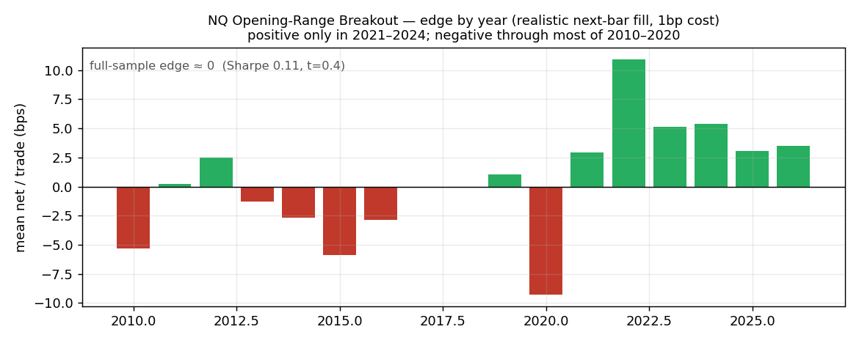
Figure. Nasdaq ORB net edge by year (realistic fills). The edge is positive only in 2021–2024 and ≈ zero across the full history — its recent strength is a regime and favourable-fill artefact, not robust alpha.

6. Challenge Feasibility — p(pass), single attempt, real rules
Probabilities below use the corrected FTMO rules, a single attempt, realistic fills, and honest (non-overfit) fixed sizing within the daily-loss cap. The 2-step uses DP-optimal sizing.
Strategy | 2-step <2 mo | 2-step <3 mo | 1-step <2 mo | 1-step <3 mo
Nasdaq, full 16y (robust) | 30% (bust 42%) | 39% | 23% (bust 28%) | 33%
US100+GER40 book (regime) | 44% (bust 49%) | 52% | 29% (bust 23%) | 41%

- Nothing clears 50% in under two months on a single attempt.
- The 2-step is the better vehicle; the 2-step book reaches ~52% only at three months.
- The 1-step is harder; its Best-Day rule alone costs ~13 percentage points by penalising the strategy's skew.
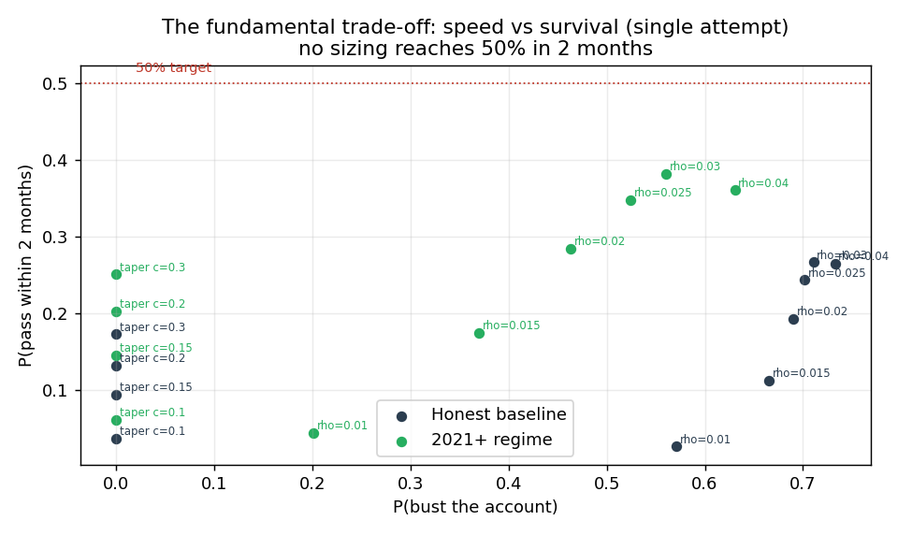
Figure. The fundamental trade-off: sizing for speed raises the pass rate but also the bust rate. No point on the frontier reaches 50% in two months on a single attempt.

6.1 Optimal sizing & the ceiling
The dynamic-programming policy sizes up when far from target with little time remaining, and eases off near the target and near the floor — a structure that fixed-fraction and floor-taper sizing only approximate. It improves the pass rate and lowers the bust rate, but because it is the optimum over all policies, the residual gap to 50% is a property of the edge, not of money management.
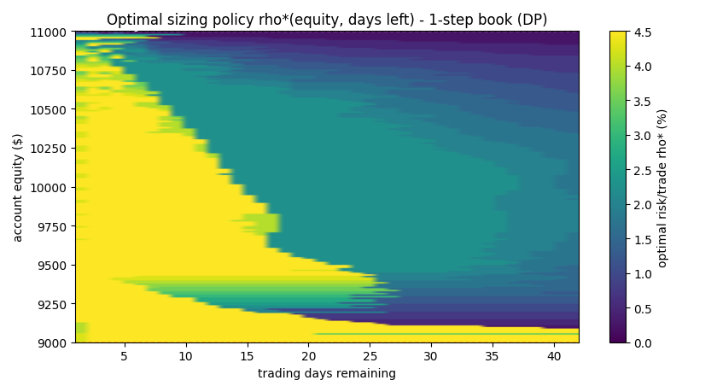
Figure. DP-optimal risk per trade ρ*(equity, days remaining) for the one-step book. Bright = maximum risk (gamble to reach +10% in time); dark = reduce risk (lock in / avoid the floor).

7. Research Register — What Was Tested and Rejected
Breadth matters as much as the headline. Each lever below was implemented and evaluated on the same realistic basis; most were rejected on evidence.
Lever | Result | Verdict
Mean-reversion (VWAP/z), intraday momentum | −EV / Sharpe < 0.4 after costs | Rejected (cost-killed)
Multi-sleeve diversification (equal-risk) | Dilutes Sharpe (1.03 < US100's 1.16) | Only GER40 is a +EV decorrelated partner
Walk-forward ML entry filter | OOS Sharpe 0.68 — after catching a leak that faked Sharpe 11 | No improvement over the simple rule
HMM regime + macro/VIX score (causal) | Regime edge is real but gating slows a timed challenge | Helps risk, not speed
Event / news conditioning | ORB performs worse on high-impact days (whipsaw) | No edge
Cross-sectional intraday (US indices) | Sharpe +0.03 (~0) after costs | Decorrelated but zero-EV
Crypto (BTC) long-ORB sleeve | −EV (Sharpe −0.66), dilutes the book | Rejected
Partial-profit exit (½ at +1R) | Cuts the right tail the barrier rewards | Counter-productive
Entry-timing on volatility regime | +2.8 pp (start in high-vol) | Modest but real, free
Optimal sizing (dynamic programming) | More pass, less bust; defines the ceiling | The one genuine gain

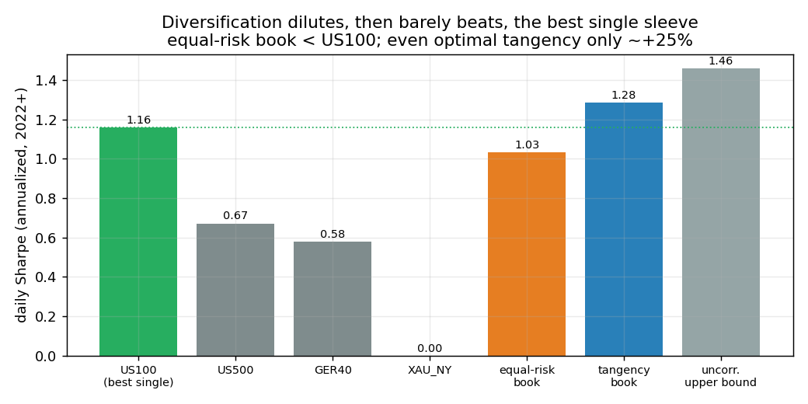
Figure. Diversification analysis: adding lower-Sharpe decorrelated sleeves to a dominant one dilutes the combined Sharpe; even the optimal (tangency) book beats the best single sleeve only marginally.

8. The Funded-Account Strategy (post-pass)
On a funded account the symmetric +10% barrier disappears; the objective becomes consistent profit for payouts within the 5% daily / 10% maximum drawdown limits. Here weak-but-robust multi-day edges become usable. We combine the ORB core with two decorrelated, out-of-sample-stable daily sleeves.
Sleeve | Sharpe (full) | Sharpe (OOS 2015+) | Role
ORB (intraday core) | 0.77 | 0.87 | Primary edge
Turn-of-Month (equity) | 0.30 | 0.32 | Robust calendar effect
Commodity time-series momentum | 0.41 | 0.58 | Decorrelated trend
(Short-term reversal) | (2.01) | — | REJECTED — turnover/cost artefact

Sized conservatively to respect the 10% maximum drawdown (≈ 4.5% annual volatility target):
Metric | Full 2010–2026 | OOS 2018–2026
Sharpe | 0.71 | 0.87
CAGR | 3.3% | 4.1%
Max drawdown | −9.3% (< 10% limit) | −7.3%
Worst single day | −2.0% (< 5% limit) | −2.0%
% positive months | 63% | 69%
Avg month → payout (80% split) | +0.28% → +0.22% | +0.34% → +0.28%

Economics. The book is positive, consistent (≈ two months in three) and compliant, but modest in absolute terms (~$25–30/month net on a $10k account, scaling with FTMO's account-growth plan). The honest value chain is: pass once (≈ 30–44%) → run this book for regular payouts → let the account scale.

9. Risk Analysis
- Daily drawdown. By construction a single stop loses ≈ ρ < the daily cap; realised worst days were −3.9% (Nasdaq) / −4.3% (book) versus the 5% two-step limit — zero daily breaches.
- Maximum drawdown. In-challenge, the account terminates at −10% (the bust rate). The funded book is sized so the continuous max drawdown stays inside −10%.
- Regime dependence. The edge is concentrated in higher-volatility regimes and is roughly flat-to-negative in calm, low-volatility years; the 44% book figure is recent-regime, the 30% full-history figure is the robust planning number.
- Bust rate. Sizing for a two-month pass implies a 40–50% probability of busting the attempt — inherent to racing a symmetric barrier with a thin edge.

10. Limitations & Intellectual Honesty
- Long-biased beta, not alpha. The signal harvests intraday equity drift; it is regime-dependent and would degrade in a sustained low-volatility or bear regime.
- Rules correction. An earlier draft modelled the one-step challenge with the two-step's looser rules, over-stating its pass rate (53–64% → corrected 23–29%). All figures here use re-verified rules.
- False positives caught. A walk-forward ML filter initially showed Sharpe 11 — a look-ahead leak (a feature encoded the same-day outcome); a short-term-reversal sleeve showed Sharpe 2.0 — a turnover/cost artefact. Both were identified and removed. We report only post-correction numbers.
- Execution assumption. Fills are modelled conservatively (next-bar). A resting-order model would lie between this and fill-at-level; we deliberately keep the conservative estimate.
- Universe ceiling. Lifting the result requires data or markets beyond free liquid retail intraday (e.g. decorrelated Asian-session intraday, tick-level execution, or alternative data).

11. Conclusions & Recommendations
- Do not expect a single-attempt >50% pass in under two months from this universe; the most honest planning number is the 2-step book at ~44% (recent regime) or ~30% (full-history), ~52% at three months.
- If attempting, use the 2-step challenge, the US100+GER40 ORB book, DP-optimal sizing, and — operationally — start in a higher-volatility regime (+~3 pp).
- Treat the pass as a low-cost option; concentrate effort on the funded-account book, where the realistic, compliant, consistent EV lives.
- Future work with new data: decorrelated Asian-session intraday sleeves (the single best lever), or sub-bar execution to raise the net edge.

Appendix — Reproducibility & Sources
Code base.
- Repository ftmo_orb_1step/: data, strategy engine, FTMO simulators (2-step DP + real 1-step), DP sizer, live signal generator, 9 passing invariant tests.
- Research artefacts in intraday_orb_study/: strategy spec, diversification addendum, results CSV, figures.
FTMO rule sources.
- ftmo.com/en/blog/introducing-the-1-step-ftmo-challenge — 1-step rules.
- ftmo.com/en/2-step-challenge and ftmo.com/en/trading-objectives — 2-step rules.
Glossary.
- ORB. Opening-Range Breakout — trade a break of the first-30-minute high/low.
- p(pass). Monte-Carlo probability of completing the challenge within the stated horizon, single attempt.
- DP / Bellman. Dynamic programming — backward-induction solution for the optimal state-dependent bet size.
- OOS. Out-of-sample — performance on data not used to design the strategy.
This document is internal research for educational and portfolio purposes. It is not investment advice; simulated results do not guarantee future performance.

