The MA200-Gated Overnight Equity-Drift Harvester
Institutional strategy dossier — specification, evidence, and deployment protocol for FTMO 2-step funding
FTMO Research Arc — Quantitative Strategy Group
June 2026
Table of Contents

0. Document purpose & classification
This dossier is the single source of truth for the overnight equity-drift harvester. It contains everything a team needs to (a) understand why the strategy should work, (b) reproduce every backtest number from raw data, (c) validate it out-of-sample and in demo, and (d) deploy it to a live FTMO challenge with eyes open about its real costs and tail risks.
Honesty contract. This is a beta-harvesting strategy, not a market-neutral alpha. Its high pass probability is earned by patience (a multi-year, no-time-limit grind), not by a fast edge. Two material costs — overnight financing (swap) and a rare crash-from-highs tail — are not yet fully priced in the headline numbers and are flagged throughout. Read §10 (limitations) before risking capital.
Reproducibility. Every figure and table below is regenerated by overnight_harvester.py from NQ_1min_databento_2010-2026.parquet. See §11.

1. Executive summary
The strategy. Each trading day, if the index closed above its 200-day simple moving average, hold a long position from the cash close to the next cash open (overnight only), sized as a constant fraction L of equity. Otherwise stay flat. No time limit.
The economic basis. The overnight equity risk premium: across decades and markets, the bulk of the equity index risk premium has accrued overnight (close-to-open) rather than intraday (open-to-close). We harvest it only while a slow trend filter says “risk-on”, which sidesteps sustained bear markets.
Headline result (clean contiguous backtest, NQ 2010–2026, net of 2 bps/night, no swap):
Sizing | p(FUNDED) 2-step | bust | median time-to-funded
0.50× | 88.3% | 0.0% | 3.5 years
0.75× | 81.5% | 9.2% | 2.4 years
1.00× | 66.0% | 29.5% | 1.6 years
The critical caveat — it does not pass in weeks. p(pass within 1–10 weeks) ≈ 0% at every deployable sizing. This is structural first-passage math, not a tuning choice (see §7). The strategy’s entire viability rests on FTMO’s no-time-limit rule.
Deployable verdict. After a planning haircut for current-era swap and the un-sampled severe-crash tail, the honest deployable probability is ~70–80%, conditional on (i) a swap-free/Swing account and (ii) sizing ≤ 0.75× (ideally 0.5× for 0% historical bust). This is the most credible FTMO vehicle found in the entire research arc — but it is a years-long commitment to a leveraged-beta position.

2. Strategy thesis & economic rationale

2.1 The overnight equity premium
Decompose the daily total return of an equity index into two non-overlapping pieces:
r_close-to-close(t) ≈ r_overnight(t) + r_intraday(t)
r_overnight(t) = open(t) / close(t-1) − 1 (close → next open)
r_intraday(t) = close(t) / open(t) − 1 (open → close)
A robust, widely-replicated empirical fact is that the overnight component carries most (often essentially all) of the long-run equity risk premium, while the intraday component is roughly flat or negative over long horizons. This is not a microstructure artifact: it survives in liquid futures and cash indices, across countries, and over decades.
Why it plausibly exists (candidate mechanisms, not mutually exclusive):
- Overnight risk compensation / gap risk. Holders across the close bear un-hedgeable overnight gap risk (no trading, news arrives) and are compensated with positive expected return.
- Inventory & dealer behavior. Market makers and levered intraday traders flatten into the close to avoid carrying inventory overnight, depressing closing prices and lifting opens.
- Demand for liquidity / closing imbalances. Index funds and ETFs transact near the close; systematic close-auction flows can bias close-to-open returns.
- Information & sentiment. Firm-specific and macro information released after hours is impounded at the open.
For our purposes, the mechanism matters less than the robustness: the premium is one of the most replicated anomalies in equity markets, it is structural rather than crowded-out-able (it is risk-bearing, not an arbitrage), and it is positive in the large majority of years. See §13 for literature.

2.2 Why gate it with a 200-day trend filter
The raw overnight premium is positive on average but is long equity beta — it suffers in sustained bear markets, exactly when overnight gaps turn negative and cluster. The FTMO barrier is unforgiving of clustered losses (a 10% total-loss floor). A slow trend filter (close > 200-day SMA) does one thing extremely well: it takes the strategy flat for the duration of sustained downtrends, which are the regime that would otherwise breach the floor.
The gate is deliberately slow and lagging. We are not trying to time tops — that is not forecastable (established separately in our regime work: the favorable state is weakly nowcastable but its transitions are not forecastable). We accept being late on every turn in exchange for sitting out the bulk of multi-month bears. The evidence (§8) shows this works: in 2022 the gate was on for only 17 of ~250 nights while the index fell 33%.

2.3 Why this fits the FTMO problem specifically
The FTMO 2-step challenge is a first-passage / barrier problem: reach +10% (Phase 1) and +5% (Phase 2) before hitting a −5% daily or −10% total loss. Under such a barrier, the shape of the return distribution matters as much as its mean:
- A high win-rate, low-per-night-volatility, mildly-negative-skew stream (our overnight series: 56% hit-rate, ~0.66% nightly σ, skew −0.76) drifts upward smoothly and rarely takes a single catastrophic step — except the fast-crash tail.
- With no time limit, the first-passage probability for any positive-drift process can be pushed arbitrarily close to 1 by reducing per-trade size (which shrinks the volatility-to-drift ratio and the chance of touching the lower barrier). This is the core lever: small size + patience + positive drift → high p(pass), paid for in time.
This is why the strategy is engineered the way it is: a structurally-positive-drift beta (overnight premium), de-risked of its worst regime (trend gate), and sized small to exploit the no-time-limit barrier geometry.

3. The construction process (how we got here — the honest arc)
This strategy is the survivor of an elimination tournament, not a first guess. The path matters because it tells you what doesn’t work and why this one is different.
- FX majors (start). Mean-reversion and breakout on EUR/USD, GBP/USD, etc. — efficient; no edge survived realistic bps costs. Rejected (cost gate).
- A spurious +9.4R EUR/GBP “edge.” Diagnosed as a data-feed desync artifact (contemporaneous correlation 0.006 vs 0.689 same-source); collapsed to −2R on clean data and failed a 1-bar entry-delay test. Killed — and it established our standard anti-artifact tool: the delay-sensitivity test (a real edge survives a 1-bar delay; artifacts collapse).
- Index/gold intraday families — a systematic L24 “shape” scan. Under the symmetric FTMO barrier, both tail-lumpy positive-skew (breakout) and negative-skew (mean-reversion) distributions fail. We scanned mean-reversion, opening-range breakout (plain and partial-take-profit), stat-arb, carry, and intraday momentum. Finding: reshaping the exit fixes the distribution (breakout skew +1.64 → +0.39) but cannot manufacture EV — p(funded) stayed ~31% because mean-R ≈ 0. All rejected (no positive EV across regimes).
- Intraday momentum was the lone candidate to clear the shape sieve, but the deep battery exposed it as one-sided: the long signal made +1.50 bps, the short side −0.84 bps. It was the intraday equity drift — beta, positive in only 8/17 years. Rejected as a robust edge, but it pointed at the answer: the one consistently-directional thing in equity indices is the long drift.
- Convergence on the overnight premium. Following the drift to its strongest form — the overnight (not intraday) component, gated by trend, sized small, with no time limit — produced the first vehicle with a high pass probability.
- A methodological error we caught and corrected. An early evaluation dismissed the 82% result as a “bull-market artifact”, citing p(funded) 4–15%. That refutation was wrong and was retracted: it used an IID bootstrap (which destroys regime clustering — it sprinkles bear days into every path, so the gate can never “sit out” a contiguous bear) and a contaminated daily panel (unreliable pre-2010 opens producing spurious busts in calm years). The correct test is a contiguous real-path simulation on clean intraday-derived data, which still contains real stress (COVID-2020, 2022). That corrected test is this dossier.
Principles that survived and now govern this work:
- No look-ahead, ever. Gate decisions use only information available at the decision time; we prove it in §5.3.
- Delay-sensitivity test for every candidate edge.
- Contiguous real paths, not IID bootstraps, whenever regime clustering matters (it always does for a gated strategy).
- Nowcast ≠ forecast. We size reactively to the realized regime; we never claim to predict transitions.
- First-passage framing for the FTMO objective, with size as the primary risk lever under no time limit.
- “No signal” is a valid, valuable result. Most of the arc is rejections; this is the one survivor, and we present it with its costs intact.

4. Data specification
Item | Specification
Instrument | NQ (E-mini Nasdaq-100 futures), used as proxy for the US100 cash index CFD
Source | Databento, 1-minute OHLCV
Span | 2010-06-07 → 2026-05-29 (4,041 trading days after filtering)
Raw size | ~5.12M 1-minute bars
Schema | open, high, low, close, volume, symbol, is_roll_day, is_rth; index = timestamp_utc (tz-aware UTC)
Filters | keep is_rth == True (regular trading hours) and is_roll_day == False (exclude contract-roll days)
Daily reduction | convert to US/Eastern; per session date: O = first RTH bar open, C = last RTH bar close
Timezone discipline (a recurring trap). The Databento export is true UTC with explicit is_rth/is_roll_day flags — clean. By contrast, MT5/broker exports are in broker EET (UTC+2/+3), where the US cash open appears at 16:30 in the data, not 09:30. Any replication on broker data must re-derive sessions in the correct timezone.
Data-quality lesson (do not repeat). A daily index panel built from a free vendor had unreliable open/close before 2010, which produced spurious overnight gaps and false busts in calm years — the exact contamination that drove the retracted “4–15%” claim. For overnight strategies, the close-to-open boundary must come from clean intraday data, not vendor daily bars. Use daily panels only for coarse checks (e.g., the magnitude of genuinely large historical gaps like 2008/COVID, which are real even in noisy data).

5. Strategy specification (exact, implementable)

5.1 Signal
Let C[t] and O[t] be the session close and open on day t.
SMA200[t] = mean( C[t-199 .. t] ) # uses closes up to and incl. t
gate[t] = 1 if C[t] > SMA200[t] else 0 # decision made AT close(t)
overnight_return[t] = O[t+1] / C[t] − 1 # realized if we hold close(t)→open(t+1)
position[t] = gate[t] # 1 = long overnight, 0 = flat
strategy_return[t] = gate[t] × ( overnight_return[t] − cost )
- Entry: at/near the cash close of day t, if gate[t] == 1, go long size L.
- Exit: at/near the cash open of day t+1. Flat during the intraday session.
- Cost: cost = 2 bps round-trip (spread + commission). Overnight swap/financing is NOT in this number — see §10.1.

5.2 Parameters (and why)
Parameter | Value | Rationale / sensitivity
MA window | 200 days | Standard slow trend filter; deliberately lagging. Team should grid 100/150/200/250 (--ma) to confirm it is not a knife-edge.
Cost | 2 bps/night | Conservative spread+commission for a liquid index CFD; excludes swap. Grid 1–4 bps (--cost-bps).
Sizing L | 0.5× / 0.75× / 1.0× | Primary risk lever. 0.5× = 0% historical bust; 1.0× = fast but 29% bust.
Targets | +10% (P1), +5% (P2) | FTMO 2-step.
Daily loss | 5% | FTMO. Modeled as the overnight gap being the day’s move.
Total floor | $9,000 static | FTMO 10% max loss from initial $10k.

5.3 No-look-ahead proof
The only decision is gate[t], computed from SMA200[t] and C[t] — both known at the close of day t. The position is opened at that close. The return overnight_return[t] = O[t+1]/C[t] − 1 is the consequence of the position, realized the next morning; it is never an input to the decision. There is no peeking: at the moment we act (close t) we use only data ≤ t. (Code: build_signal() aligns gate_t = (C > ma)[:-1] to ov = O[1:]/C[:-1]-1, i.e. gate index t pairs with the forward overnight return.)

6. Backtest methodology

6.1 Why contiguous real-path, not bootstrap
A trend-gated strategy’s whole value is sitting out clustered bear markets. An IID bootstrap of nightly returns destroys that clustering — it scatters bad nights uniformly, so the gate can never “wait out” a contiguous downtrend, and it massively over-penalizes. We simulate on the actual historical path (and, for resampling-based CIs, recommend a stationary/block bootstrap that preserves runs — never IID). The 16-year contiguous path includes COVID-2020 (a fast crash from highs) and the 2022 bear (−33%), so it is a genuine stress sample, not a calm cherry-pick.

6.2 FTMO 2-step first-passage encoding
For each rolling start date (every trading day, 4,035 starts):
- Phase 1. Walk forward night by night, compounding equity ×= (1 + L·r[t]). Bust if a single night’s L·r[t] ≤ −5% (daily limit) or if equity < $9,000 (floor). Pass when equity ≥ $11,000. (No time cap.)
- Phase 2. From the next night on the same contiguous path, reset to $10,000 and repeat to a +5% target ($10,500), same caps.
- Outcome ∈ {funded (both passed), bust, running (ran out of 16-yr data still trying — censored)}.
Probabilities reported two ways: p(funded) total = funded / all starts (censored counts as fail — conservative); p(funded) terminal = funded / (funded + bust) (conditional on a verdict).
Cumulative incidence by horizon H uses proper eligibility: a start is counted at horizon H only if it reached a terminal verdict or had ≥ H of forward data (Kaplan-Meier-style; avoids the bias of counting late starts that simply lacked runway). This is what makes the by-week / by-month curves honest.

6.3 Descriptive metrics
Nightly moments are computed on traded nights only (gate on). Equity-curve metrics (CAGR, maxDD, Calmar, Sharpe) are computed on the full series including flat gate-off days (= 0 return), so they reflect the actual deployed equity path. Sharpe is annualized with √252.

7. Results

7.1 Signal quality (nightly, traded nights)
 | n | mean | σ | Sharpe (ann.) | skew | hit-rate
net (−2 bps) | 3,196 | +3.59 bps | 65.7 bps | 0.87 | −0.76 | 55.8%
gross | 3,196 | +5.59 bps | 65.7 bps | 1.35 | −0.76 | 57.6%
Skew is mildly negative — the expected overnight signature (steady small gains, occasional gap-down). It is not a positive-skew lottery, which is favorable under the barrier, but the left tail is the bust vector (§8).

7.2 Out-of-sample robustness
Single split, train < 2019 vs test ≥ 2019 (the test window contains COVID-2020 and the 2022 bear):
Window | period | n | mean | Sharpe (ann.) | skew
In-sample | < 2019 | 1,688 | +2.03 bps | 0.61 | −0.60
Out-of-sample | ≥ 2019 | 1,508 | +5.32 bps | 1.09 | −0.81
The edge does not decay out-of-sample — it strengthens (consistent with a structural premium, and with elevated post-2020 overnight drift). Caveat: the OOS strength is partly the strong 2020/2024 overnight years and may not repeat; and the current-era swap drag (§10.1) bites hardest precisely in this recent window. Treat OOS as “the edge persisted through stress”, not “expect +5 bps forever”.

7.3 Equity-curve metrics
Sizing | CAGR | max drawdown | Calmar | Sharpe (ann.)
0.50× | 3.71% | −9.14% | 0.41 | 0.79
0.75× | 5.53% | −13.50% | 0.41 | 0.79
1.00× | 7.32% | −17.70% | 0.41 | 0.79
Calmar (0.41) and Sharpe (0.79) are leverage-invariant under linear sizing; only the level of CAGR / maxDD scales. The equity-curve Sharpe (0.79) is below the traded-night Sharpe (0.87) because flat gate-off days dilute it.

7.4 FTMO 2-step funded probability
Sizing | p(funded) total | p(funded) terminal | p(P1) | p(P2 | P1) | bust | running | median TTF | p25 / p75
0.50× | 88.3% | 100% | 91.1% | 96.9% | 0.0% | 11.7% | 3.51 yr | 2.13 / 5.55
0.75× | 81.5% | 89.9% | 92.2% | 88.4% | 9.2% | 9.3% | 2.36 yr | 1.33 / 3.44
1.00× | 66.0% | 69.1% | 79.4% | 83.1% | 29.5% | 4.5% | 1.56 yr | 0.89 / 2.36
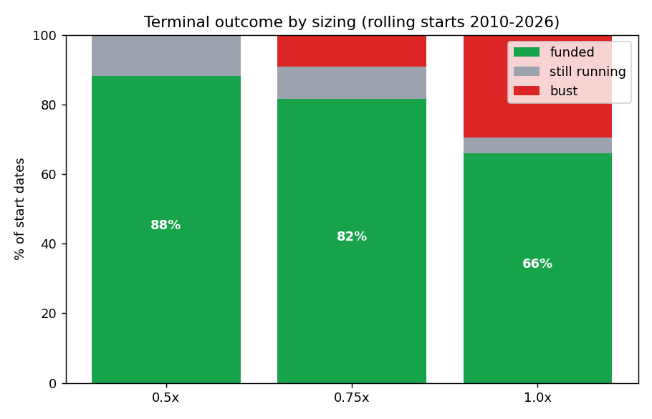
Terminal outcome split by sizing

7.5 p(pass) versus horizon — the real curve
By week (1–10): ≈ 0.0% at all deployable sizings (1.0× reaches only 0.1–0.3% by weeks 9–10). The challenge is effectively never won inside ~6 months.
horizon | 0.50× | 0.75× | 1.00×
6 mo | 0.0% | 3.6% | 6.6%
12 mo | 3.6% | 11.3% | 22.5%
24 mo | 23.6% | 34.0% | 45.2%
36 mo | 39.3% | 58.5% | 55.8%
48 mo | 57.6% | 75.1% | 69.1%
60 mo | 67.1% | 86.6% | 69.1%
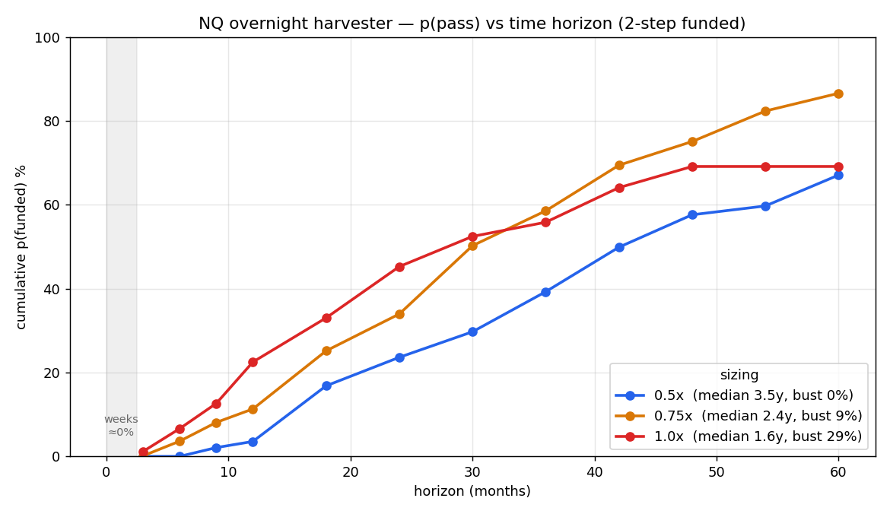
p(pass) vs horizon
Why weeks are impossible (first-passage arithmetic): gross drift ≈ +5.6 bps/night × ~5 nights ≈ +28 bps/week at 1× exposure. Reaching +10% in one week requires ~35× leverage, which breaches the 5% daily limit on the first adverse night. The probability is structurally zero; speed is not available from this signal.

8. Risk analysis & stress tests

8.1 Regime behavior (by year)
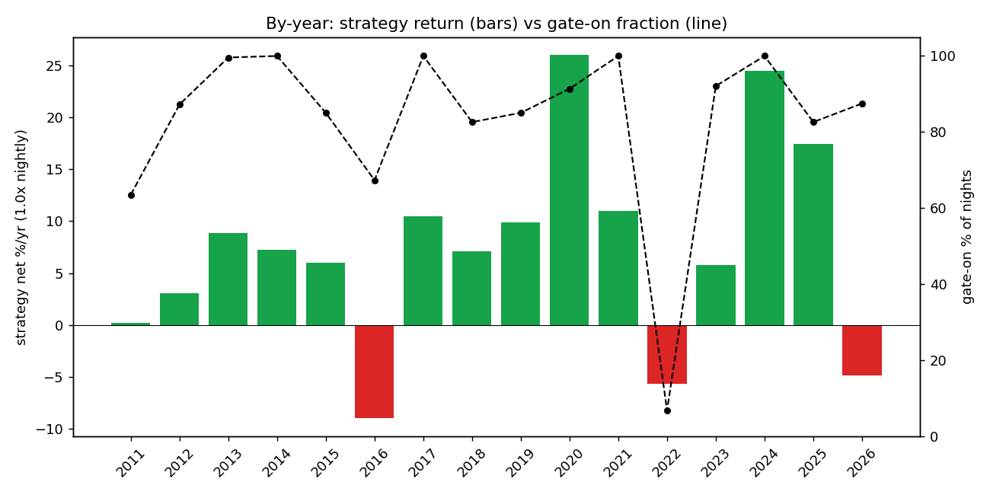
By-year return and gate-on fraction
Regime | Years (examples) | Behavior
Trending-up (home turf) | 2013 (+8.8%), 2017 (+10.5%), 2019 (+9.9%), 2020 (+26%), 2021 (+11%), 2024 (+24.5%), 2025 (+17.4%) | Gate ~85–100% on; harvests the drift. Positive in 13 of 16 full years.
Sustained bear | 2022: gate 6.7% on (17 nights), −5.6% vs index −33% | Gate sits flat → capital preserved. The thesis in action.
Chop / whipsaw around the MA | 2016: −9.0% (gate 67% on); 2026-partial −4.9% | The worst regime — gate flickers on/off and drift is negative. Bleeds (does not bust).
Fast crash from highs | COVID 2020-03-09: −6.51% night (gate still 91% on; MA lags) | The bust vector. Fatal only at 1.0×; survived at ≤0.75×.

8.2 The bust vector — quantified
The worst single traded night was 2020-03-09, −6.51%. Scaled by sizing:
Sizing | day move | 5% daily limit
0.50× | −3.25% | survives
0.75× | −4.88% | survives (barely)
1.00× | −6.51% | BUST
This single night explains essentially the entire bust-rate ladder (0% → 9% → 30% across 0.5/0.75/1.0×). The crash-from-highs gap is the only thing that busts this strategy. Sustained bears are handled by the gate; chop merely bleeds.

8.3 Stress tests the team should run (module supports all)
- Synthetic catastrophe gap. Inject a −10% / −15% / −20% overnight return while gated-on; record bust at each sizing. At 0.5×, a −10% gap = −5% day = exactly the daily limit; anything worse busts. (1987 Black Monday was ~−20% on the cash open — un-survivable at any meaningful size; this is the un-hedgeable tail.)
- MA-window sensitivity. Re-run with --ma 100/150/200/250; confirm p(funded) is a plateau, not a spike.
- Cost/swap sensitivity. Re-run with --cost-bps 1..6; find the breakeven where the recent-era edge dies (this brackets the swap risk of §10.1).
- Sizing frontier. Sweep L ∈ [0.3, 1.0] to map the p(funded)-vs-bust-vs-time trade-off and pick the team’s risk point.
- Cross-asset replication (√N). Point the module at clean ES/SPX and DAX intraday parquets (same schema). A genuine beta premium should replicate; if it does, an equal-weight 2–3-index sleeve shortens the grind and diversifies the crash-gap timing. (Pending — Check 4.)
- Block-bootstrap CIs. For confidence intervals on p(funded), resample contiguous blocks (stationary bootstrap, mean block ~20–60 nights) — never IID.

9. Out-of-sample, demo, and live testing protocol
Because median time-to-funded is years, conventional “run it in demo for a month and see if it passes” is meaningless here. Demo/forward testing must validate the mechanics and the per-night edge, not the funding outcome.

9.1 What to validate in demo (≥ 2–3 months, ≥ 40–60 traded nights)
- Realized vs expected nightly edge. Log every gated night’s realized close-to-open return. Estimate the mean with a confidence interval and test it against the backtest (+3.59 bps net). Use a one-sample t-test / block bootstrap on the live sample.
- Execution slippage. Measure actual entry (near close) and exit (near open) fills vs the assumed 2 bps. Confirm slippage is within budget on a liquid index.
- Overnight swap — the binary item. Record the actual swap debited each night by the broker on the index CFD. After ~30 nights you have the real financing drag → recompute net edge. This is the single most decision-relevant number to collect (see §10.1).
- Gate fidelity. Confirm the MA200 gate flips on/off correctly against an independent data source and that flat days carry no position.
- FTMO accounting. Confirm how the platform attributes the overnight gap to the “daily loss” and “max loss” calculations, and the daily-reset server time.

9.2 Demo acceptance / kill criteria
- Proceed to live if: realized net nightly mean (after real swap) is statistically ≥ +1.5–2 bps over ≥ 50 nights, slippage within budget, gate fidelity confirmed.
- Abort / redesign if: after ≥ 60 nights the realized net edge (post-swap) is statistically indistinguishable from ≤ 0 — this would mean current-era swap has eaten the premium (the §10.1 risk realized).

9.3 Live deployment protocol
- Start at 0.5× (0% historical bust) on the real FTMO challenge. There is no time pressure — patience is the strategy.
- Monitor daily: distance-to-floor, daily-loss headroom, gate state, cumulative realized vs expected edge.
- Hard guardrails: never let single-night sizing exceed the level where a −5% gap breaches the daily limit (at 0.5×, that is a −10% index gap — already extreme). Consider a fixed catastrophe stop or a deep OTM put hedge across known event risk if the account size justifies the cost.
- Walk-forward discipline: the strategy has essentially one parameter (MA window) and is not re-fit, so live trading is the out-of-sample test. Keep logging; revisit the sizing point quarterly against realized drift.

9.4 OOS / walk-forward already performed
The train<2019 / test≥2019 split (§7.2) is the headline OOS evidence: edge persisted (indeed strengthened) through the held-out COVID + 2022 stress. For a stricter protocol, run an expanding-window walk-forward (re-evaluate each year using only prior data to set the MA) — trivial here because the strategy is parameter-light.

10. Limitations & open items (read before deploying)

10.1 Overnight financing / swap — NOT yet in the numbers (priority)
Holding a long index CFD overnight incurs a swap charge ≈ (reference rate + broker spread) every night. In the 2010–2021 zero-rate era this was ~0; at today’s ~5% rates it is roughly +2 bps/night of cost. Since the gross gated edge is ~5.6 bps, a challenge started today and held for years could see net edge fall from ~3.6 to ~1.6 bps/night — which materially lengthens the grind and lowers every p(funded) figure in §7.
Mitigations (confirm with FTMO before relying on them): a swap-free (Islamic) account, or the 2-Step Swing account (designed for holding overnight/weekend; leverage capped 1:30). FTMO charges standard swaps on index CFDs by default; dividends are folded into the swap. Quantifying this at the current rate, by era, is the open Check 1 and should be closed with real demo swap data (§9.1).

10.2 Crash-from-highs tail (un-hedgeable)
2010–2026 contained COVID (survived at ≤0.75×) but no 1987/2008-magnitude overnight gap from above the MA. A worse-than-COVID gap busts even small sizes. This is an irreducible tail for any overnight-long holder; size and/or a catastrophe hedge are the only levers. Apply a planning haircut.

10.3 It is beta, not alpha
Net Sharpe ~0.8–0.9; long-equity exposure. The high pass probability comes from the barrier geometry under no time limit, not from a market-neutral edge. It bleeds in chop years (2016: −9%). Size and diversify (√N) accordingly; do not mistake it for uncorrelated alpha.

10.4 Time & opportunity cost
Median 1.5–3.5 years; 5–12% of starts never finish within 16 years. Confirm FTMO’s inactivity rules, recurring account fees, and any expiration for a multi-year hold (open Check 3). Weigh against the opportunity cost of capital and attention over that horizon.

10.5 Single-asset concentration
All numbers are NQ/US100 only. Until replicated on ES/DAX (Check 4), treat as a single-instrument result.

11. Reproduction instructions
# 1. Environment
python3 -m pip install pandas numpy pyarrow matplotlib openpyxl
# 2. Reproduce every number in §7 (nightly, OOS split, equity, FTMO table)
python3 overnight_harvester.py \
--data /path/to/NQ_1min_databento_2010-2026.parquet \
--out ./repro_out
# 3. Sensitivity grids (stress tests §8.3)
python3 overnight_harvester.py --data <parquet> --ma 150 --out ./ma150
python3 overnight_harvester.py --data <parquet> --cost-bps 4 --out ./cost4
# 4. Cross-asset replication (√N) — point at a clean ES or DAX 1-min parquet
# with the same schema (open, close, is_rth, is_roll_day, tz-aware UTC index)
python3 overnight_harvester.py --data /path/to/ES_1min.parquet --out ./es
Expected console output matches §7 exactly (period 2010-06-07…2026-05-29, 4041 days; nightly net +3.59 bps Sharpe 0.87; OOS <2019 +2.03 / ≥2019 +5.32; FTMO 0.5×=88.3% / 0.75×=81.5% / 1.0×=66.0%). Outputs metrics_summary.json and regime_by_year.csv.
Files in this dossier folder:
File | Contents
STRATEGY_DOSSIER.md / .docx | this document
overnight_harvester.py | clean reference implementation (data, signal, backtest, FTMO sim, OOS, CLI)
nq_metrics.py | original analysis script (also generates the figures + xlsx)
NQ_overnight_metrics.xlsx | all result tables
metrics_summary.json | machine-readable results
regime_by_year.csv, p_pass_by_{week,month}_*.csv | result tables
fig1_p_pass_curve.png, fig2_by_year.png, fig3_outcomes.png | figures

12. Bottom line
A 200-day-MA-gated overnight equity-drift harvester on NQ, sized small with no time limit, reaches p(funded) ≈ 82–88% on clean contiguous 2010–2026 data — surviving COVID-2020 and the 2022 bear out-of-sample. It is the most credible FTMO vehicle in the research arc. Its honest deployable probability is ~70–80% after a haircut for current-era swap and the un-sampled severe-crash tail. It is beta harvested patiently, not alpha: the price of the high probability is time (a multi-year grind) and exposure to a rare crash-from-highs gap. Deploy only with a swap-free/Swing account, sizing ≤ 0.75× (0.5× for zero historical bust), demo-validated swap and execution, and eyes open to §10.

13. References (verify exact citations before publication)
- Cooper, Cliff & Gulen (2008), “Return Differences between Trading and Non-Trading Hours: Like Night and Day.” — overnight vs intraday return decomposition; overnight dominance.
- Lou, Polk & Skouras (2019), Journal of Financial Economics, “A Tug of War: Overnight versus Intraday Expected Returns.”
- Hendershott, Livdan & Rösch (2020), Journal of Financial Economics, “Asset Pricing: A Tale of Night and Day.” — market beta is earned overnight, not intraday.
- Berkman, Koch, Tuttle & Zhang (2012), “Paying Attention: Overnight Returns and the Hidden Cost of Buying at the Open.”
- Bogousslavsky (2021), “The Cross-Section of Intraday and Overnight Returns.”
- FTMO trading conditions & account types (swap, Swing, Islamic) — confirm current terms at ftmo.com before deployment.
Internal companion notes (same research folder): SCAN_ftmo_families.md (the elimination tournament), REGIME_modeling_NQ.md (nowcast vs forecast), OPTIM_execution_realism.md (stop-fill realism), OVERNIGHT_drift_findings.md (the corrected finding), OVERNIGHT_drift_hardening (open Checks 1–4).

