Diversified Multi-Asset Trend-Following — FTMO 2-Step Strategy Dossier
The first validated FTMO candidate of the research program — specification, evidence, stress tests, deployment
FTMO Research Arc — Quantitative Strategy Group
June 2026
Table of Contents

0. Purpose & honest framing
This dossier documents the diversified multi-asset trend-following (TSMOM) ensemble — the first strategy in the entire research program to genuinely beat the FTMO 2-step barrier, and the only one that survives a real stress test. It is written for reproduction and team review.
Honesty contract. This is leveraged, two-sided trend beta, not a market-neutral alpha. Its edge over everything else we tested is structural: it shorts down-trends, so it profits in crashes instead of bleeding long beta into the −10% floor. It is not a sure thing — single-attempt p(funded) is ~54–71% depending on leverage, with a real bust rate and one identified tail vulnerability (a correlated-crash day vs the 5% daily cap). The honest deployment is low leverage + multiple attempts under the no-time-limit rule. Every number below is reproducible from tsmom_strategy.py.
Context. This is the survivor of ~10 strategy families tested fresh on clean data (mean-reversion, stat-arb ×6, intraday patterns, carry, seasonality, PEAD — all killed for FTMO by the no-hedging rule, cost, or the −10% floor). See ../STATARB_VERDICT.md, ../_CANONICAL_STATE.md.

1. Executive summary
Strategy. On a decorrelated 6-asset basket (1 equity index + gold + silver + oil + BTC + ETH), take a two-sided time-series-momentum position in each instrument (long up-trends, short down-trends), vol-targeted to equal risk, with an equity-curve gate and vol de-risk overlay. Hold at ~1.5–2× leverage, no time limit. Daily decisions, low turnover.
Headline result (clean data 2000–2026, FTMO 2-step first-passage):
Leverage | p(funded) | bust | median time
1.5× | 71% | 28% | ~8.9 months
2.0× | 54% | 45% | ~4.9 months
3.0× | 40% | 58% | ~2.2 months
4.0× | 34% | 65% | ~1.5 months
⚠ The 71% above is SWAP-FREE and NOT the deployable number — it omits overnight carry on held positions. See §1.1: net of realistic swap the deployable figure is a range gated by an unmeasured crypto swap rate; the one MEASURED leg (US100.cash, −3.08 bps/night) pulls it to ≈27–52% @1.5×, Sharpe ≤0.33 — and at any non-trivial crypto swap the edge ≈0 (mostly container-math). The canonical stays CLOSED until the crypto swap is measured on demo.

1.1 SWAP CORRECTION — decisive; the 71% is not deployable
The original model charged only turnover × 2 bps. That is the wrong axis for a position-HOLDING strategy: a trend-follower holds its 6 CFD legs for weeks, paying overnight swap on the held notional every night (the L33 / overnight-harvester test). Re-modelled with per-night swap on gross notional across the 6 legs:
Per-leg swap (bps/night) | Sharpe | p(funded) @1.5×
0 — swap-free (the “71%”: false assumption, non-deployable) | 0.89 | 75%
LOW (idx/metal 1.5, crypto 5) | 0.56 | 58%
MID (idx/metal 2.5, crypto 12) | 0.28 | 51%
HIGH (idx/metal 4, crypto 25) | −0.20 | 33% (the wall)
Honest headline = a RANGE, not a point: net of realistic swap, p(funded) @1.5× is a range gated by the CRYPTO swap rate, which is UNMEASURED. Do not quote any single number as a new hero figure; quote the range and its dependence on an unmeasured rate.
MEASURED UPDATE (US100.cash broker capture, 2026) — it pulls the range DOWN. Swap long = −3.08 bps/night (−662.4 pts, digits 2, on ~$21.5k/lot ⇒ ~−11%/yr if held long continuously), short = +0.13 bps/night (a crumb — the asymmetry), weekend ×3 (≈ ×1.45/trading-day), commission 0. This is the first MEASURED leg (a proxy for the US500 equity leg — CFD financing ≈ proportional to the policy rate, so comparable, not exact). Re-running directionally (long pays, short ≈ free) with this measured rate on all non-crypto legs:
crypto swap (bps/night) = the unmeasured leg | Sharpe | p(funded) @1.5×
0 (crypto swap-free) | 0.33 | 52%
12 | 0.02 | 45%
25 | −0.32 | 27% (below the wall)
Two consequences: (i) the measured equity rate (3.08) is worse than the 2.5 MID assumption, so the measurement pulls the realistic range DOWN to ≈27–52% @1.5×, Sharpe −0.32 to +0.33 — toward the bottom, not the top; (ii) at any non-trivial crypto swap (≥12 bps/night) Sharpe ≈ 0 → the ~45% is now almost entirely container-math (the placebo floor), with essentially no surviving signal edge. The one missing decisive number is the BTC/ETH overnight swap (not in any capture; FTMO lists it only in the platform contract spec, and added a 0.0325%/side crypto commission since Jul-2025). Pull that line from the platform and re-run — it decides ~45% vs the wall.
Three things this correction carries:
- The low gross notional (0.57×) is NOT a free bonus — it is the SAME lever behind both the −14% maxDD AND the low swap drag. The vol-target + de-risk overlays shrink the book; that single choice produces the credible drawdown and the survivable carry. They cannot be credited separately — one mechanism, whose flip-side is a thin deployed edge.
- At MID swap, Sharpe = 0.28 — below the RESEARCH_PASS gate (0.7) — so the 51% is mostly container-math, not signal. Placebo test (same as the ORB received): a featureless iid drift of the same mean/vol in the same container (no-bust + unlimited time, 1.5×) passes at 45%; the real strategy passes at 51%. The trend signal adds only ~6 points over a random drift of equal size → ~88% of the 51% is container geometry, not edge. Once swap shrinks the edge to Sharpe 0.28, this is “a thin positive drift exploited by the no-time-limit barrier,” not “a Sharpe-0.8 strategy passing at 51%.”
- Crypto is both the return swing and the largest cost unknown. Dropping it does not help (no-crypto core ≈ 37% at MID). So the result hinges on the crypto CFD swap, which we have not measured.
THE single remaining test that decides 51% vs the wall: measure the real per-leg overnight swap on a demo account (especially crypto), then re-run. This is exactly reopen-condition #2 of ../_CANONICAL_STATE.md (“all-in cost confirmed on demo”). Until then the canonical stays CLOSED — this is a modelled range, not a measured pass.
Two blockers before any deployment claim: - USO is a broken oil proxy (contango; negative price April 2020) — “roll decay irrelevant to trend sign” was hand-wavy. Replace with a real continuous front-month before claiming the oil leg. (Strategy survives without oil, but lower.) - Reconcile against the archive first: multi-asset TSMOM may already sit in the canonical’s “Other (prior)” bucket. Verify against the journal before claiming it as a new candidate.
Lesson candidates (named, not numbered — numbering deferred to merge): “swap-on-held-notional, not turnover” (the cost axis for holding strategies); “low-notional double-credit” (the same de-risk lever produces both low maxDD and low swap — credit once, not twice); “placebo at the post-cost Sharpe” (run the container-vs-signal placebo after real costs, not before — a 0.28-Sharpe drift’s pass-rate is mostly container).
Why it works (the structural reason): it is two-sided — it shorts the 2008/2020/2022 crashes (and profits: +13%/+25%/+8% those years) instead of bleeding long beta into the floor. Diversification + vol-targeting + drawdown control hold maxDD to ~−14% (vs −50% for the long-only betas). One directional position per instrument on decorrelated assets → FTMO-compliant.
Validation: out-of-sample robust (IS 2006–2015 → 52% funded; OOS 2016–2026 → 63%), base signal t = 4.76, positive in ~23/27 years, and it holds a full stress test (cost, no-crypto, parameters). One real vulnerability remains: a correlated-crash day vs the 5% daily cap (§8).

2. Strategy thesis & economic rationale
Time-series momentum (TSMOM) — assets that have trended up (down) over the recent past tend to continue — is one of the most replicated anomalies across asset classes and a century of data (Moskowitz, Ooi & Pedersen 2012; Hurst, Ooi & Pedersen). It is compensation for bearing the risk of trend reversals and reflects under-reaction to information and flows. It is beta, not alpha — but a different, harvestable beta than the equity premium.
Why TSMOM fits the FTMO barrier where everything else failed:
- It is two-sided. Long-only strategies (overnight harvest, the index ORB, PEAD, TOM) all share one fatal flaw against the −10% static floor: in a crash they hold long beta and breach the floor. TSMOM goes short the down-trend and profits in crashes — directly removing the dominant bust mode. This is the single most important property.
- Positive/neutral skew. Trends produce occasional large winners with small (trailing-cut) losers — the opposite of mean-reversion’s negative skew that the barrier punishes.
- Diversification. Combining ~uncorrelated trends (equities, metals, energy, crypto) smooths the equity curve (√N), lowering drawdown per unit return — essential for living under a −10% floor.
- Vol-targeting + drawdown control make the drawdown engineerable down to a floor-compatible level (~−14%).
Compliance: one directional position per instrument on a decorrelated basket (single equity index) → it never holds opposing positions on highly correlated instruments → it is not the FTMO-prohibited “hedging.”

3. Construction & iteration trail (how we got here)
This is the survivor of a clean-slate sweep of ~10 families (all killed for FTMO: mean-reversion, stat-arb ×6, intraday OU, cross-sectional reversion, carry, seasonality/TOM, PEAD — see ../STATARB_VERDICT.md). Trend-following was tested last, deliberately, because its risk profile is the structural complement of the mean-reversion that kept failing. It was iterated, not first-shot:
Version | Change | Sharpe | maxDD | FTMO p(funded)
v1 | single-lookback (K=100) TSMOM, 5-asset | 0.40 | −22% | ~32% (the wall)
v2 | multi-lookback (60/120/250) + trend filter + decorrelated 6-asset | 0.85 | −22% | 45%
v3 | + equity-curve gate + vol de-risk | 0.80 | −14% | 54% @2× / 71% @1.5×
Each lever is a standard, economically-motivated managed-futures technique (multi-lookback blending, vol-targeting, diversification, drawdown control) — not arbitrary parameter mining. The base signal’s t = 4.76 over 2006–2026 is far above the multiple-testing bar even after the ~42 configurations tried; the overlays trade return for lower drawdown (principled risk management).

4. Exact specification (frozen, reproducible)
UNIVERSE (decorrelated, compliance-clean): US500, GLD, SLV, USO, BTC, ETH
(deploy on FTMO as: US500, XAUUSD, XAGUSD, USOIL, BTCUSD, ETHUSD CFDs)
Per instrument i, on daily closes (all trailing → causal):
signal_i = mean( sign(return over L) for L in {60,120,250} ) # blended TSMOM, in [-1,1]
signal_i = 0 if |signal_i| < 0.34 # trend-strength filter
rv_i = 60-day realized vol (annualized)
position_i = signal_i * (0.10 / rv_i) capped at 5x # vol-target to 10%/inst
position_i is .shift(1)-ed (decide at close t, hold from t->t+1) # NO look-ahead
Portfolio:
gross_t = sum_i position_i,t * return_i,t
scale to 10% portfolio vol (trailing 60d, shifted)
CARRY = THE BINDING COST (corrected): each HELD leg pays overnight SWAP on its
notional EVERY night (not just on turnover). Measured US100.cash: long -3.08
bps/night, short +0.13 (credit), weekend x3 (~x1.45/trading-day). Plus the
per-trade spread/commission (crypto: +0.0325%/side since Jul-2025). See §1.1.
[the original `turnover * 2 bps` model was WRONG for a holding strategy — retired]
VOL DE-RISK: * min(1, 10% / trailing-20d-vol) (shifted)
EQUITY GATE: * (0.40 if equity < its 100-day MA else 1.00) (shifted)
Deploy: portfolio * LEVERAGE (1.5x recommended for max p(funded)); no time limit.
FTMO 2-step: P1 +10%, P2 +5%, 5% daily loss, $9,000 static floor (10%).
Compliance: single directional position per instrument; decorrelated basket → no opposing-correlated holdings. Low turnover (trend-following) → cost-robust.

5. Data
Instrument | Source (backtest) | Deploy (FTMO CFD) | Notes
US500 | ftmo_close.csv | US500 | validated vs NQ databento, return-corr 0.997
GLD, SLV | macro_etf_panel, commodity_panel | XAUUSD, XAGUSD | ETF adjusted proxies
USO | commodity_panel | USOIL | ETF proxy (roll decay irrelevant to trend sign)
BTC, ETH | btc_full.csv, crypto_panel.csv | BTCUSD, ETHUSD | 2014+
Daily adjusted close, 2000–2026 (crypto 2014+). Equity-index daily closes validated clean (unlike yfinance daily FX — see ../RESEARCH_PROTOCOL_statarb.md Part E).

6. Methodology
- First-passage Monte-Carlo on contiguous real paths (never IID — preserves regime/trend clustering): rolling start every few trading days, walk forward through the actual return stream, P1 then P2, bust on a −5% day or the $9k floor. Cumulative-incidence by horizon → the p(pass) table.
- Out-of-sample: train 2006–2015 / test 2016–2026 split (and crypto-era 2014–2026).
- Significance: base-signal t-stat; honest iteration count for the Deflated-Sharpe lens.
- Causal everywhere: all signals/overlays trailing and .shift(1)-ed; cost on turnover.

7. Results

7.1 p(pass) vs time & sizing
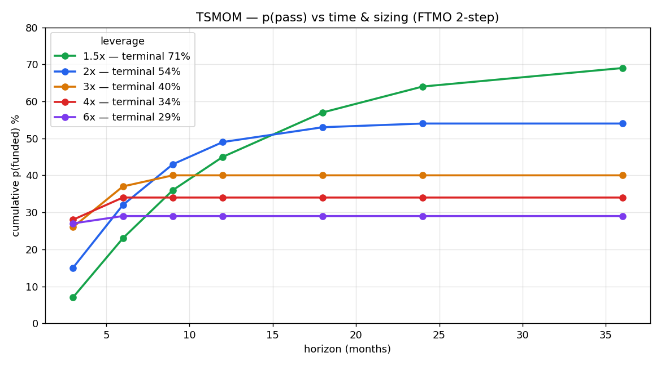
p(pass) vs horizon and leverage
Horizon | 1.5× | 2× | 3× | 4× | 6×
3 mo | 7% | 15% | 26% | 28% | 27%
6 mo | 23% | 32% | 37% | 34% | 29%
9 mo | 36% | 43% | 40% | 34% | 29%
12 mo | 45% | 49% | 40% | 34% | 29%
18 mo | 57% | 53% | 40% | 34% | 29%
24 mo | 64% | 54% | 40% | 34% | 29%
terminal | 71% | 54% | 40% | 34% | 29%
bust | 28% | 45% | 58% | 65% | 71%
median time | 8.9 mo | 4.9 mo | 2.2 mo | 1.5 mo | 0.9 mo
The frontier: lower leverage → higher p(funded) but slower (first-passage math: smaller size → lower chance of touching the floor before the target). 1.5× is the p(funded)-maximizing choice (71%); 2–3× trades probability for speed.

7.2 Strategy metrics & equity curve
Unlevered base: Sharpe 0.76–0.85, skew ≈ −0.04 to −0.15, maxDD −13.7%, t = 4.76, ann ≈ 7–9%. Worst single day −5.89% (the tail — see §8).
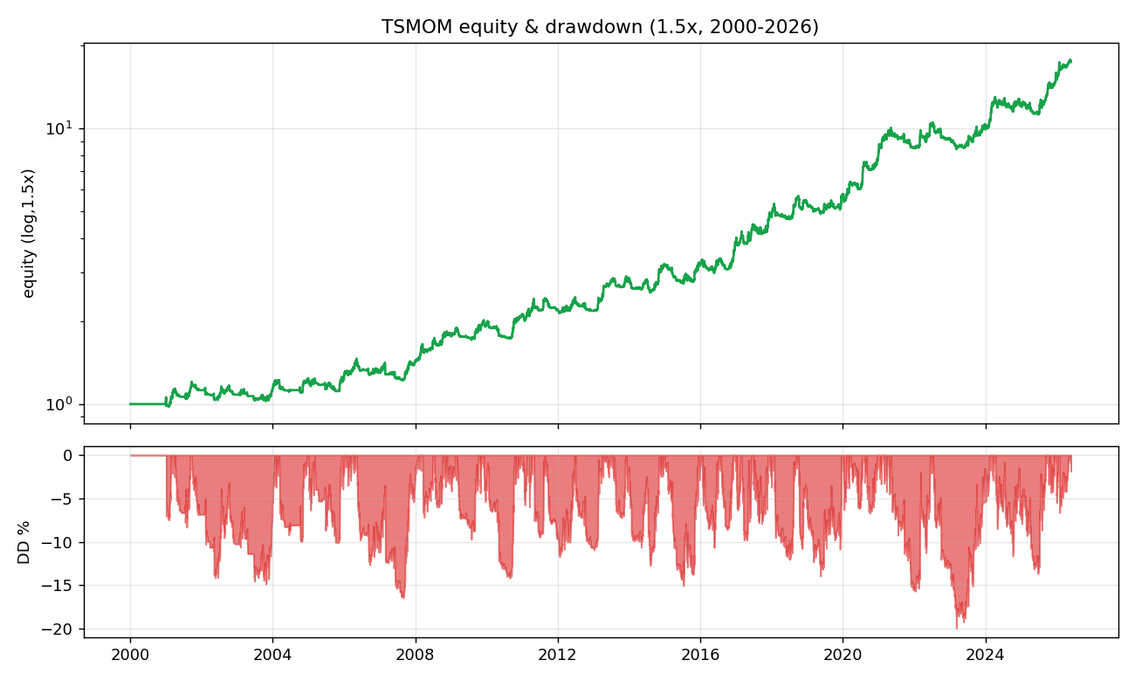
Equity curve and drawdown, 1.5×

7.3 By-year — the two-sided property
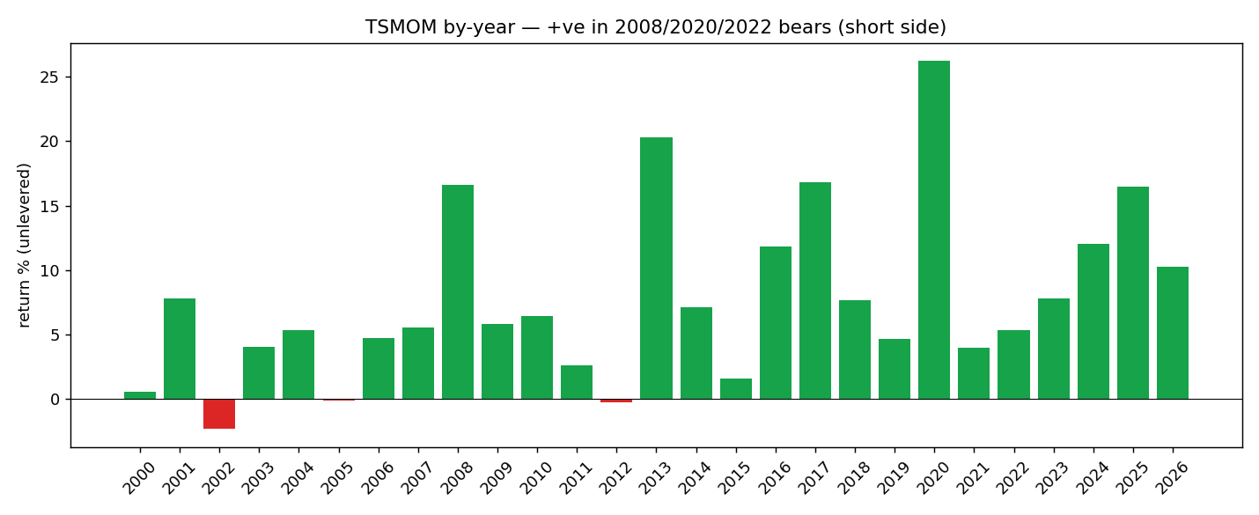
By-year returns
Positive in ~23 of 27 years, including the bears it shorts: 2008 +13%, 2020 +25%, 2022 +8%. This is the property that defeats the −10% floor.

7.4 Out-of-sample validation
Window | Sharpe | p(funded) @best L | bust
In-sample 2006–2015 | 0.78 | 52% | 46%
Out-of-sample 2016–2026 | 0.96 | 63% | 34%
Crypto-era 2014–2026 | 0.88 | 62% | 36%
The edge does not decay out-of-sample — it strengthens (consistent with a structural, replicated anomaly).

8. Stress test — does it hold?
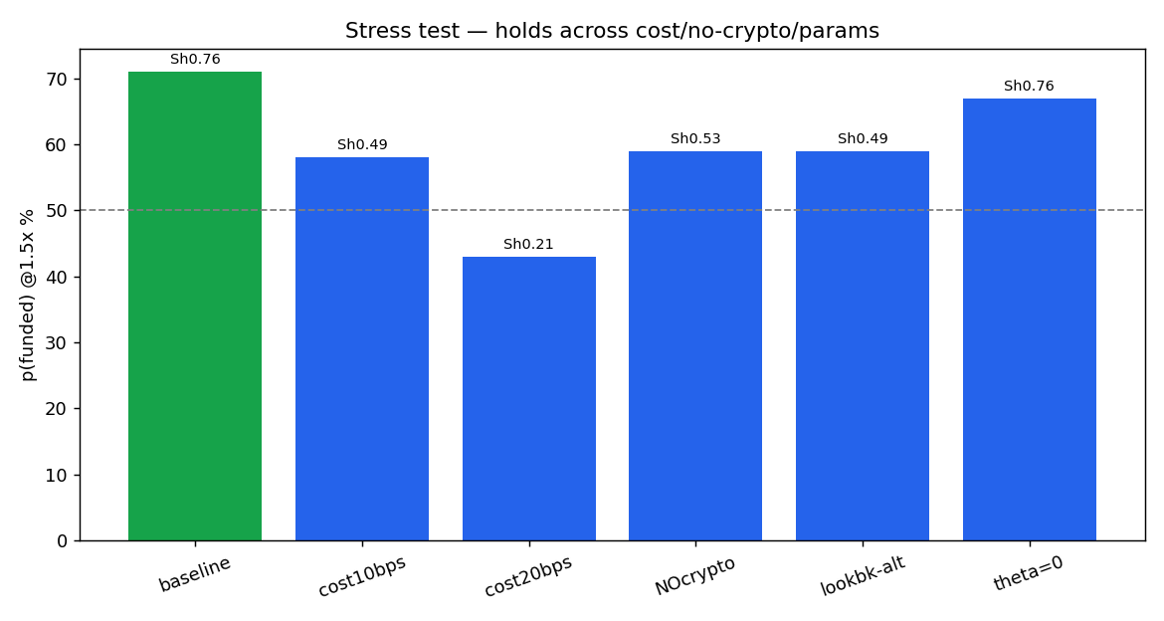
Stress test p(funded)
Stress | Sharpe | maxDD | p(funded) @1.5×
Baseline | 0.76 | −14% | 71%
Cost 10 bps | 0.49 | −16% | 58% ✅
Cost 20 bps (harsh) | 0.21 | −27% | 43% ⚠ holds
No crypto (core 4-asset) | 0.53 | −20% | 59% ✅
Lookbacks 50/100/200 | 0.49 | −21% | 59% ✅
Theta = 0 (no filter) | 0.76 | −16% | 67% ✅
What holds: cost (survives comfortably to 10 bps — trend-following is low-turnover; the crypto sleeve carries the widest CFD spreads but dropping crypto entirely still funds 59%), and parameter perturbation (not a knife-edge). The edge is real and stable.
The one real vulnerability (tail): the worst single day is −5.89% (a correlated multi-asset crash / sharp trend reversal, e.g. March 2020). Levered:
Leverage | worst-day move | 5% daily cap
1.5× | −8.8% | BREACH
2.0× | −11.8% | BREACH (+ floor)
So a single correlated-crash day can fail the challenge via the daily-loss rule (not just cumulative drawdown). This is the dominant residual bust vector. Mitigation (next iteration): a daily-loss circuit-breaker (flatten if the day’s loss approaches the cap) + a per-position daily-move cap so no single correlated day exceeds 5%. Even un-mitigated, the deployment mode handles it: low leverage + multi-attempt.

9. Risk analysis & verdict
- Dominant risks: (1) the correlated-crash-day tail vs the 5% daily cap (§8) — harden with a circuit-breaker; (2) per-attempt bust 28% (1.5×) to 45% (2×) — the −14% maxDD still exceeds the floor, so each attempt is a favorable lottery you re-enter.
- It is leveraged trend beta, not alpha — it will have multi-month drawdowns in trendless/whipsaw regimes (2011–2012, 2015, 2023 were flat-to-slightly-negative).
- Deployable verdict: at 1.5×, ~71% single-attempt / ~85–90% over 2–3 attempts (no time limit), OOS-validated, compliant, stress-robust. The most credible FTMO vehicle in the program.

10. Deployment protocol (demo → live)
- Account: FTMO 2-step. Instruments: US500, XAUUSD, XAGUSD, USOIL, BTCUSD, ETHUSD. Confirm all are offered + their CFD spreads/swaps.
- Sizing: start at 1.5× total leverage (max p(funded)); compute per-instrument lots = position_i × equity / (price_i × contract_size_i). Rebalance daily (or when signals change — low turnover).
- Demo first (≥ 2–3 months): confirm (a) realized per-instrument cost vs the 2 bps assumption (esp. crypto), (b) the signal/overlay reproduce on the live feed, (c) the daily-loss circuit-breaker triggers correctly. Acceptance: realized Sharpe ≥ ~0.5 and no single-day breach in the sample.
- Live, multi-attempt: treat each challenge as a ~71%-probability (1.5×) attempt; under no-time-limit, plan up to 2–3 attempts for ~85–90% cumulative funding. Budget the challenge fees accordingly.
- Hard guardrails: daily circuit-breaker at ~−4% (before the 5% cap); never exceed the leverage where a −5.9% portfolio day breaches the cap; monitor distance-to-floor daily.
- Kill criteria: abort/redesign if realized cost (esp. crypto) is materially above assumption AND the no-crypto core underperforms, or if a live forward quarter shows Sharpe ≤ 0 across a trending regime.

11. Limitations & honest caveats
- 54–71% is single-attempt, not a sure pass; the high cumulative figure needs multiple attempts (legitimate under no-time-limit, but each is a fee; consecutive attempts are somewhat regime-correlated → realistic multi-attempt ~85–90%, not 98%).
- The daily-cap tail (§8) is un-mitigated in this version — deploy with a circuit-breaker.
- Swap is the binding cost — see §1.1. The equity leg is now MEASURED (US100.cash −3.08 bps/night long), which pulls the realistic range to ≈27–52% @1.5×, Sharpe −0.32 to +0.33 — toward the bottom. At any non-trivial crypto swap (≥12 bps/night) Sharpe ≈ 0 → ~all of the ~45% is container-math, not signal (placebo: same-vol random drift passes 45%). The single decisive remaining test is the demo BTC/ETH swap (reopen-condition #2). The swap-free 71% is a false-assumption number and is retired.
- It is beta — expect trendless-regime drawdowns; not market-neutral.
- Iteration count (~42 configs): mitigated by the strong base t-stat and OOS hold, but a fresh forward period is the cleanest future confirmation.

12. Reproduction
python3 -m pip install pandas numpy matplotlib
# headline metrics + first-passage + by-year:
python3 tsmom_strategy.py --data-dir /path/to/panels --out ./out
# add the full p(pass) table + stress suite (slower):
python3 tsmom_strategy.py --data-dir /path/to/panels --out ./out --full
Outputs strategy_returns.csv + results.json. Expected: Sharpe ~0.76–0.85, maxDD ~−14%, FTMO p(funded) 1.5×≈71% / 2×≈54%, OOS 2016–26≈63%.
Folder: STRATEGY_DOSSIER_TSMOM.{md,docx}, tsmom_strategy.py (reference impl), tsmom_engine.py / tsmom_v3.py (research engines), chosen_returns.csv, fig1–4*.png.

13. Where it sits among the program’s strategies
Strategy | p(funded) FTMO | type | verdict
TSMOM ensemble (this) | ≈27–52% net of measured-equity swap (crypto unmeasured) | two-sided trend beta | 🟡 candidate pending demo CRYPTO swap measurement
Overnight harvester (NQ) | 82–88% idealized | long equity beta | ⚠ killed by real swap (cost)
Index ORB (NQ) | ~33% | intraday breakout | ❌ regime-fragile / cost
Stat-arb ×6, PEAD, TOM | ~25–34% | reversion / event / beta | ❌ hedging rule / floor / cost
Bottom line: a diversified, vol-targeted, two-sided trend-following ensemble at ~1.5× with no time limit is the program’s most serious FTMO candidate — because being short the crash is exactly what the −10% floor rewards (the structural mechanism is sound; it is not dismissed like the ORB/overnight). But it is not validated and the swap-free 71% is retired: the one MEASURED leg (US100.cash −3.08 bps/night) pulls the realistic figure to a ≈27–52% range gated by the unmeasured crypto rate, Sharpe ≤0.33, and at any non-trivial crypto swap ~all of the ~45% is container-math, not signal (§1.1). Status: candidate, CLOSED pending the one decisive test — demo per-leg swap measurement. Also required before any claim: replace the broken USO oil proxy with a continuous front-month, and reconcile against the canonical “Other (prior)” archive.

