Meeting 1

January 25, 2023

**Start time: 10:10am**

* Discussed the frameworks and language(s) used in the Front-End: Node.js, Angular, TypeScript, HTML and SCSS. Primary IDE used is Visual Studio Code.
* Olivier shared documents to Discord about Angular and TypeScript.

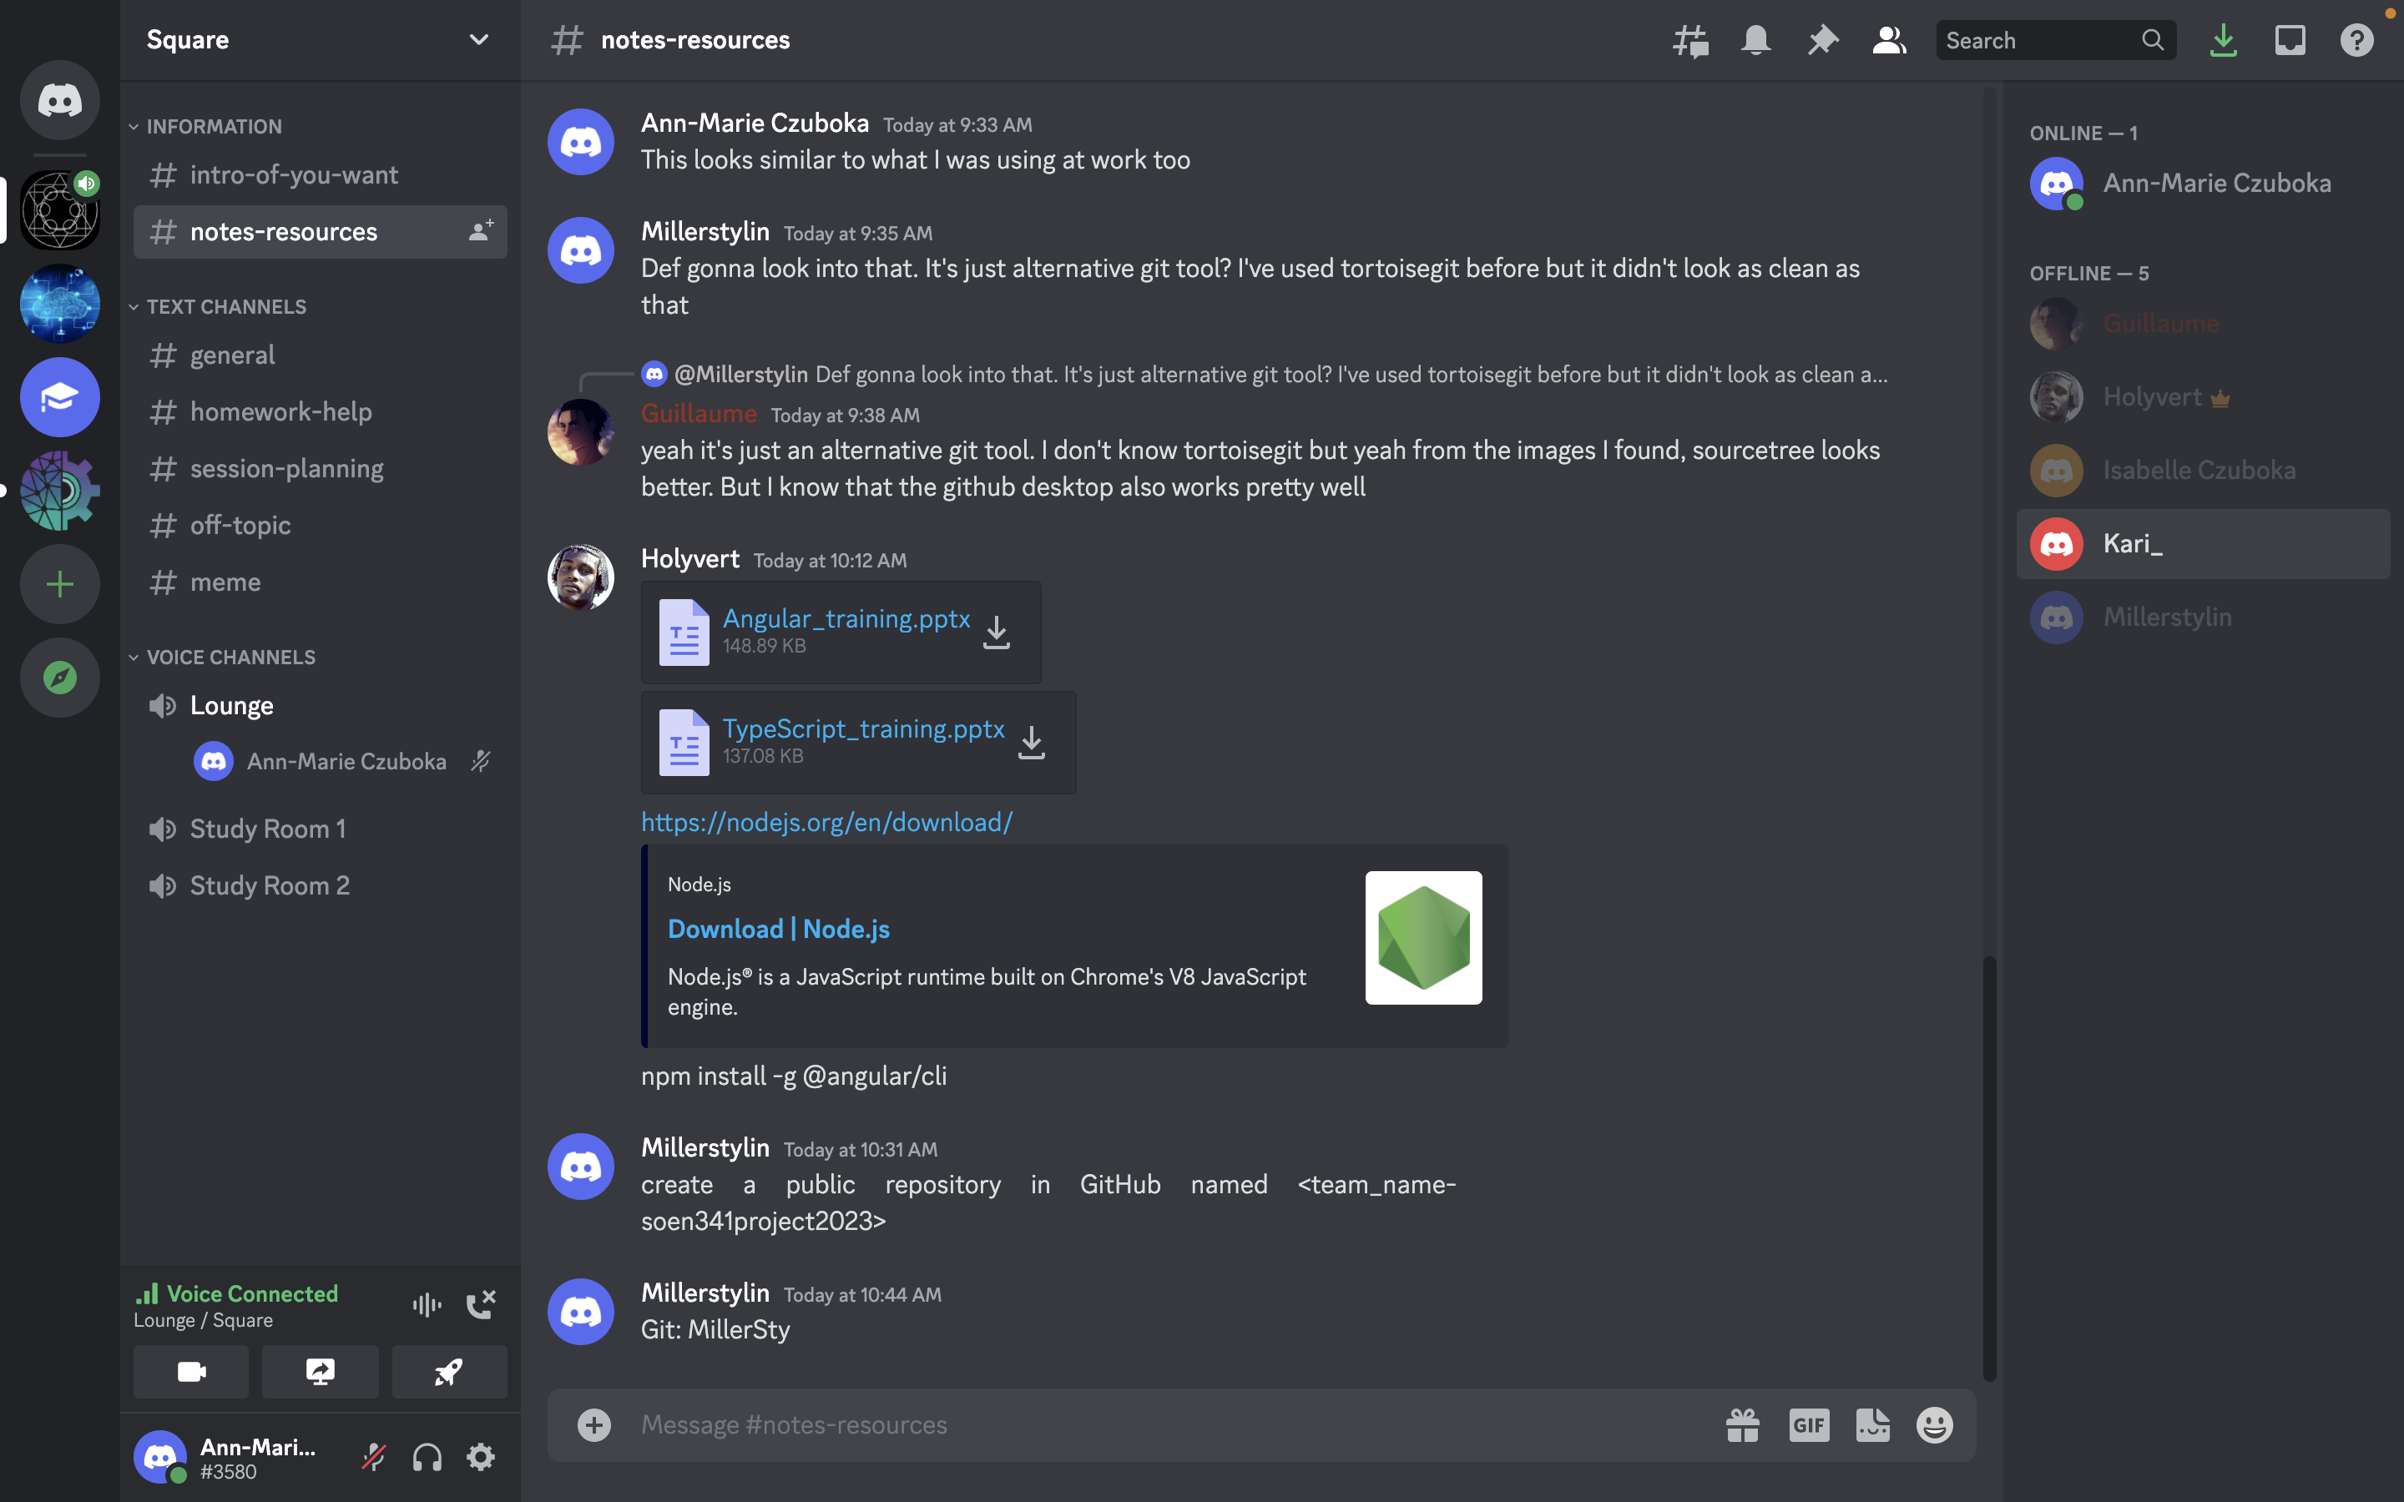

* Everyone installed node.js and angular with appropriate version.

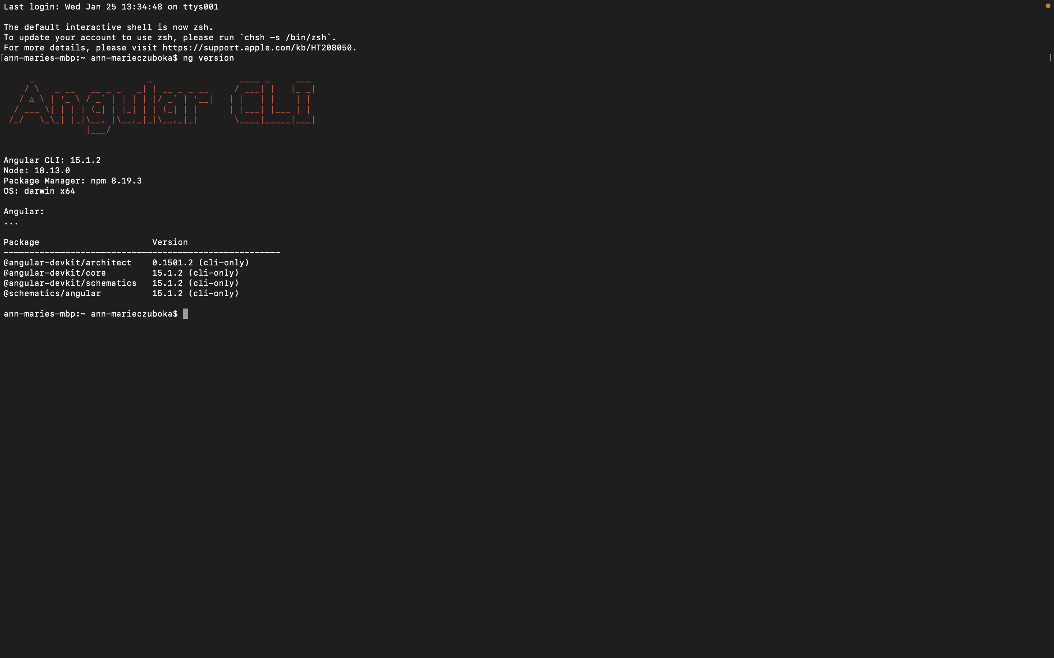

* Repository was created, named 2Squared, by Olivier and rest of team was added as collaborators.

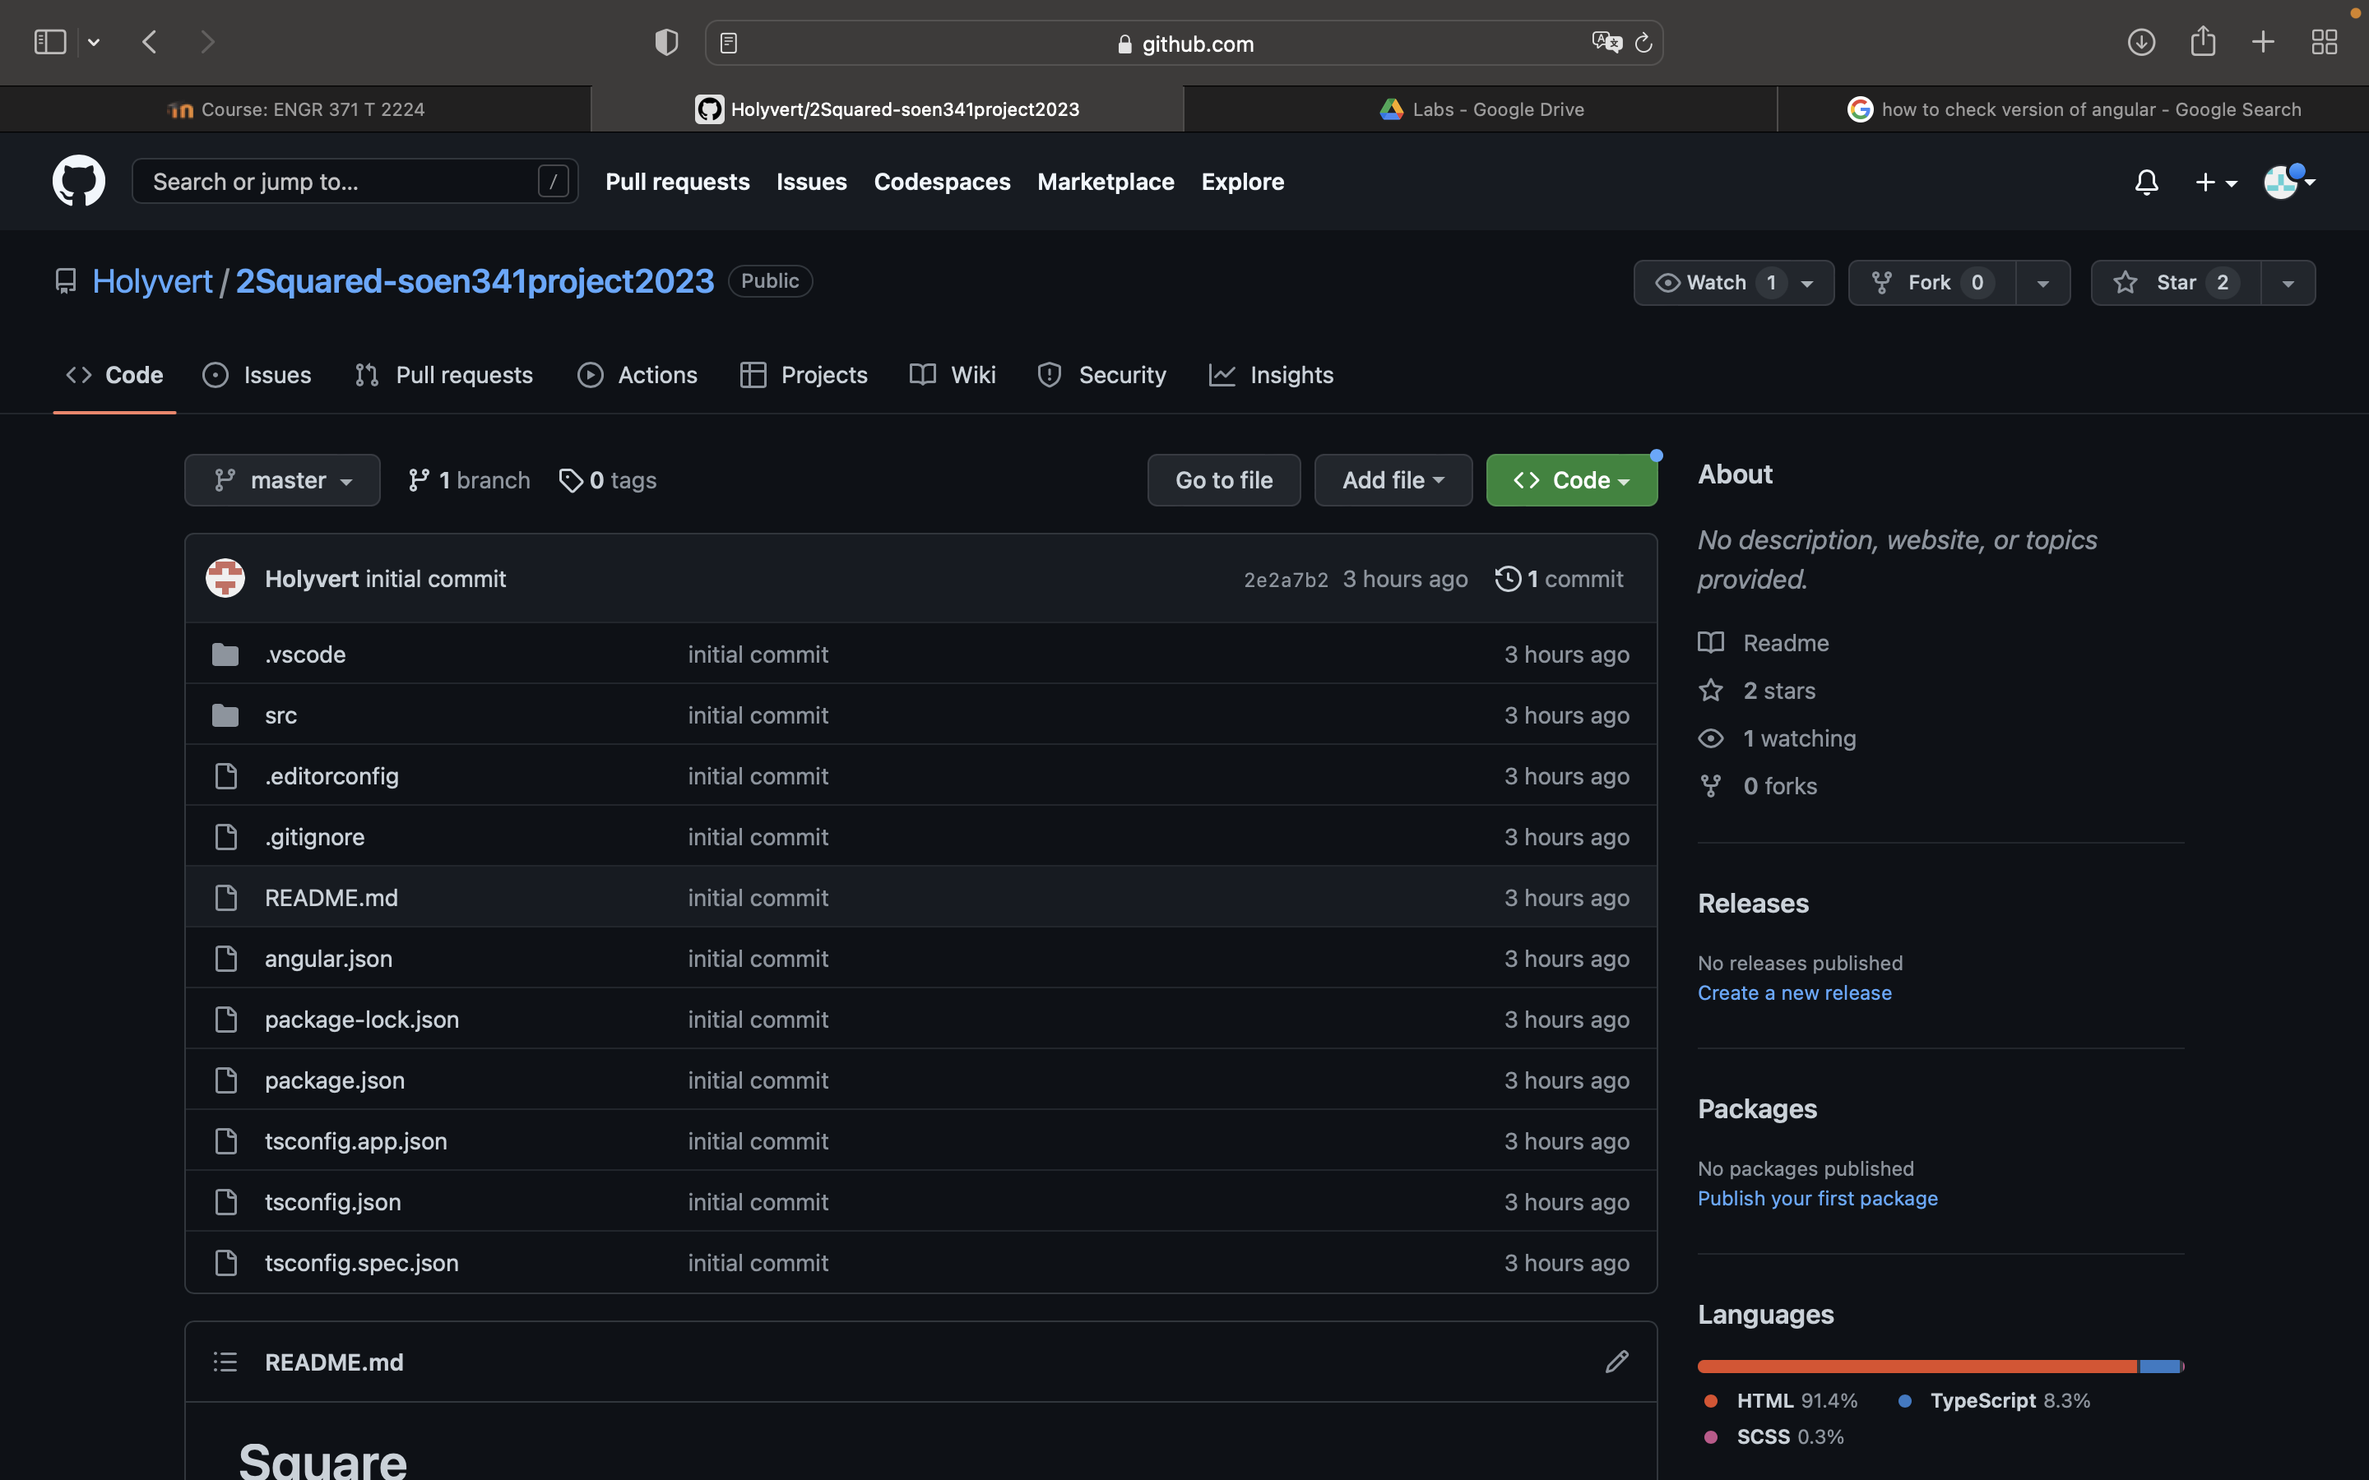

* Appropriate extensions were downloaded on Visual Studio Code. Such as Angular Language Service, Angular Snippets, Git Lens, Prettier – Code, vs-code icons and intelliCode.

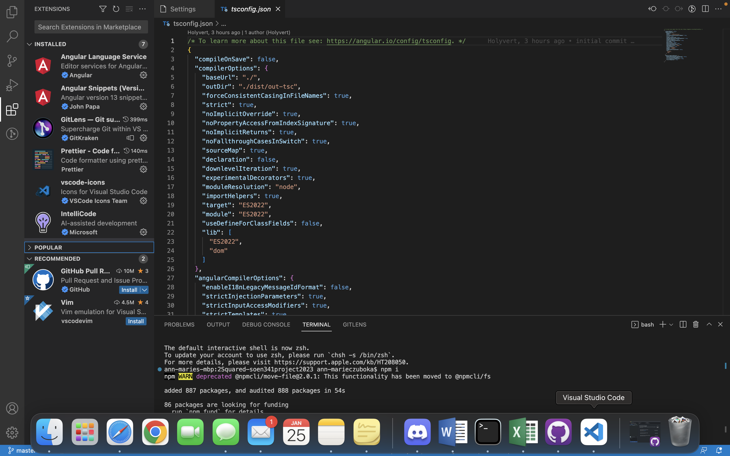

* Olivier demonstrated how to run server locally through Visual Studio Code terminal (ng s), how to stop server (control c), and how to generate component (ng gc component-name).

**End Time: 11:30 am**

*Total Time: 1 hour and 20 minutes*