Analysis of the causal effect of disruption on delay as a benchmarking tool for public transport network performance

Guillaume Amann

Department of Civil and Environmental Engineering
Imperial College London

Keywords: causal inference; benchmarking; synthetic control; disruption; public transport; network.

Abstract

While black-box models are becoming increasingly accurate for prediction problems, the desire to master and understand the relationships between factors and the dependent variable is driving the need for the development of Causal Inference, which is gaining momentum. Urban mass transit systems typically generate large volumes of data on various aspects of operations. Statistical analyses can be used to summarise and present such data, drawn from within and between systems, to understand the drivers of performance. This empirical analysis will leverage large-scale publicly available data from the General Transit Feed Specification (GTFS) feed of the Washington DC metro network to characterise the performance of transit systems, focusing on train on-time performance and the space-time inference of disruption occurrence on delays.

1. Introduction

Despite the absence of a universally accepted standard for measuring punctuality in the transit industry, there is a significant need for tools that aid network management. Instead of delving into a granular analysis of individuals travel behaviour, this study proposes to equip managers with actionable insights on the scope and impact of their decisions. This paper introduces a novel methodology to quantify system vulnerability by empirically estimating the causal effects of service disruptions on delay in arrival time. The analysis is twofold: it first examines space propagation, and then it analyses time propagation.

2. Literature review

Incidents occur regularly on urban metro systems. The occurrence of disruptions is likely to cause delays and disorder in the punctuality and regularity of the metro operation. Although the two traditional methods used to build vulnerability indicators of metro systems are topology-based and system-performance-based approaches which consider transport network as scale free networks, however, (Serafino, et al., 2020) has pointed out that this assumption is not sustainable. (Adjetey-Bahun, et al., 2016) propose the concept of resilience as an approach to measure system’s ability to: absorb perturbations, rapidly recover from perturbations. Because transport treatments (and disruptions) are typically non-randomly assigned, we observe a confounding effect that needs to be addressed to obtain unambiguous measurements of the true causal inference. To reckon with this influence, (Zhang, et al., 2021) already apply causal inference to assess system’s resilience with Propensity score method. However, ex post evaluation methods like Outcome Regression, Propensity Score, or Doubly Robust Estimation) requires to maintain strong ignorability. In practice, often untenable, because there are either insufficient measured covariates, or other sources of endogeneity thus the need for new statistical method: Synthetic Control (SC). This paper will apply SC to build a space-time map of disruption impact on delay.

3. Methodology

The validity of the evaluation methods discussed above requires us to maintain that strong ignorability holds (see section Ex Post Evaluation via Model-Based Adjustment for Confounding). In practice, this is often untenable, either because there are insufficient measured covariates to establish conditional independent, or because other sources of endogeneity (e.g., reverse causality or measurement error) are at play inhibiting a causal interpretation of the data.

The synthetic control (SC) approach can be thought of a development of DID which aims to improve comparability of the treatment and control groups. This is done by imposing weights for multiple control groups that render then more similar to the treated groups. The weights can be chosen by considering the distances in averages between treated and untreated groups or by using information on group level covariates.

The application of a propensity score matching method accounts for the non-randomness of disruptions and ensures unbiasedness of the causal estimates. In this way, the SC approach allow us to identify not only a single ATE estimate, but also reveals how the ATE effect evolves over time post-treatment. Preventing biased results in studies is important, this can be achieved by using synthetic controls, which don’t need access to post-treatment outcomes during the study’s design phase. This means you can determine synthetic control weights and make all design decisions without knowing their impact on the study’s conclusions, making the study fairer and the conclusions are more reliable.

We will use the Orange line of the Washington DC metro network as an application example of our model. The real time GTFS data is gathered from January 29th 2024 10:00am to March 24th 2024 11:59pm in order to avoid any holyday. The reason why we cover such a period of time is two-fold. It not only offer a larger sample of control units to better asses the causal inference effect, but also allow for more room for potential data collection error. Before applying SC, we need to format the gathered data to match the real time one with the scheduled one. This will form a 2-month table listing all delay and disruptions occurring to all the 26 stations of the line. Because the alerts message don not target any particular station, the disruption state (D=1) is applied to the all stops of along the line.

Study time inference: highlight potential weekly/daily pattern in disruption occurrence
Study space inference: reduce the whole network to a 1D analysis along one line to study spatial disruption and delay propagation. Furthermore, although GTFS feed proposes data for both direction of the same lane, we chose to only consider one of the two since we focus on the impact of the disruption rather than the overall outlook. Because it is very likely that any trend in the analysis will just be mirrored by the opposite irection, making the whole process rudondant, we decide to look at the space dimension like we do with time, evolving in one direction.

An illustration of the dimension reduction is shown in Figure 1. The points belonging to the same line are either the same station i at different time t (blue line) or different stations at the same time (red line).

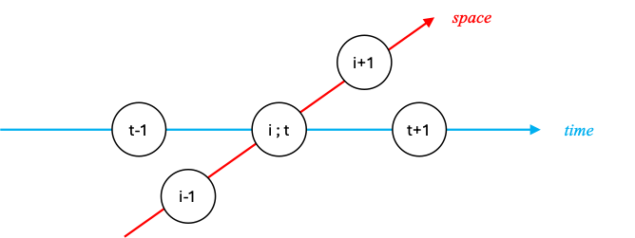

Figure 1: illustration of the space-time network

3.1. Time analysis
Although some alert message remains, we consider the disruption gone once the problem is solved. We observe delay in arrival time. To do so, we input a lag in the disruption column.

3.2. Space analysis
We observe delay in arrival time.

X is a confounder of the treatment D and the outcome Y, but Y is also a confounder for other D and Y.

In our case, we consider disruption any GTFS alert type, be they technical problem, strike, accident, weather, maintenance, medical emergency or other cause (except holiday). Plus be cautious that some alert actually signal that normal service has resumed.

Reduce from 2-dimension network analysis to 1 D line analysis

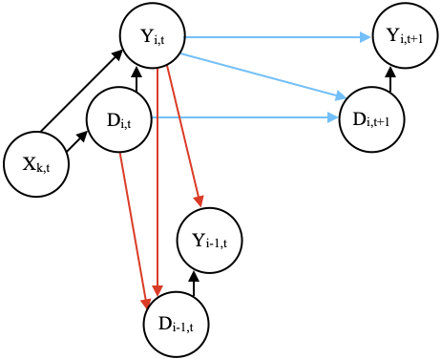

Figure 1: Figure captions in size 10 and centred

4. Result and discussion

More text here

x. Conclusions and recommendations

Write clear and concise conclusions

Room for improvement:
Removing ‘contamination’ from exogenous determinants [X] to further enhance bias estimate.
Engineering interventions often tend to be non-binary [17] so need for mathematical tools to assess the causal inference of treatment of continuous value. This kind of method would enable the estimate of causal inference of an abrupt change of ridership on delays.

2. Second section

More text here

2.1. Sub-section
No line space under sub-section titles

2.1.1 Sub-sub-section
No line space under sub-sub-section titles

Two blank lines before next section

Figures should be referred to as follows: a cross-section is shown in Figure 1.

3. Next section

More text here. Equation should all be numbered as referred to as follows: The model is described by Equation (1).

F = ma (1)

and ensure that all symbols are accurately defined.

Tables should look like this, and be referred to as Table 1 etc.

Table 1: Table captions in size 10 and centred

References in the text should be made as follows: Wadee and Gardner (2012) investigated cellular buckling, or cellular buckling was thoroughly investigated (Wadee and Gardner, 2012). The references should then appear in the reference list in alphabetical order and in the Harvard style. Where there are three or more authors, the reference in the text appears like this (Nip et al., 2010).

References

Adjetey-Bahun, K., Birregah, B., Châtelet, E. and Planchet, J.-L., (2016). A model to quantify the resilience of mass railway transportation systems. Reliability Engineering & System Safety. 153, pp. 1–14. Available from: doi: 10.1016/j.ress.2016.03.015

Graham, D. J., (2021). Causal inference for ex post evaluation of transport interventions. In: International encyclopedia of transportation. Elsevier. pp. 283–290.

Graham, D. J. and Singh, R., (2021). Model-based adjustment for conditional benchmarking. IMA Journal of Management Mathematics. Available from: doi: 10.1093/imaman/dpab021

James, G., Tibshirani, R., Hastie, T. and Witten, D., (2021). Introduction to statistical learning: with applications in R. 2nd Edition. Springer.

Serafino, M., Cimini, G., Maritan, A., Rinaldo, A., Suweis, S., Banavar, J. R. and Caldarelli, G., (2020). True scale-free networks hidden by finite size effects. Proceedings of the National Academy of Sciences. 118(2), article no: e2013825118. Available from: doi: 10.1073/pnas.2013825118

Singh, R., Graham, D. J. and Anderson, R. J., (2019). Characterizing journey time performance on urban metro systems under varying operating conditions. Transportation Research Record: Journal of the Transportation Research Board. 2673(7), 516–528. Available from: doi: 10.1177/0361198119848415

Singh, R., Hörcher, D., Graham, D. J. and Anderson, R. J., (2020). Decomposing journey times on urban metro systems via semiparametric mixed methods. Transportation Research Part C: Emerging Technologies. 114, 140–163. Available from: doi: 10.1016/j.trc.2020.01.022

Zhang, N., Graham, D. J., Hörcher, D. and Bansal, P., (2021). A causal inference approach to measure the vulnerability of urban metro systems. Transportation. Available from: doi: 10.1007/s11116-020-10152-6

