Modern Cuckoo Clock
ESP32 · 3D Printed · Wi-Fi Connected · API & Home Assistant
Author: Guillaume Anfroy You can reach me through linkedin: https://www.linkedin.com/in/guillaume-anfroy-201418/ or through github issues.

With the help of my 2 sons for the web design and sound tones
Version 1.0 · November 2026

What is Modern Cuckoo?
Modern Cuckoo is a contemporary interpretation of the traditional cuckoo clock.
Instead of reproducing a classic wooden clock, this project combines:
- ESP32 and MicroPython
- 3D printed mechanical parts
- A customizable cuckoo figure: print your own
- A configurable sound melody: play your own tone
- A modern, mobile-friendly web interface
- Built-in HTTP API that allows control and monitoring from a web browser, Home Assistant, Node-RED, Jeedom, Python scripts, or any automation platform.
- Automatic time synchronization via Wi-Fi, or standalone mode without internet
The result is a connected cuckoo clock that can be customized both mechanically and digitally.
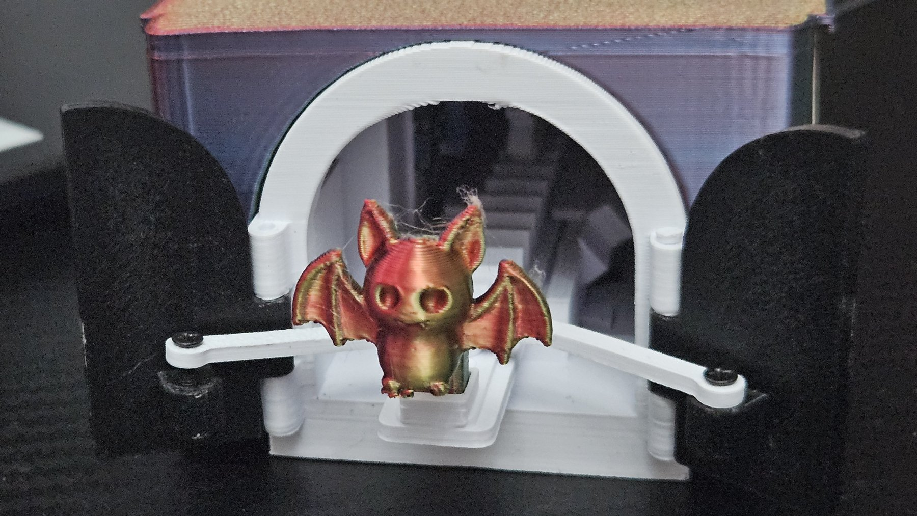 | 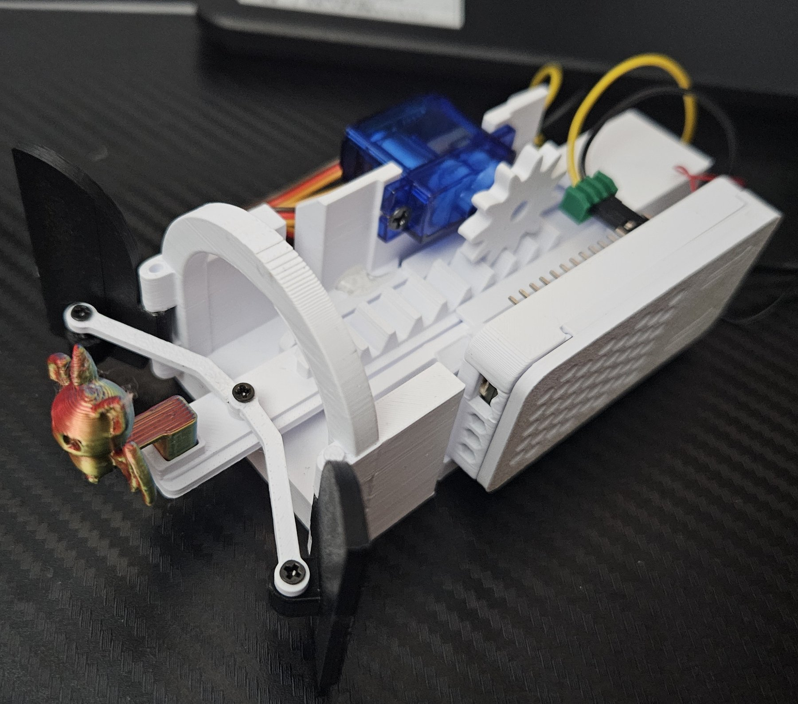

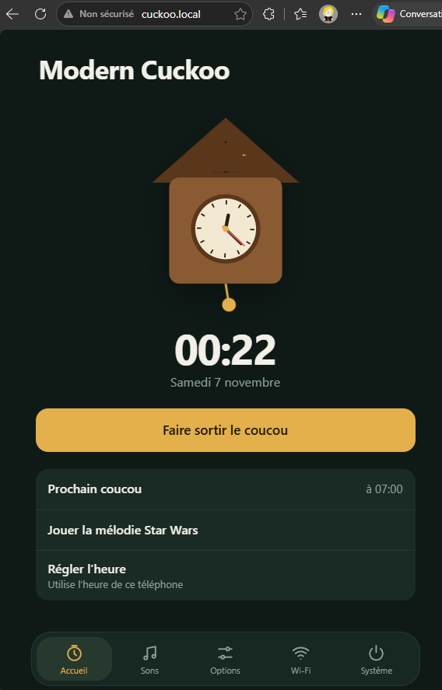 | 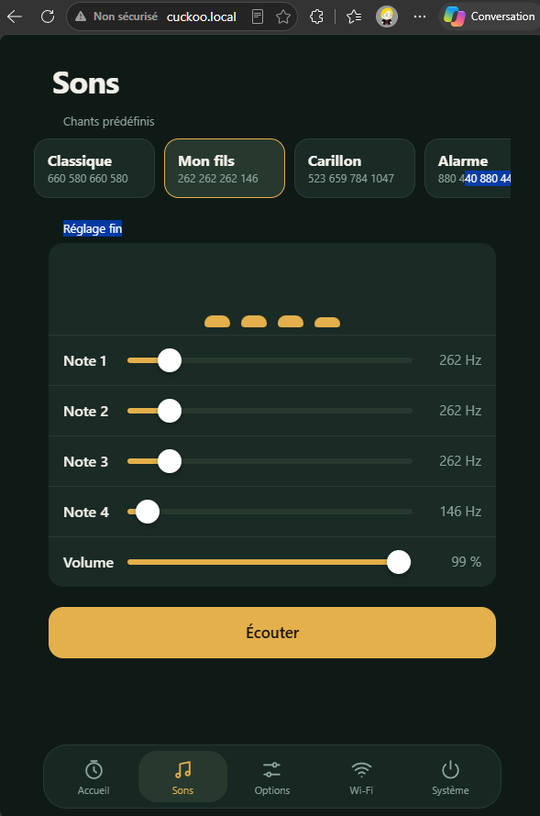

License and Credits
License: This work is licensed under the Creative Commons Attribution-NonCommercial 4.0 International License (CC BY-NC 4.0).
You are free to share and adapt this work, as long as you give appropriate credit, provide a link to the license, and indicate if changes were made. You may not use it for commercial purposes. Contact me for any commercial use. Details: https://creativecommons.org/licenses/by-nc/4.0/

Plate 1 – the 3D part mechanism is inspired by DIYhans: https://www.thingiverse.com/thing:5962496. I made numerous improvements to make it smaller and more reliable.
Plate 4 – the cuckoos come from numerous sources, such as Collection de figurines d’Halloween – Mini figurines 3D – Modèle d’Impression 3D Gratuit – MakerWorld.

Required Parts
- ESP32 (with or without OLED screen). I used an ESP-WROOM-32 ESP32 0.96
- SG90 servo motor
- Passive buzzer
- USB-C 5 V power source
- Oled SSD1306 is optionnal
- Screws: M2x8 and M2x10
- Dupont cables or wires, with soldering or mechanical connection
- 3D printing files and source code, available on GitHub: TO BE COMPLETED

1. Print the Parts
Print the mechanical parts from the file Modern Cuckoo V5.3mf using PLA+ or PETG.
Start with plate 01 for the mechanism.

2. Assemble the Mechanism

Step 1 – Install the Doors
Use either a metal paper clip or the supplied 3D printed pins.
Insert the hinges as shown in the photos.
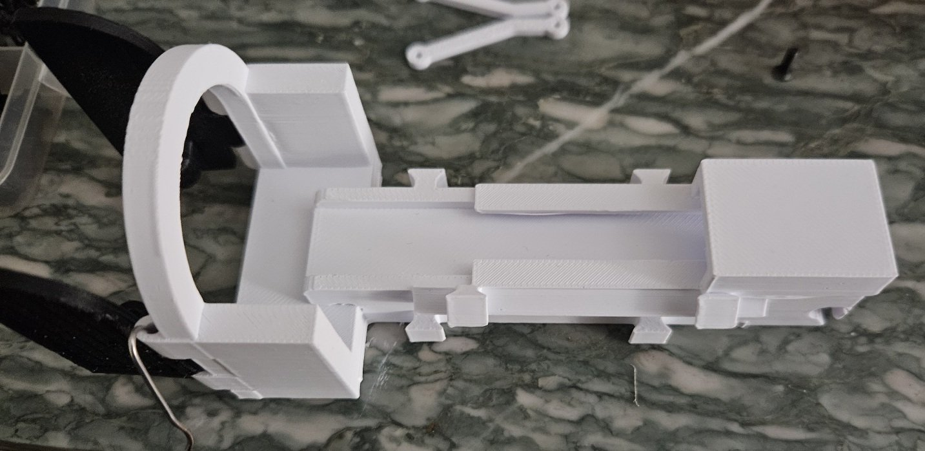 | 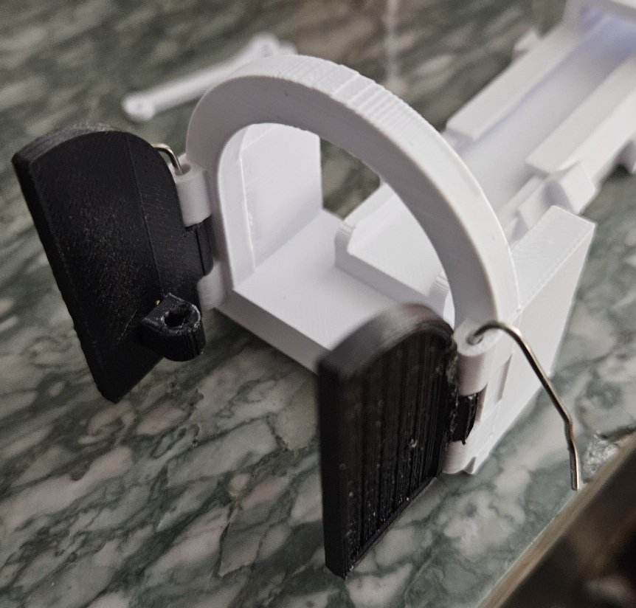

Step 2 – Assemble the Linkage
Join the two arms using 1 M2x8 screw. Do not overtighten.
The linkage must move freely without friction.
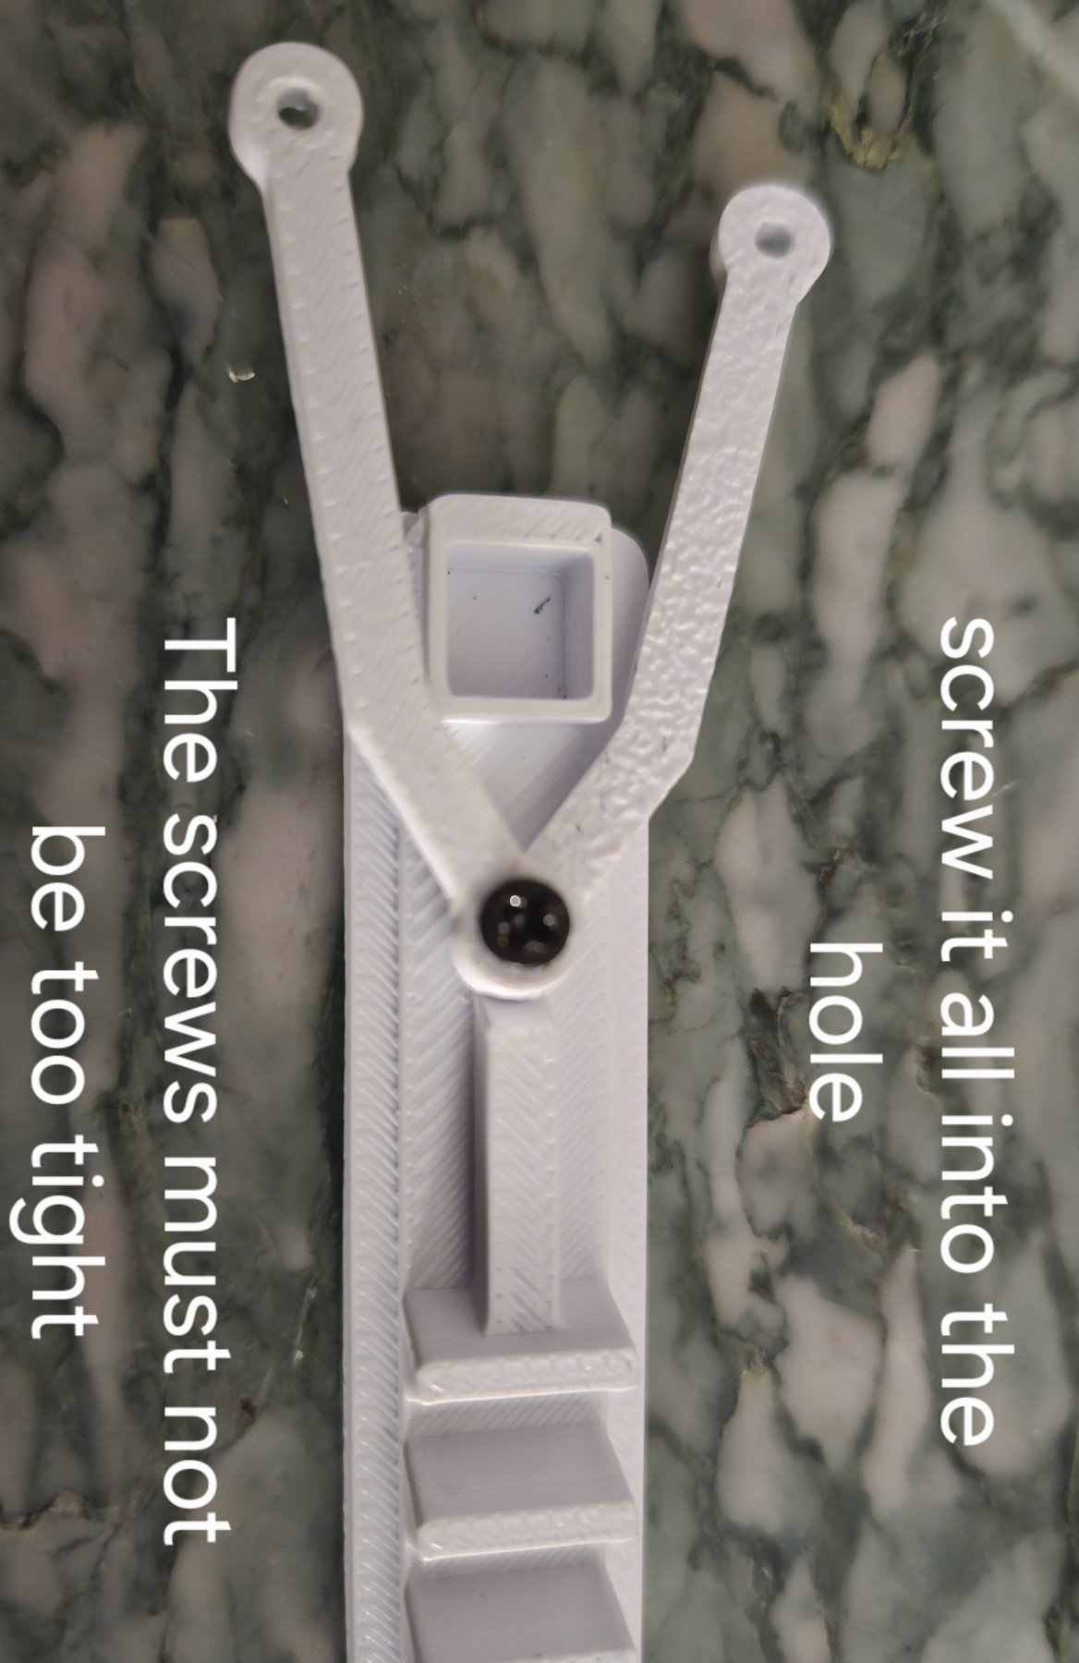 | 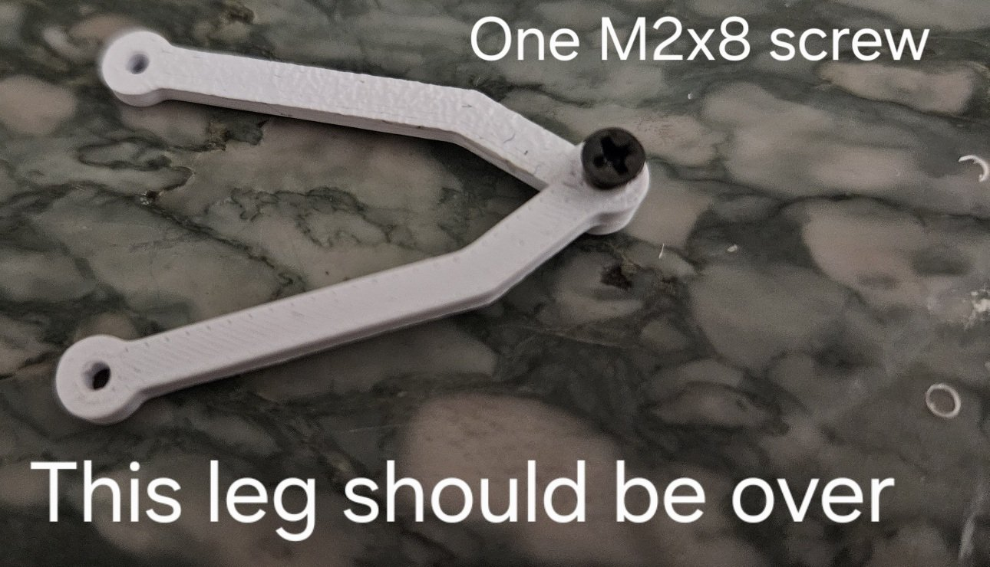  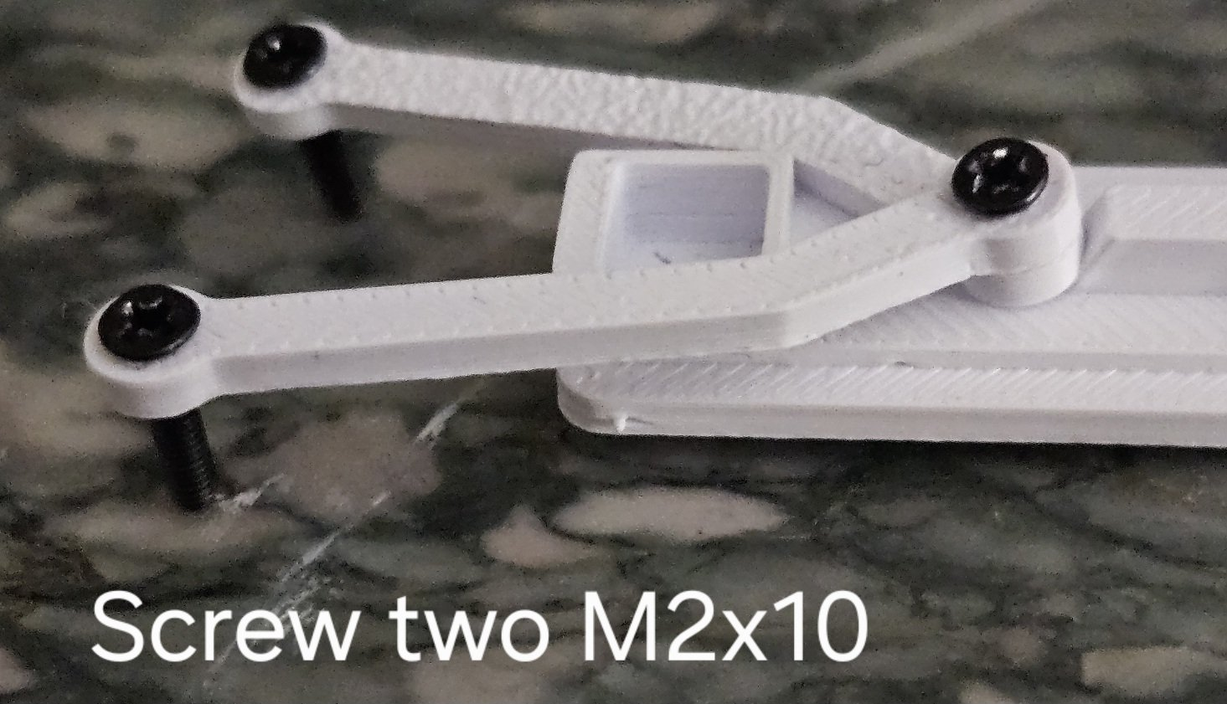

Step 3 – Install the Rack
Insert the rack mechanism into the body.
Check that the doors open and close smoothly.
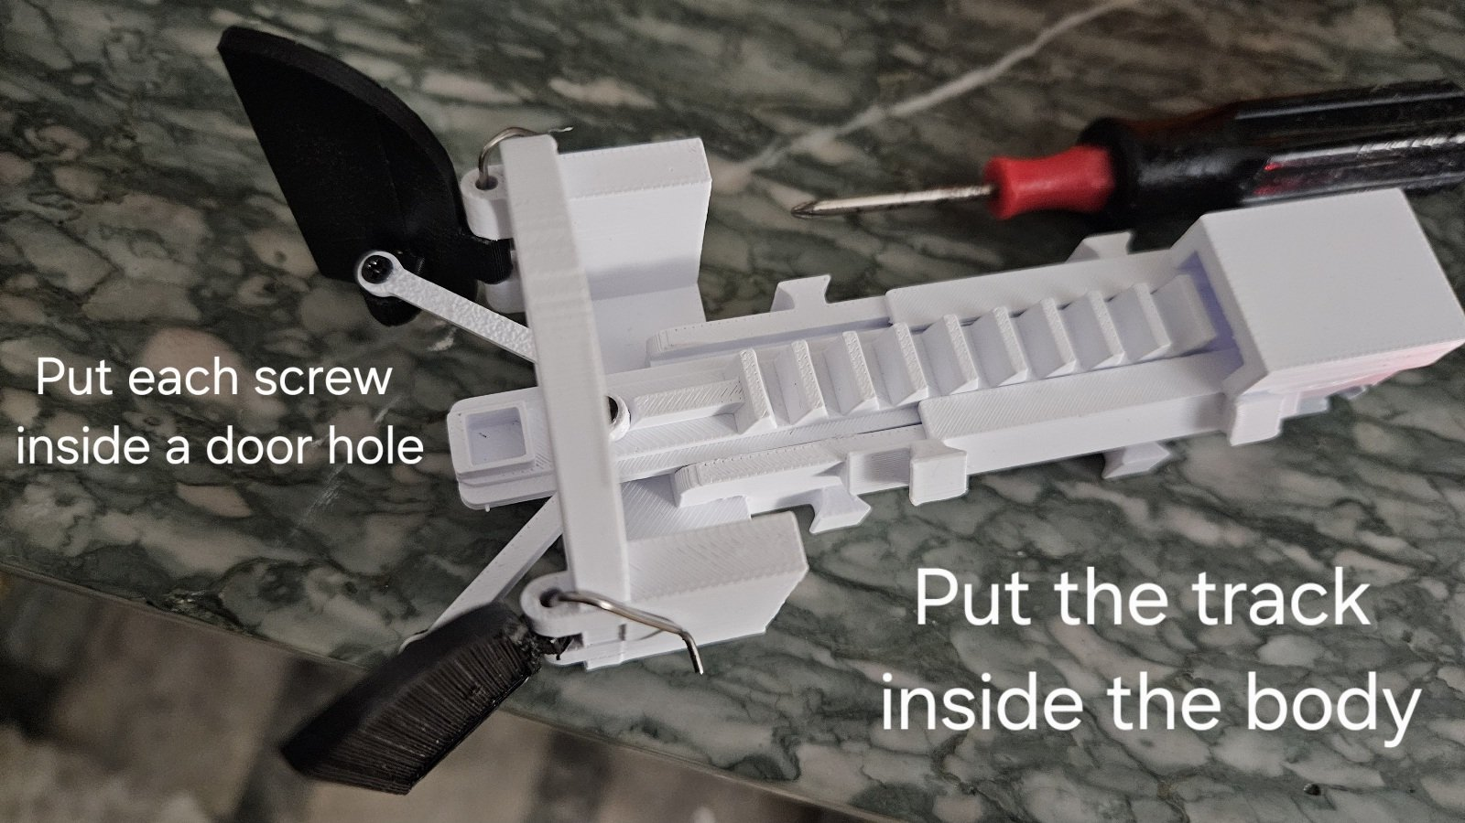

Step 4 – Install the Servo and the Buzzer
Use 2 × M2x8 screws or 2 × M2x10 screws to secure the SG90 servo.
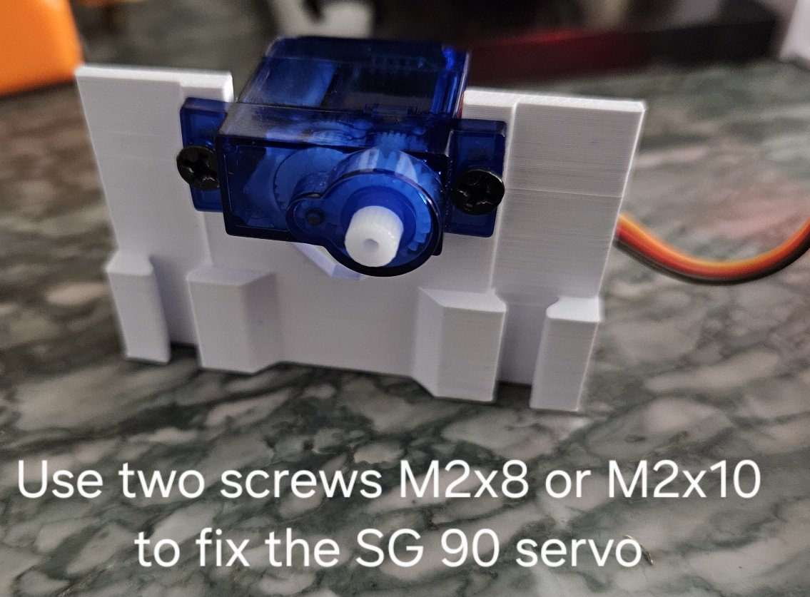 | 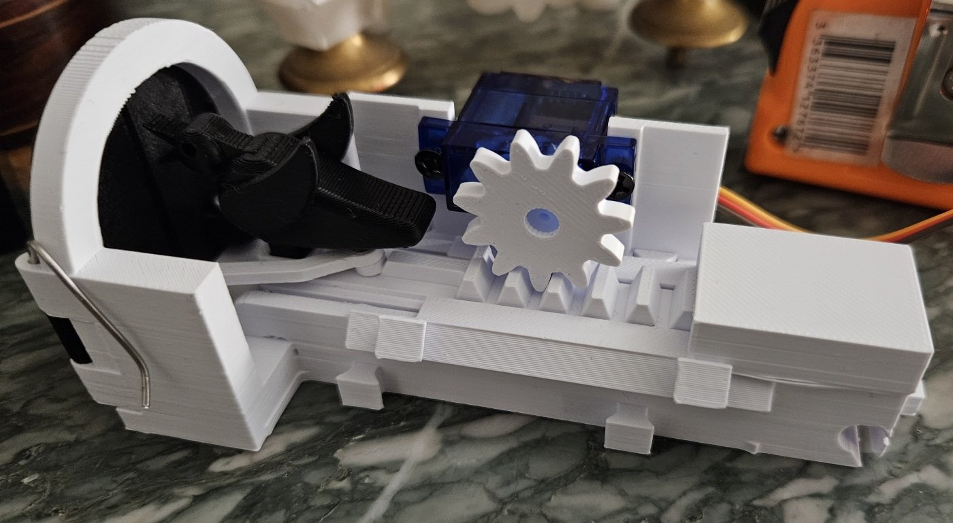

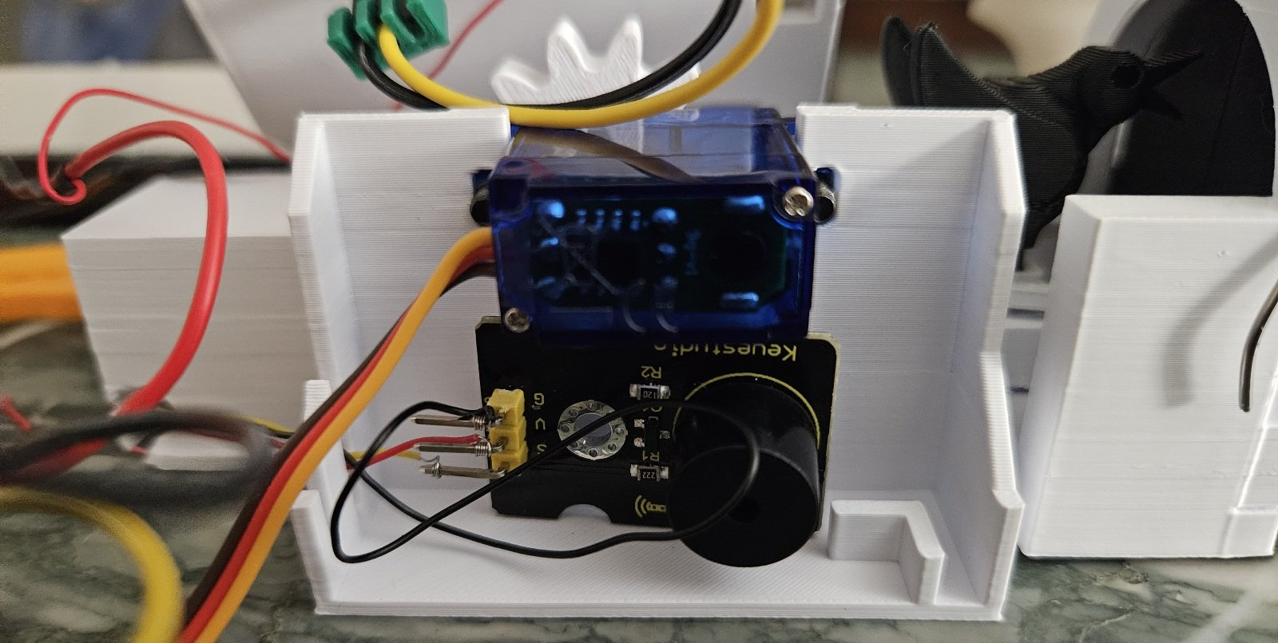  Add the buzzer under the servo | 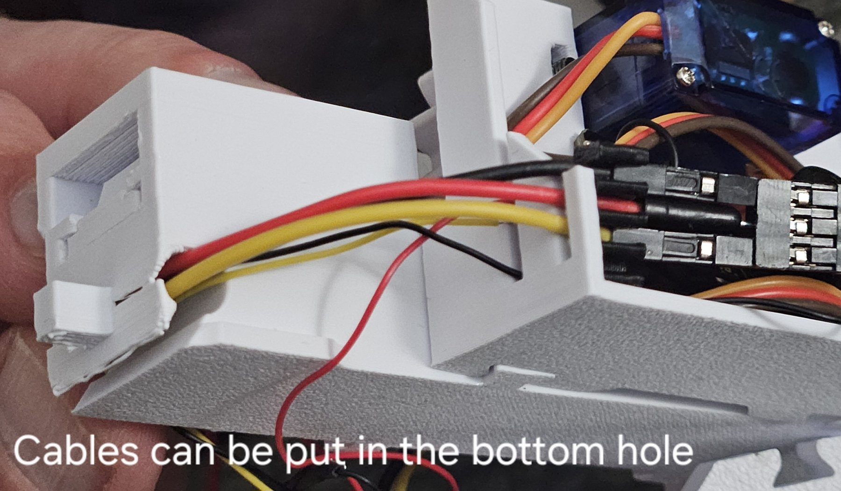

3. Wiring
Important: The ESP32 cannot supply enough current to power an SG90 servo reliably. The servo must be powered directly from the external 5 V power supply.

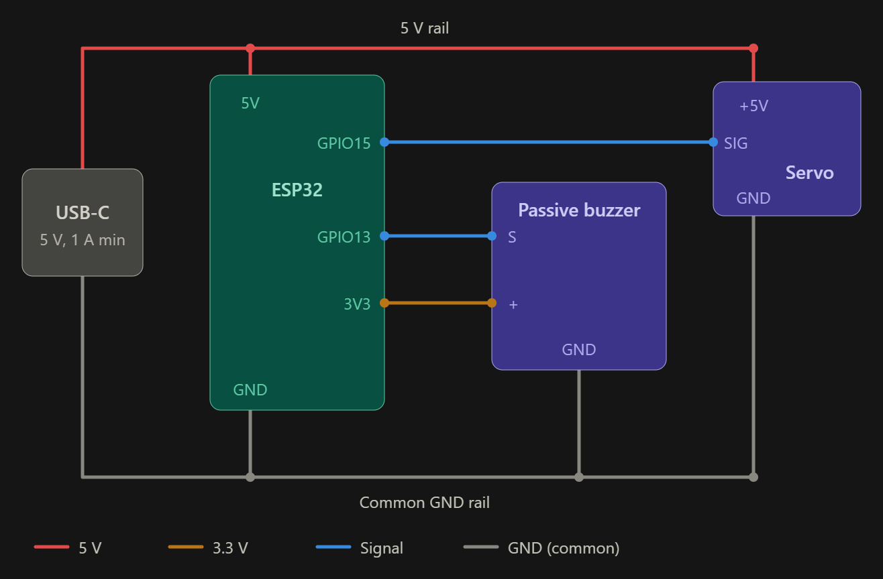
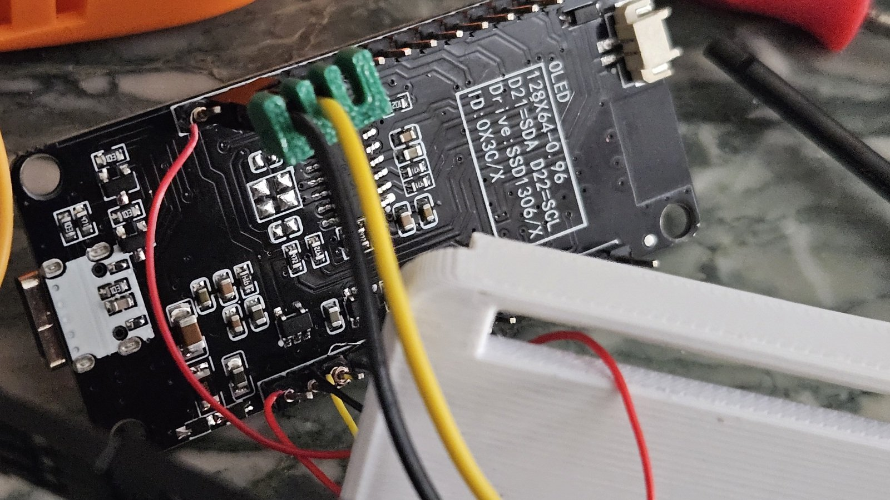
The ESP32 cannot supply enough power for the SG90 servo. Power must be provided through USB-C directly to the servo. I use a female USB connector with wires.
The 5 V rail can be used with some passive buzzers.
The on-board USB-C of the ESP32 is only used to upload the Python code and for debugging.
Be careful not to power the 5 V rail and the on-board ESP32 USB-C at the same time… or check whether your board supports it.
When a USB-C cable is connected directly to the ESP32, the sound and the configuration website will work. The servo will not work due to lack of power.
Connections
From | To
USB-C 5V | ESP32 5V · Servo +5V
USB-C GND | ESP32 GND · Servo GND · Buzzer GND
ESP32 GPIO15 | Servo Signal
ESP32 GPIO13 | Buzzer S
ESP32 3V3 | Buzzer +

4. Software Installation

Install MicroPython
First install MicroPython on your ESP32:
https://docs.micropython.org/en/latest/esp32/tutorial/intro.html

Upload the Files
Upload these files to the ESP32:
- main.py
- config.json
- secrets.py
- index.html
- ssd1306.py
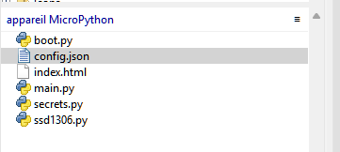

5. Configure Hardware Pins
In main.py:
SERVO_PIN = 15
BUZZER_PIN = 13

Optional OLED display:
OLED_SCL = 22
OLED_SDA = 21

OLED_WIDTH = 128
OLED_HEIGHT = 64

You may configure Wi-Fi in advance inside secrets.py:
SSID = "YourWiFi"
PASSWORD = "YourPassword"

6. First Startup
Connect the ESP32 using USB, NOT the main power. The female USB main power will be used ONLY after code testing; the servo will not be able to move at first.
Run the program. You should:
- Hear the cuckoo sound
- See messages in the serial console
- Access the web interface

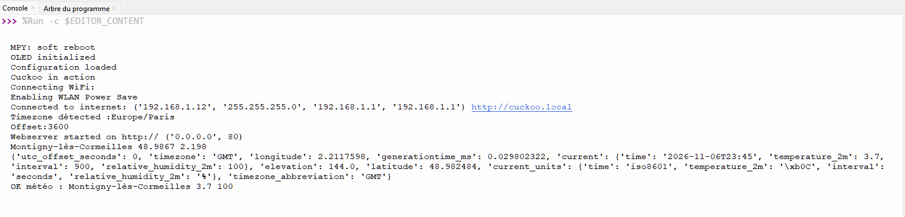
Check that there is no error
Check whether the cuckoo is connected to the internet or in AP mode.
The cuckoo can work in AP mode without an internet connection, or through a standard internet connection. If an internet connection is used, the time is set automatically. In AP mode, the time is configured from your phone.
Connect to the cuckoo by trying both addresses:
- Standard Wi-Fi through your internet box: http://cuckoo.local
- AP mode: http://192.168.4.1

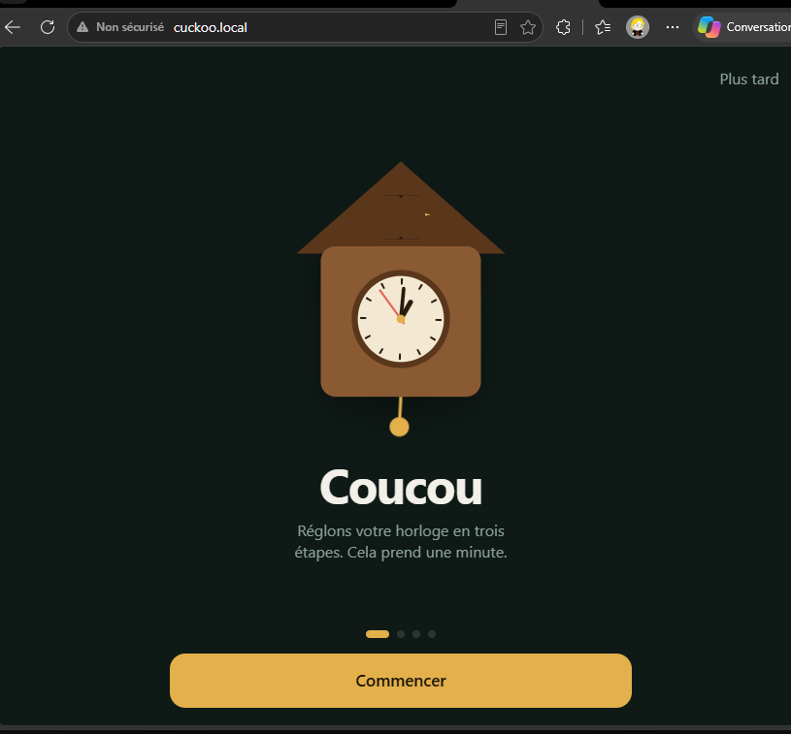

7. Final Assembly
Connect the external USB-C power supply.
The cuckoo should now:
- synchronize time
- move automatically
- play sounds
- respond to the web interface
Your Modern Cuckoo Clock is ready. Find a nice place for it in your home!

8. Optional Decorative Cover
The decorative outer cover includes a photo slot.
Supported image size: 10.5 cm × 4.9 cm
The lower rails are supplied separately to avoid the need for support material during printing.
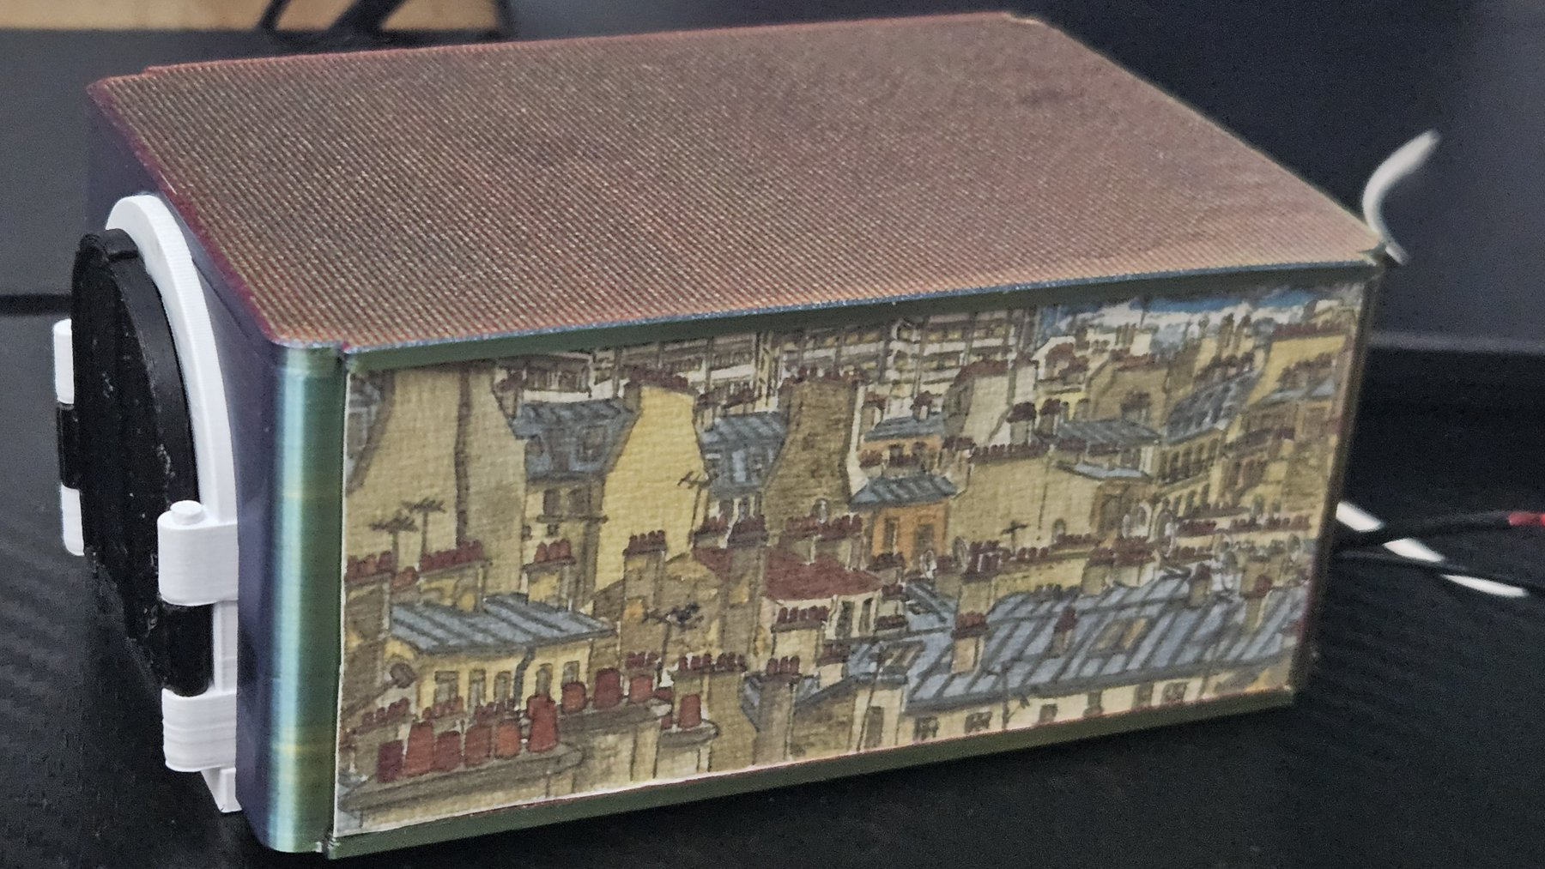

9. HTTP API & Home Automation
The Modern Cuckoo includes a built-in HTTP API that allows control and monitoring from a web browser, Home Assistant, Node-RED, Jeedom, Python scripts, or any automation platform.

Base URL: http://cuckoo.local or http://<LOCAL_IP>

Endpoint | Description
/coucou | Play the cuckoo
/starwars | Play the Star Wars melody
/cuckoo_out | Bring the cuckoo out
/cuckoo_in | Bring the cuckoo back in
/status | Get current status and statistics
/config | Get current configuration
/set | Update settings
/test | Test a custom melody
/setwifi | Update Wiâ€‘Fi credentials
/settime | Synchronize time
/timer | Manage timer
/reboot | Reboot the ESP32

Examples

http://cuckoo.local/coucou or http://<LOCAL_IP>/coucou
/status
/reboot
/timer?min=10
/set?volume=800&half=1
/test?b1=262&b2=294&b3=330&b4=392&volume=800

Example Status Response

JSON
{
"time":"21:37",
"temp":22,
"hum":58,
"cpu":41,
"rssi":-63,
"up":9523,
"total":12543,
"distance_km":1.25
}

Home Automation
Compatible with:
- Home Assistant
- Node-RED
- Jeedom
- Python scripts
- Mobile apps
- Any HTTP client
Example:

YAML :
rest_command:
cuckoo:
url: "http://cuckoo.local/coucou"

This allows the Modern Cuckoo to be easily integrated into virtually any smart home system.

