Developing a Risk Literacy Diagnostic for QUIN 102: Instrument Design, Platform Implementation, and SDM-10 Diagnostic Findings
Guillaume Bolivard
Loyola University Chicago
Independent Study -- Spring 2026

Abstract
This paper describes the design, deployment, and diagnostic findings from a 40-item pre-course financial risk literacy assessment for QUIN 102 at Loyola University Chicago. The instrument spans three knowledge domains -- Borrowing and Credit, Risk Management, and Investment and Risk -- using 26 scored and 14 unscored anchor items. A Supplemental Diagnostic Module (SDM-10) adaptively selects up to 10 open-ended follow-up items based on each student's anchor performance; an AI-assisted rubric classifies responses into misconception, knowledge gap, and selection error categories. During the Spring 2026 pilot, 354 research-consented students completed the assessment. The mean anchor score was 67.0% (SD = 17.9%), with notable variation across domains. Among 493 scored diagnostic responses, 53.9% reflected misconceptions, 31.9% selection errors, and 14.2% knowledge gaps. The selection error finding is central: among students who answered incorrectly with high confidence, nearly one in three demonstrated correct understanding in their open-ended explanation, indicating that raw MCQ scores systematically misrepresent student knowledge on format-sensitive items. The diagnostic results yield 10 specific course improvement recommendations -- spanning instructional content, instrument revision, and delivery changes -- each anchored to evidence and paired with a Paper 2 evaluation criterion. We outline limitations of the current single-cohort design and preview a planned validation study that will add pre-post measurement, factor analysis, and heterogeneity modeling.

Table of Contents
- Introduction
- Related Work
- 2.1 Financial Literacy: Definitions and Measurement
- 2.2 Domain-Specific Knowledge Gaps
- 2.3 Confidence Calibration and Overconfidence
- 2.4 Gaps in the Literature
- Instrument and Measurement Model
- 3.1 Assessment Structure
- 3.2 Scoring Methodology
- 3.3 Risk Literacy Emphasis
- Assessment Pipeline
- 4.1 Pipeline Overview and Illustrative Walkthrough
- 4.2 Adaptive Selection and Diagnostic Priority Score
- 4.3 Variant Types and Three-Way Classification
- 4.4 AI-Assisted Scoring Pipeline
- Platform and Governance Design
- 5.1 Consent Mechanics
- Pilot Operations and Descriptive Statistics
- 6.1 Participation and Completion
- 6.2 Sample Demographics
- Results
- 7.1 Anchor Score Distribution and Domain Breakdown
- 7.2 Confidence Calibration Patterns
- 7.3 Diagnostic Classification: Diagnose Composition
- 7.4 Diagnostic Classification: Confirm Composition
- 7.5 Misconception Clusters by Domain
- 7.6 Selection Error Patterns and Item Revision Targets
- 7.7 AI Scoring Validation
- Discussion
- 8.1 Key Findings
- 8.2 Course Improvement Recommendations
- 8.3 Implications for Risk Literacy Measurement
- 8.4 Oral Diagnostics as Future Modality
- Limitations
- Planned Validation Study (Paper 2 Protocol Preview)
- References
- Declaration of AI and AI-Assisted Technologies
- Appendix A: SDM-10 Selection Algorithm and Burden Controls
- Appendix B: Assessment Items (Full Question Bank)
- Appendix C: Financial Literacy Misconception Taxonomy (Layer 1)
- Appendix D: AI Scorer Model Selection Protocol
- Appendix E: Supplementary Materials
- Appendix F: Technical Implementation

1. Introduction
Financial literacy is commonly defined as the ability to understand and use financial concepts and quantitative information to make informed decisions about saving, borrowing, investing, and managing risk. In the human capital framework, these competencies influence participation in credit and asset markets, portfolio choice, and resilience to shocks. For university students, financial literacy is immediately consequential because many begin managing debt, credit, and consumption decisions under limited experience and imperfect information. Small misunderstandings in compounding, interest-rate mechanics, inflation, diversification, and insurance can translate into persistent debt burdens, fragile liquidity positions, and suboptimal portfolio choices.
Recent policy debate on consumer credit highlights why financial literacy matters for borrowing outcomes. Research suggests that creditworthiness may be influenced by financial literacy education (Lusardi & Mitchell, 2014), and that improving consumers' understanding of borrowing mechanics may help reduce delinquency and compounding penalty dynamics that raise effective borrowing costs. From this perspective, expanding access to bona fide financial literacy education is not only consumer protection but also a market-relevant intervention, because stronger credit profiles can reduce risk-based pricing pressure and contribute to lower rates over time for both borrowers and lenders.
Despite broad recognition of its importance, financial literacy is unevenly distributed across student populations. Students arrive with heterogeneous prior exposure to personal finance concepts, differences in numeracy, and unequal access to credible guidance through households, schools, employers, and digital sources. Learning is further shaped by behavioral and contextual constraints, including time scarcity, employment intensity, financial stress, risk preferences, and prior exposure to financial products. Consequently, evaluation of financial literacy instruction should address both average learning gains and the determinants of variation in learning across students.
This independent study develops and pilots a diagnostic instrument for evaluating financial and risk literacy in QUIN 102 (Financial Literacy) during the Spring 2026 offering. The instrument comprises a 40-item anchor assessment covering financial knowledge and attitudes, paired with a 10-item Supplemental Diagnostic Module (SDM-10) that adaptively probes areas of weakness identified in the anchor responses. The assessment is administered through a purpose-built web platform with coded student identifiers and structured consent mechanics.
More specifically, the independent study is organized around two research questions that frame the overall project:
- RQ1 (Learning gains): What is the magnitude of student learning in QUIN 102, overall and within the domains of borrowing and credit, investment, and risk management, as measured by pre- to post-course changes in knowledge?
- RQ2 (Heterogeneity): Which baseline behavioral and contextual variables predict heterogeneity in learning gains across students, and do these predictors differ by domain?
RQ1 and RQ2 require paired pre-post data and will be addressed in a subsequent study contingent on institutional review board approval (see Section 10). This paper (Paper 1) is an independent study deliverable that documents instrument design, platform implementation, and descriptive diagnostic findings from the pre-course assessment (February 2--9, 2026). It reports no learning gains, no inferential statistics, and no subgroup comparisons. All pre-course results are presented as operational baseline context for the planned validation study, not as standalone research findings. The SDM-10's three-way classification of open-ended responses (misconception, knowledge gap, selection error) provides diagnostic information that standard multiple-choice instruments cannot capture -- in particular, the finding that a substantial fraction of incorrect answers reflect selection errors rather than genuine misconceptions, and that a meaningful fraction of correct answers reflect lucky guesses rather than genuine understanding. These findings demonstrate that raw MCQ scores both overstate and understate student knowledge in systematic ways, with implications for instrument design and instructional targeting.

2. Related Work

2.1 Financial Literacy: Definitions and Measurement
Since the early 2000s, a growing body of research has examined how well people understand basic financial concepts and how that understanding shapes their economic decisions. Lusardi and Mitchell (2014) anchored much of this work by defining financial literacy around three core ideas -- interest compounding, inflation, and risk diversification -- and showing that individuals who grasp these concepts save more, invest more effectively, and accumulate greater wealth over time. Their "Big Three" questions have become the most widely adopted instrument for assessing basic financial literacy and form the conceptual basis for most subsequent measurement efforts, including the assessment categories used in the present study.
Although the construct is widely acknowledged, the field has lacked a standardized instrument analogous to established health literacy measures. Huston (2010) reviewed the heterogeneous measurement landscape and proposed that financial literacy instruments should contain 12--20 items spanning four content areas: money basics (time value of money, purchasing power), borrowing, investing, and asset protection. Our assessment's coverage of borrowing/credit, investment/risk, and behavioral risk management closely mirrors Huston's recommended framework. More recently, the OECD/INFE toolkit (OECD, 2022) has provided a standardized questionnaire measuring three dimensions of financial literacy -- knowledge, behavior, and attitudes -- deployed across dozens of countries to enable cross-national comparisons.
In their methodological review, Hastings, Madrian, and Skimmyhorn (2013) examined how researchers actually measure financial literacy and concluded that the "Big Five" questions -- interest rates, inflation, diversification, compound interest, and bond pricing -- remain the field's most trusted indicators, despite persistent difficulties in drawing causal links between what people know and how they behave financially. Lusardi (2019) further documented that globally, only about one-third of adults demonstrate familiarity with basic financial concepts, with illiteracy especially concentrated among women, minorities, the young, and those with lower educational attainment.
Among college students specifically, Chen and Volpe (1998) established early baseline evidence, finding that 924 college students answered only about 53% of financial literacy questions correctly, with non-business majors, women, and students with limited work experience scoring significantly lower.

2.2 Domain-Specific Knowledge Gaps
Research has documented uneven financial literacy across knowledge domains. Lusardi and Tufano (2015) established the concept of "debt literacy" as distinct from general financial literacy, finding that only about one-third of Americans comprehend interest compounding or credit card mechanics, and estimating that as much as one-third of charges and fees paid by less-knowledgeable individuals can be attributed to ignorance. Stango and Zinman (2009) identified the cognitive mechanism underlying many borrowing mistakes -- exponential growth bias, the pervasive tendency to linearize exponential functions -- which leads consumers to underestimate interest rates on loans and underestimate future values of investments.
In the investment domain, van Rooij, Lusardi, and Alessie (2011) found that while most respondents demonstrated basic financial knowledge (interest compounding, inflation, time value of money), very few understood differences between bonds and stocks, bond price-interest rate relationships, or risk diversification basics. Individuals with low advanced financial literacy were significantly less likely to participate in the stock market.
Within the college population, Akers and Chingos (2014) found striking levels of student loan illiteracy: 28% of first-year students with federal loans reported having no federal debt, and nearly half seriously underestimated their total student debt. These findings underscore why the present assessment includes borrowing/credit as a major knowledge domain.

2.3 Confidence Calibration and Overconfidence
The relationship between perceived and actual financial literacy has emerged as a critical dimension of financial competence. Allgood and Walstad (2016) demonstrated, using a national survey of 28,146 U.S. adults, that both actual (objective) and perceived (subjective) financial literacy independently influence financial behaviors across five domains. The combined measure of both perceived and actual literacy provides greater explanatory power than either alone, supporting the QUIN 102 assessment's design that generates an overconfidence index from both measures.
Robb and Woodyard (2011) found that subjective financial knowledge had a larger relative impact on financial behavior than objective knowledge, underscoring the importance of measuring confidence calibration. Porto and Xiao (2016) found that over 11% of respondents in a nationally representative sample displayed financial literacy overconfidence -- scoring above average on perceived knowledge but failing basic literacy questions -- and that these overconfident consumers were less likely to seek professional financial advice in domains where they most needed it.
In a study closely comparable to the present research, Ipatova and Merheb (2023) examined overconfidence among 169 undergraduates and confirmed the Dunning-Kruger effect in financial literacy contexts: students with lower financial proficiency systematically overestimated their knowledge and competence. Kramer (2016) provided additional evidence that confidence operates independently of knowledge in shaping financial behavior, finding that higher confidence reduces advice-seeking while no relationship exists between objective literacy and advice-seeking.

2.4 Gaps in the Literature
The literature review reveals several gaps that the present instrument addresses. First, most financial literacy measurement studies rely on fixed multiple-choice instruments that cannot distinguish between genuine misconceptions, knowledge gaps, and selection errors -- a limitation that affects both diagnostic accuracy and instructional targeting. Second, the use of adaptive diagnostic instruments that probe areas of weakness identified in an anchor assessment is novel in the financial literacy evaluation literature. Third, the simultaneous measurement of knowledge, confidence, and behavioral covariates enables analysis of confidence calibration, directly addressing Willis's (2011) concern about "confident incompetence." The present study contributes to filling these gaps by developing a diagnostic instrument that combines a fixed anchor assessment with an adaptive diagnostic module, enabling finer-grained classification of student responses than traditional MCQ-only approaches.

3. Instrument and Measurement Model

3.1 Assessment Structure
The instrument comprises three components:
- A demographic and socioeconomic baseline questionnaire (13 items) administered during onboarding
- A fixed 40-item core (anchor) assessment covering financial knowledge and attitudes
- A 10-item Supplemental Diagnostic Module (SDM-10) selected from a pre-written item bank based on students' anchor responses
Table 3.1: Item Distribution
Component | Items | Content | Scored
Baseline covariates | 13 | Demographics, financial background, debt status | No
Anchor knowledge items | 26 | Q1--Q14, Q29--Q40 (borrowing, investment, risk) | Yes
Anchor preference items | 14 | Q15--Q28 (attitudes, risk tolerance, behavior) | No
SDM-10 adaptive items | 10 | Selected from 156-variant item bank | Diagnostic only

Out of the 40 anchor items, 26 are knowledge items scored as correct/incorrect and used to compute learning gains. The remaining 14 are preference items (Q15--Q28) that assess behavioral tendencies and serve as unscored covariates for heterogeneity analysis. Each anchor item is paired with a confidence rating on a 1--3 scale (low, medium, high). The combination of correctness and confidence determines whether additional diagnostic measurement is warranted in the SDM-10.
We built the question bank by adapting and synthesizing items from established financial literacy and numeracy instruments, including the Berlin Numeracy Test, Lipkus Numeracy Scale, the "Big Three" (Lusardi and Mitchell), the FINRA National Financial Capability Study item sets, the OECD/INFE Toolkit (2022), the P-Fin Index, and related decision science instruments. Starting from an initial pool of approximately 80 candidates, we refined the bank down to a 40-item anchor assessment.

3.2 Scoring Methodology
We score knowledge items (Q1--Q14, Q29--Q40) as correct/incorrect (binary) and compute both overall and domain-level percent-correct scores across three instructional domains:
- Borrowing, Interest Rates, and Financial Numeracy Knowledge (10 items: Q1--Q10)
- Behavioral and Risk Management Knowledge (4 scored items: Q11--Q14)
- Risk and Return Knowledge (12 items: Q29--Q40)
Each anchor item also carries a confidence rating, which we use for secondary analyses (calibration and diagnostic interpretation) but which does not affect the primary score. The SDM-10 is diagnostic only and does not contribute to the student's course grade.

3.3 Risk Literacy Emphasis
The instrument emphasizes risk literacy as a core construct, consistent with the independent study's objectives. Risk literacy encompasses not only factual knowledge of diversification, insurance, and risk-return tradeoffs (assessed through scored knowledge items) but also students' self-assessed confidence in recognizing and managing risk (assessed through confidence ratings and preference items). The SDM-10 module provides a deeper diagnostic layer by probing whether incorrect answers on risk-related items reflect misconceptions (specific wrong mental models), knowledge gaps (absence of knowledge), or selection errors (correct understanding with wrong answer choice). This three-level diagnostic architecture -- knowledge score, confidence calibration, and open-ended classification -- enables measurement of both quantitative and qualitative dimensions of risk literacy.
We designed the instrument to be internally consistent and transferable. Although piloted first with Loyola University Chicago students in QUIN 102, the item bank, scoring framework, and diagnostic module are intended for adaptation to broader student populations in future work.

4. Assessment Pipeline

4.1 Pipeline Overview and Illustrative Walkthrough
The SDM-10 pipeline operates in three stages: (1) compute a diagnostic priority for each concept area based on the student's answer and confidence, (2) select up to 10 follow-up items from a pre-written variant bank ranked by priority (targeting 10, delivering 5--10 depending on available high-priority concepts), and (3) score any open-ended responses using an AI-assisted rubric aligned to the misconception taxonomy. Confidence is captured on a three-level scale (1 = low, 2 = mid, 3 = high). Two illustrative cases show how the pipeline works in practice.
Case A -- Open_Diagnose (incorrect + high confidence). A student encounters Q6, which asks what a "successful effort to lower inflation" would likely be accompanied by. The student selects "a decrease in the general level of prices" -- the incorrect answer -- and reports high confidence. Because the combination of incorrectness and high confidence produces a high diagnostic priority, the algorithm assigns an Open_Diagnose variant for the Inflation (Lowering) concept area. The student sees an open-ended prompt: "You chose 'a decrease in the general level of prices.' In your own words, explain what happens to prices when inflation is lowered." The student writes: "If inflation goes down, prices should go down too -- that's what lower inflation means." The AI scoring pipeline classifies this as a misconception (INF-01: confuses a decrease in the rate of price increase with an actual decrease in prices) and assigns taxonomy codes. The classification distinguishes this from a knowledge gap (the student has an active belief, not an absence of knowledge) and from a selection error (the student's reasoning is consistent with the wrong answer, not inconsistent with it).
Open_Diagnose is an open-ended prompt assigned when a student answers incorrectly with high confidence. Its diagnostic goal is to distinguish three response types: misconception (a specific wrong mental model), knowledge gap (absence of knowledge), or selection error (correct understanding despite the wrong answer choice).
Case B -- Open_Confirm (correct + low confidence). The same student answers Q29 correctly -- "bond prices fall when interest rates rise" -- but reports low confidence. Because a correct answer paired with low confidence leaves residual uncertainty about whether the student genuinely understands the concept, the algorithm assigns an Open_Confirm variant. The prompt asks: "You said bond prices typically fall when interest rates rise. In your own words, explain why this relationship holds." The student writes: "I'm not really sure, I think I read it somewhere but I don't remember why." The AI scoring pipeline classifies this as a likely guess -- the student cannot articulate the reasoning behind the correct answer. Without this follow-up, the anchor score of 100% on Q29 would overstate the student's understanding.
Open_Confirm is an open-ended prompt assigned when a student answers correctly with low confidence. Its diagnostic goal is to distinguish three response types: verified (genuine understanding), partial (incomplete reasoning), or likely guess (no substantive understanding despite the correct answer).
Together, these two cases illustrate the SDM-10's central contribution: standard MCQ scores classify responses as simply correct or incorrect, while the diagnostic module reveals whether incorrect answers reflect misconceptions, knowledge gaps, or format-induced errors, and whether correct answers reflect genuine understanding or fortunate guessing.

4.2 Adaptive Selection and Diagnostic Priority Score
The Supplemental Diagnostic Module (SDM-10) is an adaptive follow-up administered immediately after the 40-item anchor assessment. For each student, the module selects 10 items from a pre-written bank of 156 variants (six variants per anchor knowledge item) using an information deficit model that prioritizes subcategories where the anchor response left the most residual uncertainty about the student's understanding. The selection algorithm computes a diagnostic priority score for each of the 26 knowledge subcategories based on correctness, confidence, and item format (True/False vs. multiple choice). Higher scores indicate greater residual uncertainty; incorrect responses with high confidence receive the highest priority, signaling a likely misconception. The format-aware adjustment reflects differential guessing probability (50% for True/False vs. ~25% for MCQ). A three-phase selection procedure enforces domain minimums, fills remaining slots by descending priority, and applies an understanding-verification fallback when fewer than 10 subcategories are flagged. Open-ended items are capped at three per student to limit response burden. See Appendix A for the complete selection specification.

4.3 Variant Types and Three-Way Classification
Each SDM-10 item is drawn from one of six variant types determined by the student's anchor response pattern. Incorrect responses with high confidence trigger Open_Diagnose (open-ended); incorrect with mid confidence trigger Lower_MCQ; incorrect with low confidence trigger Lower_TF. Correct responses with low confidence trigger Open_Confirm (open-ended); correct with mid confidence trigger Same_MCQ; correct with high confidence trigger Higher_MCQ. The variant assignment rules are specified in Appendix A (Table A.3).
Every open-ended response is classified into one of three categories:
- Misconception: The student holds a specific wrong mental model (e.g., believing lower inflation means falling prices, or that insurance exists primarily for routine care). Layer 1 and Layer 2 taxonomy codes are assigned.
- Knowledge gap: The student lacks knowledge -- blank responses, "I don't know," or inability to articulate reasoning about the topic.
- Selection error: The student demonstrates correct understanding in the explanation but selected the wrong anchor answer, typically due to misreading, misclick, or True/False reversal.
This three-way classification drives differentiated instructional follow-up: misconceptions require targeted correction of the specific wrong belief, knowledge gaps require instruction from foundational principles, and selection errors flag potential item ambiguity for revision rather than student remediation.
Misconception Taxonomy. A two-layer taxonomy structures the classification. Layer 1 contains 37 generalizable financial literacy misconception families organized into seven categories (Appendix C). Layer 2 contains item-specific tags derived from observed student response patterns. Layer 1 codes are designed to transfer across assessment contexts and student populations.

4.4 AI-Assisted Scoring Pipeline
Open-ended responses are scored using GPT-4.1 (OpenAI, accessed via OpenRouter). The model was selected through an 11-model concordance protocol evaluating schema compliance, error rate, classification nuance, throughput, and cost (Appendix D). Each response is processed with an item-specific prompt containing anchor question context, the student's answer and confidence, applicable misconception families, calibration examples, and a structured decision tree. The model returns a JSON classification including diagnosis type, taxonomy codes, credit score, confidence level, evidence quote, and reasoning summary. All item selection decisions are deterministic and rule-based; the language model is used only for open-ended response classification.

5. Platform and Governance Design
The platform architecture (Next.js 14, PostgreSQL 15, PgBouncer) and student authentication protocol (one-way SHA-256 hashing with per-course pepper) are described in Appendix F.

5.1 Consent Mechanics
The platform implements a two-part consent flow before data collection:
- Course requirement acknowledgment (mandatory). Students review and acknowledge that the assessment is a required course assignment and that their answers are not graded for correctness.
- Research consent (voluntary). Students are presented with a separate research consent screen asking whether their de-identified responses may be used for research evaluating course learning outcomes. The screen explicitly states that declining has no impact on grades, course standing, or access to feedback. The consent decision, timestamp, and version identifier are recorded. Students may withdraw research consent at any time by contacting the course instructor; withdrawn data are excluded from subsequent analyses.
The consent flow structurally separates the course requirement from the research opt-in: a student can complete the assessment (fulfilling the course obligation) without consenting to research use. This separation is the primary safeguard of voluntariness. Before the consent flow, students view a short orientation video explaining the purpose, structure, and non-graded nature of the assessment (see Appendix E). A privacy notice displayed during onboarding describes the hashing process, data separation, and the student's right to withdraw.
Consent accounting. Of the 431 students who submitted completed assessments, 354 (82.1%) provided affirmative research consent. Zero students explicitly declined. The remaining 77 (17.9%) have a NULL consent status because they completed the assessment during the first days of the assessment window before the research consent screen was deployed in the platform. Following standard research ethics practice, students with NULL consent are treated as non-consented for all research analyses -- absence of affirmative consent is treated as non-consent, regardless of the reason.
Representativeness check. The consented subsample appears similar to the full cohort on observed score distributions, as summarized below. This comparison is descriptive; no formal equivalence test was conducted.
Table 5.1: Consented vs. Full Cohort Comparison
Metric | Consented (n = 354) | Full Cohort (N = 431) | Difference
Anchor mean | 67.0% | 67.4% | 0.4 pp
Anchor SD | 17.9% | 17.9% | 0.0 pp
Median | 69.2% | 69.2% | 0.0 pp
Below 50% band | 12.7% | 12.3% | 0.4 pp
80%+ band | 24.9% | 25.6% | 0.7 pp

The small differences (all < 1 percentage point) suggest that the NULL-consent cohort reflects deployment timing rather than a self-selected subgroup, though this cannot be confirmed without additional non-observable covariates.
Default selection. The consent screen presented "Yes, I consent" as the default selection. While the 0% explicit decline rate is consistent with students having no objection to de-identified research use, the default-yes design may have inflated the consent rate through status quo bias. Paper 2 will mitigate this by implementing a forced active choice (no default selection) in the post-assessment consent screen.
All analyses in this paper use only the research-consented subset (n = 354). For instructional purposes, all 431 students receive SDM-10 diagnostics and dashboard feedback regardless of consent status; consent governs only research publication, not educational use.

6. Pilot Operations and Descriptive Statistics
Below we report operational statistics from the pre-course assessment window (February 2--9, 2026) as quality assurance context for interpreting the SDM-10 diagnostic findings. These are descriptive operational summaries of assessment administration, not inferential research results. No subgroup comparisons, hypothesis tests, or claims about population parameters are made in this section. Subgroup analyses are deferred to Paper 2, contingent on institutional review board approval for human-subjects research.

6.1 Participation and Completion
A total of 443 students onboarded onto the platform, of whom 431 submitted completed assessments, yielding a completion rate of 97.3%. Twelve students abandoned the assessment without submission; all abandoned sessions had been idle for more than 45 hours at the time of window closure. All 431 students who submitted the anchor assessment received SDM-10 items. Of these, 300 consented students (84.7%) received the full 10-item module; 54 received between five and nine items due to insufficient high-priority subcategories in their anchor profile (the algorithm could not fill all 10 slots when a student's anchor performance was uniformly strong or weak across subcategories).
Table 6.0: Counts and Inclusion Rules
Stage | n | Rule
Enrolled (onboarded) | 443 | Created platform account with hashed ID
Completed (submitted) | 431 | Submitted anchor + SDM-10 before window close
Abandoned | 12 | Onboarded but did not submit; idle > 45 hours
Consented (research) | 354 | Affirmative "Yes" on research consent screen
Declined | 0 | Explicit "No" on research consent screen
NULL consent | 77 | Completed before consent screen deployed; treated as non-consented
Withdrawn | 0 | No withdrawals received during the study period
Research-consented analysis set | 354 | Inclusion rule: research_consent = true AND submitted_at IS NOT NULL

All tables and statistics in Sections 4, 6, and 7 use the research-consented set (n = 354) unless explicitly noted otherwise. Instructional feedback is delivered to all 431 submitters regardless of consent status.
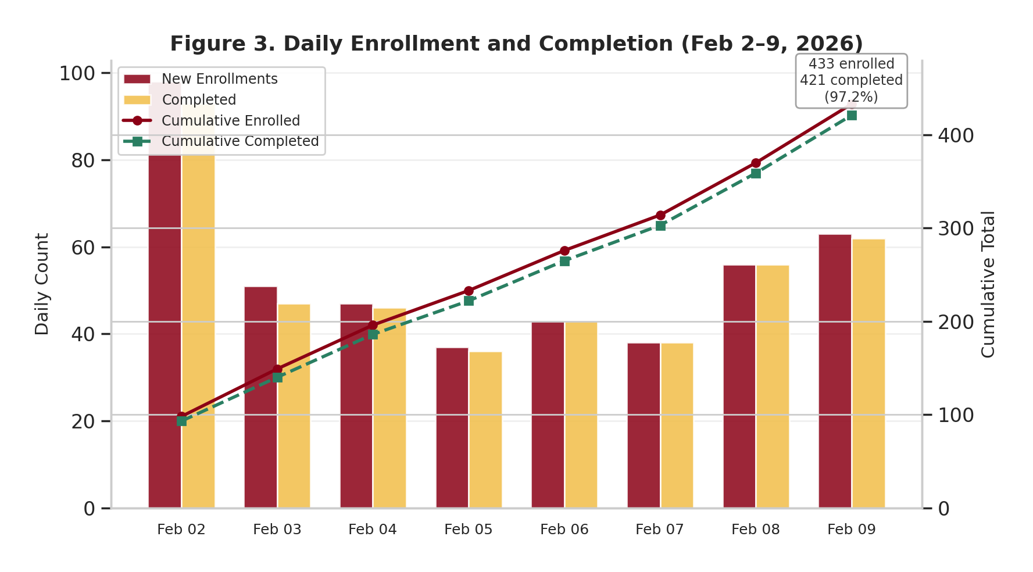
Figure 3. Daily Enrollment and Completion (Feb 2--9, 2026). Full completed cohort: 433 enrolled, 421 completed (97.2%).

6.2 Sample Demographics
The following demographic summary describes the composition of the consented sample for operational context only. No subgroup performance comparisons are reported in Paper 1.
To protect student privacy, demographic cells with fewer than 10 respondents are collapsed into an "Other/Prefer not to say" grouping or reported as suppressed (< 10), to reduce re-identification risk.
Table 6.1: Sample Demographics (Consented, n = 354)
Characteristic | n | %
Female | 213 | 60.2%
Male | 139 | 39.3%
Other/Prefer not to say | 2 | < 10 (suppressed)
English first language | 278 | 78.5%
Spanish first language | 44 | 12.4%
Other languages | 32 | 9.0%

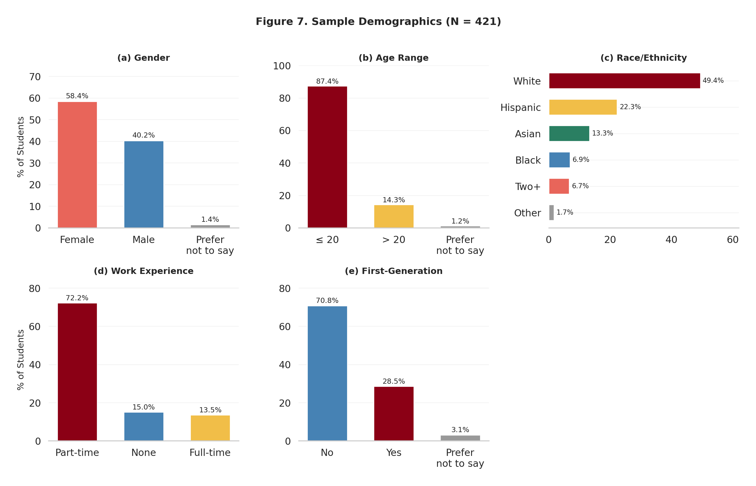
Figure 7. Sample Demographics (N = 421, full completed cohort). Panels show gender, age range, race/ethnicity, work experience, and first-generation status.
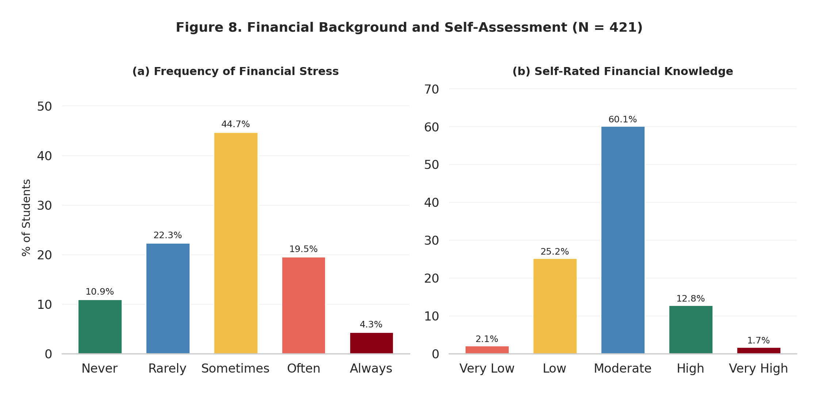
Figure 8. Financial Background and Self-Assessment (N = 421, full completed cohort). Panels show frequency of financial stress and self-rated financial knowledge.

7. Results
Important caveat: The SDM-10 open-ended items are administered only to students whose anchor responses triggered high-priority subcategories (incorrect + high confidence for diagnose, or correct + low confidence for confirm). The open-ended sample therefore reflects the tails of the confidence-accuracy distribution, not a random cross-section of the class. Misconception prevalence estimates from the SDM-10 should not be generalized to the full cohort without accounting for this conditioning.
All analyses in this section are restricted to the research-consented subset (n = 354 of 431 submitted students, 82.1%).

7.1 Anchor Score Distribution and Domain Breakdown
The following score summaries provide operational context for interpreting SDM-10 diagnostic patterns. They are not inferential claims about population-level financial literacy.
For the consented subset (n = 354), the mean anchor score was 67.0% (SD = 17.9%, median = 69.2%) across 26 scored knowledge items. Domain-level means were:
Table 7.1: Mean Accuracy by Domain (Consented, n = 354)
Domain | Items | Mean % Correct
Behavioral and Risk Management Knowledge | 4 | 72.4%
Borrowing, Interest Rates, and Financial Numeracy Knowledge | 10 | 69.2%
Risk and Return Knowledge | 12 | 63.4%

Risk and Return Knowledge was the weakest domain, driven primarily by low performance on Q38 (Inflation Protection) and Q6 (Inflation Lowering). However, this domain also has the highest selection error count (56), suggesting some of this weakness is artifactual.
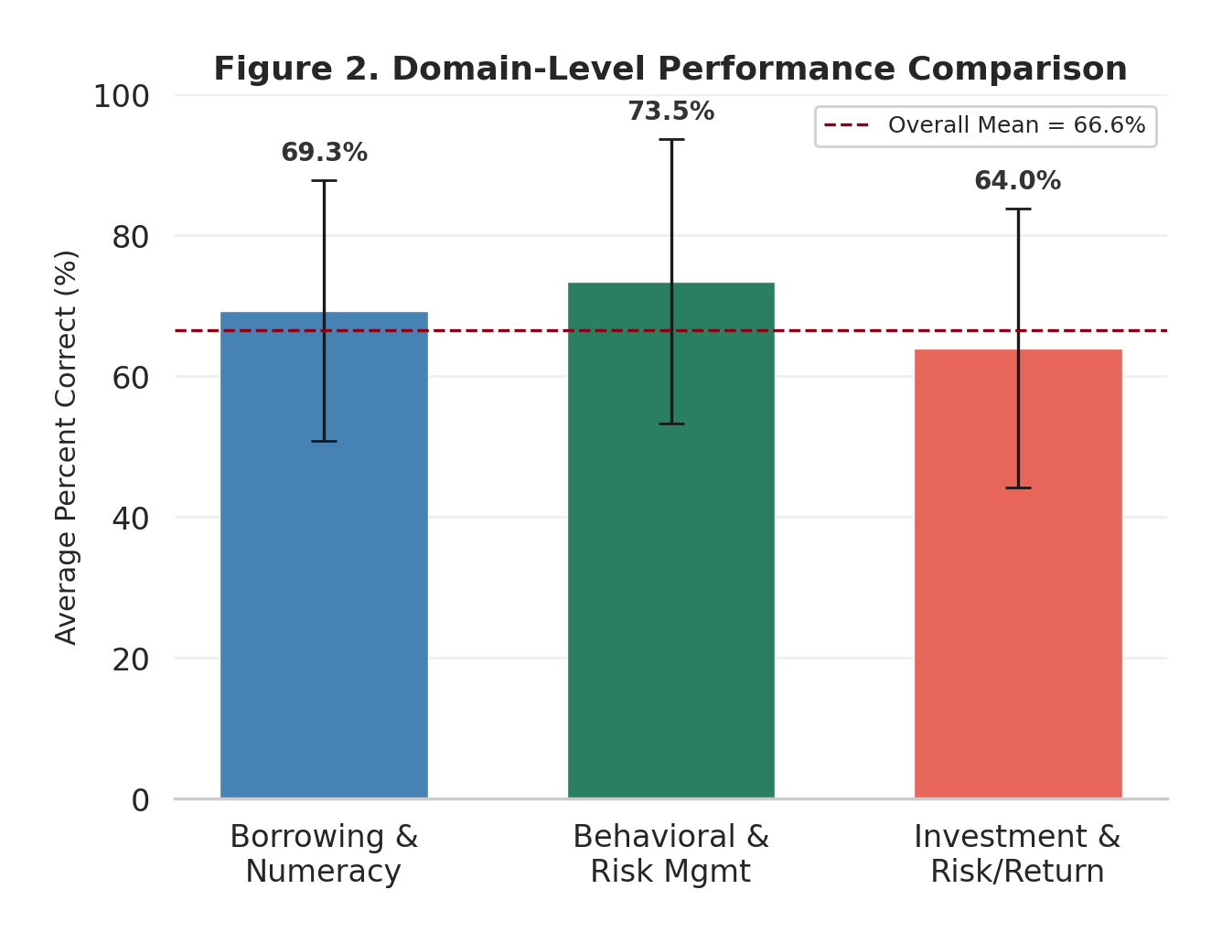
Figure 2. Domain-Level Performance Comparison (full completed cohort). Error bars show ±1 SD. Dashed line indicates overall mean (66.6%).
Table 7.2: Score Distribution by Performance Band (Consented, n = 354)
Band | n | % of Sample | Status
Below 50% | 45 | 12.7% | At risk
50--69% | 161 | 45.5% | Developing
70--79% | 60 | 16.9% | Proficient
80% and above | 88 | 24.9% | Strong

The largest segment (45.5%) falls in the 50--69% band. Combined with the 12.7% below 50%, over half the consented sample has partial or incomplete financial literacy knowledge.
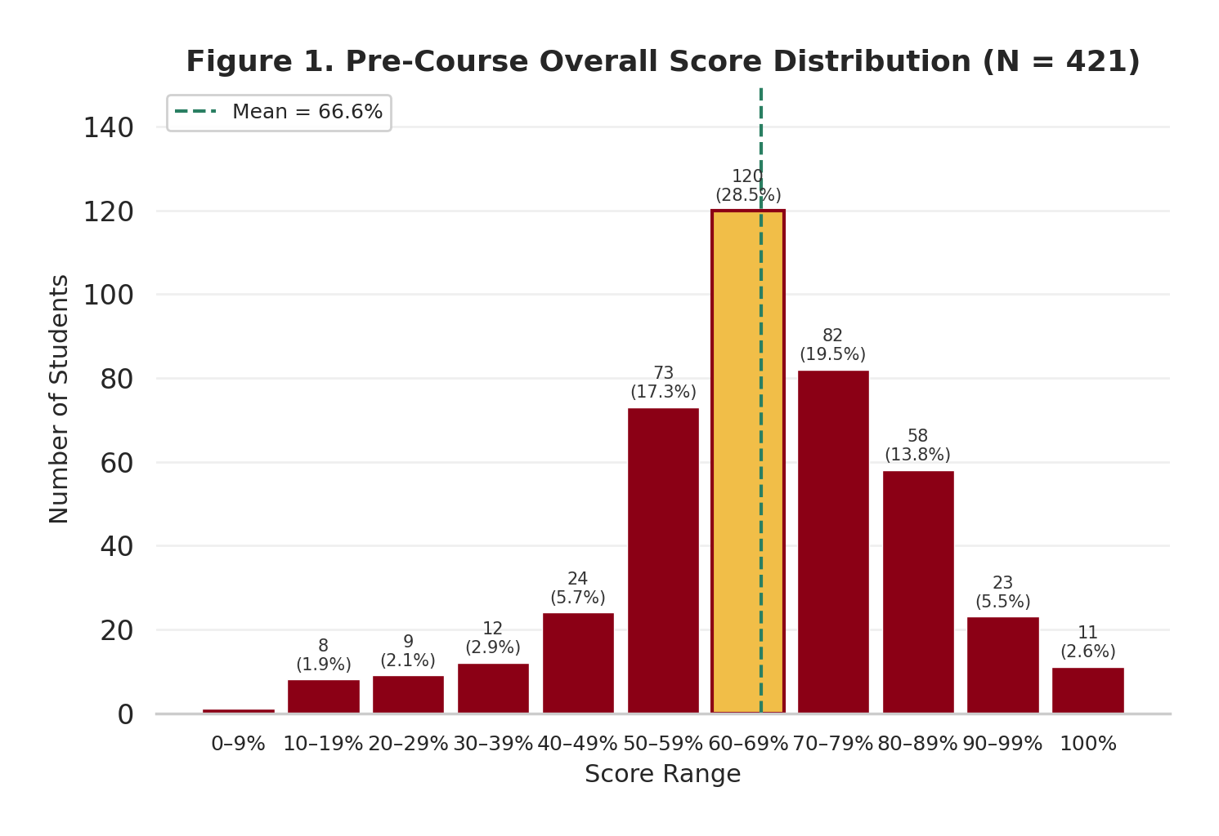
Figure 1. Pre-Course Overall Score Distribution (N = 421, full completed cohort). Dashed line shows mean (66.6%). The modal bin (60--69%) contains 28.5% of students.
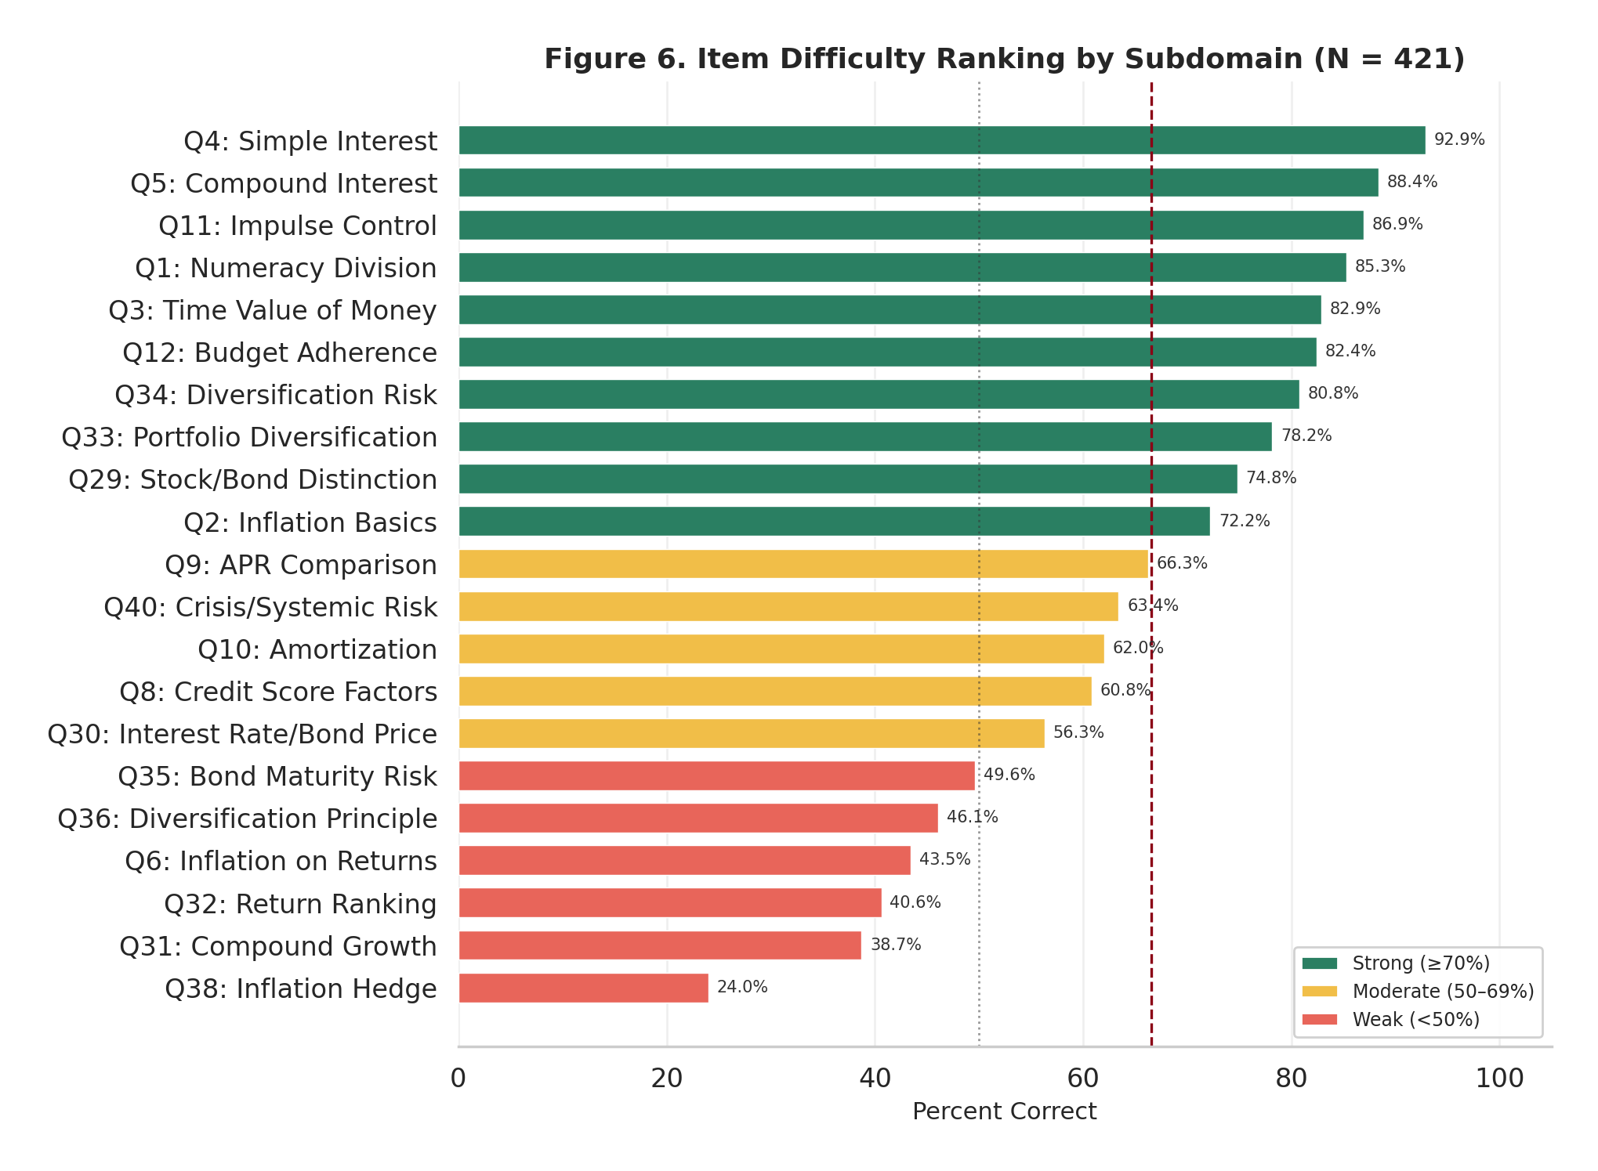
Figure 6. Item Difficulty Ranking by Subdomain (N = 421, full completed cohort). Items colored by difficulty tier: green (strong, >=70%), yellow (moderate, 50--69%), red (weak, <50%).
The consented SDM-10 mean score (64.4% across 3,340 responses) was lower than the anchor mean (67.0%), confirming that the adaptive selection algorithm appropriately targeted subcategories where students demonstrated weaker performance. These scores provide context for interpreting the SDM-10 diagnostic findings but are not the primary analytical contribution of this paper.
The median assessment duration was 18.1 minutes (consented subset). The mean duration (217.2 minutes) was heavily skewed by a small number of sessions left open without completion, including sessions that remained idle for multiple days. The median is the more representative measure of active assessment time.
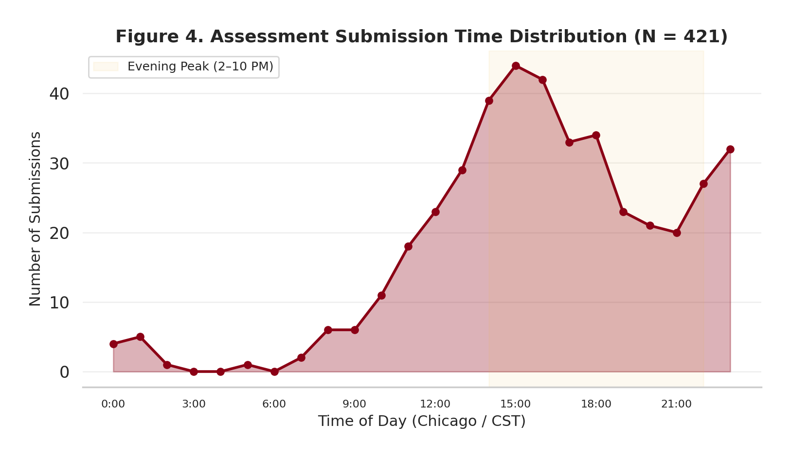
Figure 4. Assessment Submission Time Distribution (N = 421, full completed cohort). Peak submissions occurred between 2--10 PM CST (Chicago time).

7.2 Confidence Calibration Patterns
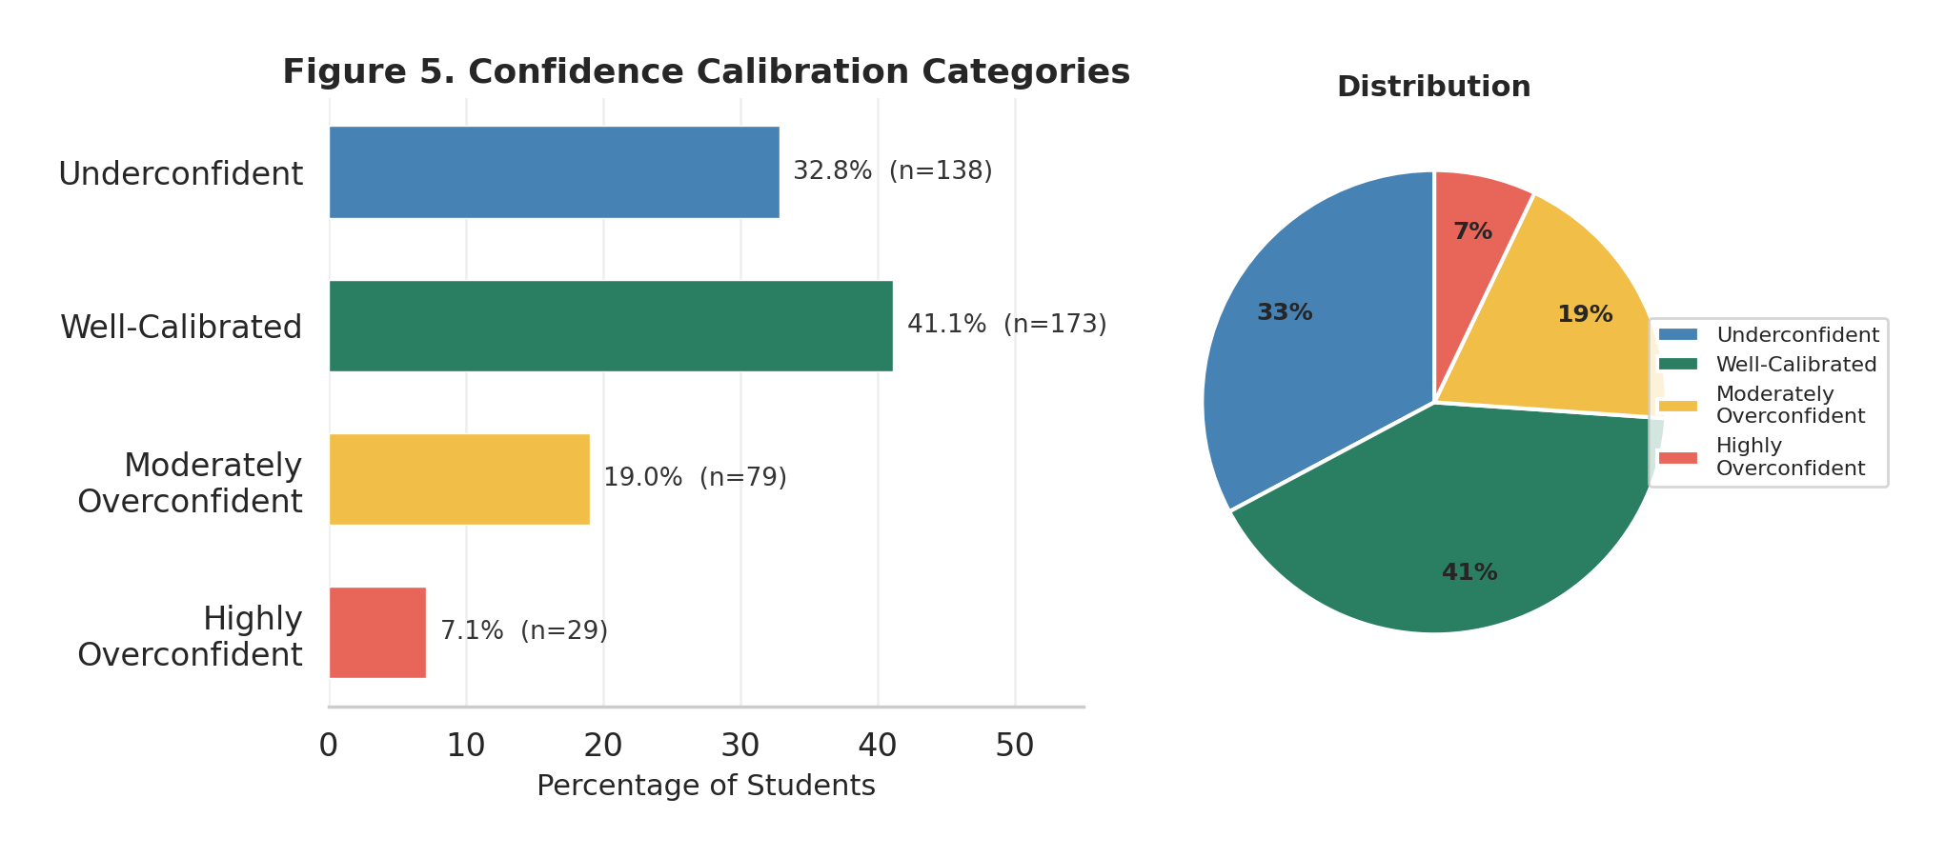
Figure 5. Confidence Calibration Categories. Distribution of students across calibration groups based on average confidence-accuracy alignment (full completed cohort).
Figure 5 presents the distribution of students across confidence calibration categories based on the alignment between average confidence ratings and anchor accuracy. Calibration patterns inform the SDM-10's adaptive logic: students with high confidence and low accuracy (overconfident) are more likely to trigger Open_Diagnose items, while students with low confidence and high accuracy (underconfident) are more likely to trigger Open_Confirm items. The distribution shows that the majority of students fall within calibrated or mildly overconfident ranges, with a smaller tail of strongly overconfident students whose high-confidence errors drive the diagnose subsample analyzed in Sections 7.3--7.6.

7.3 Diagnostic Classification: Diagnose Composition
SDM conditioning caveat. The diagnose results below reflect students who answered incorrectly with high confidence (the SDM-10 diagnose trigger condition). These rates characterize the composition of high-confidence errors, not class-wide misconception prevalence.
Of the 354 consented students who submitted the assessment, 306 (86.4%) received at least one open-ended item, generating 781 open-ended responses. The AI scoring pipeline processed 778 of these responses with zero errors.
Table 7.3: SDM-10 Open-Ended Summary (Consented Sample)
Metric | Value
Consented students completing SDM-10 | 354
Students receiving open-ended items | 306 (86.4%)
Total open-ended responses | 781
Responses scored by AI | 778
Diagnose responses scored | 493
Confirm responses scored | 285
AI scoring model | GPT-4.1 (OpenAI via OpenRouter)
AI scoring error rate | 0 / 778 (0%)

Response Quality. Among diagnose responses, 89.2% were substantive (providing reasoning beyond "I don't know" or blank responses), indicating strong student engagement with the open-ended format despite its diagnostic-only (ungraded) status. Confirm responses showed even higher quality at 93.8% substantive. This engagement rate is notable given that students were not informed that the SDM-10 was a separate module from the anchor assessment and received no grade incentive to provide detailed explanations.
Table 7.4: Diagnose Three-Way Classification (Consented, n = 493 scored, 479 classified)
Classification | n | % of classified | Interpretation
Misconception | 258 | 53.9% | Active incorrect belief confirmed
Selection error | 153 | 31.9% | Correct understanding, wrong answer
Knowledge gap | 68 | 14.2% | Acknowledged uncertainty, no model
Unclassified | 14 | --- | Ambiguous or insufficient for three-way

Of the 493 AI-scored diagnose responses, 479 (97.2%) were classified into the three-way taxonomy. Over half of classified responses (53.9%) reflected identifiable misconceptions -- specific wrong mental models that can be targeted through instruction. Nearly a third (31.9%) were selection errors, meaning the student demonstrated correct understanding in the explanation despite selecting the wrong anchor answer. This is a central finding: among students who answered incorrectly with high confidence (the SDM-10 diagnose trigger condition), almost one in three does not hold a misconception at all, but rather experienced a mismatch between their knowledge and the item format or phrasing. The 14 unclassified responses had ambiguous explanations that did not clearly fit any category. These rates reflect the high-confidence-incorrect subsample, not the full class (see Section 7 caveat).
Table 7.5: Diagnose Classification by Item (Consented, items with n >= 5, sorted by diagnose volume)
Item | Subdomain | n | Misc. | Misc.% | KG | SE | SE% | Top Tag
Q7 | Inflation (Fixed Income) | 54 | 34 | 63% | 5 | 14 | 26% | older_workers_worst
Q6 | Inflation (Lowering) | 53 | 42 | 79% | 4 | 6 | 11% | lower_inflation_means_lower_prices
Q36 | Diversification Principle | 42 | 6 | 14% | 2 | 34 | 81% | SE-reversal
Q10 | Credit Reports | 39 | 16 | 41% | 7 | 16 | 41% | SE-selfcorrect
Q8 | Auto Loans | 34 | 19 | 56% | 4 | 10 | 29% | down_payment_only
Q5 | Emergency Fund | 31 | 15 | 48% | 1 | 8 | 26% | one_month_sufficient
Q12 | Health Insurance Purpose | 28 | 23 | 82% | 1 | 4 | 14% | routine_care_primary
Q29 | Interest Rates & Bonds | 24 | 11 | 46% | 8 | 4 | 17% | positive_correlation_belief
Q2 | Borrowing/Mortgages | 22 | 7 | 32% | 8 | 7 | 32% | monthly_vs_total_confusion
Q13 | Insurance Deductible | 19 | 10 | 53% | 6 | 3 | 16% | deductible_is_max_payout
Q30 | Risk-Return Tradeoff | 17 | 14 | 82% | 1 | 0 | 0% | exceptions_disprove_rule
Q37 | Insurance Types | 17 | 7 | 41% | 3 | 7 | 41% | SE-selfcorrect
Q38 | Inflation Protection | 14 | 7 | 50% | 2 | 5 | 36% | fixed_bond_best
Q11 | Stock vs. Mutual Fund | 13 | 4 | 31% | 7 | 2 | 15% | KG-unfamiliar
Q3 | Inflation (Definition) | 13 | 4 | 31% | 3 | 6 | 46% | SE-reversal
Q32 | Long-Term Returns | 11 | 8 | 73% | 1 | 2 | 18% | bonds_safest_therefore_best
Q31 | Stock Market Function | 10 | 6 | 60% | 1 | 3 | 30% | wealth_creation_primary
Q35 | Risk-Return Relationship | 9 | 7 | 78% | 0 | 2 | 22% | real_world_counterexample
Q39 | Stocks vs. Bonds Risk | 9 | 5 | 56% | 2 | 2 | 22% | some_bonds_risky_too
Q14 | Diversification | 7 | 2 | 29% | 0 | 5 | 71% | SE-selfcorrect
Q9 | Budgeting | 6 | 1 | 17% | 0 | 5 | 83% | SE-selfcorrect
Q40 | 2008 Financial Crisis | 6 | 3 | 50% | 1 | 2 | 33% | SE-reversal
Q1 | Compound Interest | 5 | 3 | 60% | 1 | 0 | 0% | interest_as_fee

Items with the highest misconception density (> 70%) are Q12 (Health Insurance, 82%), Q30 (Risk-Return Tradeoff, 82%), Q6 (Inflation Lowering, 79%), Q35 (Risk-Return, 78%), and Q32 (Long-Term Returns, 73%). These represent topics where student errors are overwhelmingly driven by active incorrect beliefs rather than confusion or carelessness, and where instructional intervention will have the greatest impact. Items with the highest selection error rates are Q9 (83%, small n), Q36 (81%), Q14 (71%), and Q3 (46%), all sharing True/False format with negative or double-negative phrasing.

7.4 Diagnostic Classification: Confirm Composition
SDM conditioning caveat. The confirm results below reflect students who answered correctly but with low confidence (the SDM-10 confirm trigger condition). The 13.7% guess rate applies to that conditioned subsample, not to all correct responses.
Table 7.6: Confirm Three-Way Classification (Consented, n = 285)
Classification | n | %
Verified | 127 | 44.6%
Partial | 119 | 41.8%
Likely guess | 39 | 13.7%

Among students who answered correctly but with low confidence, 44.6% demonstrated genuine understanding in their explanation (verified), 41.8% showed partial understanding, and 13.7% were classified as likely guesses -- their explanations showed no understanding of the underlying concept despite selecting the correct answer. This finding validates the SDM-10's approach of probing low-confidence correct answers: on items where guessing is plausible, anchor scores alone overestimate true comprehension.
Table 7.7: Confirm Items with Highest Likely-Guess Rates (Consented, confirm n >= 5)
Item | Subdomain | Confirm n | Guess n | Guess %
Q29 | Interest Rates & Bonds | 12 | 4 | 33.3%
Q13 | Insurance Deductible | 22 | 7 | 31.8%
Q10 | Credit Reports | 15 | 4 | 26.7%
Q8 | Auto Loans | 13 | 3 | 23.1%
Q11 | Stock vs. Mutual Fund | 26 | 6 | 23.1%
Q30 | Risk-Return Tradeoff | 10 | 2 | 20.0%
Q37 | Insurance Types | 10 | 2 | 20.0%

Q29 (Bonds & Interest Rates) and Q13 (Insurance Deductible) have the highest guess rates among correct respondents. These topics may warrant additional instructional attention despite appearing well-understood based on raw anchor scores alone.
Table 7.8: Credit Score Distribution (All Consented Scored, n = 778)
Credit Score | n | %
100 (full diagnostic value) | 541 | 69.5%
50 (partial diagnostic value) | 129 | 16.6%
0 (no diagnostic value) | 108 | 13.9%

7.5 Misconception Clusters by Domain
SDM conditioning caveat. All per-item rates below are conditional on the SDM-10 diagnose trigger (incorrect + high confidence); they characterize the composition of high-confidence errors, not class-wide misconception prevalence.
The AI-assisted classification revealed distinct misconception patterns across assessment domains.
Inflation and Purchasing Power. The most prevalent misconception was INF-01 (lower inflation equals falling prices), identified in 42 consented diagnose responses -- the single most frequent misconception code in the dataset. Students systematically confused a decrease in the rate of price increase with an actual decrease in prices. On Q7 (which group is most hurt by inflation), empathy-driven reasoning (INF-05, n = 17) led students to select "young couples" because they identified personally with that demographic rather than analyzing fixed-income vulnerability.
Risk, Return, and Diversification. On Q36 (diversification principle), 81.0% of diagnose responses from consented students were classified as selection errors -- the highest selection error rate of any item. Students who answered incorrectly could explain why spreading money across assets reduces risk, but selected "False" on the True/False item, likely due to negation confusion or overthinking the word "all." On Q35 (risk-return relationship), students used real-world counterexamples from non-financial domains to argue against the general financial principle (RISK-10), indicating reasoning by analogy rather than domain-specific knowledge.
Insurance and Risk Management. On Q12 (primary purpose of health insurance), 82.1% of diagnose responses reflected the misconception that routine care is the primary function of insurance (INS-01, n = 23 of 28), with many students applying frequency-over-severity reasoning: because routine visits are more common, they must be the primary purpose (INS-02). Q13 (deductible definition) showed a high knowledge gap rate (31.6%), indicating unfamiliarity with this technical insurance term rather than a specific misconception.
Borrowing and Credit. Credit report knowledge (Q10) showed a 41.0% selection error rate, indicating that many students possessed the correct understanding but were confused by the question's "which is FALSE" framing. On Q2 (mortgage term length and total interest), 31.8% of incorrect responses were selection errors.
Table 7.9: Top 10 Misconception Codes (Consented Diagnose Responses)
Code | Misconception Family | n
INF-01 | Lower inflation = falling prices | 42
INT-05 | Interest rates not negotiable | 19
INS-01 | Insurance for routine care | 18
INF-05 | Empathy-driven inflation reasoning | 17
INF-03 | Fixed income impact misunderstood | 17
RISK-02 | Exceptions disprove general rule | 16
BORROW-05 | Emergency fund amount too low | 14
BORROW-03 | Employer credit check unknown | 12
INT-06 | Bond price-interest rate relationship reversed | 11
INS-03 | Deductible definition wrong | 10

Five dominant patterns emerged across the assessment:
- Inflation mechanics confusion -- centered on the distinction between lower inflation rates and lower prices (Q6, Q7), representing the single largest misconception cluster
- Risk-return reasoning from exceptions -- students cited specific counterexamples to invalidate general financial principles (Q30, Q35), applying inductive reasoning where deductive understanding is required
- Insurance purpose confusion -- equating frequency of use with primary function (Q12), reflecting a consumer experience bias
- Empathy-driven financial reasoning -- selecting answers based on personal identification with demographic groups rather than economic logic (Q7)
- Format-induced errors -- particularly on True/False items (Q36, Q2) where correct knowledge led to incorrect answers due to negation confusion or reversed logic

7.6 Selection Error Patterns and Item Revision Targets
SDM conditioning caveat. The selection error rates below are conditional on the SDM-10 diagnose trigger (incorrect + high confidence). They characterize the composition of errors within that subsample rather than cohort-wide rates.
The selection error finding is one of the paper's central contributions. Three items showed selection error rates exceeding 30%:
Table 7.10: High Selection Error Items (Consented Diagnose)
Item | Topic | Format | SE Rate | n | Implication
Q36 | Diversification principle | T/F | 81.0% | 34/42 | T/F format confounds; consider MCQ revision
Q10 | Credit reports (which is FALSE) | MCQ | 41.0% | 16/39 | Negation framing causes errors
Q37 | Insurance types | MCQ | 41.2% | 7/17 | Item phrasing ambiguity
Q2 | Mortgage term and total interest | T/F | 31.8% | 7/22 | T/F reversal common

The Q36 case study. Q36 merits special attention. This True/False item asks whether placing savings in multiple locations (bank, stocks, and bonds) is safer than putting all savings in one place. The correct answer is True. Among consented students, 127 of 354 (35.9%) answered incorrectly. When the SDM-10 probed 42 of the diagnosed students who were both incorrect and confident, 34 (81%) demonstrated correct understanding of diversification. Typical student explanations confirmed they understood the principle of spreading risk across asset classes but had misread or second-guessed the question. The evidence strongly suggests the True/False format or negative phrasing, rather than a lack of knowledge, caused the errors. Q36 should be revised for the post-assessment: the question can be rephrased as a standard multiple-choice item to reduce format-induced errors.
These findings demonstrate that raw MCQ scores materially understate student knowledge on these items. When a student answers incorrectly but explains the concept correctly, the anchor score of 0% misrepresents their understanding.

7.7 AI Scoring Validation
Prior to AI scoring, we conducted a manual analysis of response patterns on a calibration sample. Table 7.11 compares the predicted dominant misconception rates from manual analysis with the AI-scored results for the consented sample.
Table 7.11: Manual Prediction vs. AI Scoring Results (Consented Sample)
Item | Metric | Predicted | Actual | Assessment
Q6 | lower_inflation_means_lower_prices | 78% | 56% | Confirmed. AI distributed more to employment_link (21%).
Q36 | Selection error rate | 62% | 81% | Confirmed. Higher than predicted.
Q10 | employer_use_confusion | 33% | 31% | Near-exact match.
Q12 | routine_care_primary | 64% | 56% | Confirmed. Slight redistribution to frequency_over_severity.
Q30 | exceptions_disprove_rule | 67% | 71% | Confirmed. Slightly higher than predicted.

All five validation benchmarks were confirmed. Three showed exact or near-exact alignment (Q10, Q30, Q12), and two showed the AI distributing classifications more granularly across subtags within the same misconception family (Q6, Q36). The taxonomy is performing as designed: the scoring model produces classifications consistent with human-defined categories while offering finer-grained discrimination within misconception families.

8. Discussion

8.1 Key Findings
The SDM-10 diagnostic findings reveal that standard multiple-choice assessment scores both overstate and understate student financial literacy knowledge in systematic, measurable ways. All SDM-10 prevalence rates reported in Section 7 reflect conditioned subsamples -- diagnose items target students who answered incorrectly with high confidence, and confirm items target students who answered correctly with low confidence -- not random cross-sections of the class. Four principal findings emerged.
First, selection errors materially distort MCQ scoring. Among students who answered incorrectly with high confidence, 31.9% of classified responses demonstrated correct understanding of the underlying concept. On individual items, selection error rates reached 81% (Q36, diversification), 41% (Q10, credit reports), and 32% (Q2, mortgages). These students receive a score of zero on the anchor assessment despite possessing the targeted knowledge. The pattern is concentrated on True/False items and negation-framed MCQ items, indicating that item format rather than student knowledge drives the errors.
Second, "false correct" guesses inflate anchor scores. Among students who answered correctly but with low confidence, 13.7% were classified as likely guesses -- they could not articulate any understanding of the concept they ostensibly answered correctly. On individual items such as Q29 (33.3% guess rate) and Q13 (31.8%), anchor scores overestimate true comprehension.
Third, misconception patterns are domain-specific and instructionally actionable. Five dominant clusters emerged: inflation mechanics confusion (INF-01, the most frequent code at n = 42), risk-return reasoning from exceptions (RISK-02), insurance purpose confusion (INS-01/INS-02), empathy-driven reasoning (INF-05), and format-induced errors. These clusters are specific enough to inform targeted instructional interventions. Because the SDM-10 selects for high-priority responses, these rates should not be extrapolated to the full class without adjusting for item-level coverage (see Limitation 2).
Fourth, the three-way classification adds diagnostic value beyond MCQ scores. The SDM-10's classification (misconception/knowledge gap/selection error for diagnose; verified/partial/likely guess for confirm) provides the diagnostic specificity needed to differentiate students who need conceptual correction from those who need format remediation or foundational instruction. None of this information is available from the anchor score alone.

8.2 Course Improvement Recommendations
The diagnostic findings from Section 7 translate into 10 specific recommendations for QUIN 102 instruction and instrument revision. Each recommendation is anchored to a specific finding and evidence source; the final column describes how Paper 2 will evaluate whether the change was effective.
Table 8.1: Course Improvement Recommendations
# | Finding | Evidence | Recommended Change | Paper 2 Evaluation
1 | 79% of high-confidence errors on Q6 reflect confusion between inflation rate and price level (INF-01, 42/53 classified) | Table 7.5, Q6 row; Table 7.9, top code | Dedicate explicit instruction to distinguishing "lower inflation" (slower price increases) from "falling prices" (deflation), using rate-vs-level visual aids | Compare pre-post INF-01 prevalence on Q6 diagnose responses
2 | 82% of high-confidence errors on Q12 reflect belief that routine care is insurance's primary function (INS-01/INS-02, 23/28) | Table 7.5, Q12 row | Add module on health insurance purpose: catastrophic protection vs. routine care, using frequency-vs-severity framing | Compare pre-post Q12 accuracy and INS-01 prevalence
3 | 82% (Q30, 14/17) and 78% (Q35, 7/9) of high-confidence errors reflect reasoning-from-exceptions (RISK-02) | Table 7.5, Q30/Q35 rows | Introduce risk-return principle using financial-domain examples (historical asset class returns) rather than abstract statements | Compare pre-post RISK-02 prevalence across Q30 and Q35
4 | 81% of high-confidence errors on Q36 are selection errors caused by T/F format with negation (34/42) | Table 7.10, Q36 row; Section 7.6 case study | Revise Q36 from True/False to standard MCQ format for the post-assessment | Compare Q36 selection error rate before and after revision
5 | 41% of high-confidence errors on Q10 are selection errors caused by "which is FALSE" negation framing (16/39) | Table 7.10, Q10 row | Revise Q10 to remove negation framing (rewrite as positive identification) | Compare Q10 selection error rate before and after revision
6 | Q29 shows 46% misconception rate (INT-06, 11/24) and 33% guess rate among correct respondents (4/12) | Table 7.5, Q29 row; Table 7.7, Q29 row | Add bond pricing segment explaining inverse interest-rate/price relationship with worked numerical examples | Compare pre-post Q29 accuracy, INT-06 prevalence, and confirm guess rate
7 | Q13 shows 32% knowledge gap rate (6/19) -- unfamiliarity with deductible terminology rather than a specific misconception | Table 7.5, Q13 row | Add insurance terminology module covering deductible, premium, copay, and out-of-pocket maximum definitions | Compare pre-post Q13 knowledge gap rate
8 | Q9 (83% SE, 5/6) and Q14 (71% SE, 5/7) show format-driven errors disproportionate to conceptual misunderstanding | Table 7.10, Q9/Q14 rows | Flag Q9 and Q14 for format revision; consider rephrasing or converting to MCQ | Compare SE rates before and after revision
9 | Q2 (36% KG, 8/22) and Q8 (56% misconception INT-05, 19/34) reveal gaps in borrowing mechanics and loan negotiation knowledge | Table 7.5, Q2/Q8 rows | Add credit-literacy instructional module covering mortgage term/interest tradeoffs and consumer loan negotiation | Compare pre-post accuracy on Q2 and Q8; track INT-05 prevalence
10 | Five dominant misconception clusters emerged across the assessment (Section 7.5) | Section 7.5 cross-item patterns; Figure 5 | Generate per-student misconception profile from pre-course data; distribute targeted review materials before mid-term | Track within-subject misconception resolution rate (pre-post comparison of individual student profiles)

Recommendations 1--3 and 6--7 target instructional content; recommendations 4--5 and 8 target instrument revision; recommendation 9 targets both; recommendation 10 targets instructional delivery. All instructional changes will be implemented before the post-assessment window, enabling Paper 2 to compare pre-post rates on the specific metrics identified above.

8.3 Implications for Risk Literacy Measurement
The instrument's emphasis on risk-related items (diversification, insurance, risk-return tradeoffs, crisis awareness) combined with the SDM-10 diagnostic layer provides a richer assessment of risk literacy than traditional knowledge-only measures. The finding that students can often articulate correct risk reasoning but select wrong answers (particularly on diversification items) suggests that the gap between students' conceptual understanding and their ability to translate that understanding into correct MCQ responses is larger in the risk domain than in other domains.

8.4 Oral Diagnostics as Future Modality
A promising extension of the SDM-10 framework is an oral diagnostic modality implemented as a structured, AI-mediated interview calibrated by each student's highest-priority SDM findings. Written open-ended prompts can yield thin responses that limit diagnostic signal, while a short conversation can adaptively probe reasoning, distinguish misreading from conceptual misunderstanding, and classify misconceptions by depth -- for example, shallow misconceptions that collapse after one counterexample versus deep structural misunderstandings that persist under scaffolding. This modality would complement the baseline assessment by adding depth classification and resolution tracking, using the existing misconception taxonomy and rubric applied to transcripts, rather than replacing the anchor assessment.
The oral diagnostic would be designed as a constrained clinical-interview script with branching logic: a brief warm-up, then two to three targeted probes per participant based on their top misconceptions, using new scenarios rather than repeating original items, followed by structured follow-ups designed to test self-correction and persistence. Because oral assessment introduces additional considerations -- including speaking anxiety, language effects, transcription error, and privacy risks associated with voice data -- this modality is proposed only as a small IRB-reviewed volunteer pilot (~20--30 students) to quantify incremental diagnostic value before any scaling. This oral modality is future work and would be implemented only under IRB review with opt-in participation and a non-voice alternative path.

9. Limitations
Readers should keep the following limitations in mind when interpreting these findings.
- No causal claims. Because we report instrument design and pilot diagnostic outputs from a single pre-course assessment, no causal claims about instructional effectiveness can be drawn from Paper 1. Establishing causality requires paired pre-post data, which we plan to report in Paper 2.
- SDM subsample conditioning. The SDM-10 open-ended items are administered only to students whose anchor responses triggered high-priority subcategories (incorrect + high confidence, or correct + low confidence). Misconception prevalence estimates reflect the tails of the confidence-accuracy distribution, not a random cross-section. Per-item coverage ranges from approximately 20% (Q32) to 90% (Q7). Extrapolation to the full cohort is only appropriate when item-level coverage exceeds 50%.
- Single scoring model. A single LLM (GPT-4.1) classified all open-ended responses. We selected this model through an 11-model concordance protocol (Appendix D), and it achieved zero schema violations and zero parse errors across the 778 scored consented responses; nevertheless, automated classification may diverge from human judgment on borderline cases. The model assigned "high" confidence to 96.8% of its own classifications, which may indicate underutilization of the uncertainty channel. A human-AI agreement study on a stratified subsample would strengthen reliability evidence.
- No publishable subgroup claims. Although the pre-course assessment collected demographic and financial background data, we defer all subgroup analyses (e.g., by gender, race/ethnicity, first-generation status) to Paper 2. We plan to submit an IRB application for human-subjects research; until approval is obtained, no subgroup comparisons or inferential claims appear in this report.
- Possible lookup between anchor and SDM. The SDM-10 is administered immediately after the anchor assessment in the same session. Students may look up answers between the anchor and SDM items, potentially inflating SDM scores. The 100% SDM completion rate and the lower SDM mean score (64.4% vs. 67.0% anchor) provide some evidence against widespread lookup behavior, but the possibility cannot be excluded.
- Consent attrition. Seventy-seven students (17.9% of the cohort) have NULL consent status because they completed the assessment before the research consent screen was deployed. No student actively opted out (see Section 5.1). We exclude the NULL cohort from all research analyses per standard practice (absence of affirmative consent is treated as non-consent). A representativeness check (Section 5.1) shows the consented sample is similar to the full cohort on score distribution and classification distributions, so consent-related selection bias is unlikely. However, the reduction from 431 to 354 students slightly reduces statistical power for item-level analyses with small cell sizes.
- Legacy submission types. Legacy submission types resulting from technical adjustments during the first days of the assessment window account for approximately 20% of submissions. We reviewed and retained these submissions, but they may affect comparability for a subset of respondents.
- Variant assignment mismatch. A software defect caused 40 mismatched SDM variant assignments across 36 students due to a stale anchor score synchronization issue. We identified and filtered the mismatched responses using an anchor_score and confidence cross-check. The bug was subsequently fixed, and the misconception taxonomy is unaffected because we verified that all analyzed responses correspond to correctly triggered variants.
- Default consent selection. The research consent screen presented "Yes, I consent" as the default selection. While no student actively chose to decline (as noted in Section 5.1), the default-yes design may have inflated the consent rate through status quo bias. The consent rate (82.1%) should be interpreted with this limitation in mind. Paper 2 will use a forced active choice design with no default selection.

10. Planned Validation Study (Paper 2 Protocol Preview)
Scope boundary. This independent study paper documents instrument and platform development and pilot operations. Confirmatory evaluation and publishable analyses are planned for a subsequent IRB-reviewed study. Nothing in this section should be read as asserting that IRB approval has been obtained or that the described analyses will necessarily be conducted.
The pilot deployment reported in Sections 4--7 produced several outputs that directly shape the planned Paper 2 design, including instrument revision targets (Section 7.6), a misconception taxonomy for pre-post coding (Appendix C), and baseline coverage estimates (Table 7.5) that inform statistical power for item-level comparisons.
If approved by the Loyola University Chicago IRB, the following study is planned. A post-course assessment would be administered during the last week of the Spring 2026 semester, using the same 40-item anchor assessment and SDM-10 module with an IRB-reviewed consent process for human-subjects research. Paired pre-post analyses would compute learning gains as the difference between post-course and pre-course scores for each student, both overall and by domain. Paired t-tests (or nonparametric equivalents) would assess the statistical significance of mean gains, with standardized effect sizes (within-student Cohen's d) reported.
A multivariable regression framework is planned to model heterogeneity in learning gains as a function of baseline covariates, including demographics, financial background, work status, financial stress, self-rated knowledge, prior product experience, and preference-item responses (Q15--Q28). Separate domain-specific models would reveal whether the predictors of learning gains differ across borrowing, investment, and risk management.
Psychometric validation is planned contingent on adequate sample size. Exploratory Factor Analysis would assess dimensionality within and across domains, Cronbach's alpha would evaluate internal consistency, and item-level statistics would identify items for refinement in future administrations. If IRB-approved, demographic and financial background subgroup comparisons (by gender, race/ethnicity, first-generation status, work experience, financial stress) would be reported with appropriate transparency practices for multiple comparisons.
A central component of Paper 2 would be the SDM-10 pre-post comparison. Pre-post changes in misconception prevalence, selection error rates, and the distribution of three-way classifications would be analyzed to assess whether instruction reduces specific misconception clusters and improves the alignment between student knowledge and item responses. Paper 2 would pre-specify which misconception codes from the taxonomy are expected to change, based on QUIN 102 curriculum coverage and the 10 recommendations in Table 8.1. Of particular interest is whether the instructional interventions targeting the five dominant misconception clusters identified in Section 7.5 produce measurable reductions in misconception prevalence, and whether the instrument revisions targeting high selection error items (Q36, Q10, Q9, Q14) reduce format-driven errors as predicted.
Subgroup analyses would examine whether learning gains vary by demographic and financial background characteristics, including gender, race/ethnicity, first-generation status, work experience, and financial stress. These analyses are contingent on IRB approval and would be reported with appropriate transparency practices for multiple comparisons, including false discovery rate adjustments where applicable.
The publishable evaluation would be conducted only on IRB-consented data. The existing consent infrastructure (Section 5.1) separates instructional use from research use; this separation would be maintained in the post-assessment. All student data would remain de-identified using the one-way hashing architecture described in Appendix F. No raw student identifiers would appear in any dataset or publication. To protect student privacy in subgroup analyses, Paper 2 would suppress any demographic cell with fewer than 10 observations, consistent with the suppression rule applied in Section 6.2. The post-assessment consent screen would implement a forced active choice design (no default selection) to address the status quo bias limitation identified in Section 9.

References
Akers, B., & Chingos, M. M. (2014). Are college students borrowing blindly? Brookings Institution.
Allgood, S., & Walstad, W. B. (2016). The effects of perceived and actual financial literacy on financial behaviors. Economic Inquiry, 54(1), 675--697.
Chen, H., & Volpe, R. P. (1998). An analysis of personal financial literacy among college students. Financial Services Review, 7(2), 107--128.
Fernandes, D., Lynch, J. G., Jr., & Netemeyer, R. G. (2014). Financial literacy, financial education, and downstream financial behaviors. Management Science, 60(8), 1861--1883.
Flodén, J. (2025). Grading exams using large language models: A comparison between human and AI grading of exams in higher education using ChatGPT. British Educational Research Journal, 51(1), 201--224.
Goyal, K., & Kumar, S. (2021). Financial literacy: A systematic review and bibliometric analysis. International Journal of Consumer Studies, 45(1), 80--105.
Hastings, J. S., Madrian, B. C., & Skimmyhorn, W. L. (2013). Financial literacy, financial education, and economic outcomes. Annual Review of Economics, 5, 347--373.
Huston, S. J. (2010). Measuring financial literacy. Journal of Consumer Affairs, 44(2), 296--316.
Ipatova, E., & Merheb, K. (2023). Re-examining the Dunning-Kruger effect: Objective vs. subjective financial literacy in the young and overconfident (SSRN Working Paper No. 4645450).
Kaiser, T., Lusardi, A., Menkhoff, L., & Urban, C. (2022). Financial education affects financial knowledge and downstream behaviors. Journal of Financial Economics, 145(2), 255--272.
Kramer, M. M. (2016). Financial literacy, confidence and financial advice seeking. Journal of Economic Behavior & Organization, 131(Part A), 198--217.
Lusardi, A. (2019). Financial literacy and the need for financial education: Evidence and implications. Swiss Journal of Economics and Statistics, 155, Article 1.
Lusardi, A., & Mitchell, O. S. (2014). The economic importance of financial literacy: Theory and evidence. Journal of Economic Literature, 52(1), 5--44.
Lusardi, A., & Tufano, P. (2015). Debt literacy, financial experiences, and overindebtedness. Journal of Pension Economics and Finance, 14(4), 332--368.
Mandell, L., & Klein, L. S. (2009). The impact of financial literacy education on subsequent financial behavior. Journal of Financial Counseling and Planning, 20(1), 15--24.
Mizumoto, A., & Eguchi, M. (2024). Large language models and automated essay scoring of English language learner writing: Insights into validity and reliability. Computers and Education: Artificial Intelligence, 6, 100208.
OECD. (2022). OECD/INFE toolkit for measuring financial literacy and financial inclusion 2022. OECD Publishing.
Olivos, F., Kamelski, T., & Ascui-Gac, S. (2025). Assessing instructor-AI cooperation for grading essay-type questions in an introductory sociology course. Teaching Sociology. Advance online publication. https://doi.org/10.1177/0092055X251397371
Porto, N., & Xiao, J. J. (2016). Financial literacy overconfidence and financial advice seeking. Journal of Financial Service Professionals, 70(4), 78--88.
Robb, C. A., & Woodyard, A. (2011). Financial knowledge and best practice behavior. Journal of Financial Counseling and Planning, 22(1), 60--70.
Stango, V., & Zinman, J. (2009). Exponential growth bias and household finance. Journal of Finance, 64(6), 2807--2849.
van Rooij, M., Lusardi, A., & Alessie, R. (2011). Financial literacy and stock market participation. Journal of Financial Economics, 101(2), 449--472.
Wagner, J., & Walstad, W. B. (2019). The effects of financial education on short-term and long-term financial behaviors. Journal of Consumer Affairs, 53(1), 234--259.
Willis, L. E. (2011). The financial education fallacy. American Economic Review, 101(3), 429--434.
Yavuz, F. (2025). Utilizing large language models for EFL essay grading: An examination of reliability and validity in rubric-based assessments. British Journal of Educational Technology, 56(2), 487--506.

Declaration of AI and AI-Assisted Technologies
This study employed AI tools in three capacities, disclosed here in accordance with current best-practice guidelines for transparency in academic publishing.
- Assessment platform development. AI-assisted coding tools (GitHub Copilot, Claude Code) were used during development of the web-based assessment platform to accelerate implementation of the user interface, data collection logic, and adaptive routing algorithm. All platform functionality was independently tested and validated by the research team prior to deployment. The complete source code is publicly available for inspection in the project repository (Bolivard, 2026).
- Open-ended response scoring. GPT-4.1 (OpenAI), accessed via the OpenRouter API, served as the automated scoring engine for classifying open-ended student responses into the three-way taxonomy (misconception, knowledge gap, selection error). The model was selected from among 11 candidate LLMs through a multi-model concordance protocol (Appendix D). The scoring rubric, item-specific prompts, misconception taxonomy, and calibration examples were developed entirely by the research team based on manual analysis of student responses. Low-confidence classifications were flagged for human adjudication by the course instructor. This methodological use of LLM-based scoring follows established practices in educational assessment (Mizumoto & Eguchi, 2024; Yavuz, 2025) and is detailed in Section 4.4.
- Manuscript preparation. Generative AI tools assisted with drafting, editing, and formatting portions of this manuscript. All content was reviewed, revised, and verified by the author, who takes full responsibility for the accuracy and integrity of the publication.

Appendix A: SDM-10 Selection Algorithm and Burden Controls

Table A.1: SDM-10 Selection and Burden Controls
Control | Rule
SDM size | Target 10 items after the 40 anchor questions (5--10 delivered depending on available high-priority subcategories)
Selection basis | Ranked by diagnostic priority score (0--5) at subcategory level
Domain balance | At least 2 items per domain (borrowing/credit, investment, risk management)
Subcategory cap | Max 2 SDM items per subcategory
Open-ended cap | Max 3 open-ended items per student
Format fallback | When open-ended cap reached: Open_Diagnose → Lower_MCQ, Open_Confirm → Same_MCQ
Item source | Pre-written 156-variant item bank only; no generated questions
Grading | SDM-10 is diagnostic only; grade from 40 anchors only
Primary outcomes | RQ1/RQ2 use 26 anchor knowledge items; SDM-10 is secondary diagnostic output

Table A.2: Diagnostic Priority Score Mapping (Correctness x Confidence x Format)
The diagnostic priority score quantifies residual uncertainty about a student's understanding in each subcategory. Higher values indicate greater need for diagnostic follow-up. The format-aware adjustment reflects differential guessing probability (50% for True/False vs. ~25% for MCQ).
Confidence | Correct (MCQ) | Correct (T/F) | Incorrect (MCQ) | Incorrect (T/F)
1 (Low) | 2 | 3 | 3 | 3
2 (Mid) | 1 | 2 | 4 | 4
3 (High) | 0 | 0 | 5 | 5

Table A.3: Variant Type Assignment Rules
Anchor Pattern | Variant Type | Format | Diagnostic Goal
Incorrect + High confidence | Open_Diagnose | Open-ended | Surface and classify misconception
Incorrect + Mid confidence | Lower_MCQ | Multiple choice | Test foundational understanding
Incorrect + Low confidence | Lower_TF | True/False | Confirm basic concept recognition
Correct + Low confidence | Open_Confirm | Open-ended | Verify understanding vs. lucky guess
Correct + Mid confidence | Same_MCQ | Multiple choice | Confirm at parallel difficulty
Correct + High confidence | Higher_MCQ | Multiple choice | Probe deeper application

Table A.4: Three-Phase Selection Algorithm
Phase | Purpose | Logic
Phase 1: Domain minimums | Ensure coverage | Select highest-priority item from each domain until each has >= 2 items
Phase 2: Priority-based filling | Maximize diagnostic value | Fill remaining slots in descending diagnostic priority order with 5-level tiebreaker
Phase 3: Understanding-verification fallback | Avoid empty slots | If fewer than 10 subcategories are flagged for follow-up, add understanding-verification items (labeled mastery in the codebase) from strongest subcategories

Table A.5: Tiebreaker Hierarchy (When Diagnostic Priority Scores Are Equal)
Priority | Criterion | Rule
1 | Domain deficit | Favor domain with fewer items already selected
2 | Format priority | True/False prioritized over MCQ (reduces guessing)
3 | Subcategory spread | Max 2 items per subcategory
4 | Domain order | Borrowing → Investment → Risk Management
5 | Seeded random | Deterministic tie resolution using student hash

Table A.6: Three-Way Classification Decision Tree
Step | Condition | Classification
1 | Blank, "I don't know," or too short to interpret? | Knowledge gap
2 | Correct reasoning despite wrong anchor answer? | Selection error
3 | Student self-corrects in explanation? | Selection error
4 | Specific wrong mental model identified? | Misconception (assign Layer 1 + Layer 2 codes)
5 | Vague reasoning, no identifiable pattern? | Knowledge gap

Appendix B: Assessment Items (Full Question Bank)

Table B.1: Assessment Questions with Categories and Subcategories
Q15--Q28 are preference items (unscored).
Category | Subcategory | Count | Q# | Scored
Baseline Covariates | Demographic Characteristics | 5 | B1--B5 | --
Baseline Covariates | Financial Background & Context | 5 | B6--B10 | --
Baseline Covariates | Debt status | 2 | B11--B13 | --
Borrowing, Interest Rates, and Financial Numeracy Knowledge | Compound Interest | 1 | Q1 | Yes
Borrowing, Interest Rates, and Financial Numeracy Knowledge | Borrowing/Mortgages | 1 | Q2 | Yes
Borrowing, Interest Rates, and Financial Numeracy Knowledge | Inflation | 3 | Q3, Q6, Q7 | Yes
Borrowing, Interest Rates, and Financial Numeracy Knowledge | Borrowing/Interest | 1 | Q4 | Yes
Borrowing, Interest Rates, and Financial Numeracy Knowledge | Saving | 1 | Q5 | Yes
Borrowing, Interest Rates, and Financial Numeracy Knowledge | Borrowing | 1 | Q8 | Yes
Borrowing, Interest Rates, and Financial Numeracy Knowledge | Earning | 1 | Q9 | Yes
Borrowing, Interest Rates, and Financial Numeracy Knowledge | Borrowing/Credit | 1 | Q10 | Yes
Behavioral and Risk Management Knowledge | Risk Diversification | 2 | Q11, Q14 | Yes
Behavioral and Risk Management Knowledge | Insurance | 2 | Q12, Q13 | Yes
Behavioral and Risk Management Knowledge | Allocation Preference | 1 | Q15 | No
Behavioral and Risk Management Knowledge | Loss Aversion | 1 | Q16 | No
Behavioral and Risk Management Knowledge | Risk Perception | 1 | Q17 | No
Behavioral and Risk Management Knowledge | Social Influence and Herding | 1 | Q18 | No
Behavioral and Risk Management Knowledge | Retirement Risk Planning | 1 | Q19 | No
Behavioral and Risk Management Knowledge | Emotional Response to Loss | 1 | Q20 | No
Behavioral and Risk Management Knowledge | Decision Process | 1 | Q21 | No
Behavioral and Risk Management Knowledge | Risk Confidence | 1 | Q22 | No
Behavioral and Risk Management Knowledge | Risk Attitude | 1 | Q23 | No
Behavioral and Risk Management Knowledge | Reaction to Underperformance | 1 | Q24 | No
Behavioral and Risk Management Knowledge | Definition of Success | 1 | Q25 | No
Behavioral and Risk Management Knowledge | Downside Awareness | 1 | Q26 | No
Behavioral and Risk Management Knowledge | Risk Preference in Income | 1 | Q27 | No
Behavioral and Risk Management Knowledge | Scam Skepticism | 1 | Q28 | No
Risk and Return Knowledge | Investing | 4 | Q29, Q30, Q31, Q32 | Yes
Risk and Return Knowledge | Basic Probability -- Percentage to Frequency | 1 | Q33 | Yes
Risk and Return Knowledge | Investment Risk -- Diversification Effect | 1 | Q34 | Yes
Risk and Return Knowledge | Investment Risk -- Risk-Return Relationship | 1 | Q35 | Yes
Risk and Return Knowledge | Risk Management -- Diversification Principle | 1 | Q36 | Yes
Risk and Return Knowledge | Risk Management -- Insurance | 1 | Q37 | Yes
Risk and Return Knowledge | Investment Risk -- Inflation Risk | 1 | Q38 | Yes
Risk and Return Knowledge | Investment Risk -- Asset Class Risk | 1 | Q39 | Yes
Risk and Return Knowledge | Crisis/Systemic Risk | 1 | Q40 | Yes

B.2: Baseline Covariates (B1--B13, Not Scored)
These items collect demographic characteristics, financial background, and debt status during the onboarding phase. No responses are scored.
B1. What is your gender? (A) Female | (B) Male | (C) Prefer not to say
B2. Which category best describes your racial or ethnic background? (A) White or Caucasian | (B) Asian | (C) Black or African American | (D) Hispanic or Latino | (E) Native Hawaiian or Pacific Islander | (F) Native American or Alaska Native | (G) Two or more racial or ethnic backgrounds | (H) Other | (I) Prefer not to say
B3. What is your age range? (A) 20 or under | (B) Above 20
B4. What is your first language? (A) English | (B) Spanish | (C) Chinese (any dialect) | (D) French | (E) Russian | (F) Dutch | (G) Other (please specify)
B5. Do you have work experience? (A) No work experience | (B) Part-time employment | (C) Full-time employment
B6. Prior to enrolling in this course, had you personally used any of the following financial products? (Select all that apply) (A) Credit card | (B) Student loan | (C) Auto loan | (D) Investment account (stocks, ETFs, mutual funds) | (E) Insurance policy in your own name | (F) None of the above
B7. Before enrolling in this course, how would you rate your overall financial knowledge? (A) Very low | (B) Low | (C) Moderate | (D) High | (E) Very high
B8. How often do you feel financially stressed? (A) Never | (B) Rarely | (C) Sometimes | (D) Often | (E) Always
B9. Highest Level of Parental Education (A) Less than high school | (B) High school diploma or GED | (C) Some college, no degree | (D) Associate degree (AA/AS) | (E) Bachelor's degree (BA/BS) | (F) Graduate or professional degree | (G) Don't know | (H) Prefer not to answer
B10. Are you a first-generation college student? (A) Yes | (B) No | (C) Prefer not to say
B11. Do you currently have any student loan debt? (A) Yes | (B) No | (C) Prefer not to say
B12. If yes, what is the interest rate on your student loan debt (best estimate)? (A) Less than 5% | (B) Between 5% and 10% | (C) Above 10% | (D) I do not know | (E) Prefer not to say
B13. If yes, what is the maturity of your student loan (time until fully repaid) (best estimate)? (A) Less than 5 years | (B) 5 to 10 years | (C) More than 10 years | (D) Do not know | (E) Prefer not to say

B.3: Borrowing, Interest Rates, and Financial Numeracy Knowledge (Q1--Q10, Scored)
Q1 (Compound Interest). Suppose you had $100 in a savings account and the interest rate was 2% per year. After 5 years, how much do you think you would have in the account if you left the money to grow? (A) More than $102 | (B) Exactly $102 | (C) Less than $102 | (D) Do not know — Answer: A
Q2 (Borrowing/Mortgages). A 15-year mortgage typically requires higher monthly payments than a 30-year mortgage, but the total interest paid over the life of the loan will be less. True or false? (A) True | (B) False | (C) Do not know — Answer: A
Q3 (Inflation). High inflation means that the cost of living is increasing rapidly. True or false? (A) True | (B) False | (C) Do not know — Answer: A
Q4 (Borrowing/Interest). You lend $25 to a friend one evening and he gives you $25 back the next day. How much interest has he paid on this loan? (A) $25 | (B) $0 | (C) Do not know — Answer: B
Q5 (Saving). Lyle has a good job and earns enough to pay his bills comfortably each month. In terms of his emergency savings, how much should he have set aside? (A) $200 or so | (B) Money equal to his share of one month's rent/mortgage | (C) The equivalent of three or more months of living expenses | (D) Do not know — Answer: C
Q6 (Inflation). A successful effort to lower inflation would likely be accompanied by which of the following? (A) A decrease in the general level of prices | (B) A slower increase in prices | (C) An increase in employment | (D) Do not know — Answer: B
Q7 (Inflation). Inflation can cause difficulty in many ways. Which group would have the greatest problem during periods of high inflation? (A) Young couples with no children who both work | (B) Older, working couples saving for retirement | (C) Retirees living on a fixed income | (D) Do not know — Answer: C
Q8 (Borrowing). Jayden is shopping for an auto loan. Which of the following can he likely negotiate with the lender? (A) The interest rate | (B) The required down payment | (C) Both | (D) Neither | (E) Do not know — Answer: C
Q9 (Earning). Considering the strategy of allocating income, what is the PRIMARY advantage to your household of making a budget? (A) Ensures funds are available for bill paying and saving | (B) Reduces your taxes | (C) Increases rate of return on your investments | (D) Do not know — Answer: A
Q10 (Borrowing/Credit). Which of the following statements regarding credit reports is FALSE? (A) Credit reports are used by employers to screen job applicants | (B) A credit report includes an assessment of your worthiness to receive credit | (C) Your credit report is provided by a single source | (D) Do not know — Answer: C

B.4: Behavioral and Risk Management -- Factual Knowledge (Q11--Q14, Scored)
Q11 (Risk Diversification). Please tell me whether this statement is true or false: Buying a single company's stock usually provides a safer return than a stock mutual fund. (A) True | (B) False | (C) Do not know — Answer: B
Q12 (Insurance). Which of the following best describes the PRIMARY function of health insurance? (A) Protect against the possibility of large unexpected medical bills | (B) Cover the cost of routine health care expenses | (C) Pay for elective medical procedures | (D) Do not know — Answer: A
Q13 (Insurance). What does a home insurance deductible represent? (A) Amount you pay before insurance covers damages | (B) Monthly premium for coverage | (C) Maximum amount insurance will pay | (D) Do not know — Answer: A
Q14 (Risk Diversification). When an investor spreads money among different assets, the risk of losing money usually: (A) Increases | (B) Decreases | (C) Stays the same | (D) Do not know — Answer: B

B.5: Financial Attitudes and Preferences (Q15--Q28, Not Scored)
These 14 items capture behavioral attitudes, risk preferences, and financial decision-making tendencies. They are not scored but contribute to the behavioral profile used in the SDM-10 adaptive module.
Q15 (Allocation Preference). You receive a $10,000 bonus. What would you most likely do with it? (A) Put it in a high-interest savings account for safety | (B) Invest it in mutual funds or ETFs for steady growth | (C) Buy individual stocks with potential for high return | (D) Spend most of it and save the rest later
Q16 (Loss Aversion). Your retirement account drops 20% due to a market downturn. How do you react? (A) Sell everything, I can't risk losing more | (B) Do nothing, markets recover over time | (C) Invest more, buy while prices are low | (D) Move funds to safer options like bonds or cash
Q17 (Risk Perception). What does "risk" mean to you when it comes to financial decisions? (A) The chance I could lose money | (B) The opportunity to earn a higher return | (C) Something unpredictable that needs to be managed | (D) I'm not sure
Q18 (Social Influence and Herding). You hear that everyone is investing in a new crypto asset. What do you do? (A) Invest quickly, don't miss out | (B) Put in a small amount just in case | (C) Research carefully before acting | (D) Stay out, I avoid hype
Q19 (Retirement Risk Planning). When planning for retirement, how do you factor in risk? (A) I ignore it, retirement is far away | (B) I aim for high growth regardless | (C) I diversify and rebalance regularly | (D) I rely on my advisor to guide me
Q20 (Emotional Response to Loss). You lose $1,000 in an investment. What's your emotional reaction? (A) Angry and anxious | (B) Concerned but calm | (C) Indifferent | (D) Curious to understand why
Q21 (Decision Process). When faced with a complex financial decision, how do you typically proceed? (A) Do extensive research and consider all outcomes | (B) Go with your intuition or gut feeling | (C) Rely on advice from friends or family | (D) Delay the decision until you feel more confident
Q22 (Risk Confidence). How confident are you in recognizing when an investment is too risky for your situation? (A) Very confident, I understand my risk limits | (B) Somewhat confident, I can tell when it's extreme | (C) Not very confident, I often second-guess | (D) I usually rely on others to decide for me
Q23 (Risk Attitude). What best describes your attitude toward risk? (A) I avoid risk as much as possible | (B) I'm okay with small risks for modest gains | (C) I take calculated risks for higher rewards | (D) I actively seek out high-risk, high-reward opportunities
Q24 (Reaction to Underperformance). If your long-term investment underperforms for a year, what would you most likely do? (A) Sell and look for a better option | (B) Reduce investment but stay in | (C) Stay the course | (D) Invest more to lower the average cost
Q25 (Definition of Success). How do you define a "successful" investment? (A) One that doesn't lose money | (B) One that beats inflation | (C) One that aligns with my financial goals | (D) One that produces the highest return, regardless of risk
Q26 (Downside Awareness). When making financial decisions, how often do you consider the potential downside risk? (A) Never | (B) Rarely | (C) Sometimes | (D) Always
Q27 (Risk Preference in Income). Imagine you're offered two jobs. Job A pays more but has uncertain income and less security. Job B pays less but is stable. Which do you choose? (A) Definitely Job A | (B) Probably Job A | (C) Probably Job B | (D) Definitely Job B
Q28 (Scam Skepticism). If an investment opportunity promises unusually high returns with little explanation of how, what do you do? (A) Invest a small amount just to test it | (B) Ask for more details and do research | (C) Avoid it, it seems too good to be true | (D) Immediately take advantage before it's gone

B.6: Risk and Return Knowledge (Q29--Q40, Scored)
Q29 (Investing). If interest rates rise, what will typically happen to bond prices? (A) They will rise | (B) They will fall | (C) They will stay the same | (D) There is no relationship | (E) Do not know — Answer: B
Q30 (Investing). An investment with a high return is likely to be high risk. True or false? (A) True | (B) False | (C) Do not know — Answer: A
Q31 (Investing). Which of the following best describes what the stock market does? (A) Results in a gain in wealth for investors | (B) Creates liquidity by guaranteeing investors a profit | (C) Brings people who want to buy stocks together with those who want to sell stocks | (D) Do not know — Answer: C
Q32 (Investing). Considering a long time period (e.g., 10--20 years), which asset normally gives the highest return? (A) Savings accounts | (B) Bonds | (C) Stocks | (D) Do not know — Answer: C
Q33 (Basic Probability). In the BIG BUCKS LOTTERY, the chance of winning a $10 prize is 1%. What is your best guess about how many people would win a $10 prize if 1,000 people each buy a single ticket? (A) 5 | (B) 8 | (C) 10 | (D) 12 | (E) Do not know — Answer: C
Q34 (Diversification Effect). When an investor spreads money among different assets, does the risk of losing money usually increase, decrease, or stay the same? (A) Increase | (B) Decrease | (C) Stay the same | (D) Do not know — Answer: B
Q35 (Risk-Return Relationship). If someone offers you the chance to make a lot of money, it is likely that there is also a chance that you will lose a lot of money. True or false? (A) True | (B) False | (C) Do not know — Answer: A
Q36 (Diversification Principle). True or false: It is less likely that you will lose all of your money if you save it in more than one place. (A) True | (B) False | (C) Do not know — Answer: A
Q37 (Insurance). Which of the following insurance policies is most likely to protect you if you cause an accident that injures someone? (A) Health insurance | (B) Homeowner's or renter's insurance | (C) Auto insurance liability coverage | (D) Do not know — Answer: C
Q38 (Inflation Risk). Which of the following types of investment would best protect the purchasing power of a family's savings in the event of a sudden increase in inflation? (A) A 10-year bond paying a fixed rate of interest | (B) A certificate of deposit at a bank | (C) A 25-year home mortgage at a fixed rate | (D) A house financed with a fixed-rate mortgage | (E) Do not know — Answer: D
Q39 (Asset Class Risk). True or false: Stocks are generally riskier than bonds. (A) True | (B) False | (C) Do not know — Answer: A
Q40 (Crisis/Systemic Risk). What was a key factor contributing to the 2007 to 2008 financial crisis? (A) Strong regulation of mortgage lending | (B) Widespread failure to properly assess and manage financial risk | (C) High household savings rates | (D) Low levels of borrowing by households — Answer: B

Appendix C: Financial Literacy Misconception Taxonomy (Layer 1)
Layer 1 contains 37 generalizable financial literacy misconception families organized into seven categories. These codes are designed to be reproducible across assessment contexts, student populations, and institutions. Layer 2 item-specific tags (derived from observed student responses) are documented in the supplementary materials.

Category 1: Inflation and Purchasing Power (INF)
Code | Misconception Family | Description | Observed in Test 1
INF-01 | Lower inflation = falling prices | Confuses a decrease in the inflation rate with deflation | Yes, Q6 (dominant)
INF-02 | Inflation definition confusion | Does not understand inflation as a general rise in price levels | Yes, Q3
INF-03 | Fixed income impact misunderstood | Does not understand why fixed income earners are most hurt | Yes, Q7
INF-04 | Inflation protection confusion | Does not know which assets/contracts benefit from inflation | Yes, Q38
INF-05 | Empathy-driven inflation reasoning | Selects "who is hurt most" based on personal identification, not economic logic | Yes, Q7

Category 2: Interest, Compounding, and Time Value of Money (INT)
Code | Misconception Family | Description | Observed in Test 1
INT-01 | Interest as a fee to the saver | Believes saving money costs the saver through interest charges | Yes, Q1
INT-02 | No compounding awareness | Calculates simple interest only | Yes, Q1
INT-03 | Loan term does not affect total interest | Believes total interest is the same regardless of loan length | Yes, Q2
INT-04 | Shorter term = higher total cost | Believes shorter loan terms cost more because payments are higher | Yes, Q2
INT-05 | Interest rates not negotiable | Believes consumer interest rates are fixed by authorities | Yes, Q8
INT-06 | Bond price-interest rate relationship reversed | Believes bond prices rise when interest rates rise | Yes, Q29
INT-07 | Zero interest concept confusion | Cannot calculate interest on a simple borrow/repay scenario | Yes, Q4 (small n)

Category 3: Risk, Return, and Diversification (RISK)
Code | Misconception Family | Description | Observed in Test 1
RISK-01 | Safety = highest returns | Equates low risk with high returns | Yes, Q32
RISK-02 | Exceptions disprove general rule | Believes specific exceptions invalidate the risk-return principle | Yes, Q30, Q35
RISK-03 | Diversification increases risk | Believes spreading across assets increases complexity and risk | Yes, Q14, Q34
RISK-04 | Diversification understood but misapplied | Correct reasoning but wrong answer (selection error) | Yes, Q36
RISK-05 | Single stock safer than mutual fund | Believes concentrated investment is safer | Yes, Q11
RISK-06 | Mutual fund unfamiliarity | Does not know what a mutual fund is | Yes, Q11 (KG)
RISK-07 | Stock market guarantees returns | Believes the stock market guarantees profit | Yes, Q31
RISK-08 | Stocks vs. bonds risk confusion | Does not know stocks are generally riskier than bonds | Yes, Q39
RISK-09 | Long-term asset return confusion | Does not know stocks have historically highest long-term returns | Yes, Q32
RISK-10 | Real-world counterexamples applied | Uses non-financial scenarios to disprove financial principles | Yes, Q35

Category 4: Insurance and Risk Management (INS)
Code | Misconception Family | Description | Observed in Test 1
INS-01 | Insurance for routine care | Believes health insurance exists mainly for checkups | Yes, Q12
INS-02 | Frequency = purpose reasoning | Because routine care is used more often, it must be primary | Yes, Q12
INS-03 | Deductible definition wrong | Confuses deductible with premium, copay, or max payout | Yes, Q13
INS-04 | Liability coverage scope wrong | Believes auto liability covers own injuries | Yes, Q37
INS-05 | Insurance excludes large bills | Believes insurance does not cover major unexpected expenses | Yes, Q12

Category 5: Borrowing, Credit, and Personal Finance (BORROW)
Code | Misconception Family | Description | Observed in Test 1
BORROW-01 | Credit report vs. score confusion | Conflates credit report content with credit scoring | Yes, Q10
BORROW-02 | Single credit source belief | Believes credit information comes from one source | Yes, Q10
BORROW-03 | Employer credit check unknown | Does not know employers can check credit | Yes, Q10
BORROW-04 | Emergency fund based on income | Believes emergency fund should scale with income, not expenses | Yes, Q5
BORROW-05 | Emergency fund amount too low | Believes one month or a fixed small amount is sufficient | Yes, Q5
BORROW-06 | Budgeting purpose misunderstood | Does not understand budgeting as planning for bills and savings | Yes, Q9 (small n)

Category 6: Financial Crises and Systemic Risk (CRISIS)
Code | Misconception Family | Description | Observed in Test 1
CRISIS-01 | 2008 crisis cause reversed | Believes low borrowing caused the crash | Yes, Q40
CRISIS-02 | Crisis attributed to savings risk | Believes the crisis was about savings losing value | Yes, Q40
CRISIS-03 | Risk management role misunderstood | Cannot connect poor risk management to systemic failure | Yes, Q40

Category 7: Numeracy and Quantitative Reasoning (NUM)
Code | Misconception Family | Description | Observed in Test 1
NUM-01 | Percentage to count conversion error | Cannot calculate X% of N correctly | Yes, Q33 (small n)

Cross-Cutting Response Types (Not Misconceptions)
Code | Type | Description
KG | Knowledge Gap | Student has no knowledge (explicit IDK, blank, unfamiliar with terms)
SE | Selection Error | Student demonstrates correct understanding but selected wrong answer

Appendix D: AI Scorer Model Selection Protocol
To select the scoring model for the AI-assisted classification pipeline (Section 4.4), we conducted a multi-model concordance evaluation. Twenty identical open-ended student responses (11 diagnose, 9 confirm) were scored by 11 large language models from seven providers, accessed via the OpenRouter API. Models were evaluated on five criteria: (1) JSON schema compliance (whether diagnose items returned the correct diagnose-format output), (2) parse/API error rate, (3) classification nuance (use of partial credit, confidence variation, and balanced classification distributions), (4) throughput (wall-clock time for 20 responses), and (5) estimated cost for the full corpus.
Table D.1: Multi-Model Concordance Results (n = 20 identical responses)
Model | Provider | Schema Violations | Errors | Time (20) | Uses credit=50 | Confidence Variation | Est. Cost (953) | Verdict
GPT-4.1 | OpenAI | 0 | 0 | 41 s | Yes | 19 high / 1 medium | $2.86 | Selected
DeepSeek V3.2 | DeepSeek | 0 | 0 | 266 s | Yes | 18 high / 2 medium | $0.24 | Too slow (~3.5 h)
Grok 4.1 Fast | xAI | 0 | 1 parse failure | 144 s | Yes | 18 high / 1 medium | $0.22 | 5% error rate
Qwen3-235B | Alibaba | 0 | 0 | 84 s | No | 20 high / 0 medium | $0.07 | No partial credit
GPT-4o-mini | OpenAI | 0 | 0 | 37 s | No | 18 high / 2 medium | $0.22 | Overly strict
Claude Haiku 4.5 | Anthropic | 0 | 0 | 56 s | No | 20 high / 0 medium | $1.58 | Over-detects SE
Gemini 3 Flash | Google | 1 | 1 (rate limit) | 42 s | Yes | 18 high / 1 medium | $0.80 | Schema violation
Claude Sonnet 4.5 | Anthropic | 1 | 0 | 71 s | Yes | 19 high / 1 medium | $4.72 | Schema violation
Gemini 2.0 Flash | Google | 2 | 0 | 34 s | No | 20 high / 0 medium | $0.15 | Disqualified
Minimax M2.1 | Minimax | --- | 19 of 20 | 83 s | --- | --- | --- | Disqualified
Kimi K2.5 | Moonshot AI | --- | 20 of 20 | 173 s | --- | --- | --- | Disqualified

Schema violations occur when a diagnose item returns the confirm-format JSON (e.g., understanding_level instead of diagnosis_type). Three models were disqualified: Minimax M2.1 and Kimi K2.5 returned empty or unparseable responses on nearly all items; Gemini 2.0 Flash produced two schema violations and lacked any partial-credit classifications.
Table D.2: Inter-Model Agreement on Disputed Classifications
Four responses produced substantive disagreement among the eight non-disqualified models. Table D.2 shows the classification assigned by the five models with zero schema violations and zero or one errors.
Response | Student Text (abbreviated) | GPT-4.1 | DeepSeek V3.2 | Grok 4.1 Fast | Haiku 4.5 | Qwen3-235B
Q9 Diagnose | "safety net... preventing interest rates" | SE (selfcorrect) | SE (selfcorrect) | misconc. (BORROW-06) | SE (selfcorrect) | misconc. (BORROW-06)
Q5 Diagnose | "having a little extra cash is safe enough" | misconc. (BORROW-05), credit=50 | misconc. (BORROW-05), credit=50 | misconc. (BORROW-05), credit=100 | KG (idk), credit=0 | KG (idk), credit=0
Q13 Diagnose | "deductible is $500... insurance pays rest" | SE (selfcorrect) | misconc. (INS-03), credit=50 | SE (selfcorrect) | SE (INS-03) | misconc. (INS-03)
Q37 Confirm | "Liability coverage protects you from large payments..." | verified, credit=100 | verified, credit=100 | verified, credit=100 | partial, credit=50 | verified, credit=100

Selection Rationale. GPT-4.1 was selected as the production scorer based on: (a) zero schema violations across all 20 test items, (b) zero parse or API errors, (c) appropriate use of credit=50 for borderline misconceptions, (d) balanced classification distributions, and (e) reasonable throughput and cost (~33 minutes, ~$2.86 for the full corpus). On the disputed items, GPT-4.1's classifications aligned with the majority of the zero-error models in three of four cases, supporting its position as a concordant central scorer.

Appendix E: Supplementary Materials
Data and materials availability. The de-identified data exports, orientation video, source code, and reproducible verification script (verify_paper_tables.py) described below are available in the project repository (Bolivard, 2026). Direct download links are provided in the repository README.
- Introductory orientation video. Before beginning the assessment, each student views a short orientation video explaining the purpose, structure, and non-graded nature of the assessment.
- Source code repository. The complete platform source code, data export scripts, and verification script are publicly available in the project repository (Bolivard, 2026).
- De-identified data exports. The following data files are available for download from the project repository:
- consented_responses_354.csv -- Primary analysis dataset containing all anchor and SDM-10 responses for the research-consented subset. Fields: attempt_id, submission_type, submitted_at, duration_s, item_id, item_type, domain, subdomain, is_anchor, is_scored, student_answer, item_score, confidence, answered_at.
- all_responses_421_students.csv -- Operational dataset including non-consented responses. Used for operational context only; not included in research analyses.
- question_bank_40items.csv -- Item metadata and answer options for all 40 anchor items plus 13 baseline covariates. Fields: section, subsection, range, question_id, question_text, tags, options, correct_answer.
- diagnose_by_item.csv -- Item-level diagnose classification results showing misconception, knowledge gap, and selection error percentages with Layer 1 and Layer 2 taxonomy codes for each anchor item.
- confirm_by_item.csv -- Item-level confirm classification results showing verified, partial, and likely-guess percentages for each anchor item.
- sdm_open_answers.csv -- De-identified open-ended response text from SDM-10 diagnose and confirm items.
- misconception_taxonomy_observed.csv -- 62 observed misconception patterns mapped to items and subcategories, with Layer 1 codes, Layer 2 tags, and frequency counts.
- model_selection_concordance.csv -- 11-model comparison for AI scorer selection, with schema compliance, error rates, throughput, cost estimates, and verdict for each model.
- sdm10_item_bank.xlsx -- Canonical SDM item bank containing 182 variant rows across 26 anchor items. Fields include anchor ID, variant type, trigger condition, question text, answer options, correct answer, scoring rubric, and misconception tags.

Appendix F: Technical Implementation

F.1 Technology Stack
The assessment is administered through a dedicated web platform -- the Financial Literacy Toolkit -- developed for this study. The platform is built on Next.js 14 (App Router) with PostgreSQL 15 as the data store, accessed through PgBouncer connection pooling to support concurrent users. The application runs as a Docker containerized service with automated deployment via GitHub Actions and Traefik reverse proxy for SSL termination. The complete source code is publicly available in the project repository (Bolivard, 2026).

F.2 Student Authentication and Data Minimization
Students access the platform by entering their course code and student ID. On receipt, the platform immediately transforms each student ID into a one-way cryptographic hash (SHA-256 with a per-course pepper) and discards the raw identifier; all subsequent data storage and analysis use only the hashed key. No raw student ID numbers, names, email addresses, or other personally identifiable information are stored in the research dataset. The per-course pepper isolates student hashes across courses, preventing cross-course linkage. Age is collected as a categorical range rather than exact date of birth, and geographic identifiers are not collected.

