|  |  |
| --- | --- |
|  | Data Analytics |

**Analysis of Toxic Comments on Social Media Platforms**

**And Predict the Level of Toxicity**

CAPELLI Guillaume

Nov, 2023

# **Table of content**

**Table of content** 2

**Introduction:** 3

**Use Case Overview:** 3

**Project Goal:** 3

**Objective**: 3

**Data and data sources** 4

**YouTube**:. 4

**Reddit**: 4

**Kaggle**:. 4

**BigQuery**:. 4

**Data collection** 5

**GDPR** 6

**Data Cleaning and Exploratory Data Analysis** 7

**Data Cleaning:** 7

**EDA:** 7

**Here’s some visualisation examples:** 8

**Data base type selection** 13

**Entities. ERD** 14

**Database’s Queries** 15

**Database’s Queries – Outputs** 16

**Exposing Data via API** 17

**API – Homepage** 18

**Challenges** 19

**References** 20

# **Introduction:**

**Understanding Online Toxicity**

In a world where online interactions are increasingly shaping our perceptions and everyday experiences, the presence of toxic comments on social media has emerged as a critical concern. For me, this analysis is not just a scholarly pursuit but a necessary step towards fostering a safe digital environment. Toxic comments can deter meaningful discourse, perpetuate negativity, and even cause significant psychological harm. By analyzing these comments, I aim to unveil the patterns and triggers of online hostility, providing insights that can help platforms and communities curtail this pervasive issue.

## **Use Case Overview:**

The digital landscape offers an unparalleled platform for free expression. Yet, the anonymity and detachment provided by screens often lead to an increase in hostile and aggressive communication. My focus is on identifying and understanding these patterns of toxicity to mitigate their impact and support the creation of more respectful online communities.

## **Project Goal:**

The primary goal of my project is to dissect the complex dynamics of toxic comments across various social media platforms. The end objective is to collate these findings to inform and train a machine learning model that can detect and categorize toxicity autonomously, thereby aiding platform moderators and community managers.

## **Objective**:

I have set specific objectives to guide my analysis:

.To analyze trends in comments over time and assess how user engagement with content evolves.

.To investigate the relationship between comment attributes and user interaction, such as likes and replies.

.To categorize comments into different levels of toxicity, which will serve as foundational data for training my predictive model.

# **Data and data sources**

## 

## **YouTube**: Utilizing Selenium, I scraped comments from select videos that were known for polarizing content. I chose YouTube because it's a widely used platform where video content often elicits strong opinions and reactions, which are reflected in the comments section. This dataset offers a window into user reactions and interactions, which is pivotal for understanding the public's sentiment on widely viewed content from Police control and a Trump discour.

**Link**: <https://www.youtube.com/watch?v=kuhhT_cBtFU&t=2s>

<https://www.youtube.com/watch?v=v3abZ4aAGUU>

## **Reddit**: I harnessed the Reddit API to extract comments from specific threads that sparked debate and controversy. Reddit is a forum known for its community engagement and candid discussions, which can sometimes escalate into toxicity. By focusing on threads with divisive content, I aimed to capture a diverse range of opinions and sentiments, which is crucial for analyzing discourse patterns in an environment that fosters open discussion.

**Link**: <https://www.reddit.com/r/funny/comments/17r7lh2/was_he_impatient_or_does_he_have_a_point/?onetap_auto=true>

## **Kaggle**: The dataset from the ["Jigsaw Toxic Comment Classification Challenge"](https://www.kaggle.com/c/jigsaw-toxic-comment-classification-challenge) offered a pre-labeled and structured array of user comments. I selected this particular dataset because it provides a substantial volume of labeled data, which is invaluable for training and benchmarking my machine learning models. The labels cover a range of toxic behaviors, which are essential for a nuanced analysis of online interactions.

## **BigQuery**: Here, I tapped into expansive datasets to process and analyze comments from various online forums, leveraging the computational power of BigQuery to manage the data's scale. Big data systems like BigQuery allow for the processing of massive datasets that would be otherwise challenging to handle. By utilizing this resource, I could include a more comprehensive set of data in my analysis, ensuring that the models I develop are well-informed by a broad spectrum of user interactions.

**Link :** <https://console.cloud.google.com/bigquery?p=bigquery-public-data&d=hacker_news&page=dataset&project=da-bootcamp-2023>

# **Data collection**

* **YouTube**: In the "Youtube_WebScraping.ipynb" Jupyter notebook, I've employed a sophisticated technique for web scraping data from YouTube comments. The process begins with setting up the Selenium WebDriver, which is crucial for automated web browsing and interaction with web pages. This setup enables me to programmatically control a web browser, simulating user actions like clicking and scrolling.

**Shape**: 2238 rows × 4 columns

* **Reddit**: I install PRAW, the Python Reddit API Wrapper, which simplifies the process of accessing Reddit's API. This installation also includes dependencies like update-checker and prawcore. begins by prompting for Reddit API credentials (client_id and client_secret). These credentials are essential for accessing Reddit's API and are securely entered using Python's getpass module, which hides the client_secret input for security.

**Shape**: 2219 rows × 4 columns

* **Kaggle**: Like as mention on the data and data source section, itw as a pretty easy, but one the most important data for my project. But to get, that, itw as just a registration and a simple download.

**Shape**: 159571 rows × 9 columns

* **BigQuery**: I made sure to have all the necessary libraries by installing google-cloud-bigquery and pandas. I imported necessary modules like os from Python's standard library and bigquery from Google Cloud. My focus here was to write and execute SQL queries to extract data from BigQuery.

**Shape**: 3000 rows × 4 columns

# **GDPR**

In conducting this analysis, I am acutely aware of the importance of respecting user privacy and adhering to GDPR regulations. To ensure compliance, I've taken several steps:

1. **Data Anonymization**: Any identifiable information extracted during data collection has been anonymized. Usernames and other potential identifiers have been removed or obscured to prevent the possibility of re-identification.
2. **Data Minimization**: I've only collected the data necessary for the analysis. Superfluous details that do not contribute to the project's objectives have been excluded from the datasets.
3. **Consent and Legality**: Where applicable, I've made sure that the data collected is either publicly available or consent for its use in analysis has been obtained, aligning with the legal bases prescribed by the GDPR.
4. **Security Measures**: All datasets are stored securely, with access limited to authorized personnel only, thereby safeguarding the data against unauthorized access or breaches.

By implementing these practices, I ensure that the project not only aligns with legal frameworks but also upholds the principles of ethical data usage.

# **Data Cleaning and Exploratory Data Analysis**

## **Data Cleaning:**

Most of the time there was no need to clean the data in the sense that there were 0 nulls and 0 duplicates, I instead renamed certain columns to harmonize the dataframes with each other. I also removed all special characters from the comments. I added a "comment_length" column to all dataframes. And change the time format of the data columns.

**YouTube** **after :** 2212 rows × 5 columns

**Reddit after :** 2219 rows × 5 columns

**Kaggle after :** 159571 rows × 9 columns

**Big Query after :** 3000 rows × 5 columns

## **EDA:**

1. **Descriptive Statistics:** I calculated descriptive statistics for the 'like' and ‘comment_length’ columns. It revealed a wide variation in Likes, with a significant standard deviation. Generated a summary: Identified the number of unique authors. Analyzed the time range covered by the dataset, spanning multiple years. Investigated posting frequency to discern patterns over time and analyzed the length of text entries, providing insights into the verbosity and engagement in posts.
2. **Like Distribution:** Using a histogram, I visualized the distribution of comment likes, which displayed a right-skewed pattern indicating that most comments had likes close to zero.
3. **Activity Over Time:** A line graph depicting the number of comments over time showed a decreasing trend in comment activity.
4. **Active Users Analysis:** I identified the most active users by comment count and average like, revealing which users were most engaged in the dataset.
5. **Comment Length Correlation:** By analyzing comment length in relation to likes, I found no strong correlation between the length of a comment and its like.
6. **Word Frequency Analysis:** I generated word clouds for specific users, providing a visual representation of the most frequently used words in their comments.
7. **Special Character Removal:** For UTF-8 compatibility with MySQL, I removed all special characters from the 'comment' column, retaining only alphanumeric characters and spaces. This step was crucial to prevent encoding issues during database import.

## **Here’s some visualisation examples:**

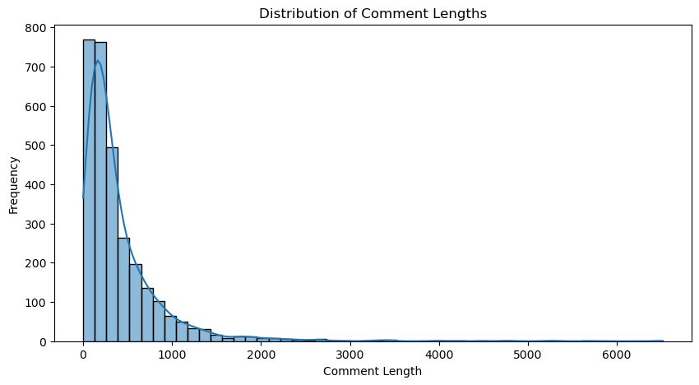

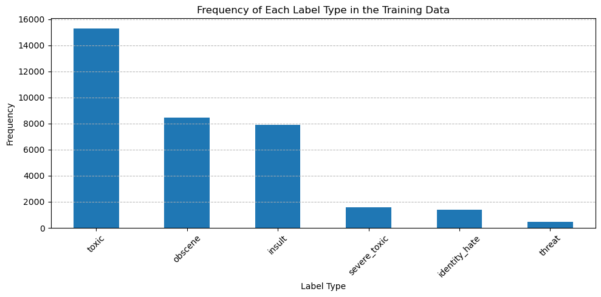

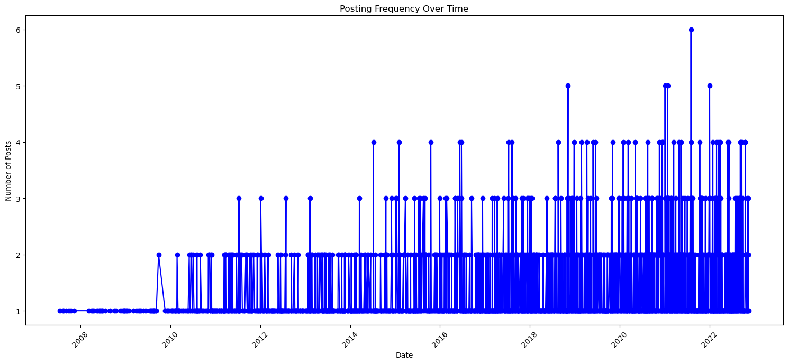

**Distribution of toxicity depending of the comment length (%)**

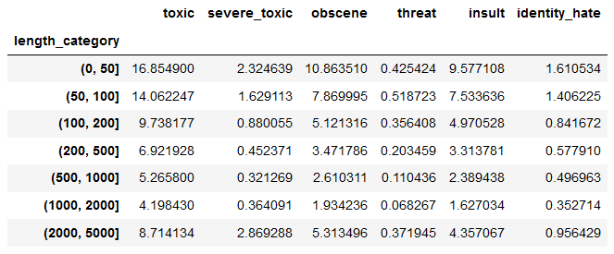

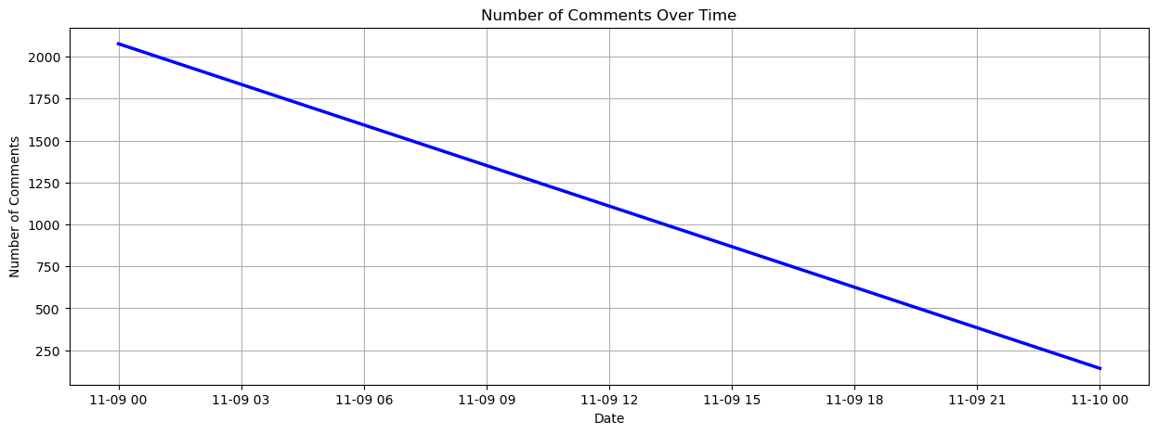

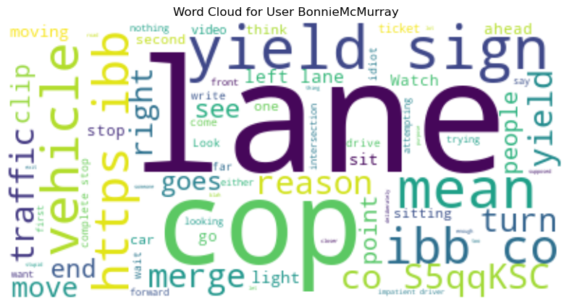

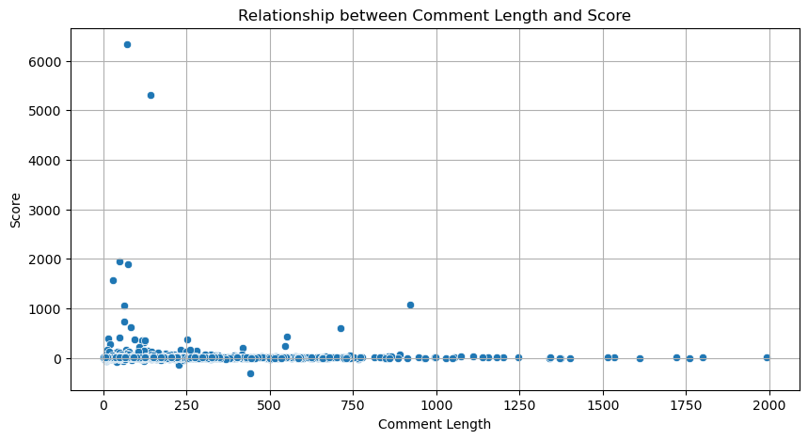

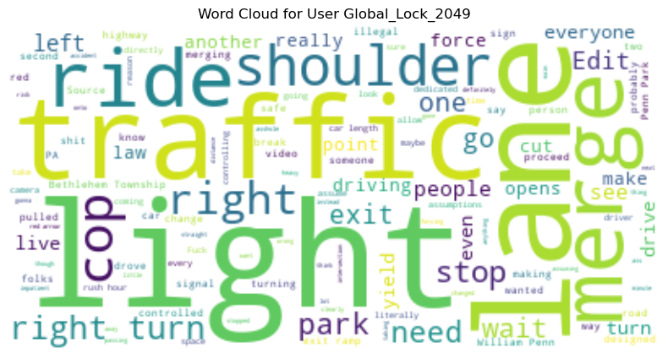

# **Data base type selection**

For this project, MySQL was the database of choice due to its excellent capability to handle structured data, which is abundant in social media commentary. Its relational nature allows me to define clear data schemas, making the organization and retrieval of data more straightforward. Additionally, MySQL's scalability means that as my data grows, the database can efficiently grow with it, which is crucial given the vast amount of comments collected.

MySQL also guarantees the integrity of my data with its transactional support. This is particularly important when integrating multiple data sources, as it ensures consistency throughout the datasets. The security features are top-notch, a non-negotiable aspect when dealing with potentially sensitive user data.

Lastly, the widespread community support and integration with numerous tools and languages streamline the process from data storage to analysis. MySQL's robustness, coupled with its ability to integrate seamlessly into the analytics pipeline, makes it an indispensable tool for my analysis.

# **Entities. ERD**

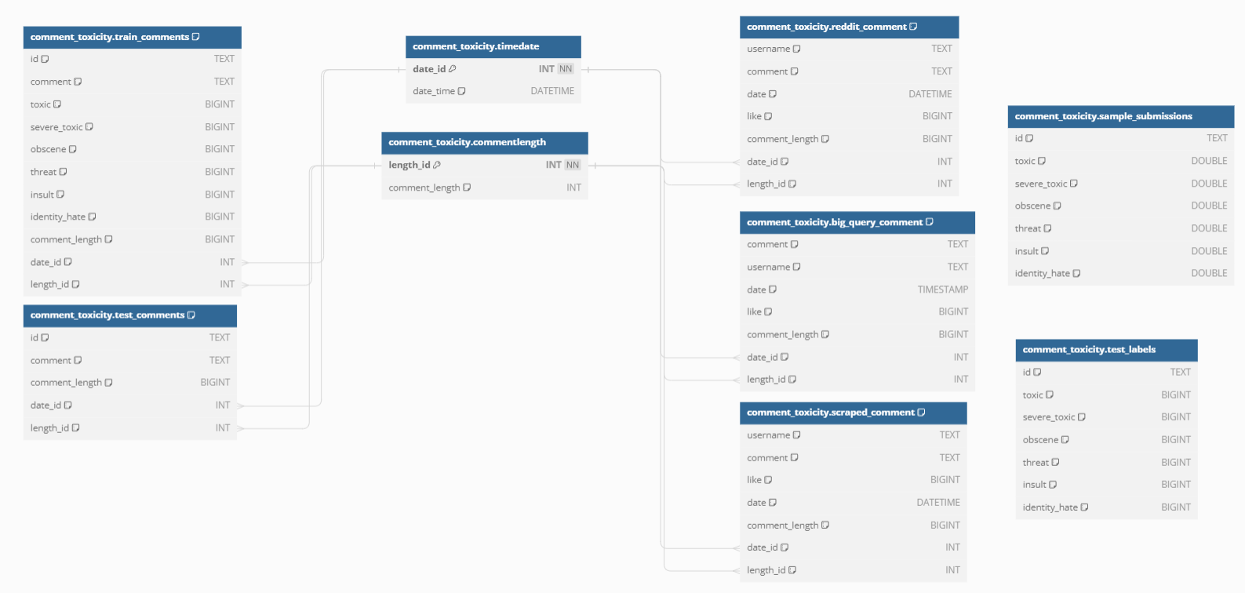

# **Database’s Queries**

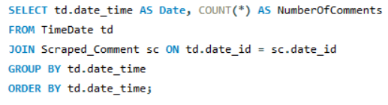

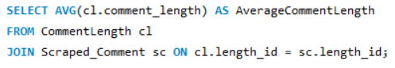

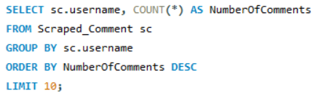

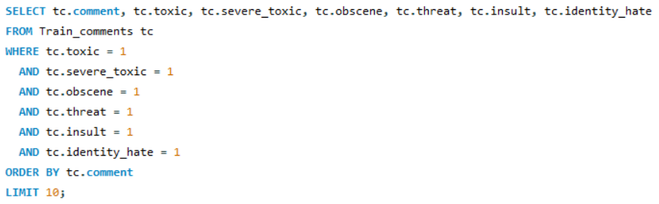

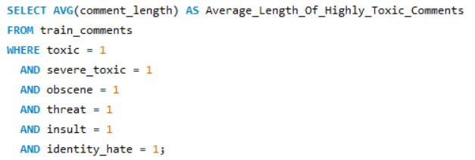

# **Database’s Queries – Outputs**

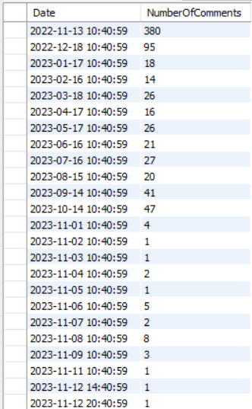

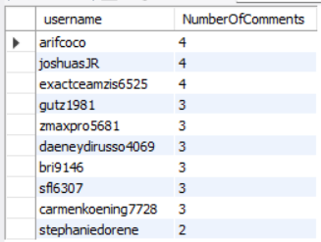 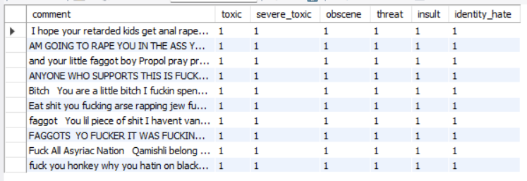



# **Exposing Data via API**

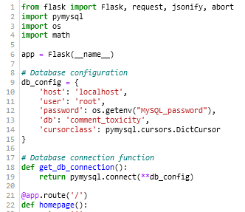

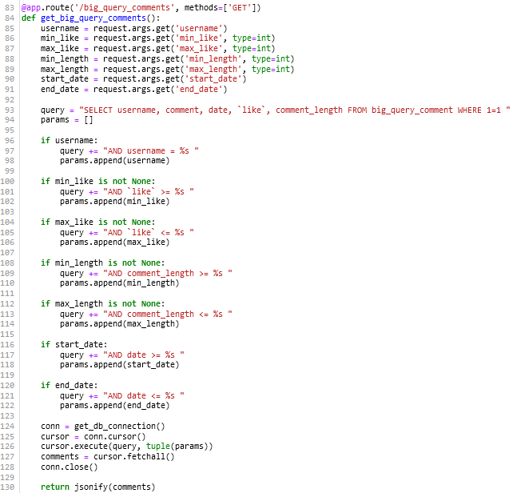

# **API – Homepage**

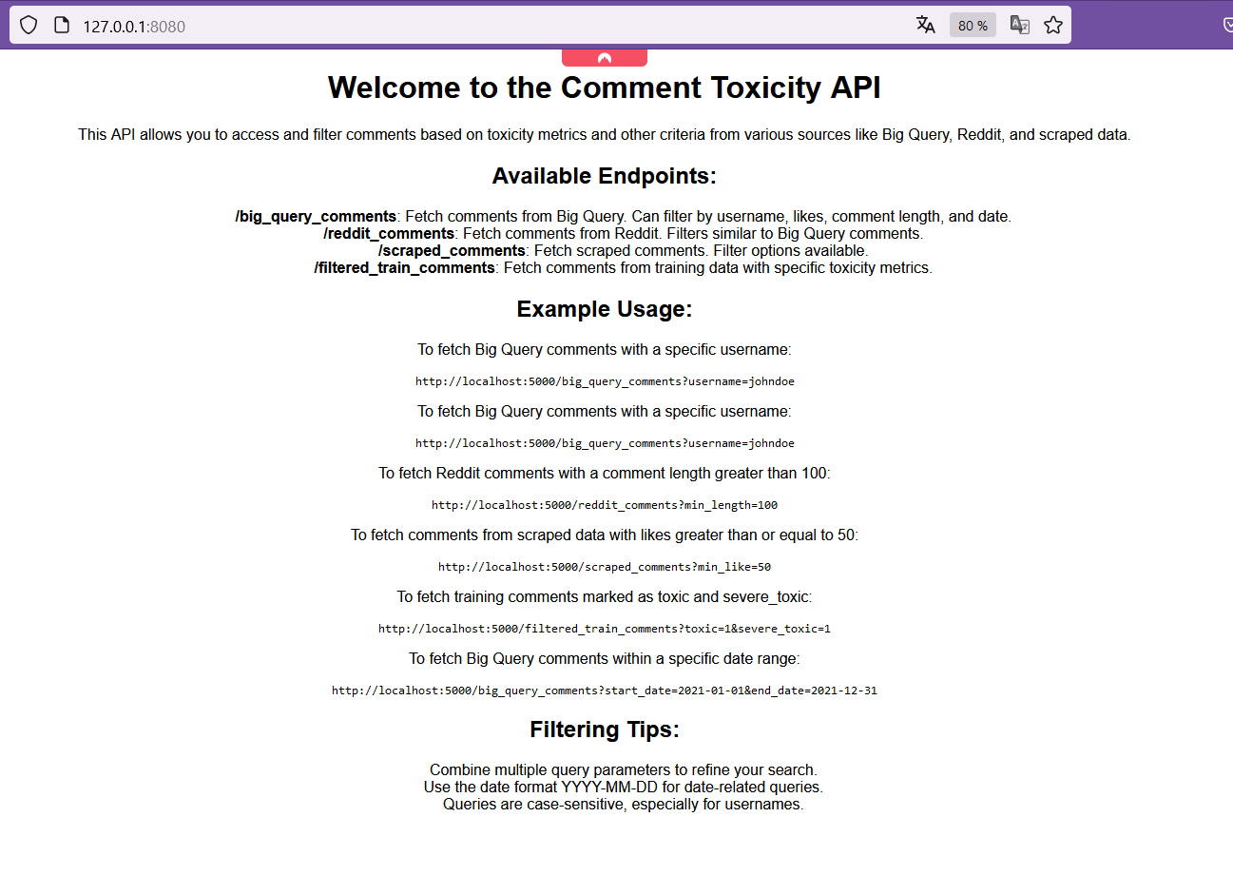

# **Challenges**

Throughout this project, I encountered a number of challenges that tested my skills and determination:

1. **Web Scraping with Selenium**: Grasping the inner workings of the ChromeDriver alongside the Selenium library for web scraping was initially daunting. It took considerable effort to understand the nuances of interacting with web elements and automating the extraction process efficiently.
2. **API Authentication Issues**: I faced a frustrating hurdle with the Reddit API when my environment variables for the Client_ID and Secret_ID didn't function as expected. It was a lesson in debugging and securing sensitive information properly within my development environment.
3. **Date Conversion**: One particularly tricky aspect was dealing with relative dates in the data, such as "3 years ago" or "9 months ago." I had to devise a method to convert these into absolute dates to create a usable timeline for my analysis.
4. **Entity-Relationship Model Creation**: Designing the ER model to accurately represent the data was intricate, especially when adding tables like DateID and CommentLengthID. It was essential to establish meaningful relationships between tables to support comprehensive queries and insights.
5. **Refreshing HTML and CSS Skills**: Finally, building the homepage for the Flask API required me to revisit and refresh my knowledge of HTML and CSS. It was a challenge to get back up to speed and ensure the front-end design was both functional and aesthetically pleasing.

These challenges were demanding, but overcoming them has significantly improved my technical abilities and problem-solving acumen. Each obstacle was an opportunity for growth, and mastering these areas was immensely satisfying and added depth to my expertise.

# **References**

**Links:**

[**https://www.youtube.com/watch?v=kuhhT_cBtFU&t=2s**](https://www.youtube.com/watch?v=kuhhT_cBtFU&t=2s)

[**https://www.youtube.com/watch?v=v3abZ4aAGUU**](https://www.youtube.com/watch?v=v3abZ4aAGUU)

[**https://www.reddit.com/r/funny/comments/17r7lh2/was_he_impatient_or_does_he_have_a_point/?onetap_auto=true**](https://www.reddit.com/r/funny/comments/17r7lh2/was_he_impatient_or_does_he_have_a_point/?onetap_auto=true)

[**Jigsaw Toxic Comment Classification Challenge**](https://www.kaggle.com/c/jigsaw-toxic-comment-classification-challenge)

[**https://console.cloud.google.com/bigquery?p=bigquery-public-data&d=hacker_news&page=dataset&project=da-bootcamp-2023**](https://console.cloud.google.com/bigquery?p=bigquery-public-data&d=hacker_news&page=dataset&project=da-bootcamp-2023)

**TRELLO:**

[**https://trello.com/b/eUwdijbo/final-project**](https://trello.com/b/eUwdijbo/final-project)

**GITHUB:**

[**https://github.com/GuillaumeCapelli/Final_Project**](https://github.com/GuillaumeCapelli/Final_Project)

**THANK YOU**