Riga Technical University

Business Informatics

Laboratory work

Spatial database

Advanced Data Technologies

Lecturer: Ainars Auzins

Students: Janis Laizans

2011

Contents

Map consist of 3

Database structure 3

Screenshots from database graphical output 4

Data 5

Building 5

Building_info 5

River 5

Trees 6

Road 6

Bridges 6

Select the objects which are in defined rectangle 7

Find the 2 nearest trees from Bath and show the distance. 8

Find the nearest building from swimming pool and show the distance and show room info. 8

Find the nearest bridge from swimming pool and show the distance. 9

# Map consist of

1. River - 1
2. Pool - 1
3. Buildings - 4
4. Trees - 7
5. Bridges – 2
6. Road (1 roundabout)

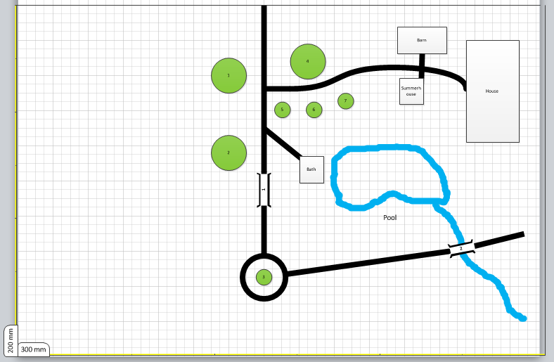

# Database structure



# Screenshots from database graphical output

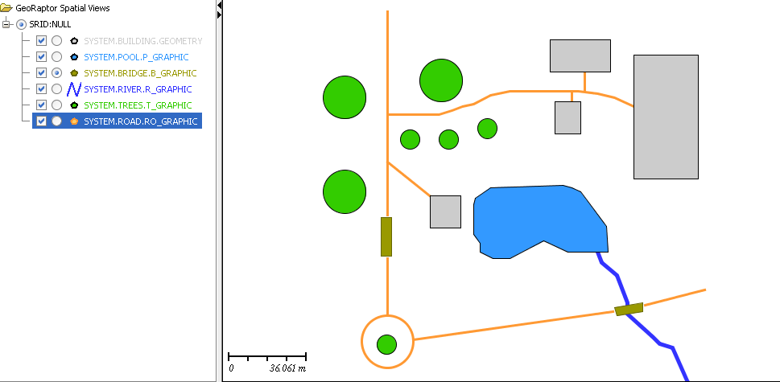

# Data

## Building

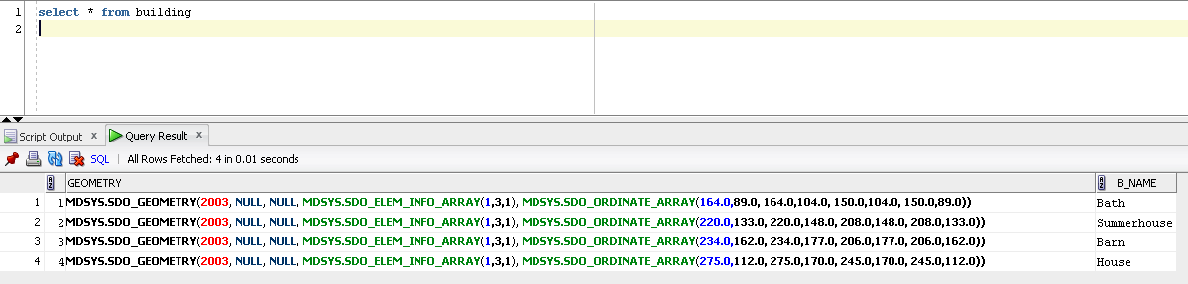

Building_info

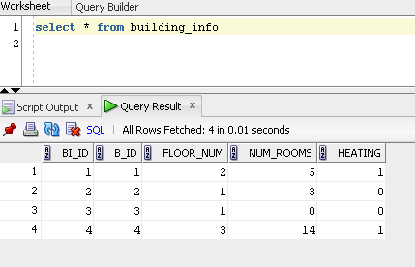

River

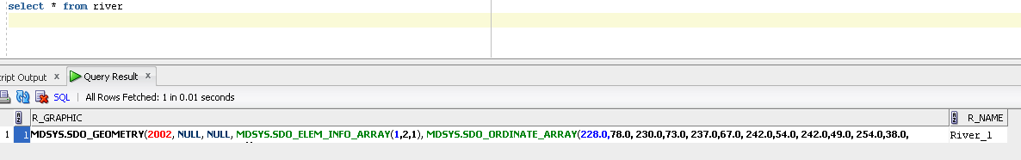

## Trees

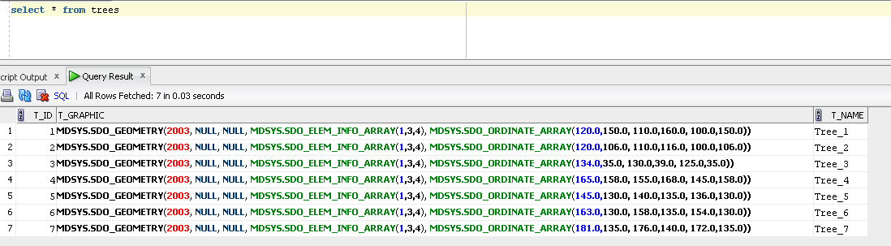

## Road

## 

## Bridges

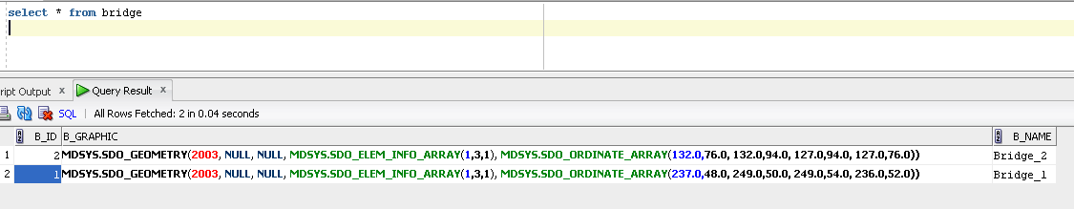

## 

# Select the objects which are in defined rectangle

*Select t_id,t_graphic,t_name*

*From trees*

*Where mdsys.sdo_anyinteract(t_graphic, mdsys.sdo_geometry(2003, null, null,*

*mdsys.sdo_elem_info_array(1,3,3),*

*mdsys.sdo_ordinate_array(135,140, 185,122))) = 'TRUE'*

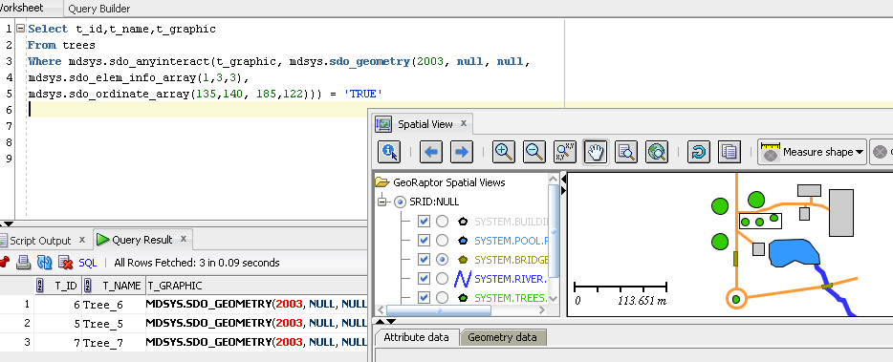

# Find the 2 nearest trees from Bath and show the distance.

*Select t_id, t_name, mdsys.sdo_nn_distance(1) as distance*

*From trees, building*

*Where b_id='1' and t_name in ('Tree_1','Tree_2','Tree_3' ,'Tree_4' ,'Tree_5' ,'Tree_6', 'Tree_7')*

*and mdsys.sdo_nn(t_graphic, geometry, 'sdo_num_res=2',1) = 'TRUE'*

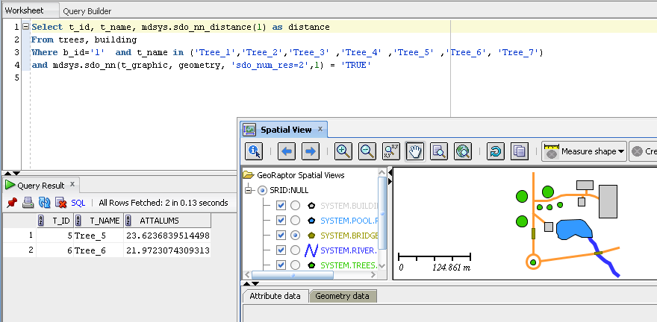

# Find the nearest building from swimming pool and show the distance and show room info.

*Select p_id, p_name,b.b_name, bi.floor_num, bi.num_rooms,mdsys.sdo_nn_distance(1) as distance*

*From pool, building b*

*left join building_info bi*

*on b.b_id=bi.b_id*

*Where p_id='1' and b.b_name in ('Bath' , 'Summerhouse', 'Barn', 'House')*

*and mdsys.sdo_nn(b.geometry, p_graphic, 'sdo_num_res=1',1) = 'TRUE'*

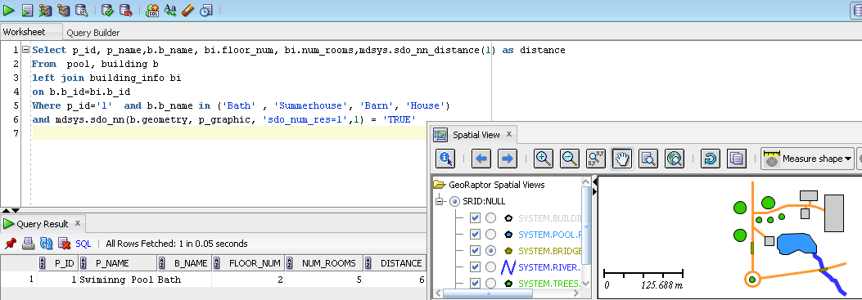

# Find the nearest bridge from swimming pool and show the distance.

*Select b_id, b_name,p_name, mdsys.sdo_nn_distance(1) as distance*

*From pool, bridge*

*Where p_id='1' and p_name in ('Swiminng Pool')*

*and mdsys.sdo_nn(b_graphic,p_graphic, 'sdo_num_res=1',1) = 'TRUE'*

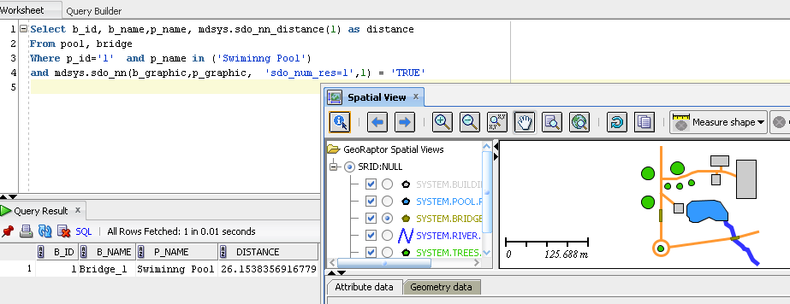

**Query to determine all the object are located in or close to 20 units away from the bath.**

*select p_name*

*from building, pool*

*where b_id=1 and mdsys.sdo_within_distance(geometry, p_graphic, ' distance=20' )= 'True'*

