**RIGA TECHNICAL UNIVERSITY**

**Faculty of computer science and information technology**

**Master’s Programme in Business Informatics**



**Laboratory works**

**6-9**

in course „Advanced Data Bases”

**Author:** Laima Genava

**Student’s card number:** 061RIB034

**Checked:** Ainars Auzins

2013

Content

1. Image for processing 3

2. Layers 3

3. Creation of tables 4

4. Metadata 6

5. Data insertion in tables 7

5.1. Data insertion in tables with command INSERT 8

5.2. Data insertion in tables with SQL*Loader 15

6. Creation of indexes 23

7. Queries 24

7.1. 2 queries with SDO_FILTER 24

7.2. 3 queries working with distance 26

7.3. 3 queries finding objects with certain type of interactions 28

8. Data visualization 30

# Image for processing

For laboratory works the author has drawn the image (Figure 1.) The image consists from buildings, trees, ponds, trails, flowerbeds, lanterns and forest.

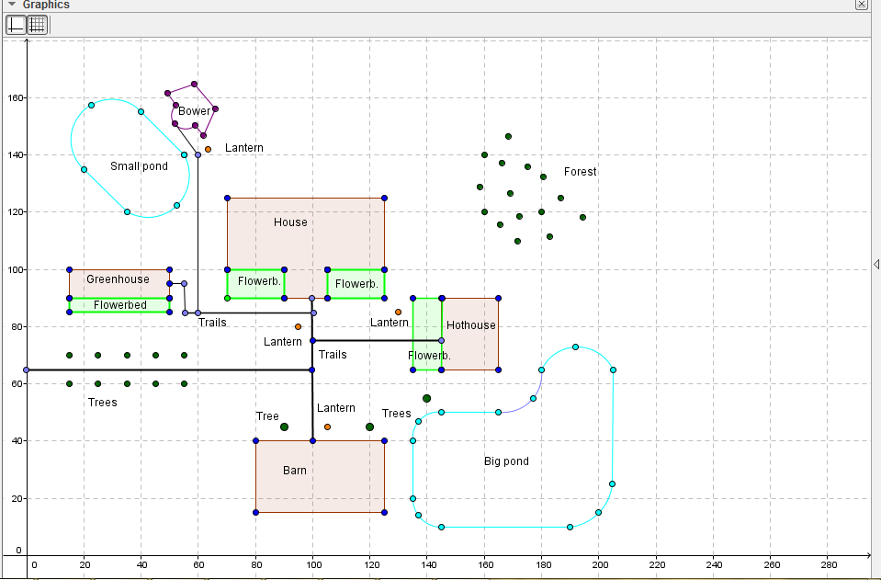

Figure 1. Image for laboratory works

# Layers

Figure 1 is divided into 7 layers. Each layer consists of several objects:

1. Trails which connects buildings.
2. Buildings: House, greenhouse, hothouse, barn, bower.
3. Trees: 13 trees.
4. Ponds: two ponds - Big and small.
5. Flowerbeds: 4 flowerbeds.
6. Lanterns – 4
7. Forest trees.

# Creation of tables

For each layer there was created table for data storage, in each table there is GEOM column with type MDSYS.SDO_GEOMETRY. In this column is stored data about objects geometry. For all tables there are connections to other tables, where are stored additional data about object's attributes. Data base structure is shown in Figure 2. Data base consists of 13 tables, 7 tables stores graphical data for layers, and in 6 tables are stored additional data for objects’ attributes.

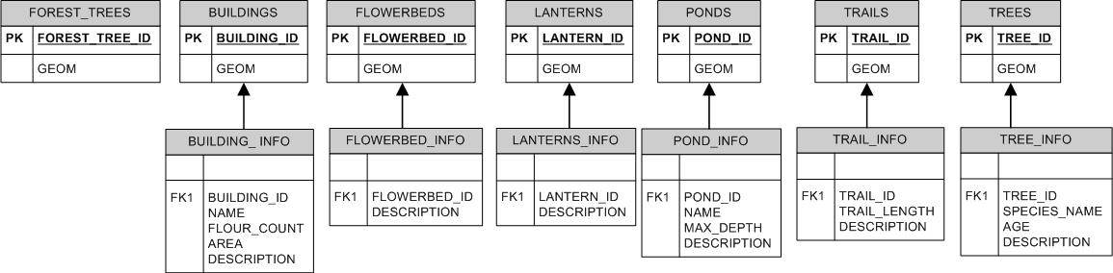

Figure 2. Data base structure

***Images from print screen for table creation are not given because of the scope of the work.***

* Buildings

*In the table Buildings the data is stored about all buildings in this country estate (Building layer)*

CREATE TABLE BUILDINGS

(

BUILDING_ID NUMBER PRIMARY KEY

,GEOM MDSYS.SDO_GEOMETRY

);

*In table Building_info is stored information about building name, floor count, area and description of building.*

CREATE TABLE BUILDING_INFO

(

BUILDING_ID NUMBER NOT NULL REFERENCES BUILDINGS (BUILDING_ID)

,NAME VARCHAR2(256) NOT NULL

,FLOOR_COUNT NUMBER

,AREA NUMBER

,DESCRIPTION VARCHAR2(4000)

);

* Ponds

*In the table Ponds the data is stored about all ponds in this country estate (Ponds layer)*

CREATE TABLE PONDS

(

POND_ID NUMBER PRIMARY KEY

,GEOM MDSYS.SDO_GEOMETRY

);

*In table Pond_info is stored information about pond’s name, maximal depth, and description of pond.*

CREATE TABLE POND_INFO

(

POND_ID NUMBER NOT NULL REFERENCES PONDS (POND_ID)

,NAME VARCHAR2(256) NOT NULL

,MAX_DEPTH NUMBER

,DESCRIPTION VARCHAR2(4000)

);

* Trees

*In the table Trees the data is stored about all trees in this country estate (Trees layer)*

CREATE TABLE TREES

(

TREE_ID NUMBER PRIMARY KEY

,GEOM MDSYS.SDO_GEOMETRY

);

*In table Trees_info is stored information about trees’s species name, age, and description of tree.*

CREATE TABLE TREE_INFO

(

TREE_ID NUMBER NOT NULL REFERENCES TREES (TREE_ID)

,SPECIES_NAME VARCHAR2(256) NOT NULL

,AGE NUMBER

,DESCRIPTION VARCHAR2(4000)

);

* Trails

*In the table Trails the data is stored about all trails in this country estate (Trails layer)*

CREATE TABLE TRAILS

(

TRAIL_ID NUMBER PRIMARY KEY

,GEOM MDSYS.SDO_GEOMETRY

);

*In table Trail_info is stored information about trails’ length, and description of trails.*

CREATE TABLE TRAIL_INFO

(

TRAIL_ID NUMBER NOT NULL REFERENCES TRAILS (TRAIL_ID)

,TRAIL_LENGTH VARCHAR2(256)

,DESCRIPTION VARCHAR2(4000)

);

* Flowerbeds

*In the table Flowerbeds the data is stored about all flowerbeds in this country estate (Flowerbeds layer)*

CREATE TABLE FLOWERBEDS

(

FLOWERBED_ID NUMBER PRIMARY KEY

,GEOM MDSYS.SDO_GEOMETRY

);

*In table Flowerbed_info is stored information about description of flowerbeds.*

CREATE TABLE FLOWERBED_INFO

(

FLOWERBED_ID NUMBER NOT NULL REFERENCES FLOWERBEDS (FLOWERBED_ID)

,DESCRIPTION VARCHAR2(4000)

);

* Lanterns

*In the table Lanterns the data is stored about all lanterns in this country estate (Lanterns layer)*

CREATE TABLE LANTERNS

(

LANTERN_ID NUMBER PRIMARY KEY

,GEOM MDSYS.SDO_GEOMETRY

);

*In table Lanterns_info is stored information about description of lanterns.*

CREATE TABLE LANTERNS_INFO

(

LANTERN_ID NUMBER NOT NULL REFERENCES LANTERNS (LANTERN_ID)

,DESCRIPTION VARCHAR2(4000)

);

* Forest

*In the table Forest_trees the data is stored about forest in this country estate (Forest_trees layer)*

CREATE TABLE FOREST_TREES

(

FOREST_TREE_ID NUMBER PRIMARY KEY

,GEOM MDSYS.SDO_GEOMETRY

);

# Metadata

After the tables of layers are created, there is a necessity to insert metadata. Metadata are stored in USER_SDO_GEOM_METADATA. Metadata describes ordinate system of layers. This ordinate system has two dimensions X (must define Xmin and Xmax, and accuracy) and Y (must define Ymin and Ymax, and accuracy). Metadata was created for 7 tables - Buildings, Ponds, Trees, Trails, Flowerbeds, Lanterns and Forest_trees.

***Images from print screen for metadata creation are not given because of the scope of the work.***

* *Buildings table*

INSERT INTO USER_SDO_GEOM_METADATA (TABLE_NAME,COLUMN_NAME,DIMINFO,SRID)

VALUES ('BUILDINGS','GEOM',MDSYS.SDO_DIM_ARRAY(MDSYS.SDO_DIM_ELEMENT('X',0,250,1),MDSYS.SDO_DIM_ELEMENT('Y',0,250,1)),NULL);

* *Trees table*

INSERT INTO USER_SDO_GEOM_METADATA (TABLE_NAME,COLUMN_NAME,DIMINFO,SRID)

VALUES ('TREES','GEOM',MDSYS.SDO_DIM_ARRAY(MDSYS.SDO_DIM_ELEMENT('X',0,250,1),MDSYS.SDO_DIM_ELEMENT('Y',0,250,1)),NULL);

* *Ponds table*

INSERT INTO USER_SDO_GEOM_METADATA (TABLE_NAME,COLUMN_NAME,DIMINFO,SRID)

VALUES ('PONDS','GEOM',MDSYS.SDO_DIM_ARRAY(MDSYS.SDO_DIM_ELEMENT('X',0,250,1),MDSYS.SDO_DIM_ELEMENT('Y',0,250,1)),NULL);

* *Trails table*

INSERT INTO USER_SDO_GEOM_METADATA (TABLE_NAME,COLUMN_NAME,DIMINFO,SRID)

VALUES ('TRAILS','GEOM',MDSYS.SDO_DIM_ARRAY(MDSYS.SDO_DIM_ELEMENT('X',0,250,1),MDSYS.SDO_DIM_ELEMENT('Y',0,250,1)),NULL);

* *Flowerbeds table*

INSERT INTO USER_SDO_GEOM_METADATA (TABLE_NAME,COLUMN_NAME,DIMINFO,SRID)

VALUES ('FLOWERBEDS','GEOM',MDSYS.SDO_DIM_ARRAY(MDSYS.SDO_DIM_ELEMENT('X',0,250,1),MDSYS.SDO_DIM_ELEMENT('Y',0,250,1)),NULL);

* *Lanterns table*

INSERT INTO USER_SDO_GEOM_METADATA (TABLE_NAME,COLUMN_NAME,DIMINFO,SRID)

VALUES ('LANTERNS','GEOM',MDSYS.SDO_DIM_ARRAY(MDSYS.SDO_DIM_ELEMENT('X',0,250,1),MDSYS.SDO_DIM_ELEMENT('Y',0,250,1)),NULL);

* *Forest_trees table*

INSERT INTO USER_SDO_GEOM_METADATA (TABLE_NAME,COLUMN_NAME,DIMINFO,SRID)

VALUES ('FOREST_TREES','GEOM',MDSYS.SDO_DIM_ARRAY(MDSYS.SDO_DIM_ELEMENT('X',0,250,1),MDSYS.SDO_DIM_ELEMENT('Y',0,250,1)),NULL);

# Data insertion in tables

Data was inserted with Insert command and with SQL*Loader.

## Data insertion in tables with command INSERT

***Images from print screen for data insertion in tables and creation of sequences are not given because of the scope of the work.***

*First was created sequences for all tables*

CREATE SEQUENCE BUILDINGS_SEQ;

CREATE SEQUENCE TRAILS_SEQ;

CREATE SEQUENCE TREES_SEQ;

CREATE SEQUENCE PONDS_SEQ;

CREATE SEQUENCE FLOWERBEDS_SEQ;

CREATE SEQUENCE LANTERNS_SEQ;

*Then I inserted data into tables*

***Buildings***

* *House.* MDSYS.SDO_GEOMETRY(2003,NULL,NULL – shows that it is a polygon geometry type in 2D (two dimensions). MDSYS.SDO_ELEM_INFO_ARRAY(1,3,1) shows that it is a polygon with straight lines. MDSYS.SDO_ORDINATE_ARRAY shows ordinates.

INSERT INTO BUILDINGS (BUILDING_ID,GEOM)

VALUES (BUILDINGS_SEQ.NEXTVAL

,MDSYS.SDO_GEOMETRY(

2003,NULL,NULL

,MDSYS.SDO_ELEM_INFO_ARRAY(1,3,1)

,MDSYS.SDO_ORDINATE_ARRAY(90,90, 105,90, 105,100, 125,100, 125,125, 70,125, 70,100, 90,100, 90,90))

);

* *Barn.* MDSYS.SDO_GEOMETRY(2003,NULL,NULL – shows that it is a polygon geometry type in 2D (two dimensions). MDSYS.SDO_ELEM_INFO_ARRAY(1,3,3) shows that it is an optimized rectangle. MDSYS.SDO_ORDINATE_ARRAY shows ordinates for two points.

INSERT INTO BUILDINGS (BUILDING_ID,GEOM)

VALUES (BUILDINGS_SEQ.NEXTVAL,MDSYS.SDO_GEOMETRY(2003,NULL,NULL

,MDSYS.SDO_ELEM_INFO_ARRAY(1,3,3)

,MDSYS.SDO_ORDINATE_ARRAY(80,15, 125,40))

);

* *Hothouse.* MDSYS.SDO_GEOMETRY(2003,NULL,NULL – shows that it is a polygon geometry type in 2D (two dimensions). MDSYS.SDO_ELEM_INFO_ARRAY(1,3,3) shows that it is an optimized rectangle. MDSYS.SDO_ORDINATE_ARRAY shows ordinates for two points.

INSERT INTO BUILDINGS (BUILDING_ID,GEOM)

VALUES (BUILDINGS_SEQ.NEXTVAL,MDSYS.SDO_GEOMETRY(2003,NULL,NULL

,MDSYS.SDO_ELEM_INFO_ARRAY(1,3,3)

,MDSYS.SDO_ORDINATE_ARRAY(145,65, 165,90))

);

* *Greenhouse.* MDSYS.SDO_GEOMETRY(2003,NULL,NULL – shows that it is a polygon geometry type in 2D (two dimensions). MDSYS.SDO_ELEM_INFO_ARRAY(1,3,3) shows that it is an optimized rectangle. MDSYS.SDO_ORDINATE_ARRAY shows ordinates for two points.

INSERT INTO BUILDINGS (BUILDING_ID,GEOM)

VALUES (BUILDINGS_SEQ.NEXTVAL,MDSYS.SDO_GEOMETRY(2003,NULL,NULL

,MDSYS.SDO_ELEM_INFO_ARRAY(1,3,3)

,MDSYS.SDO_ORDINATE_ARRAY(15,90, 50,100))

);

* *Bower.* MDSYS.SDO_GEOMETRY(2003,NULL,NULL – shows that it is a polygon geometry type in 2D (two dimensions). MDSYS.SDO_ELEM_INFO_ARRAY(1,5,2, 1,2,2, 5,2,1) shows that it is a compound polygon with straight and circular lines. MDSYS.SDO_ORDINATE_ARRAY shows ordinates.

INSERT INTO BUILDINGS (BUILDING_ID,GEOM)

VALUES (BUILDINGS_SEQ.NEXTVAL,MDSYS.SDO_GEOMETRY(2003,NULL,NULL

,MDSYS.SDO_ELEM_INFO_ARRAY(1,5,2, 1,2,2, 5,2,1)

,MDSYS.SDO_ORDINATE_ARRAY(59,150, 52,151, 52,158, 49,162, 58, 165, 66,156, 62,147, 59,150))

);

***Result:***

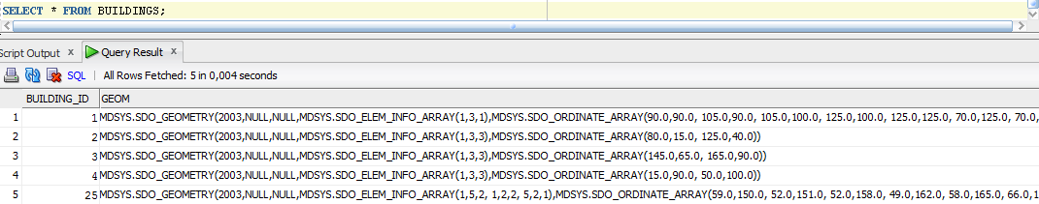

Figure 3. Content of table BUILDINGS

***Flowerbeds***

* *Flowerbeds.* MDSYS.SDO_GEOMETRY(2003,NULL,NULL – shows that it is a polygon geometry type in 2D (two dimensions). MDSYS.SDO_ELEM_INFO_ARRAY(1,3,3) shows that it is an optimized rectangle. MDSYS.SDO_ORDINATE_ARRAY shows ordinates for two points.

INSERT INTO FLOWERBEDS (FLOWERBED_ID,GEOM)

VALUES (FLOWERBEDS_SEQ.NEXTVAL,MDSYS.SDO_GEOMETRY(2003,NULL,NULL

,MDSYS.SDO_ELEM_INFO_ARRAY(1,3,3)

,MDSYS.SDO_ORDINATE_ARRAY(15,85, 50,90))

);

INSERT INTO FLOWERBEDS (FLOWERBED_ID,GEOM)

VALUES (FLOWERBEDS_SEQ.NEXTVAL,MDSYS.SDO_GEOMETRY(2003,NULL,NULL

,MDSYS.SDO_ELEM_INFO_ARRAY(1,3,3)

,MDSYS.SDO_ORDINATE_ARRAY(70,90, 90,100))

);

INSERT INTO FLOWERBEDS (FLOWERBED_ID,GEOM)

VALUES (FLOWERBEDS_SEQ.NEXTVAL,MDSYS.SDO_GEOMETRY(2003,NULL,NULL

,MDSYS.SDO_ELEM_INFO_ARRAY(1,3,3)

,MDSYS.SDO_ORDINATE_ARRAY(105,90, 125,100))

);

INSERT INTO FLOWERBEDS (FLOWERBED_ID,GEOM)

VALUES (FLOWERBEDS_SEQ.NEXTVAL,MDSYS.SDO_GEOMETRY(2003,NULL,NULL

,MDSYS.SDO_ELEM_INFO_ARRAY(1,3,3)

,MDSYS.SDO_ORDINATE_ARRAY(135,65, 145,90))

);

***Result***

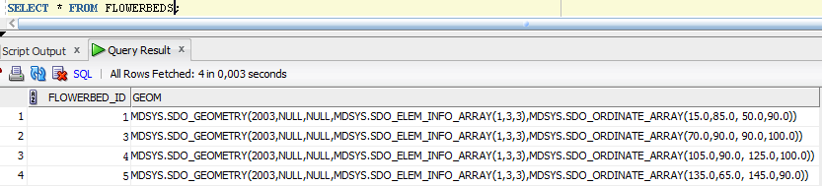

Figure 4. Content of table FLOWERBEDS

***Trees***

* *Trees.* MDSYS.SDO_GEOMETRY(2001,NULL,– shows that it is a point geometry type in 2D (two dimensions). MDSYS.SDO_POINT_TYPE(15,70,NULL) shows ordinates for point.

INSERT INTO TREES (TREE_ID,GEOM)

VALUES (TREES_SEQ.NEXTVAL,MDSYS.SDO_GEOMETRY(2001,NULL

,MDSYS.SDO_POINT_TYPE(15,70,NULL)

,NULL,NULL)

);

INSERT INTO TREES (TREE_ID,GEOM)

VALUES (TREES_SEQ.NEXTVAL,MDSYS.SDO_GEOMETRY(2001,NULL

,MDSYS.SDO_POINT_TYPE(25,70,NULL)

,NULL,NULL)

);

INSERT INTO TREES (TREE_ID,GEOM)

VALUES (TREES_SEQ.NEXTVAL,MDSYS.SDO_GEOMETRY(2001,NULL

,MDSYS.SDO_POINT_TYPE(35,70,NULL)

,NULL,NULL)

);

INSERT INTO TREES (TREE_ID,GEOM)

VALUES (TREES_SEQ.NEXTVAL,MDSYS.SDO_GEOMETRY(2001,NULL

,MDSYS.SDO_POINT_TYPE(45,70,NULL)

,NULL,NULL)

);

INSERT INTO TREES (TREE_ID,GEOM)

VALUES (TREES_SEQ.NEXTVAL,MDSYS.SDO_GEOMETRY(2001,NULL

,MDSYS.SDO_POINT_TYPE(55,70,NULL)

,NULL,NULL)

);

INSERT INTO TREES (TREE_ID,GEOM)

VALUES (TREES_SEQ.NEXTVAL,MDSYS.SDO_GEOMETRY(2001,NULL

,MDSYS.SDO_POINT_TYPE(15,60,NULL)

,NULL,NULL)

);

INSERT INTO TREES (TREE_ID,GEOM)

VALUES (TREES_SEQ.NEXTVAL,MDSYS.SDO_GEOMETRY(2001,NULL

,MDSYS.SDO_POINT_TYPE(25,60,NULL)

,NULL,NULL)

);

INSERT INTO TREES (TREE_ID,GEOM)

VALUES (TREES_SEQ.NEXTVAL,MDSYS.SDO_GEOMETRY(2001,NULL

,MDSYS.SDO_POINT_TYPE(35,60,NULL)

,NULL,NULL)

);

INSERT INTO TREES (TREE_ID,GEOM)

VALUES (TREES_SEQ.NEXTVAL,MDSYS.SDO_GEOMETRY(2001,NULL

,MDSYS.SDO_POINT_TYPE(45,60,NULL)

,NULL,NULL)

);

INSERT INTO TREES (TREE_ID,GEOM)

VALUES (TREES_SEQ.NEXTVAL,MDSYS.SDO_GEOMETRY(2001,NULL

,MDSYS.SDO_POINT_TYPE(55,60,NULL)

,NULL,NULL)

);

INSERT INTO TREES (TREE_ID,GEOM)

VALUES (TREES_SEQ.NEXTVAL,MDSYS.SDO_GEOMETRY(2001,NULL

,MDSYS.SDO_POINT_TYPE(140,55,NULL)

,NULL,NULL)

);

INSERT INTO TREES (TREE_ID,GEOM)

VALUES (TREES_SEQ.NEXTVAL,MDSYS.SDO_GEOMETRY(2001,NULL

,MDSYS.SDO_POINT_TYPE(90,45,NULL)

,NULL,NULL)

);

INSERT INTO TREES (TREE_ID,GEOM)

VALUES (TREES_SEQ.NEXTVAL,MDSYS.SDO_GEOMETRY(2001,NULL

,MDSYS.SDO_POINT_TYPE(120,45,NULL)

,NULL,NULL)

);

***Result***

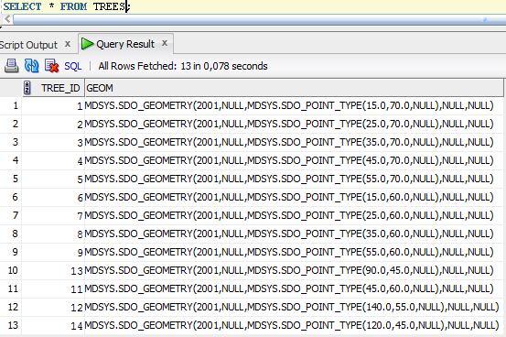

Figure 5. Content of table TREES

***Trails***

* *Trails.* MDSYS.SDO_GEOMETRY(2002,NULL,NULL – shows that it is a line geometry type in 2D (two dimensions). MDSYS.SDO_ELEM_INFO_ARRAY(1,2,1) shows that it is a simple line element. MDSYS.SDO_ORDINATE_ARRAY shows ordinates for trails.

INSERT INTO TRAILS (TRAIL_ID,GEOM)

VALUES (TRAILS_SEQ.NEXTVAL,MDSYS.SDO_GEOMETRY(2002,NULL,NULL

,MDSYS.SDO_ELEM_INFO_ARRAY(1,2,1)

,MDSYS.SDO_ORDINATE_ARRAY(0,65, 100,65))

);

INSERT INTO TRAILS (TRAIL_ID,GEOM)

VALUES (TRAILS_SEQ.NEXTVAL,MDSYS.SDO_GEOMETRY(2002,NULL,NULL

,MDSYS.SDO_ELEM_INFO_ARRAY(1,2,1)

,MDSYS.SDO_ORDINATE_ARRAY(100,40, 100,90))

);

INSERT INTO TRAILS (TRAIL_ID,GEOM)

VALUES (TRAILS_SEQ.NEXTVAL,MDSYS.SDO_GEOMETRY(2002,NULL,NULL

,MDSYS.SDO_ELEM_INFO_ARRAY(1,2,1)

,MDSYS.SDO_ORDINATE_ARRAY(50,95, 55,95, 55,85, 100,85))

);

INSERT INTO TRAILS (TRAIL_ID,GEOM)

VALUES (TRAILS_SEQ.NEXTVAL,MDSYS.SDO_GEOMETRY(2002,NULL,NULL

,MDSYS.SDO_ELEM_INFO_ARRAY(1,2,1)

,MDSYS.SDO_ORDINATE_ARRAY(100,75, 145,75))

);

INSERT INTO TRAILS (TRAIL_ID,GEOM)

VALUES (TRAILS_SEQ.NEXTVAL,MDSYS.SDO_GEOMETRY(2002,NULL,NULL

,MDSYS.SDO_ELEM_INFO_ARRAY(1,2,1)

,MDSYS.SDO_ORDINATE_ARRAY(60,85, 60,140, 52,151))

);

***Result***

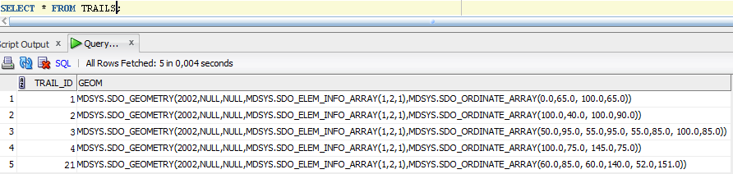

Figure 6. Content of table TRAILS

***Ponds***

* *Ponds.* MDSYS.SDO_GEOMETRY(2003,NULL,NULL – shows that it is a polygon geometry type in 2D (two dimensions). MDSYS.SDO_ELEM_INFO_ARRAY shows that it is a compound polygon with some vertices connected by straight line segments and some by circular arcs. MDSYS.SDO_ORDINATE_ARRAY shows ordinates for ponds.
* *Big pond*

INSERT INTO PONDS (POND_ID,GEOM)

VALUES (PONDS_SEQ.NEXTVAL,MDSYS.SDO_GEOMETRY(2003,NULL,NULL

,MDSYS.SDO_ELEM_INFO_ARRAY(1,5,8, 1,2,1, 3,2,2, 7,2,1, 9,2,2, 17,2,1, 19,2,2, 23,2,1, 25,2,2)

,MDSYS.SDO_ORDINATE_ARRAY(135,20, 135,40, 137,47, 145,50, 165,50, 177,55, 180,65, 192,73, 205,65, 205,25, 200,15, 190,10, 145,10, 137,14, 135,20))

);

* *Small pond*

INSERT INTO PONDS (POND_ID,GEOM)

VALUES (PONDS_SEQ.NEXTVAL,MDSYS.SDO_GEOMETRY(2003,NULL,NULL

,MDSYS.SDO_ELEM_INFO_ARRAY(1,5,4, 1,2,1, 3,2,2, 7,2,1, 9,2,2)

,MDSYS.SDO_ORDINATE_ARRAY(35,120, 20,135, 22.5,157.5, 40,155, 55,140, 52.5,122.5, 35,120))

);

***Result***

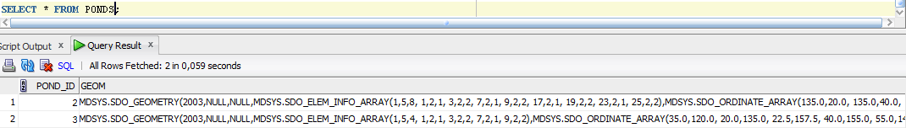

Figure 7. Content of table PONDS

***Lanterns***

* *Lanterns.* MDSYS.SDO_GEOMETRY(2001,NULL,– shows that it is a point geometry type in 2D (two dimensions). MDSYS.SDO_POINT_TYPE(15,70,NULL) shows ordinates for point.

INSERT INTO LANTERNS (LANTERN_ID,GEOM)

VALUES (LANTERNS_SEQ.NEXTVAL,MDSYS.SDO_GEOMETRY(2001,NULL

,MDSYS.SDO_POINT_TYPE(130,85,NULL)

,NULL,NULL)

);

INSERT INTO LANTERNS (LANTERN_ID,GEOM)

VALUES (LANTERNS_SEQ.NEXTVAL,MDSYS.SDO_GEOMETRY(2001,NULL

,MDSYS.SDO_POINT_TYPE(95,80,NULL)

,NULL,NULL)

);

INSERT INTO LANTERNS (LANTERN_ID,GEOM)

VALUES (LANTERNS_SEQ.NEXTVAL,MDSYS.SDO_GEOMETRY(2001,NULL

,MDSYS.SDO_POINT_TYPE(105,45,NULL)

,NULL,NULL)

);

INSERT INTO LANTERNS (LANTERN_ID,GEOM)

VALUES (LANTERNS_SEQ.NEXTVAL,MDSYS.SDO_GEOMETRY(2001,NULL

,MDSYS.SDO_POINT_TYPE(63,142,NULL)

,NULL,NULL)

);

***Result***

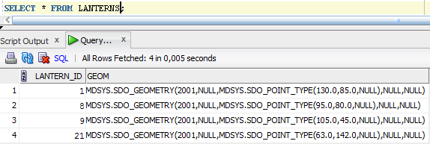

Figure 8. Content of table LANTERNS

## Data insertion in tables with SQL*Loader

SQL*Loader – is a program for data insertion into data base. With SQL * Loader help the data will be inserted into tables FOREST_TREES, BUILDING_INFO, POND_INFO, TREE_INFO, TRAIL_INFO, FLOWERBED_INFO, LANTERNS_INFO.

* ***FOREST_TREES***

The content of control file forest_trees.ctl is shown in figure 9.

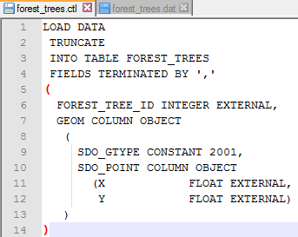

Figure 9. Control file

In the file Forest_trees.dat are shown data that will be inserted in the table FOREST_TREES.

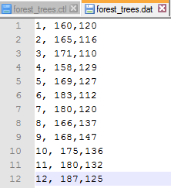

Figure 10. Data for table FOREST_TREES

After the forest_trees.dat and forest_trees.ctl were created, then from the command line the SQL* Loader was started.

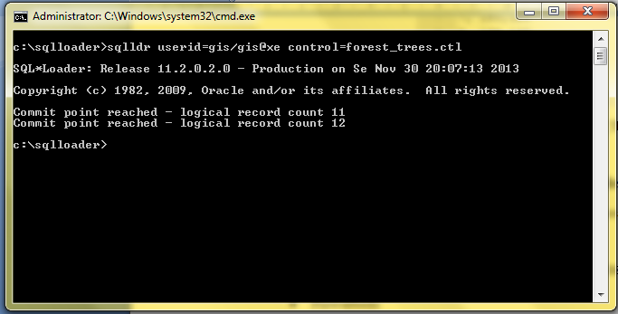

Figure 11. Data entry with SQL * Loader

To check if all data is loaded correctly, I wrote a query:

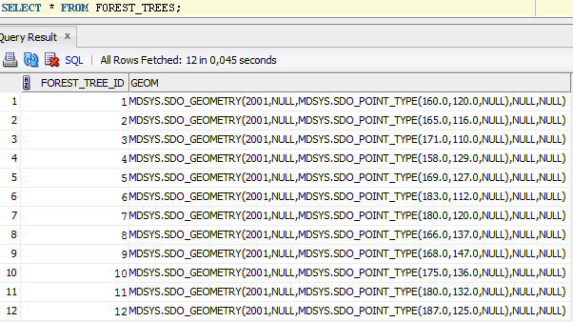

Figure 12. Content of table Forest_trees

* ***BUILDING_INFO***

The content of control file building_info.ctl is shown in figure 13.

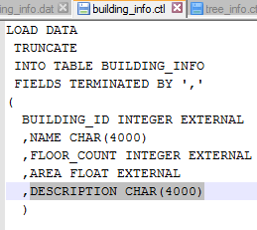

Figure 13. Control file building_info.ctl

In the file building_info.dat are shown data that will be inserted in the table BUILDING_INFO.

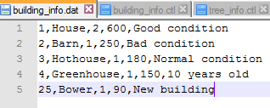

Figure 14. Data for table BUILDINGS_INFO

After the building_info.ctl and building_info.dat were created, then from the command line the SQL* Loader was started.

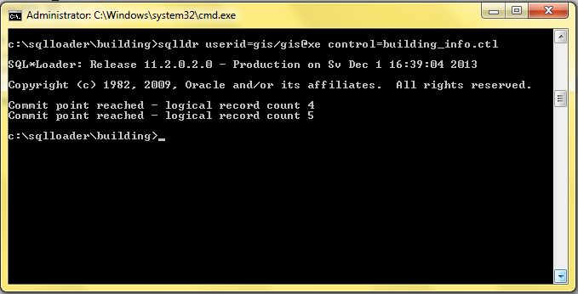

Figure 15. Data entry with SQL * Loader

To check if all data is loaded correctly, I wrote a query:

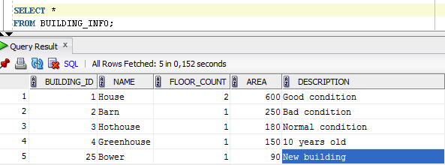

Figure 16. Content of table BUILDING_INFO

* ***LANTERS_INFO***

The content of control file lanterns_info.ctl is shown in figure 17.

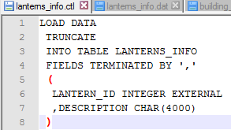

Figure 17. Control file lanterns_info.ctl

In the file lanterns_info.dat are shown data that will be inserted in the table LANTERNS_INFO.

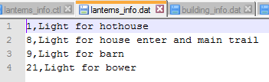

Figure 18. Data for table LANTERNS_INFO

After the lanterns_info.ctl and lanterns_info.dat were created, then from the command line the SQL* Loader was started.

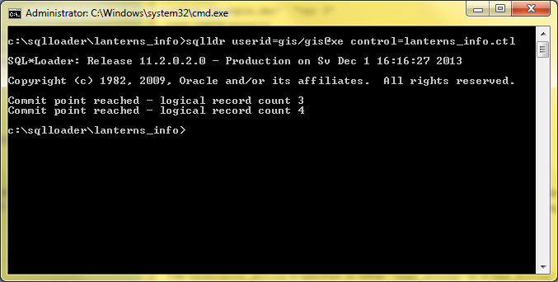

Figure 19. Data entry with SQL * Loader

To check if all data is loaded correctly, I wrote a query:

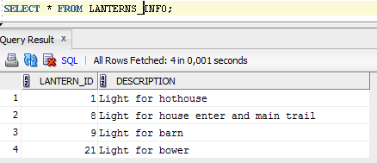

Figure 20. Content of table LANTERNS_INFO

* ***FLOWERBED_INFO***

The content of control file flowerbed_info.ctl is shown in figure 21.

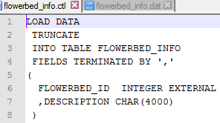

Figure 21. Control file flowerbed_info.ctl

In the file flowerbed_info.dat are shown data that will be inserted in the table FLOWERBED_INFO.

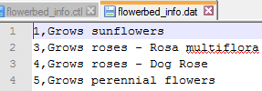

Figure 22. Data for table FLOWERBED_INFO

After the flowerbed_info.ctl and flowerbed _info.dat were created, then from the command line the SQL* Loader was started.

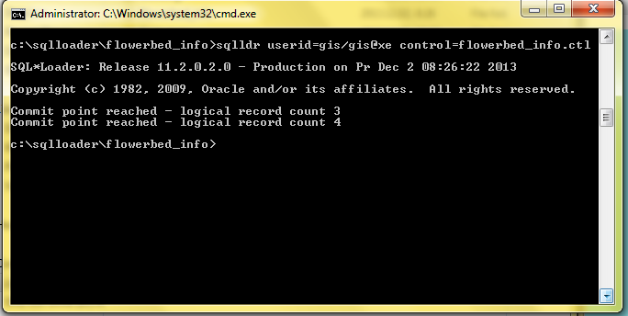

Figure 23. Data entry with SQL * Loader

To check if all data is loaded correctly, I wrote a query:

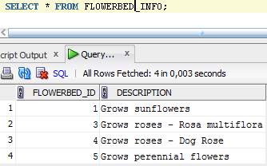

Figure 24. Content of table FLOWERBED_INFO

* ***TRAIL_INFO***

The content of control file trail_info.ctl is shown in figure 25.

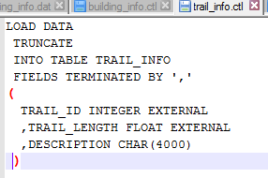

Figure 25. Control file trail_info.ctl

In the file trail_info.dat are shown data that will be inserted in the table TRAIL_INFO.

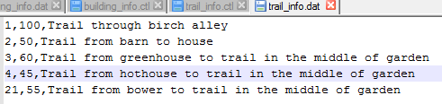

Figure 26. Data for table TRAIL_INFO

After the trail_info.ctl and trail _info.dat were created, then from the command line the SQL* Loader was started.

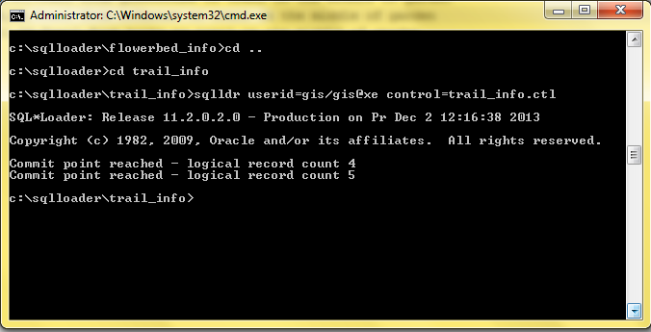

Figure 27. Data entry with SQL * Loader

To check if all data is loaded correctly, I wrote a query:

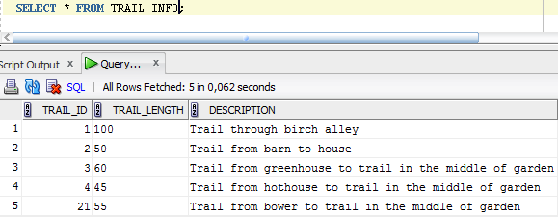

Figure 28. Content of table TRAIL_INFO

* ***TREE_INFO***

The content of control file tree_info.ctl is shown in figure 29.

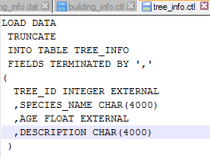

Figure 29. Control file tree_info.ctl

In the file tree_info.dat are shown data that will be inserted in the table TREE_INFO.

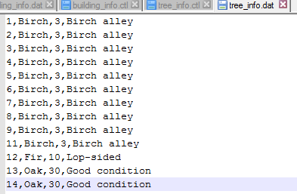

Figure 30. Data for table TREE_INFO

After the tree_info.ctl and tree _info.dat were created, then from the command line the SQL* Loader was started.

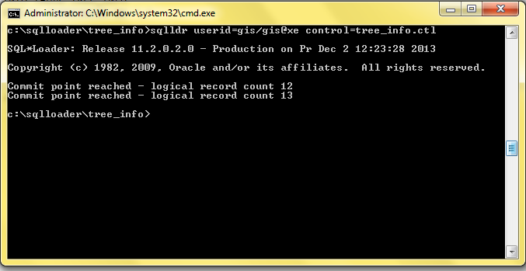

Figure 31. Data entry with SQL * Loader

To check if all data is loaded correctly, I wrote a query:

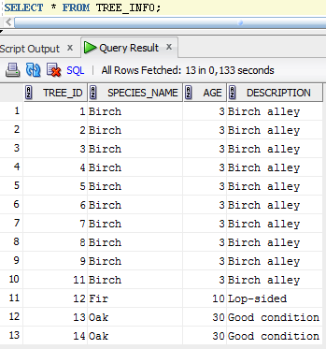

Figure 32. Content of table TREE_INFO

* ***POND_INFO***

The content of control file pond_info.ctl is shown in figure 33.

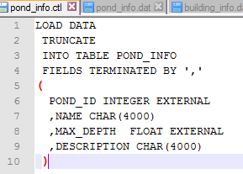

Figure 33. Control file pond_info.ctl

In the file pond_info.dat are shown data that will be inserted in the table POND_INFO.



Figure 34. Data for table POND_INFO

After the pond_info.ctl and pond _info.dat were created, then from the command line the SQL* Loader was started.

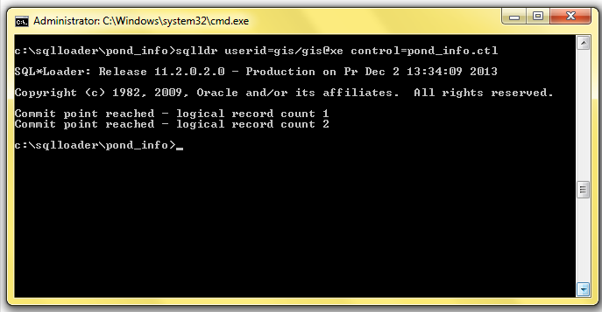

Figure 35. Data entry with SQL * Loader

To check if all data is loaded correctly, I wrote a query:

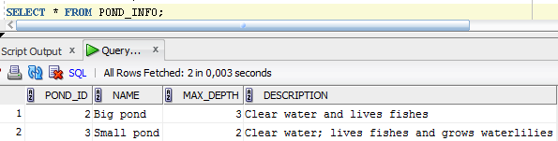

Figure 36. Content of table POND_INFO

# Creation of indexes

***Images from print screen for creation of indexes are not given because of the scope of the work.***

To increase the search effectiveness, there is an option to create indexes:

* Buildings

CREATE INDEX BUILDINGS_GEOM_IDX ON BUILDINGS(GEOM) INDEXTYPE IS MDSYS.SPATIAL_INDEX;

* Flowerbeds

CREATE INDEX FLOWERBEDS_GEOM_IDX ON FLOWERBEDS(GEOM) INDEXTYPE IS MDSYS.SPATIAL_INDEX;

* Trails

CREATE INDEX TRAILS_GEOM_IDX ON TRAILS(GEOM) INDEXTYPE IS MDSYS.SPATIAL_INDEX;

* Ponds

CREATE INDEX PONDS_GEOM_IDX ON PONDS(GEOM) INDEXTYPE IS MDSYS.SPATIAL_INDEX;

* Trees

CREATE INDEX TREES_GEOM_IDX ON TREES(GEOM) INDEXTYPE IS MDSYS.SPATIAL_INDEX;

* Lanterns

CREATE INDEX LANTERNS_GEOM_IDX ON LANTERNS(GEOM) INDEXTYPE IS MDSYS.SPATIAL_INDEX;

* Forest_trees

CREATE INDEX FOREST_TREES_GEOM_IDX ON FOREST_TREES(GEOM) INDEXTYPE IS MDSYS.SPATIAL_INDEX;

*Created Indexes’ metadata:*

SELECT INDEX_NAME, TABLE_NAME, COLUMN_NAME, SDO_INDEX_TYPE

FROM ALL_SDO_INDEX_INFO;

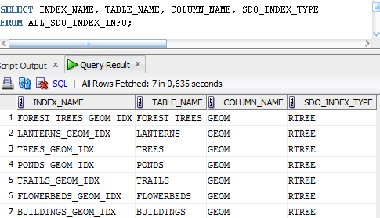

Figure 37. Indexes metadata

# Queries

## 2 queries with SDO_FILTER

***1 using one layer and constant query window***

Select objects from building layer in ordinates (1,1; 1,103; 103,1; 103,103).

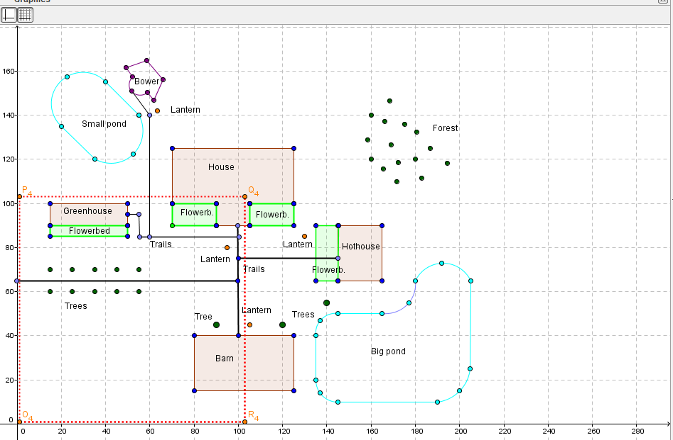

Figure 38. Objects from building layer

***SQL Query:***

SELECT B.BUILDING_ID, BI.NAME

FROM BUILDINGS B

JOIN BUILDING_INFO BI ON BI.BUILDING_ID = B.BUILDING_ID

WHERE SDO_FILTER(B.GEOM, MDSYS.SDO_GEOMETRY(2003,NULL,NULL,

MDSYS.SDO_ELEM_INFO_ARRAY(1,1003,3),

MDSYS.SDO_ORDINATE_ARRAY(1,1,103,103)),

'QUERYTYPE=WINDOW') = 'TRUE';

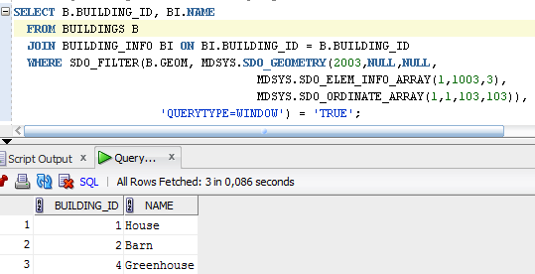

Figure 39. Query result

***1 using two layers - buildings and ponds layers.***

Select objects from building and pond layers in ordinates (1,1; 1,160; 103,1; 103,160).

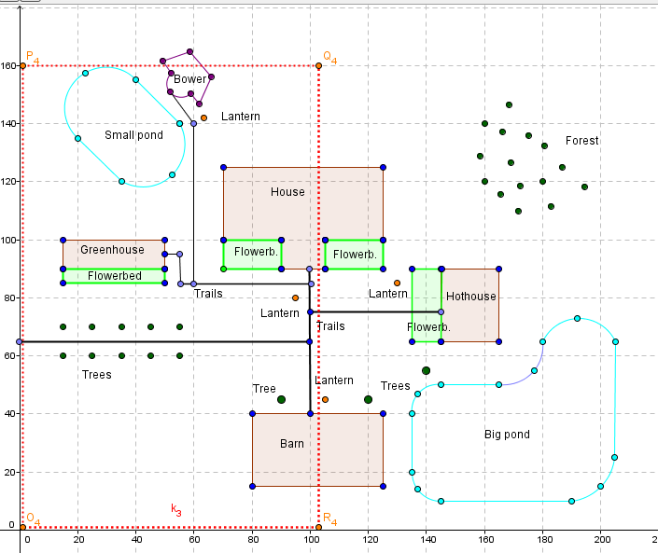

Figure 40. Objects from building and pond layers

***SQL Query:***

SELECT B.BUILDING_ID AS ID_NUMBER, BI.NAME AS OBJECT_NAME

FROM BUILDINGS B

JOIN BUILDING_INFO BI ON BI.BUILDING_ID = B.BUILDING_ID

WHERE SDO_FILTER(B.GEOM, MDSYS.SDO_GEOMETRY(2003,NULL,NULL,

MDSYS.SDO_ELEM_INFO_ARRAY(1,1003,3),

MDSYS.SDO_ORDINATE_ARRAY(1,1,103,160)),

'QUERYTYPE=WINDOW') = 'TRUE'

UNION SELECT P.POND_ID AS ID_NUMBER, PI.NAME AS OBJECT_NAME

FROM PONDS P

JOIN POND_INFO PI ON PI.POND_ID = P.POND_ID

WHERE SDO_FILTER(P.GEOM, MDSYS.SDO_GEOMETRY(2003,NULL,NULL,

MDSYS.SDO_ELEM_INFO_ARRAY(1,1003,3),

MDSYS.SDO_ORDINATE_ARRAY(1,1,103,160)),

'QUERYTYPE=WINDOW') = 'TRUE';

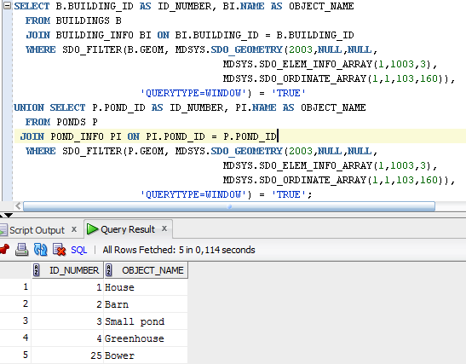

Figure 41. Query result

## 3 queries working with distance

***Finding the closest neighbors*** –Find and order buildings by distance. The point from which the distance must be measured is (70,50)

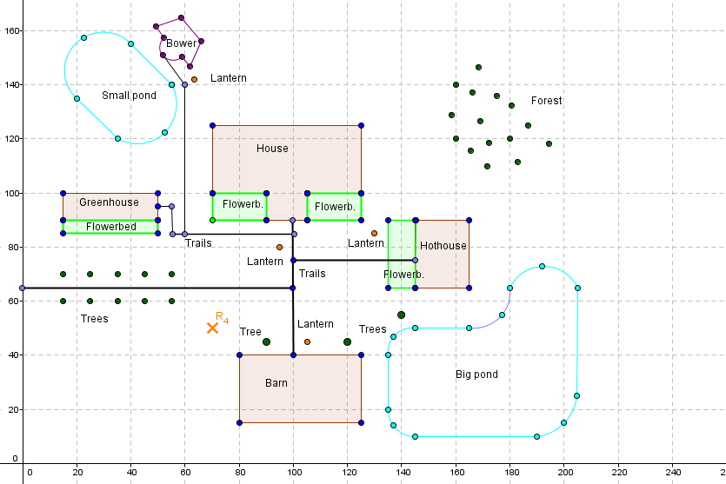

Figure 42. R4 measure distance to closest buildings

SELECT

B.BUILDING_ID, BI.NAME,

ROUND(MDSYS.SDO_NN_DISTANCE(1),1) DIST

FROM BUILDINGS B

JOIN BUILDING_INFO BI ON BI.BUILDING_ID = B.BUILDING_ID

WHERE SDO_NN(B.GEOM, MDSYS.SDO_GEOMETRY(2001, NULL,

MDSYS.SDO_POINT_TYPE(70,50,NULL), NULL, NULL),

'SDO_NUM_RES=5', 1) = 'TRUE' ORDER BY DIST;

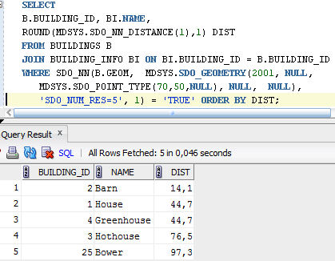

Figure 43. Query result

***Finding objects within distance*** - find objects from coordinates (100,130;100,140;120,140;120,130) within distance 60.

SELECT P.POND_ID, PI.NAME

FROM PONDS P

JOIN POND_INFO PI ON P.POND_ID = PI.POND_ID

WHERE SDO_WITHIN_DISTANCE(P.GEOM, MDSYS.SDO_GEOMETRY(2003,NULL,NULL,

MDSYS.SDO_ELEM_INFO_ARRAY(1,1003,3),

MDSYS.SDO_ORDINATE_ARRAY(100,130,120,140)),

'DISTANCE = 60') = 'TRUE';

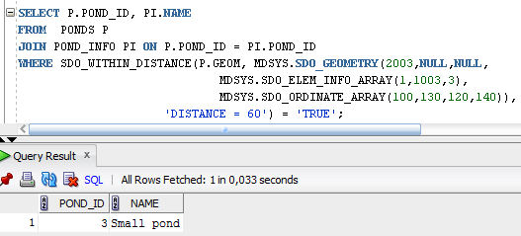

Figure 44. Query result

***Finding distance to the objects found in the previous query***

SELECT P.POND_ID, PI.NAME,

ROUND(MDSYS.SDO_NN_DISTANCE(1),1) DIST

FROM PONDS P

JOIN POND_INFO PI ON PI.POND_ID = P.POND_ID

WHERE SDO_NN(P.GEOM, MDSYS.SDO_GEOMETRY(2003,NULL,NULL,

MDSYS.SDO_ELEM_INFO_ARRAY(1,1003,3),

MDSYS.SDO_ORDINATE_ARRAY(100,130,120,140)),

'SDO_NUM_RES=1', 1) = 'TRUE' ;

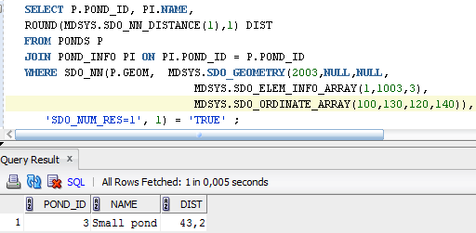

Figure 45. Query result

## 3 queries finding objects with certain type of interactions

* ***Find any interaction in ordinates (85,60; 85,70; 110,60; 110,70) – yellow rectangle.***

-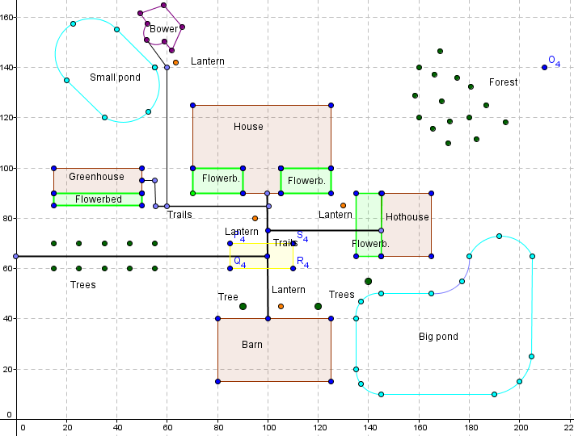

Figure 46. Yellow rectangle and objects from TRAILS table that interacts

SELECT T.TRAIL_ID, TI.TRAIL_LENGTH

FROM TRAILS T

JOIN TRAIL_INFO TI ON T.TRAIL_ID= TI.TRAIL_ID

WHERE SDO_ANYINTERACT(T.GEOM, SDO_GEOMETRY(2003, NULL, NULL,

SDO_ELEM_INFO_ARRAY(1,1003,3), SDO_ORDINATE_ARRAY(85,60, 110,70)) ) = 'TRUE';

-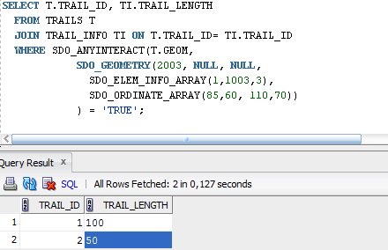

Figure 47. Query result

* ***Select objects from building layer in ordinates (1,1; 1,160; 103,1; 103,160).***

SELECT B.BUILDING_ID AS ID_NUMBER, BI.NAME AS OBJECT_NAME

FROM BUILDINGS B

JOIN BUILDING_INFO BI ON BI.BUILDING_ID = B.BUILDING_ID

WHERE SDO_OVERLAPS(B.GEOM, MDSYS.SDO_GEOMETRY(2003,NULL,NULL,

MDSYS.SDO_ELEM_INFO_ARRAY(1,1003,3),

MDSYS.SDO_ORDINATE_ARRAY(1,1,103,160))

) = 'TRUE';

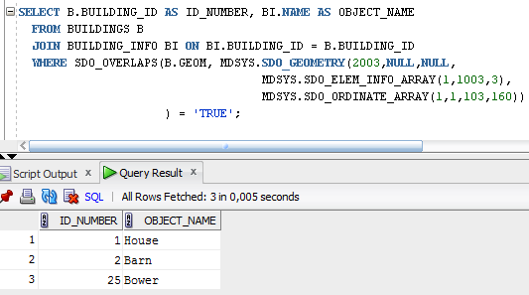

Figure 48. Query result

* ***Select objects from buildings and flowerbeds layers, which interacts.***

SELECT B.BUILDING_ID, BI.NAME, F.FLOWERBED_ID, FI.DESCRIPTION

FROM BUILDINGS B

JOIN BUILDING_INFO BI ON BI.BUILDING_ID = B.BUILDING_ID

JOIN FLOWERBEDS F ON 1=1

JOIN FLOWERBED_INFO FI ON FI.FLOWERBED_ID = F.FLOWERBED_ID

WHERE SDO_RELATE(B.GEOM,F.GEOM,'MASK = ANYINTERACT') = 'TRUE';

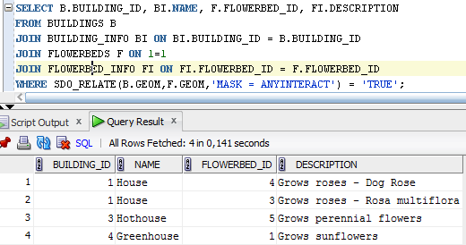

Figure 49. Query result

# Data visualization

For data visualization the Author of this work used GeoRaptor. Each layer was added to tool with the steps, which are shown in figure 50.

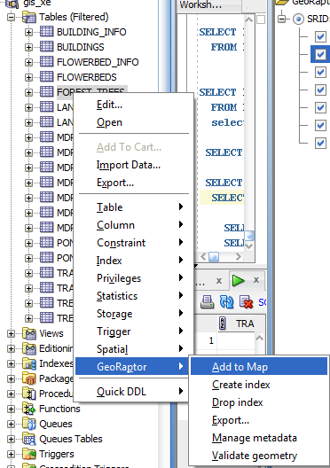

Figure 50. Add new layer to visualization

All layers are shown in figure 51.

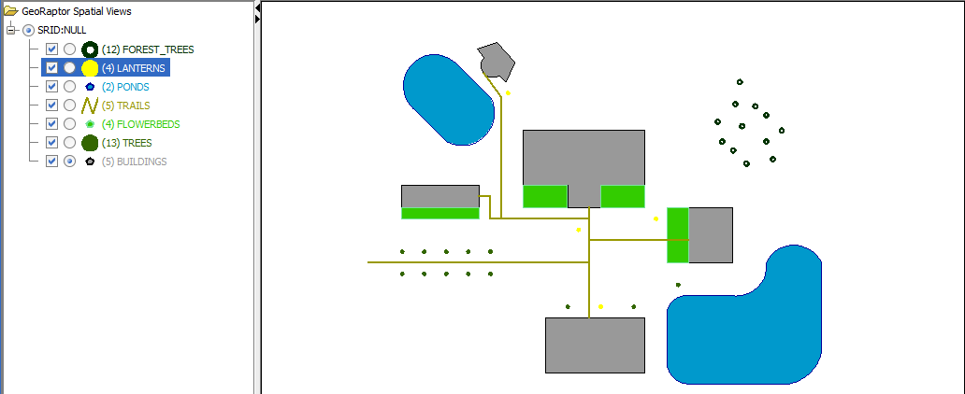

Figure 51. Layers visualization with GeoRaptor

The colors and line thickness can be changed in the way that is shown in figure 52. 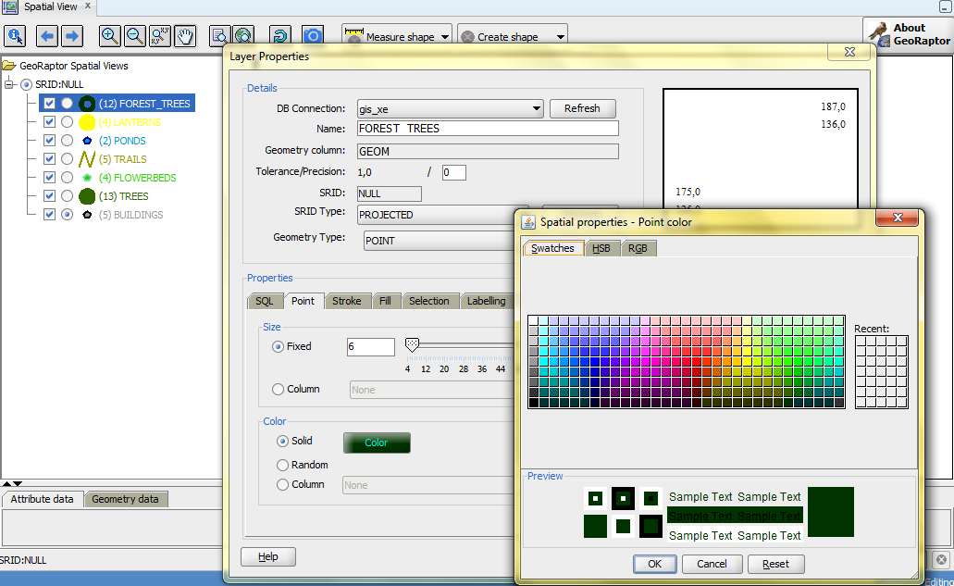

Figure 52. Change properties for objects

This program allows visualizations of only selected layers too, as it is shown in figure 53.

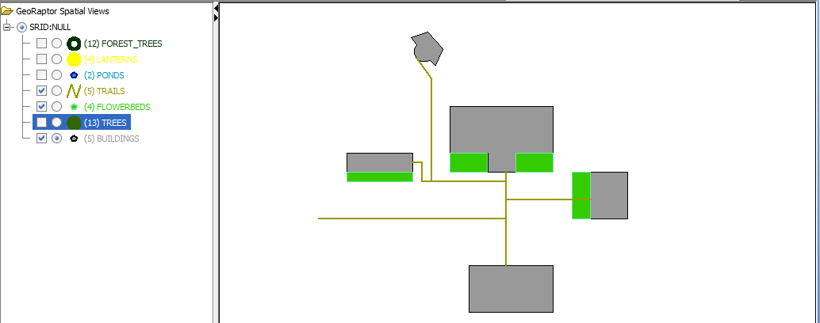

Figure 53. Selected layers visualization

The user has many more options what to do in *GeoRaptor*, but because of the scope of work, the author doesn’t describe these features.