Guillaume Minette de Saint Martin December 2015

Technology of Large Databases



Practical Work 3

Table of contents
Subject 3
Java class creation and loading in database 4
Using LOADJAVA program 4
Using CREATE JAVA command 6
Simple class 6
Complex class 6
Java class meta-data inspection. 10
Creation of PL/SQL function which call Java method. Execution of Java method. 12
Creation of PL/SQL function 12
Execution of the function 12
Creation of PL/SQL package 13
Execution 14
Java class creation, loading and testing for SELECT and INSERT queries realization. 16
Class creation and loading 16
Testing INSERT queries 19
Testing SELECT queries 20
PEOPLE_SELECT(id varchar2) 20
PEOPLE_FORESEE(id varchar2) 21
Observation 23
Conclusions 24
Annexes 25
Table 25
Classes 25
Functions and packages 28
SQL Queries 28

Subject

3. practical work. Java in database (DB1+DB2)
In 3. practical work is discussed use of Java in database server. Deadline: 2. December.
1. Java class creation and loading in database:
1) using LOADJAVA program;
2) using CREATE JAVA command.
2. Java class meta-date inspection (SELECT).
3. Creation of PL/SQL function which call Java method. Execution of Java method.
4. Java class creation, loading and testing for SELECT and INSERT queries realization.
5. Conclusions (what seems good, what bad, what like, what is problematic).

Java class creation and loading in database

Using LOADJAVA program

It is possible to load java classes using LOAD JAVA program. It allows to load into the database, a new java class that is defined in an external file. It is therefore possible to use a java editor to edit this java source file, save modifications and directly reload the file into the database.

Here the file hello.java contains the following “hello” class.
File hello.java
public class hello {
public static String hi(){
return "Hello World";
}
}
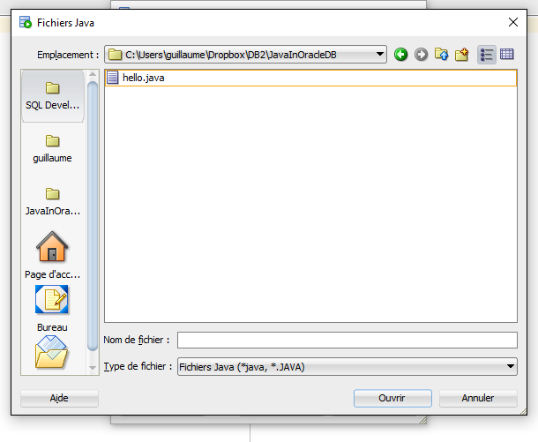

Finally, the hello class is created and available in the database.
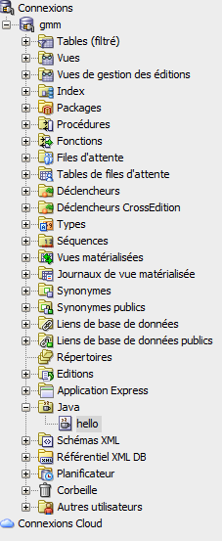

Using CREATE JAVA command

It is possible to create java classes using CREATE JAVA command. In the following sql code, a new java class called hello is created in the database.

Simple class

This class is just an example class, it only has one method and its only purpose is to print in the standard output “Hello World”.

SQL code used to create java class:

create or replace JAVA source named "hello" as
public class hello {
public static String hi(){
return "Hello World";
}
}
;

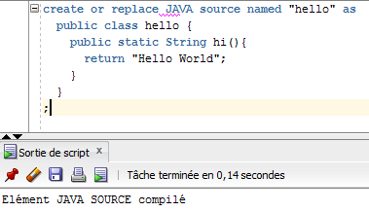

Complex class

The following class: “People” is the class used in the next parts of this project, as we will see later, it allows to insert and select data in the database.

SQL code used to create java class:

create or replace JAVA source named "People" as
import java.sql.*;
import java.io.*;
import java.lang.Math;
import oracle.jdbc.*;
public class People{

private static String someWaysToDie[]={"starving","the next war","a bullet in the head from a crazy guy","a disease","the latvian mafia revenge"};

public static void PeopleInsert (int id, String name, String surname, String education, String way_of_living) throws SQLException {
String sql = "insert into PEOPLE values (?,?,?,?,?,?)";
Connection conn = DriverManager.getConnection("jdbc:default:connection:");
PreparedStatement pstmt = conn.prepareStatement(sql);
pstmt.setInt(1, id);
pstmt.setString(2, name);
pstmt.setString(3, surname);
pstmt.setString(4, education);
pstmt.setString(5, way_of_living);
int lE=computeIE(education,way_of_living);
pstmt.setInt(6, lE);
pstmt.executeUpdate();
pstmt.close();
}

private static int computeIE(String education, String way_of_living){
int iE=generateNumber(50);
if(education.equals("None") || education.equals("")){
iE+=30;
}else if(education.equals("Bachelor")){
iE+=80;
}else if(education.equals("Master")){
iE+=90;
}else if(education.equals("PHD")){
iE+=100;
}else{
iE+=55;
}
if(!way_of_living.equals("Citizen")){
if(way_of_living.equals("Rigan")){
iE+=10;
}else{
iE-=11;
}
}
return iE;
}

private static int generateNumber(int a){
double rand = Math.random()*a;
int i=(int)Math.round(rand);
return i;
}

public static void PeopleForesee(String id) throws SQLException{
String sql="select a.name, a.surname, a.education, a.way_of_living, a.life_expectation from people a where id = ?";
try{
Connection conn = DriverManager.getConnection("jdbc:default:connection:");
PreparedStatement pstmt = conn.prepareStatement(sql);
pstmt.setString(1, id);
ResultSet rrset = pstmt.executeQuery();
foresee(rrset);
rrset.close();
pstmt.close();
}catch(Exception e){System.err.println(e.getMessage());}
}

public static void PeopleSelect(String id) throws SQLException{
String sql="select a.name, a.surname, a.education, a.way_of_living, a.life_expectation from people a where id = ?";
try{
Connection conn = DriverManager.getConnection("jdbc:default:connection:");
PreparedStatement pstmt = conn.prepareStatement(sql);
pstmt.setString(1, id);
ResultSet rrset = pstmt.executeQuery();
display(rrset);
rrset.close();
pstmt.close();
}catch(Exception e){System.err.println(e.getMessage());}
}

private static void display(ResultSet rset) throws SQLException{
String tmp="";
ResultSetMetaData meta = rset.getMetaData();
int cols = meta.getColumnCount(), rows = 0;
for (int i = 1; i <= cols; i++){
int size = meta.getPrecision(i);
String label = meta.getColumnLabel(i);
if (label.length() > size) size = label.length();
while (label.length() < size) label += " ";
tmp = tmp + label + " ";
}
tmp = tmp+ "\n";
while (rset.next()) {
rows++;
for (int i = 1; i <= cols; i++) {
int size = meta.getPrecision(i);
String label = meta.getColumnLabel(i);
String value = rset.getString(i);
if (label.length() > size) size = label.length();
while (value.length() < size) value += " ";
tmp = tmp + value + " ";
}
tmp = tmp + "\n";
}
if (rows == 0) tmp = "No data found!\n";
System.out.println(tmp);
}

private static String getWayToDie(String where){
double rand = Math.random();
int foresee=(int)Math.round(rand*rand*rand*(someWaysToDie.length-1));
if (where.equals("Countryside")){
return someWaysToDie[foresee];
}
return someWaysToDie[someWaysToDie.length-1-foresee];
}

private static void foresee(ResultSet rset) throws SQLException{
String tmp="Here is Nostrudamas the seer ... I can see your future !\n You ";
String[][] vals=new String[6][2];
ResultSetMetaData meta = rset.getMetaData();
int cols = meta.getColumnCount(), rows = 0;
while (rset.next()) {
rows++;
for (int i = 1; i <= cols; i++) {
int size = meta.getPrecision(i);
vals[i-1][0] = meta.getColumnLabel(i);
vals[i-1][1] = rset.getString(i);
}
}
tmp+=vals[0][1]+" "+vals[1][1]+" you will live a ";
if(Integer.parseInt(vals[4][1])>60){
tmp+="long life of "+vals[4][1];
}else{
tmp+="short life of "+vals[4][1];
}
if(vals[3][1].equals("Rigan")){
tmp+=" beautiful years.";
}else{
tmp+=" years.";
}
tmp+=" Finally, you will die beacause of "+getWayToDie(vals[3][1])+".";
if (rows == 0) tmp = "No data found!\n";
System.out.println(tmp);
}
}
;

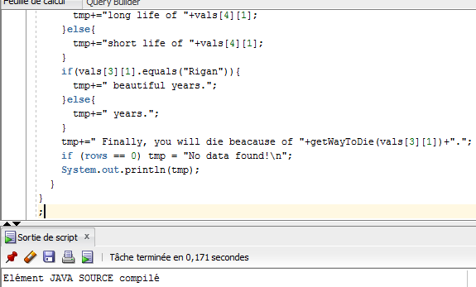

Java class meta-data inspection.

It is possible to select the meta data to check the state of the loaded classes.
For this the table USER_OBJECTS can be used.
In this table, columns OBJECT_NAME, OBJECT_TYPE, STATUS are relevant. The result is only displayed after a date filtering to avoid unneeded information

SQL query

select OBJECT_NAME, OBJECT_TYPE, STATUS
from USER_OBJECTS
where CREATED >= TO_DATE('24-11-2015', 'DD-MM-YYYY');

Output
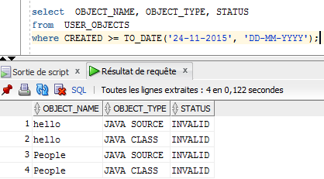
Interpretation
We can notice that the status of the source code and java class is “INVALID”, which is normal because the java classes have just been loaded in the database. It is the default behavior of the oracle database to consider as invalid the java sources and classes as long as they have not been used at least once by a SQL or PL/SQL command.
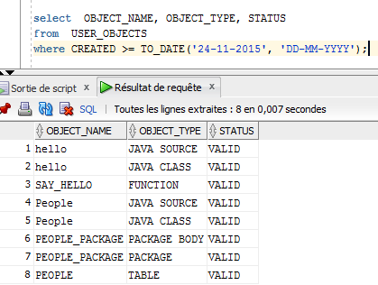
Here we can see the result of the same query after creating and using PL/SQL statements using these classes. Status are now “VALID”, as expected.

Creation of PL/SQL function which call Java method. Execution of Java method.

Creation of PL/SQL function

In order to be able to use the previously created class “hello” and its method, a PL/SQL function is created.

PL/SQL code:
create or replace function say_hello return varchar2 as
language java name 'hello.hi () return java.lang.String';

Output:

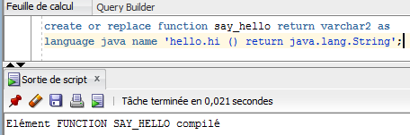

Execution of the function

To execute this function, because it is just a simple output, it is possible to call from the table dual.

SQL query:
select say_hello from dual;

Output:

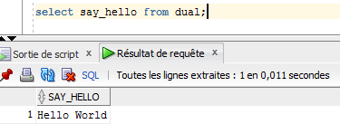

Creation of PL/SQL package

Because in Java a class is usually associated to several methods, it is logical to gather them into a unique PL/SQL package containing all usable functions related to this Java class.

For this, the package people_package, containing the 3 public methods of the class is created.

PL/SQL code:

create or replace package people_package as

procedure PEOPLE_INSERT(id number, name varchar2, surname varchar2, education varchar2, way_of_living varchar2);
procedure PEOPLE_SELECT(id varchar2);
procedure PEOPLE_FORESEE(id varchar2);
end people_package;

create or replace package body people_package as
procedure PEOPLE_INSERT(id number, name varchar2, surname varchar2, education varchar2, way_of_living varchar2) as
language JAVA name 'People.PeopleInsert(int, java.lang.String, java.lang.String, java.lang.String, java.lang.String)';

procedure PEOPLE_SELECT(id varchar2) as
language JAVA name 'People.PeopleSelect(java.lang.String)';

procedure PEOPLE_FORESEE(id varchar2) as
language JAVA name 'People.PeopleForesee(java.lang.String)';

end people_package;

Output:

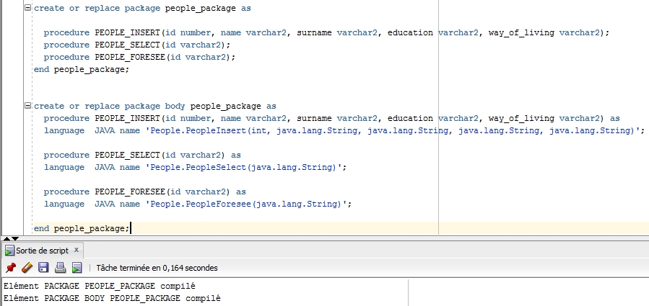

Execution

Preamble

The next functions will be used to interact with the table people:
create table people(
id integer,
name varchar2(30),
surname varchar2(30),
education varchar2(30),
way_of_living varchar2(30),
life_expectation integer
);

This table stores information about a fictive world where people live. In this world, their life expectation is strongly related to their education level as well as their way to live, for example if they live in the countryside or in a city.
Therefore, it is possible to estimate everyone's life expectation taking into account these information.
Moreover it is also possible for some people to foresee other people's future

Execution

To execute the functions in this package, it is necessary to use the keyword call followed by the name of the function.

call people_package.PEOPLE_INSERT(1, 'Jean', 'Paul','PHD', 'Rigan');
call people_package.PEOPLE_SELECT(1);
call people_package.PEOPLE_FORESEE(1);

Output

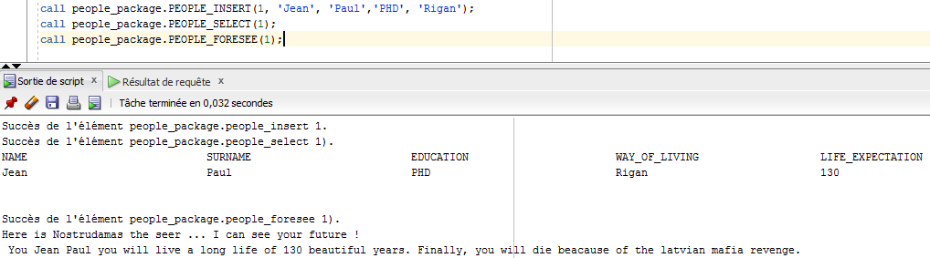

Java class creation, loading and testing for SELECT and INSERT queries realization.

Class creation and loading

The class used for SELECT and INSERT queries is the Java class “People”.

SQL code used to create java class:

create or replace JAVA source named "People" as
import java.sql.*;
import java.io.*;
import java.lang.Math;
import oracle.jdbc.*;
public class People{

private static String someWaysToDie[]={"starving","the next war","a bullet in the head from a crazy guy","a disease","the latvian mafia revenge"};

public static void PeopleInsert (int id, String name, String surname, String education, String way_of_living) throws SQLException {
String sql = "insert into PEOPLE values (?,?,?,?,?,?)";
Connection conn = DriverManager.getConnection("jdbc:default:connection:");
PreparedStatement pstmt = conn.prepareStatement(sql);
pstmt.setInt(1, id);
pstmt.setString(2, name);
pstmt.setString(3, surname);
pstmt.setString(4, education);
pstmt.setString(5, way_of_living);
int lE=computeIE(education,way_of_living);
pstmt.setInt(6, lE);
pstmt.executeUpdate();
pstmt.close();
}

private static int computeIE(String education, String way_of_living){
int iE=generateNumber(50);
if(education.equals("None") || education.equals("")){
iE+=30;
}else if(education.equals("Bachelor")){
iE+=80;
}else if(education.equals("Master")){
iE+=90;
}else if(education.equals("PHD")){
iE+=100;
}else{
iE+=55;
}
if(!way_of_living.equals("Citizen")){
if(way_of_living.equals("Rigan")){
iE+=10;
}else{
iE-=11;
}
}
return iE;
}

private static int generateNumber(int a){
double rand = Math.random()*a;
int i=(int)Math.round(rand);
return i;
}

public static void PeopleForesee(String id) throws SQLException{
String sql="select a.name, a.surname, a.education, a.way_of_living, a.life_expectation from people a where id = ?";
try{
Connection conn = DriverManager.getConnection("jdbc:default:connection:");
PreparedStatement pstmt = conn.prepareStatement(sql);
pstmt.setString(1, id);
ResultSet rrset = pstmt.executeQuery();
foresee(rrset);
rrset.close();
pstmt.close();
}catch(Exception e){System.err.println(e.getMessage());}
}

public static void PeopleSelect(String id) throws SQLException{
String sql="select a.name, a.surname, a.education, a.way_of_living, a.life_expectation from people a where id = ?";
try{
Connection conn = DriverManager.getConnection("jdbc:default:connection:");
PreparedStatement pstmt = conn.prepareStatement(sql);
pstmt.setString(1, id);
ResultSet rrset = pstmt.executeQuery();
display(rrset);
rrset.close();
pstmt.close();
}catch(Exception e){System.err.println(e.getMessage());}
}

private static void display(ResultSet rset) throws SQLException{
String tmp="";
ResultSetMetaData meta = rset.getMetaData();
int cols = meta.getColumnCount(), rows = 0;
for (int i = 1; i <= cols; i++){
int size = meta.getPrecision(i);
String label = meta.getColumnLabel(i);
if (label.length() > size) size = label.length();
while (label.length() < size) label += " ";
tmp = tmp + label + " ";
}
tmp = tmp+ "\n";
while (rset.next()) {
rows++;
for (int i = 1; i <= cols; i++) {
int size = meta.getPrecision(i);
String label = meta.getColumnLabel(i);
String value = rset.getString(i);
if (label.length() > size) size = label.length();
while (value.length() < size) value += " ";
tmp = tmp + value + " ";
}
tmp = tmp + "\n";
}
if (rows == 0) tmp = "No data found!\n";
System.out.println(tmp);
}

private static String getWayToDie(String where){
double rand = Math.random();
int foresee=(int)Math.round(rand*rand*rand*(someWaysToDie.length-1));
if (where.equals("Countryside")){
return someWaysToDie[foresee];
}
return someWaysToDie[someWaysToDie.length-1-foresee];
}

private static void foresee(ResultSet rset) throws SQLException{
String tmp="Here is Nostrudamas the seer ... I can see your future !\n You ";
String[][] vals=new String[6][2];
ResultSetMetaData meta = rset.getMetaData();
int cols = meta.getColumnCount(), rows = 0;
while (rset.next()) {
rows++;
for (int i = 1; i <= cols; i++) {
int size = meta.getPrecision(i);
vals[i-1][0] = meta.getColumnLabel(i);
vals[i-1][1] = rset.getString(i);
}
}
tmp+=vals[0][1]+" "+vals[1][1]+" you will live a ";
if(Integer.parseInt(vals[4][1])>60){
tmp+="long life of "+vals[4][1];
}else{
tmp+="short life of "+vals[4][1];
}
if(vals[3][1].equals("Rigan")){
tmp+=" beautiful years.";
}else{
tmp+=" years.";
}
tmp+=" Finally, you will die beacause of "+getWayToDie(vals[3][1])+".";
if (rows == 0) tmp = "No data found!\n";
System.out.println(tmp);
}
}
;

Testing INSERT queries

PEOPLE_INSERT(id number, name varchar2, surname varchar2, education varchar2, way_of_living varchar2);

Insert method from class People is used to insert data in table People with computing their life expectation.
In order to perform this estimation, the function takes into account the way of living of the new people as well as it's education level.
First step is using Java features to generate a random number that will be used as a common base.
Then additional input information are taken into account to compute an accurate estimation of this people life expectation according to the fictive world standards.

SQL code:

call people_package.PEOPLE_INSERT(1, 'Jean', 'Paul','PHD', 'Rigan');
call people_package.PEOPLE_INSERT(2, 'Salut', 'Fred','Bachelor', 'Citizen');
call people_package.PEOPLE_INSERT(3, 'Sauss', 'Isson',' ', 'Countryside');
call people_package.PEOPLE_INSERT(4, 'Bou', 'Teille','Master', 'Somewhere');
call people_package.PEOPLE_INSERT(5, 'Ger', 'Trudes','Master', 'Rigan');
call people_package.PEOPLE_INSERT(6, 'Camen', 'Bert','Bachelor', 'Countryside');
call people_package.PEOPLE_INSERT(7, 'Gou', 'Da',' ', 'Countryside');
call people_package.PEOPLE_INSERT(8, 'Emen', 'Tal',' ', 'Countryside');
select a.* from people a;

Output:

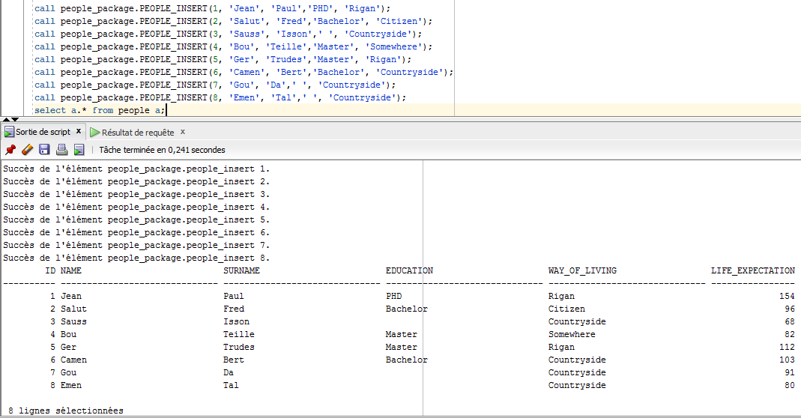
Here we can see that all elements have been inserted, their information are stored in database and people's life_expectation is computed according to the randomly generated base as well as education and way of life.

Testing SELECT queries

There is two select queries defined in People Java class:

PEOPLE_SELECT(id varchar2)

It is a simple selection of the fields of the table people in the database and as well as a display in a traditional manner.

Query:
Here we consider a table people with at least 3 rows of data with field id=1

select name, surname, education, way_of_living,life_expectation from people where id=1;
call people_package.PEOPLE_SELECT(1);

Output:

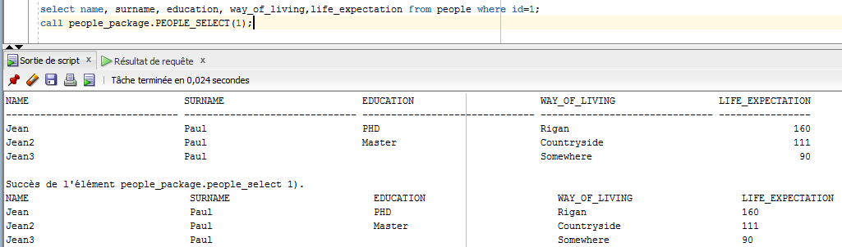
We can see here that the output of the Java method is correct comparing to the traditional SQL select query.

PEOPLE_FORESEE(id varchar2)

This is the second select function provided by People class. It uses a way of life weighted Java random generator to create a forecast on how the given person of this fictive world is the most likely to die.

Queries:

Here we will consider a table people with 8 different persons created with the following commands:

call people_package.PEOPLE_INSERT(1, 'Jean', 'Paul','PHD', 'Rigan');
call people_package.PEOPLE_INSERT(2, 'Salut', 'Fred','Bachelor', 'Citizen');
call people_package.PEOPLE_INSERT(3, 'Sauss', 'Isson',' ', 'Countryside');
call people_package.PEOPLE_INSERT(4, 'Bou', 'Teille','Master', 'Somewhere');
call people_package.PEOPLE_INSERT(5, 'Ger', 'Trudes','Master', 'Rigan');
call people_package.PEOPLE_INSERT(6, 'Camen', 'Bert','Bachelor', 'Countryside');
call people_package.PEOPLE_INSERT(7, 'Gou', 'Da',' ', 'Countryside');
call people_package.PEOPLE_INSERT(8, 'Emen', 'Tal',' ', 'Countryside');

Then, for each of them we will see what the seer of this world can say about their future:

call people_package.PEOPLE_FORESEE(1);
call people_package.PEOPLE_FORESEE(2);
call people_package.PEOPLE_FORESEE(3);
call people_package.PEOPLE_FORESEE(4);
call people_package.PEOPLE_FORESEE(5);
call people_package.PEOPLE_FORESEE(6);
call people_package.PEOPLE_FORESEE(7);
call people_package.PEOPLE_FORESEE(8);

Output:

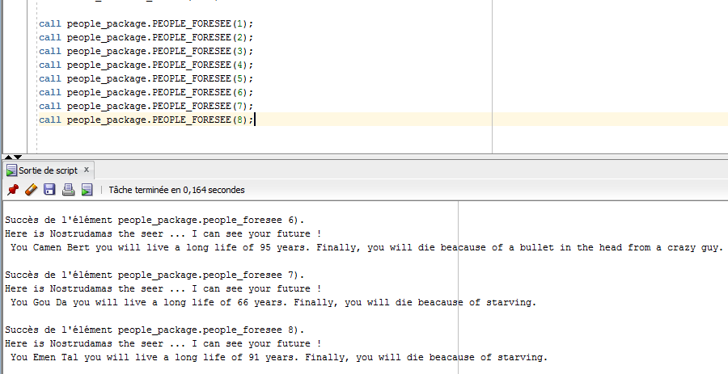
Complete output:
Succès de l'élément people_package.people_foresee 1).
Here is Nostrudamas the seer ... I can see your future !
You Jean Paul you will live a long life of 141 beautiful years. Finally, you will die beacause of a bullet in the head from a crazy guy.

Succès de l'élément people_package.people_foresee 2).
Here is Nostrudamas the seer ... I can see your future !
You Salut Fred you will live a long life of 107 years. Finally, you will die beacause of a disease.

Succès de l'élément people_package.people_foresee 3).
Here is Nostrudamas the seer ... I can see your future !
You Sauss Isson you will live a short life of 47 years. Finally, you will die beacause of a bullet in the head from a crazy guy.

Succès de l'élément people_package.people_foresee 4).
Here is Nostrudamas the seer ... I can see your future !
You Bou Teille you will live a long life of 99 years. Finally, you will die beacause of the next war.

Succès de l'élément people_package.people_foresee 5).
Here is Nostrudamas the seer ... I can see your future !
You Ger Trudes you will live a long life of 123 beautiful years. Finally, you will die beacause of the latvian mafia revenge.

Succès de l'élément people_package.people_foresee 6).
Here is Nostrudamas the seer ... I can see your future !
You Camen Bert you will live a long life of 95 years. Finally, you will die beacause of a bullet in the head from a crazy guy.

Succès de l'élément people_package.people_foresee 7).
Here is Nostrudamas the seer ... I can see your future !
You Gou Da you will live a long life of 66 years. Finally, you will die beacause of starving.

Succès de l'élément people_package.people_foresee 8).
Here is Nostrudamas the seer ... I can see your future !
You Emen Tal you will live a long life of 91 years. Finally, you will die beacause of starving.

Observation

These methods are an illustration on how to import and use a Java package in the database. For random numbers generation, People class uses the package Math that defines the function random() which is used to generate the base life expectation of a person, as well as to select a string (the way to die) in all possibilities stored in the string table attribute of the class.
Because it is working with this package, it is working with any package (as long as it is available in the database package library), which implies that it is possible to do anything inside the database when it is working in pair with Java.

Conclusions

We can see in these examples that it is possible to use any feature of the Java language an easily make it available to the database. This is exactly what was missing when creating PL/SQL object and methods directly in the database because it doesn't allows to perform complex tasks.
Taking into account that nowadays Java is the most common and used object oriented programming language in the world, it implies that almost everything that currently exists is available in Java. Furthermore, if it is available in Java, it is available in Oracle Database (assuming the needed packages are available in the database but it is not difficult to add new java packages in a java architecture).

We then have an architecture with a database that is able to store data, perform operations on it, store complex objects as well as methods, apply inheritance and naturally work in pair with the most used and updated programming language. Because everything is done by default in Oracle database, it is highly optimized and allows users to access a very powerful and relatively easy to use (comparing to a self made equivalent) data storage and processing structure.

Nevertheless, we should not forget that setting up such a architecture needs a large knowledge in several languages to be able to produce an optimized and effective database usage. An other drawback of this architecture is that the programmer should try to used Java classes the less it is possible because Java is not a very fast language and can create few related problems. According to my observations, a select query and output result with a Java class is approximately 4 times slower than the standard equivalent SQL select query.
Four is not a lot but when dealing with a very large amount of data, it makes a real difference.

Annexes

Table
create table people(
id integer,
name varchar2(30),
surname varchar2(30),
education varchar2(30),
way_of_living varchar2(30),
life_expectation integer
);

Classes
create or replace JAVA source named "People" as
import java.sql.*;
import java.io.*;
import java.lang.Math;
import oracle.jdbc.*;
public class People{

private static String someWaysToDie[]={"starving","the next war","a bullet in the head from a crazy guy","a disease","the latvian mafia revenge"};

public static void PeopleInsert (int id, String name, String surname, String education, String way_of_living) throws SQLException {
String sql = "insert into PEOPLE values (?,?,?,?,?,?)";
Connection conn = DriverManager.getConnection("jdbc:default:connection:");
PreparedStatement pstmt = conn.prepareStatement(sql);
pstmt.setInt(1, id);
pstmt.setString(2, name);
pstmt.setString(3, surname);
pstmt.setString(4, education);
pstmt.setString(5, way_of_living);
int lE=computeIE(education,way_of_living);
pstmt.setInt(6, lE);
pstmt.executeUpdate();
pstmt.close();
}

private static int computeIE(String education, String way_of_living){
int iE=generateNumber(50);
if(education.equals("None") || education.equals("")){
iE+=30;
}else if(education.equals("Bachelor")){
iE+=80;
}else if(education.equals("Master")){
iE+=90;
}else if(education.equals("PHD")){
iE+=100;
}else{
iE+=55;
}
if(!way_of_living.equals("Citizen")){
if(way_of_living.equals("Rigan")){
iE+=10;
}else{
iE-=11;
}
}
return iE;
}

private static int generateNumber(int a){
double rand = Math.random()*a;
int i=(int)Math.round(rand);
return i;
}

public static void PeopleForesee(String id) throws SQLException{
String sql="select a.name, a.surname, a.education, a.way_of_living, a.life_expectation from people a where id = ?";
try{
Connection conn = DriverManager.getConnection("jdbc:default:connection:");
PreparedStatement pstmt = conn.prepareStatement(sql);
pstmt.setString(1, id);
ResultSet rrset = pstmt.executeQuery();
foresee(rrset);
rrset.close();
pstmt.close();
}catch(Exception e){System.err.println(e.getMessage());}
}

public static void PeopleSelect(String id) throws SQLException{
String sql="select a.name, a.surname, a.education, a.way_of_living, a.life_expectation from people a where id = ?";
try{
Connection conn = DriverManager.getConnection("jdbc:default:connection:");
PreparedStatement pstmt = conn.prepareStatement(sql);
pstmt.setString(1, id);
ResultSet rrset = pstmt.executeQuery();
display(rrset);
rrset.close();
pstmt.close();
}catch(Exception e){System.err.println(e.getMessage());}
}

private static void display(ResultSet rset) throws SQLException{
String tmp="";
ResultSetMetaData meta = rset.getMetaData();
int cols = meta.getColumnCount(), rows = 0;
for (int i = 1; i <= cols; i++){
int size = meta.getPrecision(i);
String label = meta.getColumnLabel(i);
if (label.length() > size) size = label.length();
while (label.length() < size) label += " ";
tmp = tmp + label + " ";
}
tmp = tmp+ "\n";
while (rset.next()) {
rows++;
for (int i = 1; i <= cols; i++) {
int size = meta.getPrecision(i);
String label = meta.getColumnLabel(i);
String value = rset.getString(i);
if (label.length() > size) size = label.length();
while (value.length() < size) value += " ";
tmp = tmp + value + " ";
}
tmp = tmp + "\n";
}
if (rows == 0) tmp = "No data found!\n";
System.out.println(tmp);
}

private static String getWayToDie(String where){
double rand = Math.random();
int foresee=(int)Math.round(rand*rand*rand*(someWaysToDie.length-1));
if (where.equals("Countryside")){
return someWaysToDie[foresee];
}
return someWaysToDie[someWaysToDie.length-1-foresee];
}

private static void foresee(ResultSet rset) throws SQLException{
String tmp="Here is Nostrudamas the seer ... I can see your future !\n You ";
String[][] vals=new String[6][2];
ResultSetMetaData meta = rset.getMetaData();
int cols = meta.getColumnCount(), rows = 0;
while (rset.next()) {
rows++;
for (int i = 1; i <= cols; i++) {
int size = meta.getPrecision(i);
vals[i-1][0] = meta.getColumnLabel(i);
vals[i-1][1] = rset.getString(i);
}
}
tmp+=vals[0][1]+" "+vals[1][1]+" you will live a ";
if(Integer.parseInt(vals[4][1])>60){
tmp+="long life of "+vals[4][1];
}else{
tmp+="short life of "+vals[4][1];
}
if(vals[3][1].equals("Rigan")){
tmp+=" beautiful years.";
}else{
tmp+=" years.";
}
tmp+=" Finally, you will die beacause of "+getWayToDie(vals[3][1])+".";
if (rows == 0) tmp = "No data found!\n";
System.out.println(tmp);
}
}
;
create or replace JAVA source named "hello" as
public class hello {
public static String hi(){
return "Hello World";
}
}
;

Functions and packages
create or replace function say_hello return varchar2 as
language java name 'hello.hi () return java.lang.String';

create or replace package people_package as

procedure PEOPLE_INSERT(id number, name varchar2, surname varchar2, education varchar2, way_of_living varchar2);
procedure PEOPLE_SELECT(id varchar2);
procedure PEOPLE_FORESEE(id varchar2);
end people_package;

create or replace package body people_package as
procedure PEOPLE_INSERT(id number, name varchar2, surname varchar2, education varchar2, way_of_living varchar2) as
language JAVA name 'People.PeopleInsert(int, java.lang.String, java.lang.String, java.lang.String, java.lang.String)';

procedure PEOPLE_SELECT(id varchar2) as
language JAVA name 'People.PeopleSelect(java.lang.String)';

procedure PEOPLE_FORESEE(id varchar2) as
language JAVA name 'People.PeopleForesee(java.lang.String)';

end people_package;

SQL Queries

set serveroutput ON;
call DBMS_JAVA.SET_OUTPUT(7000);

select OBJECT_NAME, OBJECT_TYPE, STATUS
from USER_OBJECTS
where CREATED >= TO_DATE('24-11-2015', 'DD-MM-YYYY');

select say_hello from dual;

delete from people;

call people_package.PEOPLE_INSERT(1, 'Jean', 'Paul','PHD', 'Rigan');
call people_package.PEOPLE_INSERT(1, 'Jean2', 'Paul','Master', 'Countryside');
call people_package.PEOPLE_INSERT(1, 'Jean3', 'Paul',' ', 'Somewhere');

select name, surname, education, way_of_living,life_expectation from people where id=1;
call people_package.PEOPLE_SELECT(1);

call people_package.PEOPLE_INSERT(1, 'Jean', 'Paul','PHD', 'Rigan');
call people_package.PEOPLE_INSERT(2, 'Salut', 'Fred','Bachelor', 'Citizen');
call people_package.PEOPLE_INSERT(3, 'Sauss', 'Isson',' ', 'Countryside');
call people_package.PEOPLE_INSERT(4, 'Bou', 'Teille','Master', 'Somewhere');
call people_package.PEOPLE_INSERT(5, 'Ger', 'Trudes','Master', 'Rigan');
call people_package.PEOPLE_INSERT(6, 'Camen', 'Bert','Bachelor', 'Countryside');
call people_package.PEOPLE_INSERT(7, 'Gou', 'Da',' ', 'Countryside');
call people_package.PEOPLE_INSERT(8, 'Emen', 'Tal',' ', 'Countryside');
select a.* from people a;

call people_package.PEOPLE_FORESEE(1);
call people_package.PEOPLE_FORESEE(2);
call people_package.PEOPLE_FORESEE(3);
call people_package.PEOPLE_FORESEE(4);
call people_package.PEOPLE_FORESEE(5);
call people_package.PEOPLE_FORESEE(6);
call people_package.PEOPLE_FORESEE(7);
call people_package.PEOPLE_FORESEE(8);

