Guillaume Minette de Saint Martin

Advanced data Technologies

Lab 2

For the following results, output screenshots are made with the French version of the
software interface, I hope it will not be a problem.
Query file containing the following queries is querry.sql.

Your task is to write SQL statements that complete the following tasks:
- (Easy) Retrieve list of students in the form of one field that contains both name and surname in the form “SURNAME, Name”.
select st_surname as SURNAME, st_name as Name
from students;
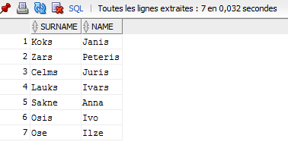
- (Easy) Find all curses whose names contain word “Data”.
select *
from courses
where C_title like '%Data%';
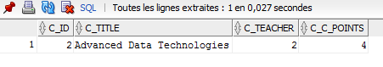
- (Easy) Retrieve all students that have average mark above 8.
select st_id
from students, grades
where st_id=g_student
group by st_id
having avg(g_grade)>8;
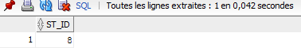
First join tables then group by student and filter according to the average mark.

- (Medium) Retrieve all students that have at least one grade below 4.
select st_id
from students, grades
where st_id=g_student
group by st_id
having min(g_grade)<4;
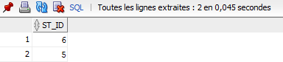
First join tables then group by student and check the grades. If the minimum grade is below 4, the student has at least one grade below 4.

- (Hard) Add a constraint specifying that the grade must be between 1 and 10.
alter table grades
add constraint g_grade CHECK ((g_grade >= 1) and (g_grade < 11)) ;
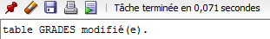
Add a check constraint to this column.
- (Easy) Drop one table.
drop table grades;
