Guillaume Minette de Saint Martin October 2015

Technology of Large Databases



Practical Work 1

Table of contents
Subject 3
Dictionary 4
French Zoos 5
Created tables 6
Tables with row type object 6
Table with object type column 6
Object collection table 6
Created Views 7
Object view 7
Traditional view 7
Object References 9
One to one references 9
One to many references 10
Object Functions 11
Data insert 11
Data extraction 12
Conclusion 13
Annexes: SQL scripts 14
Create types: 14
Create tables: 14
Create views: 15
Insert data: 15
Select queries: 17

Subject

1. practical work. Objec-relational DB storage structures
Creation of object – relational database data storage structures, data input, metadata output and data extraction (queries).
1. Table with row type objects.
2. Table with object column.
3. Table with object collection.
4. Object view.
5. Object reference 1 : 1 and 1 : M (many).
6. Use of special object functions in SQL queries.
7. Conclusions.

Dictionary

French | English
animal | animal
nom | name
poids | weight
parent | parent
pays | country
profession | job
age | age
villevisite | city visited
ville | city
lieu | place
equipe | team
environement | environment
milieu | original place to live
temperature | temperature
habitant | inhabitant

French Zoos

The idea is to create a database on the model of a zoo with animals, environments, guardians and visitors.

Therefore I created different object types related to theses data.

I also created an other type: equipe, it is a table of gardien that will be used by the object collection table.
- Animal:
create or replace type animal as object(
nom varchar2(30),
espece varchar2(30),
poids number(5,1),
parent ref animal);

- Ville:
create or replace type ville as object(
nom varchar2(30),
pays varchar2(30));

- Visiteur:
create or replace type visiteur as object(
profession varchar(30),
age number(3),
villevisite ref ville,
lieu number);

- Gardien:
create or replace type gardien as object(
nom varchar2(30),
anim animal);

- Equipe:
create or replace type equipe as table of gardien;

Created tables

Tables with row type object

Table visitors is the table that gather all the visitors of the zoos.
create table visiteurs of visiteur;

Table animaux is the table that gather all the animals.
create table animaux of animal;

Table parents is the table that gather all the animal's parents.
create table parents of animal;

Table villes is the table that gather all the cities.
create table villes of ville;

Table with object type column

Table environements is a table that contains animals and refers it to an environment, that is to say a place to live (ocean, desert, forest), a temperature and city to identify witch city's zoo is able to provide it.
create table environements(
id number(4) primary key,
ville ref ville,
milieu varchar(50),
temperature number(3),
habitant animal);

Object collection table
Table zoo is a collection that links a city (ville) with a guardian team (equipes_gardiens).
create table zoos(
ville ref ville,
equipes_gardiens equipe)
nested table equipes_gardiens store as pets;

Created Views

Object view

View animaux_de_la_savane (savannah animals) displays all the animals from table animaux (animals) that usually live in savannah (information found in table environements).
create or replace view animaux_de_la_savane of animal with object id(nom)as
select a.*
from animaux a, environements b
where a.nom=b.habitant.nom and
b.milieu='savane'
;

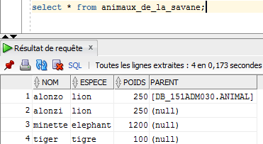

Traditional view

View panneau_de_controle (control panel) displays for each tuple with available information the name of the city where the zoo is located (ville), the focused place (milieu), the name of the animal (nom), its type (espece), the visitor next to it (visiteur) and the associated guardian (gardien).

create or replace view panneau_de_controle as
select v.nom as ville, e.milieu as milieu, e.habitant.nom as nom, e.habitant.espece as espece, a.profession as visiteur, value(u).nom as gardien
from villes v, visiteurs a, environements e, zoos z, table(z.equipes_gardiens) u
where a.villevisite.nom=v.nom and
e.ville.nom=v.nom and
a.lieu=e.id and
u.anim.nom=e.habitant.nom
order by v.nom
;
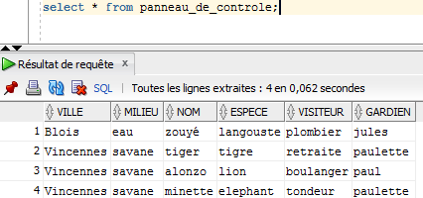

Object References

One to one references

Table animal is linked with the parent table by a one to one reference, each animal has a attribute parent that is a reference to an other animal from table parent. Here each animal has 0 or 1 parent.

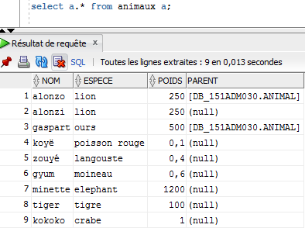
Table visiteur (visitors) also uses one to one references to table villes (cities).
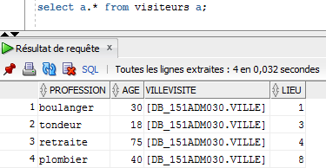

One to many references
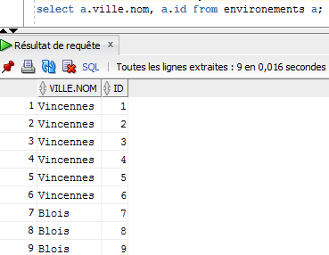
Tables environements (environments) and villes (cities) are linked by a one to many relation: one city to many environments.

Object Functions

Data insert

To insert data, the following object functions are used:

- REF ( ) :

declare
par ref animal;
begin

select ref(A) into par from parents A where A.nom = 'alonzoTheFirst';
update animaux B set B.parent = par where B.nom ='alonzo';

select ref(A) into par from parents A where A.nom = 'gaspartTheFirst';
update animaux B set B.parent = par where B.nom ='gaspart';

end;

- CURSOR and FOR IN LOOP

declare
cursor cursor_animaux1 is select * from animaux a where a.espece='lion' or a.espece='tigre' or a.espece='elephant';
cursor cursor_animaux2 is select * from animaux a where a.espece='ours' or a.espece='moineau';
cursor cursor_animaux3 is select * from animaux a where a.espece='poisson rouge' or a.espece='langouste' or a.espece='crabe';
i number default 1;
refville ref ville;
a1 animal;
a2 animal;
refa3 animal;
refa4 animal;
begin

--environements
select ref(a) into refville from villes a where a.nom='Vincennes';
for anim in cursor_animaux1 loop
insert into environements values (i,refville, 'savane', 25, animal(anim.nom,anim.espece,anim.poids,anim.parent));
i:=i+1;
end loop;

for anim in cursor_animaux2 loop
insert into environements values (i,refville, 'foret', 14, animal(anim.nom,anim.espece,anim.poids,anim.parent));
i:=i+1;
end loop;

select ref(a) into refville from villes a where a.nom='Blois';
for anim in cursor_animaux3 loop
insert into environements values (i,refville, 'eau', 15, animal(anim.nom,anim.espece,anim.poids,anim.parent));
i:=i+1;
end loop;

end;

Data extraction

- TABLE ( ) and VALUE ( ) :

select a.ville.nom as ville, value(b).nom as gardien, value(b).anim.nom as animal
from zoos a, table(a.equipes_gardiens) b ;

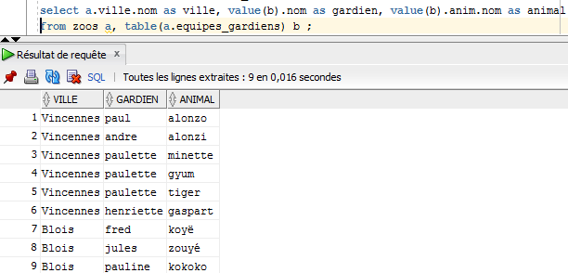

Conclusion

Object databases allows to store extremely complex structures easily. It is a very efficient way to store information like graphs, sounds or geographic data.
It can be used to optimize big complex data storage structures and allow fast response. It also allows to minimize the memory usage of data storage comparing to conventional ways to store objects, that is to say serialization into files and compression.
However because of the new possibilities it allows, this type of database is more complex to set up and requires additional qualifications comparing to standard relational databases.

Annexes: SQL scripts

Create types:

create or replace type animal as object(
nom varchar2(30),
espece varchar2(30),
poids number(5,1),
parent ref animal);

create or replace type ville as object(
nom varchar2(30),
pays varchar2(30));

create or replace type visiteur as object(
profession varchar(30),
age number(3),
villevisite ref ville,
lieu number
);

create or replace type gardien as object(
nom varchar2(30),
anim animal);

create or replace type equipe as table of gardien;

Create tables:

--row type
create table visiteurs of visiteur;
create table animaux of animal;
create table parents of animal;
create table villes of ville;

--column object type
create table environements(
id number(4) primary key,
ville ref ville,
milieu varchar(50),
temperature number(3),
habitant animal);

--collection
create table zoos(
ville ref ville,
equipes_gardiens equipe)
nested table equipes_gardiens store as pets;

Create views:

--object view
create or replace view animaux_de_la_savane of animal with object id(nom)
as
select a.*
from animaux a, environements b
where a.nom=b.habitant.nom and
b.milieu='savane';

–-simple view
create or replace view panneau_de_controle as
select v.nom as ville, e.milieu as milieu, e.habitant.nom as nom, e.habitant.espece as espece, a.profession as visiteur, value(u).nom as gardien
from villes v, visiteurs a, environements e, zoos z, table(z.equipes_gardiens) u
where a.villevisite.nom=v.nom and
e.ville.nom=v.nom and
a.lieu=e.id and
u.anim.nom=e.habitant.nom
order by v.nom
;

Insert data:

Script 1:

delete from environements;
delete from animaux;
delete from visiteurs;
delete from parents;
delete from villes;
delete from zoos;

--villes
insert into villes values(ville('Vincennes','France'));
insert into villes values(ville('Blois','France'));

--parents
insert into parents values(animal('alonzoTheFirst','lion','250,0',null));
insert into parents values(animal('gaspartTheFirst','ours','500,0',null));

--animaux
insert into animaux values(animal('alonzo','lion','250,0',null));
insert into animaux values(animal('alonzi','lion','250,0',null));
insert into animaux values(animal('gaspart','ours','500,0',null));
insert into animaux values(animal('koyë','poisson rouge','0,1',null));
insert into animaux values(animal('zouyé','langouste','0,4',null));
insert into animaux values(animal('gyum','moineau','0,6',null));
insert into animaux values(animal('minette','elephant','1200',null));
insert into animaux values(animal('tiger','tigre','100',null));
insert into animaux values(animal('kokoko','crabe','1',null));

--parents 2
declare
par ref animal;
begin

select ref(A) into par from parents A where A.nom = 'alonzoTheFirst';
update animaux B set B.parent = par where B.nom ='alonzo';

select ref(A) into par from parents A where A.nom = 'gaspartTheFirst';
update animaux B set B.parent = par where B.nom ='gaspart';

end;

Script 2:

declare
cursor cursor_animaux1 is select * from animaux a where a.espece='lion' or a.espece='tigre' or a.espece='elephant';
cursor cursor_animaux2 is select * from animaux a where a.espece='ours' or a.espece='moineau';
cursor cursor_animaux3 is select * from animaux a where a.espece='poisson rouge' or a.espece='langouste' or a.espece='crabe';
i number default 1;
refville ref ville;
begin

--environements
select ref(a) into refville from villes a where a.nom='Vincennes';
for anim in cursor_animaux1 loop
insert into environements values (i,refville, 'savane', 25, animal(anim.nom,anim.espece,anim.poids,anim.parent));
i:=i+1;
end loop;

for anim in cursor_animaux2 loop
insert into environements values (i,refville, 'foret', 14, animal(anim.nom,anim.espece,anim.poids,anim.parent));
i:=i+1;
end loop;

select ref(a) into refville from villes a where a.nom='Blois';
for anim in cursor_animaux3 loop
insert into environements values (i,refville, 'eau', 15, animal(anim.nom,anim.espece,anim.poids,anim.parent));
i:=i+1;
end loop;

end;

Script 3:

declare
refville ref ville;
refa1 animal;
refa2 animal;
refa3 animal;
refa4 animal;
refa5 animal;
refa6 animal;
begin
--equipes and visiteurs
select ref(a) into refville from villes a where a.nom='Vincennes';
select a.habitant into refa1 from environements a where a.habitant.nom='alonzo';
select a.habitant into refa2 from environements a where a.habitant.nom='alonzi';
select a.habitant into refa3 from environements a where a.habitant.nom='gaspart';
select a.habitant into refa4 from environements a where a.habitant.nom='minette';
select a.habitant into refa5 from environements a where a.habitant.nom='gyum';
select a.habitant into refa6 from environements a where a.habitant.nom='tiger';
insert into zoos values(
refville,
equipe(gardien('paul',refa1),gardien('andre',refa2),gardien('paulette',refa4),gardien('paulette',refa5),gardien('paulette',refa6),gardien('henriette',refa3))
);

insert into visiteurs values(visiteur('boulanger',30,refville,1));
insert into visiteurs values(visiteur('tondeur',18,refville,3));
insert into visiteurs values(visiteur('retraite',75,refville,4));

select a.habitant into refa1 from environements a where a.habitant.nom='koyë';
select a.habitant into refa2 from environements a where a.habitant.nom='zouyé';
select a.habitant into refa3 from environements a where a.habitant.nom='kokoko';

select ref(a) into refville from villes a where a.nom='Blois';
insert into zoos values(
refville,
equipe(gardien('fred',refa1),gardien('jules',refa2),gardien('pauline',refa3))
);

insert into visiteurs values(visiteur('plombier',40,refville,8));
end;

Select queries:

select * from villes;

select * from zoos;

select a.profession, a.age, a.VILLEVISITE.nom from visiteurs a;

select * from animaux_de_la_savane;

select * from panneau_de_controle;

select a.* from visiteurs a;

select a.* from animaux a;

select a.ville.nom, a.id from environements a;

select a.ville.nom as ville, value(b).nom as gardien, value(b).anim.nom as animal
from zoos a, table(a.equipes_gardiens) b ;

