Guillaume Minette de Saint Martin November 2015

Technology of Large Databases



Practical Work 2

Table of contents
Subject 3
Dictionary 4
Create constructor object method 5
Type creation 5
Body creation 5
Data input 6
Select queries 7
MAP type object method 9
Type and body creation 9
Select queries 9
ORDER type object method 11
Type and body creation 11
Select query 11
MEMBER type object method 13
Type and body creation 13
Package 13
Select queries 14
Method inheritance 15
Conclusions 16

Subject

2. practical work.Object methods
Use of object PL/SQL methods. Deadline: 11. november.
1. Create constructor object method. Use it for data input (INSERT).
Validate input using SELECT query.
2. Create MAP type object method. Use it for data extraction (SELECT query).
3. Create ORDER type object method. Use it for data extraction (SELECT query).
4. Create MEMBER type object method. Use it for data extraction (SELECT query).
5. Demonstrate method inheritance (create type hierarchy, create table, create MEMBER or ORDER method for supertype and subtype, perform SELECT queries wih MEMBER method with supertype objects and subtype objects).
6. Conclusions.

Dictionary

French | English
Dinosaures | dinosaurs
Triceratops | triceratops
Tyrannosaure | tyrannosaurus
Archeopteryx | archeopteryx
Liopleurodon | liopleurodon
Lezard | lizard
Megalodon | megalodon
Crocodile | crocodile
Pigeon | dove
Girafe | giraffe
Moule | mussel
Lion | lion
Anguille | eel
Moineau | sparrow
Dindon | turkey
Crier | scream
Descendant | descendant
Grosseur, taille | size
Poids | weight
Predateur | predator
Peut manger | is able to eat
Nom | name
Espece | kind
Maritime | that lives in water
Terrestre | that lives on the ground
Aerien | that lives in the air

Create constructor object method

For this practical work, the dinosaure object type will be used. This type contains the following attributes:
- nom varchar2
- espece varchar2
- poids number
- taille number

This type has 3 constructor methods:
- Constructor without arguments, it creates a default dinosaur
- Constructor with only name and espece, it fills poids and taille with default value 0
- Constructor with all attributes, it works as the default database constructor

Type creation

create or replace type dinosaure as object(
nom varchar2(30),
espece varchar2(30),
poids number(10,1),
taille number(5,1),

constructor function dinosaure return self as result,
constructor function dinosaure(nom varchar2, espece varchar2) return self as result,
constructor function dinosaure(nom varchar2, espece varchar2, poids number, taille number) return self as result
);

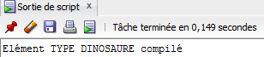

Body creation

create or replace type body dinosaure as
constructor function dinosaure return self as result is
begin
self.nom:='gyum';
self.espece:='yguanodon';
self.poids:=666;
self.taille:=2;
return;
end;
constructor function dinosaure(nom varchar2, espece varchar2) return self as result is
begin
self.nom:=nom;
self.espece:=espece;
self.poids:=0;
self.taille:=0;
return;
end;
constructor function dinosaure(nom varchar2, espece varchar2, poids number, taille number) return self as result is
begin
self.nom:=nom;
self.espece:=espece;
self.poids:=poids;
self.taille:=taille;
return;
end;
end;

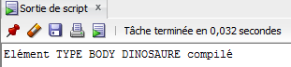

Data input

create table dinosaures of dinosaure;

insert into dinosaures values(dinosaure('klouyé','triceratops anorexique'));
insert into dinosaures values(dinosaure('zouyé','tyrannosaure',5000,5));
insert into dinosaures values(dinosaure('natlya','archeopteryx',6,2));
insert into dinosaures values(dinosaure('ruslan','liopleurodon',100000,12));
insert into dinosaures values(dinosaure('francois','lezard',1,1));
insert into dinosaures values(dinosaure('holland','lezard',2,1));
insert into dinosaures values(dinosaure('putin','megalodon',50000,15));
insert into dinosaures values(dinosaure());

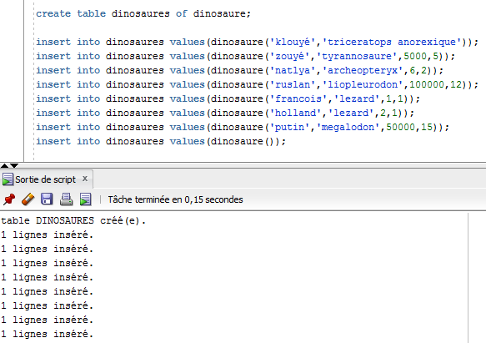

Select queries

Select all information about the whole dinosaures table.
select a.* from dinosaures a;

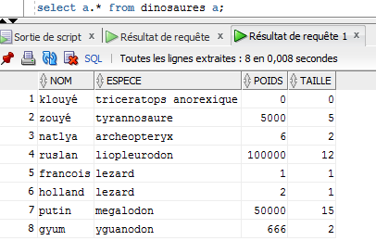
We can see here all input data and also default values for the 1st row as well as the last row which as all attributes filled with default values of no argument constructor.

MAP type object method

Map member method grosseur is used to order dinosaurs thanks to their size and weight.

Type and body creation

create or replace type dinosaure as object(
nom varchar2(30),
espece varchar2(30),
poids number(10,1),
taille number(5,1)
map member function grosseur return number
);

create or replace type body dinosaure as
map member function grosseur return number is
begin
return (self.poids+1)/(self.taille+1);
end;
end;

Select queries

Select all information and sort it by the map function in reversed order.
select a.* from dinosaures a order by value(a).grosseur() desc;

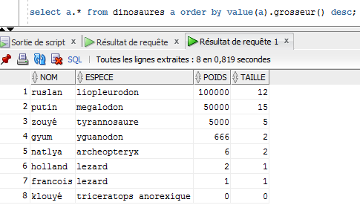
Select only dinosaurs with a size superior to 0, that is to say eliminate default value 0 ordering them using the map function.
select a.* from dinosaures a where taille > 0 order by value(a).grosseur();

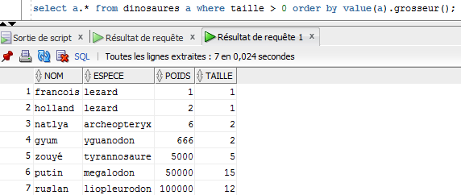

ORDER type object method

Order member method is used to compare the strength of dinosaurs in order to determine who is the predator and who is the prey. This function also prints “X eats Y” in the dbms output in case of the dinosaur of the table is the predator.

Type and body creation

create or replace type dinosaure2 as object(
nom varchar2(30),
espece varchar2(30),
poids number(10,1),
taille number(5,1),
order member function predateur(m_obj dinosaure2) return integer
);

create or replace type body dinosaure2 as
order member function predateur(m_obj dinosaure2) return integer is
begin
if self.poids*self.taille < m_obj.poids*m_obj.taille then
sys.dbms_output.put_line(self.nom || ' mange ' || m_obj.nom || ' !!!' );
return -1;
elsif self.poids*self.taille > m_obj.poids*m_obj.taille then return 1;
else return 0;
end if;
end predateur;
end;

Select query

The idea here is to compare a given dinosaur (identified by its name) to all the dinosaurs in the table.

select value(a).nom, value(a).espece, value(a).predateur(c.obj) as peut_manger, c.obj.nom, c.obj.espece
from dinosaures2 a, ( select value(b) as obj
from dinosaures2 b where nom='zouyé') c;
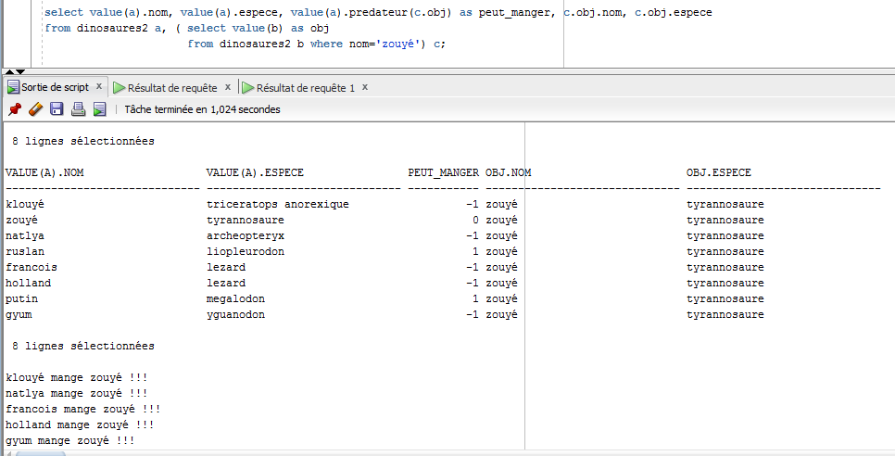

Here we can see the database output in case of the table dinosaurs is the predator.

MEMBER type object method

Member method of type dinosaur is used here to determine the sound they produce when they scream. For this, this method outputs a varchar2 that contains the scream.
The code of this method is split in the type body and an a special package.

Type and body creation

create or replace type dinosaure as object(
nom varchar2(30),
espece varchar2(30),
poids number(10,1),
taille number(5,1),
member function crier return varchar2
);

create or replace type body dinosaure as
member function crier return varchar2 is
begin
return dinoPackage.rugir(self);
end;
end;

Package

This package is used to provide the rugir (to roar) function used by screaming member function of dinosaure type.

create or replace package dinoPackage as
cris varchar2(300);
function rugir(dino dinosaure) return varchar2;
procedure cri(espece varchar2);
end dinoPackage;

create or replace package body dinoPackage as
function rugir( dino dinosaure)return varchar2 is
begin
cri(dino.espece);
return 'ATTENTION : '|| cris;
end;
procedure cri(espece varchar2) is
begin
if espece='triceratops' or espece='triceratops anorexique' or espece='stegosaure' or espece='yguanodon' then cris:= 'brraaaaaaaaaaaaaaaa';
elsif espece='tyranosaure' or espece='alosaure' then cris:= 'cryyyyyééééééééééééééééééééééééééé';
elsif espece='liopleurodon' or espece='megalodon' then cris:= '........ bloup ........... bloup ..... aaaaaaaaaaaaaaaaa ....';
elsif espece='lezard' then cris:= 'gnnéééééééééé';
else cris:= 'cuicui ?!';
end if;
end;
end dinoPackage;

Select queries

First select all the dinosaurs and make them scream.
select value(a).nom, value(a).espece,value(a).crier() from dinosaures a;

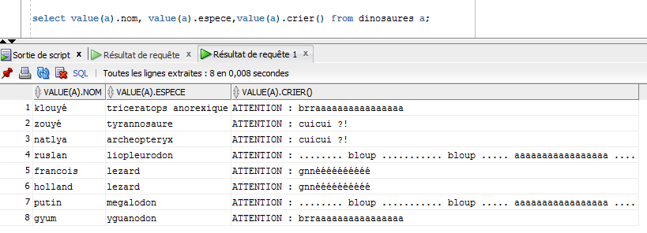
Now order the result using the previous map.
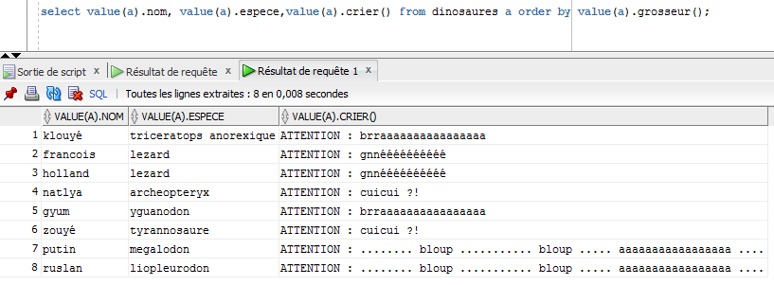

Method inheritance

For the method inheritance, we will use the descendant type with is under the dinosaur type and adds a attribute:
- type varchar2

This type has 2 constructors and overrides as well as overload the crier member method form dinosaur type.

Type and body creation

create or replace type descendant under dinosaure(
type varchar2(20),
constructor function descendant(nom varchar2, espece varchar2) return self as result,
constructor function descendant(nom varchar2, espece varchar2, type varchar2) return self as result,
overriding member function crier return varchar2,
member function crier(d descendant) return varchar2
);

create or replace type body descendant as
member function crier(d descendant) return varchar2 is
begin
if self.type <> d.type then return ' .... .... .... .... ';
elsif self.taille>d.taille then return self.nom || ' a gagné: zzbraaaaaaaaaaa ';
elsif self.taille<d.taille then return self.nom || ' a perdu: ouiiinnnnnnnnnnn ' || d.nom || ' : mouahahahahaha !!!';
else return ' paf paf paf paf ';
end if;
end;
overriding member function crier return varchar2 is
begin
return dinoPackage.nouveauRugir(self);
end;
constructor function descendant(nom varchar2, espece varchar2) return self as result is
begin
self.nom:=nom;
self.espece:=espece;
self.poids:=0;
self.taille:=0;
self.type:='aerien';
return;
end;
constructor function descendant(nom varchar2, espece varchar2, type varchar2) return self as result is
begin
self.nom:=nom;
self.espece:=espece;
self.poids:=0;
self.taille:=0;
self.type:=type;
return;
end;
end;

Method overriding

Supertype dinosaur has a member method called “crier” that has no argument and returns a varchar2. Descendant subtype also has this method but with a different result. This method uses a different function of the same package which is adapted to this subtype because it uses the new attribute: type.

Method overloading

Supertype dinosaur's crier member method takes no argument

Conclusions

