Guillaume Minette de Saint Martin November 2015

Technology of Large Databases



Practical Work 2

Table of contents
Subject 3
Dictionary 4
Create constructor object method 6
Type creation 6
Body creation 6
Data input 7
Select queries 8
MAP type object method 10
Type and body creation 10
Select queries 10
ORDER type object method 12
Type and body creation 12
Select query 12
MEMBER type object method 14
Type and body creation 14
Package 14
Select queries 15
Method inheritance 16
Type and body creation 16
Method overriding 17
Method overloading 18
Data input 18
Table descendants of descendant 18
Table dinosaures of dinosaure 19
Select queries 19
Basic data selection 19
Method overriding 20
Method overloading 21
Conclusions 23
Annexes: SQL Code 24
Create types dinosaure and dinosaure2 24
Create type descendant 26
Create package 26
Insert and select queries 27

Subject

2. practical work.Object methods
Use of object PL/SQL methods. Deadline: 11. november.
1. Create constructor object method. Use it for data input (INSERT).
Validate input using SELECT query.
2. Create MAP type object method. Use it for data extraction (SELECT query).
3. Create ORDER type object method. Use it for data extraction (SELECT query).
4. Create MEMBER type object method. Use it for data extraction (SELECT query).
5. Demonstrate method inheritance (create type hierarchy, create table, create MEMBER or ORDER method for supertype and subtype, perform SELECT queries wih MEMBER method with supertype objects and subtype objects).
6. Conclusions.

Dictionary

French | English
Dinosaures | dinosaurs
Triceratops | triceratops
Tyrannosaure | tyrannosaurus
Archeopteryx | archeopteryx
Liopleurodon | liopleurodon
Lezard | lizard
Megalodon | megalodon
Crocodile | crocodile
Pigeon | dove
Girafe | giraffe
Moule | mussel
Lion | lion
Anguille | eel
Moineau | sparrow
Dindon | turkey
Crier | scream
Descendant | descendant
Grosseur | size
Poids | weight
Predateur | predator
Peut manger | is able to eat
Nom | name
Espece | kind
Taille | height
Maritime | that lives in water
Terrestre | that lives on the ground
Aerien | that lives in the air
A gagné | has won
A perdu | has lost
Rugissement | roar
Compilé | compiled

Create constructor object method

For this practical work, the dinosaure object type will be used. This type contains the following attributes:
- nom varchar2
- espece varchar2
- poids number
- taille number

This type has 3 constructor methods:
- Constructor without arguments, it creates a default dinosaur
- Constructor with only name and espece, it fills poids and taille with default value 0
- Constructor with all attributes, it works as the default database constructor

Type creation

create or replace type dinosaure as object(
nom varchar2(30),
espece varchar2(30),
poids number(10,1),
taille number(5,1),

constructor function dinosaure return self as result,
constructor function dinosaure(nom varchar2, espece varchar2) return self as result,
constructor function dinosaure(nom varchar2, espece varchar2, poids number, taille number) return self as result
);

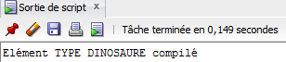

Body creation

create or replace type body dinosaure as
constructor function dinosaure return self as result is
begin
self.nom:='gyum';
self.espece:='yguanodon';
self.poids:=666;
self.taille:=2;
return;
end;
constructor function dinosaure(nom varchar2, espece varchar2) return self as result is
begin
self.nom:=nom;
self.espece:=espece;
self.poids:=0;
self.taille:=0;
return;
end;
constructor function dinosaure(nom varchar2, espece varchar2, poids number, taille number) return self as result is
begin
self.nom:=nom;
self.espece:=espece;
self.poids:=poids;
self.taille:=taille;
return;
end;
end;

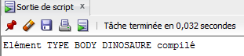

Data input

To test this type, dinosaures table is created, it's a row type object table containing dinosaurs

create table dinosaures of dinosaure;

insert into dinosaures values(dinosaure('klouyé','triceratops anorexique'));
insert into dinosaures values(dinosaure('zouyé','tyrannosaure',5000,5));
insert into dinosaures values(dinosaure('natlya','archeopteryx',6,2));
insert into dinosaures values(dinosaure('ruslan','liopleurodon',100000,12));
insert into dinosaures values(dinosaure('francois','lezard',1,1));
insert into dinosaures values(dinosaure('holland','lezard',2,1));
insert into dinosaures values(dinosaure('putin','megalodon',50000,15));
insert into dinosaures values(dinosaure());

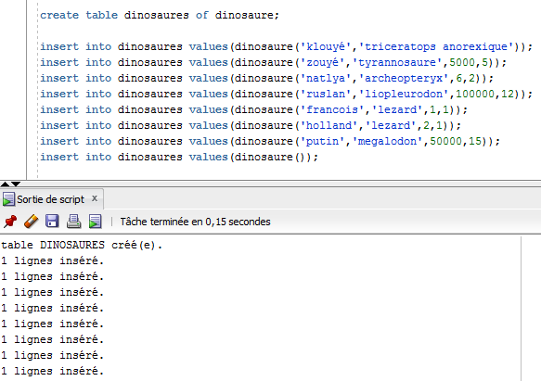

Select queries

Select all information about the whole dinosaures table.
select a.* from dinosaures a;

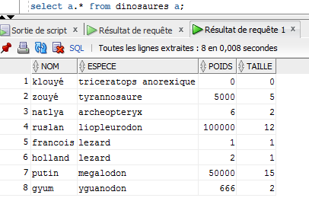
We can see here all input data and also default values for the 1st row as well as the last row which as all attributes filled with default values of the 0 argument constructor.

MAP type object method

Map member method is used to sort objects in the table. Here Map member method grosseur is used to order dinosaurs thanks to their height and weight.

Type and body creation

create or replace type dinosaure as object(
nom varchar2(30),
espece varchar2(30),
poids number(10,1),
taille number(5,1)
map member function grosseur return number
);

create or replace type body dinosaure as
map member function grosseur return number is
begin
return (self.poids+1)/(self.taille+1);
end;
end;

Select queries

Select all information and sort it by the map function in reversed order.
select a.* from dinosaures a order by value(a).grosseur() desc;

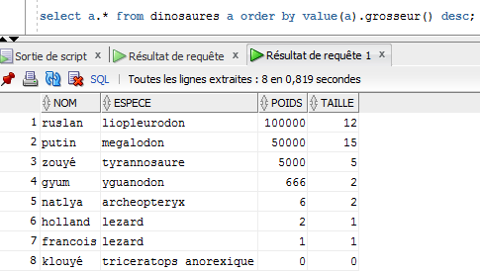
Select only dinosaurs with a size superior to 0, that is to say eliminate default value 0 ordering them using the map function.
select a.* from dinosaures a where taille > 0 order by value(a).grosseur();

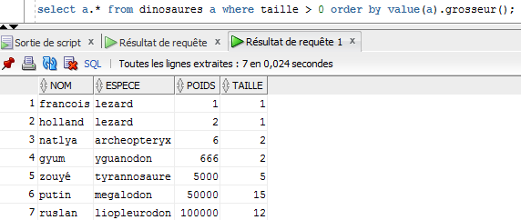

ORDER type object method

Order member method is used to compare objects. Here order member method is used to compare the strength of dinosaurs in order to determine who the predator is and who the prey is. This function also prints “X eats Y” in the DBMS output in case of the current dinosaur of the table (self) is the predator.

Type and body creation

create or replace type dinosaure2 as object(
nom varchar2(30),
espece varchar2(30),
poids number(10,1),
taille number(5,1),
order member function predateur(m_obj dinosaure2) return integer
);

create or replace type body dinosaure2 as
order member function predateur(m_obj dinosaure2) return integer is
begin
if self.poids*self.taille > m_obj.poids*m_obj.taille then
sys.dbms_output.put_line(self.nom || ' mange ' || m_obj.nom || ' !!!' );
return -1;
elsif self.poids*self.taille < m_obj.poids*m_obj.taille then return 1;
else return 0;
end if;
end predateur;
end;

Select query

The idea here is to compare a given dinosaur (identified by its name) to all the dinosaurs in the table.

select value(a).nom, value(a).espece, value(a).predateur(c.obj) as peut_manger, c.obj.nom, c.obj.espece
from dinosaures2 a, ( select value(b) as obj
from dinosaures2 b where nom='natlya') c;
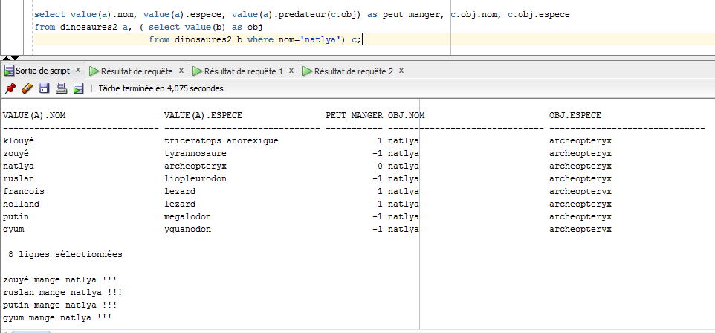

Here we can see the database output in case of the table dinosaurs (self), on the left side of the output is the predator:
- 1 self is the predator
- 0 they are equal, nothing happens
- -1 self is the pray

MEMBER type object method

Member method of type dinosaur is used here to determine the sound they produce when they scream. For this, this method outputs a varchar2 that contains the scream.
The code of this method is split in the type body and an a special package.

Type and body creation

create or replace type dinosaure as object(
nom varchar2(30),
espece varchar2(30),
poids number(10,1),
taille number(5,1),
member function crier return varchar2
);

create or replace type body dinosaure as
member function crier return varchar2 is
begin
return dinoPackage.rugir(self);
end;
end;

Package

This package is used to provide the rugir function used by the screaming (crier) member method of dinosaure type.

create or replace package dinoPackage as
cris varchar2(300);
function rugir(dino dinosaure) return varchar2;
procedure cri(espece varchar2);
end dinoPackage;

create or replace package body dinoPackage as
function rugir( dino dinosaure)return varchar2 is
begin
cri(dino.espece);
return 'ATTENTION : '|| cris;
end;
procedure cri(espece varchar2) is
begin
if espece='triceratops' or espece='triceratops anorexique' or espece='stegosaure' or espece='yguanodon' then cris:= 'brraaaaaaaaaaaaaaaa';
elsif espece='tyranosaure' or espece='alosaure' then cris:= 'cryyyyyééééééééééééééééééééééééééé';
elsif espece='liopleurodon' or espece='megalodon' then cris:= '........ bloup ........... bloup ..... aaaaaaaaaaaaaaaaa ....';
elsif espece='lezard' then cris:= 'gnnéééééééééé';
else cris:= 'cuicui ?!';
end if;
end;
end dinoPackage;

Select queries

First select all the dinosaurs and make them scream.
select value(a).nom, value(a).espece,value(a).crier() from dinosaures a;

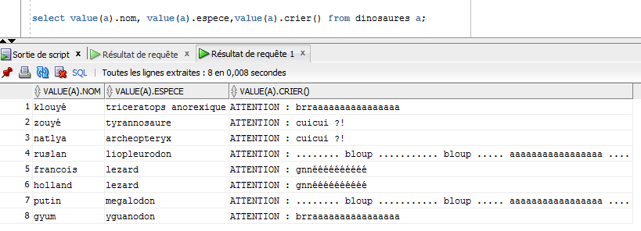
Now order the result using the previous map.
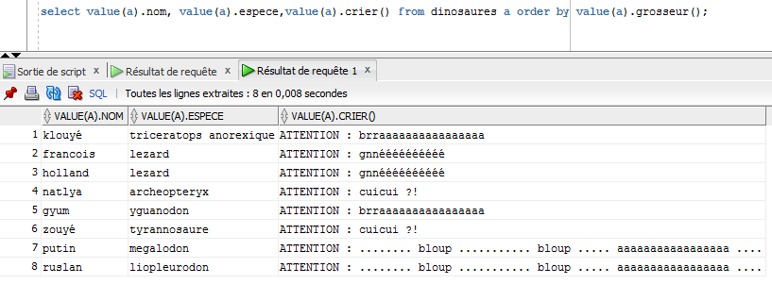
Here we can notice that the biggest dinosaurs live in the see and then are not able to scream ...

Method inheritance

For the method inheritance, we will use the descendant type with is under the dinosaur type and adds an attribute:
- type varchar2

This type has 2 constructors and overrides as well as overloads the crier member method form dinosaur type.

Type and body creation

create or replace type descendant under dinosaure(
type varchar2(20),
constructor function descendant(nom varchar2, espece varchar2) return self as result,
constructor function descendant(nom varchar2, espece varchar2, type varchar2) return self as result,
overriding member function crier return varchar2,
member function crier(d descendant) return varchar2
);

create or replace type body descendant as
member function crier(d descendant) return varchar2 is
begin
if self.type <> d.type then return ' .... .... .... .... ';
elsif self.taille>d.taille then return self.nom || ' a gagné: zzbraaaaaaaaaaa ';
elsif self.taille<d.taille then return self.nom || ' a perdu: ouiiinnnnnnnnnnn ' || d.nom || ' : mouahahahahaha !!!';
else return ' paf paf paf paf ';
end if;
end;
overriding member function crier return varchar2 is
begin
return dinoPackage.nouveauRugir(self);
end;
constructor function descendant(nom varchar2, espece varchar2) return self as result is
begin
self.nom:=nom;
self.espece:=espece;
self.poids:=0;
self.taille:=0;
self.type:='aerien';
return;
end;
constructor function descendant(nom varchar2, espece varchar2, type varchar2) return self as result is
begin
self.nom:=nom;
self.espece:=espece;
self.poids:=0;
self.taille:=0;
self.type:=type;
return;
end;
end;

Package added functions:

create or replace package dinoPackage as
cris varchar2(300);
function rugir(dino dinosaure) return varchar2;
function nouveauRugir(anim descendant) return varchar2;
procedure cri(espece varchar2);
procedure nouveauCri(type varchar2);
end dinoPackage;

create or replace package body dinoPackage as
function rugir( dino dinosaure)return varchar2 is
begin
cri(dino.espece);
return 'ATTENTION : '|| cris;
end;
function nouveauRugir( anim descendant)return varchar2 is
begin
nouveauCri(anim.type);
return '** ATTENTION NOUVEAU RUGISSEMENT : '|| cris;
end;
procedure cri(espece varchar2) is
begin
if espece='triceratops' or espece='triceratops anorexique' or espece='stegosaure' or espece='yguanodon' then cris:= 'brraaaaaaaaaaaaaaaa';
elsif espece='tyranosaure' or espece='alosaure' then cris:= 'cryyyyyééééééééééééééééééééééééééé';
elsif espece='liopleurodon' or espece='megalodon' then cris:= '........ bloup ........... bloup ..... aaaaaaaaaaaaaaaaa ....';
elsif espece='lezard' then cris:= 'gnnéééééééééé';
else cris:= 'cuicui ?!';
end if;
end;
procedure nouveauCri(type varchar2) is
begin
if type='maritime' then cris:= '... bloup ... plouf .... bloupbloup ...... .....';
elsif type='terrestre' then cris:= 'sssssssssshhsssssssssssssss';
elsif type='maritimezoui' then cris:= 'STAAAAAAAAN';
else cris:= 'cuicui !!!!';
end if;
end;
end dinoPackage;

Method overriding

Supertype dinosaur has a member method called “crier” that has no argument and returns a varchar2. Descendant subtype also has this method but with a different result. This method uses a different function of the same package which is adapted to this subtype because it uses the new object attribute: type.

overriding member function crier return varchar2

overriding member function crier return varchar2 is
begin
return dinoPackage.nouveauRugir(self);
end;

Method overloading

Supertype dinosaur's crier member method takes no argument but subtype descendant’s overloaded crier takes an argument and has a different behavior: it outputs the sound produced by the self descendant and the given one when they decide to fight but only if they are of the same type. Indeed it is stupid to simulate fight between an animal that lives in water and another in the air.

member function crier(d descendant) return varchar2

member function crier(d descendant) return varchar2 is
begin
if self.type <> d.type then return ' .... .... .... .... ';
elsif self.taille>d.taille then return self.nom || ' a gagné: zzbraaaaaaaaaaa ';
elsif self.taille<d.taille then return self.nom || ' a perdu: ouiiinnnnnnnnnnn ' || d.nom || ' : mouahahahahaha !!!';
else return ' paf paf paf paf ';
end if;
end;

Data input

Table descendants of descendant

First in a simple object row table: table descendants made of descendant.

create table descendants of descendant;

insert into descendants values(descendant('zouyé','crocodile',50,2,'maritimezoui'));
insert into descendants values(descendant('gyum','fishkoyé','maritime'));
insert into descendants values(descendant('natlya','pigeon'));
insert into descendants values(descendant('klouyé','girafe',80,1,'terrestre'));
insert into descendants values(descendant('ruslan','moule',1,1,'maritime'));
insert into descendants values(descendant('angela','lion',150,1.5,'terrestre'));
insert into descendants values(descendant('merkel','anguille',1,3,'maritime'));
insert into descendants values(descendant('rimi','moineau',100,10,'aerien'));

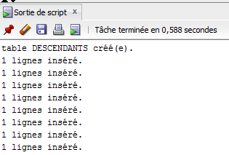

Table dinosaures of dinosaure

Secondly in this line we will add a descendant, subclass of dinosaure in the previous table: dinosaures that originally contains only pure dinosaurs.
insert into dinosaures values(descendant('grosRimi','dindon',40,4,'aerien'));

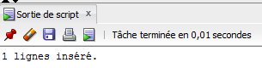

Select queries

Basic data selection

First select all information about descendants table:

select a.* from descendants a ;
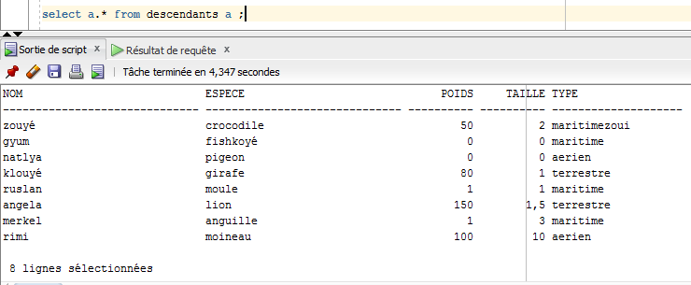

Method overriding

Then with the descendant methods in the descendants table: overridden method crier()

select value(a).nom, value(a).espece,value(a).crier() from descendants a;

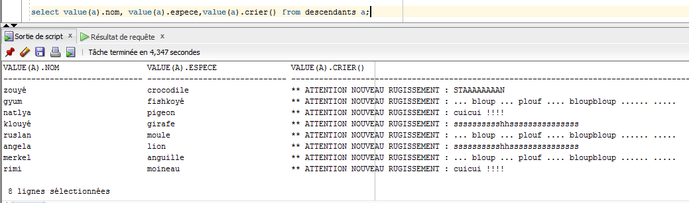
Here we can see that it is the the overridden version of the crier() method that is used (“ATTENTION NOUVEAU RUGISSEMENT” is typical from descendant type).

But the most interesting with method overriding is the result of this query on the dinosaurs table with the new descendant item in the last row:

select value(a).nom, value(a).espece,value(a).crier() from dinosaures a;

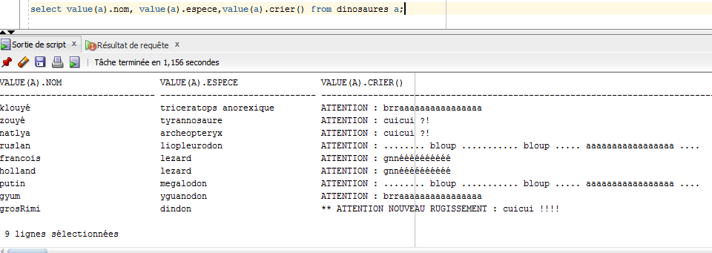

Observation
Here we can see that inheritance is a very powerful feature: in this table of dinosaurs, it is possible to call the crier() method on every row and the type corresponding method is used. In fact it is something really strong because the DBMS knows that any item of dinosaure type can apply this method and because descendant is a subtype of dinosaure, the DBMS allows the usage of this method, even if the implementation is different.
Therefore it is possible with this overriding to perform extremely complex actions in a single command. We can for example consider a table of polygons storing all the data of a map, this table contains also subtypes such as triangles, squares and rectangles. The objective is to compute the total area occupied by these items. Supertype has a method area() that is a general and not optimized method, however subtypes override this method to implement specific and optimized way of compute their area. When the user will want to know the total occupied area, he will just have to sum the result of each result of area() method of each item. The DBMS will always use the “latest” method considering types hierarchy to compute each area and the query result will be naturally optimized.

Method overloading

Here will be tested the behavior of the overloaded crier() method, that is to say the crier() version from descendant type that takes an other descendant in argument.
For this the descendant named “ruslan” will be used to simulate the sound of fight against the descendants of the whole table.
select value(a).nom, value(a).espece, value(a).type,value(a).crier(c.obj)
from descendants a, ( select value(b) as obj
from descendants b where nom='ruslan') c;

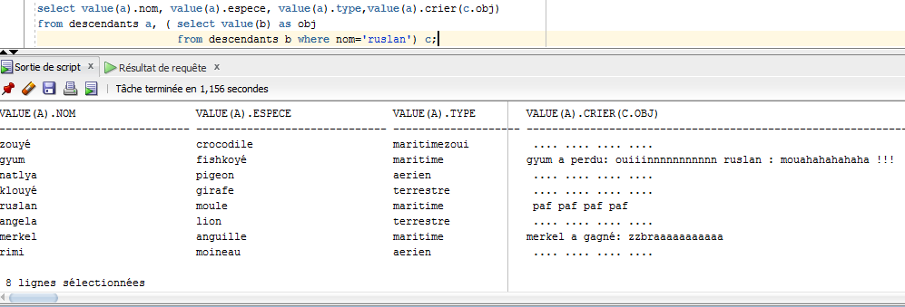
We can see that the overloaded method is working correctly and displaying the expected results: fight description is displayed when the fight can take place and “... … … ...” is displayed when descendant's type is different, as expected.

Conclusions

As in object oriented programming, object relational databases allow usage of methods related to manipulated objects.
With these methods, first it is possible to organize the output of the table, but it is also possible to define default values to attributes as well as defining complex comparison procedures between two objects. Moreover, it is possible to define any method, with or without interactions with other objects as well as type and method inheritance, which is a very import part of object oriented programming languages.
Therefore we can conclude that object oriented databases are able to take a part of object oriented programs by carrying out a lot of features and by the inherent optimization of databases make the resulting program much more efficient than a simple single programming language program.
Object relational databases are then a way to distribute computations, in order to set a distributed system up but not only on the purpose of storing data but also for method execution concerning the stored objects.
Moreover the possibility offered by oracle databases to execute java programs internally extends even more this distribution opportunity and allows programs and computations to be even more easily optimized which is useful when dealing with large amount of data.

Annexes: SQL Code

Create types dinosaure and dinosaure2

drop table dinosaures;
drop type descendant;

create or replace type dinosaure as object(
nom varchar2(30),
espece varchar2(30),
poids number(10,1),
taille number(5,1),
constructor function dinosaure return self as result,
constructor function dinosaure(nom varchar2, espece varchar2) return self as result,
constructor function dinosaure(nom varchar2, espece varchar2, poids number, taille number) return self as result,
map member function grosseur return number,
member function crier return varchar2
)not final;

create or replace type body dinosaure as
constructor function dinosaure return self as result is
begin
self.nom:='gyum';
self.espece:='yguanodon';
self.poids:=666;
self.taille:=2;
return;
end;
constructor function dinosaure(nom varchar2, espece varchar2) return self as result is
begin
self.nom:=nom;
self.espece:=espece;
self.poids:=0;
self.taille:=0;
return;
end;
constructor function dinosaure(nom varchar2, espece varchar2, poids number, taille number) return self as result is
begin
self.nom:=nom;
self.espece:=espece;
self.poids:=poids;
self.taille:=taille;
return;
end;
map member function grosseur return number is
begin
return (self.poids+1)/(self.taille+1);
end;
member function crier return varchar2 is
begin
return dinoPackage.rugir(self);
end;
end;

drop table dinosaures2;

create or replace type dinosaure2 as object(
nom varchar2(30),
espece varchar2(30),
poids number(10,1),
taille number(5,1),
constructor function dinosaure2 return self as result,
constructor function dinosaure2(nom varchar2, espece varchar2) return self as result,
constructor function dinosaure2(nom varchar2, espece varchar2, poids number, taille number) return self as result,
order member function predateur(m_obj dinosaure2) return integer
);

create or replace type body dinosaure2 as
constructor function dinosaure2 return self as result is
begin
self.nom:='gyum';
self.espece:='yguanodon';
self.poids:=666;
self.taille:=2;
return;
end;
constructor function dinosaure2(nom varchar2, espece varchar2) return self as result is
begin
self.nom:=nom;
self.espece:=espece;
self.poids:=0;
self.taille:=0;
return;
end;
constructor function dinosaure2(nom varchar2, espece varchar2, poids number, taille number) return self as result is
begin
self.nom:=nom;
self.espece:=espece;
self.poids:=poids;
self.taille:=taille;
return;
end;
order member function predateur(m_obj dinosaure2) return integer is
begin
if self.poids*self.taille > m_obj.poids*m_obj.taille then
sys.dbms_output.put_line(self.nom || ' mange ' || m_obj.nom || ' !!!' );
return -1;
elsif self.poids*self.taille < m_obj.poids*m_obj.taille then return 1;
else return 0;
end if;
end predateur;
end;

Create type descendant

drop table dinosaures;
drop table descendants;

create or replace type descendant under dinosaure(
type varchar2(20),
constructor function descendant(nom varchar2, espece varchar2) return self as result,
constructor function descendant(nom varchar2, espece varchar2, type varchar2) return self as result,
overriding member function crier return varchar2,
member function crier(d descendant) return varchar2
);

create or replace type body descendant as
member function crier(d descendant) return varchar2 is
begin
if self.type <> d.type then return ' .... .... .... .... ';
elsif self.taille>d.taille then return self.nom || ' a gagné: zzbraaaaaaaaaaa ';
elsif self.taille<d.taille then return self.nom || ' a perdu: ouiiinnnnnnnnnnn ' || d.nom || ' : mouahahahahaha !!!';
else return ' paf paf paf paf ';
end if;
end;
overriding member function crier return varchar2 is
begin
return dinoPackage.nouveauRugir(self);
end;
constructor function descendant(nom varchar2, espece varchar2) return self as result is
begin
self.nom:=nom;
self.espece:=espece;
self.poids:=0;
self.taille:=0;
self.type:='aerien';
return;
end;
constructor function descendant(nom varchar2, espece varchar2, type varchar2) return self as result is
begin
self.nom:=nom;
self.espece:=espece;
self.poids:=0;
self.taille:=0;
self.type:=type;
return;
end;
end;

Create package

create or replace package dinoPackage as
cris varchar2(300);
function rugir(dino dinosaure) return varchar2;
function nouveauRugir(anim descendant) return varchar2;
procedure cri(espece varchar2);
procedure nouveauCri(type varchar2);
end dinoPackage;

create or replace package body dinoPackage as
function rugir( dino dinosaure)return varchar2 is
begin
cri(dino.espece);
return 'ATTENTION : '|| cris;
end;
function nouveauRugir( anim descendant)return varchar2 is
begin
nouveauCri(anim.type);
return '** ATTENTION NOUVEAU RUGISSEMENT : '|| cris;
end;
procedure cri(espece varchar2) is
begin
if espece='triceratops' or espece='triceratops anorexique' or espece='stegosaure' or espece='yguanodon' then cris:= 'brraaaaaaaaaaaaaaaa';
elsif espece='tyranosaure' or espece='alosaure' then cris:= 'cryyyyyééééééééééééééééééééééééééé';
elsif espece='liopleurodon' or espece='megalodon' then cris:= '........ bloup ........... bloup ..... aaaaaaaaaaaaaaaaa ....';
elsif espece='lezard' then cris:= 'gnnéééééééééé';
else cris:= 'cuicui ?!';
end if;
end;
procedure nouveauCri(type varchar2) is
begin
if type='maritime' then cris:= '... bloup ... plouf .... bloupbloup ...... .....';
elsif type='terrestre' then cris:= 'sssssssssshhsssssssssssssss';
elsif type='maritimezoui' then cris:= 'STAAAAAAAAN';
else cris:= 'cuicui !!!!';
end if;
end;
end dinoPackage;

Insert and select queries

SET SERVEROUTPUT ON;
drop table descendants;
drop table dinosaures;
create table dinosaures of dinosaure;

insert into dinosaures values(dinosaure('klouyé','triceratops anorexique'));
insert into dinosaures values(dinosaure('zouyé','tyrannosaure',5000,5));
insert into dinosaures values(dinosaure('natlya','archeopteryx',6,2));
insert into dinosaures values(dinosaure('ruslan','liopleurodon',100000,12));
insert into dinosaures values(dinosaure('francois','lezard',1,1));
insert into dinosaures values(dinosaure('holland','lezard',2,1));
insert into dinosaures values(dinosaure('putin','megalodon',50000,15));
insert into dinosaures values(dinosaure());

select value(a) from dinosaures a;
select a.* from dinosaures a;

select a.* from dinosaures a where taille > 0 order by value(a).grosseur();

drop table dinosaures2;

create table dinosaures2 of dinosaure2;

insert into dinosaures2 values(dinosaure2('klouyé','triceratops anorexique'));
insert into dinosaures2 values(dinosaure2('zouyé','tyrannosaure',5000,5));
insert into dinosaures2 values(dinosaure2('natlya','archeopteryx',6,2));
insert into dinosaures2 values(dinosaure2('ruslan','liopleurodon',100000,12));
insert into dinosaures2 values(dinosaure2('francois','lezard',1,1));
insert into dinosaures2 values(dinosaure2('holland','lezard',2,1));
insert into dinosaures2 values(dinosaure2('putin','megalodon',50000,15));
insert into dinosaures2 values(dinosaure2());

select value(a) from dinosaures2 a;

select value(a).nom, value(a).espece, value(a).predateur(c.obj) as peut_manger, c.obj.nom, c.obj.espece
from dinosaures2 a, ( select value(b) as obj
from dinosaures2 b where nom='natlya') c;

select value(a).nom, value(a).espece,value(a).crier() from dinosaures a;

select value(a).nom, value(a).espece,value(a).crier() from dinosaures a order by value(a).grosseur();

create table descendants of descendant;
insert into descendants values(descendant('zouyé','crocodile',50,2,'maritimezoui'));
insert into descendants values(descendant('gyum','fishkoyé','maritime'));
insert into descendants values(descendant('natlya','pigeon'));
insert into descendants values(descendant('klouyé','girafe',80,1,'terrestre'));
insert into descendants values(descendant('ruslan','moule',1,1,'maritime'));
insert into descendants values(descendant('angela','lion',150,1.5,'terrestre'));
insert into descendants values(descendant('merkel','anguille',1,3,'maritime'));
insert into descendants values(descendant('rimi','moineau',100,10,'aerien'));
insert into dinosaures values(descendant('grosRimi','dindon',40,4,'aerien'));

select a.* from descendants a ;

select value(a).nom, value(a).espece,value(a).crier() from descendants a;

select value(a).nom, value(a).espece,value(a).crier() from dinosaures a;

select value(a).nom, value(a).espece,value(a).crier(c.obj)
from descendants a, ( select value(b) as obj
from descendants b where nom='grosRimi') c;

select value(a).nom, value(a).espece, value(a).type,value(a).crier(c.obj)
from descendants a, ( select value(b) as obj
from descendants b where nom='ruslan') c;

