Guillaume Minette de Saint Martin December 2015

Technology of Large Databases



Practical Work 4

Table of contents
Subject 3
XML documents and schema files. 4
XML document 5
XSD Document 6
Design and creation of XML tables 10
Unstructured type 10
Structured type 10
Binary type 10
Perform input of data 12
Extraction of data 13
Perform registration of schema 15
Create table for structured type of storage with use of schema. 17
Creation 17
Inspection of the created elements 17
Queries 19
Additional queries 22
Relational type of data from XML stored data 22
XML type of data from relational type of data 22
Analysis 24
Conclusions 25
Annexes 26
SQL code 26
XML document 27
XML schema 29

Subject

4th practical work (DB1+DB2). XML DB
Design of XML database. Deadline: 14. December.
1. With XML editor (EditX, Oxygen, …) design and create XML documents and schema files.
2. Design and creation of XML database data storage object-relational tables with XMLType use:
– unstructured type (CLOB type);
– structured type (OR type);
– if You use Oracle12, binary type.
3. Perform input of data (as text and use bfile (directory creation and use of large object function bfile)).
4. Perform extraction of data (queries (4)) from tables.
5. Perform registration of schema.
6. Create table for structured type of storage with use of schema.
7. Perform 4 queries.
8. Perform queries:
– to achieve relational type of data from XML stored data;
– to achieve XML type of data from relational type of data.
9. Conclusions.

XML documents and schema files.
To create the XML documents, I used Altova XMLSpy. Then, thanks to this editor, I generated the related XSD schema.
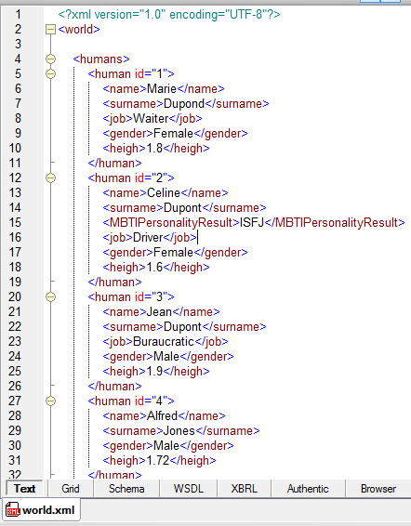
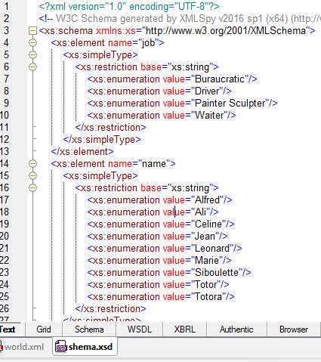
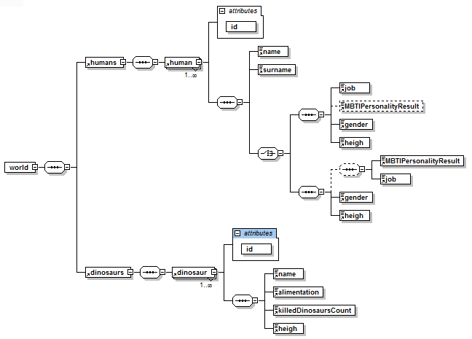XML tree representation

XML document

The XML document is the following, it is a description of a world with humans and dinosaurs.

<?xml version="1.0" encoding="UTF-8"?>
<world>

<humans>
<human id="1">
<name>Marie</name>
<surname>Dupond</surname>
<job>Waiter</job>
<gender>Female</gender>
<heigh>1.8</heigh>
</human>
<human id="2">
<name>Celine</name>
<surname>Dupont</surname>
<MBTIPersonalityResult>ISFJ</MBTIPersonalityResult>
<job>Driver</job>
<gender>Female</gender>
<heigh>1.6</heigh>
</human>
<human id="3">
<name>Jean</name>
<surname>Dupont</surname>
<job>Buraucratic</job>
<gender>Male</gender>
<heigh>1.9</heigh>
</human>
<human id="4">
<name>Alfred</name>
<surname>Jones</surname>
<gender>Male</gender>
<heigh>1.72</heigh>
</human>
<human id="5">
<name>Leonard</name>
<surname>Davici</surname>
<job>Painter Sculpter</job>
<MBTIPersonalityResult>ENTP</MBTIPersonalityResult>
<gender>Male</gender>
<heigh>1.72</heigh>
</human>
</humans>

<dinosaurs>
<dinosaur id="1">
<name>Totor</name>
<alimentation>Meat</alimentation>
<killedDinosaursCount>50</killedDinosaursCount>
<heigh>9</heigh>
</dinosaur>
<dinosaur id="2">
<name>Totora</name>
<alimentation>Meat</alimentation>
<killedDinosaursCount>42</killedDinosaursCount>
<heigh>7.42</heigh>
</dinosaur>
<dinosaur id="3">
<name>Siboulette</name>
<alimentation>Vegetables</alimentation>
<killedDinosaursCount>2</killedDinosaursCount>
<heigh>12</heigh>
</dinosaur>
<dinosaur id="4">
<name>Ali</name>
<alimentation>Vegetables</alimentation>
<killedDinosaursCount>5</killedDinosaursCount>
<heigh>4</heigh>
</dinosaur>
</dinosaurs>

</world>

XSD Document

The related XSD schema generated by Altova XMLSpy is the following:

<?xml version="1.0" encoding="UTF-8"?>
<!-- W3C Schema generated by XMLSpy v2016 sp1 (x64) (http://www.altova.com) -->
<xs:schema xmlns:xs="http://www.w3.org/2001/XMLSchema">
<xs:element name="job">
<xs:simpleType>
<xs:restriction base="xs:string">
<xs:enumeration value="Buraucratic"/>
<xs:enumeration value="Driver"/>
<xs:enumeration value="Painter Sculpter"/>
<xs:enumeration value="Waiter"/>
</xs:restriction>
</xs:simpleType>
</xs:element>
<xs:element name="name">
<xs:simpleType>
<xs:restriction base="xs:string">
<xs:enumeration value="Alfred"/>
<xs:enumeration value="Ali"/>
<xs:enumeration value="Celine"/>
<xs:enumeration value="Jean"/>
<xs:enumeration value="Leonard"/>
<xs:enumeration value="Marie"/>
<xs:enumeration value="Siboulette"/>
<xs:enumeration value="Totor"/>
<xs:enumeration value="Totora"/>
</xs:restriction>
</xs:simpleType>
</xs:element>
<xs:element name="heigh">
<xs:simpleType>
<xs:restriction base="xs:decimal">
<xs:enumeration value="1.6"/>
<xs:enumeration value="1.72"/>
<xs:enumeration value="1.8"/>
<xs:enumeration value="1.9"/>
<xs:enumeration value="12"/>
<xs:enumeration value="4"/>
<xs:enumeration value="7.42"/>
<xs:enumeration value="9"/>
</xs:restriction>
</xs:simpleType>
</xs:element>
<xs:element name="human">
<xs:complexType>
<xs:sequence>
<xs:element ref="name"/>
<xs:element ref="surname"/>
<xs:choice>
<xs:sequence>
<xs:element ref="job"/>
<xs:element ref="MBTIPersonalityResult" minOccurs="0"/>
<xs:element ref="gender"/>
<xs:element ref="heigh"/>
</xs:sequence>
<xs:sequence>
<xs:sequence minOccurs="0">
<xs:element ref="MBTIPersonalityResult"/>
<xs:element ref="job"/>
</xs:sequence>
<xs:element ref="gender"/>
<xs:element ref="heigh"/>
</xs:sequence>
</xs:choice>
</xs:sequence>
<xs:attribute name="id" use="required">
<xs:simpleType>
<xs:restriction base="xs:byte">
<xs:enumeration value="1"/>
<xs:enumeration value="2"/>
<xs:enumeration value="3"/>
<xs:enumeration value="4"/>
<xs:enumeration value="5"/>
</xs:restriction>
</xs:simpleType>
</xs:attribute>
</xs:complexType>
</xs:element>
<xs:element name="world">
<xs:complexType>
<xs:sequence>
<xs:element ref="humans"/>
<xs:element ref="dinosaurs"/>
</xs:sequence>
</xs:complexType>
</xs:element>
<xs:element name="gender">
<xs:simpleType>
<xs:restriction base="xs:string">
<xs:enumeration value="Female"/>
<xs:enumeration value="Male"/>
</xs:restriction>
</xs:simpleType>
</xs:element>
<xs:element name="humans">
<xs:complexType>
<xs:sequence>
<xs:element ref="human" maxOccurs="unbounded"/>
</xs:sequence>
</xs:complexType>
</xs:element>
<xs:element name="surname">
<xs:simpleType>
<xs:restriction base="xs:string">
<xs:enumeration value="Davici"/>
<xs:enumeration value="Dupond"/>
<xs:enumeration value="Dupont"/>
<xs:enumeration value="Jones"/>
</xs:restriction>
</xs:simpleType>
</xs:element>
<xs:element name="dinosaur">
<xs:complexType>
<xs:sequence>
<xs:element ref="name"/>
<xs:element ref="alimentation"/>
<xs:element ref="killedDinosaursCount"/>
<xs:element ref="heigh"/>
</xs:sequence>
<xs:attribute name="id" use="required">
<xs:simpleType>
<xs:restriction base="xs:byte">
<xs:enumeration value="1"/>
<xs:enumeration value="2"/>
<xs:enumeration value="3"/>
<xs:enumeration value="4"/>
</xs:restriction>
</xs:simpleType>
</xs:attribute>
</xs:complexType>
</xs:element>
<xs:element name="dinosaurs">
<xs:complexType>
<xs:sequence>
<xs:element ref="dinosaur" maxOccurs="unbounded"/>
</xs:sequence>
</xs:complexType>
</xs:element>
<xs:element name="alimentation">
<xs:simpleType>
<xs:restriction base="xs:string">
<xs:enumeration value="Meat"/>
<xs:enumeration value="Vegetables"/>
</xs:restriction>
</xs:simpleType>
</xs:element>
<xs:element name="killedDinosaursCount">
<xs:simpleType>
<xs:restriction base="xs:byte">
<xs:enumeration value="2"/>
<xs:enumeration value="42"/>
<xs:enumeration value="5"/>
<xs:enumeration value="50"/>
</xs:restriction>
</xs:simpleType>
</xs:element>
<xs:element name="MBTIPersonalityResult">
<xs:simpleType>
<xs:restriction base="xs:string">
<xs:enumeration value="ENTP"/>
<xs:enumeration value="ISFJ"/>
</xs:restriction>
</xs:simpleType>
</xs:element>
</xs:schema>

Design and creation of XML tables

Unstructured type

In oracle databases, an unstructured storage type is CLOB (character large object). To create a table of data with XML type, we can use this CLOB type with the following command:

create table clobTable of xmltype xmltype store as clob;
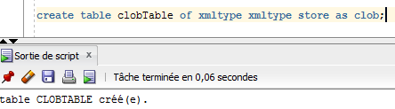

Structured type

In oracle databases, a structured storage type is object relational. To create a table of data with XML type, we can use this object relational type with the following command:

create table relTable of xmltype xmltype store as object relational
xmlschema "http://localhost:8080/public/schema.xsd" element "world";

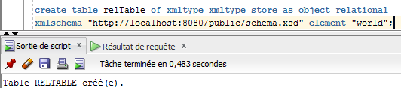

Binary type

The best type to be used when using a XML database is binary type, a new type recently introduced in oracle databases, the command to use this type is the following:
create table binTable of xmltype xmltype store as binary xml;

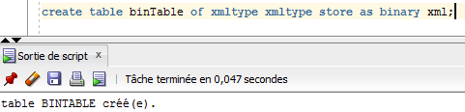

Perform input of data

Data can be input thanks to the following commands:
insert into binTable values(XMLType(
'<?xml version="1.0" encoding="UTF-8"?>
<world> …........................................ </world>'
));
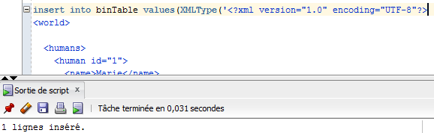

Which is also working with bfile

insert into binTable values (xmltype(bfilename('XMLDIR','world.xml'),nls_charset_id('UTF8')));
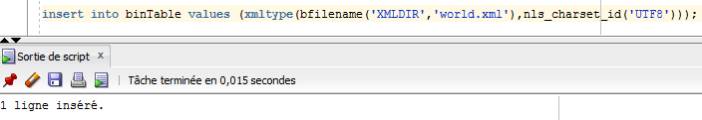

Then a new row of type XMLType is added to the table.

Extraction of data

Extraction of all names and surnames of the humans in the colbTable:

select extract(object_value, '/world/humans/human/name'), extract(object_value, '/world/humans/human/surname')
from clobTable;

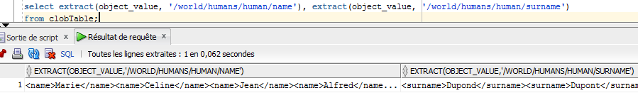
Extraction of all information in the binTable:

select a.*
from binTable a;

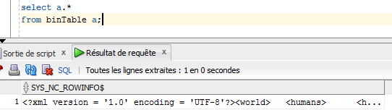
Extraction of information about dinosaur with id 2 of the clobTable

select extract(object_value, '/world/dinosaurs/dinosaur[2]')
from clobTable;

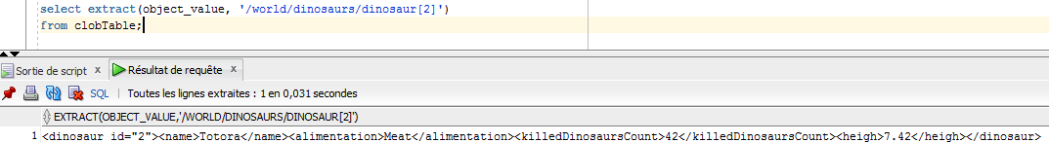
Tests about values in database: function existsnode()

Compare the real value and the result of the function existnode() with a given value

select extract(object_value, '/world/humans/human[1]/job'), existsnode(object_value, '/world/humans/human[1]/job="Waiter"'),
extract(object_value, '/world/humans/human[2]/job'), existsnode(object_value, '/world/humans/human[2]/job="Waiter"')
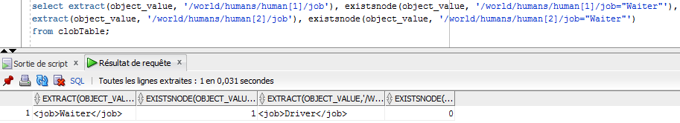
from clobTable;

Existnode() returns 1 if the node with the given value exists, 0 otherwise.

Perform registration of schema

To register a schema, first it is needed to register a directory which contains this schema:
In order to do this, the XMLDIR directory is registered, it contains the needed schema.

Command:

create or replace directory XMLDIR as 'C:\XMLDB';
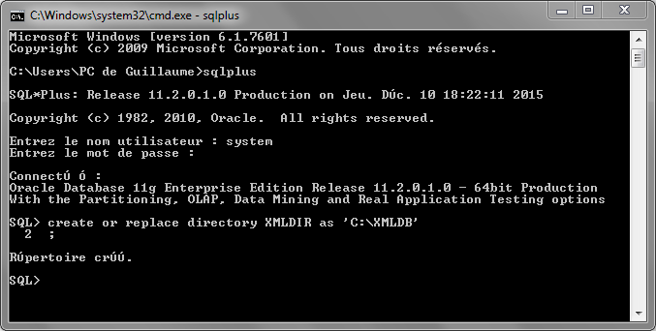
After this, it is possible to register the schema
Command:
begin
DBMS_XMLSCHEMA.REGISTERSCHEMA(
SCHEMAURL => 'http://localhost:8080/public/schema.xsd',
SCHEMADOC => bfilename ('XMLDIR', 'schema.xsd'),
CSID => nls_charset_id ('UTF8'));
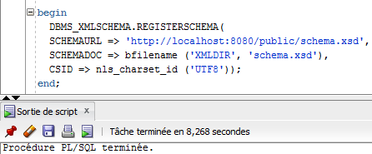
end;

Finally, the schema is in the database
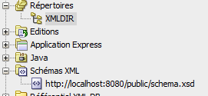
It is possible to select it :
Command:
select schema_url from user_xml_schemas;
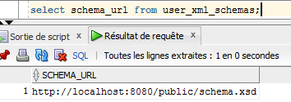

Create table for structured type of storage with use of schema.

Creation
In order to create a structured type of storage with a schema, we need to use the previously registered schema. The following statement allows to do it:

create table relTable of xmltype xmltype store as object relational
xmlschema "http://localhost:8080/public/schema.xsd" element "world";

Inspection of the created elements

To check what has been done in the database after this table creation, it is possible to inspect the user_xml_tables table that contains information about XML tables.

Command:
select table_name, xmlschema, element_name, storage_type from user_xml_tables;
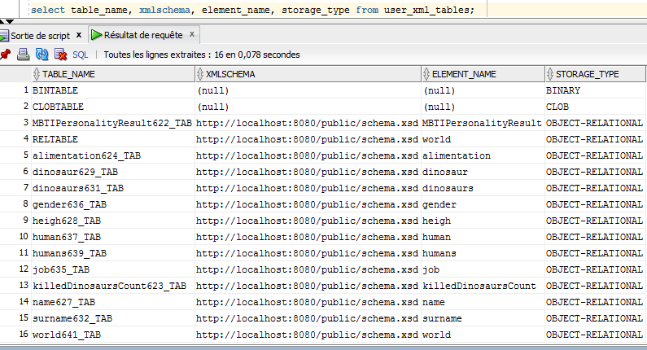
Here we can see the two previously created tables BINTABLE and CLOBTABLE that are stored as excepted as BINARY and CLOB but we also recognize all elements present in the xml document that are related to the registered schema and are stored as OBJECT-RELATIONAL.
It is a structured type of storage that is completely different than clob or binary, it describes precisely each element.

Queries

After insertion of data in the relational table by the following command, select queries are performed.
For the following queries, the output will be displayed with SQLPlus because there is a compatibility bug with SQLDeveloper and outputting data from object-relational table with XML.
Command:
insert into relTable values (xmltype(bfilename('XMLDIR','world.xml'),nls_charset_id('UTF8')));

Select all informations about this table:
select * from relTable ;
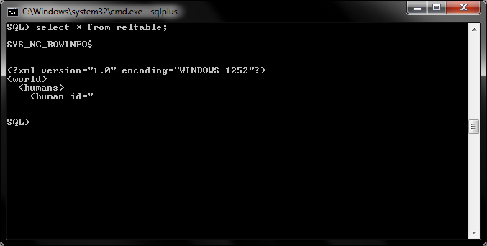

Select information about dinosaur with id 3:
select extract(object_value, '/world/dinosaurs/dinosaur[3]') from reltable;
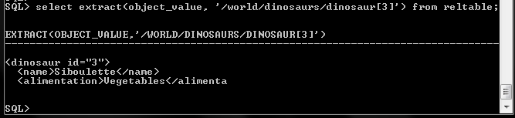
Select information and output as a string, usage of function getStringVal():

select extract(object_value, '/world/humans/human[2]').getStringVal(),
extract(object_value, '/world/humans/human[2]')
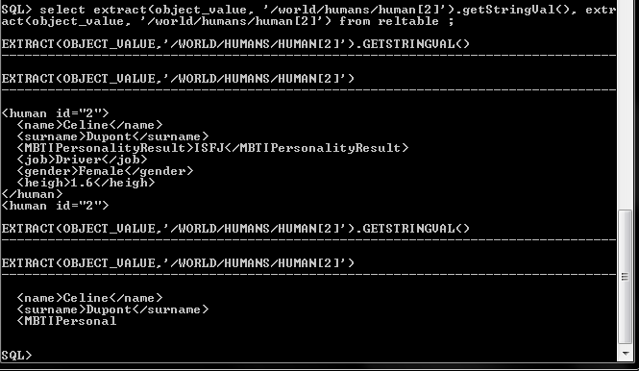
from reltable ;

Here the 1st part is the result of the toStringVal() method, we can see the entire result and the 2nd part is the result of the same query without toStringVal() method: the result is not displayed entirely by outputting a string, this function forces the complete output of the query.

Selection of the schema URL of an element, usage of function getSchemaURL():

select extract(object_value, '/world/humans/human[2]').getSchemaURL()
from reltable ;

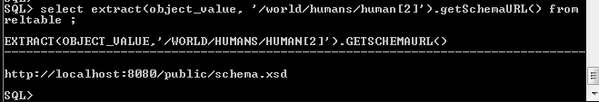
As expected, here is the previously registered XSD schema related to the table.

Try to insert a data that doesn't fit with the XML Schema:

The age tag is not defined in the XML Schema.

insert into reltable values (xmltype('<?xml version="1.0" encoding="UTF-8"?>
<world>
<dinosaurs>
<dinosaur id="1">
<name>Totor</name>
<alimentation>Meat</alimentation>
<age>15</age>
<killedDinosaursCount>50</killedDinosaursCount>
<heigh>9</heigh>
</dinosaur>
</dinosaurs>
</world>'));
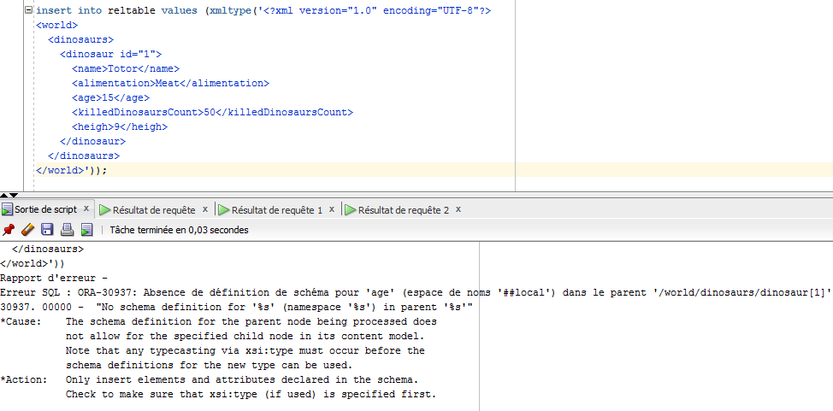

As expected in the structured type, the age tag is not allowed, the insertion is forbidden, an error is produced. This table has a well defined structure which includes constraints that have been automatically imported from the XML Schema.

Additional queries

Relational type of data from XML stored data

It is possible to achieve relational type of data from XML stored data by using the EXTRACTVALUE() function and converting the needed XML nodes into relational data.

Command:
SELECT EXTRACTVALUE(object_value,'/world/humans/human[1]/name') as name,
EXTRACTVALUE(object_value,'world/humans/human[1]/surname') as surname,
EXTRACTVALUE(object_value,'world/humans/human[1]/MBTIPersonalityResult') as MBTIPersonalityResult,
EXTRACTVALUE(object_value,'world/humans/human[1]/job') as job,
EXTRACTVALUE(object_value,'world/humans/human[1]/gender') as gender,
EXTRACTVALUE(object_value,'world/humans/human[1]/heigh') as height
FROM bintable;

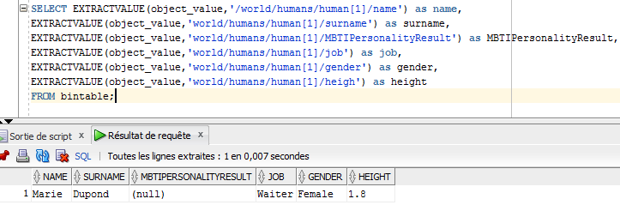
We can see here the classical relational version of the data stored as XMLType.

XML type of data from relational type of data

By using the function XMLFOREST(), it is possible to create XMLType from relational type of data. When using this function, the produced XMLType object has nodes relatively to the name of the relational table columns.

To use this function, a relational table is needed, therefore the following table will be used:
create table mythology(
name varchar(30),
type varchar(30),
gender varchar(30)
);
insert into mythology (name, type, gender) values ('hyperion', 'titan','male');
insert into mythology (name, type, gender) values ('tethys', 'titan','female');
insert into mythology (name, type, gender) values ('polyphemus', 'cyclop','male');
insert into mythology (name, type, gender) values ('poseidon', 'god of the sea','male');
insert into mythology (name, type, gender) values ('atalanta', 'argonaut','male');

select * from mythology;
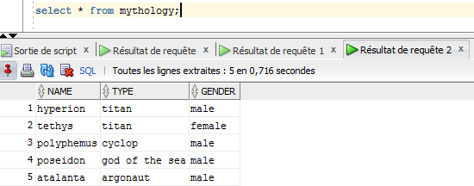
Then, with the XMLFOREST() function, it is possible to convert this table into XMLType data.

Command:
select xmlforest(name, type, gender) as xmltype
from mythology;

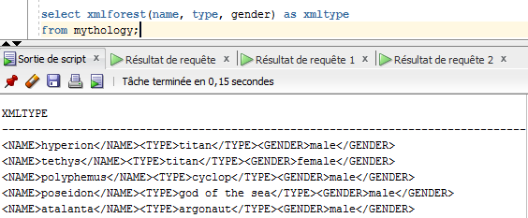

Analysis

With this transformations from a classical type to another, here XML, it is possible to do convert anything in a portable way, that is to say it is possible to save tables in standard formats as XML. This is allows then to save tables in an other way than using the database and therefore communicate data or even tables between two systems, databases or just programs.

Conclusions
XML databases are very different than standard databases, they need the usage of XPaths, are bases on text files and need a least a XML Schema to have a defined structure.
This file base structure allows to define and fill differently the database comparing to the traditional ways (create table (...); insert into (…)) but it allows to design tables independently of the database, by different editors and automatically create the constraints.
According to this principle, it is possible to save and transfer information very easily for a program to another and it is exactly what almost all programs do to transfer data from their databases.
Moreover, because it is easy to convert data from XML to relational as well as the reverse operation, it is possible to convert and transfer or import any table of any kind through data systems.
However we should not forget that information technologies are evolving all the time and XML is a very old language (20 years is old in the information technologies world). Nowadays, XML tends to be replaced by a similar but more optimized language, the JavaScript Object Notation, JSON.

Annexes

SQL code

select schema_url from user_xml_schemas;

drop table relTable;
drop table binTable;
drop table clobTable;

create table binTable of xmltype xmltype store as binary xml;

create table clobTable of xmltype xmltype store as clob;

create table relTable of xmltype xmltype store as object relational
xmlschema "http://localhost:8080/public/schema.xsd" element "world";

insert into binTable values (xmltype(bfilename('XMLDIR','world.xml'),nls_charset_id('UTF8')));

select table_name, xmlschema, element_name, storage_type from user_xml_tables;

select extract(object_value, '/world/humans/human/name'), extract(object_value, '/world/humans/human/surname')
from clobTable;

select extract(object_value, '/world/humans/human[1]/job'), existsnode(object_value, '/world/humans/human[1]/job="Waiter"'),
extract(object_value, '/world/humans/human[2]/job'), existsnode(object_value, '/world/humans/human[2]/job="Waiter"')
from clobTable;

select * from user_xml_tables;

select extract(object_value, '/world/humans/human/name'), extract(object_value, '/world/humans/human/surname')
from clobTable;

select extract(object_value, '/world/dinosaurs/dinosaur[2]')
from clobTable;

insert into relTable values (xmltype(bfilename('XMLDIR','world.xml'),nls_charset_id('UTF8')));

select * from relTable ;

select extract(object_value, '/world/humans/human[2]').getStringVal(),
extract(object_value, '/world/humans/human[2]')
from reltable ;

select extract(object_value, '/world/humans/human[2]').getSchemaURL() from reltable ;

insert into reltable values (xmltype(select * from bintable));

insert into reltable values (xmltype('<?xml version="1.0" encoding="UTF-8"?>
<world>
<dinosaurs>
<dinosaur id="1">
<name>Totor</name>
<alimentation>Meat</alimentation>
<age>15</age>
<killedDinosaursCount>50</killedDinosaursCount>
<heigh>9</heigh>
</dinosaur>
</dinosaurs>
</world>'));

--

SELECT EXTRACTVALUE(object_value,'/world/humans/human[1]/name') as name,
EXTRACTVALUE(object_value,'world/humans/human[1]/surname') as surname,
EXTRACTVALUE(object_value,'world/humans/human[1]/MBTIPersonalityResult') as MBTIPersonalityResult,
EXTRACTVALUE(object_value,'world/humans/human[1]/job') as job,
EXTRACTVALUE(object_value,'world/humans/human[1]/gender') as gender,
EXTRACTVALUE(object_value,'world/humans/human[1]/heigh') as height
FROM bintable;

select * from bintable;

drop table mythology;

create table mythology(
name varchar(30),
type varchar(30),
gender varchar(30)
);
insert into mythology (name, type, gender) values ('hyperion', 'titan','male');
insert into mythology (name, type, gender) values ('tethys', 'titan','female');
insert into mythology (name, type, gender) values ('polyphemus', 'cyclop','male');
insert into mythology (name, type, gender) values ('poseidon', 'god of the sea','male');
insert into mythology (name, type, gender) values ('atalanta', 'argonaut','male');

select * from mythology;

select xmlforest(name, type, gender) as xmltype
from mythology;

XML document
<?xml version="1.0" encoding="UTF-8"?>
<world>

<humans>
<human id="1">
<name>Marie</name>
<surname>Dupond</surname>
<job>Waiter</job>
<gender>Female</gender>
<heigh>1.8</heigh>
</human>
<human id="2">
<name>Celine</name>
<surname>Dupont</surname>
<MBTIPersonalityResult>ISFJ</MBTIPersonalityResult>
<job>Driver</job>
<gender>Female</gender>
<heigh>1.6</heigh>
</human>
<human id="3">
<name>Jean</name>
<surname>Dupont</surname>
<job>Buraucratic</job>
<gender>Male</gender>
<heigh>1.9</heigh>
</human>
<human id="4">
<name>Alfred</name>
<surname>Jones</surname>
<gender>Male</gender>
<heigh>1.72</heigh>
</human>
<human id="5">
<name>Leonard</name>
<surname>Davici</surname>
<job>Painter Sculpter</job>
<MBTIPersonalityResult>ENTP</MBTIPersonalityResult>
<gender>Male</gender>
<heigh>1.72</heigh>
</human>
</humans>

<dinosaurs>
<dinosaur id="1">
<name>Totor</name>
<alimentation>Meat</alimentation>
<killedDinosaursCount>50</killedDinosaursCount>
<heigh>9</heigh>
</dinosaur>
<dinosaur id="2">
<name>Totora</name>
<alimentation>Meat</alimentation>
<killedDinosaursCount>42</killedDinosaursCount>
<heigh>7.42</heigh>
</dinosaur>
<dinosaur id="3">
<name>Siboulette</name>
<alimentation>Vegetables</alimentation>
<killedDinosaursCount>2</killedDinosaursCount>
<heigh>12</heigh>
</dinosaur>
<dinosaur id="4">
<name>Ali</name>
<alimentation>Vegetables</alimentation>
<killedDinosaursCount>5</killedDinosaursCount>
<heigh>4</heigh>
</dinosaur>
</dinosaurs>

</world>

XML schema
<?xml version="1.0" encoding="UTF-8"?>
<!-- W3C Schema generated by XMLSpy v2016 sp1 (x64) (http://www.altova.com) -->
<xs:schema xmlns:xs="http://www.w3.org/2001/XMLSchema">
<xs:element name="job">
<xs:simpleType>
<xs:restriction base="xs:string">
<xs:enumeration value="Buraucratic"/>
<xs:enumeration value="Driver"/>
<xs:enumeration value="Painter Sculpter"/>
<xs:enumeration value="Waiter"/>
</xs:restriction>
</xs:simpleType>
</xs:element>
<xs:element name="name">
<xs:simpleType>
<xs:restriction base="xs:string">
<xs:enumeration value="Alfred"/>
<xs:enumeration value="Ali"/>
<xs:enumeration value="Celine"/>
<xs:enumeration value="Jean"/>
<xs:enumeration value="Leonard"/>
<xs:enumeration value="Marie"/>
<xs:enumeration value="Siboulette"/>
<xs:enumeration value="Totor"/>
<xs:enumeration value="Totora"/>
</xs:restriction>
</xs:simpleType>
</xs:element>
<xs:element name="heigh">
<xs:simpleType>
<xs:restriction base="xs:decimal">
<xs:enumeration value="1.6"/>
<xs:enumeration value="1.72"/>
<xs:enumeration value="1.8"/>
<xs:enumeration value="1.9"/>
<xs:enumeration value="12"/>
<xs:enumeration value="4"/>
<xs:enumeration value="7.42"/>
<xs:enumeration value="9"/>
</xs:restriction>
</xs:simpleType>
</xs:element>
<xs:element name="human">
<xs:complexType>
<xs:sequence>
<xs:element ref="name"/>
<xs:element ref="surname"/>
<xs:choice>
<xs:sequence>
<xs:element ref="job"/>
<xs:element ref="MBTIPersonalityResult" minOccurs="0"/>
<xs:element ref="gender"/>
<xs:element ref="heigh"/>
</xs:sequence>
<xs:sequence>
<xs:sequence minOccurs="0">
<xs:element ref="MBTIPersonalityResult"/>
<xs:element ref="job"/>
</xs:sequence>
<xs:element ref="gender"/>
<xs:element ref="heigh"/>
</xs:sequence>
</xs:choice>
</xs:sequence>
<xs:attribute name="id" use="required">
<xs:simpleType>
<xs:restriction base="xs:byte">
<xs:enumeration value="1"/>
<xs:enumeration value="2"/>
<xs:enumeration value="3"/>
<xs:enumeration value="4"/>
<xs:enumeration value="5"/>
</xs:restriction>
</xs:simpleType>
</xs:attribute>
</xs:complexType>
</xs:element>
<xs:element name="world">
<xs:complexType>
<xs:sequence>
<xs:element ref="humans"/>
<xs:element ref="dinosaurs"/>
</xs:sequence>
</xs:complexType>
</xs:element>
<xs:element name="gender">
<xs:simpleType>
<xs:restriction base="xs:string">
<xs:enumeration value="Female"/>
<xs:enumeration value="Male"/>
</xs:restriction>
</xs:simpleType>
</xs:element>
<xs:element name="humans">
<xs:complexType>
<xs:sequence>
<xs:element ref="human" maxOccurs="unbounded"/>
</xs:sequence>
</xs:complexType>
</xs:element>
<xs:element name="surname">
<xs:simpleType>
<xs:restriction base="xs:string">
<xs:enumeration value="Davici"/>
<xs:enumeration value="Dupond"/>
<xs:enumeration value="Dupont"/>
<xs:enumeration value="Jones"/>
</xs:restriction>
</xs:simpleType>
</xs:element>
<xs:element name="dinosaur">
<xs:complexType>
<xs:sequence>
<xs:element ref="name"/>
<xs:element ref="alimentation"/>
<xs:element ref="killedDinosaursCount"/>
<xs:element ref="heigh"/>
</xs:sequence>
<xs:attribute name="id" use="required">
<xs:simpleType>
<xs:restriction base="xs:byte">
<xs:enumeration value="1"/>
<xs:enumeration value="2"/>
<xs:enumeration value="3"/>
<xs:enumeration value="4"/>
</xs:restriction>
</xs:simpleType>
</xs:attribute>
</xs:complexType>
</xs:element>
<xs:element name="dinosaurs">
<xs:complexType>
<xs:sequence>
<xs:element ref="dinosaur" maxOccurs="unbounded"/>
</xs:sequence>
</xs:complexType>
</xs:element>
<xs:element name="alimentation">
<xs:simpleType>
<xs:restriction base="xs:string">
<xs:enumeration value="Meat"/>
<xs:enumeration value="Vegetables"/>
</xs:restriction>
</xs:simpleType>
</xs:element>
<xs:element name="killedDinosaursCount">
<xs:simpleType>
<xs:restriction base="xs:byte">
<xs:enumeration value="2"/>
<xs:enumeration value="42"/>
<xs:enumeration value="5"/>
<xs:enumeration value="50"/>
</xs:restriction>
</xs:simpleType>
</xs:element>
<xs:element name="MBTIPersonalityResult">
<xs:simpleType>
<xs:restriction base="xs:string">
<xs:enumeration value="ENTP"/>
<xs:enumeration value="ISFJ"/>
</xs:restriction>
</xs:simpleType>
</xs:element>
</xs:schema>

