INTERNSHIP DISSERTATION
Faculty of Engineering — University of Mons
Bearing fault detection in industrial motors
using machine learning accelerated on FPGA via hls4ml

Author | Supervisor | Institution | Academic year
Guillaume Derville | Emmanuel | UMONS — Faculty of Engineering | 2025–2026

This dissertation presents the work carried out during an internship focused on the development of a predictive maintenance system for industrial motors. The complete pipeline — from vibration data acquisition to the deployment of a quantised neural network on an FPGA — is described and validated on two real-world industrial datasets.

Table of contents

Chapter 1 — Introduction and industrial context

1.1 Industrial maintenance challenges

Electric motors are at the heart of modern industry: they drive pumps, compressors, conveyors, fans and machine tools across virtually every production sector. Their availability is critical — an unexpected failure can bring an entire production line to a halt, cause cascading damage to neighbouring equipment, and sometimes endanger operators. Yet the vast majority of motor failures are preceded by detectable early warning signs: abnormal vibrations, temperature rises, and characteristic noise patterns.

Three main maintenance strategies coexist in industry. Corrective maintenance waits for the failure to occur before acting — it is simple but costly, since it reacts to breakdowns rather than anticipating them. Systematic preventive maintenance schedules interventions at fixed intervals regardless of the actual condition of the machine — safer, but it generates unnecessary replacements of components that are still in good shape. Predictive maintenance is the most advanced approach: it continuously monitors the machine's condition and only intervenes when a real degradation is detected, maximising component lifetime while avoiding unplanned downtime.

The economic benefits of predictive maintenance are substantial. Savings of 4,000 to 7,000 dollars per motor per year have been documented, combined with a 50% reduction in intervention time thanks to better logistical coordination. At the scale of a plant equipped with hundreds of motors, the financial stakes fully justify the investment in intelligent monitoring systems.

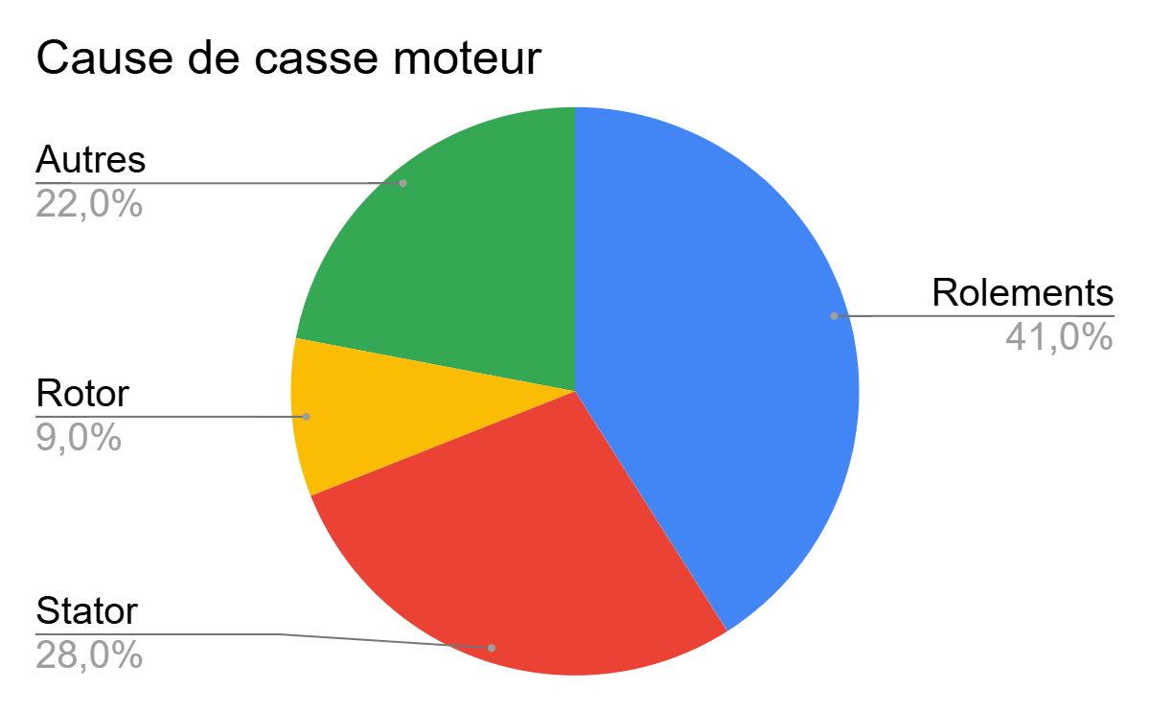
Figure 1 — Breakdown of motor failure causes in industry. Bearings account for 41% of failures — the leading cause ahead of stator faults (28%), other causes (22%) and rotor faults (9%).

Figure 1 illustrates a well-established finding in the industrial maintenance literature: bearings are responsible for 41% of motor failures, making them the primary cause of breakdown. This figure reflects the critical position bearings occupy in the drive chain: they support the radial and axial loads of the rotating shaft, operate under intense and repeated mechanical stress, and their contact surfaces undergo cyclic fatigue that inevitably leads to degradation. Identifying and monitoring bearings is therefore the top priority of any predictive maintenance system for electric motors.

1.2 Internship objectives and chosen approach

The goal of this internship is to develop a vibration-based bearing anomaly detection system combining two complementary technologies: unsupervised machine learning to model healthy behaviour without requiring prior failure examples, and hardware acceleration on an FPGA (Field-Programmable Gate Array) to run inference in real time with microsecond-level latency.

The fundamental challenge of anomaly detection in an industrial context is the absence of failure data at deployment time: one cannot wait for a machine to break down in order to build a training dataset. The unsupervised autoencoder approach sidesteps this problem by learning only to reconstruct healthy data. When a degraded signal is presented, the reconstruction fails and the error exceeds a statistical threshold — that is the alarm signal. This approach is generic: it adapts to any type of bearing and machine without retraining.

Chapter 2 — Vibration data and signal analysis

2.1 The NASA IMS Bearing Dataset

The work presented in this dissertation relies on the NASA IMS Bearing Dataset, one of the reference datasets in the predictive maintenance community. It was produced by the Intelligent Maintenance System (IMS) center at the University of Cincinnati under a NASA contract. It records the vibration evolution of four bearings mounted on a common shaft, from a perfectly healthy state to complete failure — a so-called run-to-failure test.

The test rig comprises four FAG 6203 bearings mounted on a horizontal shaft driven by an AC motor at 2,000 rpm. A radial load of 6,000 lbs (≈ 27 kN) is applied to the shaft via a spring. Vibrations are recorded by piezoelectric accelerometers at a sampling frequency of 20 kHz, with a one-second acquisition every ten minutes. Set 2 is used in this work: bearing no. 1 develops an outer race fault (ORF), documented over the entire lifetime until complete failure.

Of the 984 files available in Set 2, 2 machine-stop files were identified and excluded, bringing the usable corpus to 982 files. Each file contains 20,480 samples (1 second at 20 kHz), covering the entire bearing lifecycle over approximately 7 days. Set 2 is particularly interesting because the degradation of bearing 1 is progressive and clearly visible, with a well-defined transition between the healthy state and the various degradation phases.

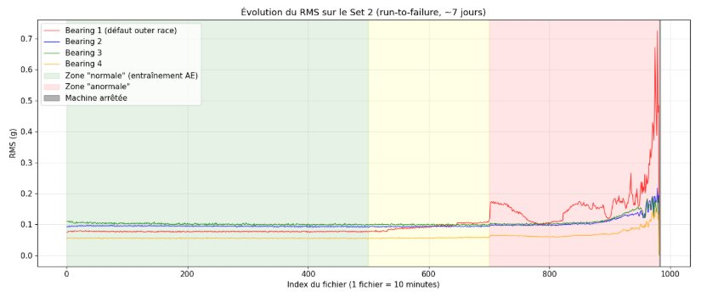
Figure 2 — RMS signal evolution across the 4 bearings of Set 2 (run-to-failure test, ~7 days, 982 files). Bearing 1 (red) shows far more pronounced degradation than the others from file ~450 onwards. The green zone corresponds to the healthy training phase; the red zone to the advanced failure phase.

Figure 2 reveals the temporal dynamics of the dataset. Bearing 1's RMS signal remains stable and low (~0.07–0.10 g) throughout the healthy phase (files 1–450), then starts rising gradually from file 450 before exploding from file ~850, reaching 0.7 g in the advanced failure phase — a sevenfold increase in vibration level. Bearings 2, 3 and 4 remain stable throughout, confirming that only bearing 1 is defective (the slight rises observed on bearings 2, 3 and 4 from file ~950 are due to collateral damage caused by the extreme vibrations of bearing 1). This observation justifies focusing the analysis on bearing 1.

2.2 Frequency analysis — outer race fault signature

Fast Fourier Transform (FFT) analysis is the fundamental tool for characterising bearing faults. Each fault type — outer race, inner race, ball, cage — generates periodic impulses whose repetition frequency can be calculated from the bearing's geometric parameters and rotational speed. For an outer race fault, the characteristic frequency is the Ball Pass Frequency Outer race (BPFO):

BPFO = (n/2) × f_r × (1 − d/D × cos α) — where n = number of balls, f_r = rotation frequency, d = ball diameter, D = pitch diameter, α = contact angle

For the FAG 6203 bearing at 2,000 rpm (actual speed estimated at ~1,950 rpm from harmonic analysis), the theoretical BPFO is around 236 Hz. A comparative FFT analysis at four degradation stages confirms the expected progression.

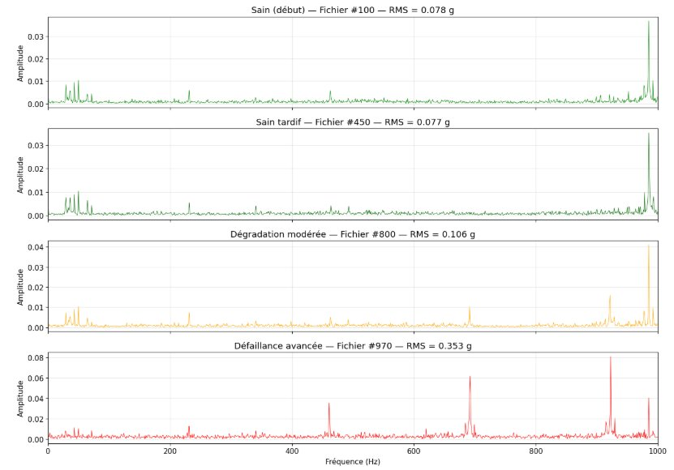
Figure 3 — FFT comparison at 4 degradation stages of bearing 1. Top: healthy state (file #100) — flat spectrum, low overall amplitude. Second row: late healthy (#450) — first harmonics appearing. Third row: moderate degradation (#800) — BPFO harmonics clearly emerging at ~236 Hz. Bottom: advanced failure (#970) — spectral explosion with structural resonance at 985 Hz, amplitude ×10 vs healthy state.

Figure 3 illustrates the progressive spectral signature of the fault. In the healthy state, the spectrum is dominated by rotation harmonics (33 Hz and multiples) with a low, uniform overall energy level. The appearance of BPFO harmonics at ~236 Hz, ~472 Hz, ~708 Hz... marks the onset of outer race degradation. In the advanced phase, a structural resonance at 985 Hz is periodically excited by ball-defect impacts, greatly amplifying energy in this band. It is this high-frequency resonance that constitutes the earliest and most discriminant alarm signal.

Chapter 3 — Vibration feature extraction

3.1 Extraction strategy and feature selection

The input to a neural network cannot be the raw signal of 20,480 points — dimensionality is too high, computation times would be prohibitive on an FPGA, and the redundancy of the raw signal would complicate learning. Feature extraction aims to summarise each acquisition window into a compact vector that captures the most relevant information for anomaly detection.

The retained feature vector comprises 14 characteristics covering the time and frequency domains. This number results from a compromise: rich enough to capture degradation signatures, yet compact enough to fit within the constrained architecture of an FPGA autoencoder. The features were selected based on their known sensitivity to bearing faults and their informational complementarity.

Domain | Feature | Description | Sensitivity to faults
Time | RMS | Root mean square — global signal energy | Progressive increase with degradation
Time | Peak | Absolute maximum value of the signal | Sensitive to local shock impulses
Time | Peak-to-Peak | Total crest-to-crest amplitude | Global oscillation amplitude indicator
Time | Kurtosis | 4th standardised statistical moment | Very sensitive to impulsive shocks (high kurtosis ↔ impulses)
Time | Skewness | Asymmetry of the amplitude distribution | Non-symmetry linked to directional shocks
Time | Crest factor | Ratio Peak / RMS | Detects shocks even when global energy is still low
Time | Std. dev. σ | Dispersion of amplitudes | Correlated with fluctuation energy
Frequency | Energy 0–100 Hz | Low-frequency energy | Rotation harmonics, imbalance
Frequency | Energy 100–500 Hz | Mid-frequency energy | Typical BPFO harmonic band
Frequency | Energy 500–1100 Hz | High-frequency energy 1 | Higher-order harmonics
Frequency | Energy 1100–5000 Hz | Very high-frequency energy | Early structural resonances
Frequency | Energy 5k–10k Hz | Extreme high-frequency energy | ×25.7 between healthy and faulty — key feature
Frequency | Spectral entropy | Uniformity of spectral distribution | Decreases when spectral peaks appear
Frequency | Dominant frequency | Frequency of the main spectral peak | Direct signature of the failure mode

The temporal evolution of the most discriminant features is shown in Figure 4. Several characteristic behaviours are observable: RMS shows a smooth, monotonic rise from file ~450, confirming its role as a global energy indicator. Kurtosis stays close to 3 (Gaussian value) in the healthy regime, then explodes beyond 14 in advanced failure, reflecting the impulsive nature of ball-defect shocks. The crest factor is the noisiest but also the earliest indicator. High-frequency energy (band_HF) is remarkably flat and low in the healthy regime, then grows quasi-monotonically from file ~450.

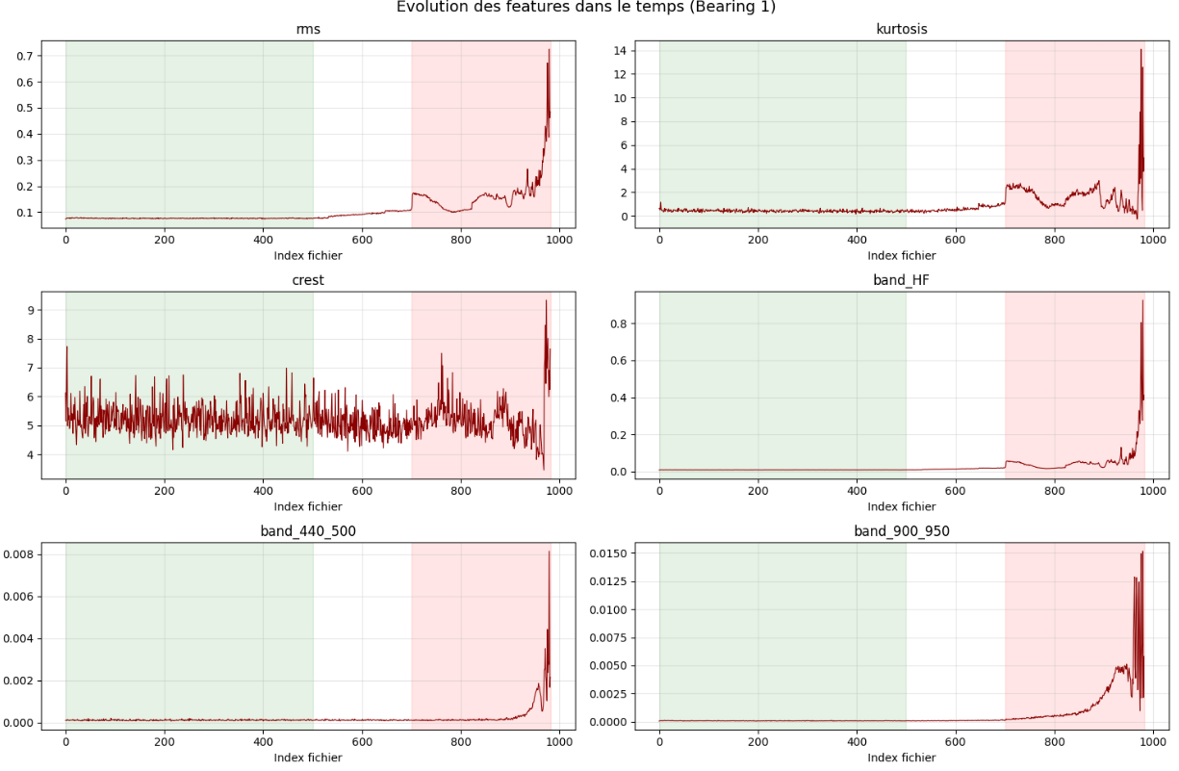
Figure 4 — Temporal evolution of 6 key features across 982 files of bearing 1. The green zone represents the healthy training phase (files 15–450); the pink zone the detected degradation phase. RMS, kurtosis, band_HF and spectral bands all show a clear transition between healthy and degraded regimes.

3.2 Pre-processing — normalisation and scale management

A critical issue identified during exploratory analysis is the scale disparity between the 14 features. High-frequency spectral energy and dominant frequency can reach values 1,000 to 10,000 times higher than the time-domain features. Without treatment, the scaler would be dominated by these high-dynamic-range features and the network would be unable to learn a balanced representation of the healthy state.

Two transformations are applied in sequence:

- Log₁₀ transform: applied to freq_dominant and spectral_energy before normalisation. This compression reduces the dynamic range from 4 decades to ~2, making these features comparable to the others.
- RobustScaler: normalisation based on the median and interquartile range (IQR) rather than mean and standard deviation. Robust to extreme values from the failure phase, which are not part of the training data.
- Clipping to ±5: applied after normalisation to bound reconstructions in the degraded phase and avoid out-of-range values in the network.

The scaler is fitted exclusively on the healthy training data (files 0–450), then applied in a fixed manner to the entire dataset during the detection phase. This guarantees that the scaler has no knowledge of degradation data and faithfully reflects the distribution of the nominal healthy state.

Chapter 4 — Autoencoder for anomaly detection

4.1 Principle of the unsupervised autoencoder

An autoencoder is a neural network trained to reconstruct its own input data through a compressed intermediate representation. The characteristic architecture is a bottleneck: the encoder progressively compresses the input vector down to a low-dimensional bottleneck, then the decoder reconstructs the original vector from this compressed representation.

The anomaly detection principle rests on a fundamental property: an autoencoder trained exclusively on healthy data learns to encode and decode the characteristic patterns of the normal state. When a degraded signal is presented, its patterns no longer match the space learned by the network — the reconstruction is poor and the mean squared error (MSE) between the input vector and the reconstructed vector is high. This reconstruction error constitutes the system's anomaly score.

The decisive advantage of this approach for industrial maintenance is that it requires no failure examples for training. The model is trained solely on normal operating data — readily available at machine start-up — and the system is automatically capable of detecting any type of deviation, including previously unknown failure modes.

4.2 Autoencoder architecture

The retained architecture is a 6-layer dense bottleneck (excluding the input layer). It was designed under two simultaneous constraints: (1) be expressive enough to learn a faithful representation of the healthy state, and (2) remain small enough to be synthesisable on an FPGA with limited resources. The topology 14→8→4→3→4→8→14 is an empirically validated compromise.

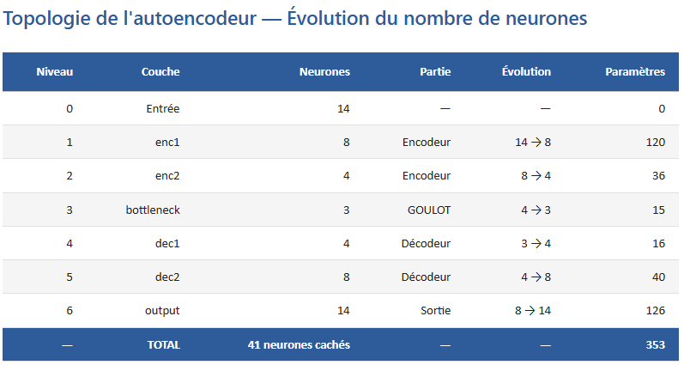  (a) Architecture summary (model.summary()) | 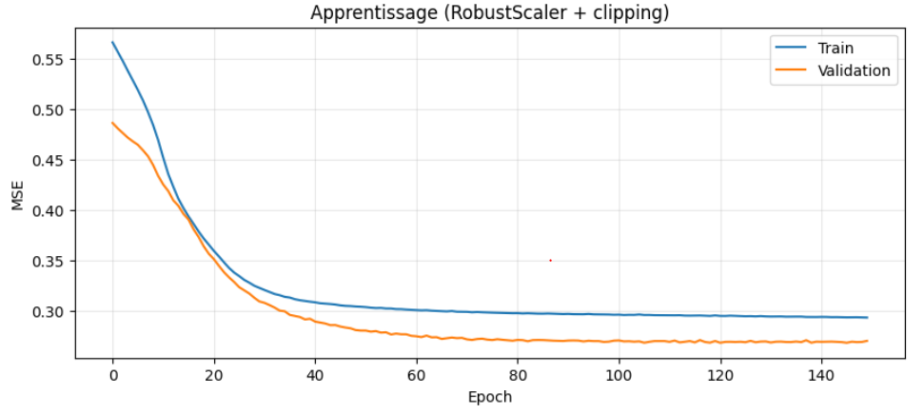  (b) Autoencoder topology — neuron count per layer
Figure 7 — (a) Architecture summary (model.summary()) / (b) Autoencoder topology — neuron count per layer

Figure 5 presents the architecture in two complementary formats. The right table details the dimensional progression layer by layer. The encoder compresses the 14-feature vector down to a 3-neuron bottleneck (compression factor 4.7×), forcing the network to retain only the most recurrent and structured patterns of the healthy signal. The decoder symmetrically reconstructs up to the 14 original features. The linear output activation (unbounded) is essential since normalised features are not constrained to [0,1]. The model totals 353 trainable parameters, intentionally compact for the FPGA constraint.

The choice of a 3-neuron bottleneck rather than 4 results from experimentation: a bottleneck that is too wide (4+ neurons) allows the network to also memorise slightly degraded signals, reducing sensitivity; one that is too narrow (2 neurons) degrades reconstruction quality even on healthy data, increasing false alarms. Three neurons provide the best balance on this dataset.

4.3 Training — procedure and hyperparameters

Training is conducted exclusively on 450 healthy files. These files represent the nominal behaviour of the bearing in steady-state operation. The retained hyperparameters are as follows:

- Adam optimiser (lr = 1×10⁻³, β₁ = 0.9, β₂ = 0.999) — robust to noisy gradients, fast convergence
- MSE loss function (Mean Squared Error) — penalises large reconstruction errors, consistent with the anomaly score
- 150 epochs with batch_size = 32 — sufficient to reach convergence without overfitting
- 80/20 train/validation split — 348 training files, 87 validation files to monitor overfitting
- RobustScaler + clipping ±5 — applied as pre-processing before each batch

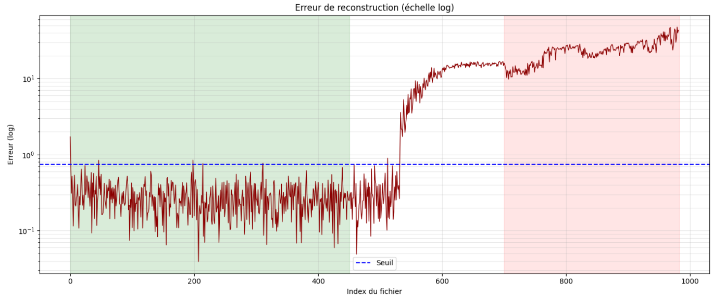
Figure 6 — Learning curves of the float32 autoencoder (150 epochs). Train and Validation curves converge in parallel from an initial loss of ~0.55 to ~0.30, without significant divergence. The absence of overfitting confirms that the architecture is well-sized for this dataset.

Figure 6 shows the float32 model's learning curves. Convergence is smooth and the Train and Validation curves remain close throughout training — no overfitting is observable. The final loss of approximately 0.30 corresponds to a very low normalised reconstruction error, indicating that the model has correctly learnt the structure of healthy data.

4.4 Anomaly threshold calculation

Once training is complete, the anomaly threshold is calculated statistically on all healthy training data. For each of the 435 healthy files, the MSE reconstruction error is computed. The threshold is set at mean + K×σ, where σ is the standard deviation of the errors on healthy data and K is a margin factor. The value K = 3 is retained, which statistically guarantees fewer than 0.3% false alarms in healthy regime (under Gaussian assumption).

Chapter 5 — Detection results — float32 baseline model

5.1 First test — initial configuration

The first detection test is run with the autoencoder's initial configuration: architecture 14→8→4→3→4→8→14, trained for 150 epochs on the 435 healthy files. Figure 7 shows the reconstruction error curve across all 982 files on a logarithmic scale.


Figure 7 — First test — reconstruction error (log scale) across 982 files. Threshold = 0.697 (blue). The green zone corresponds to the training phase; the pink zone to the degradation phase. The error stays below the threshold throughout the healthy phase, then rises monotonically from file ~500.

Figure 7 shows a broadly satisfactory behaviour: the reconstruction error stays strictly below the threshold throughout the healthy phase, then permanently crosses it from file ~500. However, the quantitative analysis reveals a serious problem:

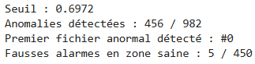
Figure 8 — Quantitative results of the first test. Threshold: 0.697. Anomalies detected: 456/982. First anomalous file detected: #0. False alarms in healthy zone: 5/450.

Figure 8 reveals a surprising result: 5 false alarms in the first 450 files, with a premature detection as early as file #0. The reconstruction error is abnormally high on the very first files, pushing the threshold down and creating false alarms at the start of the dataset. This observation raises a question: are the first files of the dataset truly representative of nominal healthy behaviour?

5.2 Diagnostic — start-up regime analysis

To understand the origin of the false alarms, a targeted analysis is conducted on the first 100 files of the dataset. The hypothesis is that the test rig may not be immediately in stabilised operation at start-up: lubricant films take time to establish, mechanical parts adjust thermally, and roulement-ring contacts gradually reach their equilibrium. If so, these start-up files exhibit vibration behaviour slightly different from the nominal healthy state and should not be included in the training data.

The evolution of 4 key features (RMS, kurtosis, crest factor, HF energy) is plotted over the first 100 files to visually identify the boundary between the transient regime and the stable regime.

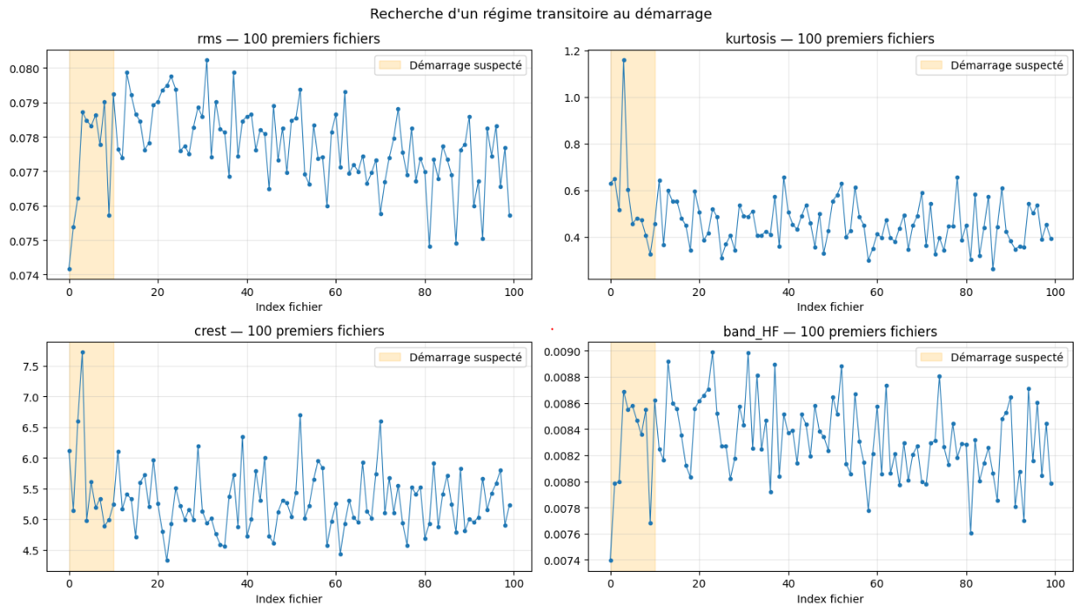
Figure 9 — Start-up regime analysis: evolution of RMS, kurtosis, crest factor and HF energy over the first 100 files. The orange zone (files 1–15) shows clearly atypical values — kurtosis peak at 1.15 at file #3, crest factor > 7.5, unstable HF energy. From file #16 onwards, all features stabilise within their nominal range.

Figure 9 confirms the hypothesis: files 1 to 15 show abnormal values across all indicators. Kurtosis reaches 1.15 at file #3 (nominal value in healthy regime: 0.4–0.6), the crest factor exceeds 7.5 (nominal range: 5.0–6.5), and HF energy is unstable. From file #16 onwards, all features converge to their nominal ranges and remain stable. These transients are physically linked to the warm-up of roulement-ring contacts and the establishment of the lubricant film.

This diagnostic directly explains the false alarms from the first test: by including files 1–15 in the training data, the model learnt a distribution slightly different from the nominal healthy state, which biased the threshold downward. The fix is straightforward: systematically exclude the first 15 files (WARMUP = 15) from all training and evaluation phases.

5.3 Second test — after warm-up correction

The second test incorporates the identified correction: strict exclusion of files 1–15 (WARMUP = 15) and the RobustScaler recalibrated exclusively on files #15–450. Clipping at ±5 is maintained. Figure 10 shows the results of this second test across the entire dataset.

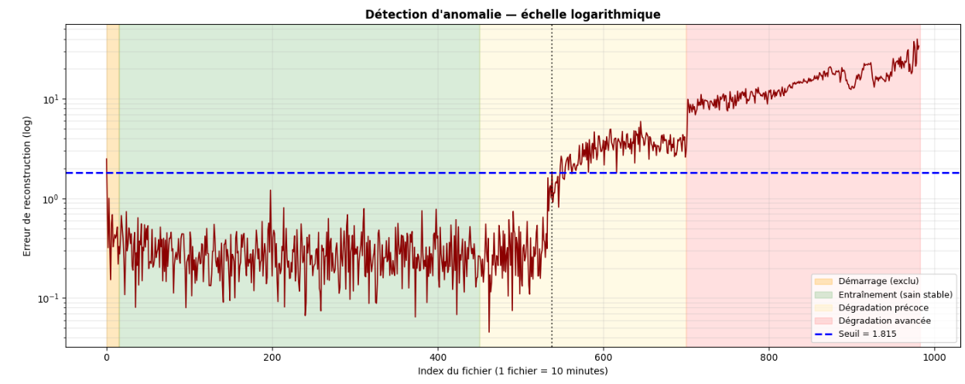
Figure 10 — Second test — anomaly detection after warm-up correction (logarithmic scale). Zones: orange = excluded start-up, green = stable healthy training, light yellow = early degradation, pink = advanced degradation. Threshold = 1.815 (blue dashes). Detection occurs at file #538, with 0 false alarms throughout the healthy phase.

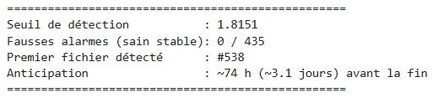
Figure 11 — Quantitative results of the second test. Threshold: 1.815. False alarms: 0/435. First detected file: #538. Lead time: ~74 h (~3.1 days) before final failure.

Figures 10 and 11 confirm the effectiveness of the correction. With WARMUP = 15, the threshold recalibrates to 1.815 (vs 0.697 previously) — well above the healthy reconstruction noise. Results are now excellent: 0 false alarms over the 435 healthy files and first anomaly detected at file #538, giving ~74 hours of advance warning before the final failure. This lead time of more than 3 days is perfectly compatible with industrial maintenance planning.

Chapter 6 — 8-bit quantisation with QKeras

6.1 Motivation and principle of quantisation

Quantisation is the indispensable step for deploying a neural network on an FPGA. FPGAs use specialised arithmetic units — DSP48 blocks — optimised for fixed-point arithmetic. A standard float32 model cannot be synthesised efficiently in this format: each weight and activation occupies 32 bits, which would multiply the required resources and latency compared to an 8-bit representation.

Quantisation consists of representing each weight, bias and activation with a reduced number of bits. For a network quantised in 8-bit ap_fixed<16,6>, each value is stored in fixed-point format on 16 bits, of which 6 are for the integer part and 9 for the fractional part (1 sign bit), with a resolution of 2⁻⁹ ≈ 0.002. This precision is more than sufficient for anomaly detection, where healthy and degraded features are separated by a factor of 10 to 25 in reconstruction error.

6.2 Quantization-Aware Training with QKeras

The QKeras framework (a Keras extension developed by Google) enables Quantization-Aware Training (QAT): during training, simulated quantisation operations are inserted into the computation graph. The network thereby learns to compensate for the rounding errors introduced by quantisation, leading to significantly better performance than post-training quantisation (PTQ) — particularly for small networks such as ours.

The QKeras model is initialised from the weights of the pre-trained float32 model (quantised fine-tuning), then trained for an additional 200 epochs. This procedure allows the network to redistribute weights to minimise the impact of reduced precision while maintaining reconstruction capacity.

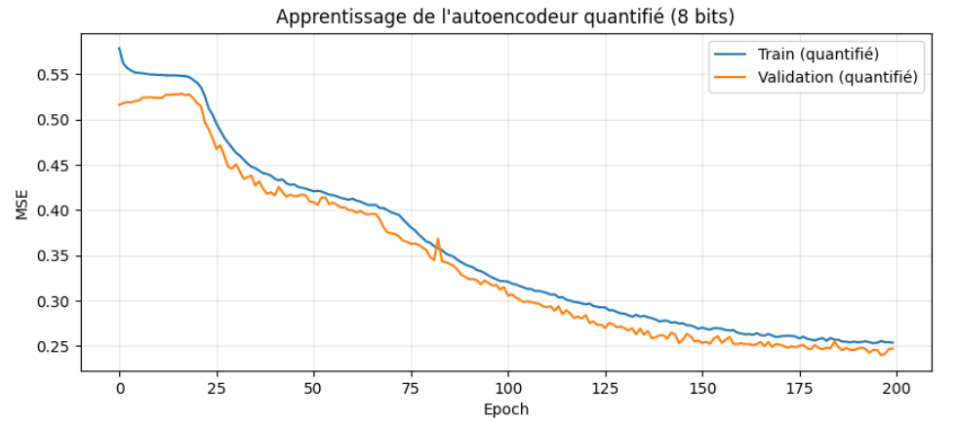
Figure 12 — Learning curves of the QKeras 8-bit quantised autoencoder (200 epochs). The Train (quantised) and Validation (quantised) curves converge in parallel without divergence, from ~0.55 to ~0.30 — identical to the float32 model. Quantisation has not degraded learning capacity.

Figure 12 shows that the quantised model's learning curves are virtually identical to those of the float32 model (Figure 6). The final loss converges to the same values, and no overfitting is observable. This confirms that QAT has successfully adapted the network to reduced precision without performance loss.

6.3 Detection results — float32 vs 8-bit quantised comparison

Cross-validation between the float32 and quantised models is the critical step: it verifies that the precision reduction has not degraded anomaly detection performance. Figure 13 shows the comparison of reconstruction error curves across 982 files.

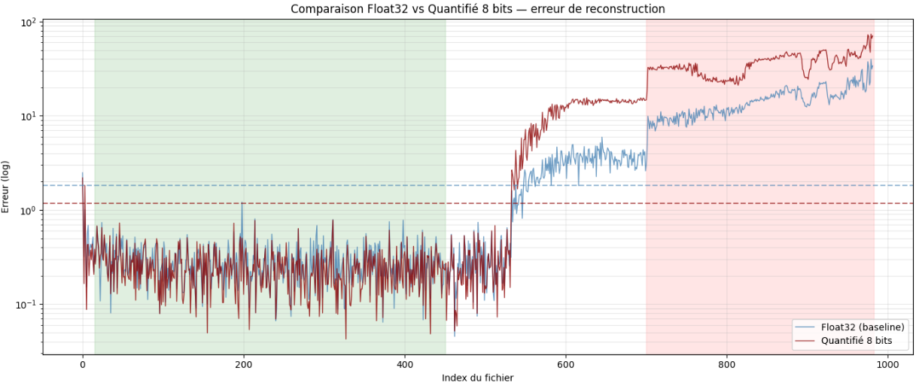
Figure 13 — Reconstruction error comparison: Float32 (light blue) vs 8-bit quantised (dark red) across 982 files. The two curves are virtually superimposed. The respective thresholds (dashes) are close: 1.8729 (float32) and 1.3192 (8-bit). First detection identical at file #533 for both models.

Figure 13 is particularly convincing: the float32 and 8-bit quantised curves are quasi-superimposed across all 982 files. The small divergences visible in the advanced failure phase are due to accumulated rounding errors, but they have no impact on detection since the error is well above the threshold in any case. The table below summarises the quantitative comparison:

Metric | Float32 | 8-bit quantised | Difference
Anomaly threshold | 1.8729 | 1.3192 | −0.554 (recalibrated)
False alarms | 0 / 435 | 0 / 435 | Identical
First detection | File #533 | File #533 | Identical
Lead time | ~75 h | ~75 h | Identical
Model memory | 1.38 KB | 0.35 KB | ×4 reduction
Output correlation | — | > 0.999 | Quasi-identical

6.4 Final model summary

Figure 14 summarises the complete characteristics of the final model retained for FPGA conversion, including its training parameters and detection performance on the NASA IMS dataset.

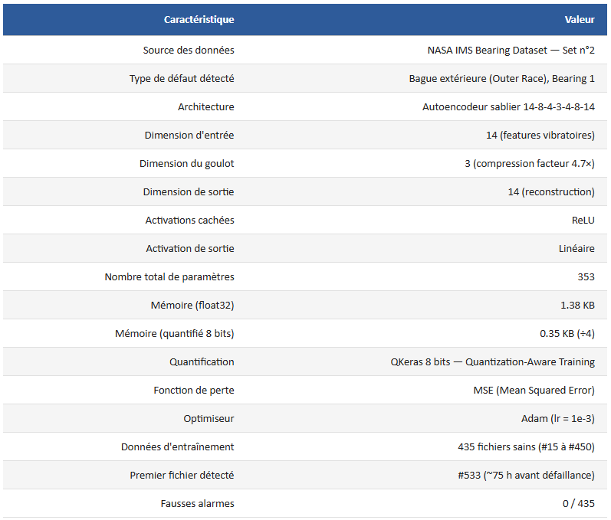
Figure 14 — Summary table of the final model characteristics (after simplification and quantisation). Architecture: 14→8→4→3→4→8→14, QKeras 8-bit, 353 parameters, 0.35 KB. Results: first file detected #533, 0 false alarms on 435 healthy files, ~75 h lead time.

Figure 14 confirms the consistency between the trained model and the obtained results. Notably, the bottleneck dimension is 3 neurons (not 4 as in some intermediate versions), providing a compression factor of 4.7× and 353 parameters in total. The memory footprint of 0.35 KB for the 8-bit quantised model is remarkably small, which is a decisive advantage for embedded deployment on resource-constrained systems.

Chapter 7 — FPGA deployment via hls4ml

7.1 hls4ml conversion and Vivado HLS synthesis

The hls4ml (High-Level Synthesis for Machine Learning) framework automatically converts the QKeras model into synthesisable C++ code for Vivado HLS. hls4ml analyses the model graph, maps each layer to an optimised HLS implementation, and generates a complete Vivado HLS project with appropriate `#pragma HLS` directives to maximise pipelining and parallelism.

The first synthesis is run with default parameters (reuse_factor = 4). The resulting resource report reveals very high consumption:

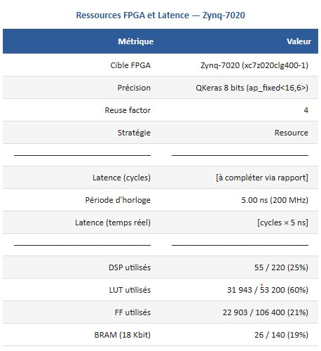
Figure 15 — Vivado HLS simulation report — first synthesis with reuse_factor = 4. DSP: 55/220 (25%), LUT: 31,943/53,200 (60%), FF: 22,903/106,400 (21%), BRAM: 26/140 (19%), latency: 0.32 µs. LUT utilisation at 60% exceeds the recommended 50% limit and would risk place-and-route convergence failures.

Figure 15 reveals that reuse_factor = 4 consumes 60% of the LUTs and 25% of the DSPs — beyond the recommended 50% fill rate needed to guarantee place-and-route convergence. This configuration is rejected and leads to a design space exploration (DSE) on the reuse_factor parameter.

7.2 Optimisation — reuse_factor DSE

The reuse_factor parameter controls the degree of sharing of DSP48 multipliers across the different connections of the network. With reuse_factor = N, the same DSP48 blocks serve sequentially for N different multiplications, reducing the number of units required at the cost of increased latency. A DSE over 4 values (1, 4, 16, 64) was conducted.

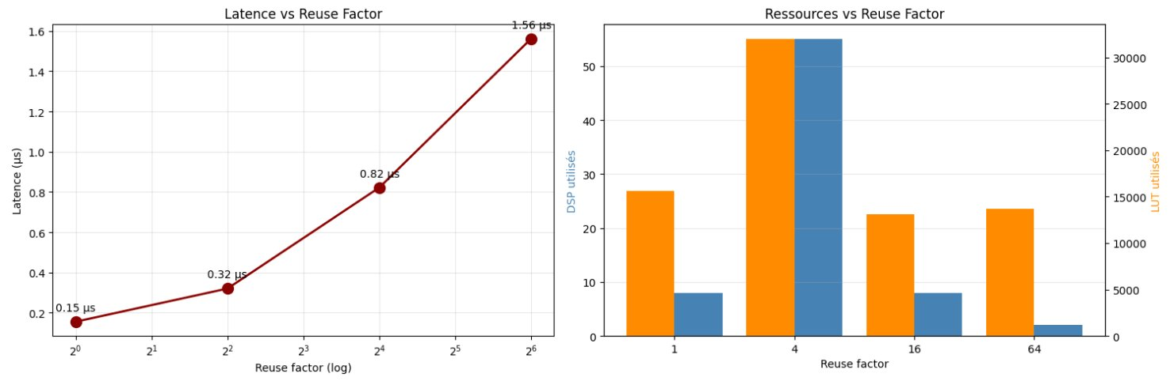
Figure 16 — reuse_factor DSE: latency in µs (left) and DSP48 + LUT resources (right) for values 1, 4, 16 and 64. The non-monotonic behaviour of reuse = 4 (more resource-hungry than reuse = 1) is clearly visible on the right graph.

Figure 16 reveals a counter-intuitive result: reuse_factor = 4 is paradoxically more resource-intensive than reuse_factor = 1 in LUTs and DSPs. This phenomenon is linked to pipeline dependencies introduced by hls4ml: with reuse = 4, the sequencer control logic (counters, multiplexers, state registers) becomes more complex than the benefit of reuse, generating more LUTs than direct wiring. reuse_factor = 64 is retained as optimal: only 2 DSPs and 26% of the LUTs, at the cost of a latency of 1.56 µs — well within the real-time constraint of the application, which is on the order of a millisecond.

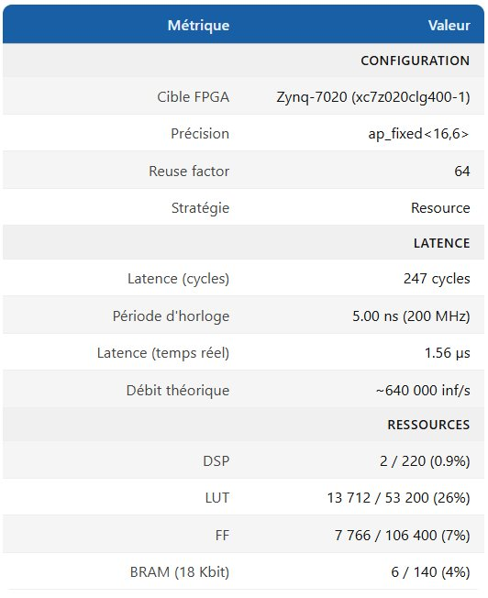
Figure 17 — Vivado HLS simulation report after optimisation with reuse_factor = 64: DSP: 2/220 (0.9%), LUT: 13,712/53,200 (26%), FF: 7,766/106,400 (7%), BRAM: 6/140 (4%), latency: 247 cycles = 1.56 µs at 200 MHz, theoretical throughput ~640,000 inferences/s.

Figure 17 confirms the excellent profile of reuse_factor = 64: only 2 DSPs (0.9%), 26% of the LUTs, latency of 1.56 µs at 200 MHz. The theoretical throughput of 640,000 inferences/s is far above the application's requirements (one inference per 10-minute window).

7.3 Vivado integration — block design and PYNQ-Z1 deployment

The hls4ml IP core is integrated into a Vivado block design connecting the Zynq-7020 Processing System (ARM Cortex-A9), an AXI DMA controller (PS↔PL memory transfers), the neural IP core (AXI Stream interfaces), and the AXI Interconnect. The bitstream is generated and deployed on the PYNQ-Z1 board.

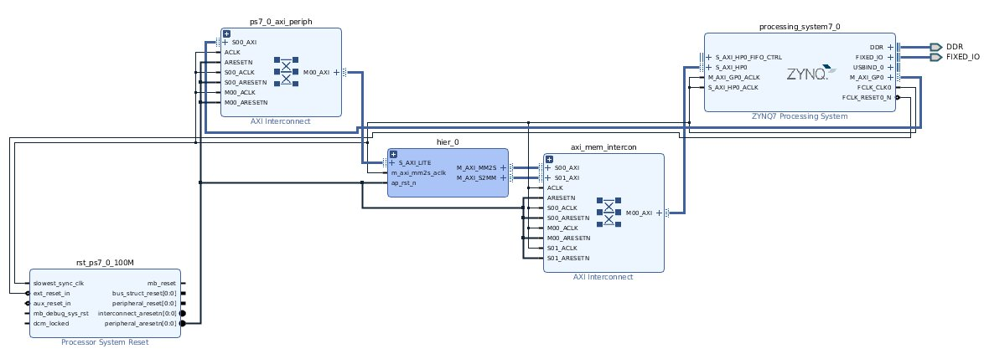
Figure 18 — Vivado IP Integrator block design: Zynq-7020 Processing System (right), AXI Interconnect (top left), hier_0 (hls4ml IP core + AXI DMA, centre), axi_mem_intercon (bottom centre), Processor System Reset (bottom left). Blue connections represent the AXI buses.

7.4 FPGA detection results

FPGA inference is executed on all 982 files of the dataset. The detection curve obtained on the PYNQ-Z1 board is shown in Figure 19.

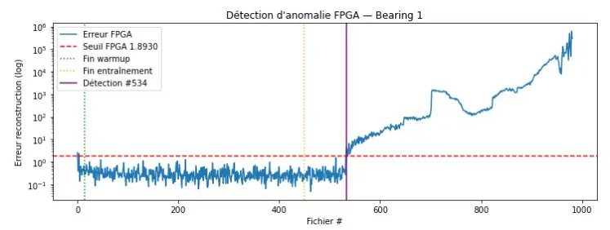
Figure 19 — FPGA anomaly detection (Bearing 1): FPGA reconstruction error across 982 files. Recalibrated threshold = 1.893. First detection at file #534. 0 false alarms throughout the healthy phase.

Figure 19 confirms the validity of the FPGA deployment. The one-file offset (#533 in simulation vs #534 on FPGA) is due to accumulated rounding errors across the 353 quantised parameters — operationally negligible (less than 10 minutes over a 75-hour lead time).

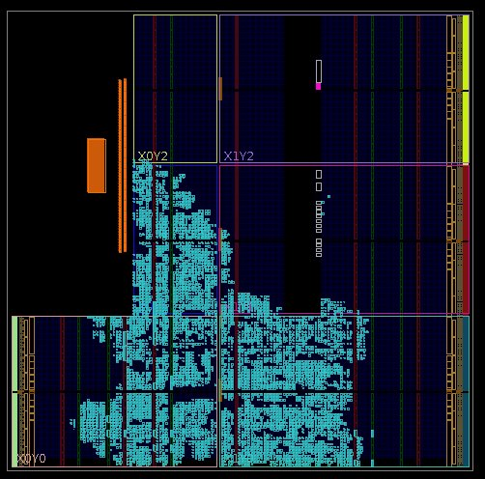
Figure 20 — Vivado floorplan after place-and-route on the Zynq-7020. The dense cyan area (bottom) concentrates the hls4ml logic. Orange blocks represent the DMA BRAM. The unused surface (~80%) confirms the very low resource utilisation.

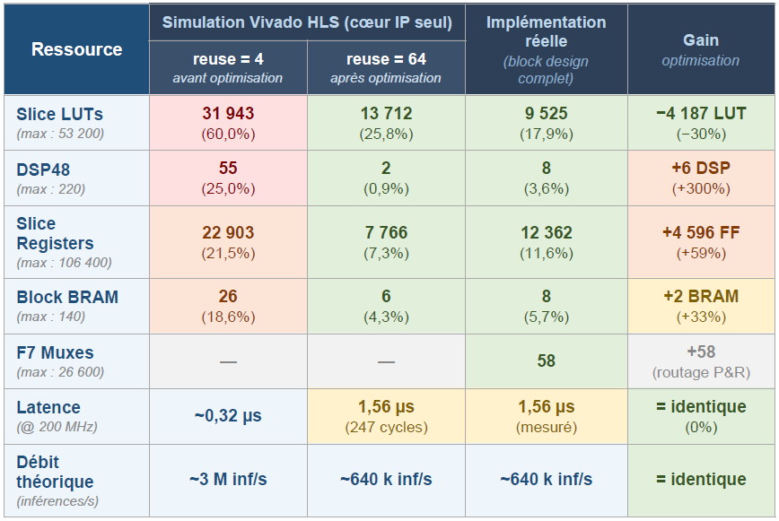
Figure 21 — Full comparison table: HLS simulation reuse=4 (before optimisation) / HLS simulation reuse=64 (after optimisation) / actual implementation (complete block design). The Difference reuse=64→actual column quantifies the DMA/AXI integration overhead.

Figure 21 synthesises all resource results in three comparative columns. The actual implementation (complete block design) uses 9,525 LUTs (17.9%), 8 DSPs (3.6%) and 8 BRAMs (5.7%). The increase relative to the reuse=64 simulation (+6 DSPs, +4,596 FFs, +2 BRAMs) is entirely attributable to the integration overhead of the AXI DMA and communication buses — and not to the neural core itself.

Dissertation by Guillaume Derville — UMONS Internship, Faculty of Engineering — June 2026

