Pangolab v0.6 Documentation

- Using Pangolab
  - A few things about the functioning of Pangolab
Pangolab is a software developed in python to control multiple instruments for experiments. It contains three parts: the top left one to connect devices, the bottom left contains the instructions that will be send to the device while the bottom right contains the buttons to execute those instructions, finally there is two graph windows for plotting data.
The program is multithreaded, meaning several parts of the program are executed in parallel. There is one thread for the GUI (to avoid lags in the plot/ freezing window), one thread for the handling of the instructions and one thread per device (it allows faster and simultaneous measurements).

  - Connecting a device
Enter the GPIB or COM addresses of your instruments in the boxes in the top left corner of the window. Select the right instruments names for each box and press connect. If the address is GPIB0::00::INSTR, Pangolab will not attempt to connect. If the address contains a ‘::’, it will attempt to connect using the pyvisa module and if it contains a ‘COM’, it will attempt to connect using the minimalmodbus module.
Few parameters are measured when the device is connected such as the unit of the lockins (current or voltage). If you change this parameter, you must restart Pangolab.
  - Manipulating instructions
Adding, editing and removing instructions is pretty intuitive but here a few infos/tips:
- Some functions require to have some devices connected in order to be edited. It is thus best to connect the devices before loading saved instructions from a file.
- You can use up to 6 variables in the math/jumpif function: variables.A,variables.B,…,variables.F. These variables can be used in other compatible functions like the write function in boxes where you can right some text. You can also acces the latest (and more) acquired data using variables.Data[‘key_of_the_data_to access’][-1]
- The math and jumpif executes python code. The math module is imported so you can use function like sin,exp… (example: sin(variables.E) < 1)
- You can put -1 instead of a value in the wait time box of the idle function to wait indefinitely
  - Plotting
A 1D plot window is available to plot multiple graph. It plots first the first Y box and then the others. If the length of X axis is different from the length of the Y axis, the plot will not be updated.
The 2D plotting is launched automatically when the Sweep2D function is launched. The plot may have a 1 point difference while plotting. This difference is only graphical and can be fixed by choosing another Z-axis and put it back to the previous one.
  - Automatic file saving
While open, Pangolab saves automatically the data in memory in the temp folder every hour. This delay can be changed by going around line 562 and change the value: self.TempFileTimer.start(int(3600*1e3))
Comment this line if you do not want to automatically save the data. File and saving parameters can be changed by editing the TempFileSaver.py
  - Stuff about multithreading/data structures
Memory access/writing is always tricky when dealing with multithreaded programs because multiple threads accessing the same variable can cause errors. That is why only few variables are shared globally between threads, the other ones are only locally declared. These global variables are all declared in the variables.py file.

1.6.1 Variables.Data
Dictionnary containing a list per data_key. Example:variables.Data[‘1_Euro2404_T’] = [21,20,20…] (Temperature in C)
It used by every thread.

1.6.2 Variables.Querylist
List of 10 lists (one per device) containing all the write and read requests that the device must do. Those requests are added by the module actionThread and removed once performed by the thread of the device (in the Worker class).

1.6.3 Variables.actionlist
List of lists that contains all the instruction that must be executed by the actionThread module. The main UI/Pangolab thread adds/removes/edits item while the actionThread only reads it. There is one list per line in the GUI.

1.6.4 Variables.id_in_process
Integer that corresponds to which instruction/line is being executed right now.

2. Improving Pangolab

2.1 Adding a device
Each device has its own separate python file with its own class.

2.1.1 Writing the python module for a device
Python device modules must respect key features in order to work with Pangolab. It must contain one main class that will be used by Pangolab that takes one argument (ie in the _init_ function): the instance of the GPIB instrument. The instance can be used for write or read operations. (example: myinstance.write(‘outp on’)). The instance can be either from the pyvisa module or minimalmodbus depending on the device. The detection of the module used is automatic in pangolab using the format of the instrument address.

2.1.1.1 Keys
The Pangolab program uses keys to identify devices, read and write requests and datasets. Device keys are created by Pangolab but the three others must be given by the module. That is why each module must feature the 3 functions data_info, read_info and write_info that takes the number of the device (an integer) as only argument and return a list of keys.
data_keys: Each value that can be measured by the device must have a data_key. For instance, if a device can measure a voltage on several channels, there must be a key per channel. Data_keys have this structure: devicenumber_devicename_nameofthedata
read_keys: Each request for data must have its own key. One read_key can be associated with the multiple data_keys if the request returns several values (More on that later). Read_keys have this structure: devicenumber_devicename_nameofthereadquery
write_keys: Each write operation must have a key that is used along with a list of argument to write values on a device. Write_keys have this structure: devicenumber_devicename_nameofthewritequery

2.1.1.2 Pattern
The Pangolab program generates customized windows for writing values for each device automatically using the data from the modules. This data is given by the write_pattern function which takes the number of the device and a write key as argument and returns a list which contains the pattern of the window associated with the writing key.
The returned list has the following structure: [(object1name, object1type, object1information),(object2name, object2type, object2information),…]
The name corresponds to the text of the label that will be displayed on top of the object, it must be a string.
The type is either ‘choice’ or ‘text’. ‘choice’ will display a combobox and ‘text’ will display an input text box that can be used to enter numbers or text. The module is in charge of handling the type of the input afterwards (if it should be a string, a float or an integer).
The information must be the list of the argument desired in the combobox. It is recommended to put ‘None’ (as a string) as one of the arguments so that the user can choose to send a command or not. (More on that in the Write function section)
If it is a ‘text’ type object, it can be anything as it will not be used (a Nonetype object works).

2.1.1.3 Read function
Each module has one Read function that takes a read_key as only argument and returns a list of tuples containing each a data_key and a measured value: [(data_key1,value1),(data_key2,value2),…]
In order to be properly manipulated in Pangolab (for plotting mostly), the measured value must be in the proper format. Pyvisa queries returns strings, if the measurement is floating point number, then that string must be converted to a float.

2.1.1.4 Write function
Each module has one Write function that takes a write_key and a list as arguments and returns the boolean True when the execution of the function is finished. The list contains the data used by the Write function (voltage values for example).

2.1.2 Adding the module to Pangolab
First you must import the module in pangolab (around line 50).
Then you must add the device in the DevicesDict (around line 70) as follow: “the name of the device”:mymodule.myclass.
And then you’re ready to use the device (if the module is written properly).

2.2 Adding a function

2.2.2 Writing the GUI
Each function has two (python) functions:
- one that displays the dialog to edit it: myfunctionDialog
- the other that do something when the dialog is closed: myfunctionEvent
There are usually more python functions because some functions can display multiple windows successively or update the content on the window depending on what is selected.
When the dialog is opened, it should read the content of the actionlist and load it in the boxes of the window if it is not empty. The python function that does that should be called when the pyqt items have been added to the dialog but the dialog has not been showed.
When the dialog is closed, myfunctionEvent should put the parameter in the actionlist and update the display.
It is recommended to copy some parts of the write function and edit it at first instead of writing a function from scratch.

2.2.2 Connect the function to the GUI
In order to add the function into the GUI, you need to add the two lines at line 700 in the function LaunchCustomDialog:
You also need to add the line self.ListActionBox.addItem('myfunction') around line 460.

2.2.3 Implement the function
To implement your function, you must edit the file actionThread.py

2.2.3.1 Writing the function

You must first declare your function as myfunctionFunc which takes no argument (except self since it is in a class).
The parameters needed by the function are in variables.actionlist[variables.id_in_process].
The first item variables.actionlist[variables.id_in_process][0] is the name of the function, the next items are the parameters. (depending on how myfunctionEvent has been written in Pangolab, variables.actionlist[variables.id_in_process] may have a length greater than 2)
Everytime your function is able to be stopped (if the user presses stop or next, your function should be stopped if it is possible), you should add the following lines:
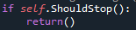
Before the end of execution of the function, the following lines must be executed:
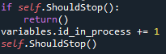
If you need to write or read something in your function, you can call ReadCustom,WriteCustom or ReadWithoutSaving (cf comments in Code).

2.2.3.2 Adding the function
For the function to be called, two line must be added on the ActionToFunction around line 60:

If all the previous steps have been done properly, your function should be working.

Bug sweep 2D
It seems that if I start the sweep 2D using none at Z axis the range of the scale bar growths to infinite
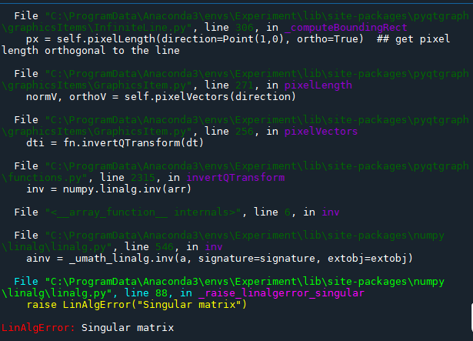

Bug setTemp – range Off does not work – change the box kind to be string and solve all the troubles.
