**Soundplanes**



Arquitectura e Integración de Sistemas Software

Grado de Ingeniería del Software

Curso 2º

George Laurentiu Bogdan (geobog@alum.us.es)

Guillermo Diz Gil (guidizgil@alum.us.es)

Carmen Mª Muñoz Pérez (carmunper1@alum.us.es)

Francisco Rodríguez Pérez (frarodper4@alum.us.es)

Tutor: Javier Troya Castilla

Group number: 1

Application link: <http://soundplanes.appspot.com/>

Project link in projETSII, GitHub or similar: <https://github.com/GuilleX7/Soundplanes>

VERSION HISTORY

|  |  |  |  |
| --- | --- | --- | --- |
| DAte | Version | Details | Participants |
| 14/03/2014 | 1.0 | - Includes introduction, prototypes of the user interfaces and UML diagrams of components and deployment | George Laurentiu Bogdan  Guillermo Diz Gil  Carmen Mª Muñoz Pérez  Francisco Rodríguez Pérez |
|  |  |  |  |
|  |  |  |  |
|  |  |  |  |
|  |  |  |  |

Index

1 Introduction 4

1.1 Integrated applications 4

1.2 Project development 5

2 User Interface Prototypes 6

2.1 Landing page view 6

2.2 Setup view 7

2.3 Location view 8

2.4 Main view 9

2.5 Profile menu view 10

2.6 Airport menu view 11

2.7 Airport chat view 12

2.8 Airport lyrics view 13

3 Architecture 14

3.1 Component diagram 14

3.2 Deployment diagram 14

3.3 High-level sequence diagram 15

3.4 Class diagram 15

3.5 Sequence diagram 15

4 Implementation 16

5 Tests 17

6 User’s Manual 18

6.1 Mashup 18

6.2 API REST 18

References 19

# Introduction

Today, people are increasingly interested in learning more about other cultures. Thanks to technologies that are continuously growing, it is becoming easier to establish this communication. On the other hand, music is a key element in our society and unites people from all over the world. Even so, with the exception of very international artists, we are not aware of the musical culture of countries other than our own. Since music is such an important cultural element in each country and in people, we intend to carry out a project that consists of offering an innovative and educational service in the form of an international online radio.

Thus, Soundplanes wants to offer an interactive online radio service with the possibility of chatting with people from anywhere in the world. It will give its users the opportunity to listen to the most listened songs from each country, as well as to offer their own playlist. In this way, users will have the opportunity to learn new songs, as well as meet many people from around the world.

## Integrated applications

We will be using the following applications:

* **Youtube:** Youtube web player will be our music player. We will also use its REST API for fetching some metadata.
* **Spotify:** we will be using Spotify as a music search site. The user will be able to search for any existing song in Spotify and play it.
* **Genius**: will be used to fetch song’s lyrics.
* **Leaflet:** will be used for displaying interactive maps in the web browser. Used in combination with *OpenStreetMap*
* **OpenStreetMap:** will provide us map tiles through its public tile servers.
* **Facebook:** we will allow the user to log in with his Facebook social account and post what music are they listening to at any time.

|  |  |
| --- | --- |
| Application name | URL API documentation |
| Youtube | <https://developers.google.com/youtube/iframe_api_reference?hl=es>  <https://developers.google.com/youtube/v3/docs> |
| Spotify | <https://developer.spotify.com/documentation/web-api/> |
| Genius | <https://docs.genius.com/> |
| Leaflet | <https://leafletjs.com/reference-1.6.0.html> |
| OpenStreetMap API | <https://wiki.openstreetmap.org/wiki/Tile_servers> |
| Facebook | <https://developers.facebook.com/docs/javascript> |

## Project development

We are thinking about all the different applications that we could integrate in our final application. Some of these may not work as expected and be removed, or we could change our visions about what do we want our application to be.

# User Interface Prototypes

Our application will work as a single-page application. This means we will display all our views dynamically, without the loading of additional pages. We expect this to improve the user experience.

## Landing page view

A first view of the page, where the project is described to the user

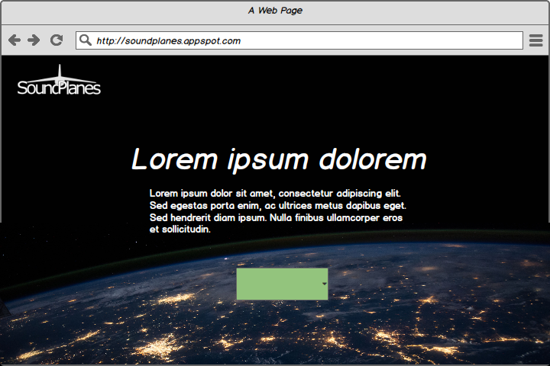

Figure 1. Landing page view’s user interface prototype

## Setup view

User is requested his nickname to be displayed in-game, after that it has two options, to allow the use of user’s location in order to improve his experience or to choose the location manually, this is where its base will be located.

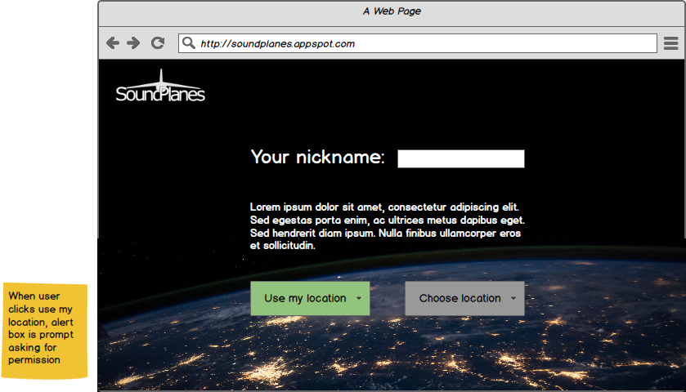

Figure 2. Setup view’s user interface prototype

## Location view

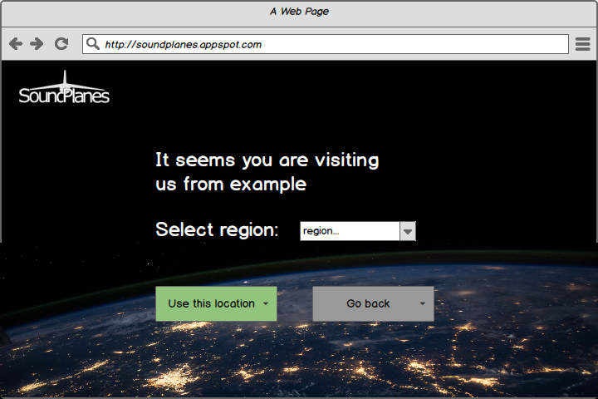If user want to choose location manually, it’ll show the country from where he is visiting our site, and he will pick the region of the country. If he wants to use its location automatically, he can go back.

Figure 3. Location view's user prototype interface

## Main view

This will be the main view of the player, the region where the player is will be displayed, the plane is user’s position and he can see nearby bases.

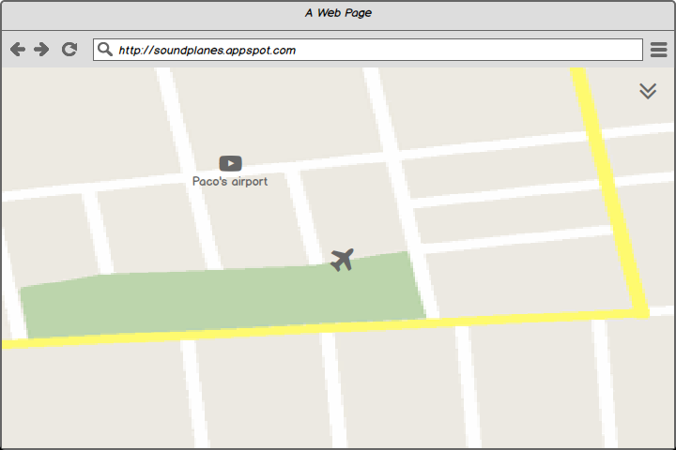

Figure 4. Main view's user prototype interface

## Profile menu view

In this tab it is displayed user information, where he can change his nickname or link his account with Spotify or Facebook. You can also see your base from here.

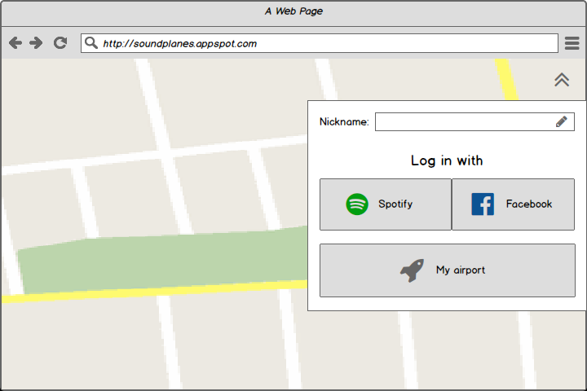

Figure 5. Profile menu view's user interface prototype

## Airport menu view

Here is where it’s displayed user’s airport information. User can change airport’s name, see the number of visitors that are currently in the base, and the total number of visitors overall. User can also change the actual playlist of the base or delete the base.

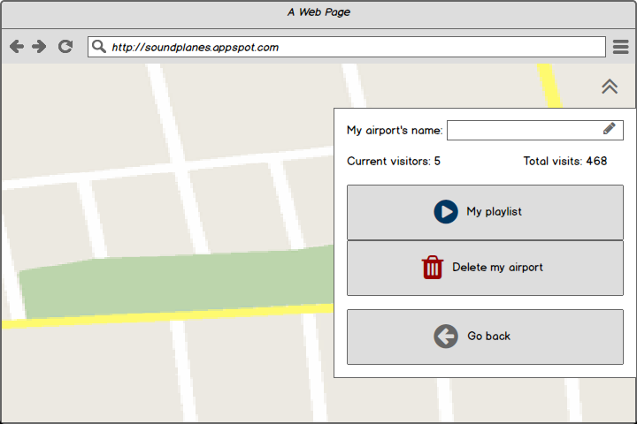

Figure 6. Base menu view's user interface prototype

## Airport chat view

Here is the chat of the airport where users can chat with each other.

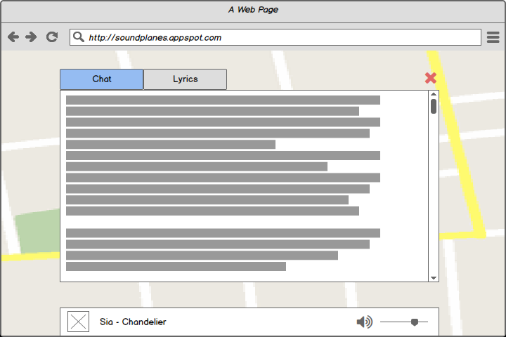

Figure 7. Airport chat view's user interface prototype

## Airport lyrics view

Lyrics of the song that is currently playing in the base

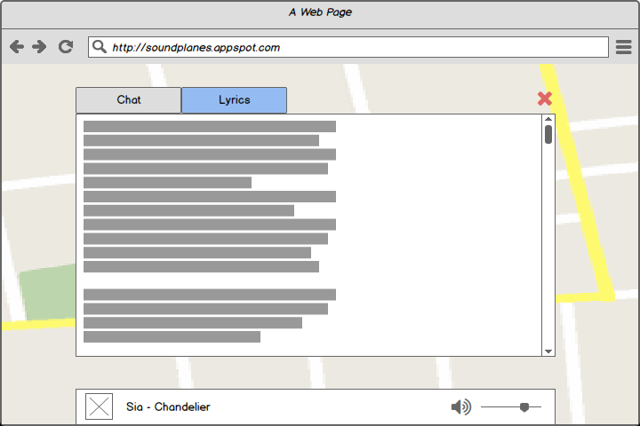

Figure 8. Airport lyrics view's user interface prototype

# Architecture

## Component diagram

## Deployment diagram

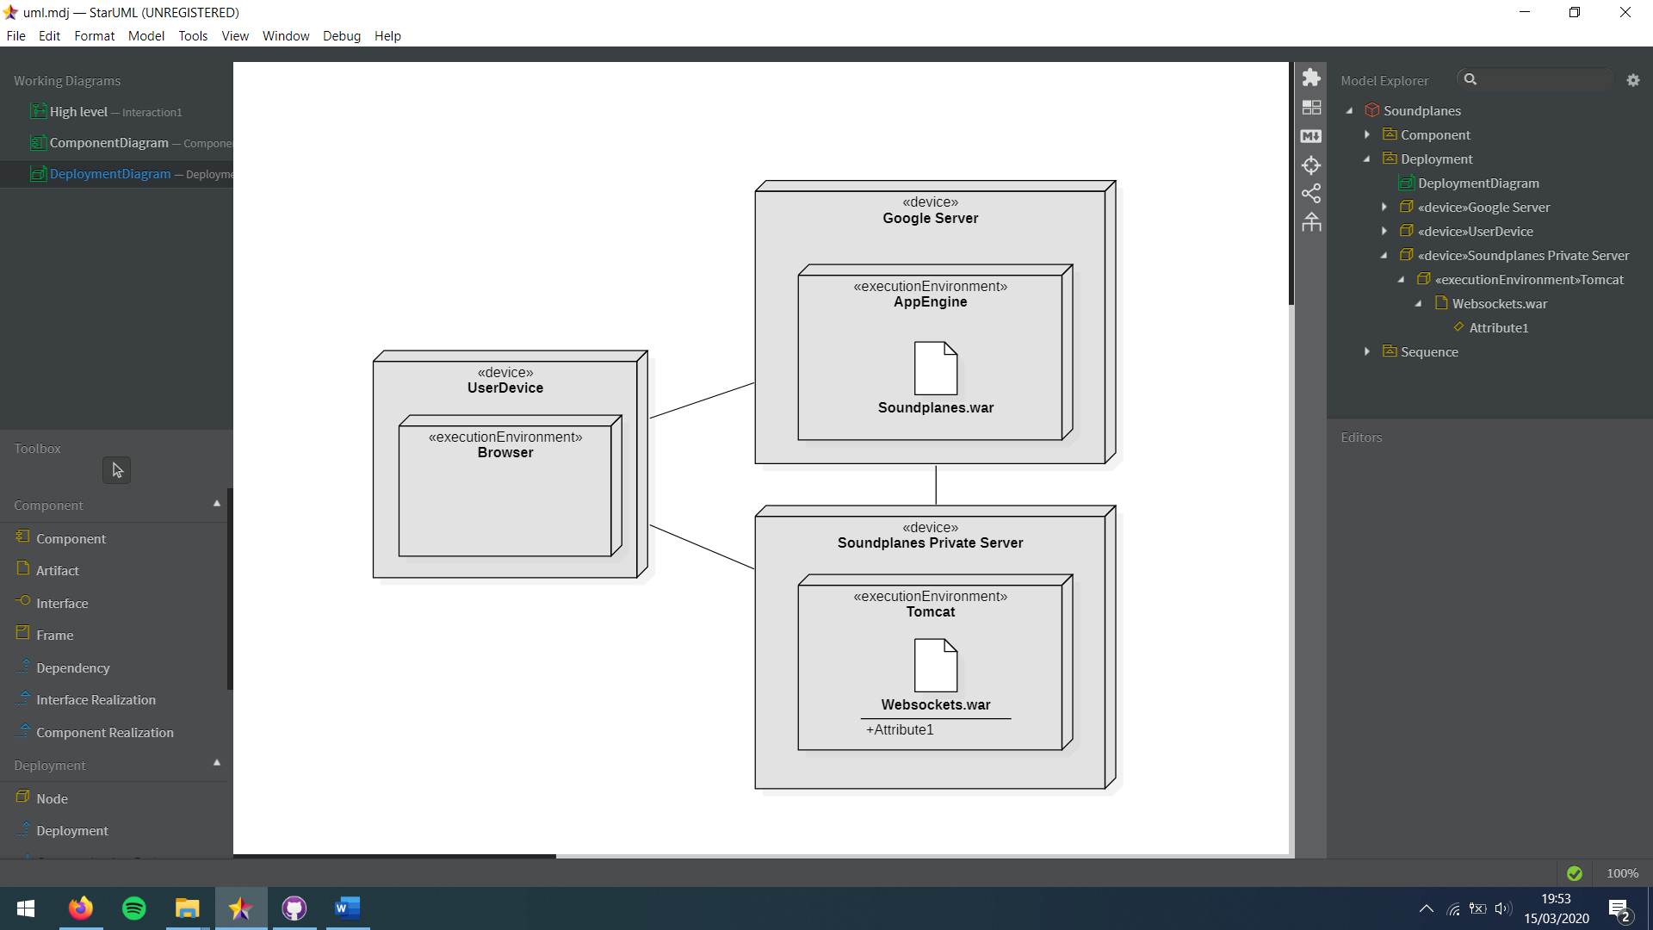

## High-level sequence diagram

## Class diagram

It hasn’t been done yet.

## Sequence diagram

It hasn’t been done yet.

# Implementation

It hasn't been done yet.

# Tests

It hasn't been done yet

|  |  |
| --- | --- |
| Summary |  |
| Total number of tests performed |  |
| Number of automated tests |  |

|  |  |
| --- | --- |
| ID | **Test 1** |
| Description |  |
| Input |  |
| Expected output |  |
| Result |  |
| Automated |  |

# User’s Manual

## Mashup

It hasn't been done yet.

## API REST

It hasn't been done yet.

# References

[1] *Balsamiq*. <http://balsamiq.com/>. Accessed January 2014.

[2] J. Webber, S. Parastatidis y I. Robinson. *REST in Practice: Hypermedia and Systems Architecture.* O'Reilly Media. 2010.