1. **Requirements and Installation**
2. **Usage**

**Design Template**

**Configuration file**

**Factorial configurations**

**Run: python ImplementXil.py configuration.xml**

For instance:

**ILYA@ILYA-PC** /cygdrive/c/Release/FactorialDesign/Python

**$** python ImplementXil.py ./Configs/config_MC8051.xml

**Wait for completion, for monitoring refer to monitoring module.**

**Main Results (implementation properties):**

summary_power_estimated (.csv/.xml)

summary_power_simulated (.csv/.xml)

config_pattern.xml – for later use by SBFI tools

**Per-configuration results**

./design_dir/design_label_[Index]/netgen/

./Log/

./par/

./map/…

./synthesis/…

**User Interface: monitoring module**

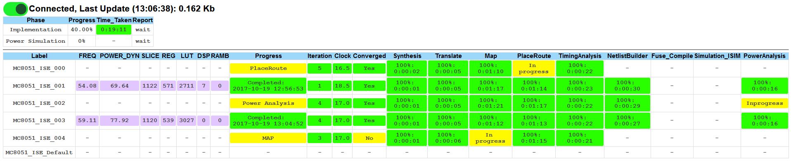

If the connection status is ‘Disconnected’ – click the switchbox, once connected it will be highlighted in green. If the connection status is ‘Connection error’ – check that you are using Firefox browser; otherwise make this folder accessible for web-server (DocumentRoot attribute in httpd.conf for apache), so you can use any web-browser in this case.



*Result in *.csv format*

*Result in *.xml format*

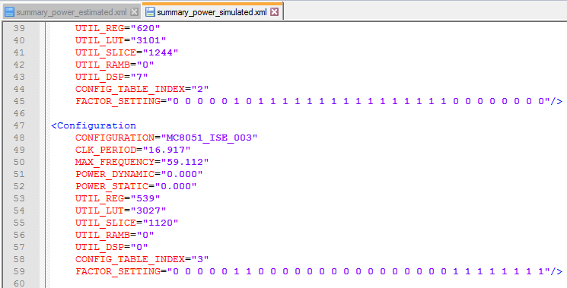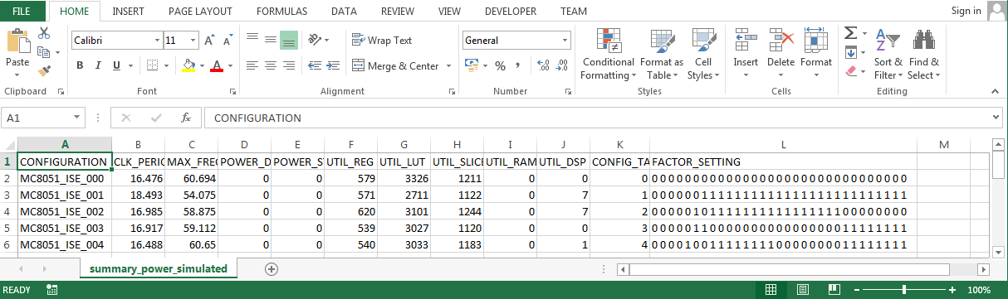

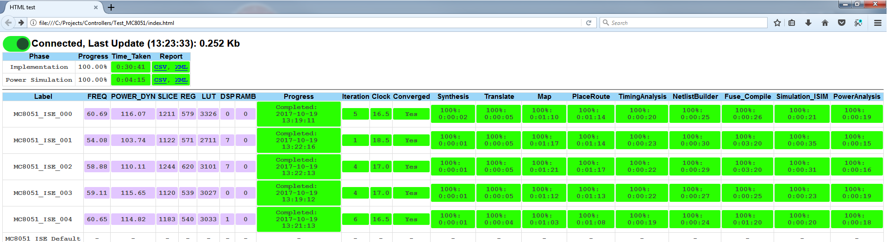

*Monitoring page (open in Firefox, or any other browser under web-server)*

*Resulting netlist*

*Detailed log*

*Detailed Power report*

