# **Mobius 12.1 DEMO**

1. Verify if “Mobius” repository is defined

1. **Activate Audit**

1. **Load mobius_demo image**

$ **k3d image load mobius_demo_12.1.tar -c zenith**

INFO[0002] Importing image(s) into cluster 'zenith'

INFO[0002] Starting new tools node...

INFO[0003] Starting Node 'k3d-zenith-tools'

INFO[0004] Saving 1 tarball(s) to shared image volume...

INFO[0024] Importing images into nodes...

INFO[0024] Importing images from tarball '/k3d/images/k3d-zenith-images-20230307084110-file-mobius_demo_12.1.tar' into node 'k3d-zenith-agent-1'...

INFO[0024] Importing images from tarball '/k3d/images/k3d-zenith-images-20230307084110-file-mobius_demo_12.1.tar' into node 'k3d-zenith-agent-0'...

INFO[0024] Importing images from tarball '/k3d/images/k3d-zenith-images-20230307084110-file-mobius_demo_12.1.tar' into node 'k3d-zenith-server-0'...

INFO[0084] Removing the tarball(s) from image volume...

INFO[0086] Removing k3d-tools node...

INFO[0087] Successfully imported image(s)

INFO[0087] Successfully imported 1 image(s) into 1 cluster(s)

1. **Run mobius12-demo-load job**

$ **kubectl apply -f job_load_mobius12_demo_ca20.yaml**

job.batch/mobius12-demo-load created

Note: 4 to 6 minutes for completing the job

$ **kubectl logs job/mobius12-demo-load -n zenith**

……….

'/home/demo/DAFs/XRays/20221130' -> '/mnt/efs/XRays/20221130'

'/home/demo/DAFs/XRays' -> '/mnt/efs/XRays'

2. Changing files permissions

Mobius Remote Cli Config:

3. Adjust Mobius View URL

asg:

mobius:

cli:

repos:

- repositoryName: "Mobius"

repositoryUrl: "http://asg-mobius-view:80/mobius"

userName: "ADMIN"

user:

basicauth:

userName: "admin"

password: "ASG_ENC(c1LpoXEIRe3h7b6TVoDfNP91rGK/9wGM)"

4. Loading Content Classes and Indexes definitions

Mobius CLI tool

Copyright (C) 2020-2022, Rocket Software, Inc. or its affiliates. All rights reserved.

Mon Mar 13 17:31:58 2023 - Getting repository information.

Mon Mar 13 17:32:02 2023 - Repository ID: ECF8B1B3-7743-4F27-9821-453A5658A45E Repository Name: Mobius Repository Type: VDR

Mon Mar 13 17:32:02 2023 - XML request processing started.

Mon Mar 13 17:34:03 2023 - Total entries processed: 50

Mon Mar 13 17:34:03 2023 - XML request processed successfully

--------------------------------------

MobiusCli log

--------------------------------------

5. Loading references to DAF files and Indexes

Mobius CLI tool

Copyright (C) 2020-2022, Rocket Software, Inc. or its affiliates. All rights reserved.

Mon Mar 13 17:34:09 2023 - Getting repository information.

Mon Mar 13 17:34:12 2023 - Repository ID: ECF8B1B3-7743-4F27-9821-453A5658A45E Repository Name: Mobius Repository Type: VDR

Mon Mar 13 17:34:12 2023 - XML request processing started.

Mon Mar 13 17:36:13 2023 - Total entries processed: 4711

Mon Mar 13 17:36:13 2023 - XML request processed successfully

--------------------------------------

MobiusCli log

--------------------------------------

$ **kubectl delete job/mobius12-demo-load -n zenith**

job.batch "mobius12-demo-load" deleted

**View demo data**

Zenith console -> Mobius View

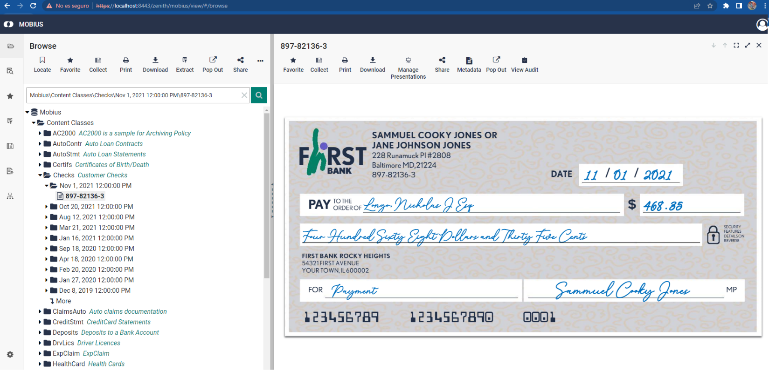

1. **Run mobius-demo-delete job (**delete all demo data, not other content classes**)**

$ **kubectl apply -f job_delete_mobius12_demo_ca20.yaml**

job.batch/mobius12-demo-delete created

$ **kubectl logs job/mobius12-demo-delete -n zenith**

1. Deleting DAFs files

2. Adjusting Mobius Remote Cli Config:

3. Mobius Remote CLI Config

asg:

mobius:

cli:

repos:

- repositoryName: "Mobius"

repositoryUrl: "http://asg-mobius-view:80/mobius"

userName: "ADMIN"

user:

basicauth:

userName: "admin"

password: "ASG_ENC(c1LpoXEIRe3h7b6TVoDfNP91rGK/9wGM)"

4. Deleting references to DAF files and Indexes

Mobius CLI tool

Copyright (C) 2020-2022, Rocket Software, Inc. or its affiliates. All rights reserved.

Mon Mar 13 17:34:09 2023 - Getting repository information.

Mon Mar 13 17:34:12 2023 - Repository ID: ECF8B1B3-7743-4F27-9821-453A5658A45E Repository Name: Mobius Repository Type: VDR

Mon Mar 13 17:34:12 2023 - XML request processing started.

Mon Mar 13 17:36:13 2023 - Total entries processed: 4711

Mon Mar 13 17:36:13 2023 - XML request processed successfully

--------------------------------------

MobiusCli log

--------------------------------------

5. Deleting Content Classes and Indexes definitions

Mobius CLI tool

Copyright (C) 2020-2022, Rocket Software, Inc. or its affiliates. All rights reserved.

Mon Mar 13 17:31:58 2023 - Getting repository information.

Mon Mar 13 17:32:02 2023 - Repository ID: ECF8B1B3-7743-4F27-9821-453A5658A45E Repository Name: Mobius Repository Type: VDR

Mon Mar 13 17:32:02 2023 - XML request processing started.

Mon Mar 13 17:34:03 2023 - Total entries processed: 50

Mon Mar 13 17:34:03 2023 - XML request processed successfully

--------------------------------------

MobiusCli log

--------------------------------------

$ **kubectl delete job/mobius12-demo-delete -n zenith**

job.batch "mobius12-demo-delete" deleted