https://github.com/AZANIR/cypressAllure
Code Review

1. It is not clear what is meant under ‘Change “Username” and “Password”’ in ‘Steps to run’ section on github repository.

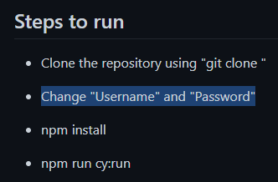
2. Allure reporter does not pull up test data.
- npm run allure:generate
- npm run report

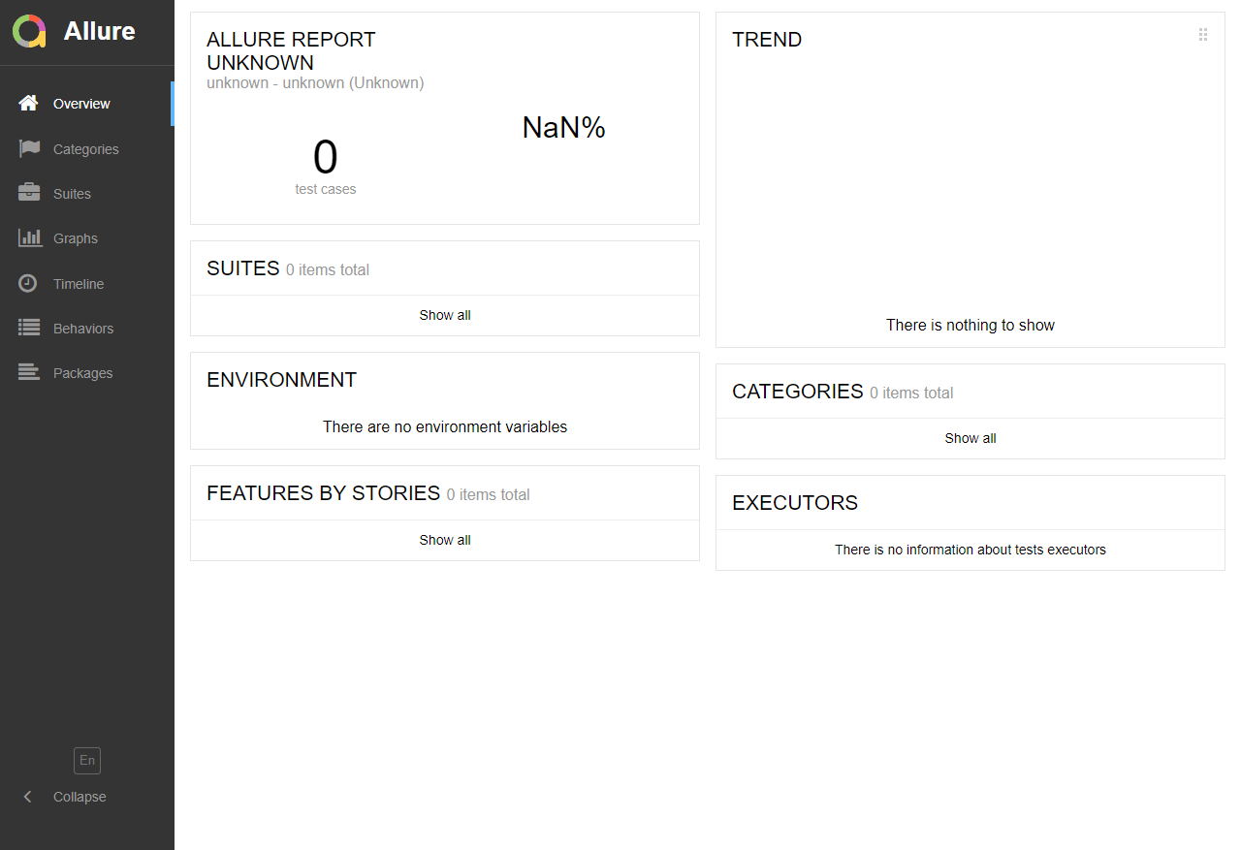

3. myAccount.test.ts Do nothing.

4. Assertions included in pages files but not in test specs.

5. Test ‘login with wrong email format credentials read data from fixture’ fails with wrong expectation.

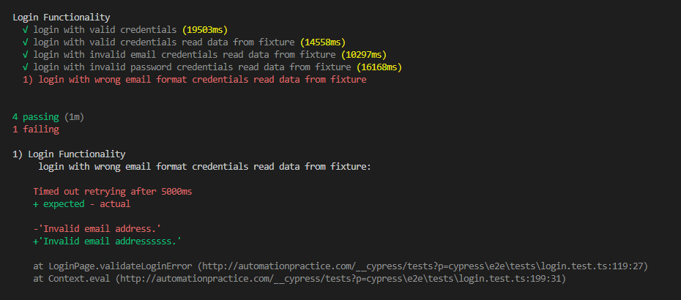
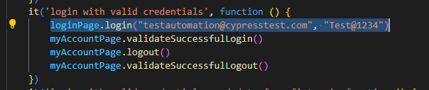
6. Should raw data be inside spec tests?

