Layout

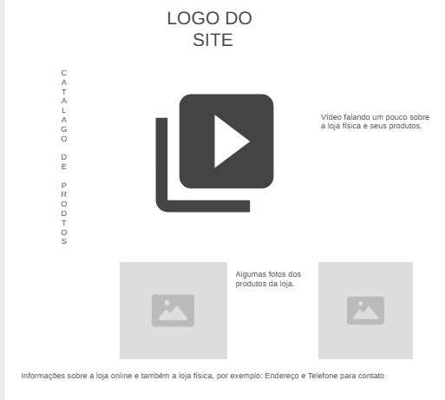

<https://wireframe.cc/IAKKnU>