1Basic

Use External Tools and Gnu Core Tools to enhance your shell skills. Compose them using pipes and filters.

1. Unzip (using the terminal) our ​titanic.zip​ file to ​titanic

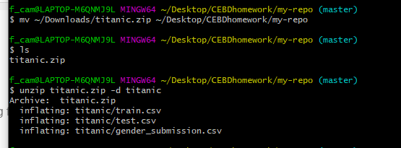

1. Provide the shape/dimensions of the file ​train.csv​?

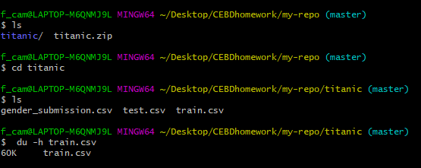

1. List the first 5 rows of the file. Now list the last 5.

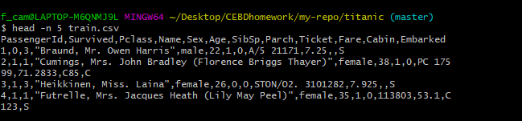

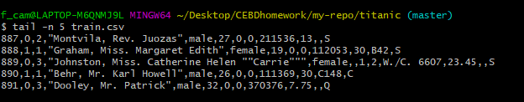

1. Print this file in your screen using ​cat​ now use the ​less​ command

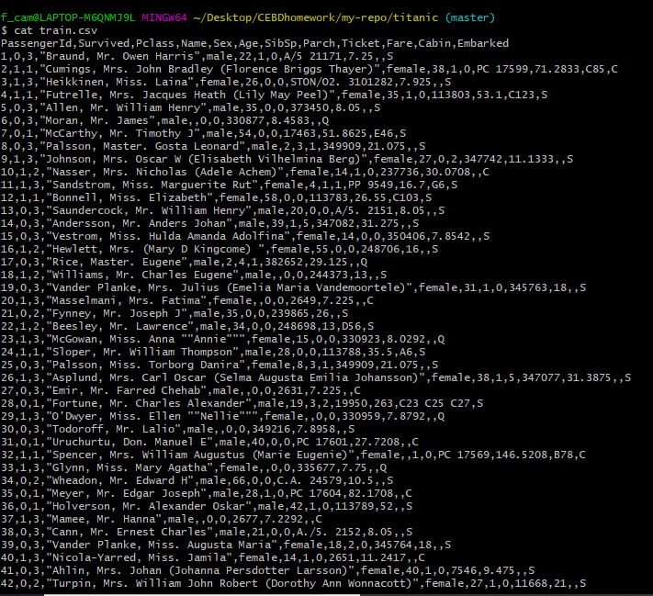

Less

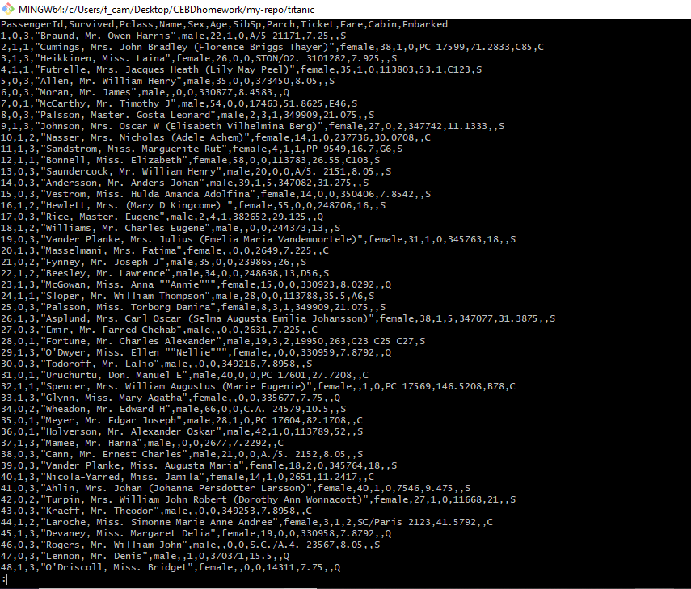

1. Can you print only the names of all people in the file?

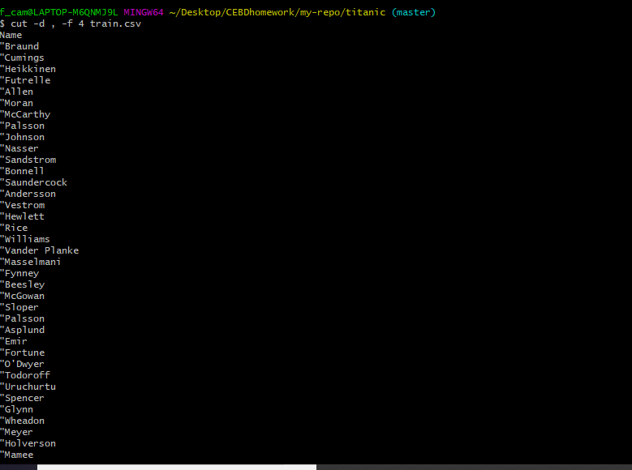

1. Print this file last 5 lines save the output to train_tail.csv

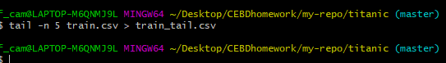

7. Print only the lines 3 to 5 of the file?

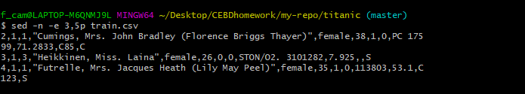

8. Can you explain the command ​du -a . | sort -n -r | head -n 20​ and why would you use it?

