Radiative Timescale Constraints on Boundary Layer Evolution in Models of Titan
Guillermo Adrian Chin-Canche
Instituto Tecnológico Superior de Calkiní (ITESCAM), Tecnológico Nacional de México, Calkiní, Campeche, Mexico
Corresponding author: gcchin@itescam.edu.mx
Submitted to Planetary and Space Science

Abstract
Charnay and Lebonnois (2012) observed that the radiative time constant of Titan's troposphere exceeds 2.5 Titan years, so that direct solar heating cannot generate a diurnal cycle and the boundary layer must instead be driven through the sensible heat flux. That observation underpins current modeling practice, but it has never been made quantitative. Here we derive the associated thresholds. For a gray plane-parallel atmosphere, net radiative heating of the layer in contact with the surface requires a surface-to-air temperature contrast exceeding T_{a}(ε^{−1/4} − 1), approximately 1.2 K for Titan; the threshold is set by the surface emissivity and is independent of optical depth, surface pressure, and vertical grid. Destabilization of the potential temperature profile, which is what turbulence generation requires, is more demanding, because the lowest layers cool more efficiently than those above them. Using an independent implementation of the published gray two-stream scheme for Titan, we locate the heating threshold at a contrast of 2.15 K and the destabilization threshold at 2.53 K, and we show that a sweep over the infrared optical depth, its weighting coefficient, and the downward flux at the model top produces no combination that heats the lower atmosphere. Even at a 3 K contrast, eroding the observed static stability over the lowest four kilometers would require of order 30 Titan solar days, an order of magnitude longer than the integrations used in current one-dimensional studies.
Keywords: Titan; planetary boundary layer; radiative timescales; surface energy balance; atmospheric modeling; Huygens

1. Introduction
The planetary boundary layer records how a surface energy budget is partitioned. On Titan it is also one of the few atmospheric properties accessible from a single vertical profile, which makes it a diagnostic of surface and subsurface conditions that cannot be observed directly. Published estimates of its depth nevertheless disagree by an order of magnitude, from a shallow mixed layer near 300 m inferred from the Huygens descent (Tokano et al., 2006) to 2 to 3.5 km inferred from radio occultation and dune spacing (Lindal et al., 1983; Lorenz et al., 2010; Schinder et al., 2011).
Amid that disagreement there is one point of consensus, and it is quantitative in origin. Charnay and Lebonnois (2012) open their analysis by noting that, because the radiative time constant of Titan's troposphere exceeds 2.5 Titan years, direct solar heating of the troposphere is unable to generate a diurnal or even seasonal cycle, and that solar heating of the surface instead induces diurnal variations in the lower troposphere through the sensible heat flux.
This is a strong statement. It says that the boundary layer cannot be driven by radiative heating of the air and must instead be driven by the surface. It has shaped modeling practice ever since. Han and Lora (2025) write their surface energy balance with no radiative source term for boundary layer turbulence, and Hartwick et al. (2026) treat the sensible heat flux as the input to their boundary layer scheme.
The statement has never been given thresholds. It is asserted as a scalar comparison of timescales, which leaves open the questions that matter in practice: under what conditions, if any, can radiative heating contribute; how large a surface-to-air temperature contrast must be before it does; and how long would radiative destabilization take if it did occur. This paper supplies those thresholds. Section 2 derives them analytically. Section 3 evaluates them numerically for Titan conditions and tests their sensitivity to the uncertain radiative parameters. Section 4 applies them to published studies. Section 5 discusses what the constraint implies for one-dimensional modeling and for Dragonfly.

2. The constraint
Three conditions must be held in sequence for radiative heating to deepen a boundary layer. They are independent, and each of them is necessary.
Condition A, net heating. The divergence of the net radiative flux must be positive somewhere within the layer.
Condition B, destabilization. Net heating is not sufficient. Turbulence is generated by buoyancy, which responds to the vertical gradient of potential temperature and not to its absolute tendency. A column that warms uniformly does not become more unstable.
Condition C, timescale. The destabilization must erode the existing static stability within the duration of the integration.
Sections 2.1 to 2.3 treat the first two conditions analytically, and Section 2.4 establishes the timescale against which the third must be judged.

2.1 Energy balance of a thin gray layer
Consider a layer of infrared optical thickness dτ ≪ 1 at temperature T, receiving an upward flux F↑ from below and a downward flux F↓ from above. In the two-stream approximation, sketched in Figure 1, the layer absorbs a fraction dτ of each incident flux and emits into both hemispheres,
$\frac{dE}{dt}=dτ(F^{↑}+F^{↓}-2σT^{4})$ (1)
The factor of two carries the argument. A layer absorbs from two directions but emits in two directions; its emission is set by its own temperature, while its absorption is set by its surroundings. Figure 1 makes the asymmetry explicit, and it is this asymmetry that produces the threshold derived in Section 2.2.
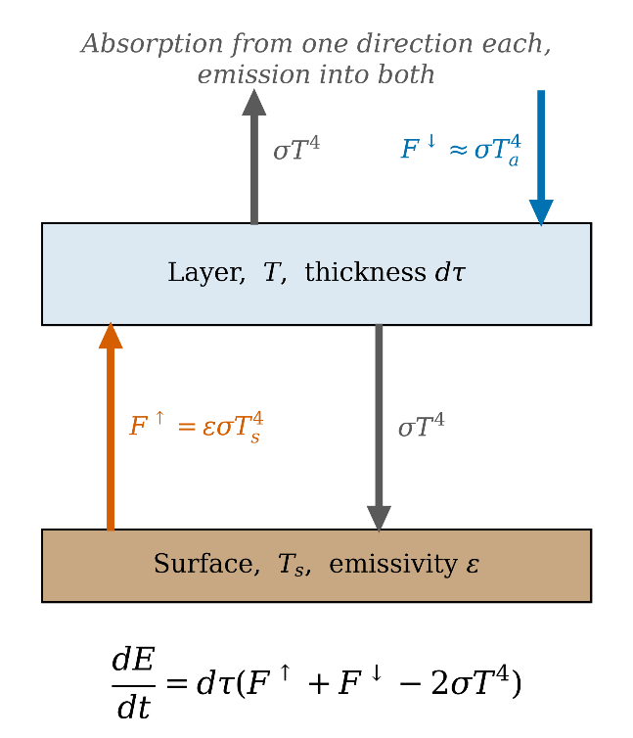
Figure 1. Radiative energy balance of a thin gray layer. The layer absorbs the upward flux from the surface and the downward flux from above, one from each direction, but emits into both hemispheres. The doubling of the emission term against the single absorption terms is what sets the heating threshold of Equation (4).

2.2 The heating threshold
For the layer in contact with the surface, F↑ = ε σ T_{s}⁴, with ε the surface emissivity. In an optically thick atmosphere the downward flux originates in the layers immediately above, whose temperature differs from T_{a} only by the lapse rate over one optical depth, so that to leading order F↓ ≈ σ T_{a}⁴. Substituting into Equation (1),
$\frac{dE}{dt}≈dτσ(εT_{s}^{4}-T_{a}^{4})$ (2)
From Equation (2), net heating requires
$\frac{T_{s}}{T_{a}}>ε^{-1/4}$ (3)
or, equivalently, a minimum surface-to-air contrast
$ΔT_{min}≈T_{a}(ε^{-1/4}-1)$ (4)
For ε = 0.95, the value adopted alike by Charnay and Lebonnois (2012), Lebonnois et al. (2012), Han and Lora (2025), and Hartwick et al. (2026), and for T_{a} = 93 K, Equation (4) gives ΔT_{min} ≈ 1.2 K. Two features deserve emphasis.
First, the threshold is set almost entirely by the surface emissivity: a perfect emitter would give zero, and the five percent deficit assumed for Titan regolith is what creates the barrier. Second, the threshold is independent of the infrared optical depth, of the surface pressure, and of the vertical grid. It is a thermodynamic statement rather than a modeling choice.
The optically thin limit, in which F↓ is negligible, gives the far more restrictive condition ε T_{s}⁴ > 2 T_{a}⁴ and a threshold near 19 K. Titan's lower atmosphere is not in that limit, and we quote the optically thick result throughout.

2.3 The destabilization requirement
Writing the radiative heating rate as Ṫ_{rad}(z), the rate of change of the potential temperature gradient satisfies
$\frac{∂}{∂t}(\frac{∂θ}{∂z})∝\frac{∂{\overset{˙}{T}}_{rad}}{∂z}$ (5)
Equation (5) shows that the profile destabilizes only where the heating decreases with height, or equivalently where the cooling increases with height.
In a gray atmosphere overlying a warm surface the opposite is generically true near the ground. The lowest layers see the surface most directly and absorb the most, but they are also the warmest and emit the most, and their downward emission is absorbed by the surface rather than escaping to space. The net result is that the lowest layers cool more efficiently than those above them, and the radiative effect is stabilizing. No compact analytic threshold exists for Condition B, because the sign of ∂Ṫrad/∂z depends on the full temperature profile; we therefore evaluate it numerically in Section 3.

2.4 The radiative timescale
The Newtonian relaxation time of a column of surface pressure p is
$τ_{rad}=\frac{c_{p}p}{4gσT^{3}}$ (6)
For Titan, with c_{p} = 1101 J kg⁻¹ K⁻¹, p = 1.45 × 10⁵ Pa, g = 1.352 m s⁻² and T = 93 K, Equation (6) gives τ_{rad} ≈ 6.4 × 10⁸ s, that is, 469 Titan solar days, equivalent to 0.69 Titan years for the lowest 20 km. Charnay and Lebonnois (2012) quote a value exceeding 2.5 Titan years for the full 40 km troposphere; the two figures are consistent, since the timescale scales with the mass of the column. Either figure is two to three orders of magnitude longer than the few-sol integrations used in one-dimensional studies. This is the quantitative content of the statement that Titan's troposphere is radiatively sluggish.

3. Numerical evaluation

3.1 Method
We evaluate the thresholds with an independent implementation of the gray two-stream scheme of Chatain et al. (2022, Appendix A), which is the broadband scheme in current use for Titan mesoscale modeling. The implementation solves the two-stream equations for the diffuse shortwave intensities analytically for a truncated Henyey–Greenstein phase function and integrates the longwave transfer layer by layer with the optical depth parameterization of Schneider et al. (2012). Table 1 lists every parameter entering the calculation, together with the source from which each value is taken.
Parameter | Symbol | Value | Units | Source
Solar constant | S₀ | 15.04 | W m⁻² | Hartwick et al. (2026)
Downward IR at model top | I_IR | 2 | W m⁻² | Hartwick et al. (2026)
Surface albedo | α | 0.3 | — | Hartwick et al. (2026)
Surface emissivity | ε | 0.95 | — | Hartwick et al. (2026)
Visible optical depth | τ_vis | 8 | — | Chatain et al. (2022)
Infrared optical depth | τ_IR | 10 | — | Hartwick et al. (2026)
Visible scaling exponent | γ | 0.21 | — | Schneider et al. (2012)
IR weighting coefficient | f | 0.15 | — | Chatain et al. (2022)
Single scattering albedo | ω₀ | 0.9 | — | Chatain et al. (2022)
Asymmetry factor | g | 0.85 | — | Chatain et al. (2022)
Atmospheric layers | N | 56 | — | Hartwick et al. (2026)
Surface pressure | p_s | 1.45 × 10⁵ | Pa | Hartwick et al. (2026)
Model top pressure | p_t | 6.60 × 10⁴ | Pa | Hartwick et al. (2026)
Specific heat | c_p | 1101 | J kg⁻¹ K⁻¹ | Hartwick et al. (2026)
Surface gravity | g | 1.352 | m s⁻² | standard
Table 1. Model configuration. Parameter, symbol, value, units, and source for every quantity entering the radiative transfer calculation.
The atmosphere is initialized from the HASI descent profile (Fulchignoni et al., 2005) interpolated onto 56 pressure levels spanning 1.45 to 0.66 bar. Heating rates are evaluated at local noon, when the shortwave contribution is largest and the mechanism under examination is most favored.
Every result reported in Sections 2 and 3, and every quantity shown in Figures 1 to 4 and in Tables 1 and 2, is a diagnostic evaluated on an initialized atmospheric state together with the radiative transfer scheme. No time integration is performed, and no boundary layer, surface layer, or subsurface scheme is exercised. The thresholds are properties of the radiative transfer and of the observed thermal profile, and not outcomes of a simulation.
Results attributed to the archive of Hartwick et al. (2026) throughout Sections 3.6 and 4.4 and shown in Figures 5 and 6 and in Tables 3 and 4, are read from their published output (doi:10.5281/zenodo.17246644) and are not reproductions of it. The two sources are kept separate by design, and each figure and table is labeled with the one it comes from. Rates expressed per Titan solar day use a sol of 1 378 080 s, the value implied by the archived integration, so that our rates and the archived rates are expressed in the same unit and can be compared directly.
Two configuration choices are stated openly, because the published descriptions are incomplete. The vertical distribution of layers is not published for the scheme we implement; we adopt a geometric progression, and the results below are insensitive to that choice because the heating rate profile is smooth. The visible optical depth is quoted inconsistently in the sources; we adopt the value tuned against Huygens DISR data (Tomasko et al., 2008) and note that the shortwave contribution is in any case two orders of magnitude below the longwave terms in the lower atmosphere.

3.2 The heating rate profile
With surface and air temperatures equal, the radiative heating rate is negative throughout the lower atmosphere and increases monotonically with height. It rises from −0.0832 K per Titan sol in the lowest layer, 5.4 m above the surface, to −0.0733 K per sol at 171 m, −0.0482 K per sol at 541 m, −0.0136 K per sol at 1382 m, and −0.0053 K per sol at 1652 m. The lowest layer therefore cools some sixteen times faster than the layer at 1.65 km.
This is the behavior anticipated in Section 2.3: the radiative effect is stabilizing, and Condition B fails before Condition A is reached. Taking the surface figure at face value, changing the temperature of the lowest atmospheric layer by one kelvin radiatively would take 12 Titan sols. This is an independent confirmation of Section 2.4, obtained from the heating rates rather than from the bulk relaxation formula.
Figure 2 shows how the profile responds as the surface-to-air contrast is increased from 0 to 4 K. Positive heating rates appear near the ground only at large contrast, and, as anticipated, the vertical gradient of the heating rate changes sign at a larger contrast still than the heating rate itself does.
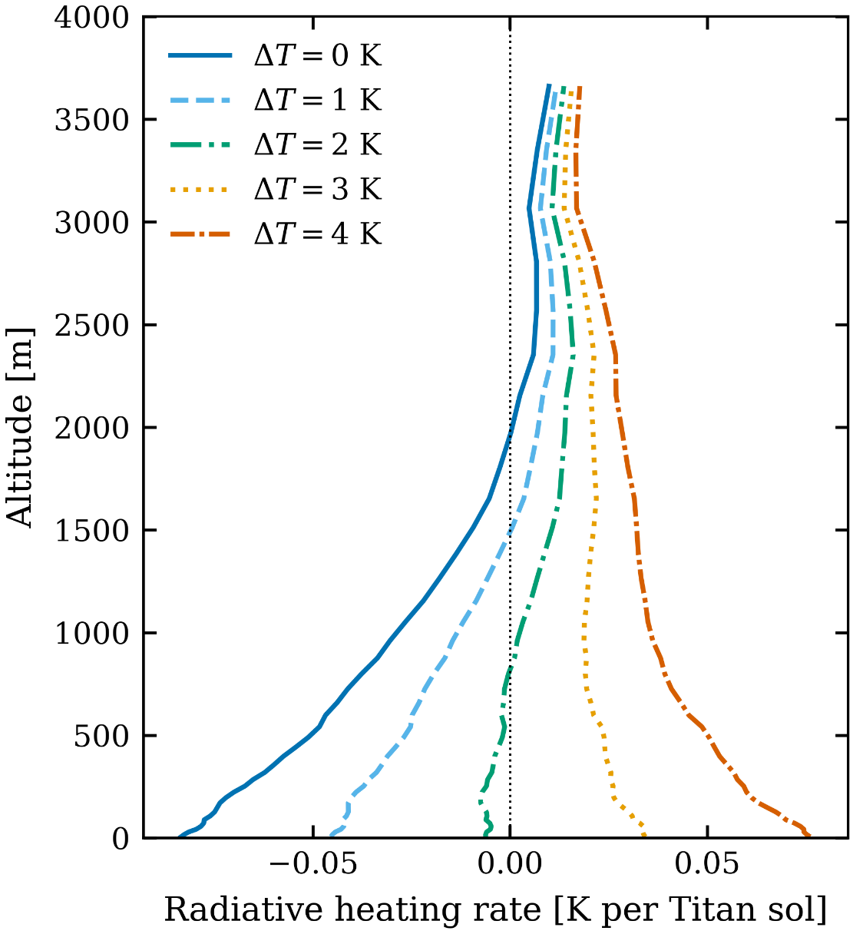
Figure 2. Radiative heating rate against altitude for surface-to-air temperature contrasts of 0 to 4 K. The profile is negative everywhere at small contrast; positive values appear near the ground only at large contrast, and the vertical gradient changes sign at a larger contrast still.

3.3 Threshold contrasts
Increasing the contrast raises the heating rate of the lowest layer, because the surface emission it absorbs grows as Ts⁴ while its own emission is unchanged. Solving for the sign changes locates the two thresholds. The analytic heating threshold of Equation (4) is 1.20 K; the numerical heating threshold for the lowest layer is 2.15 K; and the numerical destabilization threshold over the lowest four kilometers is 2.53 K, which is the zero-crossing plotted in Figure 3.
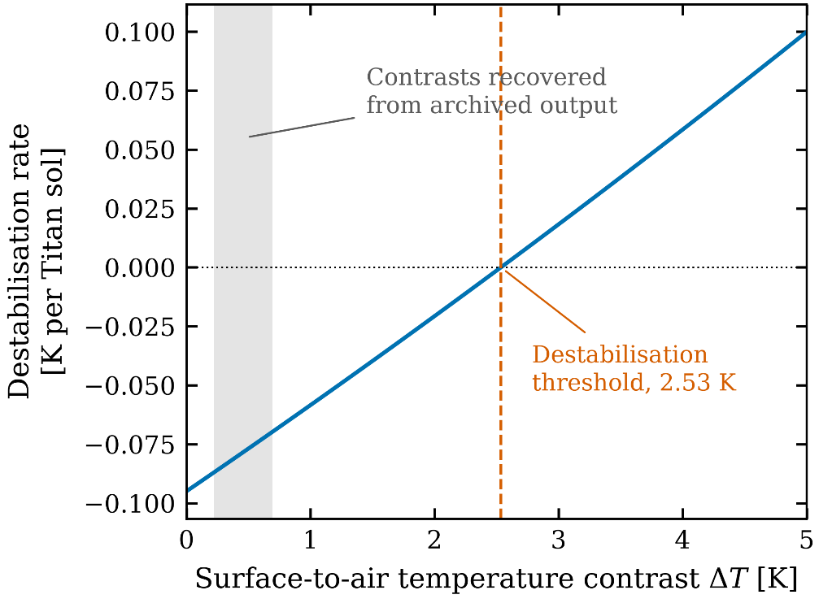
Figure 3. Destabilization rate, defined as the difference in radiative heating rate between the surface layer and 4 km, against surface-to-air contrast. The zero crossing at 2.53 K marks the destabilization threshold. The shaded band spans the contrasts recovered from the archived output of Hartwick et al. (2026).
The numerical heating threshold exceeds the analytic estimate because the derivation of Section 2.2 neglects the lapse rate between the surface and the level from which the downward flux originates. The ordering of the three values is as expected, and all of them exceed the diurnal contrasts reported in the studies examined in Section 4, which are of order 0.1 to 2 K; the shaded band in Figure 3 spans the contrasts recovered from the archive of Hartwick et al. (2026), and it lies entirely to the left of the zero crossing.

3.4 Sensitivity to the radiative parameters
Because several parameters are uncertain, we swept the three that most directly control the longwave budget: the downward infrared flux prescribed at the model top (0, 2, 4, and 8 W m⁻²), the surface infrared optical depth (10 and 30), and the weighting coefficient between the linear and quadratic terms of the optical depth parameterization (0.15 and 0.50). The sixteen resulting combinations are reported in Table 2, which gives, for each of them, the maximum radiative heating rate below 2.5 km, the heating rate in the layer in contact with the surface, and the vertical gradient of the heating rate over the lowest four kilometers. The minimum heating rate is not listed separately, because in all sixteen combinations it coincides exactly with the surface value.
I_IR  (W m⁻²) | τ_IR | f | Max. heating  (K sol⁻¹) | Surface heating  (K sol⁻¹) | Gradient  (K sol⁻¹)
0 | 10 | 0.15 | +0.0045 | −0.0837 | −0.0882
0 | 10 | 0.50 | +0.0011 | −0.0746 | −0.0757
0 | 30 | 0.15 | +0.0211 | −0.1702 | −0.1913
0 | 30 | 0.50 | +0.0208 | −0.1453 | −0.1661
2 | 10 | 0.15 | +0.0059 | −0.0834 | −0.0894
2 | 10 | 0.50 | +0.0031 | −0.0741 | −0.0772
2 | 30 | 0.15 | +0.0211 | −0.1702 | −0.1913
2 | 30 | 0.50 | +0.0208 | −0.1453 | −0.1661
4 | 10 | 0.15 | +0.0073 | −0.0832 | −0.0905
4 | 10 | 0.50 | +0.0051 | −0.0737 | −0.0788
4 | 30 | 0.15 | +0.0211 | −0.1702 | −0.1913
4 | 30 | 0.50 | +0.0208 | −0.1453 | −0.1661
8 | 10 | 0.15 | +0.0102 | −0.0827 | −0.0929
8 | 10 | 0.50 | +0.0091 | −0.0728 | −0.0819
8 | 30 | 0.15 | +0.0211 | −0.1702 | −0.1913
8 | 30 | 0.50 | +0.0208 | −0.1453 | −0.1661
Table 2. Sweep over the three uncertain longwave parameters: the downward infrared flux at model top, the infrared optical depth, and its weighting coefficient. No combination produces net heating in the lower atmosphere or reverses the sign of the vertical heating gradient.
Across the full sweep the maximum heating rate anywhere below 2.5 km reaches +0.021 K per sol, against a cooling rate of −0.083 K per sol in the lowest layer of the reference configuration. No combination in Table 2 produces heating in the lowest layers, and none reverses the sign of the vertical gradient. The conclusion is insensitive to the parameter values within the ranges considered.

3.5 The mixing timescale
From the HASI profile, the potential temperature increases by Δθ = 0.652 K between the surface and 4 km. Eroding that stratification by radiative destabilization alone takes a time that diverges at the threshold of Section 3.3 and falls steeply above it. At a contrast of 2.53 K the destabilization rate is zero by construction and the mixing time is unbounded. At 3.0 K the rate is +0.0183 K per sol and the mixing time 35.8 sols; at 3.5 K, +0.0382 K per sol and 17.1 sols; and at 4.5 K, +0.0790 K per sol and 8.3 sols. Figure 4 plots the relation over the full range of contrasts.
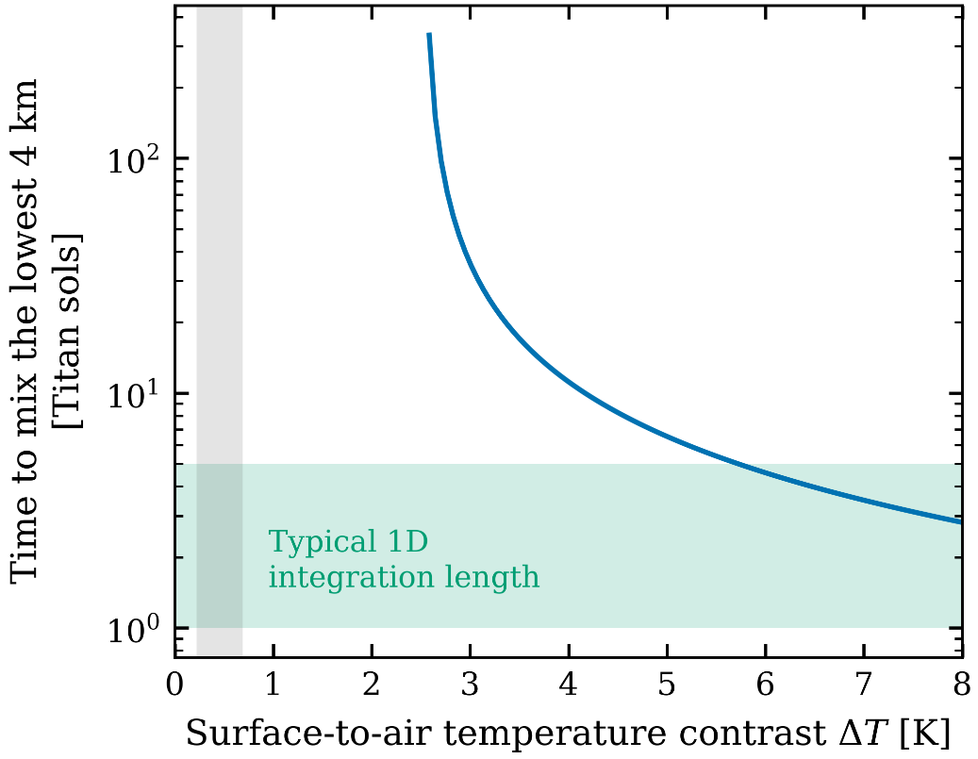
Figure 4. Time required to erode the observed static stability over the lowest four kilometers, against surface-to-air contrast, on logarithmic axes. The horizontal band spans typical one-dimensional integration lengths; the vertical band spans contrasts reported in published Titan studies. The two do not intersect.
One-dimensional studies of Titan's boundary layer typically integrate for five Titan sols, of which the first is discarded as spin-up. As Figure 4 makes plain, the band of typical integration lengths and the band of contrasts reported in published Titan studies do not intersect. Even a contrast of 4.5 K, more than twice the largest diurnal contrast reported in any study we examined, would require eight sols to mix a four-kilometer column.

3.6 Validation against archived output
The preceding sections rest on our own implementation of the gray scheme. To establish that the implementation is faithful rather than merely self-consistent, we compare its heating rates against the archived output of Hartwick et al. (2026), which used an independent code, mtWRF, with the same published parameter set. The archived longwave heating rate is recovered from the net flux divergence,
$\overset{˙}{T}=-\frac{g}{c_{p}}\frac{∂F_{net}}{∂p}$ (7)
Equation (7) is evaluated at local noon on the third Titan sol of the dry baseline run. Our profile is evaluated at the same local time with a zero surface-to-air contrast, which is the condition the archived run approaches at that hour. Figure 5 compares the two profiles, and Table 3 gives the values at four altitudes together with the relative difference at each.
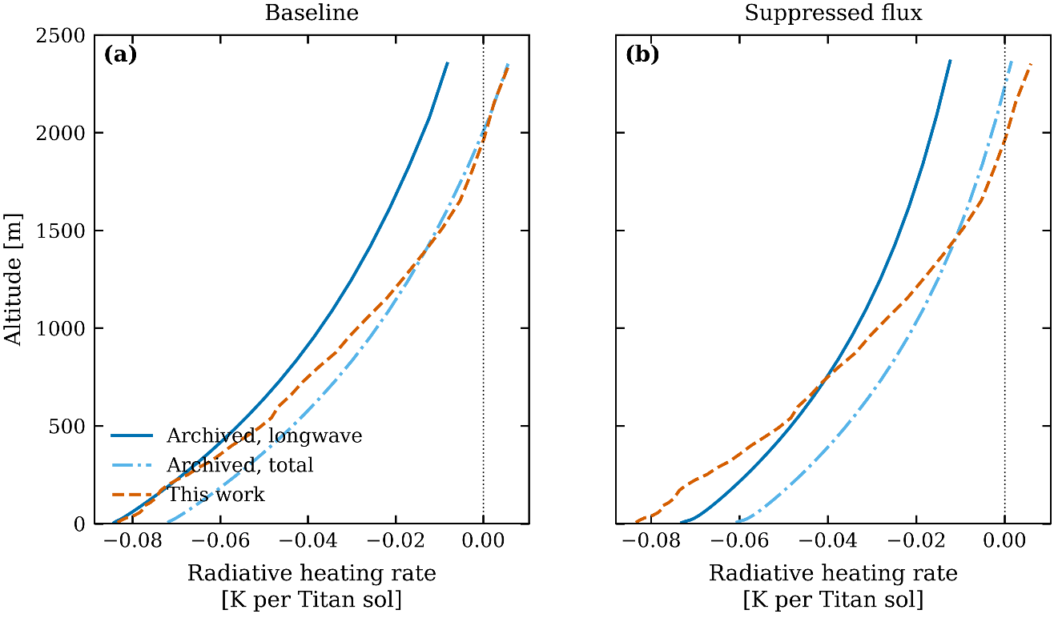
Figure 5. Longwave heating rate profiles from the archived output of Hartwick et al. (2026), for the baseline and suppressed-flux runs, against the profile computed here. Agreement in the lowest layer is 0.90 %.
Altitude (m) | Archived (K sol⁻¹) | This work (K sol⁻¹) | Difference (%)
5.4 | −0.0842 | −0.0834 | 0.90
172.1 | −0.0730 | −0.0735 | 0.77
556.4 | −0.0535 | −0.0483 | 9.65
1415.8 | −0.0258 | −0.0137 | 47.03
Table 3. Archived against computed longwave heating rates at four altitudes, with the relative difference at each. Agreement is best in the lowest layers, which is where the argument of Sections 2 and 3 operates.
In the lowest model layer, 5.4 m above the surface, the archived cooling rate is −0.0842 K per Titan sol and ours is −0.0834 K per Titan sol, a difference of 0.90 %. As Table 3 shows, agreement degrades with height, reaching 9.65 % at 556 m and 47.03 % at 1416 m, where both rates are small and their difference is dominated by the coarser vertical resolution of the archive above the refined near-surface layers. Since the argument of Sections 2 and 3 turns on the sign and magnitude of the heating in the lowest layers, where agreement is best, the comparison supports the conclusions drawn.
We emphasize what this comparison does and does not establish. It validates the radiative scheme, which is what Sections 2 and 3 use. It says nothing about the coupled boundary layer model, which is not exercised anywhere in this work; see the scope statement in Section 3.1.

4. Application to published studies
We apply the constraint to four studies spanning both model classes and fourteen years of work, asking in each case whether the mechanism invoked is consistent with the thresholds established in Section 3.

4.1 Charnay and Lebonnois (2012)
This study states the constraint and builds on it. The boundary layer is driven entirely by the sensible heat flux, which varies from −0.05 W m⁻² at night to +1.1 W m⁻² at midday, with a diurnal mean of +0.23 W m⁻², about five percent of the top-of-atmosphere solar flux. The diurnal layer reaches 800 m at 15:00 local time; the 2 km seasonal layer is attributed to the reversal of the Hadley cell at equinox, that is, to circulation rather than to any local radiative process. Consistent.

4.2 Lebonnois et al. (2012)
The companion model description uses a Mellor–Yamada boundary layer scheme with the sensible heat flux as its surface boundary condition. No radiative source for boundary layer turbulence appears. Consistent.

4.3 Han and Lora (2025)
This study develops a theoretical framework in which surface temperature variability is governed by subsurface conduction at diurnal timescales and by atmospheric damping at seasonal ones. Its surface energy balance carries no radiative source term for turbulence, and the atmospheric damping coefficient it introduces is noted by the authors to take the same functional form as the expression for the sensible heat flux.
The radiative transfer in this model is nongray and includes multiple scattering, so the threshold of Section 2.2 does not apply in the strict form derived here. The study nonetheless reaches the same structural conclusion independently. Diurnal boundary layer depths range from 130 m to 1420 m, surface diurnal amplitudes from 0.12 to 0.21 K, and peak sensible heat fluxes from 0.8 to 1.2 W m⁻². Consistent, and independently so.

4.4 Hartwick et al. (2026)
This study examines whether subsurface methane evaporation is required to reproduce the 800 m diurnal layer. Its central conclusion, that dry simulations overpredict the layer and that a modest latent heat flux is required, follows from the surface energy budget and is unaffected by the present analysis.
The study also reports a sensitivity experiment in which the sensible heat flux is artificially reduced by an order of magnitude, to about 0.15 W m⁻². The boundary layer in that experiment deepens rather than shallows, reaching 4 to 5 km, and the explanation offered is radiative: the surface warms by more than one kelvin, emits more thermal radiation, and the opaque lower atmosphere absorbs that emission, generating turbulence.
Applying the constraint, a contrast greater than one kelvin lies below both thresholds of Section 3.3. At 3 K, the mixing time for a four-kilometer column would be 35.8 sols against a five sol integration, as Figure 4 shows. The reported deepening is therefore not accounted for by the mechanism offered.
We emphasize the scope of that statement. It does not mean the deepening did not occur, and it does not bear on the study's conclusion about methane evaporation. It means that if the deepening occurred, its cause lies elsewhere.
The archived output allows the comparison to be made directly rather than inferred from the text. Table 4 collects the relevant quantities by Titan sol for both runs, and Figure 6 shows them as time series against the thresholds of Section 3.3. Over sols 2 to 5, the maximum surface-to-air contrast is 0.22 K in the baseline run and 0.67 K in the suppressed run. Both lie below the analytic threshold of 1.20 K, well below the numerical heating threshold of 2.15 K, and far below the destabilization threshold of 2.53 K. The phrase quoted above refers to the rise in surface skin temperature between the two runs, which reaches 1.22 K by the fifth sol, and not to the surface-to-air contrast that governs the radiative response. On either reading the thresholds are not met.
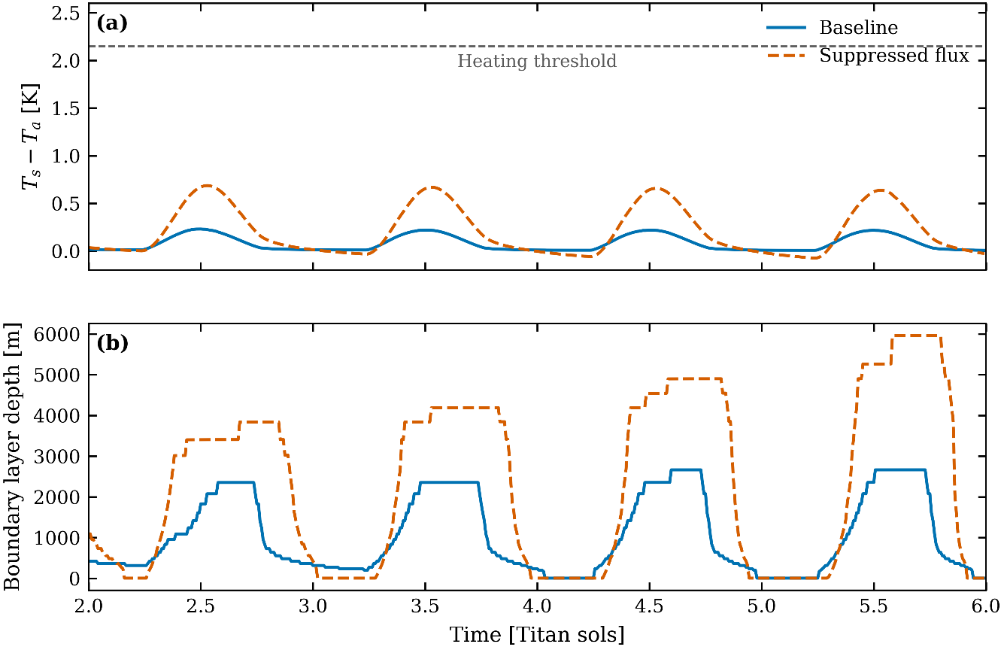
Figure 6. Surface-to-air temperature contrast and boundary layer depth over Titan sols 2 to 5, for the baseline and suppressed-flux runs of Hartwick et al. (2026). The contrast remains below the heating threshold throughout; the suppressed-flux boundary layer does not level off.
Sol | ΔT base  (K) | ΔT suppr.  (K) | δTs max  (K) | δTs mean  (K) | HFX base (W m⁻²) | HFX suppr. (W m⁻²) | PBL base (m) | PBL suppr. (m)
2 | 0.231 | 0.686 | 0.830 | 0.479 | 1.827 | 1.055 | 2353 | 3838
3 | 0.220 | 0.670 | 0.986 | 0.636 | 1.793 | 1.058 | 2353 | 4190
4 | 0.219 | 0.657 | 1.113 | 0.763 | 1.786 | 1.046 | 2664 | 4901
5 | 0.219 | 0.638 | 1.222 | 0.873 | 1.803 | 1.050 | 2664 | 5960
Table 4. Thermal contrasts, sensible heat fluxes, and boundary layer depths recovered from the archive, by Titan sol, for both runs. ΔT is the surface-to-air contrast within a run; δTs is the difference in skin temperature between the two runs.
Two further quantities in Table 4 bear on the interpretation. The peak sensible heat flux in the suppressed run is 1.06 W m⁻² against 1.79 W m⁻² in the baseline, a reduction of 41 %. And the boundary layer of the suppressed run grows by 55 % between the second and fifth sols, from 3838 m to 5960 m, without leveling off; the absence of any plateau is visible in the lower panel of Figure 6. A layer still deepening at the end of the integration is not in a diurnally repeating state, which bears on how the reported 4 to 5 km should be read.

4.5 Candidate explanations
We list six candidate explanations in descending order of likelihood; several are testable from archived output.
1. The archived flux reduction is smaller than the stated one.
The archived suppressed-flux experiment shows a peak sensible heat flux of 1.06 W m⁻² compared to 1.79 W m⁻² in the base case—a 41% reduction. The correspondence between this archived configuration and the order-of-magnitude reduction described in the text is not one-to-one, introducing diagnostic ambiguity when interpreting the 4–5 km result.
2. A larger thermal contrast than reported. A contrast greater than one kelvin is a lower bound. A contrast above 2.5 K would satisfy Conditions A and B, although Condition C would remain difficult. This is the simplest resolution.
3. A different radiative treatment. The scheme parameters are cited from Chatain et al. (2022), but models evolve. A scheme in which infrared opacity increases upward more sharply than the parameterization used here would place the emission level higher and could reverse the sign of the vertical heating gradient.
4. Turbulence generated by flux divergence rather than by buoyancy. In principle a closure could carry a direct radiative contribution to the turbulent kinetic energy budget, distinct from the buoyancy term, in which case turbulence could be generated without the potential temperature profile destabilizing. This does not appear to be the case for any of the studies considered here. All three use closures of the Mellor–Yamada family: mtWRF employs a subgrid eddy diffusion scheme of the Mellor–Yamada–Janjic type (Janjic, 1994), with the surface layer treated following Beljaars (1995), as described in Hartwick et al. (2026, §2.1); TAM employs the Mellor–Yamada scheme consistently with the approach of Charnay and Lebonnois (2012), as described in Han and Lora (2025, §2.2); and the LMDZ Titan model uses a Mellor–Yamada parameterization taken from the terrestrial version of the LMD general circulation model (Lebonnois et al., 2012, §2.2).
In the canonical formulation, the prognostic equation for turbulent kinetic energy carries four terms on its right-hand side: shear production, buoyant production, dissipation, and turbulent transport (Mellor and Yamada, 1982, Eq. 24 and Eqs. 25a–25c, p. 855; see also Yamada, 1983). There is no radiative source term, and the omission is deliberate rather than incidental. Mellor and Yamada place the radiative contribution in the mean thermodynamic equation instead, noting of their Eq. (3) that radiative effects will not be considered (Mellor and Yamada, 1982, p. 852).
The second prognostic variable of the level 2½ closure, the length scale q²l, is forced only by the same shear and buoyancy production terms (their Eq. 48, p. 860) and likewise never sees the radiative field. The same structure appears in the implementation used by the LMDZ Titan model, whose prognostic turbulent energy equation carries a source proportional to the wind shear M² = ‖∂v/∂z‖², an inhibition due to stratification N² = (g/θ)(∂θ/∂z), a dissipation in q³, and vertical diffusion (Hourdin et al., 2002, Appendix B, pp. 1121–1122), in one-to-one correspondence with the four terms of Mellor and Yamada.
Radiation therefore reaches the turbulence only indirectly, and by exactly one route that matters here. The potential temperature profile, which radiative heating modifies, enters the closure through the buoyancy term: as N² in the LMDZ implementation and as GH = −(l²/q²)βg ∂Θv/∂z in Mellor and Yamada (their Eq. 33b, p. 855). That same stratification then sets the gradient Richardson number and, through it, the stability functions that determine the eddy diffusivities. A third route runs through the lower boundary condition, where radiation acts on the surface energy balance and hence on the surface fluxes that drive the surface layer.
We state the limit of this verification. All three studies use closures of the Mellor–Yamada family, which we have confirmed from their own descriptions. The absence of a radiative source term in the turbulent kinetic energy budget is verified for the canonical formulation of Mellor and Yamada (1982) and for the implementation of Hourdin et al. (2002). We did not verify the specific implementations of the Mellor–Yamada–Janjic scheme in mtWRF or of the turbulence scheme in TAM against their own primary sources.
The distinction matters for this paper. If the coupling from radiation to turbulence is mediated by the stratification, then the constraint derived in Section 2 applies in full: radiation can generate turbulence only by destabilizing the profile, and Section 3 bounds how fast it can do so. It is worth noting that Mellor and Yamada themselves treat radiation as a consumer of the fields their closure produces rather than as an input to it, remarking that recovering water vapor and absolute temperature is needed both to determine buoyancy effects on turbulence and to compute longwave radiative cooling (p. 867). The asymmetry is the one this paper quantifies.
5. Model drift. The study reports a surface energy imbalance growing from 0.047 to 0.074 W m⁻² between the second and fifth sols. Deepening over five sols in a drifting integration need not be attributable to the imposed perturbation, and the monotonic growth of the suppressed-flux layer in Figure 6 is consistent with drift rather than with an equilibrated state.
6. Diagnostic threshold effects. Boundary layer depth diagnosed from a turbulent kinetic energy threshold can jump by hundreds of meters for small changes in the energy field, particularly where the vertical grid is coarse, and depths of 4 to 5 km lie well above the refined part of the grid. The sensitivity of the diagnosed depth to the diagnostic itself and to the choice of closure is well documented for terrestrial schemes (Holtslag and Boville, 1993; Ayotte et al., 1996; Hu et al., 2010).

5. Discussion

5.1 What the constraint establishes
The result is a bound, not a refutation. Section 2 holds for any gray plane-parallel scheme in local thermodynamic equilibrium, which describes the broadband schemes in current use for Titan, and does not depend on any implementation.
The numerical results of Section 3 rest on an independent reimplementation of the radiative transfer scheme alone, validated against archived output to 0.90 % in the layer that matters (Figure 5 and Table 3). That validation covers the radiative scheme and nothing else. We make no claim to have reproduced the coupled boundary layer models discussed in Section 4, and no result in this paper depends on our doing so: the thresholds are diagnostics of the radiative transfer, as Figures 2 and 3 and Table 2 make explicit, and the contrasts they are compared against, collected in Table 4, are read from published output rather than simulated here.

5.2 Implications for one-dimensional modeling
Radiative destabilization is not available as a mechanism on diurnal timescales. Titan's lower atmosphere is radiatively sluggish; heating rates of order 0.1 K per sol cannot restructure a column whose static stability is measured in tenths of a kelvin over kilometers, within the few-sol integrations that current studies use. The separation is the one displayed in Figure 4, where the band of accessible integration lengths and the band of reported contrasts do not overlap. Any one-dimensional result attributing boundary layer growth to radiative heating should be checked against this constraint.
A corollary is that the boundary layer depth is more directly controlled by the surface turbulent flux than a compensating-feedback picture would suggest. That strengthens rather than weakens the case for treating boundary layer depth as diagnostic of surface conditions, which is the premise on which the field's interest in the problem rests.

5.3 Relevance to Dragonfly
Dragonfly will measure boundary layer properties over many Titan sols. The constraint implies that variations observed over days to weeks cannot be attributed to radiative adjustment of the lower atmosphere, which is far too slow, and must instead reflect changes in surface turbulent fluxes or in surface energy partitioning. This narrows the space of admissible explanations for any observed variability.

6. Conclusions
1. Charnay and Lebonnois (2012) observed that Titan's troposphere is too radiatively sluggish for direct solar heating to drive a diurnal cycle, leaving the sensible heat flux as the only pathway. We have made that observation quantitative.
2. Net radiative heating of the layer in contact with the surface requires a surface-to-air contrast exceeding Ta(ε−1/4 − 1), approximately 1.2 K for Titan, as derived in Equations (1) to (4) and illustrated in Figure 1. The threshold arises from the surface emissivity being below unity and is independent of optical depth and vertical grid.
3. Destabilization of the potential temperature profile is more demanding than net heating. In an independent implementation of the published gray scheme, configured as in Table 1, the heating threshold occurs at 2.15 K and the destabilization threshold at 2.53 K (Figures 2 and 3).
4. A sweep over the downward infrared flux at model top, the infrared optical depth, and its weighting coefficient produces no combination in which the lower atmosphere heats or the vertical heating gradient reverses (Table 2).
5. At a contrast of 3 K, eroding the observed static stability over the lowest four kilometers would require approximately 36 Titan sols, against integrations of five; at 4.5 K it would still require eight (Figure 4).
6. The implementation reproduces the archived longwave cooling rate of an independent code to 0.90 % in the layer that carries the argument (Figure 5 and Table 3).
7. All four published studies examined are consistent with the constraint. One reports a boundary layer deepening under suppressed sensible heat flux that the offered radiative explanation does not account for, since the archived contrasts collected in Table 4 and plotted in Figure 6 remain below every threshold derived here; we list six candidate alternatives, of which the leading one is that the archived flux reduction is 41 %, not the order of magnitude stated in the text.

Acknowledgements and Declarations
The author thanks Luis Armando Aguilar Pereyra for his advice regarding the code structure. This work was supported by the Intelligent Environments Laboratory at the Instituto Tecnológico Superior de Calkiní (ITESCAM) - Tecnológico Nacional de México. The author also wishes to extend institutional thanks to the State Governor for her support and encouragement in initiating planetary science work in Campeche.
Declaration of competing interest. The author declares no competing financial interests or personal relationships that could have influenced this work.
Declaration regarding the use of artificial intelligence: The author declares having used Anthropic’s Claude to re-structure the code and efficiently add tags, thereby facilitating a better analysis of the programmed content. The same tool was also used to translate the original draft (written in Spanish) into English.
Credit authorship contribution statement. Guillermo Adrian Chin-Canche: Conceptualization, Methodology, Software, Formal analysis, Investigation, Writing – original draft, Writing – review and editing.

Data and code availability
The radiative transfer calculations were performed with a one-dimensional framework developed for the independent replication of Titan boundary layer models. The subset used here, comprising the configuration subsystem, the vertical grid, the model state, and the gray radiation scheme, together with the scripts producing Figures 1 to 6 and Tables 1 to 4, is archived at DOI: 10.5281/zenodo.21909362
The full framework is under development and will be described separately. The HASI Level 4 atmospheric descent profile is available from the NASA Planetary Data System (doi:10.17189/bcm3-4061).

References
Ayotte, K.W., Sullivan, P.P., Andrén, A., Doney, S.C., Holtslag, A.A.M., Large, W.G., McWilliams, J.C., Moeng, C.-H., Otte, M.J., Tribbia, J.J., Wyngaard, J.C., 1996. An evaluation of neutral and convective planetary boundary-layer parameterizations relative to large eddy simulations. Bound.-Layer Meteorol. 79, 131–175.
Beljaars, A.C.M., 1995. The parametrization of surface fluxes in large-scale models under free convection. Q. J. R. Meteorol. Soc. 121, 255–270.
Charnay, B., Lebonnois, S., 2012. Two boundary layers in Titan's lower troposphere inferred from a climate model. Nat. Geosci. 5, 106–109.
Chatain, A., Rafkin, S.C.R., Soto, A., Hueso, R., Spiga, A., 2022. Air–sea interactions on Titan. Planet. Sci. J. 3, 232.
Fulchignoni, M., et al., 2005. In situ measurements of the physical characteristics of Titan's environment. Nature 438, 785–791.
Han, S., Lora, J.M., 2025. Thermal inertia controls on Titan's surface temperature and planetary boundary layer structure. Planet. Sci. J. 6, 222.
Hartwick, V.L., Rafkin, S.C.R., Soto, A., 2026. Modeling Titan's planetary boundary layer at the Huygens landing site: evidence for the role of subsurface methane evaporation in limiting convective growth. Planet. Sci. J. 7, 178.
Holtslag, A.A.M., Boville, B.A., 1993. Local versus nonlocal boundary-layer diffusion in a global climate model. J. Clim. 6, 1825–1842.
Hourdin, F., Couvreux, F., Menut, L., 2002. Parameterization of the dry convective boundary layer based on a mass flux representation of thermals. J. Atmos. Sci. 59, 1105–1123.
Hu, X.-M., Nielsen-Gammon, J.W., Zhang, F., 2010. Evaluation of three planetary boundary layer schemes in the WRF model. J. Appl. Meteorol. Climatol. 49, 1831–1844.
Janjic, Z.I., 1994. The step-mountain eta coordinate model: further developments of the convection, viscous sublayer, and turbulence closure schemes. Mon. Weather Rev. 122, 927–945.
Lebonnois, S., Burgalat, J., Rannou, P., Charnay, B., 2012. Titan global climate model: a new 3-dimensional version of the IPSL Titan GCM. Icarus 218, 707–722.
Lindal, G.F., et al., 1983. The atmosphere of Titan: an analysis of the Voyager 1 radio occultation measurements. Icarus 53, 348–363.
Lorenz, R.D., Claudin, P., Andreotti, B., Radebaugh, J., Tokano, T., 2010. A 3 km atmospheric boundary layer on Titan indicated by dune spacing and Huygens data. Icarus 205, 719–721.
Mellor, G.L., Yamada, T., 1982. Development of a turbulence closure model for geophysical fluid problems. Rev. Geophys. Space Phys. 20, 851–875.
Schinder, P.J., et al., 2011. The structure of Titan's atmosphere from Cassini radio occultations. Icarus 215, 460–474.
Schneider, T., Graves, S.D.B., Schaller, E.L., Brown, M.E., 2012. Polar methane accumulation and rainstorms on Titan from a general circulation model. Nature 481, 58–61.
Tokano, T., Ferri, F., Colombatti, G., Mäkinen, T., Fulchignoni, M., 2006. Titan's planetary boundary layer structure at the Huygens landing site. J. Geophys. Res. 111, E08007.
Tomasko, M.G., et al., 2008. A model of Titan's aerosols based on measurements made inside the atmosphere. Planet. Space Sci. 56, 669–707.
Yamada, T., 1983. Simulations of nocturnal drainage flows by a q²l turbulence closure model. J. Atmos. Sci. 40, 91–106.

