

Instituto Tecnológico y de Estudios Superiores de Monterrey

Campus Ciudad de México

# **EXAMEN PRÁCTICO 2**

Armando Genis Alvarez A01654262

Guillermo González Jiménez A01653930

Luis Alfonso Pérez Mijangos A01653848

Junio, 2022

Diseño de sistemas en chip

1. **Diseño de Hardware:**

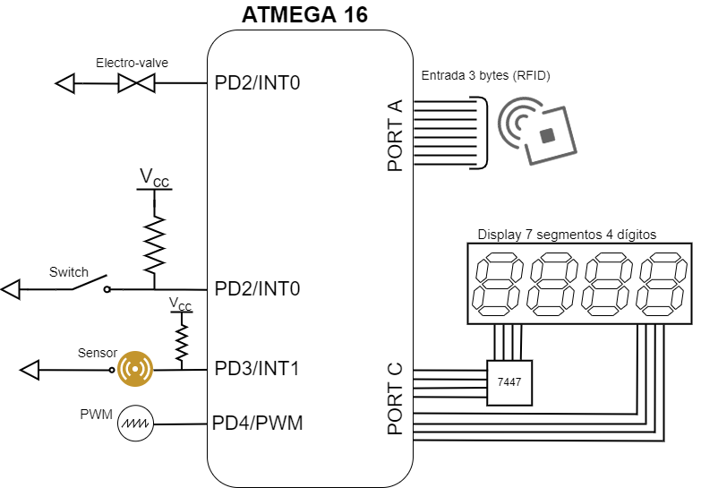

1. **Diagrama de flujo:**

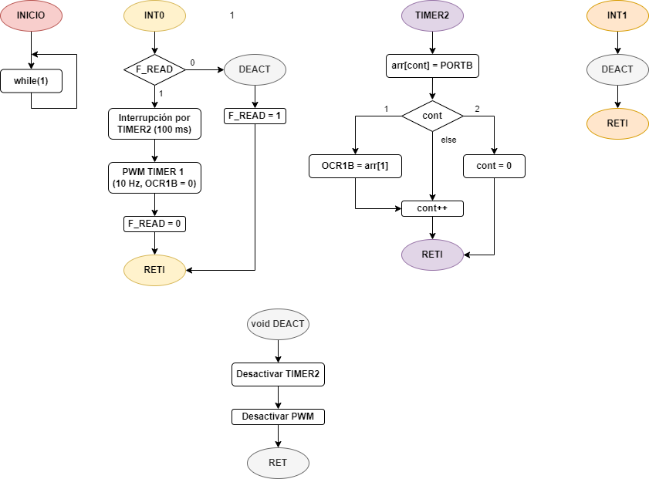

1. **Código:**

| /* |  |
| --- | --- |
|  | * main.c |
|  | * |
|  | * Created: 6/6/2022 4:43:25 PM |
|  | * Author: Robogod |
|  | */ |
|  |  |
|  | #define F_CPU 8000000UL |
|  |  |
|  | #include <xc.h> |
|  | #include <avr/io.h> |
|  | #include <avr/interrupt.h> |
|  | #include <avr/pgmspace.h> |
|  |  |
|  | uint8_t codigo_barrido = 0b11011111; |
|  | uint8_t i = 0, selector; |
|  |  |
|  | uint8_t f_read = 1, count = 0, count_int = 0; |
|  |  |
|  | uint8_t valores[3] = {0,0,0}; |
|  |  |
|  | const uint8_t temperatura[] PROGMEM = {4}; |
|  | uint8_t temp; |
|  |  |
|  | ISR(INT0_vect); // Switch interrupt (INT0) |
|  | ISR(INT1_vect); // Optical sensor interrupt (INT1) |
|  | ISR(TIMER0_COMP_vect); // RFID read (TIMER0) |
|  | ISR(TIMER2_COMP_vect); // 7 segment display (TIMER2) |
|  |  |
|  | int main(void){ |
|  | /*------ Port set up ------*/ |
|  | DDRD |= (0 << PD2); // Switch pin |
|  | DDRD |= (0 << PD3); // Optical sensor pin |
|  | DDRA = 0b00000000; // RFID pin |
|  |  |
|  | DDRD |= (1 << PD4); // Heater port (PWM = 0C1B) |
|  | DDRB |= (1 << PB0); // Electro valve port |
|  | DDRC |= 0b11111111; // 7 segments display port |
|  |  |
|  | /*------ Control word ------*/ |
|  | // External interrupts |
|  | GICR = (1 << INT0) | (1 << INT1); |
|  | MCUCR = (1 << ISC00) | (1 << ISC11); |
|  |  |
|  | // Timers interrupts |
|  | TIMSK = (1 << OCIE0) | (1 << OCIE2); |
|  |  |
|  | sei(); |
|  |  |
|  | while(1); |
|  | return 0; |
|  | } |
|  |  |
|  | ISR(INT0_vect){ |
|  | if(f_read == 1){ |
|  | OCR0 = 196; |
|  | TCCR0 = (1 << WGM01) | (1 << CS02) | (1 << CS00); //Initialize 25ms Timer |
|  |  |
|  | OCR1A = 781; |
|  | OCR1B = 0; |
|  | TCCR1A |= (1 << COM1B1) | (1 << WGM11) |(1 << WGM10); //Initialize PWM |
|  | TCCR1B |= (1 << WGM13) | (1 << WGM12) | (1 << CS12) | (1 << CS10); //Initialize PWM |
|  |  |
|  | OCR2 = 39; |
|  | TCCR2 = (1 << WGM21) | (1 << CS22) | (1 << CS21) | (1 << CS20); |
|  | f_read = 0; |
|  | } else{ |
|  | TCCR0 = 0; // Turn off 100ms Timer |
|  |  |
|  | TCCR1A = 0; // Stop PWM |
|  | TCCR1B = 0; // Stop PWM |
|  |  |
|  | TCCR2 = 0; |
|  | f_read = 1; |
|  | } |
|  | } |
|  |  |
|  | ISR(TIMER0_COMP_vect){ |
|  | if(count_int == 3){ |
|  | count_int = 0; |
|  | valores[count] = PINA; |
|  | if(count == 0){ |
|  | count++; |
|  | } else if(count == 1){ |
|  | temp = pgm_read_byte(&temperatura[0]); |
|  | if(valores[count] < temp){ |
|  | OCR1B = 586; // 75% PWM |
|  | } else if (valores[count] >= temp){ |
|  | OCR1B = 195; // 25% PWM |
|  | } |
|  | count++; |
|  | } else if(count == 2){ |
|  | if(valores[count] < 3){ |
|  | PORTB |= (1 << PB0); |
|  | } else{ |
|  | PORTB &= ~(1 << PB0); |
|  | } |
|  | count = 0; |
|  | } |
|  | } else{ |
|  | count_int++; |
|  | } |
|  | } |
|  |  |
|  | ISR(INT1_vect){ |
|  | TCCR0 = 0; // Turn down 100ms Timer |
|  | TCCR1A = 0; // Stop PWM |
|  | TCCR1B = 0; |
|  | TCCR2 = 0; |
|  | } |
|  |  |
|  | ISR(TIMER2_COMP_vect){ |
|  | selector = codigo_barrido & 0xF0; // 0-Mask to 4 LSB |
|  | PORTC = selector + valores[i++]; // Selector + value to 7 segments |
|  | codigo_barrido = (codigo_barrido << 1); // Shift left (next digit) |
|  | if(i > 2){ |
|  | i = 0; |
|  | codigo_barrido = 0b11011111; |
|  | } |
|  | } |

1. **Esquemático de Hardware (Simulación Proteus):**

