MANIPULATING DATA WITH DPLYR
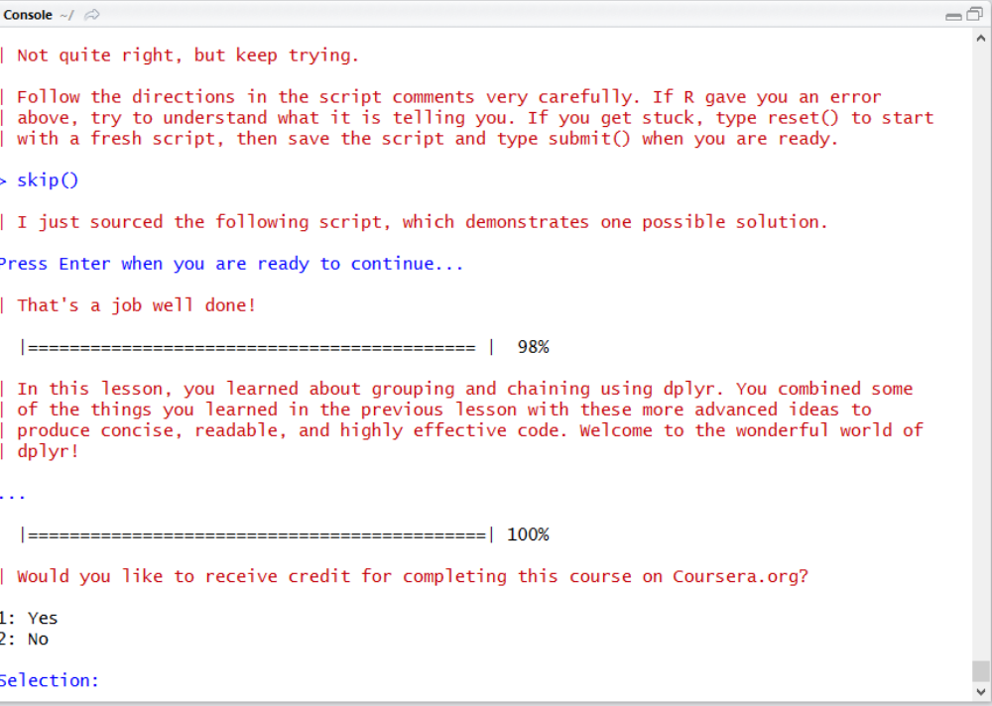

GROUPING AND CHAINING WITH DPLYR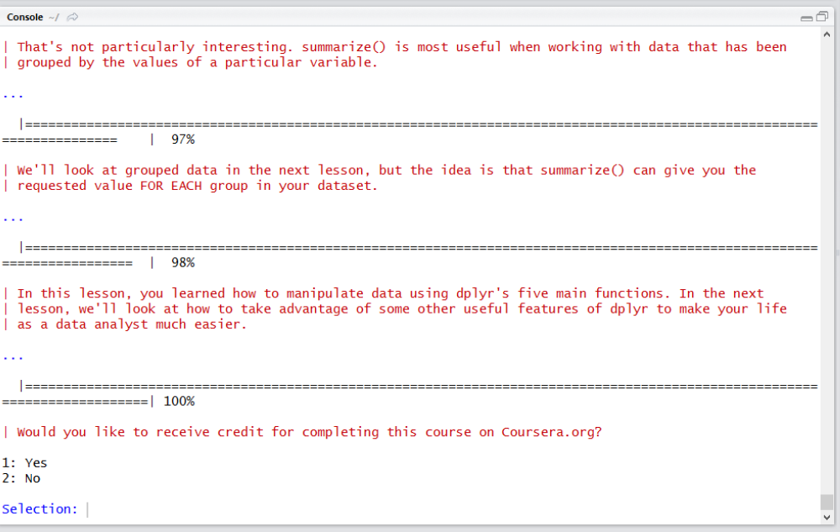

TIGYING DATA WITH TIDYR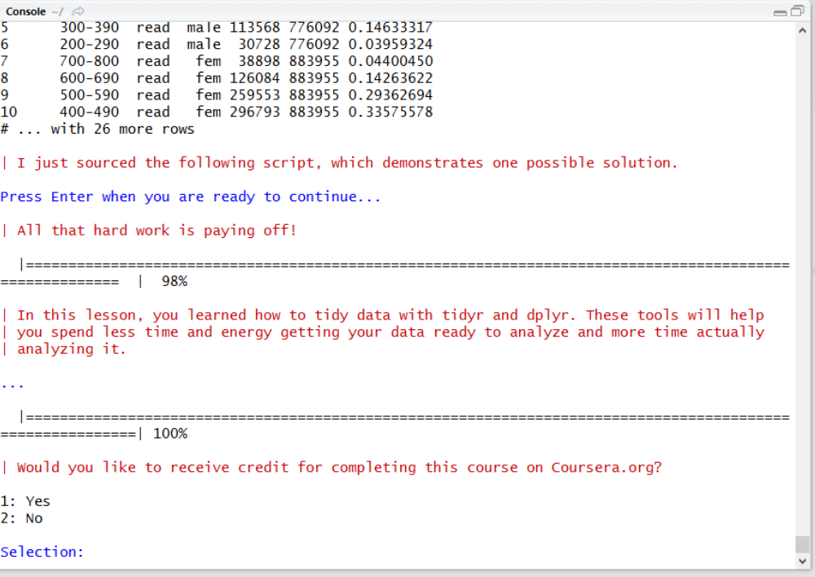
DATES AND TIMES WITH LUBRIDATE