C y b e r s e c u r i t y

CV

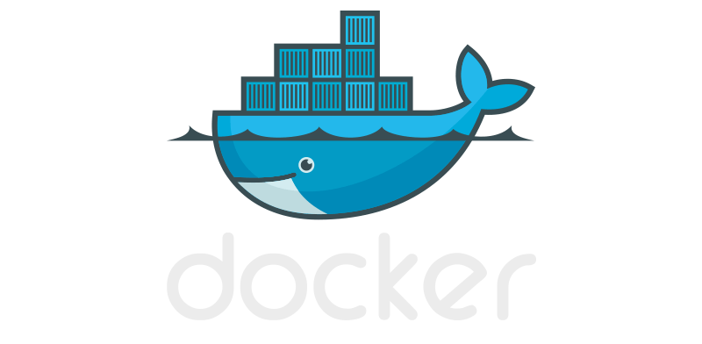

[GuillermoW7 (github.com)](https://github.com/GuillermoW7)

maldonadoesquibelg@gmail.com

My objective:

My objective is, firstly, to learn more. Secondly, I aim to make contributions within this field that I am so passionate about. Thirdly, I seek to make my income more stable and secure. My dedication and commitment to my responsibilities provide me with the assurance of aiding others in achieving their goals, while also adding an experience fueled by my curiosity.

Who am I?

Currently, I am studying for a Bachelor's degree in Administrative Informatics. My school allows me the opportunity to pursue formal employment since it is designed for individuals who work, as it is an online program. Currently, I am seeking to transition from freelance work to a formal and stable job. I am deeply interested in this field as it fascinates me, which is why in the year 2024, I decided to share my research and developments with others. To achieve this, I make use of documentation and contributions.

"My mastery of English allows me to communicate effectively in writing and listening, however, my spoken English is not very fluent but still enables me to communicate adequately."

Native

Mid

Languages I master:  
  
Ingles Español

Experience:

Over these past 4 years, I have acquired a myriad of technical and soft skills. My work has mostly been autonomous and self-taught, contributing to local businesses and companies in solving computer issues such as sudden incidents. In this manner, I have worked with a plethora of ecosystems such as the cloud, private networks, team projects, or industrial project planning.

Guillermo Maldonado Esquibel

Tools and

Languages:

* Penetration testing
* Assessment  
  vulnerability
* Malware  
  analysis
* Cloud  
  security
* Forensic
* Code
* Tools security

Technical

Skills:

* Adaptability
* Teamwork
* Ethical   
  mindset
* Continuous  
  learning
* Problems  
  solving
* Calmed behavior
* Communication

Soft  
Skills:

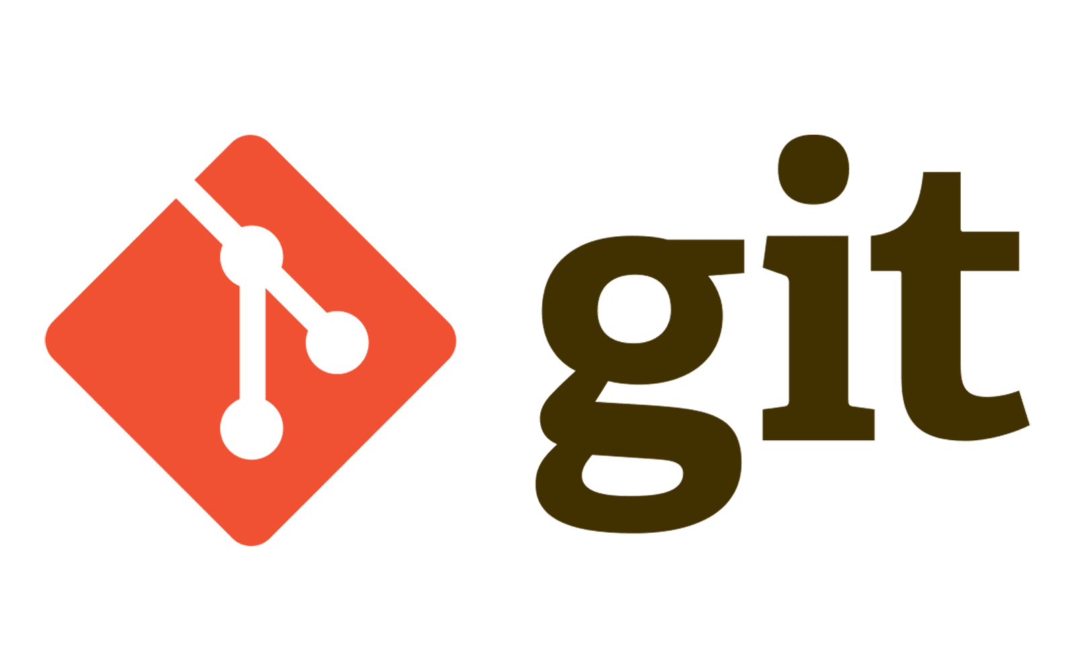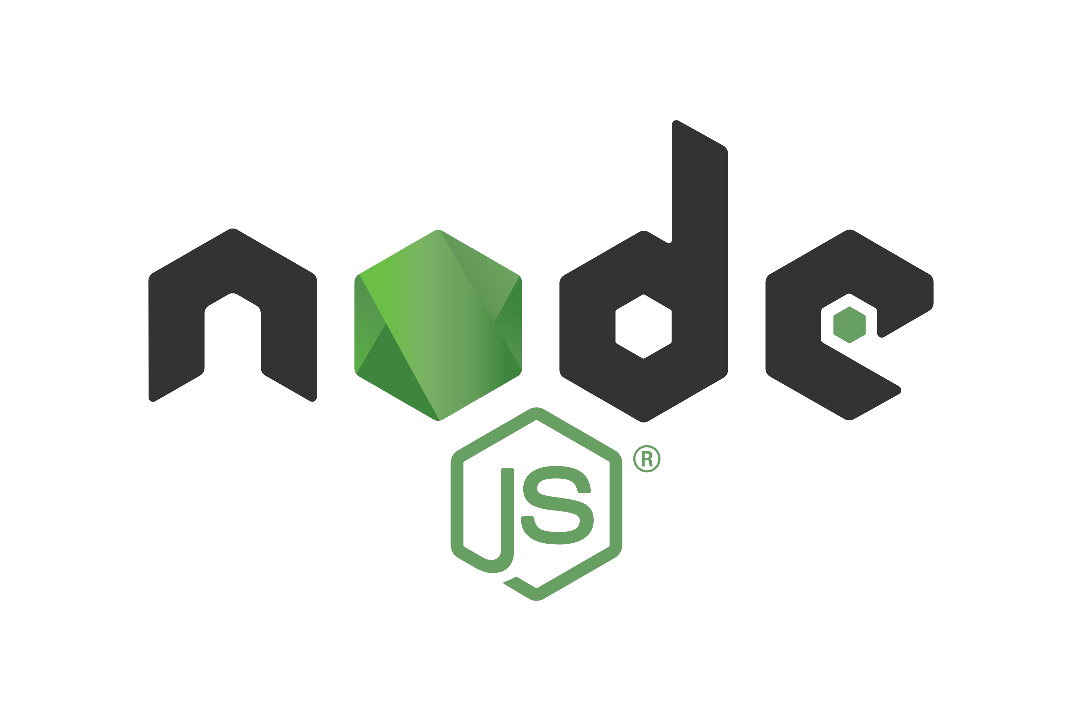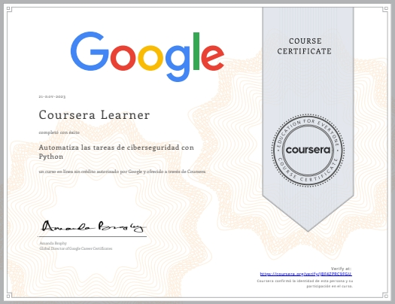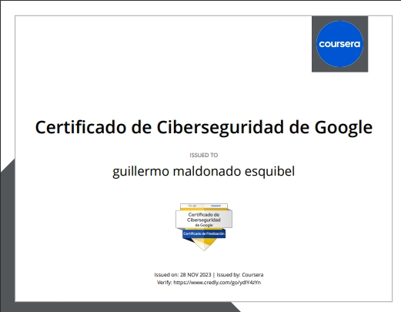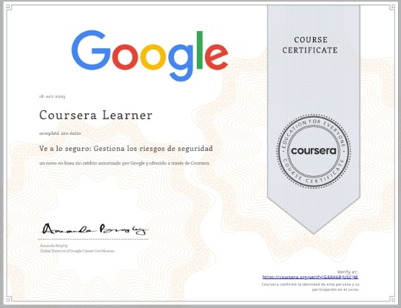

My certifications:

Currently, I hold the Google certification; however, I am aiming to obtain either the eJPT or the OSCP certifications, both of which I feel qualified to pursue. Unfortunately, due to their cost, I haven't been able to acquire them yet.

I demonstrate my experience through documentation of virtual machines and progress made in fields such as machine learning, quantum hacking, DevOps, or general challenges.

www.linkedin.com/in/guillermo-maldonado-esquibel-757b15304

https://acortar.link/mVxLiZ

+52 4431404409

Morelia, México

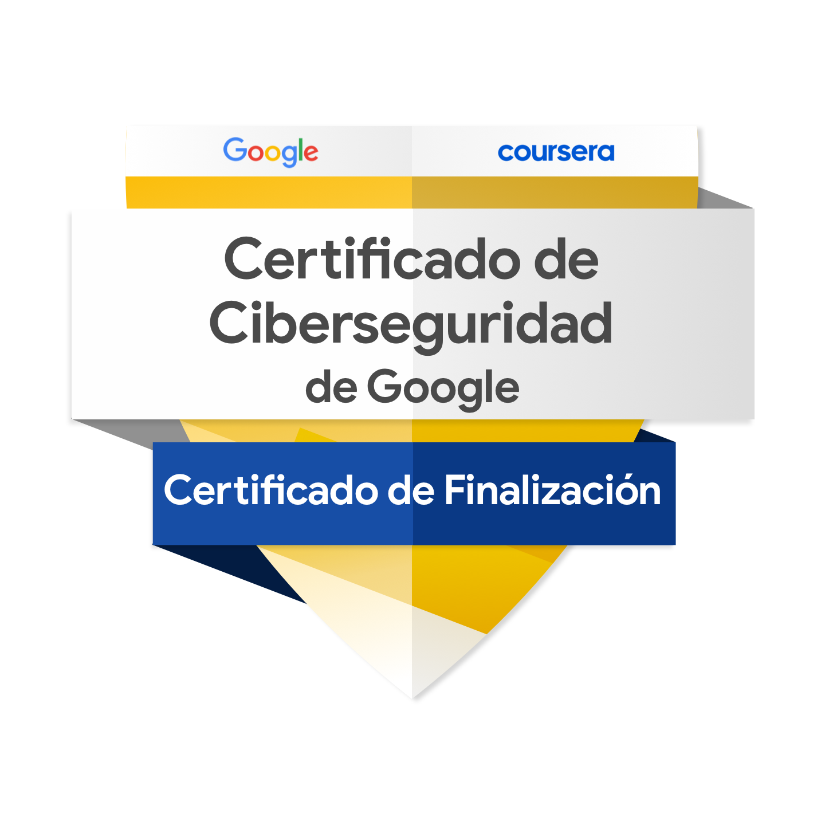

What can I bring to them?

Calmness is crucial to face sudden and complex challenges, and it's because of this that my contributions are enhanced. Having a solid plan, maintaining a healthy behavior in team environments by respecting and motivating everyone to continue. Observing and listening allows for learning new things and minimizing errors. Having a learning methodology enables me to grasp new concepts in short periods. Commitment and passion are what keep me seeking innovation in this field. Interest and empathy towards the surrounding environment. Orderliness and cleanliness in all areas. Knowledge of many other disciplines besides computer science allows me to broaden my fault detection.

For these and many more ethical and disciplinary reasons, I am a reliable individual ready to contribute to you.