Introduction
SAY THAT FERM is made by bacteria....
SAY demographic issue, ecolo green washing, babacool vegan vitamin deficiency..
SAY cheese making 6000BC(dynamics)
Fermentation process have always taking a big place in food processing for human; alcoholic fermentation is know to be used by humans since 6000BC [??], and we have found evidence of historical uses of fermentation in almost all parts of the world. However, it is important to distinguish different types of fermentation and their different uses. Firstly, Pasteur originally defined fermentation as respiration without air, which is still quite true: the concept of fermentation regroups all the microbial energetic process that occurs without air, but not necessarily under anaerobic conditions.
There is two main types of fermentation, known as ethanol fermentation and lactic acid fermentation.
Our interest will be focused on lactic acid fermentation, because this fermentation concern human (and animals) diet, instead of alcoholic beverages.
Lactic acid fermentation was and still used in many part of the world for two main reasons: it improve the conservation of the aliment, and improve his nutritive value.
Thus, such process have great potential in food industry, and the way to improve the fermentation process is to select sets of bacterium that are optimal for a substrate.

There is several problematic that lactic acid fermentation can answer, such as the necessity to feed the growing mass of humans and

Because of the nearly exponential growth rate of the world population, there is a need to investigate more efficient food processing, fermentation process are biological, a needs a very low supply of energy. Because aliments can be conserved longer, they no longer require a big amount of conservative additives [source], and less likely to be thrown at the trash bin because of their conservative qualities, thus generating less wastes.
?Their nutritive efficiency per kilogram makes these aliments takes less place for storage, transport.

Data retrieving scripts

Data download scripts
A Python script, ??? downloads informations relatives to a .gbk annotation file based on the NCBI website, from a list of accession numbers. This script use the Biopython library, to connect and select informations that are on the NCBI website.
Theses informations are:
- EC numbers of proteins found in the annotation file
- The annotation type, primary or RefSeq, both when available
- A cross reference used to get the Uniprot accession number of the protein, that is also downloaded by the script
All these informations are stored in an ORM database, detailed in the next paragraph.

The ?metagdb? ORM database
ORM database can conserve the object structures of the program. The engine is sqlite, and allows to have the database as a simple file, without a server as intermediary. SqlAchemy library was used to build this database that store the downloaded informations relatives to the .gbk annotation files.

STICK the merise schema, or a graph(better)

The RDF database
RDF (Resource Description Framework) is a group of several W3C specification, and is representative of the semantic web concept. It was originally designed to be a metadata model, but its possible to apply this technology to databases applications.
There is several different serialization format for RDF, and the one chosen for this database is Turtle, because its compact and easily readable by human.

Informations found in metabolic databases
- EC: Enzyme Commission number, is a numerical classification schema for enzymes, based on the chemical reaction they catalyses. Each number is associated to a recommended name for the enzyme. However, an EC number does not specify a particular enzyme, but an enzymatic reaction: different enzymes from different organism can receive the same EC number if they catalyses the same reaction.

- Uniprot Accession numbers: They are unique identificator for each protein, composed from 6 to 10 alphanumerical characters. However, an Uniprot entry can have several accession number, mostly because of fusion or separation of ancient numbers that are conserved.

Links between databases
- Metacyc: We can do a research from:
  - EC numbers
  - The names of compounds, genes, proteins or pathways
  - A PGDB ID (Pathway Genome DataBase) (common to biocyc websites)
    - Can be turn into an SBML file
  - A Biocyc locus ID
  - An ID from other databases (Uniprot, NCBI..)
- Uniprot:

The TGDB database (name will change, just the name..)
TGDB() is a human readable database ( a plain text file ) made by the INRIA institute (CHECK THAT). This files store a part of informations available in the Metacyc database, and a Python 2.7 library is provide to Query the file.

TGDBplus files are a subunit of the TGDB, they regroup all the metabolic information from a specific organism

This database serve as a basis for all the metabolic informations needed in this work

STICK the graph, if possible to draw this thing

The menaquinone pathway (vitamin k)
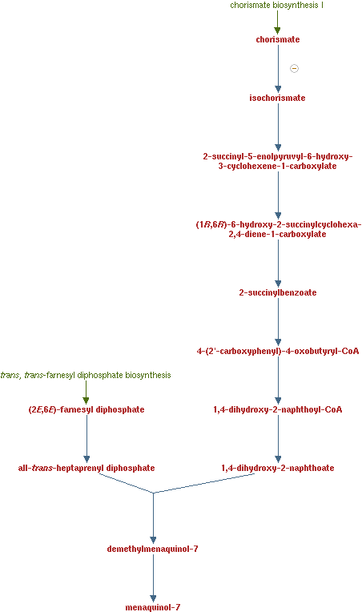
On of the main precursor is the chorismate, which is a dicarboxylate. Chorismate is used during the synthesis of several components, such as tyrosine amino acid, vitamine k and folate (b9 vitamin).
It's implication in several amino acids biosynthesis makes the component frenquently available.
The other required metabolite is the farnsesyl diphosphate, or farnesyl pyphosphate, which is used in biosynthesis of terpenes, terpenoids and sterols. It's also used in postranslational modification of proteins. The molecule is also largely available in the studied organisms.

The folate pathway (b9 vitamin):
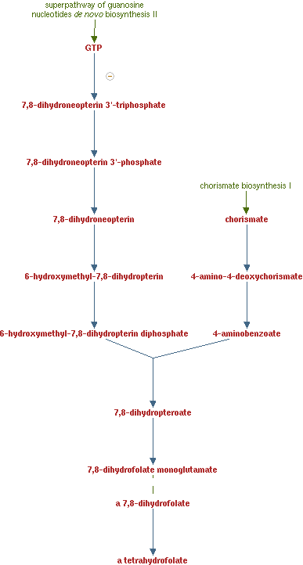
This pathway also require the chorismate as precursor, and the GTP. GTP stands for Guanosine triphosphate, which is nucleoside triphosphate. It have almost the same molecular structure of the Guanine nucleobase, but the only difference is it have have a ribose sugar and 3 phosphates.
Because of it roles in RNA synthesis and DNA replication, this molecule is widely available is organism.

The cobalamin biosynthesis ( b12 vitamin)
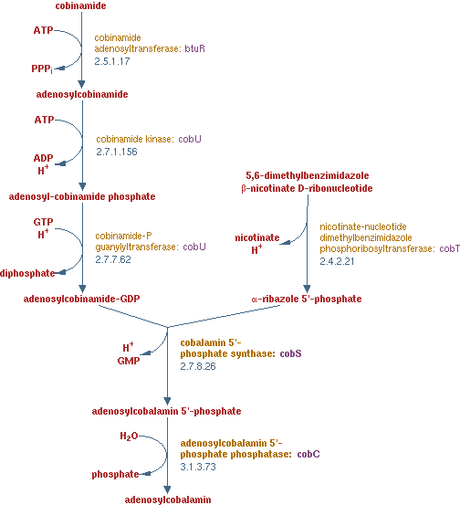
This pathway is a bit more complicated than the others, because of it precursors:

