# PK NVA237 - model qualification run dummy

Novartis  
Confidential

# Predictions

### Normalized prediction distribution error versus time

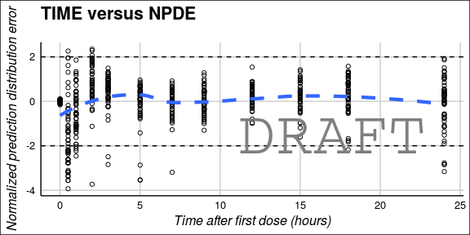

#### Normalized prediction distribution error versus population predictions

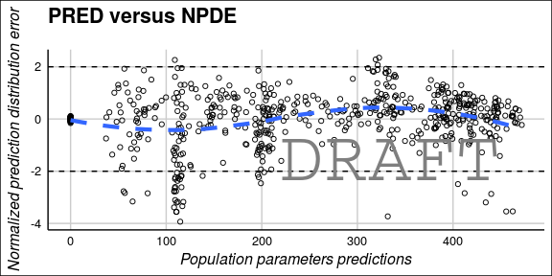

# Random effects