Lab 5 - Collaborative Filtering & Recommender System
Trent Ellingsen & Thomas Wong

Methods Implemented:
Mean Utility
Weighted Sum
Adjusted Weighted Sum

Questions
Which method produces the lowest error overall in it's predictions?

Experiment Summary
Each test gave results for mean utility, weighted sum, and adjusted weighted sum.
- test was on a user input set of 20 test cases.
- test on random sampling of 20 test cases.
- test on random sampling of 100 test cases.
- test on random sampling of 500 test cases.

Results

20 user input test cases
MU: Mean Absolute Error: 4.6616726
WS: Mean Absolute Error: 4.724894
AWS: Mean Absolute Error: 3.0566862

20 random sampling test cases
MU: Mean Absolute Error: 5.157133
WS: Mean Absolute Error: 4.262269
AWS: Mean Absolute Error: 3.2342038

MU: Mean Absolute Error: 3.5267746
WS: Mean Absolute Error: 3.9267495
AWS: Mean Absolute Error: 3.5020237

MU: Mean Absolute Error: 3.7153676
WS: Mean Absolute Error: 4.869051
AWS: Mean Absolute Error: 2.836786

100 random sampling test cases
MU: Mean Absolute Error: 4.3978386
WS: Mean Absolute Error: 4.2234406
AWS: Mean Absolute Error: 3.993107

MU: Mean Absolute Error: 4.1159763
WS: Mean Absolute Error: 4.014805
AWS: Mean Absolute Error: 4.308136

MU: Mean Absolute Error: 4.353029
WS: Mean Absolute Error: 4.0711803
AWS: Mean Absolute Error: 3.330516

500 random sampling test cases
MU: Mean Absolute Error: 4.2699814
WS: Mean Absolute Error: 4.70437
AWS: Mean Absolute Error: 4.423147

MU: Mean Absolute Error: 4.493612
WS: Mean Absolute Error: 4.456233
AWS: Mean Absolute Error: 3.7614129

Graphs
These are graphs created from the User Input data set of 20 test cases. The first graph shows the accuracy of the results. The closer the 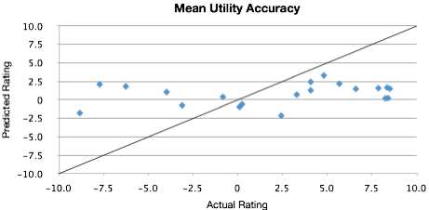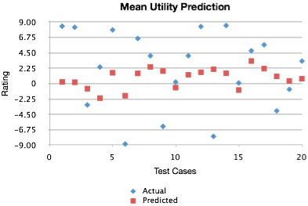points are to the line the more accurate the predicted result is. The second graph shows the actual results of the predictions versus the rating.

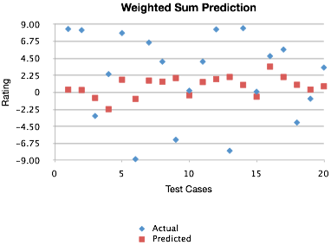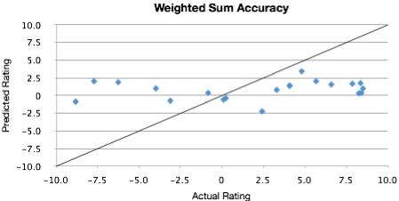

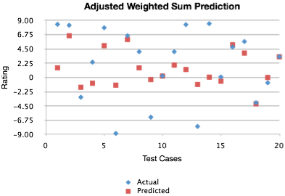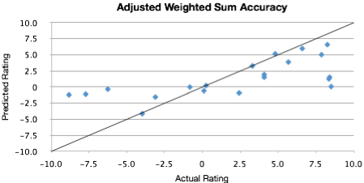

Conclusion
We discovered that the Adjusted Weighted Sum is the best in predicting user ratings. Over all the Mean Utility and Weighted sum seem to change which is better or worse for results, but we feel that the Mean Utility is consistently more accurate. For the Adjusted Weighted Sum the MAE was usually around 3 - 4. The others are usually around 4 - 5.

