Contents

Agile approach 2

Maxims 2

An agile approach to projects 2

An agile team works as one 2

Agile teams work in short iterations 2

Agile teams deliver something each iteration 2

Agile teams focus on business priorities 2

Agile teams inspect and adapt 3

An agile approach to planning 3

Multiple levels of planning 3

Conditions of satisfaction 3

Why we need the agile methods? 3

Agile Principles 4

Advantages of the agility 4

SCRUM introduction 4

Roles 5

Artifacts 5

Sessions or events 6

Planning 6

Daily session 6

Review 6

Retrospective 6

Refinement 7

SCRUM features 7

SCRUM pillars 7

Agile estimation 7

Estimating size with story points 7

Velocity 8

Techniques estimation 8

Evaluation and review techniques 8

Affinity without category 8

Estimation by analogy 8

Ouija estimation 8

Bucket system 8

The silence technique 8

Planning poker 9

Rock, paper and scissors 9

Business value and agility prioritization 9

What’s business value? 9

Commercial value 9

Market value 9

Efficiency value 9

Value to user 9

Future value 9

Value types 9

Prioritization 10

Prioritization techniques 10

Prioritizing themes 10

Factors of the prioritization 10

Value 10

Cost 11

New knowledge 11

Risks 11

Understanding of requirements 12

Requirement engineering 12

Conception 12

Inquiry 12

Elaboration 12

Negotiation 12

Specification 12

Validation 12

Stablish the basements 12

Inquiry of the requirements 12

Develop of usage cases 13

Elaboration of requirement model 13

Elements of the requirement model 13

Analysis patterns 13

Requirements of the business 13

Validation of the requirements 13

# Agile approach

## Maxims

The authors of the Agile Manifesto wrote that they value:

* Individuals and interactions over processes and tools.
* Working software over comprehensive documentation.
* Customer collaboration over contract negotiation.
* Responding to change over following a plan.

## An agile approach to projects

Main ways that agile teams work:

* Work as one team.
* Work in short iterations.
* Deliver something each iteration. Focus on business priorities.
* Inspect and adapt.

### An agile team works as one

The methodology agile have different kinds of roles, as:

* **Product owner:** person who make decisions. That role can be different person depending the situation or the software to develop.
* **Customer:** person who fund the project or to buy the software. May or may not be a user of the software.
* **Developer:** person who development software. Even the product owner may be thought of as a developer on many projects.
* **Project manager:** person who focus more on leadership than on management. Sometimes, the project manager can be a developer and the product owner occasionally.

### Agile teams work in short iterations

In these iterations happens all the work (requirements, design, coding, testing, and so on) concurrently. The iterations finish on time even if functionality is dropped to do so. The length can have a range of 4 to 12 weeks, and maintain their agility.

### Agile teams deliver something each iteration

More important than the length of the iteration chosen, is that during the iteration transform one or more requirement statements into code, tested and potentially shippable software.

### Agile teams focus on business priorities

* The team deliver features with the priority provide by the product owner. To achieve this, a release plan is created based in the team’s capabilities and the prioritized list of desired new features. And keep dependencies at minimum is often quite feasible.
* Other agile teams focus on completing and delivering user-valued features. To do that, good ways is to do with user stories, to expressing software requirements. The user stories are a brief description of the functionality desired by the customer or user. The format is free, but a fitting form is: <type user> <capability> <business value>.

### Agile teams inspect and adapt

The plan make initially can be adapted after, because the situation changes, or the features desired by the product owner, customer or user don’t have the same priority or now are inexistent.

# An agile approach to planning

The knowledge got, help improvement of the product and project, cause exist a flow of new capabilities that can make a better project or product.

* **New product knowledge:** helps us know more about what the product should be.
* **New project knowledge:** is information about the team, the technologies in use, risk and so on.

## Multiple levels of planning

The vision in a project can be slightly short, but this allow adjust and look the new horizon with dividing the planning on little spaces. Can see the relationship of the planning horizons in the next picture.

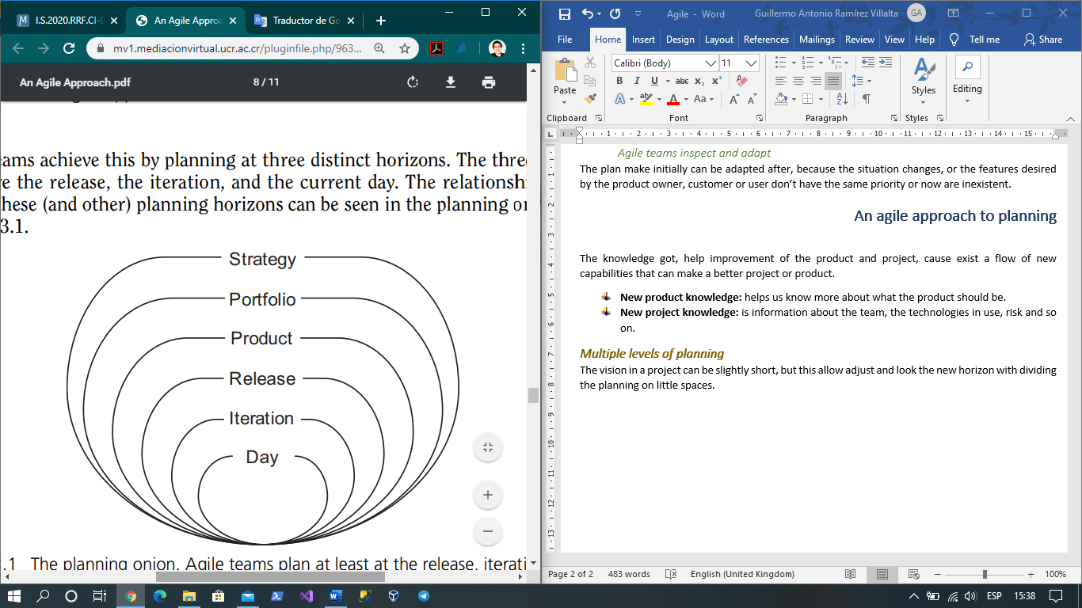

## Conditions of satisfaction

The condition of satisfaction can change cause isn’t feasible on the iteration. For other situation the condition can be very shortly, in these cases too need change. Once a release plan covering approximately the next three to six months is established.

# Why we need the agile methods?

Because the development of all features is unnecessary, cause the 20% of the product normally satisfice 80% of the need (Principle of Pareto).

To use the principle of Pareto in the agile methods we need:

* Identify and prioritize the products that make more value for the business.
* Help persons to organize the workload.

The agility it’s more culture than process.

Agile manifesto is the result of the ideas of SCRUM and XP (Extreme programming).

## Agile Principles

* The main priority is early and continuous satisfaction of the final user.
* The requirement can change and provide competitive advantage, but is responsibility of the product owner to decide that can be reduce to include those changes.
* The delivery of functional products should be frequent and consistent throughout time.
* The interested and members of the scrum team collaborate daily.
* The process improves develop with motivated individuals.
* The conversations face to face are the most effective method of communication.
* The functional product is the main measure of progress done.
* All the agile process promotes sustainable implementation. Constant work (70%).
* The continue attention of the excellency improve the agility.
* To maximize the amount of work not done satisfying the basic necessity of the interested.
* The best architecture, design and norms arise of auto-organized teams.
* The reflection and auto-critic how like to be effective are imperative.

## Advantages of the agility

* Visibility.
* Adaptability.
* Value added.
* Risk management.

# SCRUM introduction

Jeff Sutherland and Ken Schwaber create the framework SCRUM without specify the implementation of the things.

Scrum it’s iterative and incremental work strategy. Search the next:

* Management the interested expectative.
* Anticipated results.
* Flexible and adaptative framework.
* Quick return on investment.
* To mitigate risks.

## Roles

* **SCRUM Master:** has the responsibility of the team to be functionally and productively. Promote the values and practices of SCRUM. He’s the leader. Isn’t a product manager. Develop the next activities:
  + Remove impediments.
  + Promote the collaboration.
  + Protect the team of external interference.

He also has the following features:

* Understanding of service and facilitation leadership.
* incredible approach in search of the continuous improve.
* General knowledge of the product, the market and the development process.
* **Product owner:** is the responsible of the product rentability. Focus in ‘what’ more than ‘how’ (vision). Develop the following activities:
  + Define the products features.
  + Decide the date of release and the content.
  + Prioritize need according to market values.
  + Adjust product features as necessary.
  + Allow or deny generated products.

He also has the following essential features:

* + Availability.
  + Knowledge.
  + Authority.
* **Development team:** is the responsible of the technique quality of the generated products. Develop the following activities:
  + Convert needs into functional product.
  + To establish the best form to do his work.
  + Decide the product amount can be deliver per iteration.

He also has the following essential features:

* Auto-organized.
* Multidisciplinary.
* Committed.
* He needs to be cohesive.
* Dedicated to project.
* 5 ±2 persons.

## Artifacts

* **Product Backlog:** needs and desires of the interested. Ideally expressed in form that generate value. Prioritize by the product owner. Check at the start and final of each iteration in addition also in refinements.
* **Iteration Backlog:** development team tool. Each member selects the task to realize. Each element that’s incorporate is divided in tasks.
* **SCRUM Board:** contains the stories of each iteration. Is updated daily. The session daily is better in the SCRUM Board.

## Sessions or events

### Planning

**What is needed?** The team velocity, the product backlog, the product vision, and the environment conditions, technology and current product.

**What is done?** Is analysed the product backlog and is defined the vision of the iteration. Is decided la ‘best’ form of realize the projected work.

**What do you obtain?** Iteration objective and iteration backlog.

**Who participates?** The team SCRUM.

**Diary:** remember the product vision. Presentation and estimation of the elements of the product backlog, that will allow to achieve the iteration objective. Defining the scope of the iteration. Creating the iteration objective. Dates for review and retrospective sessions. Defining the hour and place of the daily session.

### Daily session

**What is needed?** All the development team and hour and place definite.

**What is done?** To analyse the team progress.

**What do you obtain?** Identified impediments and transparency.

**Who participates?** Development team and initially the SCRUM master.

**Daily:** what I did yesterday? What can I do today? What impediments can I foresee?

### Review

**What is needed?** Product increment.

**What is done?** Present the iteration result that is finished.

**What do you obtain?** Revised product and feedback of the interested.

**Who participates?** Product owner, SCRUM master, development team, and some interested.

**Daily:** welcome to participants, explain that will be demonstrated and that not. To demonstrate the product increment. Argue key events. To present the next elements of the product backlog.

### Retrospective

**What is needed?** Positive attitude.

**What is done?** Is identified and argued found in the process. Is proposed solutions for the identified impediments.

**What do you obtain?** List of impediments and compromise to improve.

**Who participates?** Product owner, SCRUM master and the development team.

**Daily:** icebreaker. Get data. Decide what to do. Closure (motivation).

### Refinement

**What is needed?** Product owner and development team doubts.

**What is done?** Is refined the user needs.

**What do you obtain?** User stories and clear needs (best estimations).

**Who participates?** Product owner, interested and the development team.

**Daily:** depend the type session.

## SCRUM features

The framework SCRUM enables people to initiate adaptative complex problems while delivering the best possible value productively and creatively. Some of the SCRUM features is:

* Lightweight.
* Easy to understand.
* Hard to dominate.
* To research and identify viable markets, technologies and products capacities.
* To develop products and improves.
* To free products and improves as much possible during the day.
* To develop and maintain cloud environment.
* To maintain and renovate products.
* SCRUM is based in the empiricism.

## SCRUM pillars

* **Transparency:** Significant aspects of the process must be visible to those responsible for the product.
* **Inspection:** the user must inspect frequently the SCRUM artefacts and the progress of the objective.
* **Adaptation:** if an inspector determines the one or more aspects of the process deviates from acceptable limits and the resulting product will be inacceptable, the process or the material must be adjusted.

# Agile estimation

It’s method that can define the relative measure time to finish a project. We can use some parameters to estimate, among them are the Fibonacci series, the Fibonacci series modify, doubles and shirt sizes. The agile teams have two different types terms, the estimates of size and estimates of duration.

* **The estimates of size:** it's oriented to the amount of work to do.
* **The estimates of duration:** refers to the time interval in which the work can be done.

In a process first need to do the estimates of size and then the estimates of duration.

## Estimating size with story points

Only that I need is if a story is larger or smaller than other stories and features.

To estimate exist two correct ways to get started, the first to select the story that you expect to be one of the smallest stories and you’ll work with and say it story is estimate at 1 story point. Second way is to look at a story that can be in the middle of the chosen range and assign half of the range's story points to it.

## Velocity

Is calculated by the number of story points done by the team during the iteration. The velocity with few iterations corrects estimation errors.

## Techniques estimation

* What our brain says.
* Consensus.
* Triangulation.
* Relative estimation.
* Reduce a great story to small task and take of reference.
* Expert opinion.

### Evaluation and review techniques

This technique is based in three values:

* Optimist value.
* Pessimist value.
* Probable value.

Use the formula BETA = (O+P+4M)/6.

### Affinity without category

Don’t use categories only work with a factor previous defined. The initial goal is only having the stories grouped.

### Estimation by analogy

Use the comparation between other finished stories, this technique needs stories completed.

### Ouija estimation

It’s placed the scale elements in the extern of the table and play.

### Bucket system

It’s selected a random story and continue selecting other stories, if the system is unbalanced the team stop, and readjust the scale.

### The silence technique

Using a scale, is created categories.

* Modify a realized estimation.
* Take and categorize a new random story.

All the process is done in silence.

### Planning poker

All the team sit around the table if they were going to play poker.

* Read the story and all the team show his estimation.
* If exists difference then the high and down tries to convince the team.

### Rock, paper and scissors

It’s like a planning poker but without the cards.

# Business value and agility prioritization

Our priority is to satisfice the customer through the continuous and fast delivery of value. The price is that to pay and the value is that to generate.

## What’s business value?

That’s concept can answer the following question:

* How know if the development team generate value?
* All that is deliver by the business generate value?
* What’s does “maximize value” mean in terms of behaviour and take decisions?
* How know what’s the functionality that generate more value for the business?

“The generate value just is quantify when is deliver”

### Commercial value

How functionalities turn into profits.

How many profits can produce the work?

### Market value

It represents el potential to increment the number of customers.

How many customers can attract?

### Efficiency value

Reduce the operative cost, thus generate value

How much time can we save?

### Value to user

It represents the benefit that users have to continue using the product.

to what extent will this decrease the probability of a customer leaving?

### Future value

increases the possibility to obtains benefits from the aforementioned values.

How mane can save that in time or in money in the future?

### Value types

Finance, to user, process, increase.

The profit of the company partners is the result, no the strategy.

## Prioritization

Factors that can influence in the prioritization: business value, development cost and risk.

The cost can change and need to be recalculated.

Exist several types of risk: temporal, economic, functional. Don´t to do task with high risk and low value.

The stack must be ordered and prioritized. How categorize?

Mental states of the prioritization.

* Past
* Future
* Business
* Technician

Key ask for the product owner:

* What’s elements generate more business value?
* What’s the low hanging fruit?

## Prioritization techniques

* **Piramide:** priority 1, priority 2, ....
* **MoSCoW:** Must, should, could, won’t have.
* **1000 colones:** fictitious money and invert that.
* **“Campeonatito”:** champions scheme.
* **Poker priority:** use like a planning poker.
* **Business value for urgency**
* **Kano model:** How do you feel if the product has or haven’t this functionality? And answer with five scale.

## Prioritizing themes

### Factors of the prioritization

* Financial value of having features.
* Cost of development the new features
* The amount and significance of learning and new knowledge created by developing the features.
* The amount of risk removed by developing the features.

### Value

First estimate the financial impact, but this estimation can be complex because the variables like timing of sale, the average value of a sale, number of sales and so on.

### Cost

The cost can change when is needed to develop new features. A good way to estimate the possible cost is the conversion of story points in money, following use the information to know what is the price of a story point.

### New knowledge

Knowledge about the product and project.

### Risks

* Schedule risk
* Cost risk
* Functionality risk

# Understanding of requirements

The user usually doesn’t know the specific information or that want.

## Requirement engineering

Tasks and techniques to understand the requirements is called requirement engineering.

### Conception

How starts the project? In this phase is needed the basic comprehension of the problem, the solution origin and the effectiveness in the communication and collaboration between the participants and the software team.

### Inquiry

What’s the objectives of the product or system? That can have a lot of problems like:

* **Scope problems**
* **Comprehension problems**
* **Volatility problems**

### Elaboration

Develop a requirement model refined that can identify aspects of the software function, the behaviour and information.

### Negotiation

In this phase is needed order the requirements by priority and after analyse the conflicts.

### Specification

Can be document, a group of graphics models, a formal math model, a set of use scenarios, a prototype or any combination of there.

### Validation

Is evaluated the product quality.

## Stablish the basements

* **Participants identification**: a participant is any person can be benefit direct or indirect by the develop system.
* **Recognize the multiples points of view**
* **Work to the collaboration**
* **Do the firsts questions**

## Inquiry of the requirements

* **Inquiry of the requirements in collaborative mode**
  + Both software engineering and participants lead the meetings.
  + Stablished the rules for preparation and participation.
  + Suggested a diary formal enough to can talk about the most important points, but the informal enough to encourage the free flow ideas.
  + A facilitator.
  + Is used a “definition mechanism”.
* **Deployment of quality function**
  + Normal requirements
  + Expected requirements
  + Exciting requirements.
* **Usage scenarios**
* **Inquiry of work products**

## Develop of usage cases

* First is needed identify the actors
  + Is necessary identify the actors, exceptions, main functions, variations, so on…

## Elaboration of requirement model

The objective of the model of the analysis is describe the information domains, function, and behaviour that is required for the system based in computer.

### Elements of the requirement model

The elements of the requirement model are determined by the modelling analysis method, however, the most models have general elements:

* **Elements based in the scenario**
* **Elements based in classes**
* **Behaviour elements**
* **Flow-oriented elements**

### Analysis patterns

Is integrated in the analysis model referencing the pattern name.

## Requirements of the business

* To identify key participants of the system or subsystem.
* Determinate the “terms to win” of the participants.
* Negotiate terms to win of the participants.

## Validation of the requirements

All the features in the product is reviewed and is questioned the functionality.

# Product ideation

A product requirement is innovation.

## INVEST

Exist a framework that’s use to categorize the user stories. The story need to be: verificable, negociable, valiosa, estimable, simple e independiente.